Supplementary Information

Full-Color High-Resolution Inkjet-Printed Perovskite Imager with Monolithically Integrated Thin-Film Transistor Array
Yiyi Zhu et al.

The PDF file includes:
Supplementary Notes 1-6, Supplementary Figs. 1-11
Supplementary Notes
Supplementary Note 1. Figures of Merit for TFT Performance and Implications for Image Acquisition Technology.
The figures of merit of the TFT utilized in our images are shown in Fig. S1. TFT with different W/L values all demonstrate decent performance. Overall, in the off state (V_{gs}=0V), the TFT shows a high effective resistance of 10¹² Ω, whereas in the on state (V_{gs} =15V), the effective resistance drops to 10⁶ Ω when connected in series within the circuit. These findings highlight the high quality and reliability of our TFT technology, which reliable performance characteristics that are crucial for optimal image acquisition.
Supplementary Note 2. Integration of Perovskite-Based Imager using TFT Technology for Enhanced Imaging Performance.
Fig. S2 presents the process flow diagram and microscopic images that illustrate the fabrication steps involved in the creation of a full-color perovskite-based imager. The integration approach described in this study utilizes inkjet printing techniques for the fabrication of perovskite photodetector. This technique enables the precise deposition of perovskite materials onto various substrates and their monolithic integration with TFT readout circuits. By integrating the photodetector with the readout circuits seamlessly, the transmission distance of signals is minimized, thereby reducing the potential for signal loss or degradation.
The utilization of TFT technology allows for the creation of pixelated arrays, enabling high-resolution imaging and individual control of each pixel. This integration provides several advantages, including low-cost fabrication, scalability, high resolution, low power consumption, and lightweight device design. Overall, this integration strategy offers a scalable approach for high-resolution, full-color imaging.
Supplementary Note 3. To Address the ‘Coffee Ring’ Effect, We Investigated the Surface Wettability and Uniformity of Perovskite Ink on SnO_{x}-coated ITO (SnO_{x}-ITO) Arrays. These Arrays were Sputter-Deposited, followed by the Removal of a Photoresist Layer and O₃ Plasma Treatment on the Fabricated Substrate.
The ‘coffee ring’ effect occurs when a liquid droplet evaporates, resulting in a ring-like deposit due to uneven solute distribution at the droplet's edges. To prevent this effect, it is critical to inhibit the pinning of the contact line, adjust the capillary flow distribution towards the contact line, and suppress solute movement to the droplet's edge. Figs. S3 a,b illustrate the contact angle and receding angle measurements of the perovskite ink on SnO_{x}-ITO. Both the contact angle and receding angle were found to be close to 0°, indicating the superhydrophilicity of the perovskite ink on SnO_{x}-ITO. The interface formed between SnO_{x}-ITO and the perovskite ink effectively prevents the radial transport of perovskite colloids caused by a pinned three-phase contact line. In comparison, as shown in Figs. S3 c,d, the contact angle of the perovskite precursor solution was measured at 21.771° on the glass reference substrate and at 13.182° on the reference ITO substrate. These measurements highlight significant differences in wettability among the substrates when exposed to the perovskite precursor solution.
Fig. S3e depicts a drop of perovskite ink on the SnO_{x}-ITO substrate, where the perovskite ink evenly covers the SnO_{x}-ITO areas, while the SnO_{x} uncoated areas lack any perovskite ink solution. This difference in wettability is caused by the varying substrate properties. When dispensed onto the substrate and allowed to evaporate naturally in the ambient environment (around 25°C), the perovskite inks, as shown in Fig. S3e, display a homogeneous distribution. This observation suggests that there is ample space for precursor particles to disperse at low drying temperatures, facilitating the development of smooth and dense perovskite thin films (refer to Fig. S3f). Specifically, the cross-section SEM image in Fig. S6 reveals a uniform orientation maintained throughout, indicating minimal defects and pinholes. This finding underscores a controlled crystallization process during the printing of perovskite crystals onto the substrate.
Supplementary Note 4. Understanding the Coffee-Ring Effect in Perovskite Film Deposition: Nucleation Analysis and Substrate Wettability Influence.
To enhance our understanding of the formation process of the coffee-ring effect during printing, we utilized a camera and optical microscopy (OM) to capture the surface morphologies of the perovskite film deposition process on both the SnO_{x}-ITO and glass reference substrates. Fig. S4 provides detailed microscopy photographs of the evolution of perovskite precursor liquid films over time. We observed that the perovskite precursor liquid film on the reference substrate ruptured, leading to the formation of the coffee-ring effect along the newly created three-phase contact line and at the boundary of the precursor film on the reference substrate. This effect significantly impacts the quality of the perovskite layer when scaling up the printing size. On the other hand, the liquid film of the perovskite precursor on the SnO_{x}-ITO substrate remains homogeneously distributed and intact.
A thorough discussion was conducted to analyze the nucleation mode and confirm the nucleation rate. According to classical nucleation theory, perovskite nucleation is governed by Gibbs free energy. In the case of perovskite nucleation occurring in a thin precursor film on both the reference substrate and the SnO_{x}-ITO and glass substrate with O₃ plasma treatment, it is likely to be heterogeneous nucleation.
The Gibbs free energy of heterogeneous nucleation (∆G_{het}) can be calculated using Equations (1) and (2). Equation (1) expresses ∆G_{het} as the product of the Gibbs free energy of homogeneous nucleation (∆G_{hom}) and the contact angle factor (f(θ)). The contact angle factor (f(θ)) is determined by Equation (2), which involves the contact angle (θ). The contact angle plays a significant role in influencing heterogeneous nucleation. At a contact angle of 180°, heterogeneous nucleation transforms into homogeneous nucleation, while at 0°, there is no nucleation barrier. Therefore, enhancing the substrate's wettability to the perovskite precursor solution, particularly transforming it from hydrophilic to superhydrophilic, reduces ∆G_{het} and facilitates quick nucleation from the substrate.
∆G_{het} =∆G_{hom}•f($θ$) (1)
f($θ$)=$\frac{1}{4}(2-3\cos{θ}+{\cos{θ}}^{3})$ (2)
The nucleation rate (dN/dt) is defined by Equation (3), which includes the pre-exponential factor (A), the Boltzmann constant (K), and temperature (T). If the nucleation rate surpasses the radial transport speed of the perovskite colloid due to capillary force, the coffee-ring effect can be effectively suppressed.
$\frac{dN}{dt}=A∙exp\left(-\frac{{∆G}_{het}}{KT}\right)$ (3)
To verify the nucleation process, experiments were conducted using optical microscopy to observe the nucleation of the perovskite precursor solution on various substrates at room temperature. Small emerging particles were identified as growing perovskite nucleation. Nucleation on the reference substrate was slow, and subsequent nucleation typically occurred along existing nuclei. The SnO_{x}-ITO substrate, on the other hand, demonstrated increased nucleation and a more even distribution of nucleation sites, attributed to the higher supersaturation resulting from the rapid evaporation of the solvent on the substrate. This led to consistent nucleation sites and an accelerated sedimentation rate of the perovskite precursor, improving nucleation uniformity.
The evaporation rate, as indicated in Equation (4), is inversely proportional to the contact angle ($θ_{C}$). It is crucial to control the evaporation rate in order to achieve high-quality perovskite films with appropriate crystallization kinetics.
$J\left(θ_{C}\right)∝L-\frac{π-2θ_{C}}{2\left(π-θ_{C}\right)}$ (4)
Where, $J\left(θ_{C}\right)$ represents the evaporation flux, $θ_{C}$ is the contact angle, and L denotes the position on the droplet, measured as the distance from the three contact lines.
To describe the crystallization kinetics of the perovskite solution on different substrates, the LaMer model was applied. The LaMer model consists of three stages: Stage I, where the solution transitions from the initial state to reaching the supersaturated concentration ($C_{s}$) but still below the minimum nucleation concentration ($C_{min}^{nu}$); Stage II, where nucleation begins as the solution concentration exceeds $C_{min}^{nu}$; and Stage III, where crystal growth follows nucleation as the solution concentration ranges between $C_{min}^{nu}$ and $C_{s}$.
The number of nucleation sites and the speed of crystallization significantly impact the quality of the perovskite film. In inkjet printing processes, achieving homogeneous fast nucleation and slow crystal growth is vital. The utilization of inkjet printing for perovskites in RGB full-color detection can yield highly uniform patterns that rival the homogeneity of state-of-the-art materials.
Supplementary Note 5. Valence Band Maximum Analysis of Cs_{0.05}FA_{0.83}MA_{0.125}PbBr_{0.33}I_{2.67}, CsPbI₃ and BA_{0.05}Cs_{0.83}PbBr₃ through UPS Spectra.
- UPS spectra of Cs_{0.05}FA_{0.83}MA_{0.125}PbBr_{0.33}I_{2.67}
Fig. S7 demonstrates that the valence band maximum region is identified at 1.70 eV below the Fermi level (E_{f}), as determined by the intercept of the intensity plotted on a logarithmic scale (refer to the inset).¹
The location of valence band maximum (E_{v}) is,
E_{v} = − (21.22 eV−16.78eV+1.70eV)= −6.14eV (5)
- UPS spectra of CsPbI₃
Fig. S7 demonstrates that the valence band maximum region is identified at 2.33 eV below the Fermi level (E_{f}), as determined by the intercept of the intensity plotted on a logarithmic scale (refer to the inset).
The location of valence band maximum (E_{v}) is,
E_{v} = − (21.22 eV−16.49eV+2.33eV)= −7.06 eV (6)
- UPS spectra of BA_{0.05}Cs_{0.83}PbBr₃
In Fig. S7, the valence band maximum region is determined by the intercept to zero of the intensity plotted on a logarithmic scale (see inset) is at 3.20 eV below the Fermi level (E_{f}).
The location of valence band maximum (E_{v}) is,
E_{v} = − (21.22 eV−17.26eV+3.20eV)= −7.16 eV (7)
Supplementary Note 6. Characterization of Noise Power Spectrum and Dark Current in Red Light Perovskite-based Photodetector (R-PPD), Green Light Perovskite-based Photodetector (G-PPD) and Bule Light Perovskite-based Photodetector (B-PPD) at −0.5 V Bias Voltage and Frequencies Ranging from 1 to 100 kHz
- Noise power spectrum of G-PPD and B-PPD from 1 to 100 kHz at a bias voltage of −0.5 V.
Device surface areas: 25µm*25µm (refer to Fig. S2c)
R-PPD I_{d}= 6.64×10⁻¹¹ (refer to Fig. S10a)
G-PPD I_{d}= 1.29×10⁻¹⁰ (refer to Fig. S10a)
B-PPD I_{d}= 2.55×10⁻⁹ (refer to Fig. S10a)
- The noise current is contributed by the shot noise (NPSD_{s}), generation-recombination noise (NPSD_{G-R}), and 1/f noise (NPSD_{1/f}).
The shot noise power spectral density (NPSD_{s}) is calculated by
NPSD_{s}=$\sqrt{2qI_{d}}$ Where, q=1.602176634 ×10⁻¹⁹ C (8)
R-PPD NPSD_{s}=4.61277×10⁻¹⁵
G-PPD NPSD_{s}=6.42741×10⁻¹⁵
B-PPD NPSD_{s}=2.85677×10⁻¹⁴
- The calculated result of dark current R-PPD under different Frequency
The G-R noise power spectral density is given by
NPSD_{G-R}$=\sqrt{4qMI_{d}/(1+{(2πfτ )}^{2})}$= NPSD_{s} $\sqrt{2M/(1+{(2πfτ )}^{2})}$ (9)
Where M, f and τ were photocurrent gain, operating frequency, and average carrier lifetime, respectively.
The current gain (defined as the ratio between the number of absorbed photons to generate photoelectrons per unit time and the number of electrons collected per unit time in the dark)
- The carrier life-time of perovskites (refer to Fig. 2l)
R-PPL Cs_{0.05}FA_{0.83}MA_{0.125}PbBr_{0.33}I_{2.67} $τ_{e}=$31.00 ns
G-PPL CsPbBr₃ $τ_{e}=$20.75 ns
B-PPL BA_{0.05}Cs_{0.83}PbBr₃ $τ_{e}=$18.25 ns
- Photocurrent gain (refer to Fig. 3c)
R-PPL: M=1.67
G-PPL: M=1.68
B-PPL: M=1.48
- The calculated dark current results of R-PPD at various frequencies can be found in Fig. 3h
The 1/f noise power spectral density is calculated by
NPSD_{1/f} $=C\sqrt{ I_{d}^{α}/f^{β}}$ (10)
where C, α, and β were constant, I_{d} was the dark current, and f was the operating frequency.
Here we set α, β at 2.45, 0.9 respectively. C=1.5
- The calculated dark current results of G-PPD at various frequencies can be found in Fig. S10c
The 1/f noise power spectral density is calculated by
NPSD_{1/f} $=C\sqrt{ I_{d}^{α}/f^{β}}$ (11)
where C, α, and β were constant, I_{d} was the dark current, and f was the operating frequency.
Here we set α, β at 2.38, 1 respectively. C=1
- The calculated dark current results of G-PPD at various frequencies can be found in Fig. S10d
The 1/f noise power spectral density is calculated by
NPSD_{1/f} $=C\sqrt{ I_{d}^{α}/f^{β}}$ (12)
where C, α, and β were constant, I_{d} was the dark current, and f was the operating frequency.
Here we set α, β at 2.50, 1.17 respectively. C=0.95.
Supplementary Note 6. Figures of Merit for Perovskite-based Photodetector (PPD) Performance.
- Light Dependent Resistor (LDR)
The LDR is commonly expressed in a logarithmic scale as
$LDR=20log\frac{J_{upper}}{J_{lower}}=20log\frac{L_{upper}}{L_{lower}}$ (13)
In this study, the current density (J) and input light irradiance (L) are critical parameters. The upper and lower limits of the LDR are determined based on their deviation from linearity.
To obtain a more accurate estimation of the LDR, the contribution of noise current derived from the Noise Equivalent Power (NEP) was considered.
- The spectral responsivity ($R_{λ}$)
The spectral responsivity is a key figure-of-merit, as shown in Fig. 3d. It quantifies the device's capability to convert incident light into an electrical signal. The spectral responsivity can be calculated using the equation
$R_{λ}=\frac{J_{ph}}{L_{light}}$ (14)
where $J_{ph}$ represents the photocurrent density obtained by dividing the photocurrent ($I_{ph}$) by the effective device area (S), and $L_{light}$ denotes the incident light intensity.
Responsivity (R) is defined as
R= (I_{ph}−I_{d})/P (15)
where I_{ph} is the photocurrent, I_{d} is the dark current, and P is the incident optical power.
- The spectral responsivity ($R_{λ}$)
In Fig. S11, the determination of the −3 dB bandwidth involved analyzing the frequency-dependent photocurrent. To compare the power disparity between two sources, the dB figure-of-merit was applied.
The relative response (dB) is computed as 10log (Power A / Power B). For instance, if the power of A is twice that of B:
20lg (Current A / Current B) = 20lg2 = −3 dB. (16)
This implies that A's power is 3 dB higher than B's.

Supplementary Figures
Supplementary Fig. 1 | Transfer Characteristics of Thin-Film Transistor (TFT) with Various Channel Width-to-Length Ratios: (a) TFT W/L = 100µm / 20µm, (b) TFT W/L = 100µm / 50µm, (c) TFT W/L = 100µm / 100µm, (d) TFT W/L = 100µm / 200µm, (e) TFT W/L = 50µm / 50µm, (f) TFT W/L = 50µm / 100µm, (g) TFT W/L = 50µm / 200µm, (h) TFT W/L = 20µm / 20µm, (i) TFT W/L = 20µm / 50µm, (j) TFT W/L = 20µm / 200µm, (k) TFT W/L = 10µm / 5µm, (l) TFT W/L = 10µm / 10µm, (m) TFT W/L = 5µm / 5µm, (n) TFT W/L = 5µm / 10µm. When extracting the photocurrent from a particular pixel, the top electrode of each pixel is linked to a shared 0V potential. The scan line voltage is adjusted to 10V to activate the TFT corresponding to the chosen pixel, while the TFT associated with the other pixels are turned off by applying a voltage of −5V.

Supplementary Fig. 2 | Process Flow Diagram and Microscopic Images for the Fabrication of a Full-Color Perovskite-Based Color Imager. (a) Process Flow Diagram: The fabrication process consists of the following steps: Preparation of the sacrificial layer (photoresistor 504) through magnetron sputtering. Patterning of the sacrificial layer accomplished through lithography and hydrochloric acid etching. Deposition of the bottom electrode (ITO) and the electron transport layer (SnO_{x}) via magnetron sputtering. Removal of the photoresist layer. Deposition of the perovskite photoactive layer (PPL) through inkjet printing. Deposition of the hole transport layer (Sprio-OMeTAD) through spin-coating. Deposition of the barrier layer (MoO_{x}) using thermal evaporation. Deposition of the top electrodes (ZIO) via sputtering. Wire bonding the full-color perovskite-based color imager with TFT arrays. Encapsulation using epoxy and glass. Inkjet printing deposition of the perovskite filter layer (PFL). Complete encapsulation of the entire device using epoxy. Microscopic Images: (b) The TFT after patterning the sacrificial layer via lithography and hydrochloric acid etching. (scale bars, 30µm) (c) The SnO_{x}-coated ITO (SnO_{x}-ITO) arrays were deposited using a photoresist layer as a mask for patterning, followed by sputter deposition of ITO and SnO_{x}. Afterward, the photoresist was removed, and the fabricated substrate underwent O₃ plasma treatment to enhance the device's hydrophilicity (scale bars, 30 µm), (d) Inkjet printing of perovskites onto as-fabricated TFT arrays. (scale bars, 30µm)

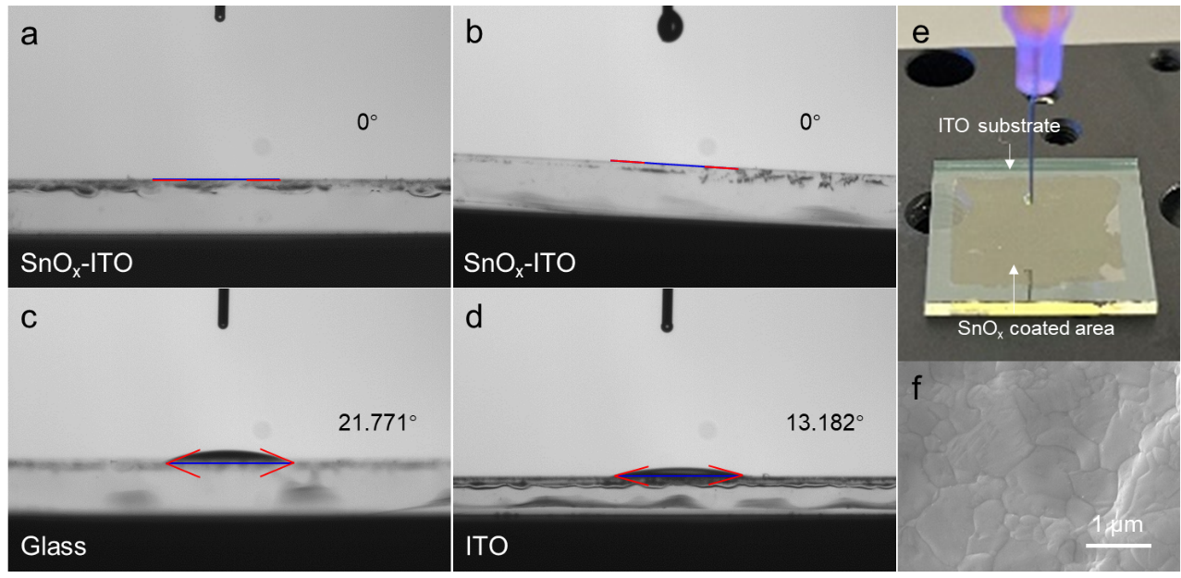

Supplementary Fig. 3 | Surface Characterization and Perovskite Precursor Behavior on different Substrates. Measurements were carried out on SnO_{x}-ITO to determine: (a) Contact angles, and (b) Receding angle. The contact angles of the perovskite precursor solution were also assessed on: (c) an O₃ plasma-treated glass substrate, and (d) an O₃ plasma-treated ITO substrate. (e) Photography of the perovskite precursor solution on the SnO_{x}-ITO. (f) A top-view scanning electron microscopy (SEM) image showcasing printed perovskites on the SnO_{x}-ITO, with a scale bar of 1 μm.

Supplementary Fig. 4 | Microscopy images capture the progression of perovskite inks on different substrates, illustrating their evolution at various stages. Specifically, the temporal evolution of CsPbBr₃ ink on both glass reference and SnO_{x}-ITO substrates is documented. On the glass reference, the evolution is observed (a1) during the nucleation process at the droplet's edges, (a2) during the nucleation process at the droplet's center, and (a3) throughout the growth process at the droplet's center. Similarly, on the SnO_{x}-ITO substrates, (b1) the nucleation process, (b2) growth process, and (b3) formation of the continuous thin-film for the CsPbBr₃ ink are depicted. Furthermore, the temporal evolution of ink Cs_{0.05}FA_{0.83}MA_{0.125}PbBr_{0.33}I_{2.67} on the SnO_{x}-ITO substrates is shown during (c1) the nucleation process, (c2) growth process, and (c3) post-formation of the continuous thin-film. Finally, the evolution of BA_{0.05}Cs_{0.83}PbBr₃ ink on the SnO_{x}-ITO substrates is visualized during (d1) the nucleation process, (d2) growth process, and (d3) after the formation of the continuous thin-film.

Supplementary Fig. 5 | Photographs, Microscopy and Fluorescence Imaging of Inkjet-Printed Perovskite Films. (a-c) Optical images of inkjet-printed Cs_{0.05}FA_{0.83}MA_{0.125}PbBr_{0.33}I_{2.67.} films. (d1) Optical microscopy image, and (d2, d3) fluorescence images of inkjet-printed Cs_{0.05}FA_{0.83}MA_{0.125}PbBr_{0.33}I_{2.67.} (e1) Optical microscopy image, and (e2, e3) fluorescence images of inkjet-printed CsPbBr₃. (f1) Optical microscopy image, and (f2, f3) fluorescence images of inkjet-printed BA_{0.05}Cs_{0.83}PbBr₃. All fluorescence images were captured under 365 nm UV excitation.

Supplementary Fig. 5 | The Cross-Sectional and Top-View of Scanning Electron Microscope (SEM) Images of PPD. The cross-section view SEM images show (a) a complete narrowband R-PPD, comprising the (b) cross-sectional view and (c) top-view SEM image of perovskite filter layer (R-PFL) fabricated through inkjet-printing of CsPbBr₃, (d) cross-sectional view showing the epoxy-IZO interface, and (e) a red light perovskite-based photodetector, featuring R-PPL fabricated via inkjet-printing of Cs_{0.05}FA_{0.83}MA_{0.125}PbBr_{0.33}I_{2.67}. Photodetector light-absorber layers for (f) red, (g) green, and (h) blue were fabricated using inkjet-printing of Cs_{0.05}FA_{0.83}MA_{0.125}PbBr_{0.33}I_{2.67} (R-PPL), CsPbBr₃ (G-PPL), and BA_{0.05}Cs_{0.83}PbBr₃ (B-PPL), respectively. Perovskite filter layers for (i) red, (j) green, and (k) blue light were fabricated using inkjet-printing of CsPbBr₃ (R-PFL), CsPbBr₃ (G-PFL), and BA_{0.05}Cs_{0.83}PbBr₃ (B-PFL), respectively.

Supplementary Fig. 7 | Ultraviolet Photoelectron Spectroscopy (UPS) Spectra of Cs_{0.05}FA_{0.83}MA_{0.125}PbBr_{0.33}I_{2.67}, CsPbBr₃ and BA_{0.05}Cs_{0.83}PbBr₃ (a) UPS spectra of the cut-off region (E_{cutoff}=16.78 eV), work function (WF, ϕ), and valence band edge region (VBM) for Cs_{0.05}FA_{0.83}MA_{0.125}PbBr_{0.33}I_{2.67}, (b) UPS spectra of the cut-off region (E_{cutoff}=16.49 eV), work function (WF, ϕ), and valence band edge region (VBM) for CsPbBr₃, (c) UPS spectra of the cut-off region (E_{cutoff}=17.26eV), (WF, ϕ), and VBM for BA_{0.05}Cs_{0.83}PbBr₃

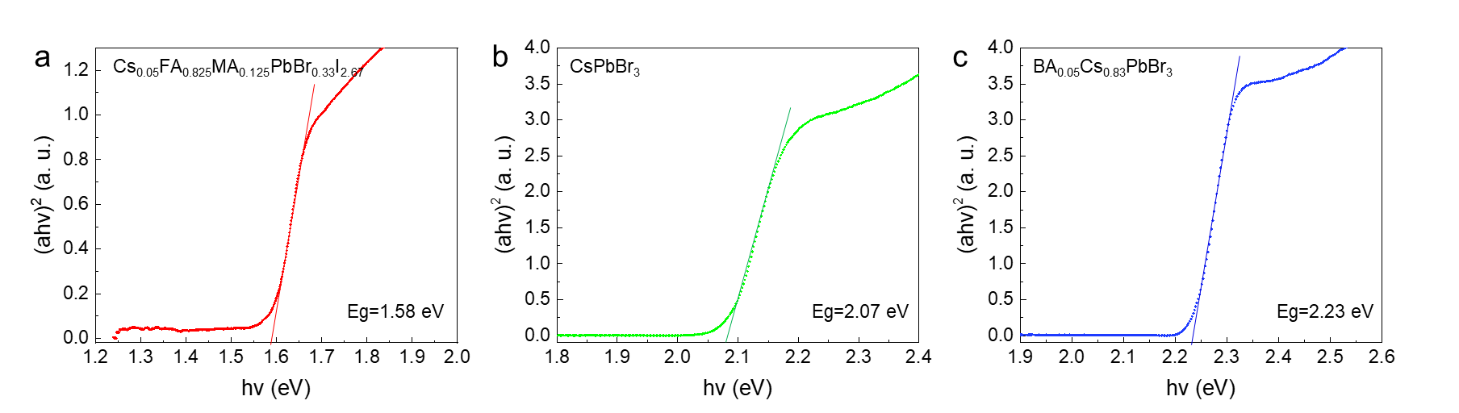

Supplementary Fig. 8 | The curve of (ahv)² versus hv for Perovskites (a) Cs_{0.05}FA_{0.83}MA_{0.125}PbBr_{0.33}I_{2.67}, (b) CsPbBr₃, (c) BA_{0.05}Cs_{0.83}PbBr₃
Supplementary Fig. 9 | Response Bandwidth of R-PPD at Bias of −0.5 V and Illumination Intensity of 6.0 mW cm⁻² Across Various Frequencies. (a1, a2) f=10 Hz, (b1, b2) f= 20 Hz, (c1, c2) f= 30 Hz, (d1, d 2) f= 40 Hz, (e1, e2) f=50 Hz, (f1, f2) f= 60 Hz, (g1, g 2) f= 70 Hz, (h1, h2) f= 80 Hz, (i1, i2) f= 90 Hz, (j1, j2) f= 100 Hz, (k1, k2) f= 110 Hz, (l1, l2) f= 120 Hz, (m1, m2) f= 130 Hz, (n1, n2) f= 140 Hz, (o1, o2) f= 150 Hz, (p1, p2) f=160 Hz, (q1, q2) f= 170 Hz, (r1, r2) f= 180 Hz, (s1, s2) f= 190 Hz, (t1, t2) f= 200 Hz, (u1, u2) f=300 Hz, (v) f= 400 Hz, (w) f= 500 Hz, (x) f= 600 Hz, (y) f= 700 Hz, (z) f=800 Hz, (Ⅰ) f= 900 Hz, (Ⅱ) f= 2000 Hz, (Ⅲ) f= 3000 Hz, (Ⅳ) f=4000 Hz, (Ⅴ) f=5000 Hz, (Ⅵ) f=6000 Hz, (Ⅶ) f=7000 Hz, (Ⅷ) f=8000 Hz, (Ⅸ) f=9000 Hz, (Ⅹ) f=10000 Hz, (Ⅺ) f=20000 Hz, (Ⅻ) f=30000 Hz, (XIII) f=40000 Hz.

Supplementary Fig. 10 | Characterization of R-, G-, and B-PPD in Dark Environment: I-t and I-V Curves, Current Noise Analysis. (a) The I-t curve of R-, G-, and B-PPD at a bias of −0.5 V in the dark environment. The R-PPD are denoted by red dots, G-PPD by green squares, and B-PPD by blue triangles. (b) The I-V measurements of the R-, G-, and B-PPD in the dark environment. The R-PPD are denoted by red circles, G-PPD by open squares, and B-PPD by open triangles. The measured current noise and of (c) G-PPD and (d) B-PPD as a function of frequency at a bias of −0.5 V. In addition, the shot noise, 1/f noise, and G-R noise limit were calculated and included for reference.

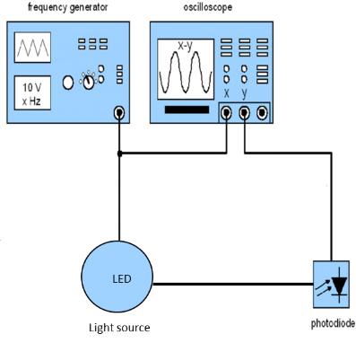

Supplementary Fig. 12 | The circuit diagram illustrating the setup for acquiring a −3 dB bandwidth.
Reference:
(1) Klein, A.; Körber, C.; Wachau, A.; Säuberlich, F.; Gassenbauer, Y.; Harvey, S. P.; Proffit, D. E.; Mason, T. O. Transparent conducting oxides for photovoltaics: Manipulation of fermi level, work function and energy band alignment. Materials 2010, 3 (11), 4892-4914.

