Direct Regeneration of Layered Oxide Cathodes via Seawater
Ning Xue¹, Yuanyuan Cui²*, Xiaoyan Wu¹, Yuyao Zhang¹, Luyao Wang¹, Ruixin Hao¹, Tianyi Gao¹, Jinjiang Liang¹, Yihang Yang¹, Yi Yu¹ and Wei Liu¹*
¹State Key Laboratory of Quantum Functional Materials, School of Physical Science and Technology, Shanghai Key Laboratory of High-resolution Electron Microscopy, ShanghaiTech University, Shanghai 201210, China
²School of Materials Science and Engineering, Shanghai University, Shanghai, 200444, China

* Corresponding author. E-mail: liuwei1@shanghaitech.edu.cn
E-mail: cui-yy@shu.edu.cn

Supporting Information

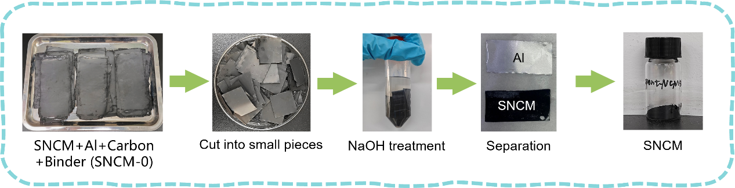
Figure S1. The process of obtaining SNCM powder via the separation treatment of waste NCM electrode sheets.

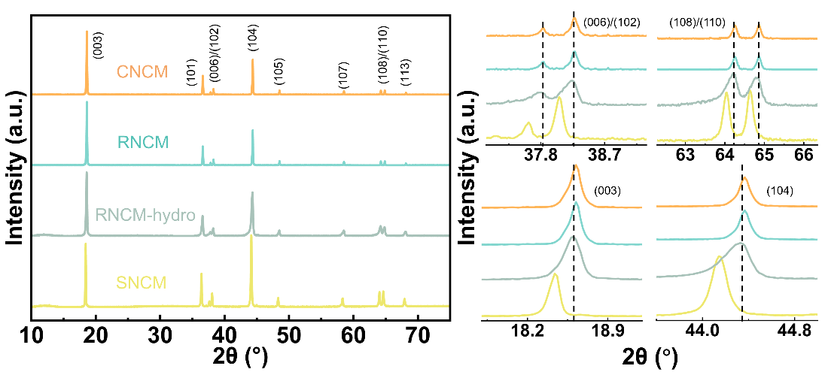
Figure S2. XRD patterns and partial enlarged details of SNCM, RNCM-hydro, RNCM and CNCM.

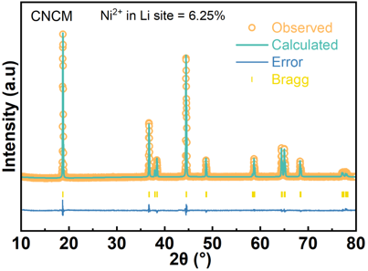
Figure S3. The Rietveld refinement XRD pattern of CNCM.

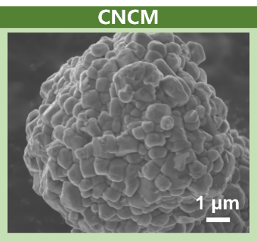
Figure S4. The SEM image of CNCM.

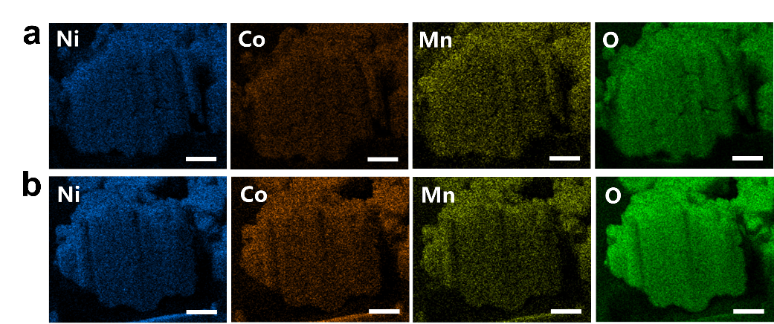
Figure S5. The distribution of Ni, Co, Mn, and O elements on the inner surfaces of the cut (a) SNCM and (b) RNCM-hydro particles. (Scale bar=1 μm)

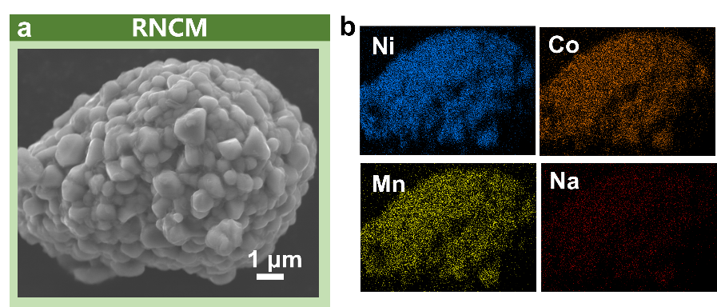
Figure S6. (a) The SEM image of RNCM and (b) the corresponding EDS mapping of Ni, Co, Mn and Na for RNCM.

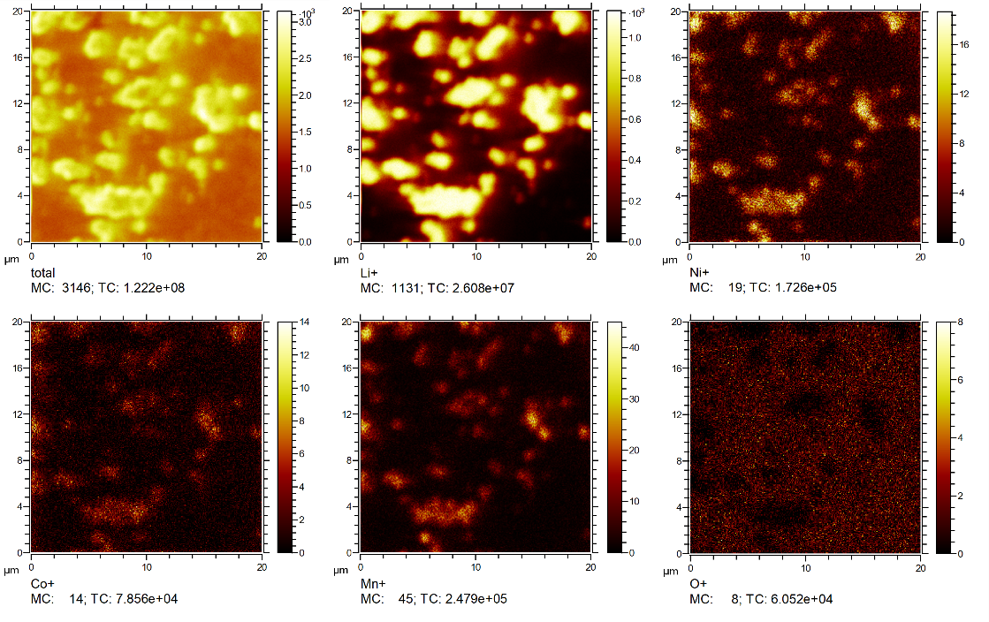
Figure S7. Surface TOF-SIMS chemical imaging of Li⁺, Ni⁺, Co⁺ and Mn⁺ species at RNCM.

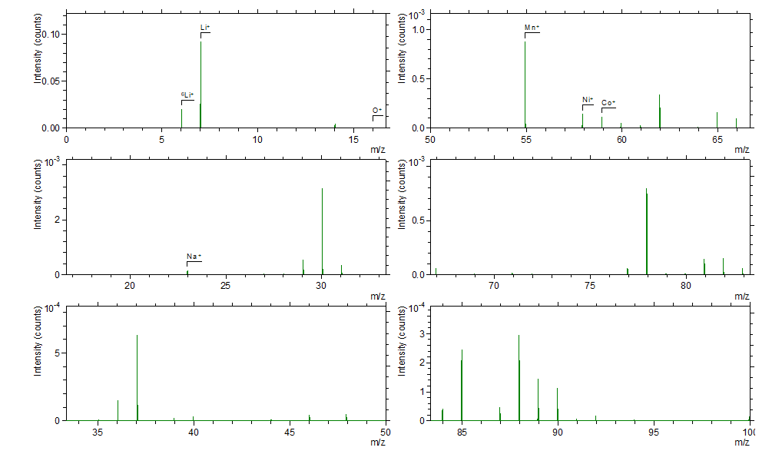
Figure S8. TOF-SIMS spectrum of Li⁺, Ni⁺, Co⁺, Mn⁺ and Na⁺ in RNCM cathode in positive ion mode.

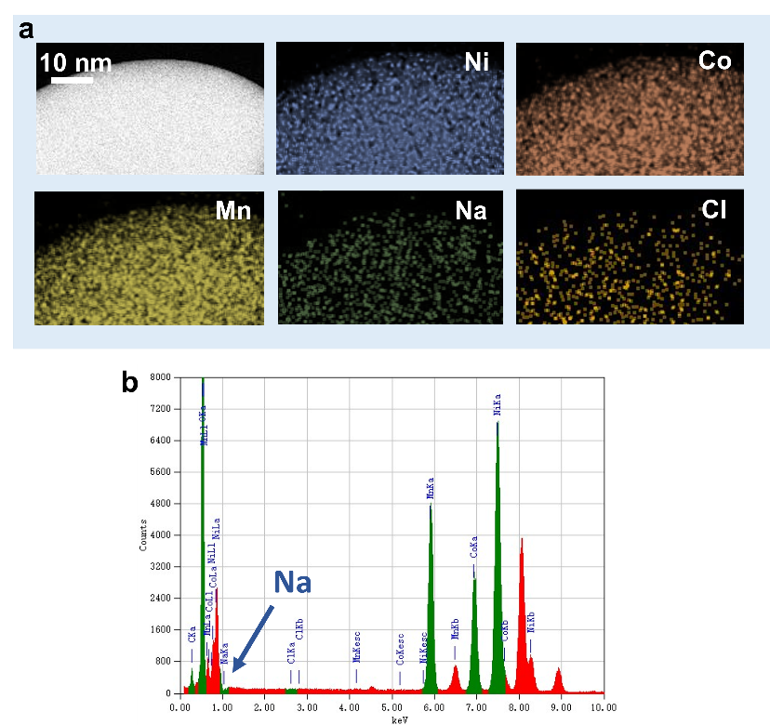

Figure S9. (a) STEM of RNCM and corresponding EDS mapping of Ni, Co, Mn, Na and Cl. (b) TEM-EDS spectra of RNCM.

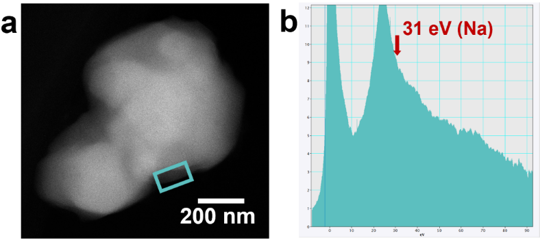
Figure S10. Na L-edge EELS spectra of RNCM-LN.

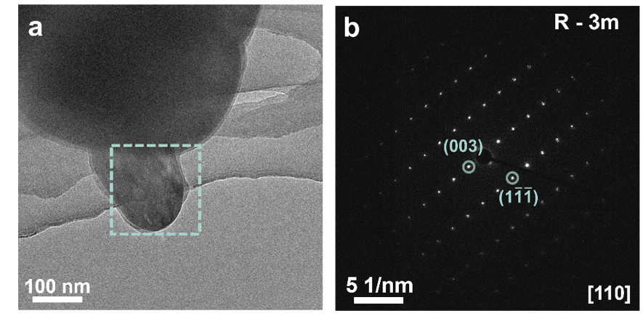
Figure S11. (a) Low-magnification TEM image of RNCM. (b) Diffraction information of the area within the dark green frame.

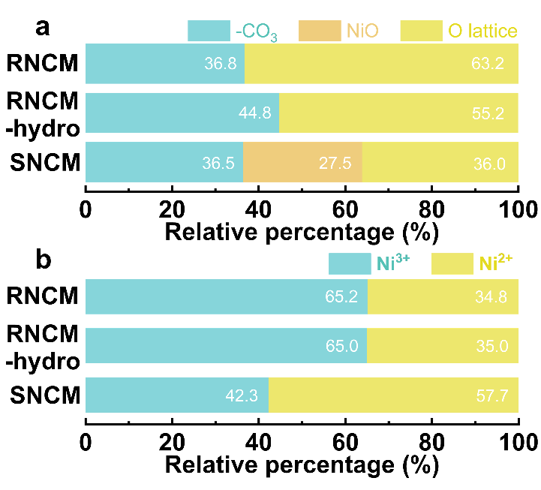
Figure S12. The proportion changes of (a) O and (b) Ni contents in SNCM, RNCM-hydro and RNCM.

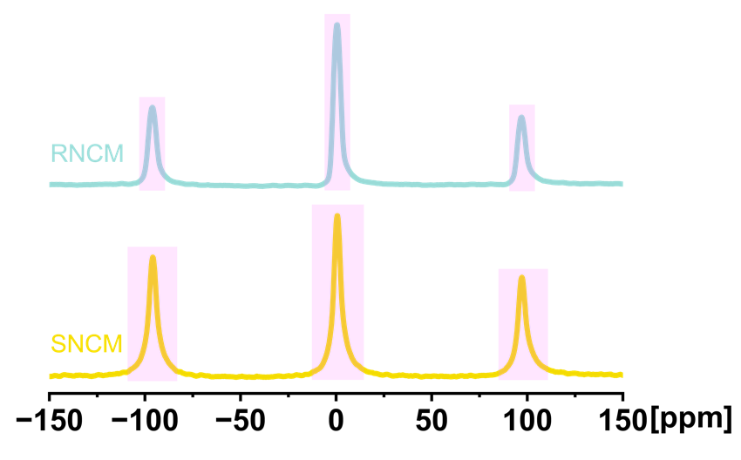
Figure S13. The ⁷Li MAS Solid NMR of SNCM and RNCM.

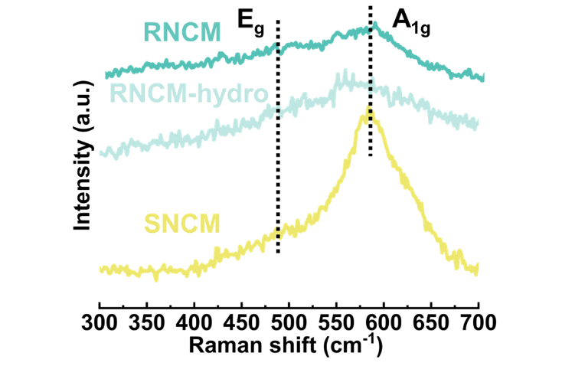
Figure S14. Raman spectra of SNCM, RNCM-hydro and RNCM.

Figure S15. FT-IR spectra of SNCM, RNCM-hydro and RNCM.

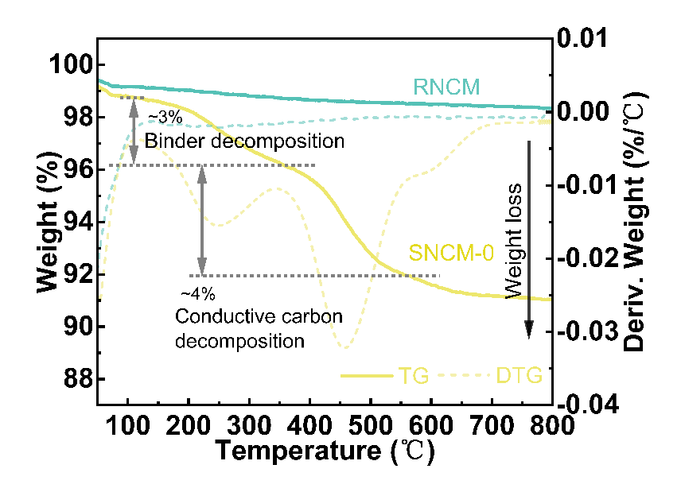
Figure S16. TG and DTG Curves of SNCM-0 and RNCM from RT to 800℃.

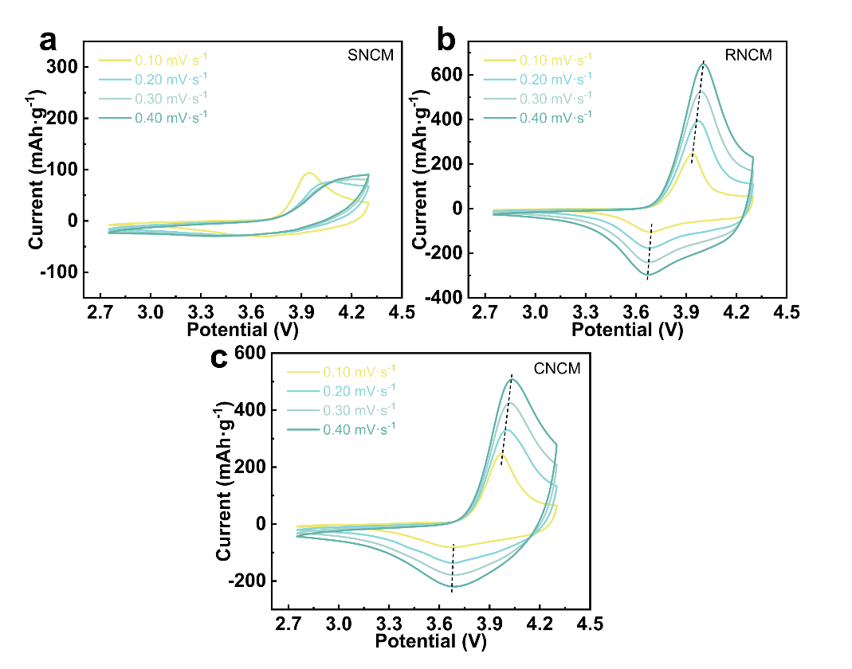
Figure S17. CV curves of (a) SNCM, (b) RNCM and (c) CNCM of different scan rates.

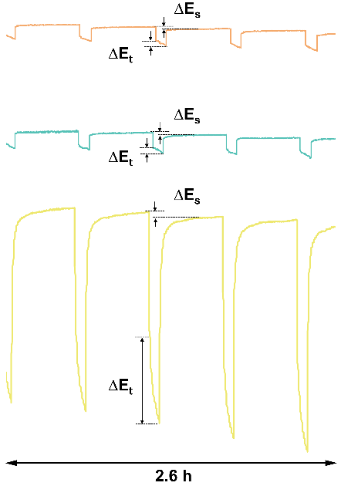
Figure S18. The magnified diagram of GITT voltage profiles.

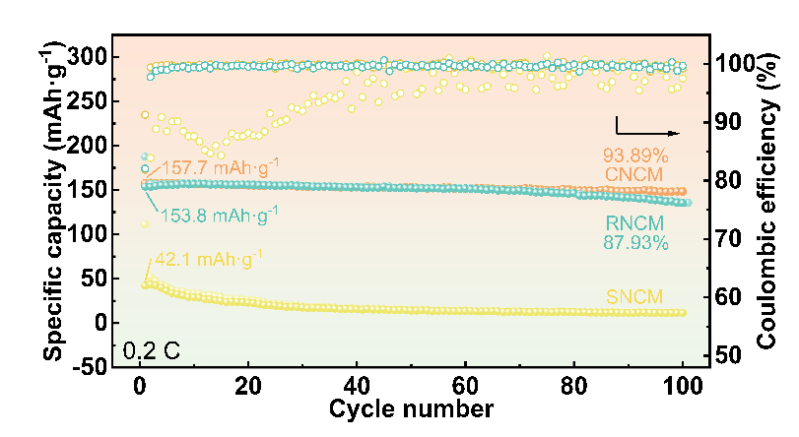
Figure S19. Cycling stability at 0.2 C in half cell of NCMs.

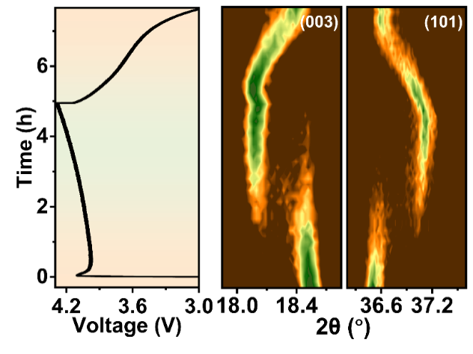
Figure S20. The selected in-situ XRD contour plots of CNCM and corresponding voltage curves.

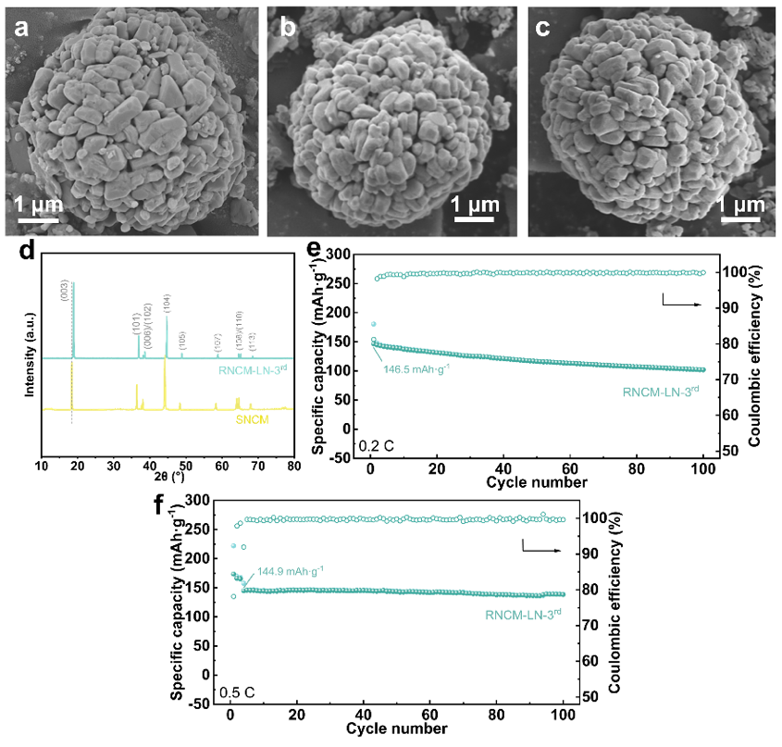
Figure S21. SEM images of (a) RNCM-1st, (b) RNCM -2nd and (c) RNCM-3rd. (d) XRD patterns of RNCM-3rd. Cycling performance in half cell of RNCM-3rd (e) at 0.2 C and (f) at 0.5 C.

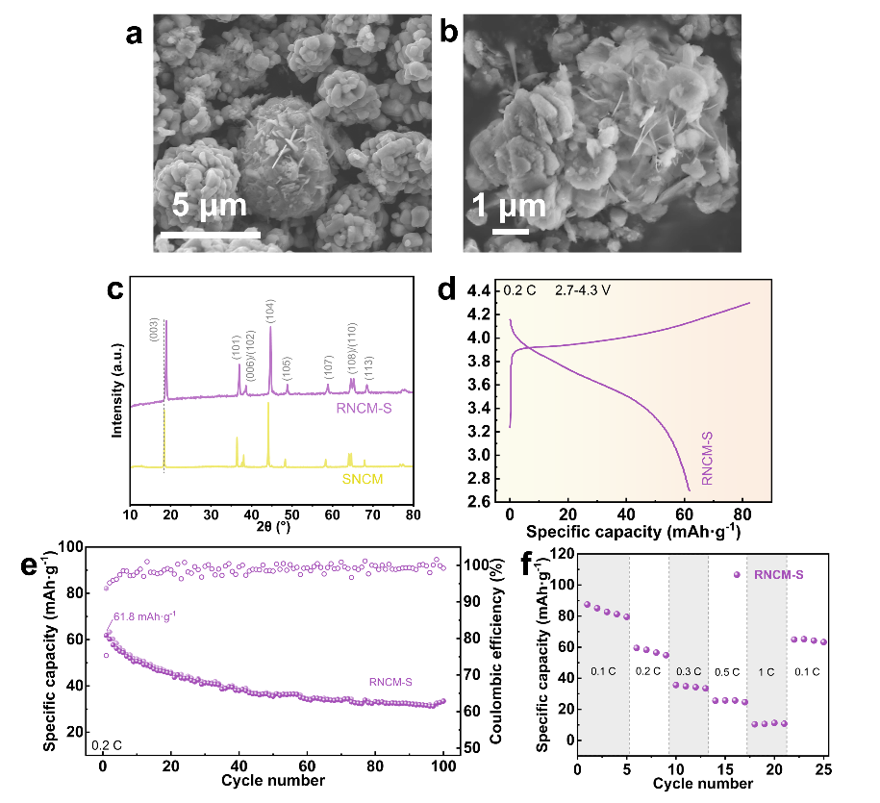
Figure S22. (a), (b) SEM images of RNCM-S (obtained by the solid-phase method). (c) XRD patterns of RNCM-S. (d), (e) and (f) The electrochemical performance of RNCM-S.

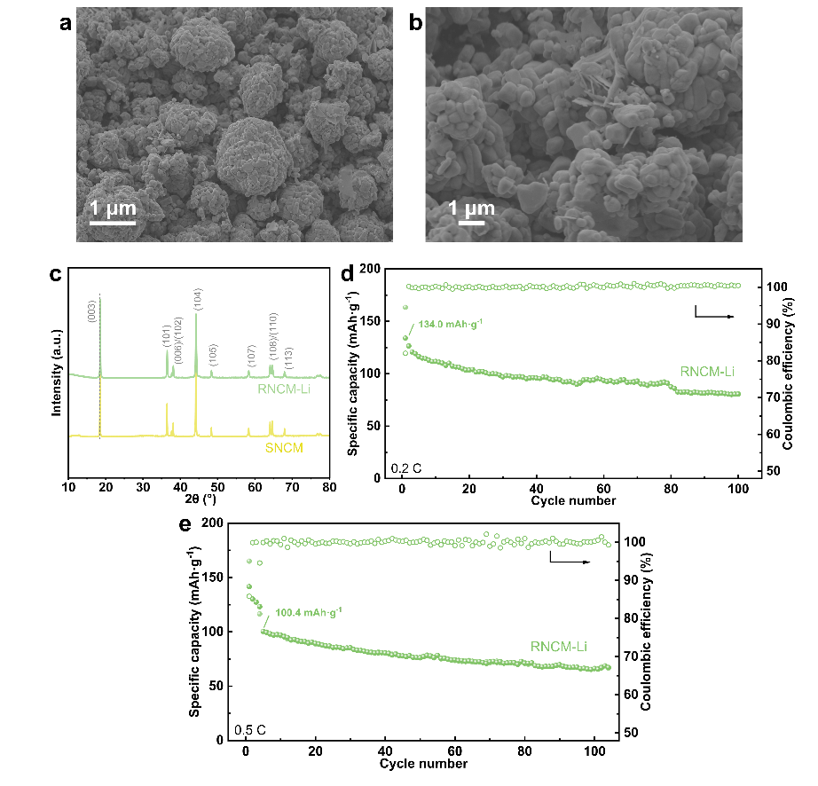
Figure S23. (a) and (b) SEM images of RNCM-Li. (c) XRD patterns of RNCM-Li. Cycling performance in half cell of RNCM-Na (d) at 0.2 C and (e) at 0.5 C.

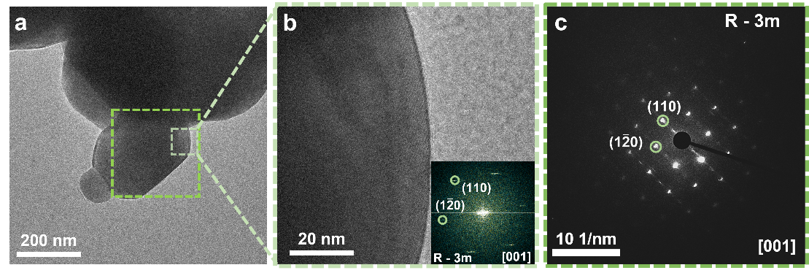
Figure S24. (a) Low-magnification TEM image of RNCM-Li. (b) TEM image of the area within the light green frame and the corresponding high-resolution information. (c) Diffraction information of the area within the dark green frame.

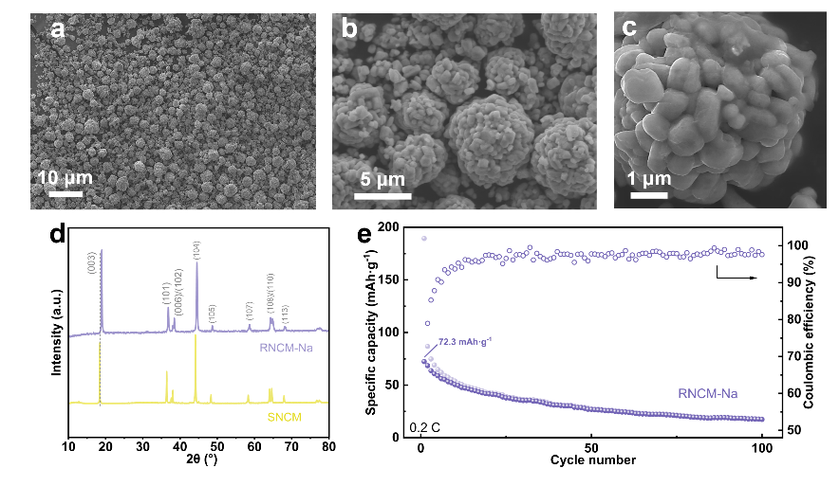
Figure S25. (a), (b) and (c) SEM images of RNCM-Na. (d) XRD patterns of RNCM-Na. (e) Cycling performance in half cell of RNCM-Na at 0.2 C.

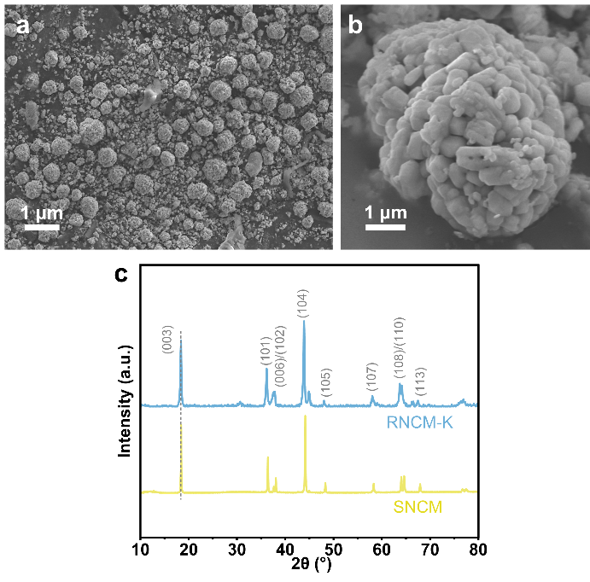
Figure S26. (a), (b) SEM images of RNCM-K. (c) XRD patterns of RNCM-K.

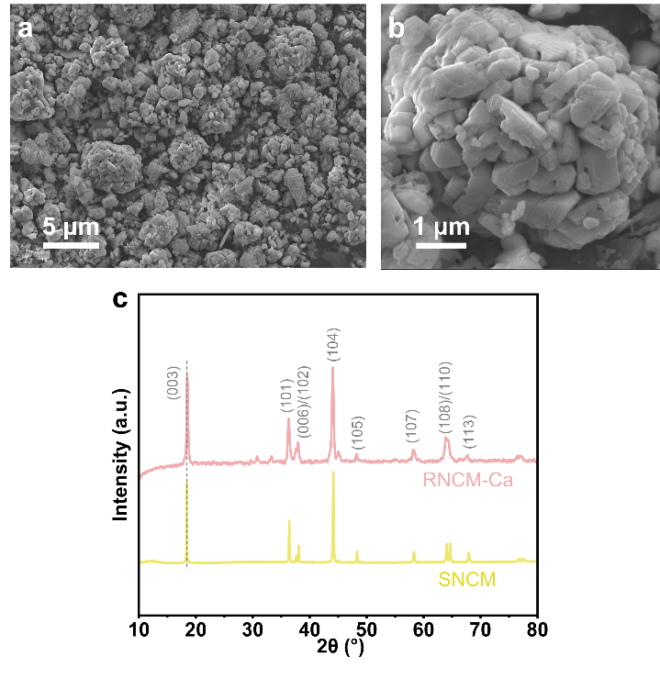
Figure S27. (a), (b) SEM images of RNCM-Ca. (c) XRD patterns of RNCM-Ca.

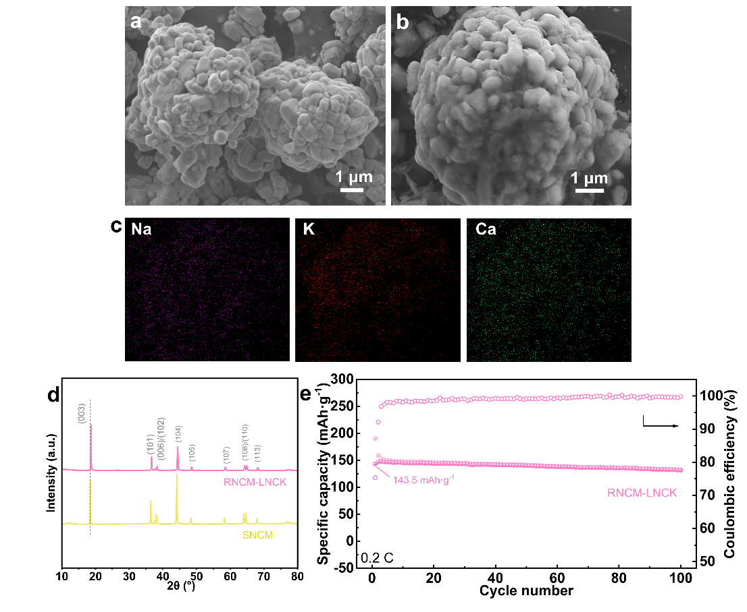
Figure S28. (a), (b) SEM images of RNCM-LNCK. (c) The corresponding Na, K and Ca EDS mapping of RNCM-LNCK. (d) XRD patterns of RNCM-LNCK. (e) Cycling performance in half cell of RNCM-LNCK at 0.2 C.

Table S1. Molar ratio of Li, Ni, Co and Mn in SNCM, CNCM and RNCM with different hydrothermal treatment temperature.
Sample | Li/TM ratio | Ni/TM ratio | Co/TM ratio | Mn/TM ratio
SNCM | 0.57 | 0.49 | 0.23 | 0.28
RNCM-150 | 0.89 | 0.49 | 0.22 | 0.29
RNCM-175 | 0.90 | 0.49 | 0.22 | 0.29
RNCM-200 | 0.99 | 0.49 | 0.22 | 0.29
CNCM | 1.02 | 0.50 | 0.21 | 0.29

Table S2. The XRD refinement results.
 | a-axis (Å) | c-axis (Å) | Ni²⁺ in Li site (%) | c/a
SNCM | 2.87926 | 14.27249 | 10.82 | 4.957
RNCM-hydro | 2.86878 | 14.24439 | 5.80 | 4.965
RNCM | 2.86714 | 14.22648 | 4.10 | 4.962
CNCM | 2.86635 | 14.22002 | 6.25 | 4.961

Table S3. The details in calculation the atomic and electronic structures of NCM523 systems.
Parameters | Settings
Pseudopotential type | Projector augmented wave (PAW)
Exchange-correlation functional | Generalized gradient approximation (GGA)  of Perdew–Burke–Ernzerh (PBE)
Valence electron configurations | O-2s²2p⁴, Ni-3d⁶4s², Mn-3d⁶4s¹, Co-3d⁸4s¹  Li-2s¹, Na-3s¹, K-4s¹ Ca-4s²
Effective Coulomb repulsion (U_{eff}) | 3.5 eV for Ni, 3.3 eV for Co, and 6.4 eV for Mn
Cutoff energy | 450 eV
Total energies convergence | 1×10⁻⁴ eV/unit cell
Systems | NCM bulk | NCM slab absorption with M (M=Li, Na, K, or Ca) | NCM bulk insertion with M (M=Li, Na, K, or Ca)
Number of atoms | 29 Li, 60 O, 9 Mn, 6 Co, 15 Ni | 30Li, 60 O, 9 Mn, 6 Co, 15 Ni, 1 M | 29Li, 60 O, 9 Mn, 6 Co, 15 Ni, 1 M
k-point meshes for optimization | 4×2×1 | 4×2×1 | 4×2×1
Vacuum thickness (Å) | 0 | 15 | 0
Relax ions | All atoms are relaxed. | Top 2 and bottom 2 layers are relaxed | All atoms are relaxed.
Change cell volume | Yes | No | Yes
Change cell shape | Yes | No | Yes

