Table of Content

Table S1. The risk of bias assessment of cohort studies according to the Risk Of Bias In Non-randomized Studies—of Interventions (ROBINS-I) tool 2
Figure S1. Randomized controlled trial assessment with the revised Cochrane tool to assess risk of bias (ROB-2 tool). 3
Figure S2. Forest plot for infection-related outcomes. 4
Figure S3. Estimates of the pooled duration of hospitalization and ICU stay. 5
Figure S4. Pooled incidence of multiple organ failure and systemic inflammatory response syndrome. 6
Figure S5. Pooled results of days to achieving EN target and incidence of acute compartment syndrome 7
Appendix A. Database search in EMBASE, MEDLINE, and the CENTRAL. 8
Appendix B. PRISMA 2020 Checklist 9

Table S1. The risk of bias assessment of cohort studies according to the Risk Of Bias In Non-randomized Studies—of Interventions (ROBINS-I) tool

Cohort studies | Confounding | Selection of participants into the study | Classification of interventions | Deviations from intended interventions | Missing data | Measurement of outcomes | Bias in selection of the reported result | Overall risk
Liu#, 2015 | LOW | LOW | LOW | LOW | LOW | LOW | LOW | LOW
Liu, 2015 | LOW | LOW | LOW | LOW | LOW | LOW | LOW | LOW
Huang, 2016 | LOW | LOW | LOW | LOW | LOW | LOW | LOW | LOW
Zhou, 2016 | MODERATE | LOW | LOW | MODERATE | SEVERE | LOW | LOW | SEVERE
Li, 2018 | SEVERE | LOW | MODERATE | LOW | LOW | MODERATE | LOW | SEVERE
Zerem, 2020 | LOW | LOW | LOW | LOW | LOW | LOW | LOW | LOW
Huang, 2023 | LOW | LOW | LOW | LOW | LOW | LOW | LOW | LOW
Wen, 2023 | LOW | LOW | LOW | LOW | LOW | LOW | LOW | LOW

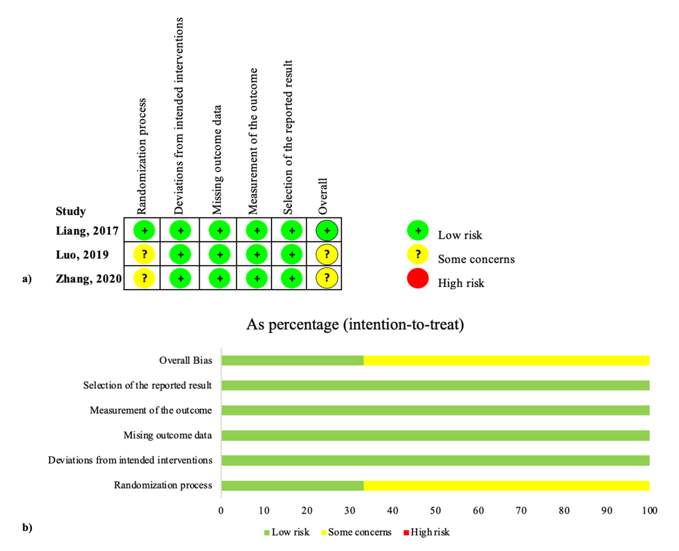

Figure S1. Randomized controlled trial assessment with the revised Cochrane tool to assess risk of bias (ROB-2 tool): a) Traffic light plot; b) weighted summary plot.
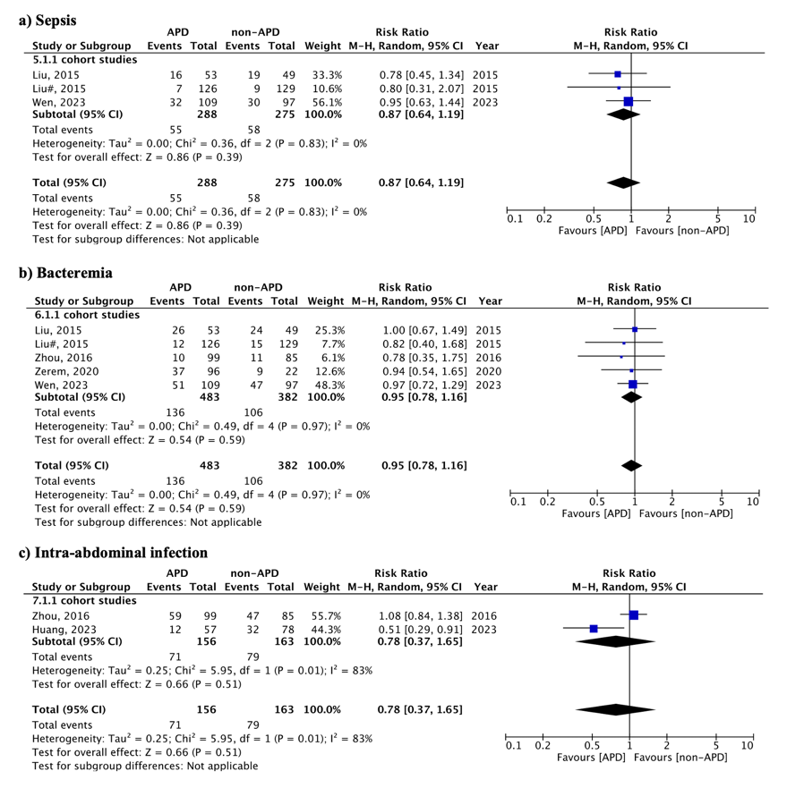

Figure S2. Forest plot for infection-related outcomes: a) Sepsis; b) Bacteremia; c) Intra-abdominal infection. APD, abdominal paracentesis drainage; CI, confidence interval; M-H, Mantel-Haenszel.

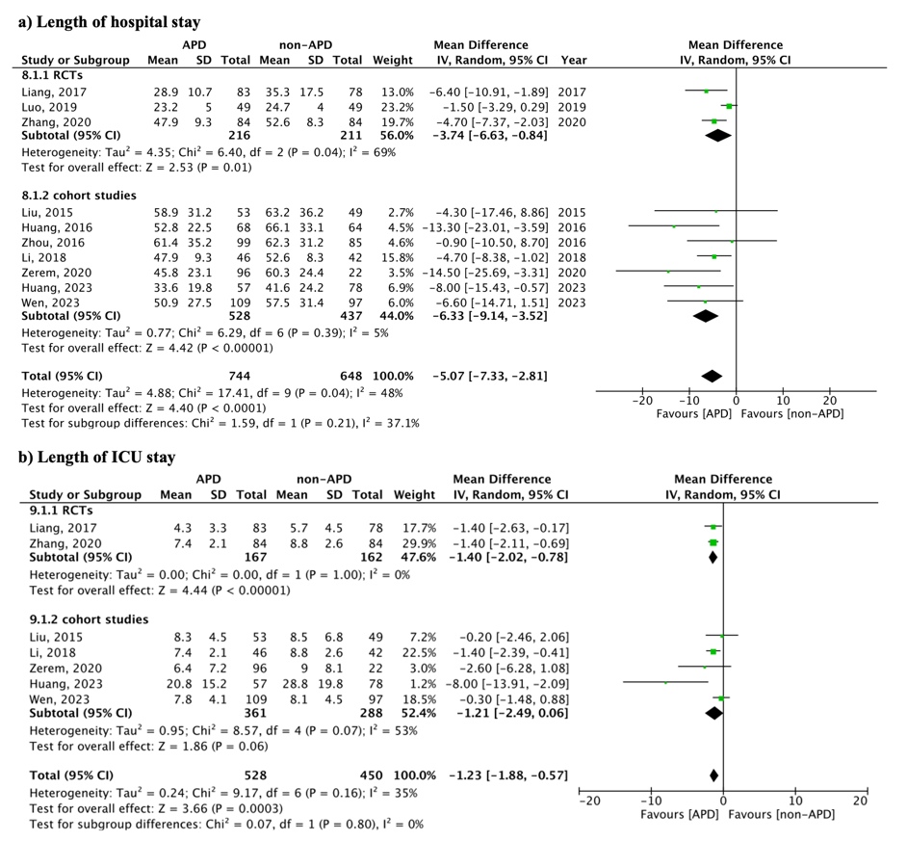

Figure S3. Estimates of the pooled duration of hospitalization and ICU stay: a) Length of hospital stay; b) Length of ICU stay. APD, abdominal paracentesis drainage; CI, confidence interval; ICU, intensive care unit; M-H, Mantel-Haenszel.

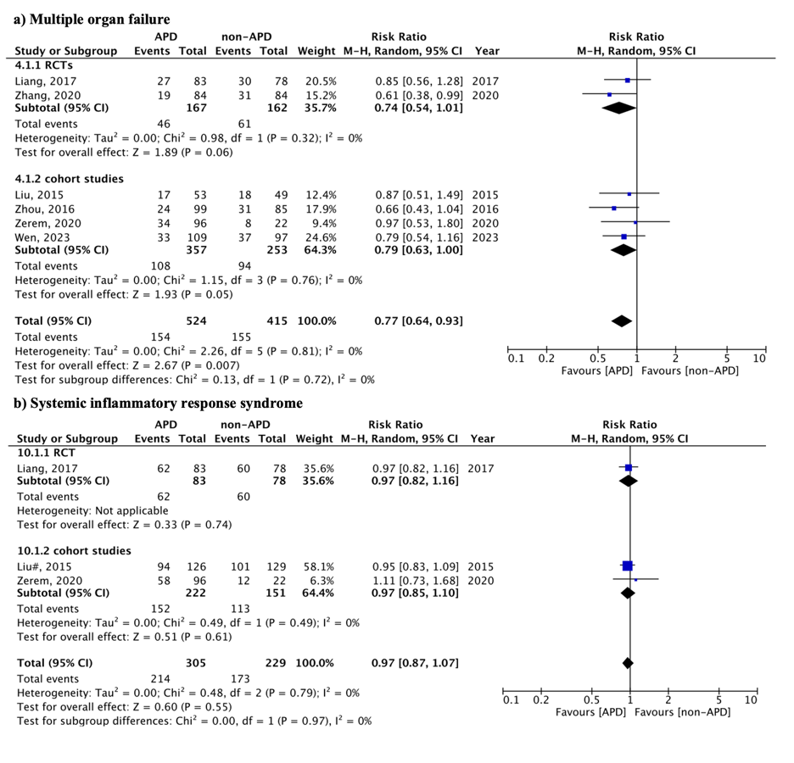

Figure S4. Pooled incidence of multiple organ failure and systemic inflammatory response syndrome: a) Multiple organ failure; b) Systemic inflammatory response syndrome. APD, abdominal paracentesis drainage; CI, confidence interval; M-H, Mantel-Haenszel.

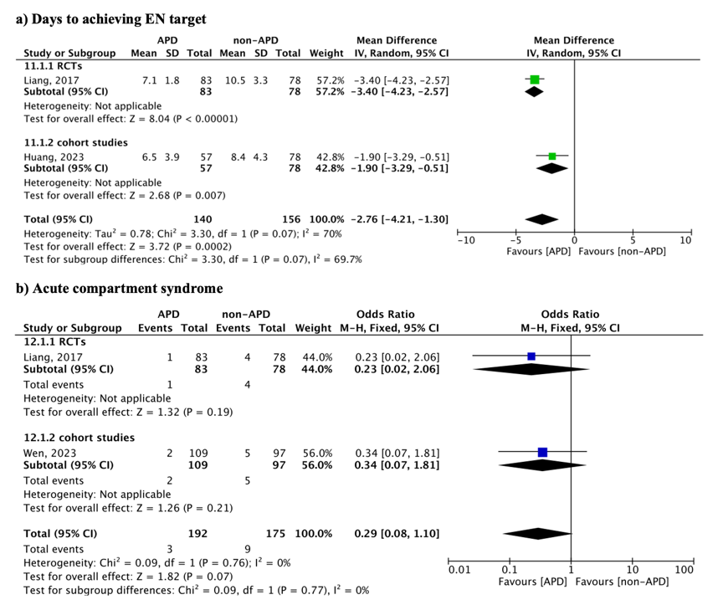

Figure S5. Pooled results of days to achieving EN target and incidence of acute compartment syndrome: a) Days to achieving EN target; b) Acute compartment syndrome. APD, abdominal paracentesis drainage; CI, confidence interval; EN, enteral nutrition; M-H, Mantel-Haenszel.

Appendix A. Database search in EMBASE, MEDLINE, and the CENTRAL.
Until January, 2026

EMBASE (via EMBASE), 31
#1 | 'acute pancreatitis'/exp | 43,928
#2 | 'acute pancreatitis':ab,ti | 46,887
#3 | #1 OR #2 | 56,795
#4 | 'abdominal paracentesis drainage'/exp | 13
#5 | 'abdominal paracentesis drainage':ab,ti | 32
#6 | #4 OR #5 | 32
#7 | #3 AND #6 | 31

MEDLINE(via OvidSP), 20
#1 | acute pancreatitis.af. | 30,677
#2 | pancreatitis.sh. | 49,650
#3 | 1 or 2 | 59,221
#4 | abdominal paracentesis drainage.af. | 20
#5 | 3 and 4 | 20

CENTRAL(via Cochrane Library), 6
#1 | MeSH descriptor: [Pancreatitis] explode all trees | 1,884
#2 | 'acute pancreatitis':ti,ab,kw | 3,638
#3 | #1 OR #2 | 4,393
#4 | (abdominal paracentesis drainage):ti,ab,kw | 38
#5 | #3 AND #4 | 6

Appendix B. PRISMA 2020 Checklist

Section/topic | Item No | Checklist item | Reported on Page Number/Line Number | Reported on Section/Paragraph
TITLE
Title | 1 | Identify the report as a systematic review. | Page 1 | Title
ABSTRACT
Abstract | 2 | See the PRISMA 2020 for Abstracts checklist (Table 2). | Page 2 | Abstract
INTRODUCTION
Rationale | 3 | Describe the rationale for the review in the context of existing knowledge. | Page 4-5 | Paragraph 1-4
Objectives | 4 | Provide an explicit statement of the objective(s) or question(s) the review addresses. | Page 5 | Paragraph 5
METHODS
Eligibility criteria | 5 | Specify the inclusion and exclusion criteria for the review and how studies were grouped for the syntheses. | Page 6-7 | Study selection
Information sources | 6 | Specify all databases, registers, websites, organisations, reference lists and other sources searched or consulted to identify studies. Specify the date when each source was last searched or consulted. | Page 5-6 | Search methodology
Search strategy | 7 | Present the full search strategies for all databases, registers and websites, including any filters and limits used. | Supplementary files | Appendix 1
Selection process | 8 | Specify the methods used to decide whether a study met the inclusion criteria of the review, including how many reviewers screened each record and each report retrieved, whether they worked independently, and if applicable, details of automation tools used in the process. | Page 6 | Study selection
Data collection process | 9 | Specify the methods used to collect data from reports, including how many reviewers collected data from each report, whether they worked independently, any processes for obtaining or confirming data from study investigators, and if applicable, details of automation tools used in the process. | Page 7 | Outcomes and data extraction
Data items | 10a | List and define all outcomes for which data were sought. Specify whether all results that were compatible with each outcome domain in each study were sought (e.g. for all measures, time points, analyses), and if not, the methods used to decide which results to collect. | Page 7 | Outcomes and data extraction
Data items | 10b | List and define all other variables for which data were sought (e.g. participant and intervention characteristics, funding sources). Describe any assumptions made about any missing or unclear information. | Page 7 | Outcomes and data extraction

Study risk of bias assessment | 11 | Specify the methods used to assess risk of bias in the included studies, including details of the tool(s) used, how many reviewers assessed each study and whether they worked independently, and if applicable, details of automation tools used in the process. | Page 7-8 | Quality of evidence assessment
Effect measures | 12 | Specify for each outcome the effect measure(s) (e.g. risk ratio, mean difference) used in the synthesis or presentation of results. | Page 8 | Statistical analysis
Synthesis methods | 13a | Describe the processes used to decide which studies were eligible for each synthesis. | Page 8 | Statistical analysis
Synthesis methods | 13b | Describe any methods required to prepare the data for presentation or synthesis, such as handling of missing summary statistics, or data conversions. | Page 8 | Statistical analysis
Synthesis methods | 13c | Describe any methods used to tabulate or visually display results of individual studies and syntheses. | Page 8 | Statistical analysis
Synthesis methods | 13d | Describe any methods used to synthesize results and provide a rationale for the choice(s). If meta-analysis was performed, describe the model(s), method(s) to identify the presence and extent of statistical heterogeneity, and software package(s) used. | Page 8 | Statistical analysis
Synthesis methods | 13e | Describe any methods used to explore possible causes of heterogeneity among study results. | / | /
Synthesis methods | 13f | Describe any sensitivity analyses conducted to assess robustness of the synthesized results. | Page 9 | Sensitivity analysis and cumulative meta-analysis
Reporting bias assessment | 14 | Describe any methods used to assess risk of bias due to missing results in a synthesis (arising from reporting biases). | Page 8 | Assessment of reporting biases
Certainty assessment | 15 | Describe any methods used to assess certainty (or confidence) in the body of evidence for an outcome. | Page 9 | Trial sequence analysis (TSA)
RESULTS
Study selection | 16a | Describe the results of the search and selection process, from the number of records identified in the search to the number of studies included in the review, ideally using a flow diagram. | Page 10 | Literature research and study characteristics; Figure 1
Study selection | 16b | Cite studies that met many but not all inclusion criteria (‘near-misses’) and explain why they were excluded. | / | /
Study characteristics | 17 | Cite each included study and present its characteristics. | Page 10 | Literature research and study characteristics; Table 1
Risk of bias in studies | 18 | Present assessments of risk of bias for each included study. | Page 10; Supplementary files | Risk of bias assessment and certainty of evidence; Figure S1 and Table S1
Results of individual studies | 19 | For all outcomes, present, for each study: (a) summary statistics for each group (where appropriate) and (b) an effect estimate and its precision (e.g. confidence/credible interval), ideally using structured tables or plots. | / | /

Results of syntheses | 20a | For each synthesis, briefly summarise the characteristics and risk of bias among contributing studies. | Page 10-13 | Primary outcome; Secondary outcomes
Results of syntheses | 20b | Present results of all statistical syntheses conducted. If meta-analysis was done, present for each the summary estimate and its precision (e.g. confidence/credible interval) and measures of statistical heterogeneity. If comparing groups, describe the direction of the effect. | Page 10-13 | Primary outcome; Secondary outcomes
Results of syntheses | 20c | Present results of all investigations of possible causes of heterogeneity among study results. | / | /
Results of syntheses | 20d | Present results of all sensitivity analyses conducted to assess the robustness of the synthesized results. | Page 10-11 | Primary outcome
Reporting biases | 21 | Present assessments of risk of bias due to missing results (arising from reporting biases) for each synthesis assessed. | / | /
Certainty of evidence | 22 | Present assessments of certainty (or confidence) in the body of evidence for each outcome assessed. | Page 10-13 | Primary outcome; Secondary outcomes; Table 2
DISCUSSION
Discussion | 23a | Provide a general interpretation of the results in the context of other evidence. | Page 13-15 | Discussion paragraph 1-3
Discussion | 23b | Discuss any limitations of the evidence included in the review. | Page 15-16 | Discussion paragraph 4
Discussion | 23c | Discuss any limitations of the review processes used. | Page 15-16 | Discussion paragraph 4
Discussion | 23d | Discuss implications of the results for practice, policy, and future research. | Page 15-16 | Conclusions
OTHER INFORMATION
Registration and protocol | 24a | Provide registration information for the review, including register name and registration number, or state that the review was not registered. | Page 5 | Search methodology
Registration and protocol | 24b | Indicate where the review protocol can be accessed, or state that a protocol was not prepared. | Page 5 | Search methodology
Registration and protocol | 24c | Describe and explain any amendments to information provided at registration or in the protocol. | / | /
Support | 25 | Describe sources of financial or non-financial support for the review, and the role of the funders or sponsors in the review. | Page 16 | Title page: Funding
Competing interests | 26 | Declare any competing interests of review authors. | Page 17 | Title page: Conflicts of interest
Availability of data, code and other materials | 27 | Report which of the following are publicly available and where they can be found: template data collection forms; data extracted from included studies; data used for all analyses; analytic code; any other materials used in the review. | / | /

PRISMA 2020 for Abstracts checklist

Section/topic | Item No | Checklist item | Reported on Page Number/Line Number | Reported on Section/Paragraph
TITLE
Title | 1 | Identify the report as a systematic review. | Page 1 | Title
BACKGROUND
Objectives | 2 | Provide an explicit statement of the main objective(s) or question(s) the review addresses. | Page 2 | Paragraph 1
METHODS
Eligibility criteria | 3 | Specify the inclusion and exclusion criteria for the review. | Page 2 | Paragraph 2
Information sources | 4 | Specify the information sources (e.g. databases, registers) used to identify studies and the date when each was last searched. | Page 2 | Paragraph 2
Risk of bias | 5 | Specify the methods used to assess risk of bias in the included studies. | / | /
Synthesis of results | 6 | Specify the methods used to present and synthesize results. | / | /
RESULTS
Included studies | 7 | Give the total number of included studies and participants and summarise relevant characteristics of studies. | Page 2 | Paragraph 3
Synthesis of results | 8 | Present results for main outcomes, preferably indicating the number of included studies and participants for each. If meta-analysis was done, report the summary estimate and confidence/credible interval. If comparing groups, indicate the direction of the effect (i.e. which group is favoured). | Page 2 | Paragraph 3
DISCUSSION
Limitations of evidence | 9 | Provide a brief summary of the limitations of the evidence included in the review (e.g. study risk of bias, inconsistency and imprecision). | / | /
Interpretation | 10 | Provide a general interpretation of the results and important implications. | Page 2 | Paragraph 4
OTHER
Funding | 11 | Specify the primary source of funding for the review. | / | /
Registration | 12 | Provide the register name and registration number. | / | /

