Supporting Information for
Flexible Carbon Nanotube-based Terahertz Devices for Next-generation Wireless Communications

Yan Li¹, Mingyue Fu¹, Weifeng Wu¹, Xiaowei He¹, Rui Chen^{3,*}, Jianwei Han³, Li Ding^{1,4,*}, Sheng Wang^{1,2,*}
¹ Key Laboratory for the Physics and Chemistry of Nanodevices and Center for Carbon-Based Electronics, School of Electronics, Peking University, Beijing, China
² State Key Laboratory of Photonics and Communications
³ National Space Science Center Chinese Academy of Sciences Beijing 100190, P. R. China
⁴ Chongqing Institute of Carbon-based Integrated Circuits, Peking University, Chongqing, China
* Corresponding author. Email: shengwang@pku.edu.cn (S.W.); lding@pku.edu.cn (L.D.); chenrui2010@nssc.ac.cn (R.C.)

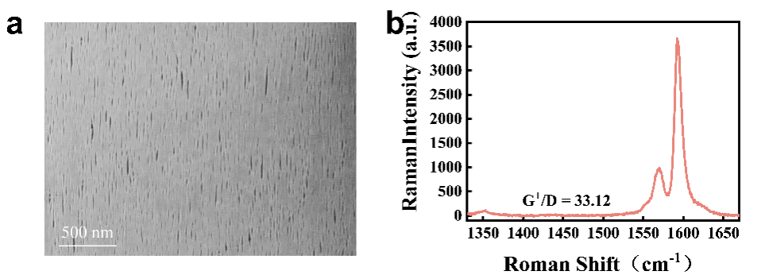
Fig. S1 | a, SEM image of the vertically aligned ACNT arrays, with an estimated density exceeding 100 nanotubes per micron, facilitating efficient carrier transport. b, Raman spectrum of ACNT arrays, exhibiting a G⁺/D ratio of ~33.12, indicative of high structural quality.

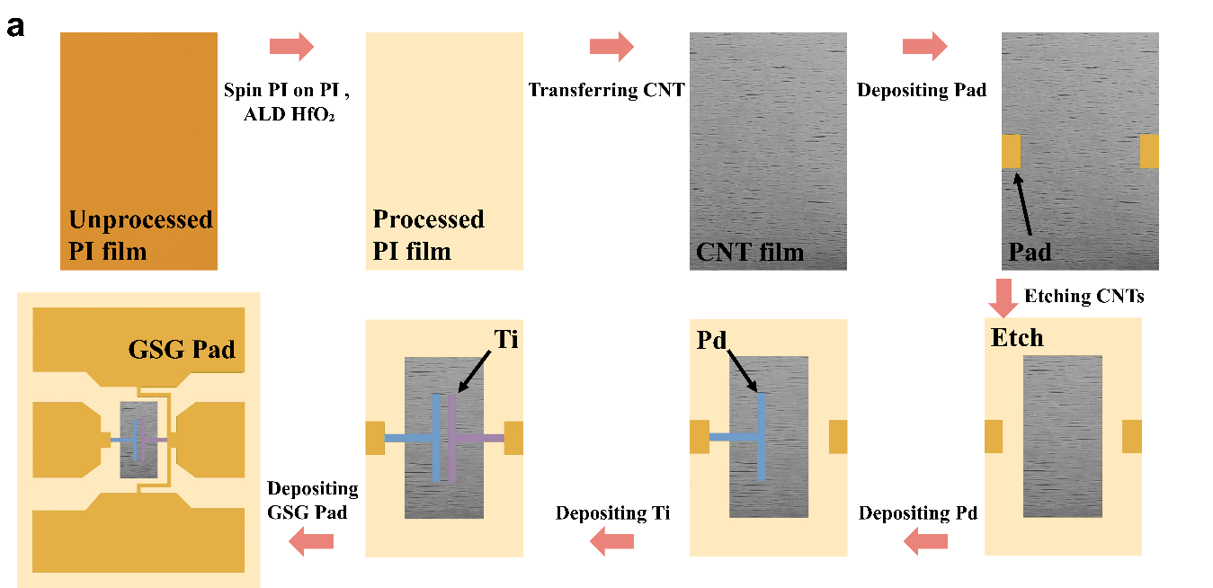
Fig. S2 | Schematic diagram of the fabrication process of the flexible Schottky diodes based on ACNT arrays. The detailed process is described in Methods.

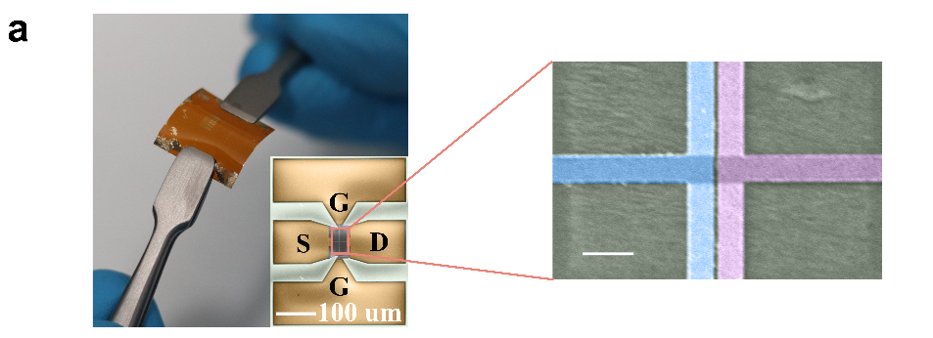
Fig. S3 | SEM image of a flexible schottky diodes based on CNTs with a G-S-G structure. The image on the right is an enlarged image of the device channel.

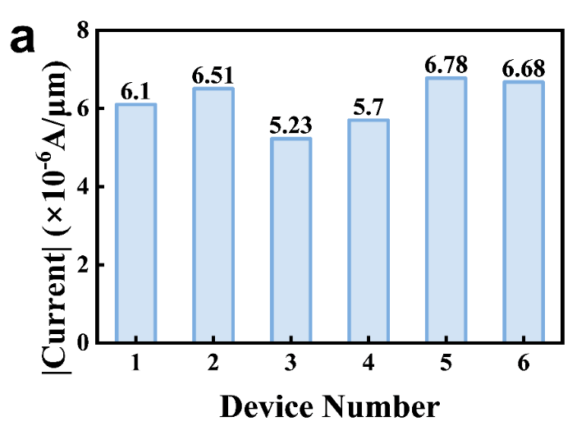
Fig. S4 | Current-density distribution at 1 V of forward bias for ACNT flexible Schottky diodes. Histogram of the current density 𝐽 measured at 𝑉 = 1 V for ACNT-FSBDs.

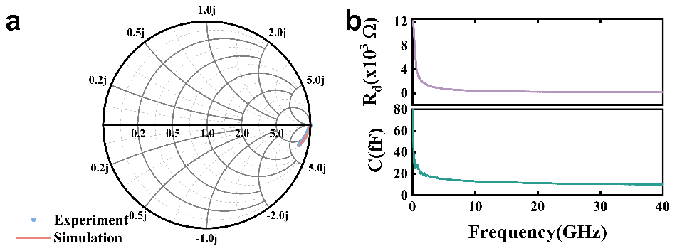
Fig. S5 | a, Smith chart representation of the flexible Schottky diode with a channel width of 20 μm and a length of 200 nm, measured at 0 V bias. The ADS simulation results are overlaid for comparison, demonstrating the impedance characteristics. b, Frequency-dependent variation of resistance (top) and capacitance (bottom) for the diode, spanning from 100 MHz to 40 GHz. Symbols denote values extracted from the measured RF response (experimental data).

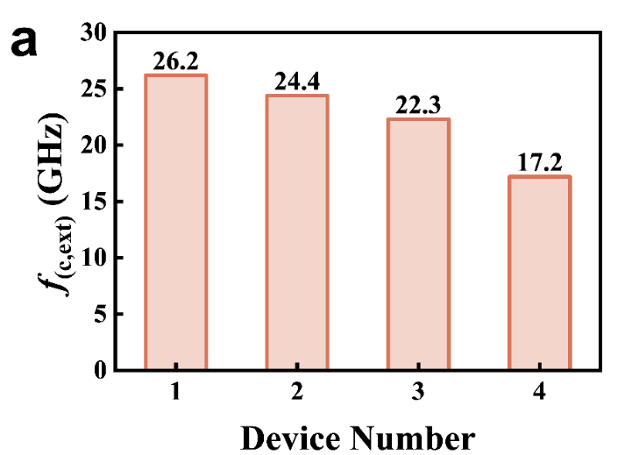
Fig. S6 | Extrinsic cutoff frequency of CNT-FSBDs. Histogram showing the extrinsic cutoff frequency f_{c,ext} for CNT-FSBDs at zero bias (flat state), aggregated over 4 devices ( W = 60 µm). The 𝑓_{c,ext} is obtained from rectifier measurements as the −3 dB (half-power) point where the rectified output V_{out} drops to $1/\sqrt{2}$ (≈0.707) of its peak (low-frequency) value, thus reflecting parasitic losses of the full device/circuit.

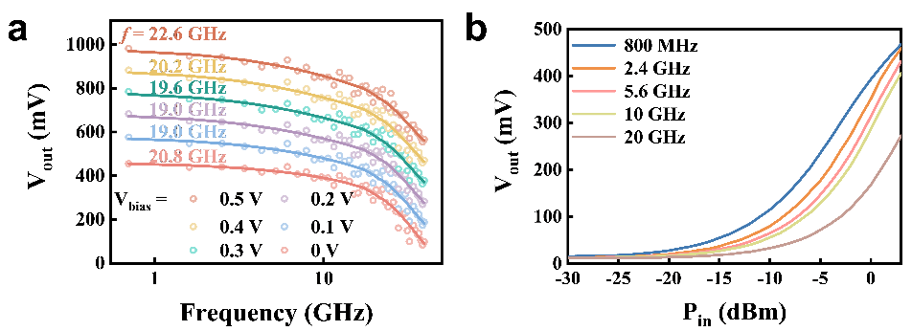
Fig. S7 | Extrinsic cutoff frequencies of flexible Schottky diodes based on ACNT arrays at different bias voltages and different power. a, Extrinsic cutoff frequencies of diodes at different bias voltages, measured at an input power of 0 dBm. b, Output voltage as a function of input RF power in the Wide power range (-30 to 3 dBm) at five different operating frequencies (800 MHz, 2.4 GHz, 5.6 GHz, 10 GHz, and 20 GHz). The Schottky diode features a channel length of 200 nm and a width of 60 μm, with measurements conducted at 0 V bias, demonstrating its frequency-dependent rectification performance.

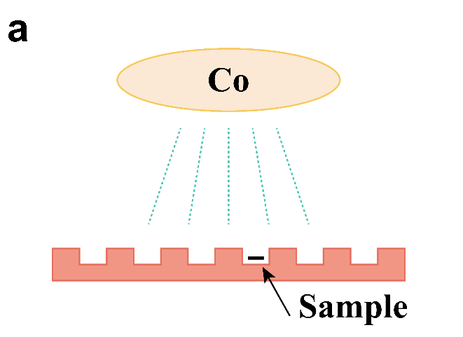
Fig. S8 | Schematic diagram of radiation-resistant instrument. The sample platform is a multi-hole plate, and different holes are exposed to different radiation doses.

 | Substrate |  | Current Density at 1V (A/µm) | f_{(c,int)} (GHz) | f_{(c,ext)} (GHz) | Ref.
 | Flexible | Hard
ZnO |  | Glass | 4.52×10⁻¹⁰ | 330 | 10 | 1
IGZO | PET |  | 2.53×10⁻⁹ | 16.7 | 6.3 | 2
IGZO |  | Glass |  | 1.8 | 1.1 | 3
Graphene | Foil |  | 4.89×10⁻⁸ | 100 | \ | 4
MoS₂ | PI |  | 3.11×10⁻⁶ | ≥100 | 10 | 5
GaAs | PI |  | 5.78×10⁻⁵ |  | 4 | 6
GaAs | CNF |  |  | 15.1 | 5.8 | 7
Ge | Plastic |  | \ | 20 |  | 8
Ge | Plastic |  |  | 10 |  | 9
Si | PET |  | \ | \ | 1.6 | 10
WSe₂ |  | Glass | \ | \ | 10 | 11
Organic |  | Glass | \ | \ | 14 | 12
This work | PI |  | 3.08×10⁻⁵ | ≥335.7 | 28.6
Tab. S1 | Benchmarking of key performance metrics. Current density at 1 V, intrinsic cutoff frequency 𝑓_{c,int}, and extrinsic cutoff frequency 𝑓_{c,ext} compiled from prior reports. Source articles are listed in Supplementary References.

 | Substrate |  | TID (Mrad) | Ref.
 | Flexible | Hard | TID (Mrad) | Ref.
IGZO |  | Si | 0.25 | 13, 14
GaAs |  | Si-GaAs | 1 | 15
GaAs-Si |  | \ | 2 | 16
Si |  | Si | 3 | 17
CNT on |  | Si | 15 | 18
CNT on |  |  | 2.2 | 19
CNT on |  |  | 15.5 | 20
CNT | PI |  | 2 | 21
CNT | PI |  | 4 | 18
This work | PI |  | 3
Tab. S2 | Benchmarking of TID performance. Literature sources compiled for TID benchmarking of devices discussed in the main text. Full citations are provided in Supplementary References.

References
1. Georgiadou D. G., et al. 100 GHz zinc oxide Schottky diodes processed from solution on a wafer scale. Nat. Electron. 3, 718-725 (2020).
2. Zhang J. W., Li Y. P., Zhang B. L., Wang H. B., Xin Q., Song A. M. Flexible indium-gallium-zinc-oxide Schottky diode operating beyond 2.45 GHz. Nat. Commun. 6, 7561 (2015).
3. Chasin A., et al. Gigahertz Operation of a-IGZO Schottky Diodes. IEEE Trans. Electron Devices. 60, 3407-3412 (2013).
4. Wang Z., et al. Flexible One-Dimensional Metal–Insulator–Graphene Diode. ACS Appl. Electron. Mater. 1, 945-950 (2019).
5. Zhang X., et al. Two-dimensional MoS2-enabled flexible rectenna for Wi-Fi-band wireless energy harvesting. Nature. 566, 368-372 (2019).
6. Jung Y. H., Zhang H. L., Lee I. K., Shin J. H., Kim T. I., Ma Z. Q. Releasable High-Performance GaAs Schottky Diodes for Gigahertz Operation of Flexible Bridge Rectifier. Adv. Electron. Mater. 5, 1800772 (2019).
7. Jung Y. H., et al. High-performance green flexible electronics based on biodegradable cellulose nanofibril paper. Nat. Commun. 6, 7170 (2015).
8. Qin G., et al. Experimental characterization and modeling of the bending strain effect on flexible microwave diodes and switches on plastic substrate. Appl. Phys. Lett. 99, 243104 (2011).
9. Qin G. X., et al. Fabrication and Characterization of Flexible Microwave Single-Crystal Germanium Nanomembrane Diodes on a Plastic Substrate. IEEE Electron Device Lett. 34, 160-162 (2013).
10. Sani N., et al. All-printed diode operating at 1.6 GHz. Proc. Natl. Acad. Sci. U.S.A. 111, 11943-11948 (2014).
11. Yang S. J., et al. Ultrafast 27 GHz cutoff frequency in vertical WSe2 Schottky diodes with extremely low contact resistance. Nat. Commun. 11, 1574 (2020).
12. Loganathan K., et al. 14 GHz Schottky Diodes Using a p‐Doped Organic Polymer. Adv. Mater. 34, 2108524 (2022).
13. Guo Z., et al. Total-ionizing-dose effects in IGZO thin-film transistors. IEEE Trans. Nucl. Sci. 70, 2002-2007 (2023).
14. Guo Z., et al. Total-ionizing-dose effects in IGZO thin-film transistors with SiO 2 oxygen-penetration layers. IEEE Trans. Nucl. Sci. 77, 461-468 (2023).
15. Ren S., et al. Total ionizing dose (TID) effects in GaAs MOSFETs with La-based epitaxial gate dielectrics. IEEE Trans. Nucl. Sci. 64, 164-169 (2016).
16. Behera R., Nidhin T., Sakthivel M., Jayanthi T., Madhusoodanan K. Total ionizing dose effects in GaAs-Si based electronic components. In: 2017 Innovations in Power and Advanced Computing Technologies (i-PACT)). IEEE (2017).
17. Zhang R. Q., Cui J. W., Li Y. D., Guo Q., Zheng Q. W. Total Ionizing Dose Effects on 22 nm UTBB FD-SOI MOSFETs up to 100 Mrad(Si). IEEE Trans. Electron Devices. 71, 3490-3497 (2024).
18. Zhu M. G., et al. Radiation-hardened and repairable integrated circuits based on carbon nanotube transistors with ion gel gates. Nat. Electron. 3, 622-629 (2020).
19. Zhu M. G., Zhang Z., Peng L. M. High‐performance and radiation‐hard carbon nanotube complementary static random‐access memory. Adv. Electron. Mater. 5, 1900313 (2019).
20. Zhu M., Zhou J., Sun P., Peng L.-M., Zhang Z. Analyzing Gamma-Ray Irradiation Effects on Carbon Nanotube Top-Gated Field-Effect Transistors. ACS Appl. Mater. Interfaces. 13, 47756-47763 (2021).
21. Wang X., et al. Ultralow-Power and Radiation-Tolerant Complementary Metal-Oxide-Semiconductor Electronics Utilizing Enhancement-Mode Carbon Nanotube Transistors on Paper Substrates. Adv. Mater. 34, 2204066 (2022).

