Supplement2
e Figure1: Acupuncture and needle-knife therapy point positioning
e Figure2: Modified Oswestry Disability Index (MODI)
e Table1: Selection of acupuncture needles and needle insertion depth
e Table2: Needle knife instruments and release methods
e Table3: Primary and Secondary Outcomes

e Table1: Selection of acupuncture needles and needle insertion depth
 | Needle  specification | Acupuncture angle | Acupuncture depth
Shen shu (BL23) | 0.30 × 75 mm | 90 degree angle | 20-30mm
Da chang shu (BL25) | 0.30 × 75 mm | 90 degree angle | 20-30mm
Qi hai shu (BL21) | 0.30 × 75 mm | 90 degree angle | 20-30mm
Ci liao (BL32) | 0.30 × 75 mm | 90 degree angle | 20-30mm
Zhong liao (BL33) | 0.30 × 75 mm | 90 degree angle | 20-30mm

e Table2: Needle-knife instruments and release methods
Acupoint needle-knife instrument Needle-knife operation method
Qi hai shu (BL21)  Da chang shu (BL25)  Shen shu (BL23)  Ci liao (BL32)  Zhong liao (BL33) | 1.0 mm × 80 mm | The three-step slow push methodª  The three-step slow push method  The three-step slow push method  The three-step slow push method  The three-step slow push method
1.0 mm × 80 mm
1.0 mm × 80 mm
1.0 mm × 80 mm
1.0 mm × 80 mm
a: The operation method of the needle knife is as follows:
1. The physician locates the point with the left hand and holds the needle knife with the right hand, inserting the needle from the outer side of the fingertip.
2. Before needle insertion, the patient is instructed to take a deep breath. The physician swiftly inserts the needle-knife along the outer edge of the supporting finger into the subcutaneous tissue.
3. A brief pause of 3–5 seconds follows, during which the patient is guided to breathe deeply and slowly. As the patient's exhalation is about to end, longitudinal cutting and transverse stripping are performed 2–3 times to release the superficial tissues.
4. After another pause of 3–5 seconds, the patient is again guided to breathe deeply and slowly. As the exhalation is about to end, the needle knife is gently advanced into the middle layer. Longitudinal cutting and transverse stripping are performed 2–3 times to release the middle layer soft tissues.
5. Following a pause of 3–5 seconds to confirm the accuracy of the treatment site, the patient is guided to breathe deeply and slowly. As the exhalation is about to end, the needle knife is gently advanced into the deep layer until the bone surface is reached. Longitudinal cutting and transverse stripping are performed 2–3 times.
6. After a final pause of 3–5 seconds, the patient's sensation is inquired about. The patient is guided to breathe deeply and slowly, and as the patient inhales, the needle knife is quickly withdrawn. After needle withdrawal, the therapy site is compressed for 15 minutes to stop bleeding, covered with a sterile gauze, and kept dry for 24 hours.

e Table3: Primary and Secondary Outcomes
Domain | Instrument
Curative effect | Effective rateª
Pain | Visual Analogue Scaleb
Dysfunction | Oswestry Disability Indexc
Range of motion | Lumber Functional Mobilityd
Blood serum levels of TNF - α/ng ·L - 1 | Enzyme-linked immunosorbent assay  (ELISA)^{e}
Blood serum levels of  IL - 6/ng ·L – 1  Blood serum levels of  IL - 1β/ng ·L - 1 | Enzyme-linked immunosorbent assay  (ELISA)  Enzyme-linked immunosorbent assay  (ELISA)
a: Efficacy evaluation criteria: Cure: Pain in the waist and legs disappears, functions recover, straight leg raising angle ≥ 70°, no limitation in movement, imaging improves or stabilizes. Markedly Effective: Pain significantly reduces, functions significantly improve, straight leg raising angle ≥ 60°, able to live and work normally. Effective: Pain slightly alleviates, functions partially recover, and the straight leg raising angle increases Ineffective: Symptoms do not improve or worsen; functional disorders persist.
b: Based on the classification, "0-2" is rated as "excellent," "3-5" as "good," "6-8" as "acceptable," and "> 8" as "poor." In terms of the average score, mild pain is (2.57 ± 1.04) points; moderate pain is (5.18 ± 1.41) points; severe pain is (8.41 ± 1.35) points.
c: (0-10 points): Mild functional impairment; daily activities are basically normal. (11-20 points): Moderate functional impairment; some activities are restricted, and intervention is required. (21-30 points): Severe functional impairment, significantly affects life, active treatment is recommended. (31-40 points): Severe functional impairment, may require surgeryor intensified rehabilitation. (41-50 points): Completely disabled; urgentmedical intervention is necessary.
d: Before treatment, after one course of treatment, and 3 months after treatment, the patient's lumbar spine flexion and lateral bending range of motion were measured using a goniometer to evaluate the clinical efficacy.
e: Higher → The inflammation becomes more severe, and the condition becomes more active.

e Figure1:Acupuncture and needle-knife therapy point positioning
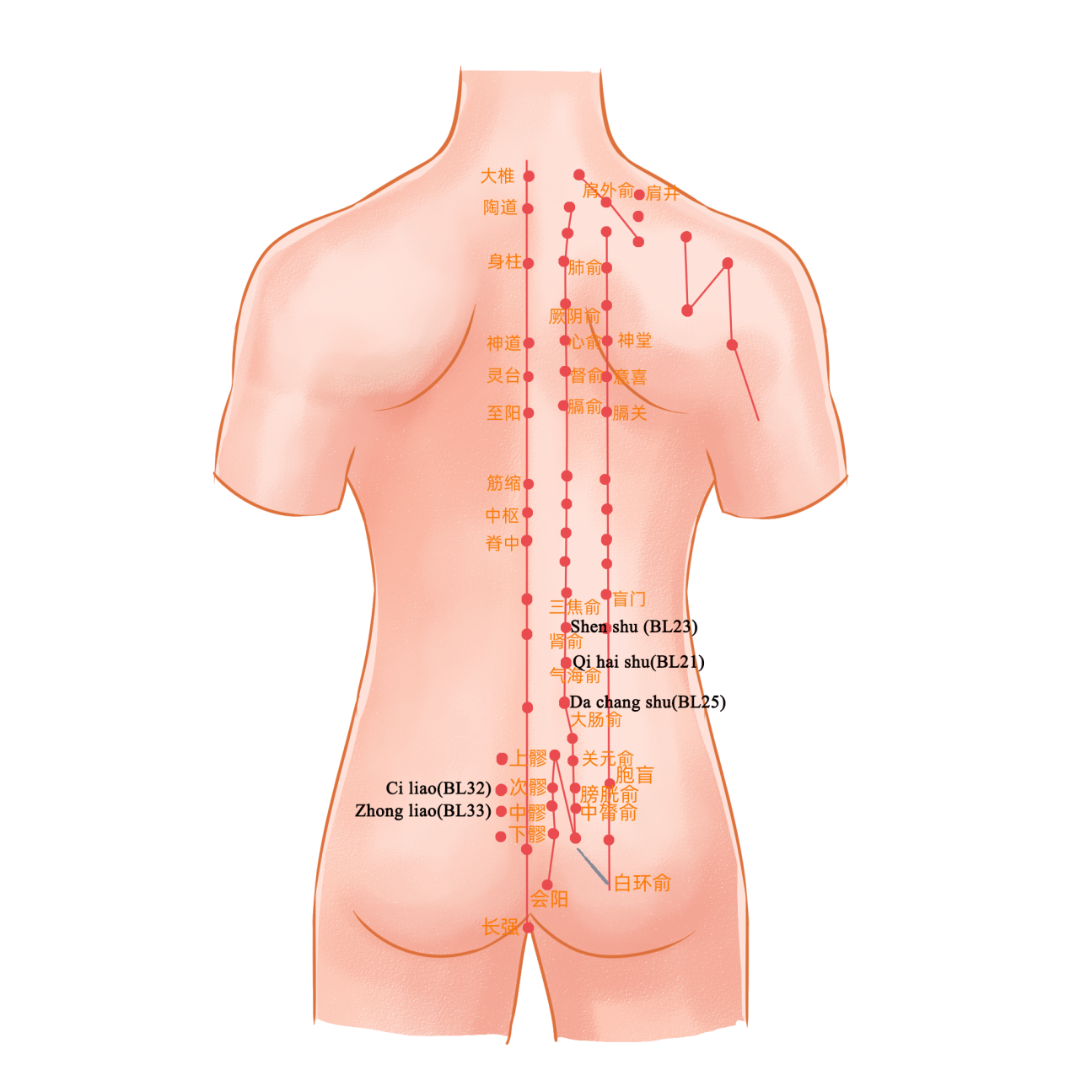

e Figure2:Modified Oswestry Disability Index (MODI)
