Supplement1

Ethics approval and consent to participate
This retrospective study was conducted as part of the [Clinical Efficacy Analysis of Chronic Nonspecific Low Back Pain Treated by "Occasional Stabbing Method" with Needle Knife] project, which was approved by the institutional review board of [The Third Affiliated Hospital of Henan University of Chinese Medicine] (Approval No. XXX). We have also registered at the International Traditional Medicine Clinical Trial Registration Platform (https://itmctr.ccebtcm.org.cn/mgt/project/user/approved-list):ITMXXX. All patients gave their written informed consent before participating in the clinical trial. The details of our study, including trial objectives, characteristics, probable benefits and risks, other available treatment alternatives, and the subjects’ rights as well as obligations as stated in the Declaration of Helsinki, will be made clear to the patients by study personnel who have their grouping code, and their agreement will be required. After obtaining the written informed consent, the subjects will be enrolled in the study. During the process of the trial, if new points regarding the study ethics emerge, written revisions regarding the informed consent will be handled by the Ethics Committee, and after their approval, the individuals’ consent will be requested again. In case of the patients’ withdrawal, their available data will be kept for the final analyses.
Dissemination
Study results will be first communicated to each participant and later disseminated to researchers and the general public through courses, presentations, and the internet, regardless of the magnitude or direction of effect. The results will also be documented in a published peer-reviewed academic journal.
Consent for publication
Not applicable.
Availability of data and materials
The submitted manuscript is a study protocol which includes no primary data now. More date and materials unmentioned can be obtained from the corresponding author by the contact methods provided in the manuscript.
Patient and Public Involvement
The patients are from the Acupuncture Department of the Third Affiliated Hospital of Henan University of Chinese Medicine. The final outcome will be published in a journal.
Informed consent statement
All patients will be provided informed consent for publication of the case.
Authors’ contributions
Competing interests
None declare that they have competing interests.
Issue Date: 06 December, 2025
Protocol Amendment Version: 2.1

Figure1 Ethical approval materials for research projects
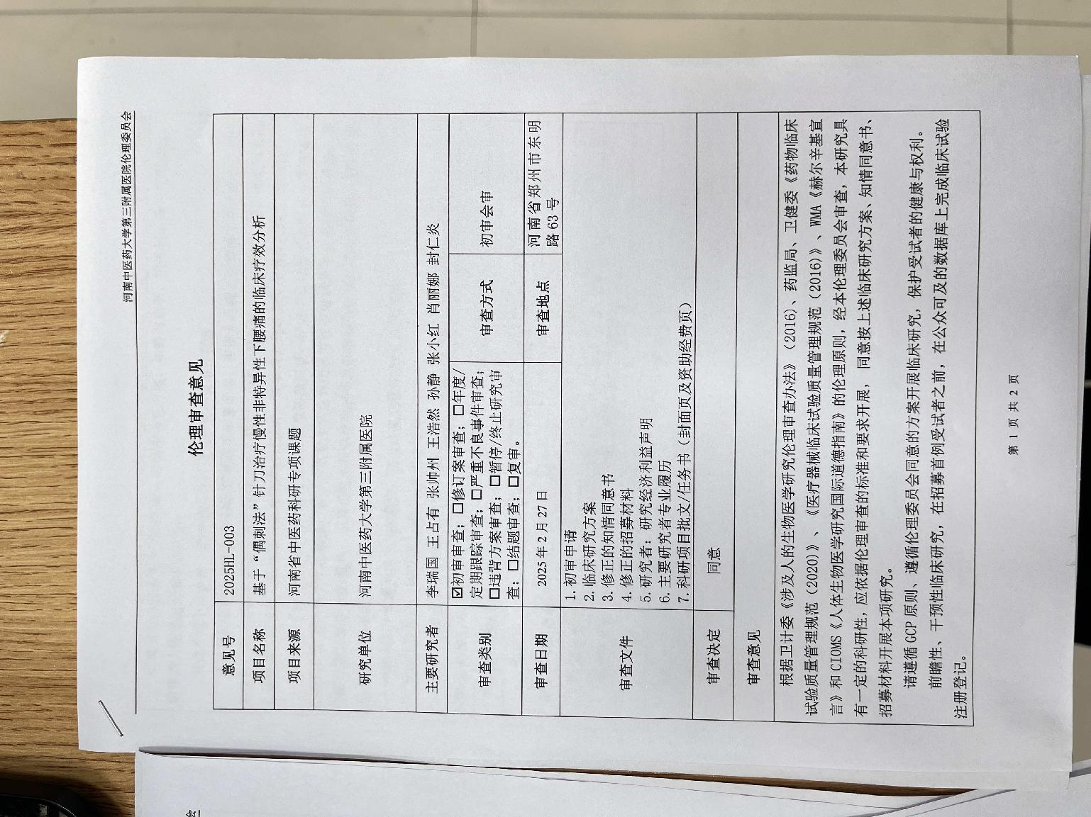

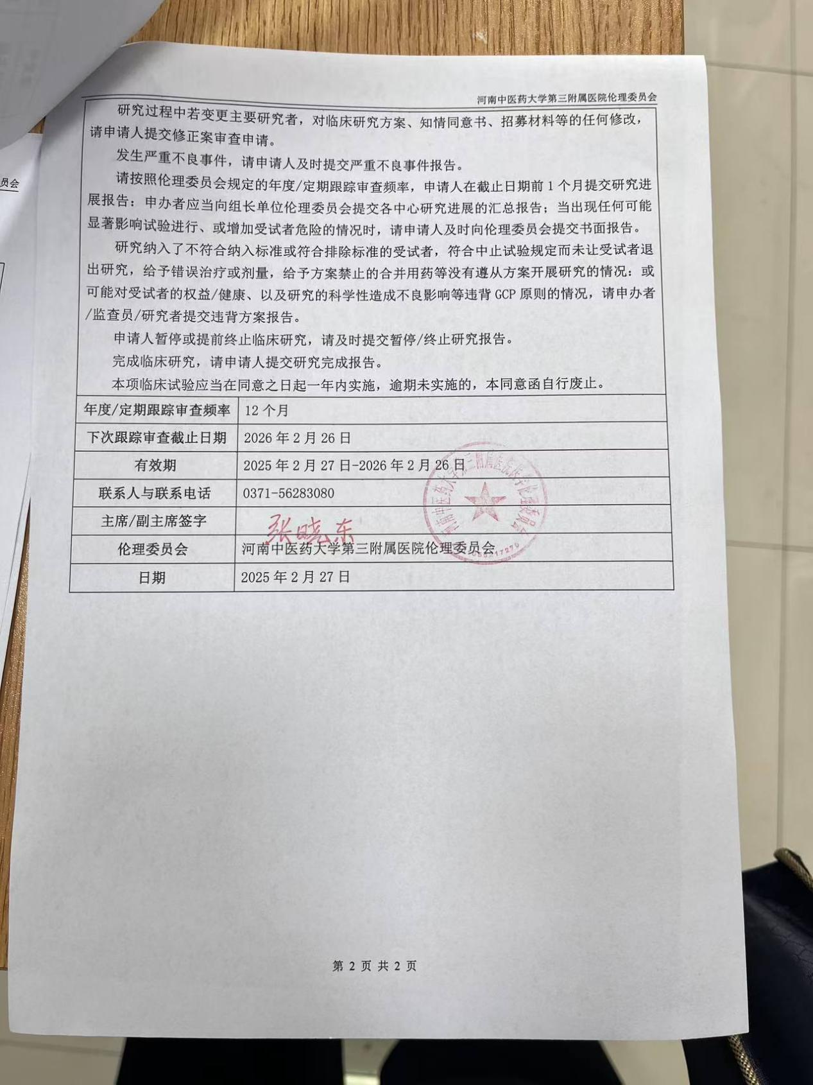

Review date | January 14, 2025
Location of review | Jinshui District, Zhengzhou City, Henan Province
Clinical research approvals | NA
Clinical Research Program | Clinical Efficacy Analysis of Chronic Nonspecific Low Back Pain Treated by "Occasional Stabbing Method" with Needle Knife
Review of  documentation | informed consent
Contract Research Organization/CRO | The Third Affiliated Hospital of Henan University of Chinese Medicine
Clinical Research Organization | The Third Affiliated Hospital of Henan University of Chinese Medicine
Principal Investigator | Li Ruiguo, Wang Zhanzong, Zhang Shuai zhou
Review methods | ■Conference review □Expedited review
Approval validity date | February 27, 2025, to February 26, 2026
The Third Affiliated Hospital of Henan University of Chinese Medicine
Date : February 27,2025

