Supplementary tables and figures
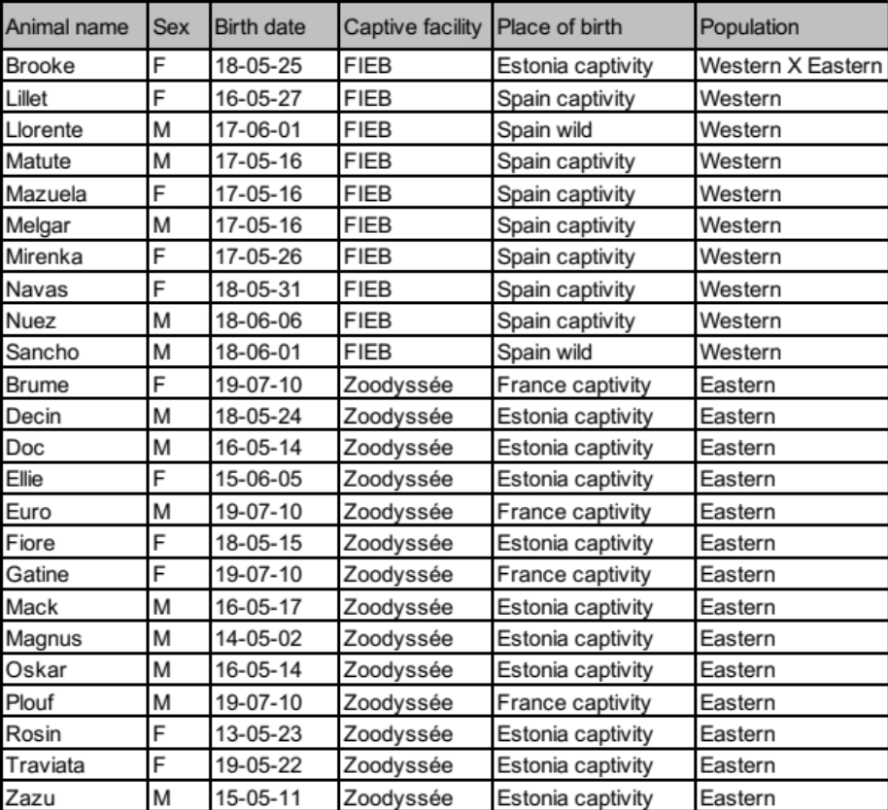
Table S1. List of animals sampled

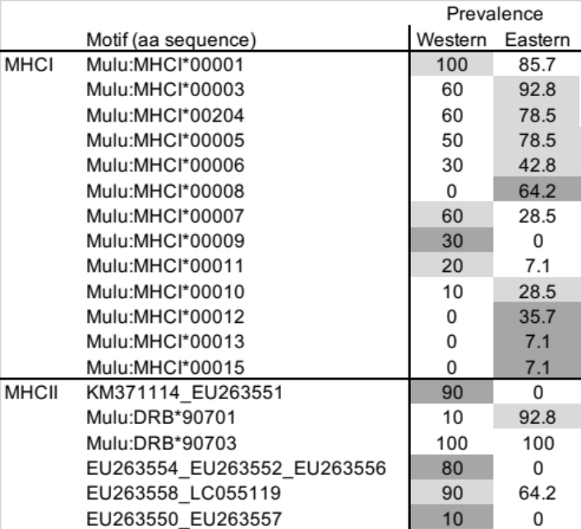

Table S2. Prevalence (%) of MHC motifs found in the mink population (n=10; n=14, respectively). Dark grey shading highlights motifs strictly found in one population, and light grey shading shows higher prevalence of each motif in one group.

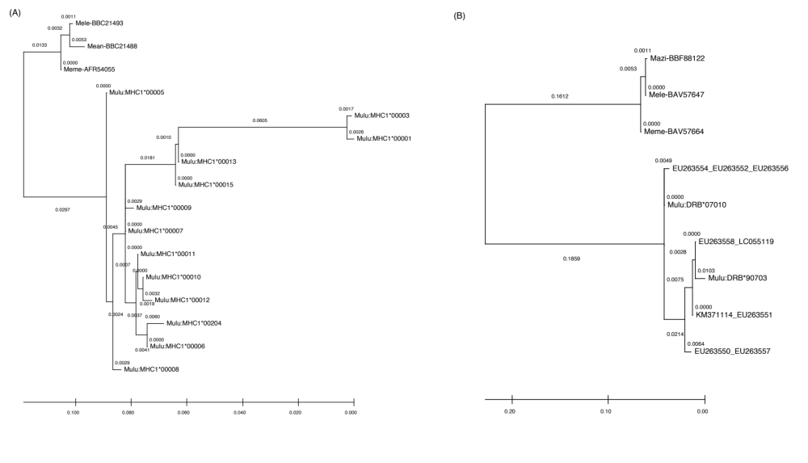
Figure S1. ﻿Maximum-likelihood trees constructed based on the chemical binding properties of the amino acids in the peptide binding regions, as described by five physico-chemical descriptor variables (z-descriptors) for each amino acid, for (A) MHC-I exon 2 motifs and (B) MHC-II DRB motifs.

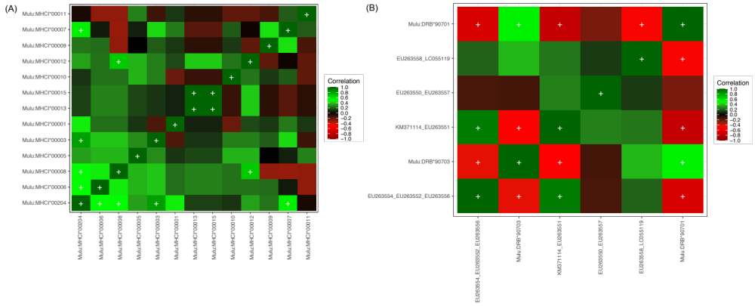
Figure S2. Spearman pairwise correlations between the presence/absence of common motifs in (A) MHC-I exon 2 and (B) MHC-II DRB exon 2. Positive correlations are colored in green, and red for negative correlations, white plus signs denote significant correlations (P-value < 0.05). Correlated motifs are likely to represent haplotype blocks among populations.
Figure S3. ﻿Alignment of partial (A) MHC class I exon 2 and (B) MHC class II DRB exon 2 amino acid sequences of M. lutreola. Orange shading represent motifs only present in western mink and blue shading to the eastern population. Asterisks (*) represent amino acid residues pointing toward the T-cell receptors, carets (^) highlight antigen-binding site residues pointing up on an alpha-helix, postulated to interact with peptides and/or T-cell receptors. Tildes (~) indicate residues on an alpha-helix that is pointing away from the antigen-biding sites, postulated to interact with T-cell receptors. Residues that form the beta-sheet or alpha-helix, and residues that influence the binding of the CD8/CD4 glycoprotein are marked under the alignment for MHC-I and MHC-II respectively (Sin et al., 2012; ﻿Bjorkman & Parham, 1990; Reche & Reinherz 2003).

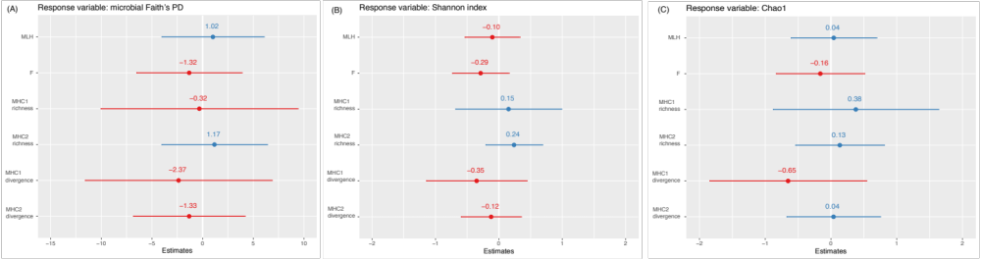

Figure S4. Distribution of estimates for three microbial richness indexes (A: Faith’s PD, B: Chao1, C: Shannon index) for linear regression models with neutral and adaptive genetic diversity measures. Dots represent the mean for each estimate and whiskers extending to the last data points, in red are negative correlations and blue for positive. MLH: Microsatellite markers’ multilocus heterozygosity, F: Microsatellites inbreeding coefficient, MHC-I and MHC class II richness and divergence. A: F-statistic: 0.5502, R-squared: 0.1626, p-value: 0.7633, B: F-statistic: 0.5795, R-squared: 0.1698, p-value: 0.7417, C: F-statistic=0.5082, R-squared: 0.1521, p-value=0.7939.

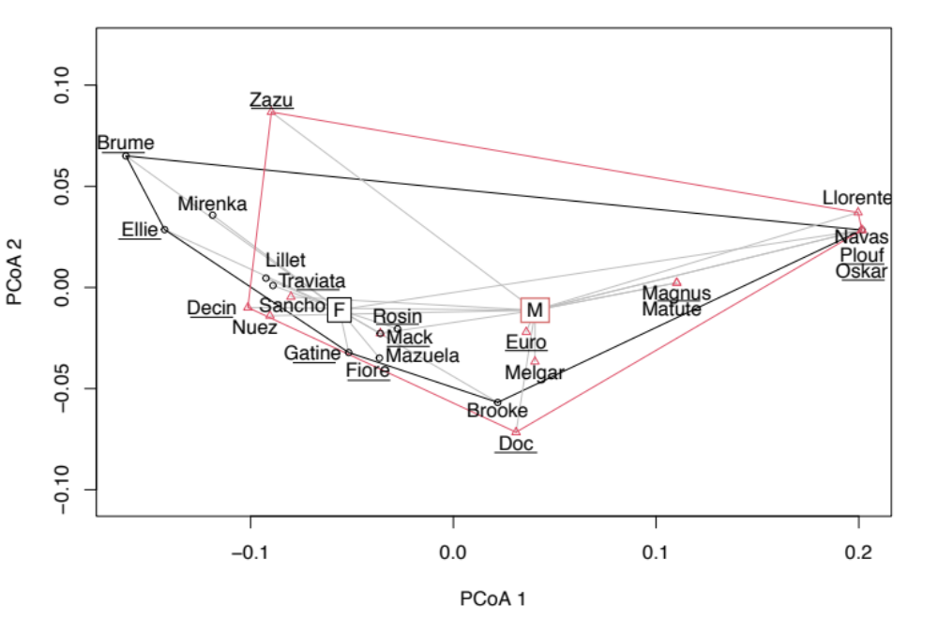
Figure S5. ﻿Differences in E-mink MHC-I motif composition visualized by principal coordinates analysis of unweighted UniFrac distances. Individuals are labelled according to their name their population or origin (animal names from eastern population are underlined, not underlined for western). Clusters correspond to the sex of each individual where the value is indicated at the centroid.

