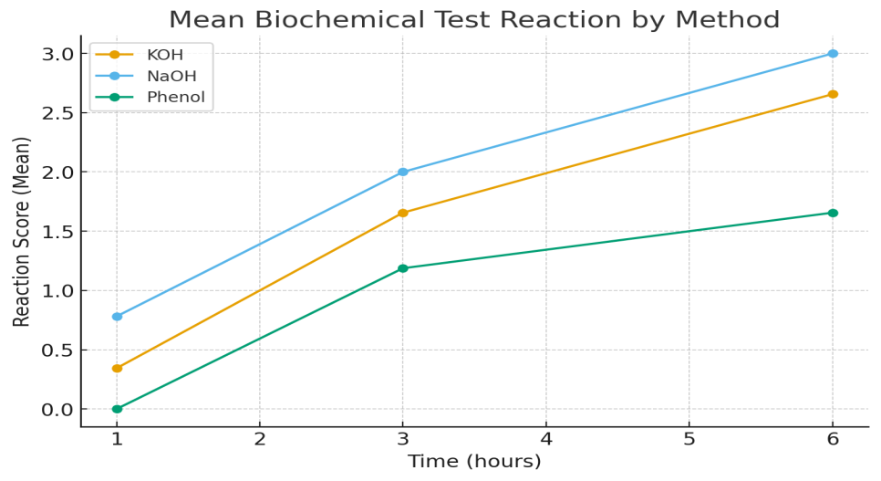

Graph.1 Reaction score for different tests

