Supplementary material
Table S1.
Chi² for the p-values from pairwise comparisons between the treatment groups using Log-Rank tests (degrees of freedom per comparison = 1) to detect significant differences in survival probability of bumblebees exposed to single stressors or combinations (ozone, heat, microplastic) for 10 days. C = control, O₃ = ozone, H = heat, MP = microplastic, HO₃ = heat + ozone, MPO₃ = microplastic + ozone, MPH = microplastic + heat, MPHO₃ = microplastic + heat + ozone.
 | C | O₃ | H | MP | HO₃ | MPO₃ | MPH
O₃ | 0.000 | NA | NA | NA | NA | NA | NA
H | 0.000 | 0.000 | NA | NA | NA | NA | NA
MP | 8.644 | 8.644 | 8.644 | NA | NA | NA | NA
HO₃ | 1.000 | 1.000 | 1.000 | 6.087 | NA | NA | NA
MPO₃ | 16.27 | 16.27 | 16.27 | 2.097 | 13.56 | NA | NA
MPH | 20.57 | 20.57 | 20.57 | 4.053 | 17.76 | 0.300 | NA
MPHO₃ | 23.57 | 23.57 | 23.57 | 5.787 | 20.57 | 0.934 | 0.152

Data S2. (separate file)
The data gives a list of all proteins identified in the fat body proteome of Bombus terrestris.
File name: S2_Identified_ proteins_Bombus_terrestris.xlsx
Data S3. (separate file)
The data gives a list of all bumblebee fat body proteome changes of all treatment groups compared to the control.
File name: S3_Differentially_altered_proteins_total.xlsx
Table S4.
Z-values for the p-values from the pairwise comparisons between the treatment groups using Log-Rank test (degrees of freedom per comparison = 1) to detect significant differences in relative fat body content of bumblebees exposed to multiple stressors (ozone, heat, microplastic) for 10 days. C = control, O₃ = ozone, H = heat, HO₃ = heat + ozone, MP = microplastic, MPO₃ = microplastic + ozone, MPH = microplastic + heat, MPHO₃ = microplastic + heat + ozone.
 | C | O₃ | H | MP | HO₃ | MPO₃ | MPH
O₃ | -0.665
H | -0.648 | 0.009
MP | 0.073 | 0.686 | 0.671
HO₃ | -0.663 | -0.006 | -0.015 | 0.685
MPO₃ | -3.060 | -2.470 | -2.450 | -2.930 | -2.440
MPH | -1.320 | -0.770 | -0.771 | -1.310 | -0.759 | 1.410
MPHO₃ | -2.170 | -1.650 | -1.650 | -2.120 | -1.640 | 0.472 | -0.823

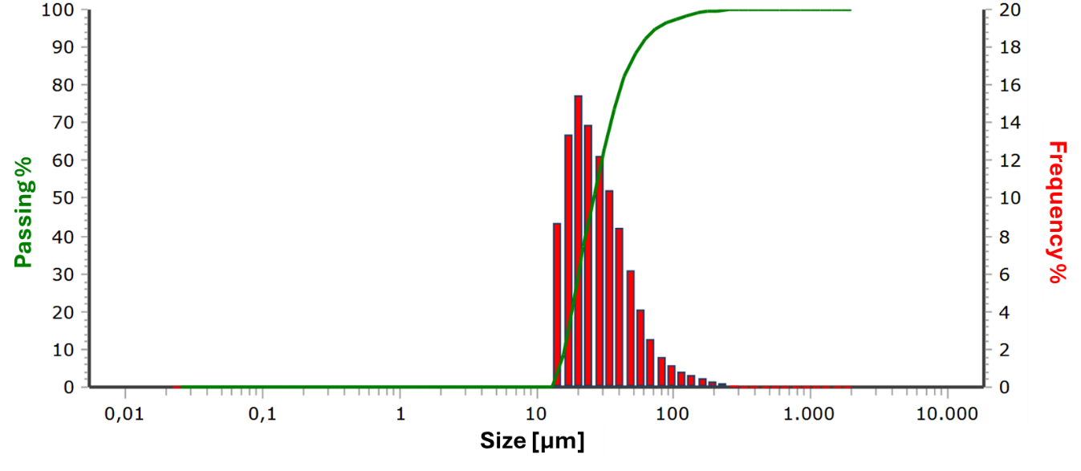
Figure S5.
Size distribution of LDPE microplastic particles of the 20-75 µm fraction. The particle size-distribution was determined by a Microtrac Sync particle analyser (Microtrac RETSCH GmbH, Haan, Germany).
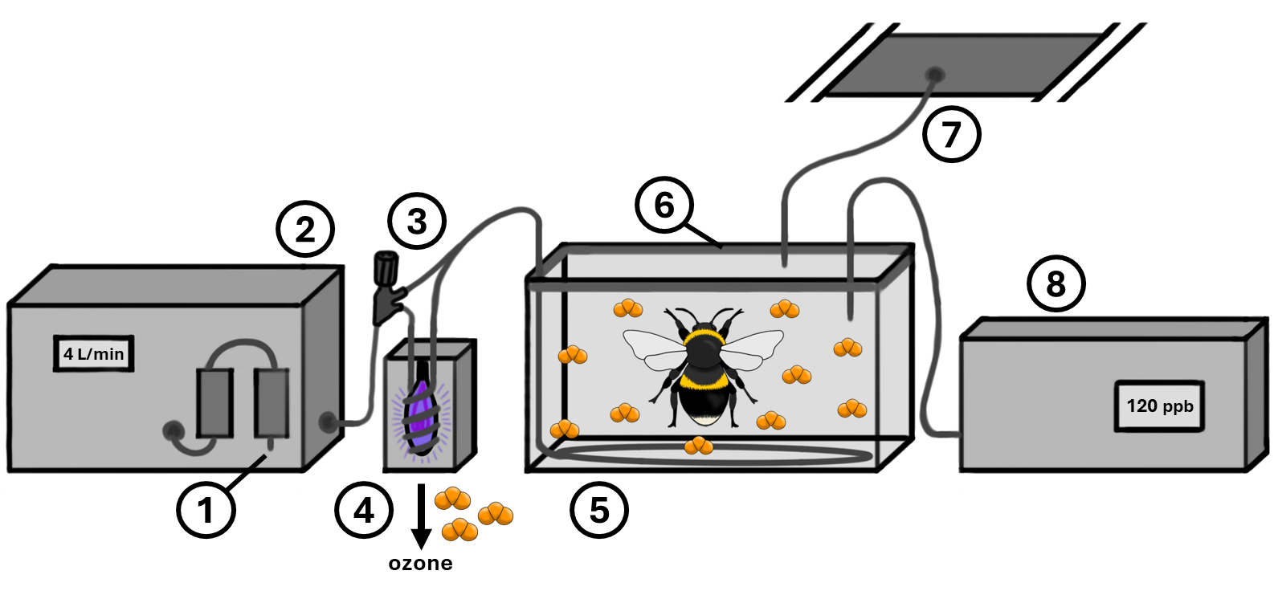
Figure S6.
Experimental setup for ozone exposition of bumblebee workers consisting of 1) air inlet with filtering chambers of a 2) air feed pump, 3) branching with rotary control, 4) UV-lamp chamber, 5) gas outlet (Teflon tube) in a 12-litre glass tank, 6) Teflon-foil wrapped acrylic glass cover sealed on the tank with body sealant (dark grey), 7) exhaust air connection to the laboratory ventilation system, and 8) ozone analyser.

Table S7.
Calculation of the LDPE concentration in the food dough, corresponding to a concentration of about 4 % LDPE in sugar water, measured in terms of sugar content.
Goal concentration of LDPE in sugar water  (Apiinvert : water, 1:1, V:V; c_{LDPE_SW}) |  | = | 42.500 $\frac{g}{l}$
Apiinvert content in sugar water (c_{ApiinvertSW}) |  | = | 0.500 $\frac{l}{l}$
Density of Apiinvert (ϱ_{Apiinvert}) |  | = | 1.455 $\frac{kg}{l}$
Sugar content of Apiinvert (c_{sugarApiinvert}) |  | = | 0.727 $\frac{kg}{kg}$
Sugar content of Apifonda (c_{sugarApifonda}) |  | = | 0.900 $\frac{kg}{kg}$
Sugar content of Apifonda + 15 % powdered sugar  (c_{sugarApifonda15}) |  | = | 0.915 $\frac{kg}{kg}$
Calculation of LDPE concentration in Apifonda (c_{LDPE_Apifonda}):

$$c_{LDPE_Apifonda}=\frac{1}{c_{ApiinvertSW}×c_{LDPPE_SW}}×\frac{1}{ϱ_{Apiinvert}×c_{sugarApiinvert}}×\frac{1}{c_{sugarApifonda15}}$$
$$c_{sugarApiinvert}=\frac{1}{0.5\frac{l}{l}}×42.500\frac{g}{l}×\frac{1}{1.455\frac{kg}{l}×0.727\frac{kg}{kg}}×\frac{1}{0.915 \frac{kg}{kg}}$$
 | = 87.821 $\frac{g}{kg}$ |  | ≈ 88 $\frac{g}{kg}$

Table S8.
Calculation of the maximum MP concentration in mass per volume that was used in the study of Zhu et al. 2024.
Maximum concentration of PE spheres used in the study of Zhu et al. 2024 in number of particles per volueme (c_{maxN:V}): |  | = | 10⁵ $\frac{particles}{ml}$
Largest diameter of PE spheres (d_{max}) |  | = | 100 µm
Largest radius of PE spheres (r_{max}) |  | = | 0.005 cm
Maximum density of PE (ϱ_{PEmax}) |  | = | 0.97 $\frac{g}{{cm}^{3}}$
Calculation of the maximum PE concentration that was used in the study of Zhu et al. 2024 in mass per volume (c_{maxM:V}):

$$c_{maxM:V}=\frac{4}{3}×π×{\left(r_{max}\right)}^{3}×ϱ_{Apiinvert}×c_{maxN:V}$$
$$c_{maxM:V}=\frac{4}{3}×π×{\left(0.005 cm\right)}^{3}×0.97\frac{g}{{cm}^{3}}{×10}^{5}\frac{particles}{ml}$$
 | = 50.8 $\frac{g}{L}$ |  | ≈ 51 $\frac{g}{L}$

Data S9. (separate file)
Overview over all proteins of the bumblebee fat body proteome that were significantly altered in abundance after exposition to a) ozone, b) heat, c) microplastic (MP), d) ozone and heat, e) MP and ozone, f) MP and heat, and g) MP heat and ozone, compared to the untreated control.
File name: S9_Significantly_differentially_altered_proteins.csv
Data S10. (separate file)
The data represent bumblebee mortality over the 10-day experimental period.
File name: S10_CSV_MultStress_B-terr_Mortality.csv
Data S11. (separate file)
The data represent the bumblebees’ relative fat body content after the 10-day experimental period.
File name: S11_CSV_MultStress_B-terr_FatBody.csv

