Supplementary Figures and Tables

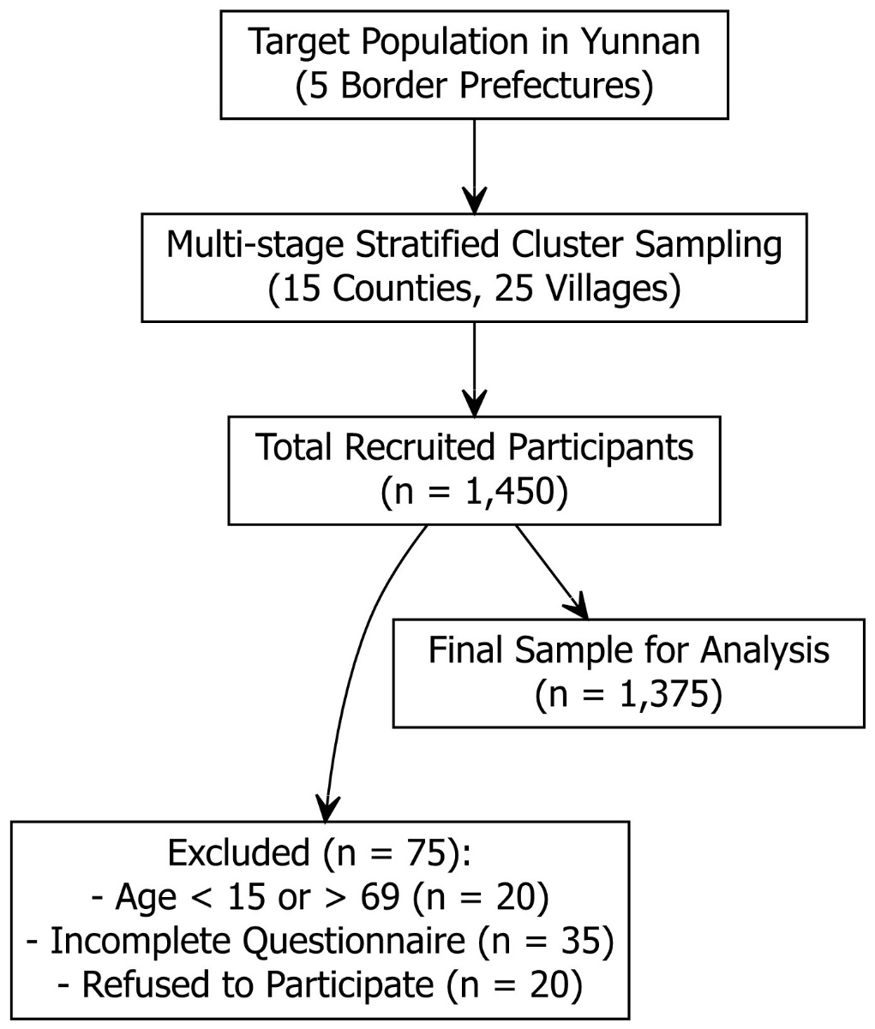
Figure S1. Flowchart of participant selection and inclusion.
The study employed a multi-stage stratified cluster sampling method across five border prefectures in Yunnan Province. Out of 1,450 initially recruited residents, 75 were excluded based on specific criteria (age limits, data completeness, or refusal). A final total of 1,375 participants were included in the statistical analysis. (Note: DESEM = Directly-Entering-Socialism Ethnic Minorities)

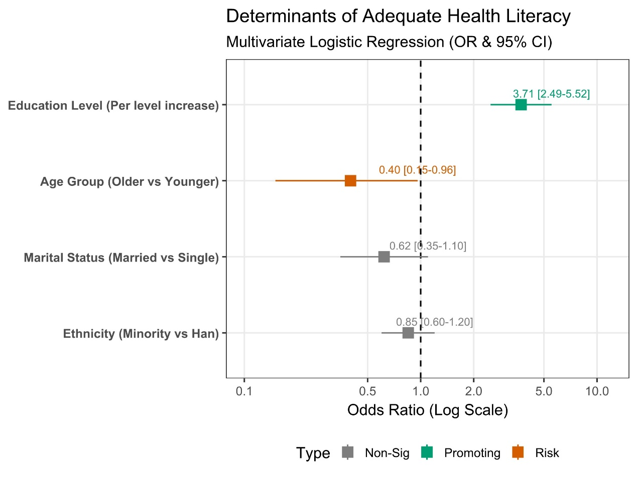
Figure S2. Forest plot showing the determinants of adequate health literacy (Multivariate Logistic Regression).
Note: Squares indicate the Odds Ratio (OR), and horizontal lines represent the 95% confidence intervals. The vertical dashed line at OR=1 represents no effect. Education level is the sole significant predictor lying to the right of the line, indicating a strong positive association.

Table S1. Multivariate Logistic Regression Analysis of Factors Associated with Health Literacy
Variable | B | S.E. | Wald χ2 | P-value | OR (95% CI)
Education Level | 1.311 | 0.202 | 42.153 | <0.001 | 3.709 (2.493 – 5.518)
Constant | -3.123 | 0.134 | 541.705 | <0.001 | 0.044
Note: 1.OR (Odds Ratio): An OR of 3.709 indicates that for each successive increase in education level (e.g., from primary school to middle/high school), the likelihood of possessing adequate health literacy is 3.7 times higher.
2.Adjusted Variables: The model was adjusted for age, gender, ethnicity, marital status, and smoking behavior. These variables are not presented in the final equation as they did not reach statistical significance (P > 0.05) in the multivariate model (Age: P = 0.051, Gender: P = 0.467, Ethnicity: P = 0.85, Marital status: P = 0.12).

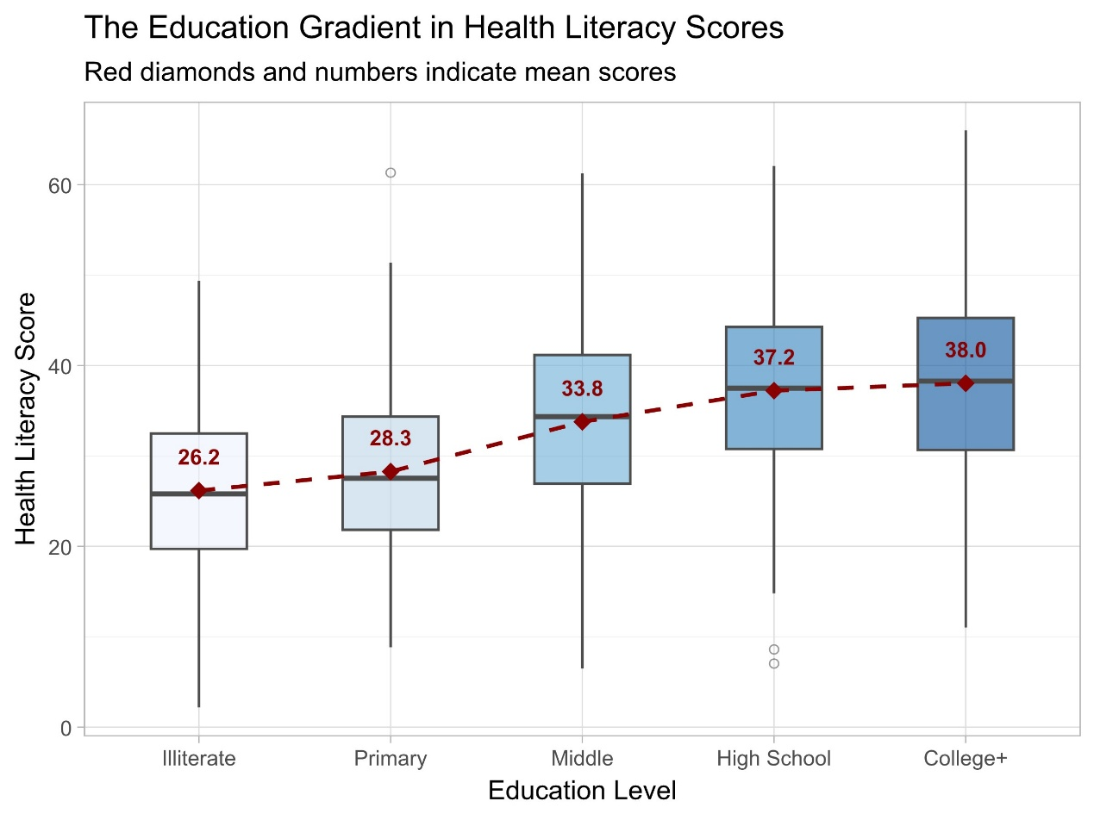
Figure S3. The education gradient in health literacy scores.
Note: Boxplots show the distribution of health literacy scores across different education levels. The red diamond and dashed line indicate the trend of mean scores, highlighting a stepwise increase with higher education levels.

Table S2. Multiple Linear Regression Analysis of Factors Associated with Health Literacy Scores
Variable | Unstandardized Coefficients (B) | Std. Error | Standardized Coefficients (β) | t-value | P-value | VIF
(Constant) | 24.931 | 1.808 | — | 13.788 | < 0.001 | —
Education Level | 4.883 | 0.441 | 0.384 | 11.061 | < 0.001 | 1.945
Age | -0.097 | 0.026 | -0.146 | -3.733 | < 0.001 | 2.451
Marital Status | 0.887 | 0.668 | 0.051 | 1.327 | 0.185 | 2.384
Gender (Male=1) | 0.233 | 0.523 | 0.011 | 0.446 | 0.656 | 1.006
Annual Income | -1.04×10⁻⁵ | 0.000 | -0.020 | -0.767 | 0.443 | 1.046
Note:
B: Unstandardized coefficient. Represents the change in the health literacy score for a one-unit change in the predictor.
Example: For every 1-level increase in education, the score increases by 4.88 points.
Example: For every 1-year increase in age, the score decreases by 0.10 points.
β: Standardized coefficient. Allows comparison of the relative strength of predictors. Education (β=0.384) has a much stronger effect than Age (β=-0.146).
VIF (Variance Inflation Factor): All VIF values are < 3, indicating no serious multicollinearity issues among the predictors.

Table S3. Disparities in Health Literacy Scores Across Occupational Stratification
 | Descriptive Statistics
Occupation | N (%) | Mean ± SE
Professional/Technical | 15 (1.1%) | 40.85 ± 2.52
Commercial/Service | 32 (2.3%) | 38.39 ± 1.72
Manual Laborers | 330 (24.0%) | 36.99 ± 0.54
Students | 64 (4.7%) | 36.17 ± 1.22
Unemployed/Retirees | 42 (3.1%) | 35.92 ± 1.50
Clerks | 33 (2.4%) | 33.63 ± 1.70
Civil Servants | 18 (1.3%) | 33.31 ± 2.30
Others | 98 (7.1%) | 31.37 ± 0.98
Farmers | 743 (54.0%) | 28.65 ± 0.36
Note: Data are presented as mean ± standard error (SE). Overall differences were tested using One-way ANOVA (F = 27.571, P < 0.001). Post-hoc tests revealed that 'Farmers' scored significantly lower than 'Commercial/Service' and 'Professional/Technical' workers, illustrating a clear occupational gradient.

