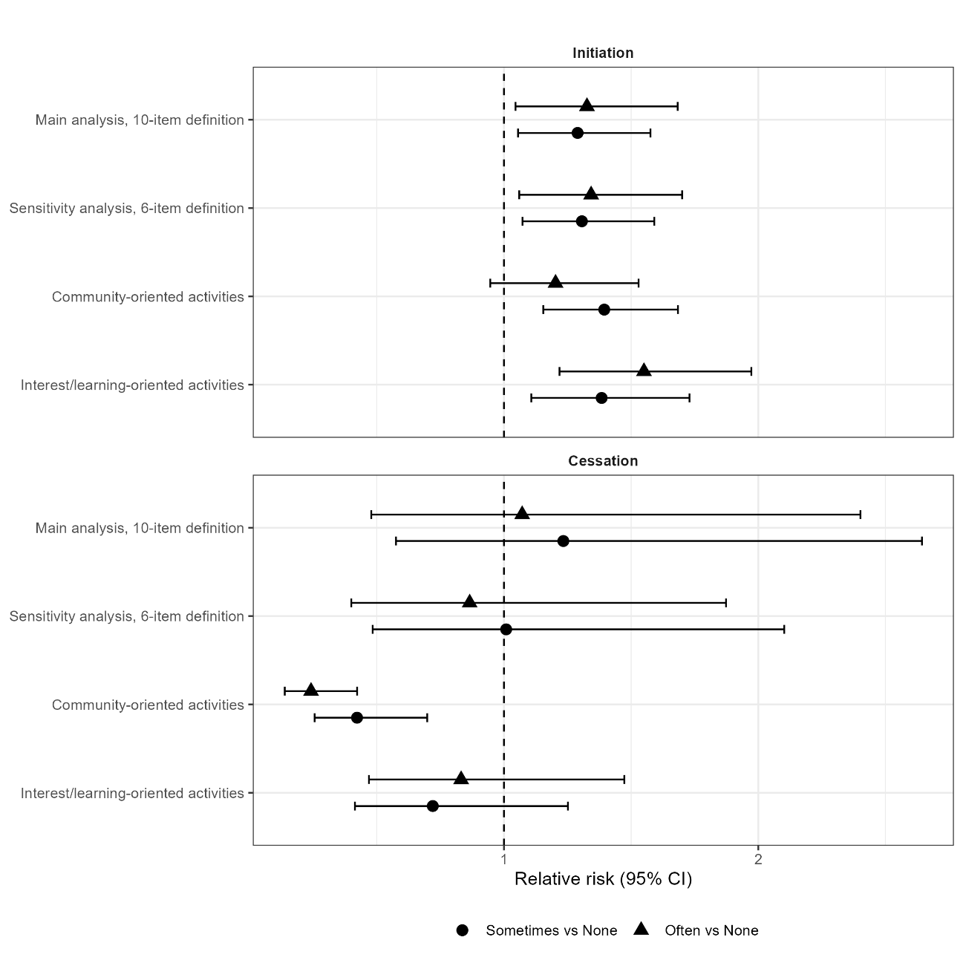
Supplementary Figure 1. Associations of neighborhood interaction at age 65 with social participation outcomes.
Relative risks and 95% confidence intervals (CIs) for neighborhood interaction at age 65 are shown. Estimates were obtained from fully adjusted modified Poisson regression models with robust standard errors after multiple imputation. The fully adjusted models included sex, entry year, body mass index category, smoking status, drinking status, educational attainment, marital status, living arrangement, work status, walking time, exercise frequency, competence in daily living, depressive symptoms, hypertension, diabetes mellitus, and cardiovascular disease. Circles represent Sometimes vs None, and triangles represent Often vs None.

