Supplementary Figures

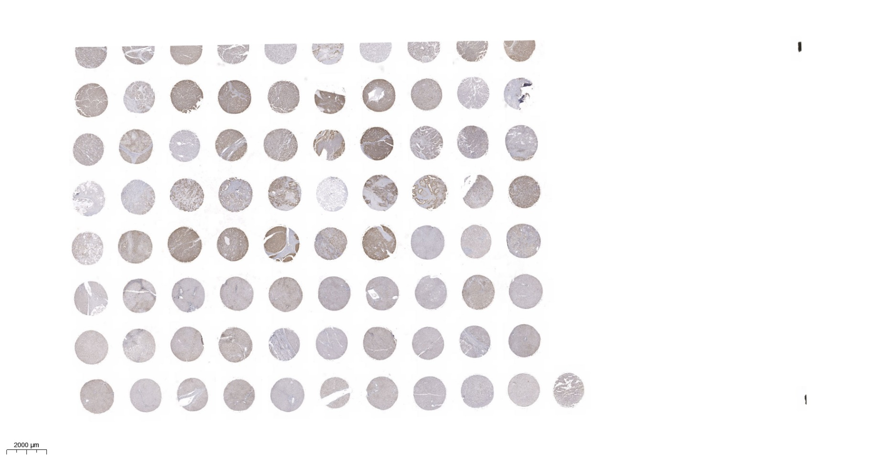
2000µm
Figure S1. Immunohistochemical analysis of YBX1 expression in a tissue microarray (TMA). Shown is the complete TMA image (LV8011a) probed with anti-YBX1 antibody. Each circular core represents an individual tissue specimen processed via immunohistochemistry to evaluate YBX1 protein localization and intensity. Variability in staining intensity reflects differential YBX1 expression across samples. Scale bar = 2000 µm.

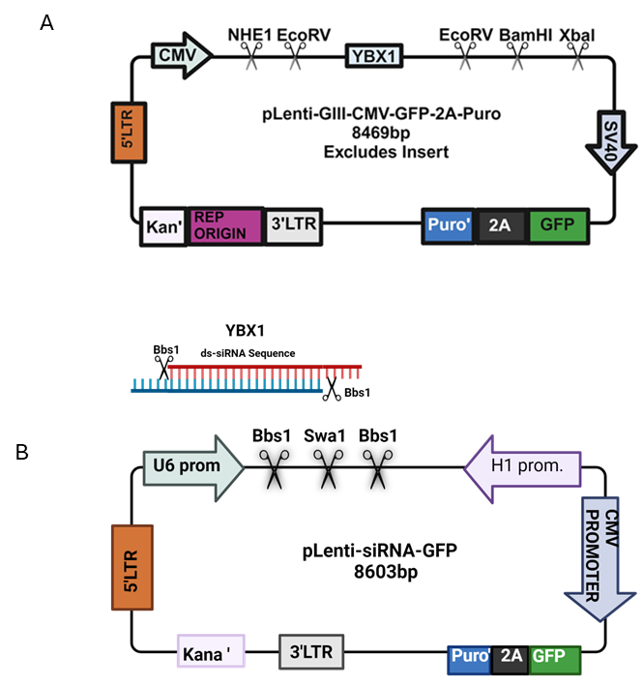
Figure S2. Plasmid maps for YBX1 overexpression and knockdown cell lines.
A) Schematic of the lentiviral vector pLenti-GIII-CMV-GFP-2A-Puro used for YBX1 overexpression. The YBX1 coding sequence is cloned downstream of the CMV promoter, enabling constitutive expression. The vector also includes a GFP reporter (tagged) and a puromycin resistance cassette linked by a 2A peptide for selection and tracking.
B) Map of the pLenti-siRNA-GFP vector used for stable knockdown of YBX1 via expression of YBX1-targeting short hairpin RNAs (shRNAs) under the U6 and H1 promoters. Four independent siRNA constructs targeting YBX1 were used. Both vectors include puromycin resistance and GFP for dual selection and visualization.

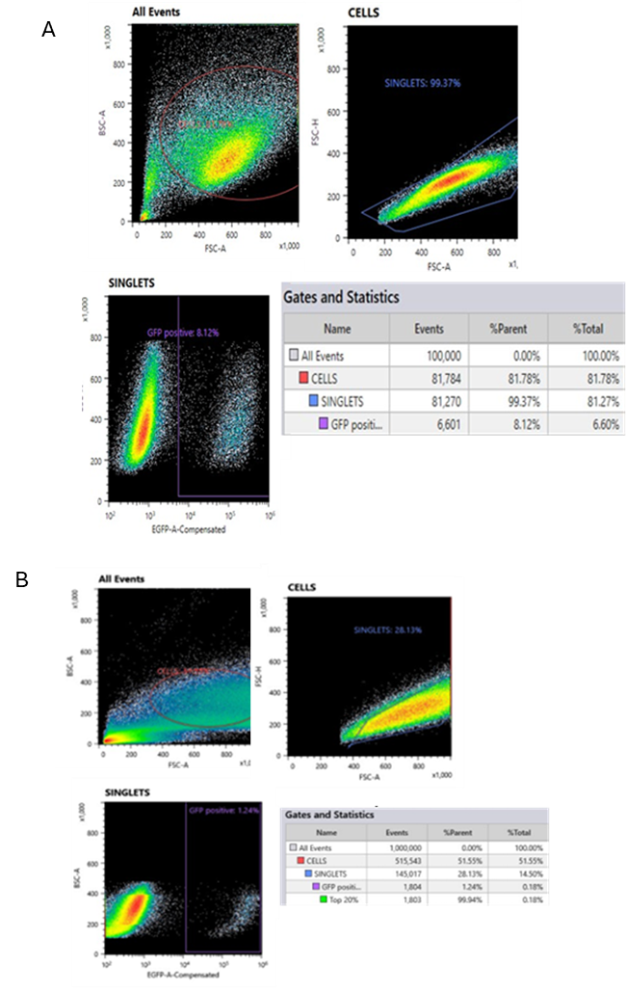
Figure S3. Fluorescence-activated cell sorting analysis to enrich GFP-positive stable cell lines.
A) FACS plots showing the gating strategy and quantification for YBX1-overexpressing cell lines. Cells were first gated on FSC-A vs. BSC-A to identify viable cells, then on singlets, and finally on GFP-positive cells. Approximately 8.12% of total events were GFP-positive, indicating successful transduction and puromycin selection.
B) FACS plots for YBX1 knockdown cell lines. A similar gating strategy was used, yielding 1.24% GFP-positive cells initially. The top 20% of GFP-positive cells (0.81% of total events) were further enriched to establish a stable knockdown population.

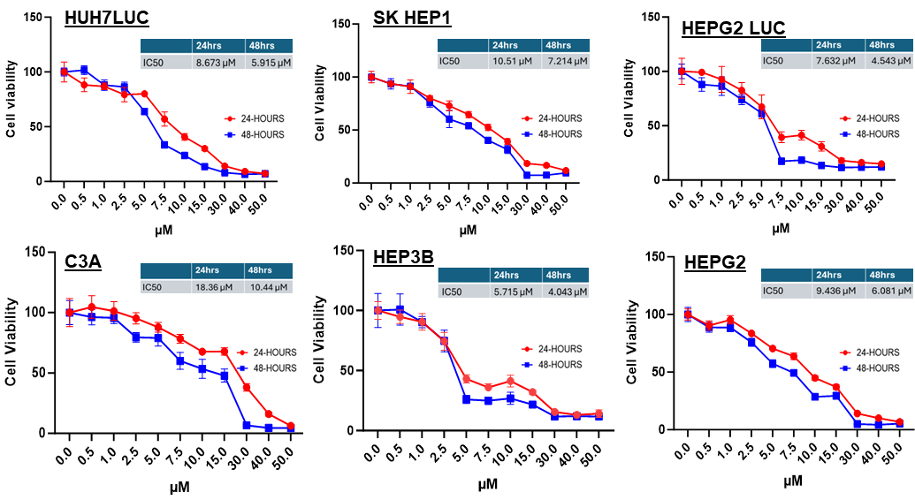
Figure S4. IC50 of different HCC cell lines. Graphs represent cell viability (%) in response to increasing concentrations of sorafenib (0–50 μM) in six different HCC cell lines: HUH7LUC, SK HEP1, HEPG2 LUC, C3A, HEP3B, and HEPG2. Cells were treated for 24 hours (red circles) and 48 hours (blue squares), and viability was assessed using the MTT assay. IC₅₀ values were calculated by nonlinear regression from the dose-response curves and are shown in the inset tables. Data are shown as the mean ± SE. The comparison between the two groups was performed using an unpaired t-test (*p < 0.05; ** p < 0.01; *** p < 0.001; **** p < 0.0001).

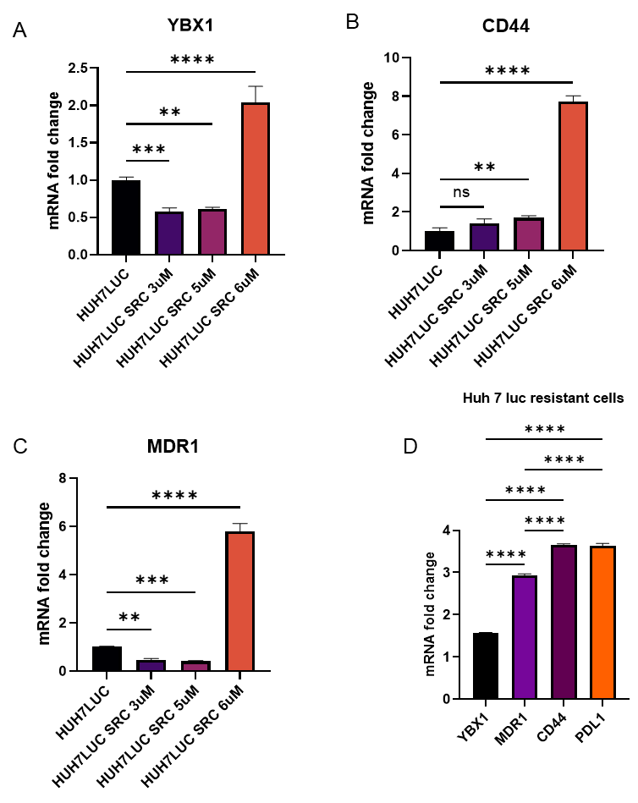
Figure S5. Molecular characterization of a developed sorafenib-resistant Huh7Luc cell line. The Huh7Luc cell line was gradually exposed to increasing concentrations of sorafenib to establish a sorafenib-resistant (SRC) model. Relative mRNA expression levels were measured by quantitative RT-PCR at different treatment concentrations.
(A) YBX1, (B) CD44, (C) MDR1, and (D) the final resistant cells showing fold changes in YBX1, MDR1, CD44, and PD-L1. Progressive upregulation of YBX1, CD44, and MDR1 is observed with increasing drug concentration, and all markers are significantly elevated in the fully resistant Huh7Luc-SR cell line. Data are shown as the mean ± SE. The comparison between the two groups was performed using an unpaired t-test (*p < 0.05; ** p < 0.01; *** p < 0.001; **** p < 0.0001).

Supplementary Table S1: Antibodies used in the study

YBX1 | Cell signaling technology | 8480s
MDR1 | Cell signaling technology | 13342s
PDL1 | Cell signaling technology | 29122s
CD44 | Cell signaling technology | 3570s
YBX1 | Abcam | ab15580

Supplementary Table S2: RT-PCR Primers used in this study

Beta actin F | 5’-GCA TGG GTC AGA AGG ATT CC-3’
Beta actin R | 5’-AGG ATG CTG CTC TTG CTC TG-3’
YBX1 F | 5’-CCC CAG GAA GTA CCT TCG C-3’
YBX1 R | 5’- AGC GTC TAT AAT GGT TAC GGT CT-3’
MDR1 F | 5’- GGG AGCC TTA ACA CCC GAC TTA-3’
MDR1 R | 5’- GCC AAA ATC ACA AGG GTT AGC TT-3’
PDL1 F | 5’- CCC AGC GAT CCC AAG ATA CAA-3’
PDL1 R | 5’-GAC AGC CGG AGA GAT ACG TCT-3’
CD44 F | 5’-CTC CCG CTT TGC AGG TGT A-3’
CD44 R | 5’-CAT TGT GGG CAA GGT GCT ATT-3’

Supplementary Table S3: siRNA used to Knockdown YBX1

YBX1-1 | AGGCAGCAAATGTTACAGGTCCTGGTGGT
YBX1-2 | CCAGTTCAAGGCAGTAAATATGCAGCAGA
YBX1-3 | AACCCTCCTGTGCAGGGAGAAGTGATGGA
YBX1-4 | AGAGAGGACGGCAATGAAGAAGATAAAGA
Scramble | CGCAAATGGGCGGTAGGCGTG

