Extended Data Figures

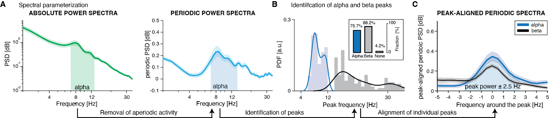

Extended Data Fig. 1 | Spectral parameterization identifies prominent alpha activity in VC/VS recordings at the first recording session S1. A, Bootstrapped average (thick line, 10,000 iterations) and 95% confidence interval (shaded area) of absolute power spectral density (PSD, green) in the 2–35 Hz range (log–log scale). The alpha frequency range (7–14 Hz) is highlighted (N = 144 bipolar pairs across 24 hemispheres from 13 patients). B, Same as in A for periodic PSD (cyan) after removal of the aperiodic component. C, The plot shows the distribution of oscillatory peaks identified by FOOOF (alpha, blue; beta, gray). C, Same as in A for periodic PSD aligned to the individual alpha (blue) and beta (gray) peak (−5 to +5 Hz window). Peak periodic power was averaged within a ± 2.5-Hz window around the individual alpha peak.

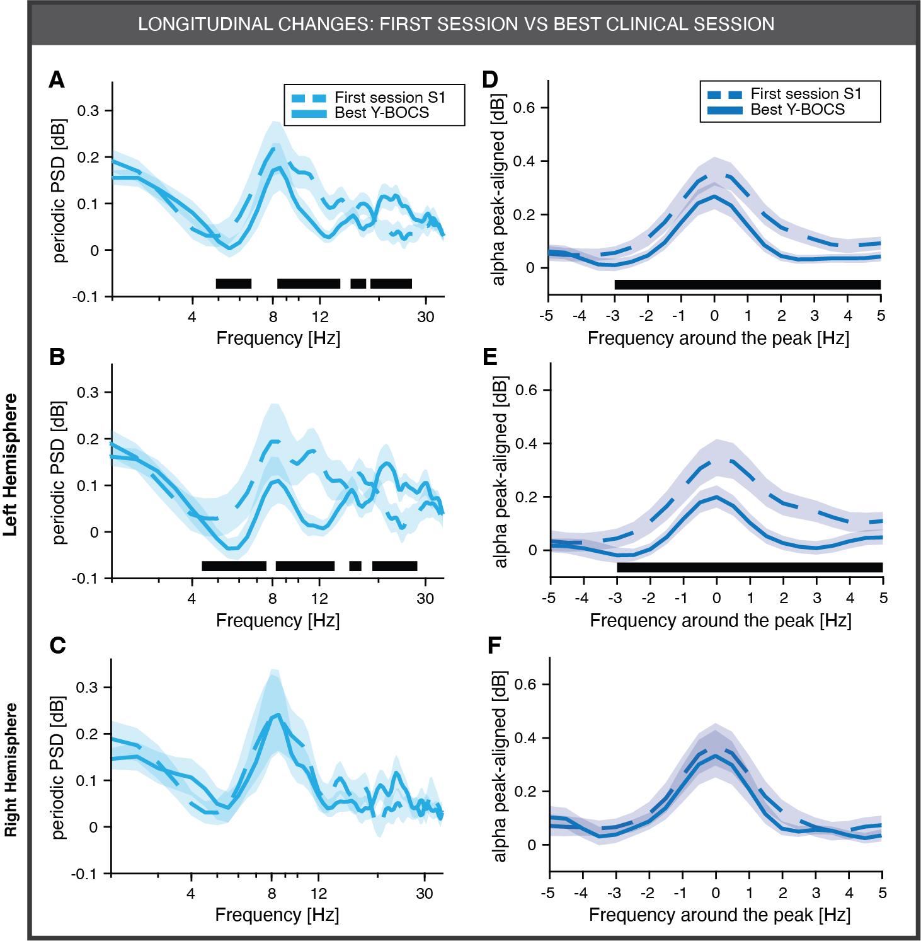

Extended Data Fig. 2 | Periodic alpha power is suppressed when the OCD patient yields the maximal DBS benefit. A, Bootstrapped average (thick line) and 95% confidence interval (shaded area) of periodic power spectral density (PSD, cyan) in the 2–35 Hz range (log–log scale), split by session (dashed line, first recording session S1; solid line, session with best clinical improvement; N = 582 bipolar channel pairs across 24 hemispheres from 12 patients). Statistical significance was tested with a cluster-based permutation test for paired data (10,000 permutations: black line, α = 0.01). B-C, Same analysis restricted to left (B) and right (C) hemispheres. D-F, Same analyses as in A-C for periodic PSD aligned to the individual alpha peak (−5 to +5 Hz window). Statistical significance is summarized with asterisks (*P < 0.05, **P < 0.01, ***P < 0.001).

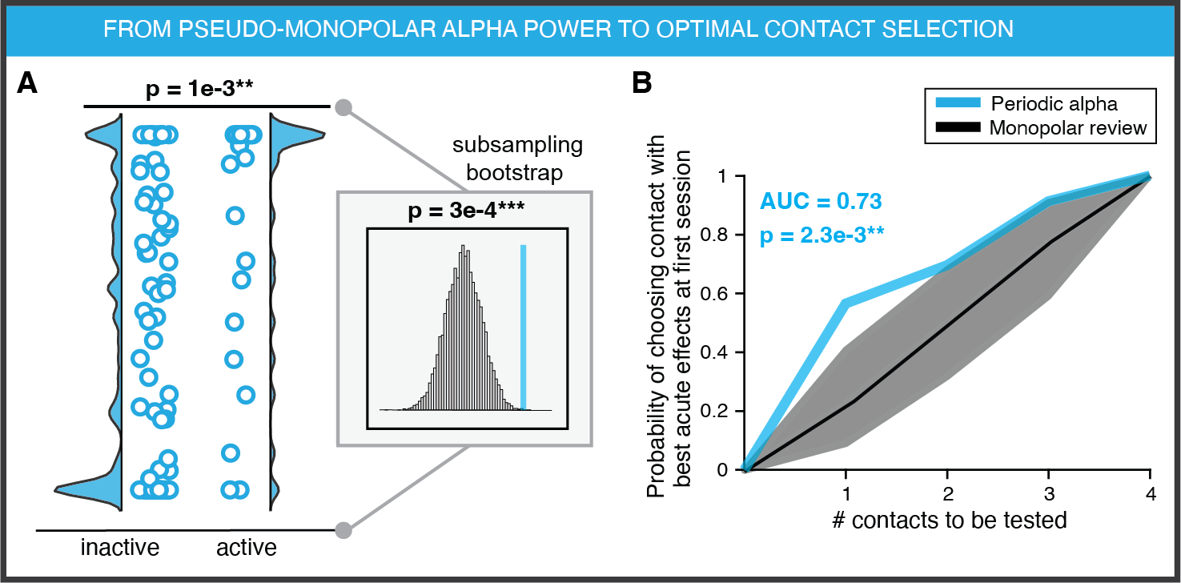
Extended Data Fig. 3 | Periodic alpha power identifies optimal stimulation contacts despite the choice of the alpha frequency band. A, Distribution of periodic alpha power (cyan) in inactive versus active contacts, defined as those chosen for stimulation during the first programming session (largely overlapping with the first recording session, S1). Periodic alpha power was quantified in the canonical alpha frequency band (7 - 14. Each circle represents a contact. Inset shows comparison of alpha power in active contacts (vertical line) against a sample-balanced distribution of inactive contacts generated by subsampling (10,000 iterations) (N = 96 contacts across 24 hemispheres from 13 patients). B, Cumulative probability of selecting the clinically optimal stimulation contact based on the highest alpha power rank across contacts within each hemisphere. Dashed line and gray shaded area indicate prediction accuracy of the monopolar contact review with 95% confidence interval. Prediction capability was quantified as area under the curve (AUC; chance = 0.5, perfect prediction = 1) and tested against the manual mapping distribution. P values are summarized by asterisks (*P < 0.05, **P < 0.01, ***P < 0.001).

