Supplementary Information
Pallidal alpha activity is an electrophysiological biomarker of symptoms severity in obsessive-compulsive disorder
by Vissani et al.

Supplementary Notes

Supplementary Tables
Supplementary Table 1. Demographic and clinical details of the OCD cohort of patients
Supplementary Table 2. DBS lead models and stimulation settings
Supplementary Table 3. Correlation between alpha power and Y-BOCS at the first recording session S1
Supplementary Table 4. Longitudinal correlation between changes of Y-BOCS and alpha power with respect to the first programming session S1
Supplementary Table 5. Longitudinal relationship between alpha power and Y-BOCS scores across recording sessions using linear mixed-models
Supplementary Table 6. Anatomical mapping of alpha activity

Supplementary Figures
Supplementary Figure 1. Heterogeneous clinical trajectories during DBS treatment
Supplementary Figure 2. Impedance (kΩ) of deep brain stimulation leads over time
Supplementary Figure 3. Goodness of fit of specparam (a.k.a. FOOOF) model for all recordings across all sessions
Supplementary Figure 4. Alpha peaks are more prevalent in the right hemisphere at the first recording session S1
Supplementary Figure 5. Robust correlation between periodic alpha power with OCD symptoms severity regardless frequency band definition and bipolar channel pair selection
Supplementary Figure 6. Absolute alpha power correlates with symptom severity in OCD patients
Supplementary Figure 7. Robust correlation between absolute alpha power with OCD symptoms severity regardless frequency band definition and bipolar channel pair selection
Supplementary Figure 8. Changes in the aperiodic activity explain the broadband low-frequency increase in absolute power in the more severe OCD patients
Supplementary Figure 9. Normalization of absolute spectra spills effects observed in the alpha band to the beta band
Supplementary Figure 10. Inter-hemispheric asymmetry of DBS leads placement
Supplementary Figure 11. Absolute beta power increases when the OCD patient yields the maximal DBS benefit
Supplementary Figure 12. No difference in relative power when the OCD patient yields the maximal DBS benefit
Supplementary Figure 13. Pseudo-monopolar alpha power enables anatomical mapping and optimal contact identification
Supplementary Figure 14. Absolute alpha power does not identify optimal stimulation contacts.
Supplementary Figure 15. Relative alpha power similarly to periodic alpha power identifies optimal stimulation contacts
Supplementary Figure 16. Spatial analysis for absolute alpha power
Supplementary Figure 17. Spatial analysis for relative alpha power.

Supplementary Notes
To maintain comparability with prior literature, we repeated all analyses using absolute and relative power spectra and discussed here in the Supplementary Information.

Caveats when interpreting absolute power spectra
While absolute power spectra retain interpretability by keeping the unit of measure (e.g., ${μV^{2}}/{Hz}$) of the recorded signal, they are affected from factors such as changes in electrode impedance or recording conditions that can introduce scaling effects. Moreover, absolute power spectra conflate changes in oscillatory activity with changes in the aperiodic activity of the spectrum. Variations in the aperiodic offset or slope can produce broadband shifts in spectral power, leading to apparent increases or decreases within conventional frequency bands even in the absence of changes in the underlying oscillatory activity.

Caveats when interpreting relative power spectra
Previous studies investigating electrophysiological biomarkers in other DBS cohorts and targets have primarily relied on relative power spectra, typically obtained by normalizing absolute power by the total power within a broad frequency range (e.g., 5–95 Hz) ^{1–3}. This normalization aims to mitigate broadband scaling effects in the absolute power spectrum, however, can introduce interdependencies between power changes across frequency bands, thereby complicating the interpretation of spectral shifts and their correlations with clinical variables. For instance, an increase in low-frequency absolute power would result in both a genuine increase in low-frequency relative power and an artifactual decrease in relative high-frequency power due to the shared normalization denominator. Consequently, the apparent suppression of higher-frequency activity may not reflect a true physiological change but rather a mathematical consequence of how relative power is computed. These dependencies underscore the importance of interpreting relative power spectra with caution, particularly when examining relationships across frequency bands.

Low frequency absolute power correlates with OCD symptom severity but is driven by changes in aperiodic slope and offset (related to Figure 2).
Patients with more severe OCD showed increased low-frequency activity (2–12 Hz, P < 1e-4) in the absolute spectra (Supplementary Fig. 6A). To investigate this further, we correlated absolute power spectra with Y-BOCS scores in frequency bins. Absolute power in the 2–11.5 Hz range showed the strongest positive correlation with OCD severity (P < 1e-4), with a peak correlation of R = 0.71 at 5 Hz (Supplementary Fig. 6B). We next summarized these relationships at the hemisphere level by selecting one bipolar channel pair per hemisphere — either the pair with the highest alpha power or the mean across all pairs — and correlated alpha power with Y-BOCS scores. Correlations were computed for both the canonical alpha band and a ± 2.5 Hz window centered on the individual alpha peak (Supplementary Fig. 7 and Supplementary Table 3). Absolute alpha power correlated with Y-BOCS scores regardless of the channel-selection method in each hemisphere (maximum bipolar pair: R = 0.59 [0.25 – 0.80], P = 3.2e-3 in Supplementary Fig. 6C; mean across pairs: R = 0.50 [0.13 – 0.75], P = 1.22e-2). Correlations were stronger when alpha power was computed at the individual peak (maximum bipolar pair: R = 0.58 [0.23 – 0.80], P = 2.4e-3; mean across bipolar pairs: R = 0.56 [0.19 – 0.78], P = 5.09e-3). However, these effects coincided with systematic changes in the aperiodic component of the spectrum, with patients with more severe OCD showing a steeper aperiodic slope (P = 9e-4) and higher offset (P = 1.9e-3) (Supplementary Fig. 8A-B). Consistently, both aperiodic offset (R = 0.49, P = 1.4e-2) and exponent (R = 0.51, P = 1.16e-2) showed positive correlations with OCD symptom severity (Supplementary Fig. 8C). Together, these findings indicate that the low-frequency elevation observed in absolute spectra largely reflects changes in the aperiodic background rather than changes in isolated oscillatory activity.

Relative alpha power is suppressed in less severe OCD patients, but does not consistently correlate with OCD symptom severity across patients (related to Figure 2).
Similar to what was observed in the absolute and periodic power spectra, relative alpha power (5.5–12 Hz, P < 1e-4) remained elevated in patients with more severe OCD symptoms (Supplementary Figs. 9A). This increase in relative alpha power was accompanied by a reduction in relative beta power (12–30 Hz), which might either represent a genuine physiological effect or be driven by the normalization procedure applied to the power spectrum.
Despite the group-level differences in the alpha band between more and less severe OCD patients, no significant correlation was observed between relative alpha power and Y-BOCS scores (Supplementary Figs. 9B). Notably, relative power in the 13–35 Hz range showed the strongest negative correlation with OCD severity (P < 1e-4), with a peak correlation of R = -0.72 at 25–35 Hz. Relative alpha power did not significantly correlate with Y-BOCS scores regardless of the channel-selection method in each hemisphere (maximum bipolar pair: R = 0.22 [-0.20 – 0.58], P = 2.9e-1; mean across pairs: R = -0.03 [-0.43 – 0.38], P = 8.89e-1) (Supplementary Table 3). Correlation was slightly significant only when we used the relative peak alpha power computed at the individual peak, but not consistent across channel-selection methods (maximum bipolar pair: R = 0.44 [0.04 – 0.72], P = 3.44e-2; mean across bipolar pairs: R = 0.17 [-0.25 – 0.54], P = 4.27e-1). Overall, these results indicate that while relative alpha power differentiates more-severe from less-severe OCD patients at the group level, it does not consistently track OCD symptom severity across individuals. Moreover, the apparent reduction in relative beta power suggests that normalization-related interdependencies may obscure or redistribute genuine physiological effects across frequency bands.

Absolute and relative alpha power do not robustly rack the clinical state of the OCD patient
Across sessions, decreases in peak absolute alpha power were not significantly associated with improvements in OCD symptoms (Supplementary Table 4; all P > 0.06). When we used linear mixed-effect models (LME) to model the relationship between Y-BOCS and peak absolute alpha power, we found a significant hemisphere × alpha power interaction (maximum bipolar pair: F= 7.04, P = 9.58e-3, mean across pairs: F = 8.74, P = 4.16e-3). Running a simple LME in the left hemisphere confirmed a mild association between Y-BOCS and peak absolute alpha power (maximum bipolar pair: β = 0.67 ± 0.27 (Mean ± 95th CI), F = 5.91, P = 2.05e-2; mean across pairs: β = 1.16 ± 0.58, F = 3.95, P = 5.48e-2), which was not present in the right hemisphere (maximum bipolar pair: β = -0.14 ± 0.14, F = 0.92, P = 3.44e-1; mean across pairs: β = -0.3 ± 0.32, F = 0.91, P = 3.46e-1). Results were qualitative similar when using absolute alpha power in the canonical alpha frequency band (Supplementary Table 5). When we compared absolute power spectra between the first recording session (S1) and the session corresponding to the greatest DBS-induced clinical improvement, we observed a significant increase in absolute beta power (20–35 Hz) when patients experienced the maximal clinical benefit (P < 1e-4, Supplementary Fig. 11A). This effect was present in both hemispheres but was more prominent in the right hemisphere (Supplementary Fig. 11B-C).

Across sessions, decreases in peak relative alpha power were not significantly associated with improvements in OCD symptoms (Supplementary Table 4; all P > 0.07). We also observed an opposite trend between the two hemispheres, with a negative correlation in the left hemisphere (maximum bipolar pair: R = -0.57 [-0.79 – -0.26], P = 6e-4; mean across pairs: R = -0.31 [–0.66 – 0.14], P = 8.61e-1) and a positive trend in the right hemisphere (maximum bipolar pair: R = 0.09 [-0.32 – 0.49], P = 6.08e-1; mean across pairs: R = 0.2 [-0.24 – 0.59, P = 2.74e-1). LME analyses showed a significant hemisphere × alpha power interaction (maximum bipolar pair: F= 8.37, P = 5.06e-3, mean across pairs: F = 17.21, P = 9.24e-5). Running a simple LME in the left hemisphere confirmed a mild association between Y-BOCS and peak relative alpha power (maximum bipolar pair: β = 114.78 ± 51.4, F = 4.99, P = 3.17e-2; mean across pairs: β = 285.9 ± 78.9, F = 13.13, P = 9.16e-4), which was not present in the right hemisphere (maximum bipolar pair: β = -30.52 ± 25.49, F = 1.43, P = 2.39e-1; mean across pairs: β = -35.8 ± 29.68, F = 1.45, P = 2.36e-1). Results were qualitative similar when using relative alpha power in the canonical alpha frequency band (Supplementary Table 5). When we compared relative power spectra between the first recording session (S1) and the session corresponding to the greatest DBS-induced clinical improvement, we did not observe any significant different (Supplementary Fig. 12).

Relative alpha but no absolute alpha power identifies optimal stimulating contact
We examined whether absolute alpha power could explain therapeutic DBS settings, similarly to periodic alpha power (Supplementary Fig. 14). We did not find any significant result with no difference between alpha activity in active and inactive contacts (Supplementary Fig. 14A) and no predictive performance as to the optimal stimulation contact (AUC < 0.61, P > 0.34).

When we repeated all the analyses using relative alpha power, we found alpha activity at active contacts exceeded that at inactive contacts, whether computed in the canonical alpha band (P = 1.85 e-2) or in the ±2.5 Hz narrowband around the peak (P = 2.6e-3) (Supplementary Fig. 15A). These findings were robust to potential imbalances in sample size, as a sample-balanced bootstrapping procedure yielded similar results (inset plots in Supplementary Fig. 15A). The contact with the highest relative alpha power significantly outperformed the conventional manual review (chance level) in identifying the optimal stimulating contact (AUC = 0.71, P = 3.2e-3). The probability of selecting the optimal stimulating contact was 56.5% when using the first-ranked contact, which increased up to 69.6% when also including the second-ranked one (Supplementary Fig. 15B). Slightly worse performance was obtained when using the relative peak alpha power, with an AUC = 0.68 (P = 1.1e-2). The probability of selecting the optimal stimulating contact was 43.5% when using the first-ranked contact, which increased up to 65.2% when also including the second-ranked one (Supplementary Fig. 15B). Finally, we found that the alignment between electrophysiology-based and clinical-based choice of optimal contact for relative alpha power (rank difference = 0.87 [0.44 – 1.35], P = 1.8e-3) and peak relative alpha power (rank difference = 0.696 [0.348 – 1.087], P = 3e-4) was significantly lower than for conventional manual mapping.

Absolute and relative alpha power display inconsistent results as to spatial localization
The spatial centroid of recording sites exhibiting the top 5% of peak absolute and relative alpha power was located in the anterior portion of the GPe (MNI coordinates: X = –10.12, Y = 4.07, Z = –4 mm; Supplementary Fig. 16, Supplementary Fig. 17 and Supplementary Table 6). When assessing spatial focality using the distance to the spatial maximum, peak absolute alpha power showed a significant correlation with Euclidean distance (R = 0.34 [0.15–0.50], P = 1e-3), whereas peak relative alpha power did not (R = 0.13 [–0.07 – 0.33], P = 1.88e-2). Conversely, when spatial focality was quantified using the moment of inertia, peak relative alpha power exhibited a significantly more focal spatial distribution than expected from a uniform distribution (I = 23.63 mm², √I = 4.86 mm, P = 1e-3), whereas peak absolute alpha power did not (I = 19.55 mm², √I = 4.42 mm, P = 1.17e-2).

We next examined the relationship between alpha activity and the distance to anatomical borders within the VC/VS region. Both peak absolute alpha power (R = 0.32 [0.12–0.49], P = 1.8e-3) and peak relative alpha power (R = 0.37 [0.18 – 0.53], P = 8e-4) showed significant correlations with the distance to the GPe border, indicating higher alpha activity at recording sites located closer to the GPe. A weaker opposite trend was observed with the BNST border, reaching significance only for peak relative alpha power (R = –0.20 [–0.39 – 0], P = 4.56e-2). Comparable results were obtained when relative alpha power was computed by averaging the relative power spectrum across the canonical alpha band (Supplementary Table 6).

Anatomical consideration on the left hemisphere dominance of neural-symptom severity correlations

One consistent theme in our findings is pronounced left-hemispheric dominance of alpha–symptom relationships. In the left hemisphere, electrode contacts were positioned significantly more posteriorly (mean ± s.e.m., ΔY = 0.6 mm ± 0.5 mm, P = 1e-4 and laterally (ΔX = 1.2 mm ± 0.6 mm, P = 1e-4) compared to the right hemisphere. This resulted in placements that were closer to the GPe border (Δ distance to GPe = 1.47 mm ± 1.0 mm, P = 2.58e-2) and further from the BNST border (Δ distance = 2.10 mm ± 0.9 mm, P = 2.7e-2) (Supplementary Fig. 18). Alpha peaks occurred more frequently in the right hemisphere (83.3%) than in the left (68.0%; P = 2.5e-3), whereas beta peaks were similarly distributed across hemispheres (left: 86.1% vs. right: 90.3%; P = 2.95e-1).

Supplementary Tables
Supplementary Table 1 | Demographic and clinical details of the OCD cohort of patients.
Patient ID | Age at surgery [years] | Sex | OCD age onset [years] | OCD duration [years] | Primary OCD theme | Days of implant [days] | Clinic visits with Y-BOCS (and Percept data) [#] | Days of clinic visits with Percept data after DBS therapy onset [days] | Pre-surgery Y-BOCS | Y-BOCS at first Percept recording session | Y-BOCS at last Percept recording session | YBOCS improvement at last Percept recording session [%]
OP01 | 53 | F | 11 | 42 | Harm to others | 419 | 8 (5) | S1: -20  S5: 330 | 36 | 35 | 21 | 41.7
OP02 | 22 | M | 10 | 12 | Counting | 763 | 13 (4) | S1: 232  S4: 618 days | 27 | 37 | 29 | -7.4
OP03 | 21 | F | 11 | 12 | Urge to ingest | 1448 | 28 (6) | S1: 113  S6: 1294 | 36 | 29 | 21 | 41.7
OP04 | 36 | M | 20 | 26 | Contamination | 1399 | 11 (4) | S1*: -5  S4: 1191 | 33 | 33 | 31 | 6.1
OP05 | 23 | F | 10 | 13 | Scrupulosity | 520 | 14 (3) | S1: 0  S3: 252 | 30 | 17 | 17 | 43.3
OP06 | 45 | F | 15 | 30 | Health anxiety | 1563 | 19 (6) | S1: 0  S6: 1464 | 30 | 15 | 15 | 50
OP07 | 31 | F | 18 | 23 | Contamination | 1497 | 16 (5) | S1**: 441  S5: 1123 | 35 | 30 | 37 | -5.7
OP08 | 26 | F | 15 | 23 | Checking/rechecking | 397 | 3 (3) | S1: -4  S3: 6 | 27 | 25 | 19 | 29.6
OP09 | 24 | F | 18 | 6 | Self-harm | 475 | 4 (4) | S1: -14  S4: 126 | 36 | 34 | 24 | 33.3
OP10 | 28 | F | 11 | 17 | Hypersexuality | 328 | 4 (3) | S1: 0  S3: 97 | 35 | 32 | 11 | 68.6
OP11 | 60 | F | 11 | 49 | Scrupulosity | 349 | 5 (3) | S1: 0  S3: 119 | 30 | 30 | 28 | 6.7
OP12 | 33 | M | 12 | 21 | Checking/rechecking | 744 | 11 (6) | S1: 0  S6: 504 | 31 | 33 | 8 | 74.2
OP13 | 58 | M | 17 | 56 | Counting | 153 | 2 (1) | S1: 77 | 28 | 2 | 2 | 92.9
 | 35.3 ± 14.0 | 9F/ 4M | 13.8 ± 3.6 | 25.4 ± 15.2 |  | 773 ± 515 | 11 ± 8 (4 ± 1) |  | 31.8± 3.5 | 27.1± 10 | 20.2 ± 9.8 | 36.5 ± 30.9
*Only the left hemisphere was included for analyses in the first recording session S1.
**Only the right hemisphere was included for analyses in the first recording session S1

Supplementary Table 2 | DBS lead models and stimulation settings.
 |  | Lead model |  | First stimulation settings (monopolar review) |  | Last stimulation settings
Patient ID | IPG | Left Hemisphere | Right Hemisphere | Left Hemisphere | Right Hemisphere | Left Hemisphere | Right Hemisphere
OP01 | Percept RC | Medtronic SenSight B33015 | Medtronic SenSight B33015 | E2-C+: 5 mA, 90 uS, 125 Hz | E1-C+: 5 mA, 150 uS, 125 Hz | E2-C+: 5.5 mA, 90 uS, 125 Hz | E1-C+: 5.5 mA, 150 uS, 125 Hz
OP02 | Percept RC | Medtronic SenSight B33015 | Medtronic SenSight B33015 | E2-C+: 6 mA, 150 uS, 125 Hz | E1-C+: 4 mA, 90 uS, 125 Hz | E1-C+: 5 mA, 150 uS, 125 Hz | E1-C+: 5 mA, 90 uS, 125 Hz
OP03 | Percept PC | Medtronic 3387 | Medtronic 3387 | E2-C+: 4.5 mA, 60 uS, 130 Hz | E2-C+: 3.4 mA, 80 uS, 130 Hz | E1-C+: 3 mA, 60 uS, 130 Hz | E1-C+: 3 mA, 60 uS, 130 Hz
OP04* | Percept PC | Medtronic 3387 | Medtronic 3387 | E1-C+: 3 mA, 210 uS, 130 Hz  E2-C+: 3 mA, 210 uS, 130 Hz |  | E2-C+: 5.7 mA, 40 uS, 130 Hz | E2-C+: 2.5 mA, 40 uS, 130 Hz  E1-C+: 2.5 mA, 40 uS, 130 Hz
OP05 | Percept RC | Medtronic SenSight B33015 | Medtronic SenSight B33015 | E1-C+: 5 mA, 150 uS, 125 Hz | E1-C+: 5 mA, 150 uS, 125 Hz | E1-C+: 7 mA, 150 uS, 125 Hz | E1-C+: 7 mA, 150 uS, 125 Hz
OP06 | Percept RC | Medtronic 3387 | Medtronic 3387 | E1-C+: 4 mA, 150 uS, 130 Hz | E1-C+: 4 mA, 90 uS, 130 Hz | E1-C+: 6.5 mA, 130 uS, 130 Hz | E1-C+: 8 mA, 120 uS, 130 Hz
OP07† | Percept PC | Medtronic 3387 | Medtronic 3387 |  | E1-C+: 3 mA, 90 uS, 125 Hz | E0-C+: 6 mA, 150 uS, 125 Hz | E0-C+: 6 mA, 90 uS, 125 Hz
OP08† | Percept RC | Medtronic SenSight B33015 | Medtronic SenSight B33015 | E2-C+: 5 mA, 90 uS, 125 Hz | E2-C+: 5 mA, 90 uS, 125 Hz | E2-C+: 5 mA, 90 uS, 125 Hz | E2-C+: 5 mA, 150 uS, 125 Hz
OP09 | Percept PC | Medtronic SenSight B33015 | Medtronic SenSight B33015 | E3-C+: 6 mA, 90 uS, 130 Hz | E0-C+: 6 mA, 150 uS, 130 Hz | E3-C+: 6 mA, 90 uS, 130 Hz | E0-C+: 6 mA, 150 uS, 130 Hz
OP10 | Percept RC | Medtronic SenSight B33015 | Medtronic SenSight B33015 | E1-C+: OFF | E1-C+: 4.5 mA, 90 uS, 125 Hz | E1-C+: OFF | E1-C+: 4.5 mA, 90 uS, 125 Hz
OP11† | Percept RC | Medtronic SenSight B33015 | Medtronic SenSight B33015 | E3-C+: 6 mA, 90 uS, 125 Hz | E0-C+: 6 mA, 90 uS, 130 Hz | E1-C+: 6 mA, 150 uS, 125 Hz | E1-C+: 7 mA, 120 uS, 130 Hz
OP12 | Percept RC | Medtronic SenSight B33015 | Medtronic 3387 | E2-C+: 5 mA, 150 uS, 125 Hz | E2-C+: 5 mA, 90 uS, 125 Hz | E2-C+: 7 mA, 150 uS, 125 Hz | E1-C+: 5 mA, 90 uS, 125 Hz
OP13* | Percept RC | Medtronic SenSight B33015 | Medtronic SenSight B33015 | E2-C+: 3.6 mA, 150 uS, 135 Hz  E1-C+: 3.6 mA, 150 uS, 135 Hz | E1-C+: 5.8 mA, 90 uS, 125 Hz | E2-C+: 3.6 mA, 150 uS, 135 Hz  E1-C+: 3.6 mA, 150 uS, 135 Hz | E1-C+: 5.8 mA, 90 uS, 125 Hz

*These patients were initially implanted with the legacy ActivaTM PC system before being upgraded to the PerceptTM device. The DBS onset time refers to the onset of stimulation with the Percept device.
†These patients had previously undergone other neurosurgical procedures, such as cingulotomy or subcaudate tractotomy, prior to DBS implantation.

Supplementary Table 3 | Correlation between alpha power and Y-BOCS at the first recording session S1
 |  | Max bipolar pair |  | Mean of bipolar pairs
Model | Hemisphere | R [95th CI] | p | R [95th CI] | p
Y-BOCS ~ 1 + absolute alpha | Both* | 0.59 [0.25 0.80] | 3.2e-3** | 0.5 [0.13 0.75] | 1.22e-2*
Y-BOCS ~ 1 + absolute alpha | Left | 0.65 [0.13 0.89] | 2.19e-1 | 0.57 [-4.42e-3 0.86] | 5.66e-2
Y-BOCS ~ 1 + absolute alpha | Right | 0.52 [-7.42e-2 0.84] | 8.37e-2 | 0.45 [-0.16 0.81] | 1.38e-1
Y-BOCS ~ 1 + absolute peak alpha | Both* | 0.58 [0.23 0.80] | 2.4e-3** | 0.56 [0.19 0.78] | 5.09e-3**
Y-BOCS ~ 1 + absolute peak alpha | Left | 0.67 [0.16 0.90] | 2.14e-2 | 0.64 [0.10 0.89] | 2.94e-2*
Y-BOCS ~ 1 + absolute peak alpha | Right | 0.42 [-0.21 0.81] | 1.76e-1 | 0.42 [-0.19 0.80] | 1.62e-1
Y-BOCS ~ 1 + relative alpha | Both | 0.22 [-0.20 0.58] | 2.9e-1 | -0.03 [-0.43 0.38] | 8.89e-1
Y-BOCS ~ 1 + relative alpha | Left | 0.44 [-0.18 0.81] | 1.51e-1 | 0.05 [-0.54 0.61] | 8.77e-1
Y-BOCS ~ 1 + relative alpha | Right | 0.03 [-0.55 0.59] | 9.21e-1 | -0.04 [-0.60 0.55] | 8.99e-1
Y-BOCS ~ 1 + relative peak alpha | Both | 0.44 [0.04 0.72] | 3.44e-2* | 0.17 [-0.25 0.54] | 4.27e-1
Y-BOCS ~ 1 + relative peak alpha | Left | 0.73 [0.26 0.92] | 1e-2** | 0.39 [-0.24 0.79] | 2.18e-1
Y-BOCS ~ 1 + relative peak alpha | Right | -0.05 [-0.61 0.54] | 8.64e-1 | -0.06 [-0.61 0.53] | 8.46e-1
Y-BOCS ~ 1 + periodic alpha | Both | 0.70 [0.41 0.86] | 3.9e-4*** | 0.46 [0.07 0.73] | 2.59e-2*
Y-BOCS ~ 1 + periodic alpha | Left | 0.79 [0.41 0.94] | 1.69e-3** | 0.66 [0.45 0.15] | 1.93e-2*
Y-BOCS ~ 1 + periodic alpha | Right | 0.62 [0.07 0.88] | 3.48e-2* | 0.28 [-0.35 0.74] | 3.76e-1
Y-BOCS ~ 1 + periodic peak alpha | Both | 0.62 [0.28 0.82] | 1.3e-3*** | 0.51 [0.13 0.76] | 1.25e-2*
Y-BOCS ~ 1 + periodic peak alpha | Left | 0.75 [0.30 0.92] | 7.89e-3** | 0.49 [-0.11 0.83] | 1.06e-1
Y-BOCS ~ 1 + periodic peak alpha | Right | 0.53 [-0.06 0.85] | 8.37e-1 | 0.48 [-0.13 0.83] | 1.08e-1
R indicates the Spearman correlation coefficient using ranked data. P values are summarized by asterisks (*P < 0.05, **P < 0.01, ***P < 0.001). Significant results are in bold.

Supplementary Table 4 | Longitudinal correlation between changes of Y-BOCS and alpha power with respect to the first programming session S1

 |  | Max bipolar pair |  | Mean of bipolar pairs
Model | Hemisphere | R [95th CI] | p | R [95th CI] | p
Y-BOCS improvement [S1%] ~ 1 + absolute alpha change [S1ΔdB] | Both | -0.17 [-0.44 -0.17] | 1.71e-1 | -0.04 [-0.32 0.25] | 7.92e-1
Y-BOCS improvement [S1%] ~ 1 + absolute alpha change [S1ΔdB] | Left | -0.31 [-0.63 0.08] | 8.93e-1 | -0.11 [-0.48 0.3] | 5.33e-1
Y-BOCS improvement [S1%] ~ 1 + absolute alpha change [S1ΔdB] | Right | -0.001 [-0.41 0.39]] | 9.94e-1 | 0.11 [-0.3 0.5] | 5.37e-1
Y-BOCS improvement [S1%] ~ 1 + absolute peak alpha change [S1ΔdB] | Both | -0.22 [-0.48 -0.07] | 7.81e-2 | -0.15 [-0.43 0.14] | 2.53e-1
 | Left | -0.33 [-0.66 0.08] | 6.38-2 | -0.25 [-0.6 0.16] | 1.62e-1
 | Right | -0.05 [-0.48 0.37] | 7.79e-1 | 0.03 [-0.4 0.45] | 8.5e-1
Y-BOCS improvement [S1%] ~ 1 + relative alpha change [S1Δ] | Both | 0.01 [-0.26 0.29] | 9.34e-1 | 0.04 [-0.26 0.35] | 7.49e-1
Y-BOCS improvement [S1%] ~ 1 + relative alpha change [S1Δ] | Left | -0.38 [-0.66 -0.02] | 3.13e-1* | -0.23 [-0.59 0.21] | 1.98e-1
Y-BOCS improvement [S1%] ~ 1 + relative alpha change [S1Δ] | Right | 0.4 [0.020.72] | 2.4e-2* | 0.3 [-0.1 0.68] | 9.21e-2
Y-BOCS improvement [S1%] ~ 1 + relative peak alpha change [S1Δ] | Both | -0.22 [-0.48 0.06] | 7.66e-2 | -0.04 [-0.33 0.26] | 7.25e-1
 | Left | -0.57 [-0.79 -0.26] | 6e-4*** | -0.31 [-0.66 0.14] | 8.61e-2
 | Right | 0.09 [-0.32 0.49] | 6.08e-1 | 0.2 [-0.24 0.59] | 2.74e-1
Y-BOCS improvement [S1%] ~ 1 + periodic alpha change [S1ΔdB] | Both | -0.34 [-0.57 -0.07] | 6.05-3** | -0.15 [-0.42 0.14] | 2.53e-1
Y-BOCS improvement [S1%] ~ 1 + periodic alpha change [S1ΔdB] | Left | -0.50 [-0.74 -0.16] | 3.5e-3** | -0.39 [-0.68 -0.02] | 2.5e-2*
Y-BOCS improvement [S1%] ~ 1 + periodic alpha change [S1ΔdB] | Right | -0.15 [-0.54 0.25] | 4.02e-1 | 0.13 [-0.27 0.48] | 4.91e-1
Y-BOCS improvement [S1%] ~ 1 + periodic peak alpha change [S1ΔdB] | Both | -0.37 [-0.61 -0.09] | 2.9e-3** | -0.29 [-0.55 -0.01] | 1.77e-2*
 | Left | -0.51 [-0.76 -0.16] | 3.19e-3** | -0.42 [0.7 -0.05] | 1.8e-2*
 | Right | -0.17 [-0.58 0.25] | 3.55e-1 | -0.17 [-0.56 0.24] | 3.4e-1

R indicates the Spearman correlation coefficient using ranked data. A negative sign of R means that a negative change in the alpha power (suppression) is related to a positive change of Y-BOCS (improvement) with respect to S1, i.e., the first programming/recording session. P values are summarized by asterisks (*P < 0.05, **P < 0.01, ***P < 0.001). Significant results are in bold.

Supplementary Table 5 | Within-patient consistency of the relationship between alpha power and Y-BOCS scores across clinical visits using linear mixed-models.

 |  |  |  | Max bipolar pair |  |  | Mean of bipolar pairs
 | Model | Hemisphere | Term | β [SE] | F[df] | p | β [SE] | F[df] | p
absolute alpha | Interaction | Both | Hemisphere*alpha power | -0.14 [0.05] | 6.91 [1, 69.19] | 1.05e-2* | -0.22 [0.11] | 4.28 [1, 69.1] | 4.24e-2*
absolute alpha | Interaction | Both | alpha power | 0.13 [0.05] | 3.12 [1,73.53] | 8.13e-2 | 0.20 [0.11] | 1.59 [1, 74.42] | 2.11e-1
absolute alpha | Simple | Left | alpha power | 0.17 [0.07] | 6.25 [1, 34.18] | 1.74e-2* | 0.26 [0.13] | 3.81 [1, 34.94] | 5.92e-2
absolute alpha | Simple | Right | alpha power | -0.05 [0.05] | 1.61 [1, 33.86] | 2.12e-1 | -0.11 [0.09] | 1.28 [1, 35.09] | 2.65e-1
absolute peak alpha | Interaction | Both | Hemisphere*alpha power | -0.59 [0.23] | 7.04 [1, 69.37] | 9.85e-3** | 2.27 [0.6] | 8.74 [1, 74.48] | 4.16e-3**
absolute peak alpha | Interaction | Both | alpha power | 0.56 [0.23] | 3.53 [1, 72.54] | 6.42e-2 | 0.94 [0.47] | 2.08 [1. 72.92] | 1.54e-1
absolute peak alpha | Simple | Left | alpha power | 0.67 [0.27] | 5.91 [1, 33.9] | 2.05e-2** | 1.16 [0.58] | 3.95 [1, 34.21] | 5.48e-2
absolute peak alpha | Simple | Right | alpha power | -0.14 [0.14] | 0.92 [1, 33.54] | 3.44e-1 | -0.3 [0.32] | 0.91 [1, 33.97] | 3.46-1
relative alpha | Interaction | Both | Hemisphere*alpha power | -33.88 [10.45] | 10.5 [1,70.83] | 1.81e-3** | -61.63 [15.54] | 15.72 [1, 69.71] | 1.75e-4***
relative alpha | Interaction | Both | alpha power | 36.48 [11.99] | 05.57 [1,77.5] | 2.08e-2* | 59.32 [15.9] | 8.22 [1, 74.23] | 5.39e-3**
relative alpha | Simple | Left | alpha power | 44.64 [15.28] | 8.55 [1, 38.88] | 5.73e-3** | 69.89 [19.57] | 12.75 [1, 36.19] | 1.03e-3**
relative alpha | Simple | Right | alpha power | -7.09 [9.91] | 0.51 [1, 35.99] | 4.79e-1 | -9.79 [10.78] | 0.82 [1, 33.4] | 3.7e-1
relative peak alpha | Interaction | Both | Hemisphere*alpha power | -105.63 [36.51] | 8.37 [1, 70.76] | 5.06e-3** | -252.29 [60.81] | 17.21 [1, 70.15] | 9.24e-5***
relative peak alpha | Interaction | Both | alpha power | 103.09 [40.9] | 3.75 [1, 75.77] | 5.64e-2 | 249.24 [64.72] | 10.58 [1, 73.16] | 1.73e-3**
relative peak alpha | Simple | Left | alpha power | 114.78 [51.4] | 4.99 [1, 36.8] | 3.17e-2* | 285.9 [78.9] | 13.13 [1, 34.87] | 9.16e-4***
relative peak alpha | Simple | Right | alpha power | -30.52 [25.49] | 1.43 [1, 35.79] | 2.39e-1 | -35.8 [29.68] | 1.45 [1, 32.79] | 2.36e-1
periodic alpha | Interaction | Both | Hemisphere*alpha power | -2.08 [0.62] | 11.33 [1, 69.4] | 1.25e-3** | -3.05 [0.85] | 12.85 [1, 69.78] | 6.22e-4***
periodic alpha | Interaction | Both | alpha power | 2.27 [0.6] | 8.74 [1, 74.48] | 4.16e-3** | 3.28 [0.89] | 8.48 [1,75.73] | 4.71e-3**
periodic alpha | Simple | Left | alpha power | 3.024 [0.74] | 15.71 [1, 36.71] | 3.27e-4*** | 4.72 [1.13] | 17.59 [1, 37.21] | 1.62e-4***
periodic alpha | Simple | Right | alpha power | 0.05 [0.58] | 0.01 [1, 34.46] | 9.28e-1 | -0.29 [0.77] | 0.14 [1, 35.19] | 7.12e-1
periodic peak alpha | Interaction | Both | Hemisphere*alpha power | -13.04 [3.79] | 11.87 [1, 69.62] | 9.72e-4*** | -18.15 [5.22] | 12.11 [1,69.99] | 8.67e-4***
periodic peak alpha | Interaction | Both | alpha power | 12.97 [3.97] | 6.24 [1 74.63] | 1.47e-2* | 18.68 [5.73] | 6.65 [1, 75.33] | 1.19e-2*
periodic peak alpha | Simple | Left | alpha power | 16.48 [5.02] | 10.76 [1, 36.39] | 2.29e-3** | 23.57 [7.23] | 10.62 [1, 36.38] | 2.43e-3**
periodic peak alpha | Simple | Right | alpha power | -2.78 [3.48] | 0.64 [1, 35.98] | 4.29e-1 | -3.5 [4.27] | 0.67 [1, 35.93] | 4.17e-1
We run a model with an interaction term between the Hemisphere and the alpha power metric (Y-BOCS ~ Hemisphere*alpha power metric + stimulation amplitude + days after DBS onset + 1|ID) pooling data across hemispheres. We repeated the analysis with a simpler model (Y-BOCS ~ alpha power metric + stimulation amplitude + days after DBS onset + 1|ID) using only either the left or the right hemisphere. The coefficient β (SE: standard error), the F-statistic (df: degrees of freedom estimated using the Satterthwaite approximation) and p-values are reported for all terms involving the alpha power metric. ID indicates the patient. P values are summarized by asterisks (*P < 0.05, **P < 0.01, ***P < 0.001). Significant results are in bold.

Supplementary Table 6 | Anatomical mapping of alpha activity
 |  | absolute alpha | absolute peak alpha | relative alpha | relative peak alpha | periodic alpha | periodic peak alpha
Weighted center of mass [mm] | X | -9.16 | -10.58 | -10.75 | -10.66 | -10.47 | -10.55
Weighted center of mass [mm] | Y | 4.72 | 5.02 | 5.83 | 5.54 | 5.25 | 5.58
Weighted center of mass [mm] | Z | -4.28 | -3.09 | -2.47 | -2.68 | -2.79 | -2.65
Peak location [mm] | X | -10.12 | -10.12 | -10.49 | -10.12 | -11.37 | -10.12
Peak location [mm] | Y | 4.07 | 4.07 | 3.58 | 4.07 | 3.08 | 4.07
Peak location [mm] | Z | -4 | -4 | -4.12 | -4 | -3.77 | -4
Spatial focality [inertia] | $I$ [mm²] | 22.43 | 19.55 | 26.16 | 23.63 | 22.05 | 23.25
Spatial focality [inertia] | $√I$ [mm] | 4.74 | 4.42 | 5.11 | 4.86 | 4.7 | 4.82
Spatial focality [inertia] | P | 3.14e-1 | 1.17e-1 | 1e-2** | 1e-3** | 1e-3*** | 2e-3**
Spatial focality [distance to peak] | R | 0.32 [0.13 0.49] | 0.34 [0.15 0.50] | 0.12 [-0.08 0.31] | 0.13 [-0.07 0.33] | 0.37 [0.18 0.53] | 0.27 [0.08 0.45]
 | P | 2e-3*** | 1e-3*** | 2.56e-1 | 1.88e-1 | 1e-3*** | 7e-3**
Distance from GPe | R [95th CI] | 0.28 [0.08 0.45] | 0.32 [0.12 0.49] | 0.29 [0.09 0.46] | 0.37 [0.18 0.53] | 0.33 [0.14 0.5] | 0.32 [0.23 0.49]
Distance from GPe | p | 5.2e-3*** | 1.8e-3** | 4e-3** | 8e-4*** | 1.2e-3** | 1e-3***
Distance from BNST | R [95th CI] | -0.01 [-0.21 0.19] | -0.01 [-0.21 0.19] | -0.19 [-0.37 0.01] | -0.20 [-0.39 0] | 0.11 [-0.1 0.3] | 0.06 [-0.14 0.26]
Distance from BNST | p | 9.07e-1 | 9.18e-1 | 6.62e-2 | 4.56e-2* | 3.19e-1 | 5.26e-1
Distance from Nacc | R [95th CI] | 0.07 [-0.13 0.26] | 0.05 [-0.15 0.25] | -0.09 [-0.29 0.11] | -0.11 [-0.31 0.09] | 0.01 [-0.19 0.21] | < 0.01 [-0.2 0.2]
Distance from Nacc | p | 5.04e-1 | 6.31e-1 | 3.77e-1 | 2.73e-1 | 8.86e-1 | 9.91e-1
R indicates the Spearman correlation coefficient using ranked data. P values are summarized by asterisks (*P < 0.05, **P < 0.01, ***P < 0.001). Significant results are in bold.

Supplementary Figures

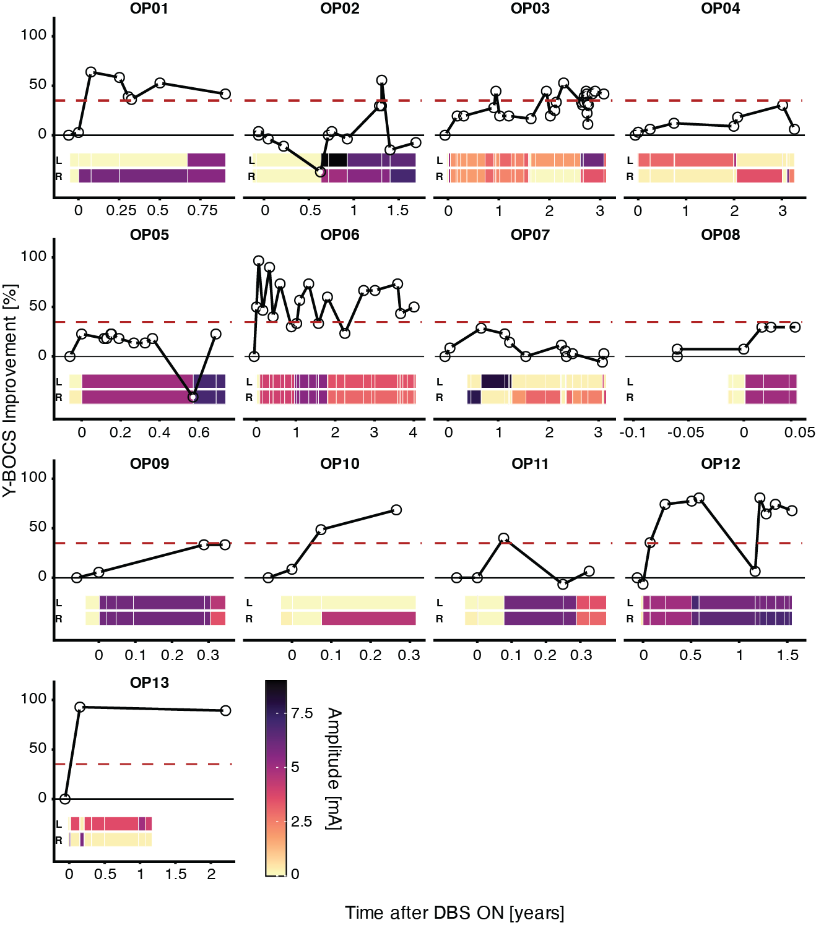

Figure S1 | Heterogeneous clinical trajectories during DBS treatment. Evolution of OCD symptom severity after DBS for each individual patient, quantified using Yale–Brown Obsessive Compulsive Scale (Y-BOCS) scores obtained at postoperative clinic visits. Clinical improvement is expressed as percent change relative to the preoperative baseline. Patients were considered responders when achieving >35% reduction in Y-BOCS score (red dashed line). The patch at the bottom displays stimulation amplitude (mA) over the course of DBS treatment for the left and right hemispheres. A linear mixed-effects model reveals a significant effect of time (F = 5.22, P = 2.4e-2).
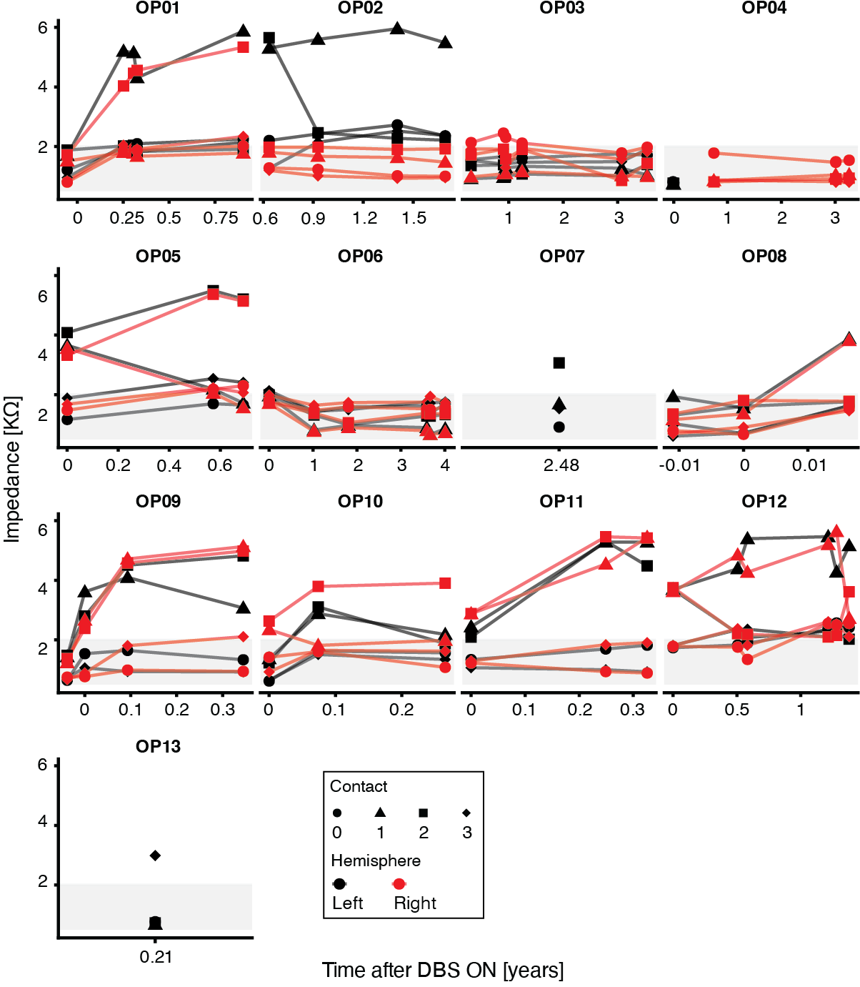

Figure S2 | Impedance (kΩ) of deep brain stimulation leads over time. Impedance values for each contact (E0: circle, E1: triangle, E2: inverted triangle, E3: diamond) are plotted versus time since deep brain stimulation onset (years) for the left (solid black line) and right (dashed black line) hemispheres. Impedance measurements were not necessarily obtained on the same days as neural recordings. The gray shaded region indicates the acceptable impedance range (0–2 kΩ). A linear mixed-effects model did not reveal a significant effect of time (F = 0.02, P = 8.97 × 10⁻¹).

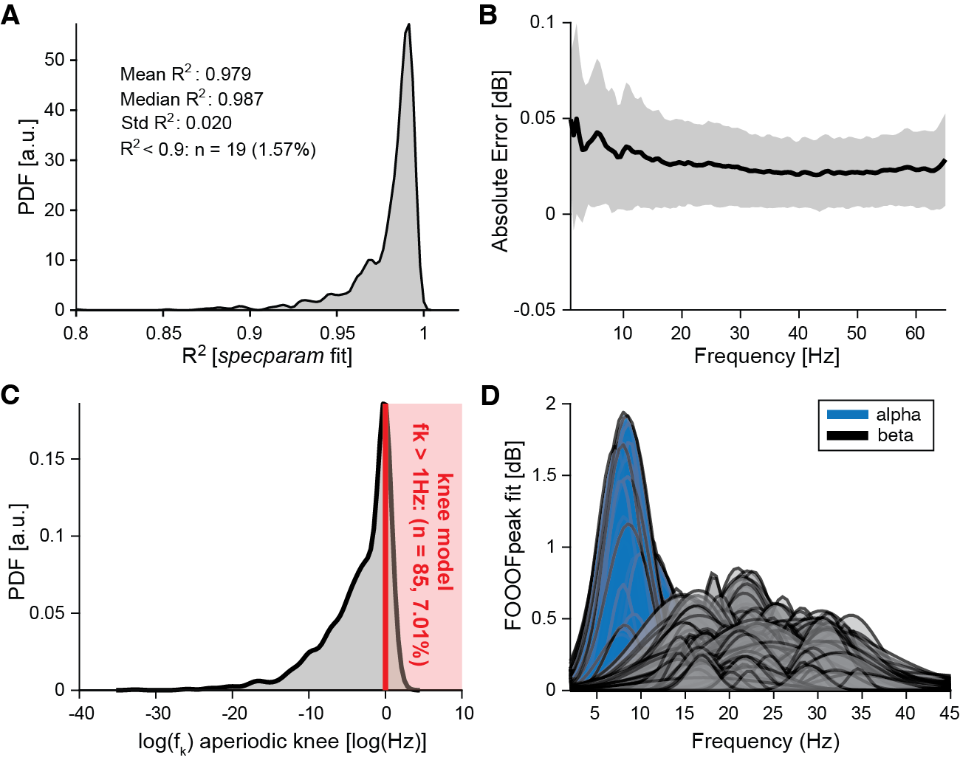

Figure S3 | Goodness of fit of specparam (a.k.a. FOOOF) model for all recordings across all sessions. A, Distribution of R² shows an overall good agreement between the data and the FOOOF model output. Only < 2% of model fits had a R² < 0.9. B, Diagnostic plot of the frequency-by-frequency absolute error of model fits. The lack of structure indicates no frequency-specific mismatch between the properties of the data and the model fits. The solid black line and the shaded gray area depicts the average and the standard deviation, respectively. C, Distribution of the logarithm (for visualization) of aperiodic knee frequency $f_{k}$. In only 7.01% of cases (red shaded region) the model adequately fits knee in the absolute power spectra by converging to $f_{k}< 1$or equivalently ${log(f}_{k})< 0$. D, Visualization of the periodic components fitted by the FOOOF model in the alpha (blue) and beta (black) frequency band.

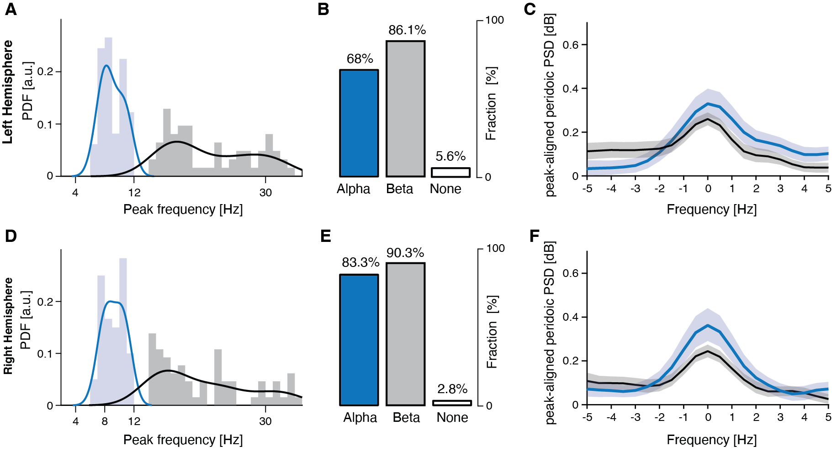
Figure S4 | Alpha peaks are more prevalent in the right hemisphere at the first recording session S1. A, Distribution of oscillatory peaks identified by FOOOF within the alpha (blue) and beta (black) frequency bands using only recordings in the left hemisphere. B, Fraction of neural recordings showing at least one alpha peak, one beta peak, or none (white). C, Bootstrapped average (thick line; 10,000 iterations) and 95% confidence interval (shaded area) of the periodic PSD aligned to the individual alpha (blue) and beta (black) peaks (−5 to +5 Hz window). D-F, Same analyses as in A-C restricted to the right hemisphere.

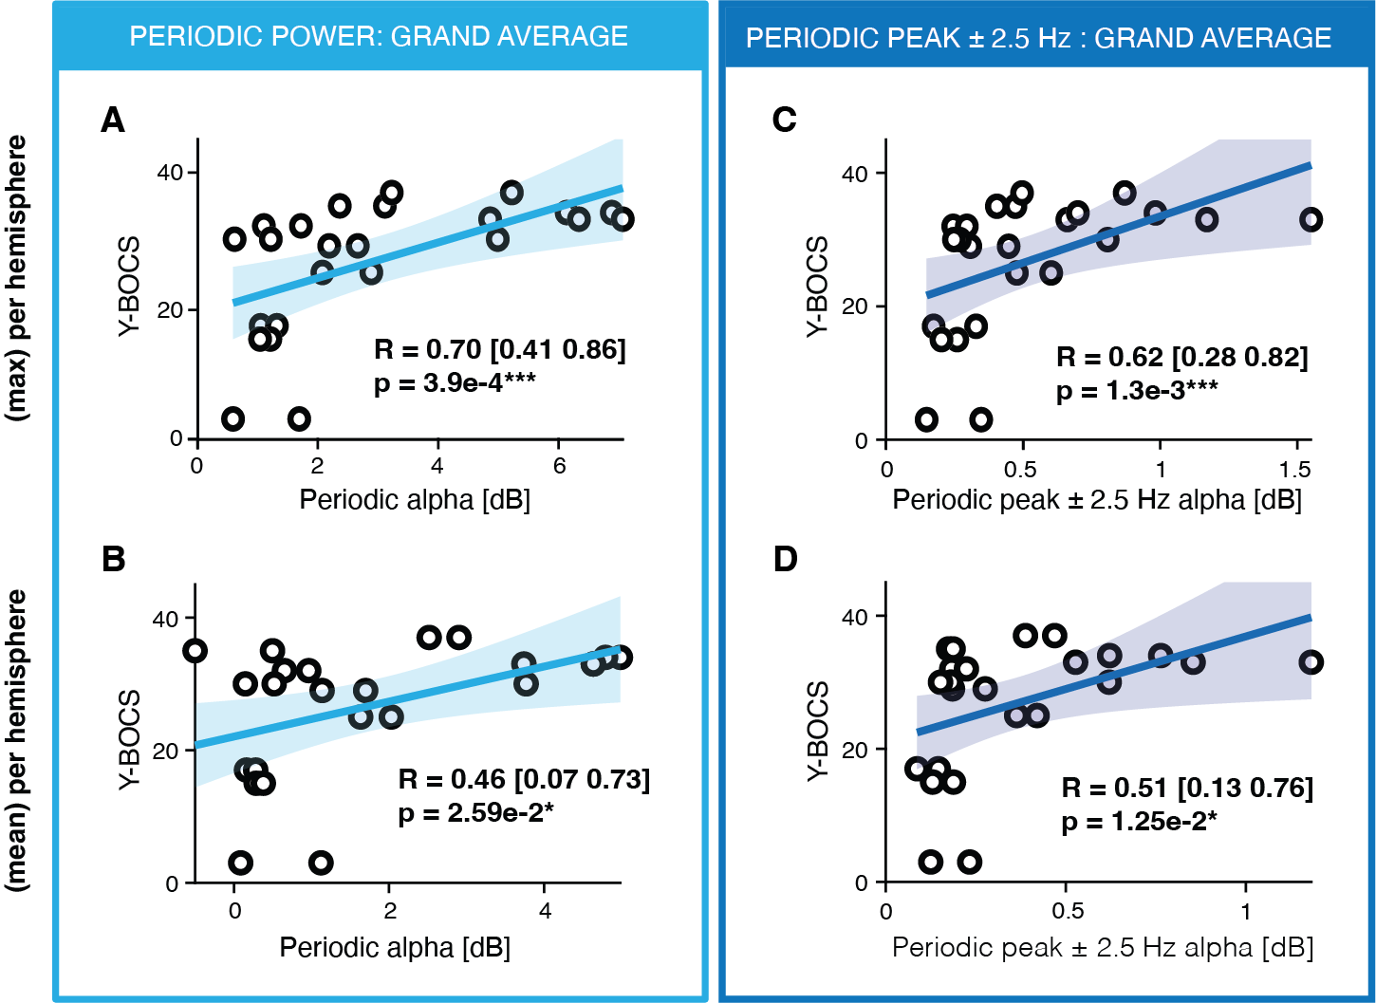

Figure S5 | Robust correlation between periodic alpha power with OCD symptoms severity regardless frequency band definition and bipolar channel pair selection. A Correlation between periodic alpha power (cyan, 7–14 Hz) and Y-BOCS scores across patients. Each circle denotes one patient. Spearman correlation coefficients and 95% confidence intervals are reported; shaded region shows linear fit ±95% CI (visualization only). Only the bipolar channel pair with the highest power in each hemisphere was included in the analyses (N=24). B, Same analyses as in A using the average of the power across bipolar channel pairs in each hemisphere (N=24). C-D, Same analyses as in A-B for the peak of periodic alpha power (blue). A, C are a replication of panels in Figure 2C. P values are summarized by asterisks (*P < 0.05, **P < 0.01, ***P < 0.001). See also Supplementary Table 3 for results including only left or right hemisphere.

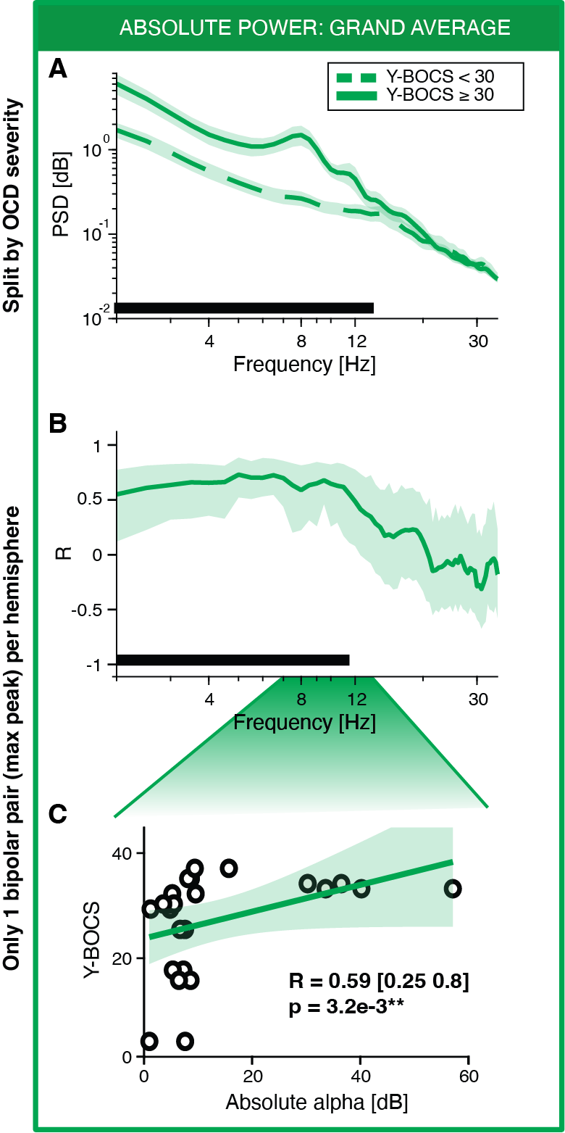

Figure S6 | Absolute alpha power correlates with symptom severity in OCD patients. A, Bootstrapped average absolute power spectra (thick line; 10,000 iterations) and 95% confidence intervals (shaded area) stratified by symptom severity (Y-BOCS < 30, green dashed; Y-BOCS ≥ 30, green solid). Differences between groups were assessed using a cluster-based permutation test for unpaired data (10,000 permutations). Solid black line indicates significant clusters (α = 0.01). Only recordings acquired during the first recording session S1 were used (N = 144 bipolar channel pairs from 24 hemispheres in 13 patients). B, Bootstrapped average and 95% confidence interval of the frequency-wise Spearman correlation between absolute PSD and Y-BOCS scores. Significance was assessed using a cluster-based permutation test (α = 0.01; black line). C, Correlation between absolute alpha power (7–14 Hz) and Y-BOCS scores across patients. Each circle denotes one patient. Spearman correlation coefficients and 95% confidence intervals are reported; the green shaded region shows the linear fit ±95% CI (visualization only). In B–C, only the bipolar channel pair with the highest power in each hemisphere was included (N = 24 hemispheres). P values are summarized by asterisks (*P < 0.05, **P < 0.01, ***P < 0.001).

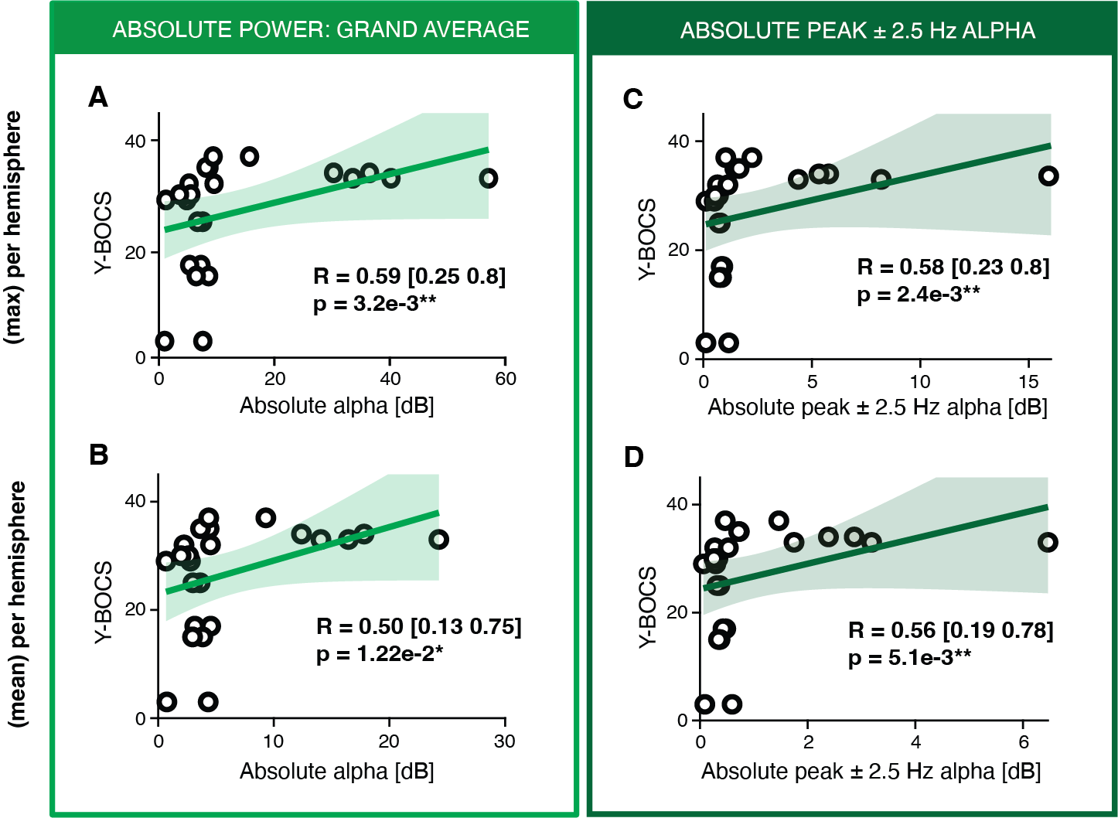

Figure S7 | Robust correlation between absolute alpha power with OCD symptoms severity regardless frequency band definition and bipolar channel pair selection. A Correlation between absolute alpha power (green, 7–14 Hz) and Y-BOCS scores across patients. Each circle denotes one patient. Spearman correlation coefficients and 95% confidence intervals are reported; shaded region shows linear fit ±95% CI (visualization only). Only the bipolar channel pair with the highest power in each hemisphere was included in the analyses (N=24). B, Same analyses as in A using the average of the power across bipolar channel pairs in each hemisphere (N=24). C-D, Same analyses as in A-B for the peak of absolute alpha power (dark green). A, C are a replication of panels in Figure 2C. P values are summarized by asterisks (*P < 0.05, **P < 0.01, ***P < 0.001). See also Supplementary Table 3 for results including only left or right hemisphere.

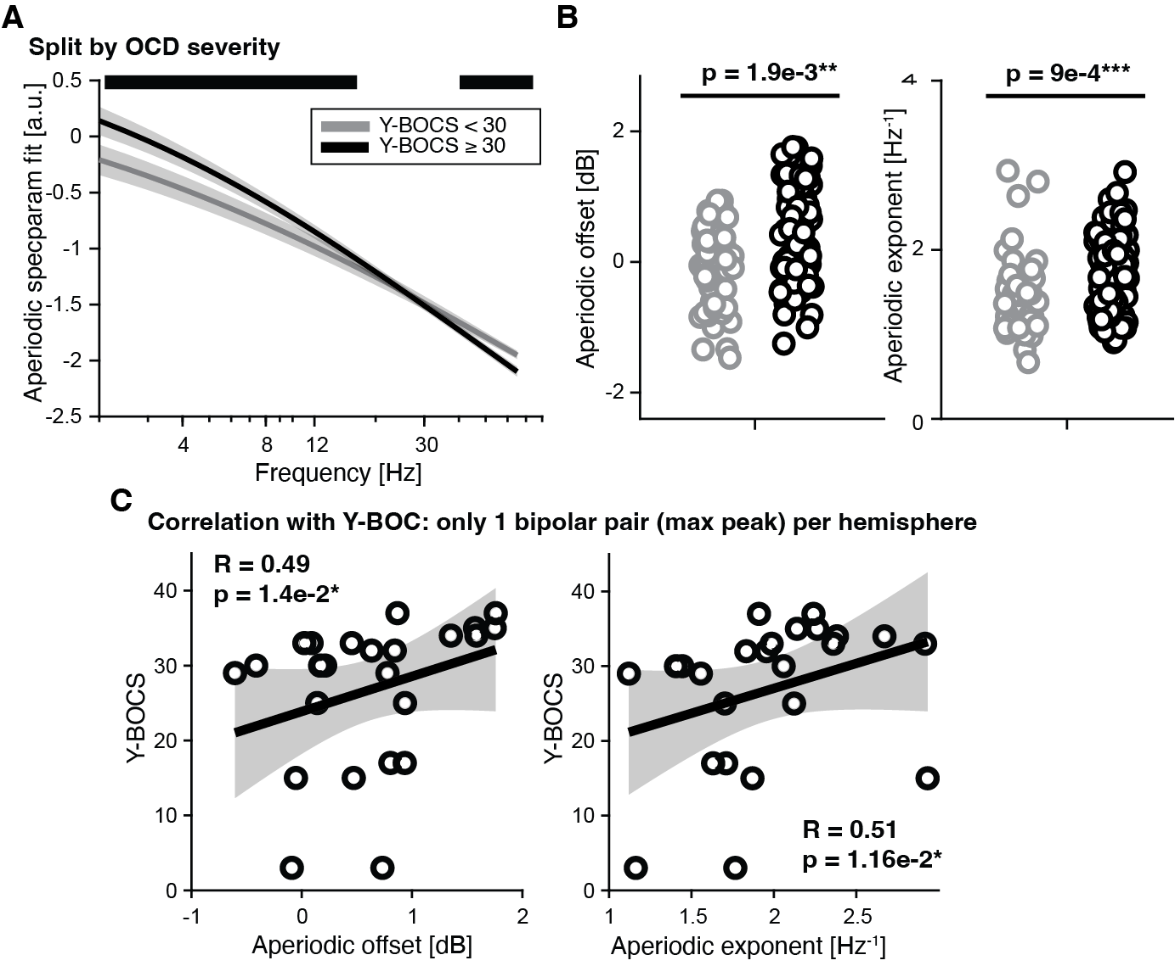

Figure S8 | Changes in the aperiodic activity explain the broadband low-frequency increase in absolute power in the more severe OCD patients. A, Bootstrapped average of aperiodic activity as modeled by the specparam algorithm (thick line; 10,000 iterations) and 95% confidence intervals (shaded area) stratified by symptom severity (Y-BOCS < 30, gray; Y-BOCS ≥ 30, black). Differences between groups were assessed using a cluster-based permutation test for unpaired data (10,000 permutations). Solid black line indicates significant clusters (α = 0.01). Only recordings acquired during the first recording session S1 were used (N = 144 bipolar channel pairs from 24 hemispheres in 13 patients). B, Distribution of aperiodic offset and exponent distributions stratified by symptom severity. C, Correlation between aperiodic offset, aperiodic exponent and Y-BOCS scores across patients. Each circle denotes one patient. Spearman correlation coefficients and 95% confidence intervals are reported; the gray shaded region shows the linear fit ±95% CI (visualization only). In C, only the bipolar channel pair with the highest power in each hemisphere was included (N = 24 hemispheres). P values are summarized by asterisks (*P < 0.05, **P < 0.01, ***P < 0.001).

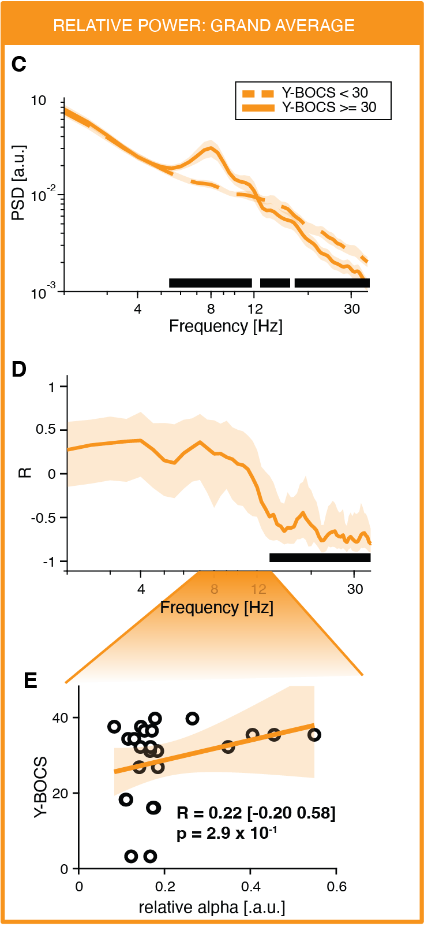

Figure S9 | Normalization of absolute spectra spills effects observed in the alpha band to the beta band.
A, Bootstrapped average relative power spectra (thick line; 10,000 iterations) and 95% confidence intervals (shaded area) stratified by symptom severity (Y-BOCS < 30, orange dashed; Y-BOCS ≥ 30, orange solid). Differences between groups were assessed using a cluster-based permutation test for unpaired data (10,000 permutations). Solid black line indicates significant clusters (α = 0.01). Only recordings acquired during the first recording session S1 were used (N = 144 bipolar channel pairs from 24 hemispheres in 13 patients). B, Bootstrapped average and 95% confidence interval of frequency-wise Spearman correlation between relative PSD and Y-BOCS. Significance was assessed with a cluster-based permutation test (α = 0.01; black line). C, Lack of correlation between relative alpha power (7–14 Hz) and Y-BOCS scores across patients. Each circle denotes one patient. Spearman correlation coefficients and 95% confidence intervals are reported; shaded region shows linear fit ±95% CI (visualization only). In B-C, only the bipolar channel pair with the highest power in each hemisphere was included in the analyses (N=24).

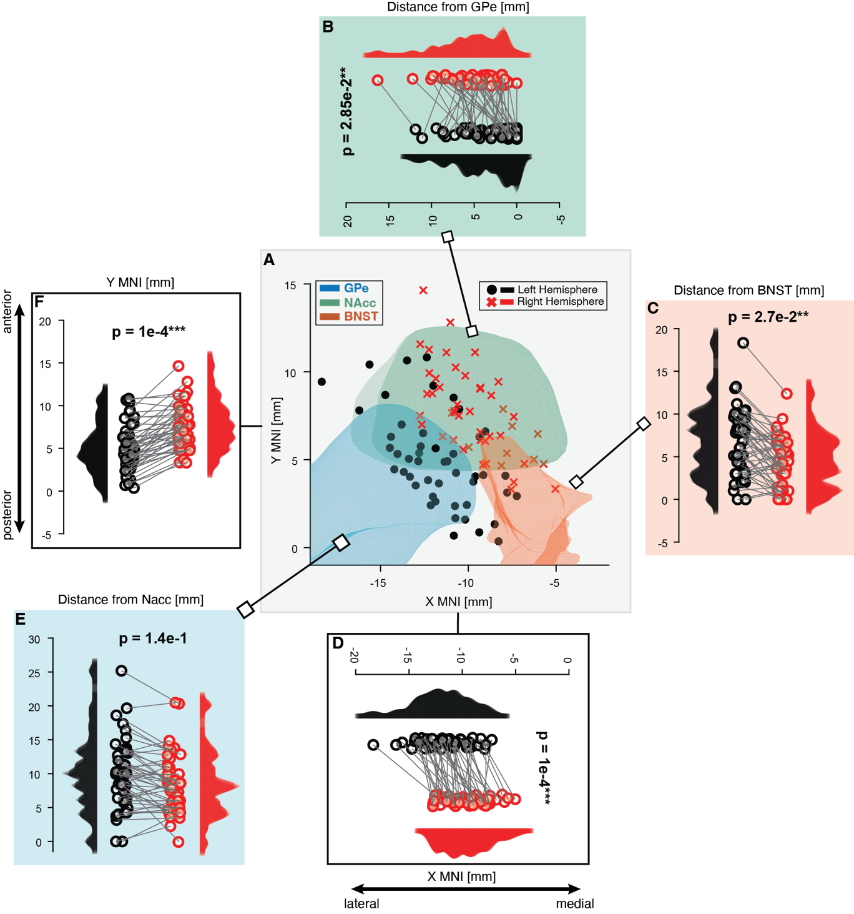

Figure S10 | Inter-hemispheric asymmetry of DBS leads placement. A, Location of DBS contacts in the axial plane in MNI coordinates across all patients. Coordinates of contacts in the right hemisphere (red cross) are non-linearly flipped to the left hemisphere (black circle). External globus pallidus (GPe, blue) and nucleus accumbens (NAcc, green) from the OCD Response Tract AtlasSupplementary Fig. 14, and bed nucleus of the stria terminalis (BNST, orange) from the Human Hypothalamus AtlasSupplementary Fig. 14 are depicted. Lower values of X MNI indicate a more lateral placement. Lower values of Y MNI indicate a more posterior placement. B, Inter-hemispheric (left hemisphere: black, right hemisphere: red) comparison of the distance between the contacts and GPe border. C, Same analyses as in B for the distance from BNST border. D, Inter-hemispheric comparison of the X MNI coordinate (left hemisphere: black, right hemisphere: red) of the DBS contacts. E, Same analyses as in B for the distance from Nacc border. F, Same analyses as in D for Y MNI coordinates of the DBS contacts. All p-values are evaluated using permutation tests (10000 permutations) for paired data and summarized with asterisks (*P < 0.05, **P < 0.01, ***P < 0.001).

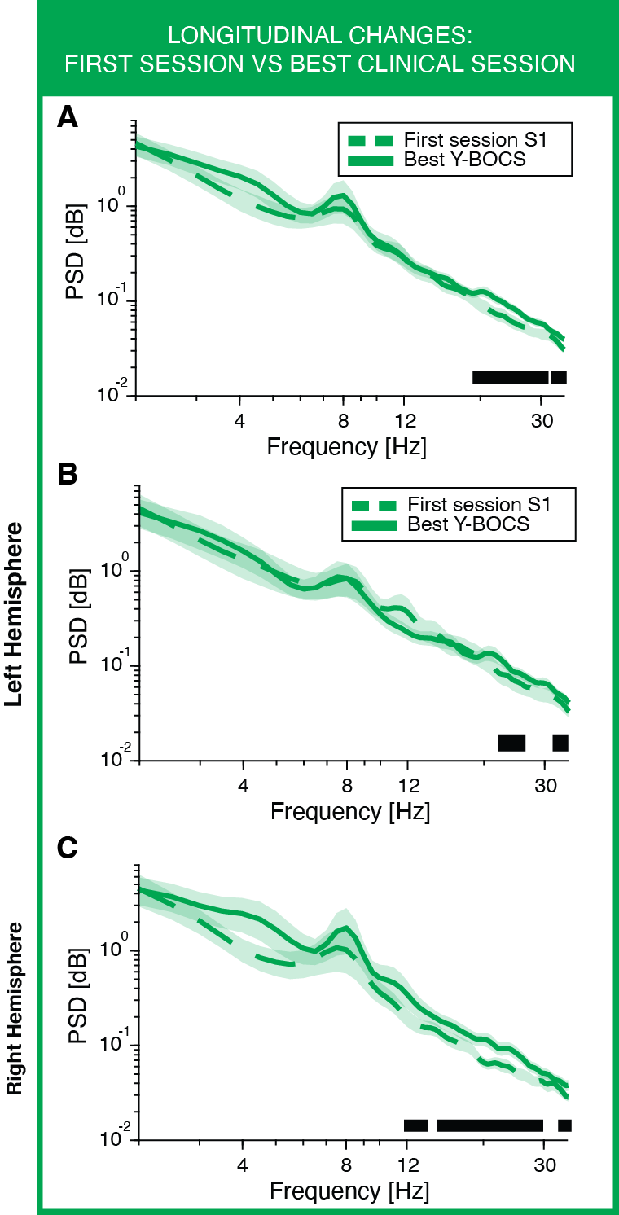

Figure S11 | Absolute beta power increases when the OCD patient yields the maximal DBS benefit. A, Bootstrapped average (thick line) and 95% confidence interval (shaded area) of absolute power spectral density (PSD, green) in the 2–35 Hz range (log–log scale), split by session (dashed line, first recording session S1; solid line, session with best clinical improvement; N = 582 bipolar channel pairs across 24 hemispheres from 12 patients). Statistical significance was tested with a cluster-based permutation test for paired data (10,000 permutations: black line, α = 0.01). B-C, Same analysis restricted to left (B) and right (C) hemispheres. Statistical significance is summarized with asterisks (*P < 0.05, **P < 0.01, ***P < 0.001).

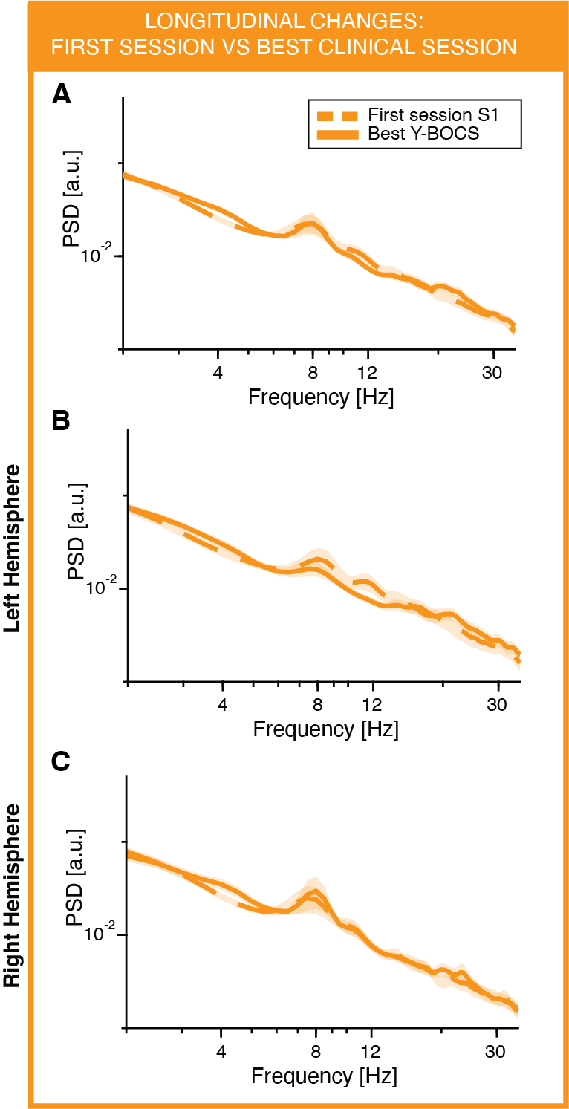

Figure S12 | No difference in relative power when the OCD patient yields the maximal DBS benefit. A, Bootstrapped average (thick line) and 95% confidence interval (shaded area) of relative power spectral density (PSD, orange) in the 2–35 Hz range (log–log scale), split by session (dashed line, first recording session S1; solid line, session with best clinical improvement; N = 582 bipolar channel pairs across 24 hemispheres from 12 patients). Statistical significance was tested with a cluster-based permutation test for paired data (10,000 permutations: black line, α = 0.01). B-C, Same analysis restricted to left (B) and right (C) hemispheres. Statistical significance is summarized with asterisks (*P < 0.05, **P < 0.01, ***P < 0.001).

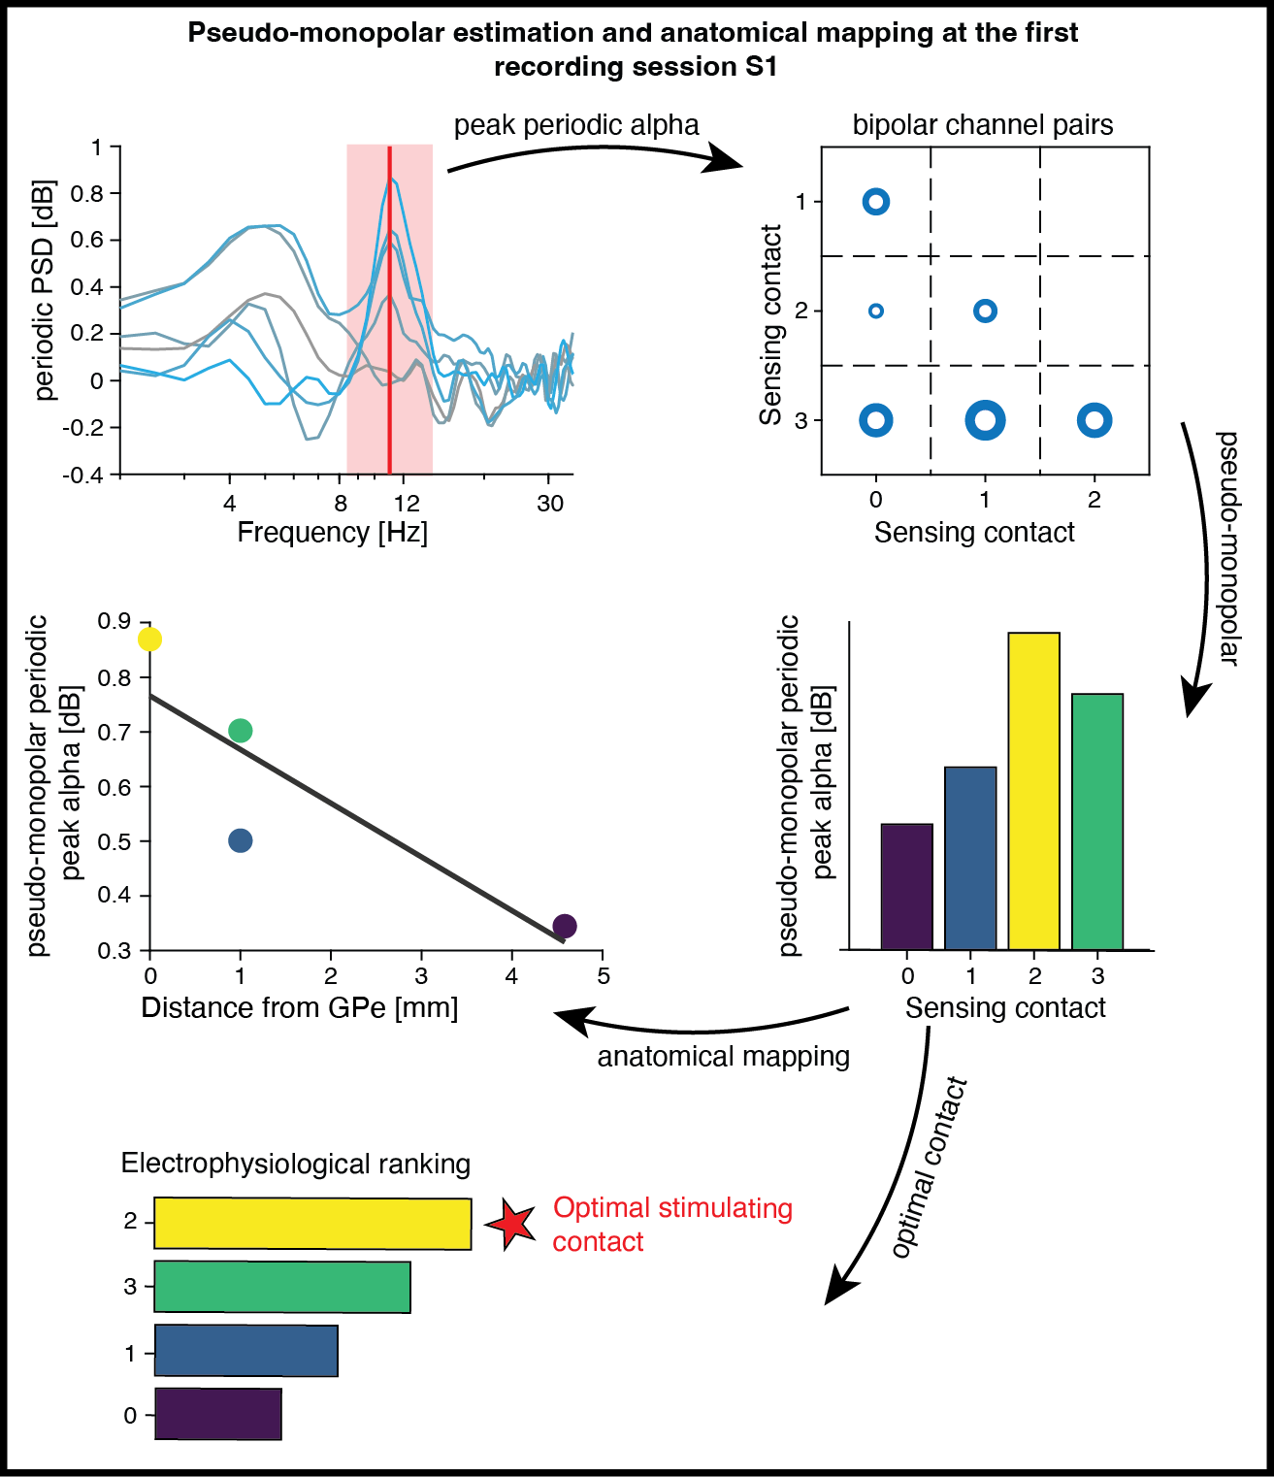

Figure S13 | Pseudo-monopolar alpha power enables anatomical mapping and optimal contact identification. First, periodic power spectra are visualized for all bipolar channel pairs (gray to cyan gradient). The power in the ± 2.5 Hz window (red shaded rectangle) around the peak (or in the alpha band) is then calculated and allocated in a 3-by-3 matrix. The radius of the circle encodes the intensity of the peak periodic alpha power. Then, the pattern-based methodSupplementary Fig. 14 is used to extract contact-level contributions of the observed bipolar alpha power, i.e., pseudo-monopolar power. Finally, pseudo-monopolar peak periodic alpha power can be plotted versus the distance from anatomical landmarks (e.g., GPe) or in the MNI space for anatomical mapping and visualization. DBS electrode contacts can also be ranked according to the pseudo-monopolar peak periodic alpha power to determine how many top-ranked contacts needed to be tested before the clinically selected (optimal; red star) stimulation contact is reached. The same approach is also applied for absolute (Supplementary Fig. 14) and relative (Supplementary Fig. 15) power spectra.

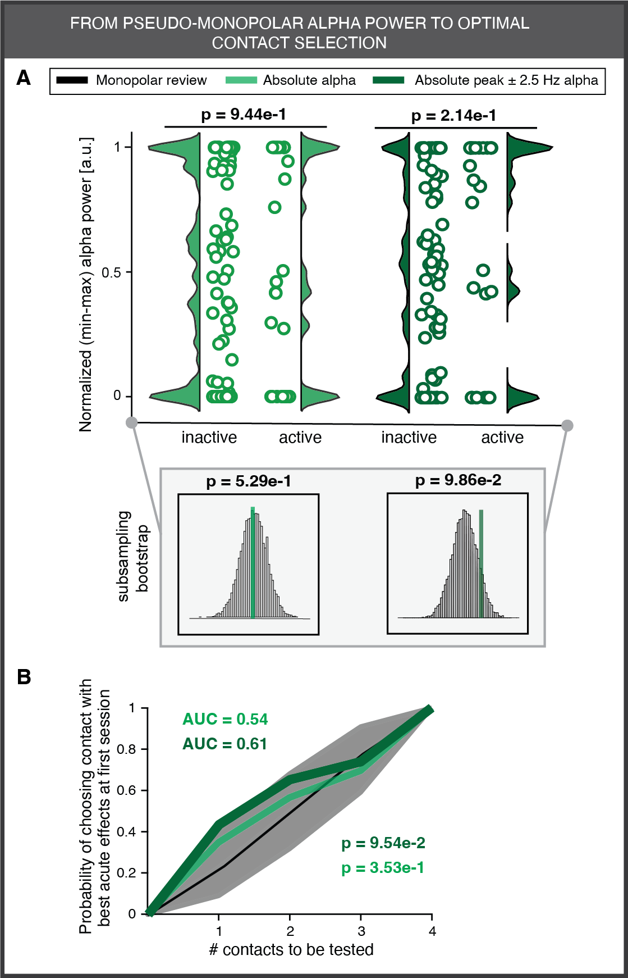

Figure S14 | Absolute alpha power does not identify optimal stimulation contacts. A, Distribution of absolute alpha power (conventional alpha frequency band; green) and peak absolute alpha power (±2.5 Hz window centered on the individual alpha peak; dark green) in inactive versus active contacts, defined as those chosen for stimulation during the first programming session (largely overlapping with the first recording session, S1). Each circle represents a contact. Inset shows comparison of alpha power in active contacts (vertical line) against a sample-balanced distribution of inactive contacts generated by subsampling (10,000 iterations) (N = 96 contacts across 24 hemispheres from 13 patients). B, Cumulative probability of selecting the clinically optimal stimulation contact based on the highest alpha power rank across contacts within each hemisphere. Dashed line and gray shaded area indicate prediction accuracy of the monopolar contact review with 95% confidence interval. Prediction capability was quantified as area under the curve (AUC; chance = 0.5, perfect prediction = 1) and tested against the manual mapping distribution. P values are summarized by asterisks (*P < 0.05, **P < 0.01, ***P < 0.001).

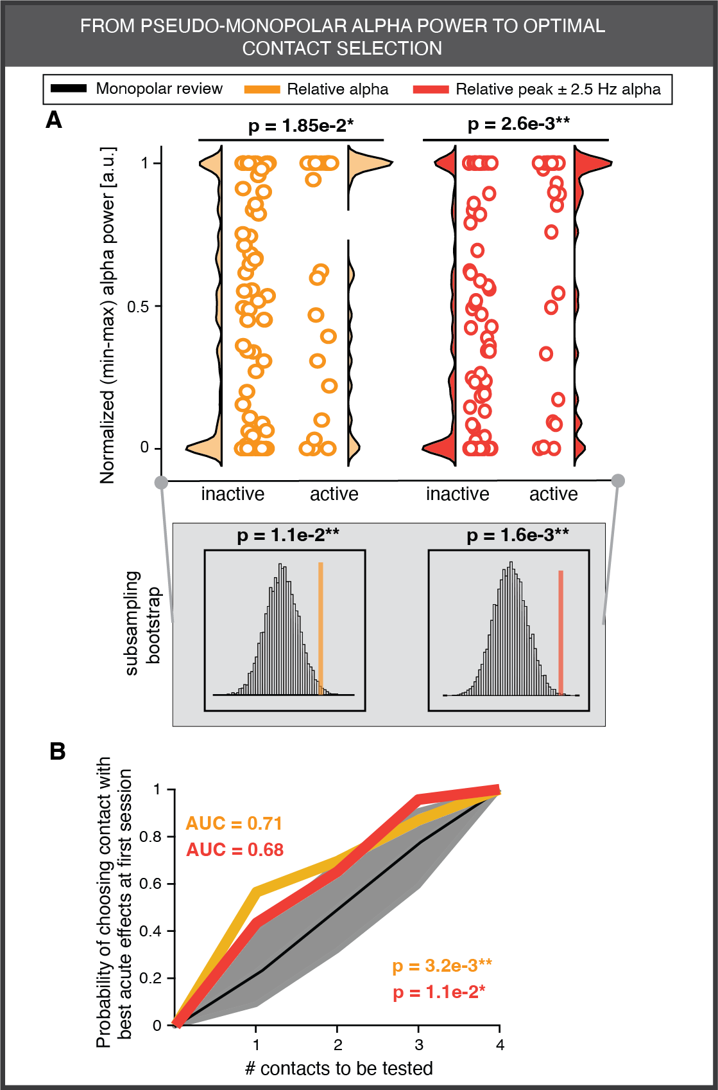

Figure S15 | Relative alpha power similarly to periodic alpha power identifies optimal stimulation contacts. A, Distribution of relative alpha power (conventional alpha frequency band, orange) and peak relative alpha power (±2.5 Hz window centered on the individual alpha peak; dark orange) in inactive versus active contacts, defined as those chosen for stimulation during the first programming session (largely overlapping with the first recording session, S1). Each circle represents a contact. Inset shows comparison of alpha power in active contacts (vertical line) against a sample-balanced distribution of inactive contacts generated by subsampling (10,000 iterations) (N = 96 contacts across 24 hemispheres from 13 patients). B, Cumulative probability of selecting the clinically optimal stimulation contact based on the highest alpha power rank across contacts within each hemisphere. Dashed line and gray shaded area indicate prediction accuracy of the monopolar contact review with 95% confidence interval. Prediction capability was quantified as area under the curve (AUC; chance = 0.5, perfect prediction = 1) and tested against the manual mapping distribution. P values are summarized by asterisks (*P < 0.05, **P < 0.01, ***P < 0.001).

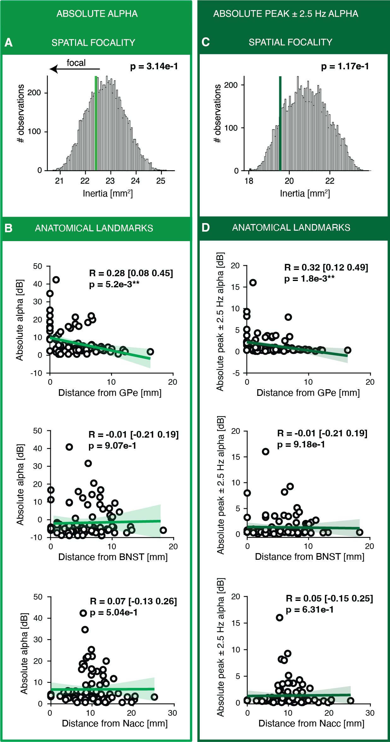
Figure S16 | Spatial analysis for absolute alpha power. A, Inertia, an index of spatial dispersion of absolute alpha power (conventional alpha frequency band; green) (lower values indicate more focal clustering around a center of mass), for the observed distribution (vertical blue line) compared with a null distribution generated by randomly permuting contact locations (10,000 permutations). B, Correlation between pseudo-monopolar absolute alpha power and distance from each contact to the nearest border of the GPe, NAcc, and BNST. Each circle denotes one contact; Spearman correlation coefficients (sign inverted) and 95% confidence intervals are reported. Shaded region shows linear fit (green line) ±95% CI (for visualization only). C-D, Same analyses as A-B for peak absolute alpha power (±2.5 Hz window centered on the individual alpha peak; dark green). P values are summarized by asterisks (*P < 0.05, **P < 0.01, ***P < 0.001).

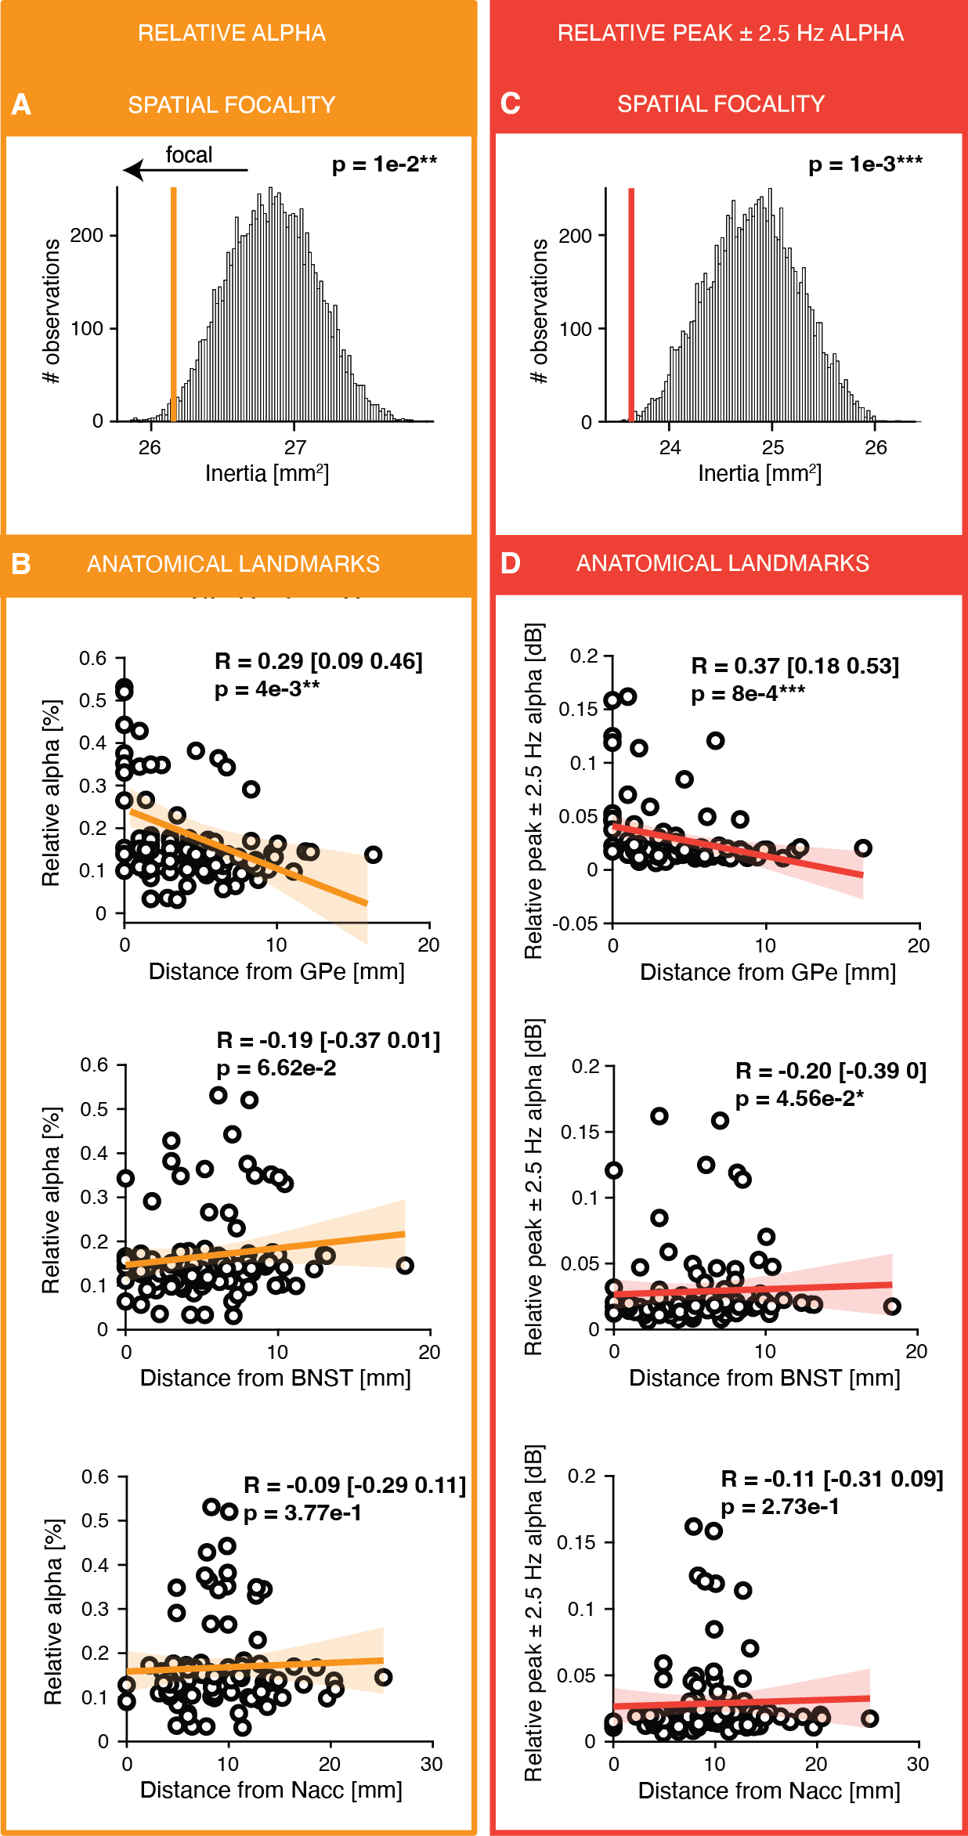
Figure S17 | Spatial analysis for relative alpha power. A, Inertia, an index of spatial dispersion of relative alpha power (conventional alpha frequency band; orange) (lower values indicate more focal clustering around a center of mass), for the observed distribution (vertical blue line) compared with a null distribution generated by randomly permuting contact locations (10,000 permutations). B, Correlation between pseudo-monopolar relative alpha power and distance from each contact to the nearest border of the GPe, NAcc, and BNST. Each circle denotes one contact; Spearman correlation coefficients (sign inverted) and 95% confidence intervals are reported. Shaded region shows linear fit (orange line) ±95% CI (for visualization only). C-D, Same analyses as A-B for peak relative alpha power (±2.5 Hz window centered on the individual alpha peak; dark green). P values are summarized by asterisks (*P < 0.05, **P < 0.01, ***P < 0.001).

References

1. Neumann, W.-J. et al. Subthalamic synchronized oscillatory activity correlates with motor impairment in patients with Parkinson’s disease. Mov. Disord. 31, 1748–1751 (2016).
2. Neumann, W.-J. et al. A localized pallidal physiomarker in cervical dystonia. Ann. Neurol. 82, 912–924 (2017).
3. Lofredi, R. et al. Subthalamic beta bursts correlate with dopamine-dependent motor symptoms in 106 Parkinson’s patients. NPJ Parkinsons Dis 9, 2 (2023).
4. Bush, A., Zou, J. F., Lipski, W. J., Kokkinos, V. & Richardson, R. M. Aperiodic components of local field potentials reflect inherent differences between cortical and subcortical activity. Cerebral Cortex 34, bhae186 (2024).
5. Li, N. et al. A unified functional network target for deep brain stimulation in obsessive-compulsive disorder. Biological Psychiatry https://doi.org/10.1016/j.biopsych.2021.04.006 (2021) doi:10.1016/j.biopsych.2021.04.006.
6. Neudorfer, C. et al. A high-resolution in vivo magnetic resonance imaging atlas of the human hypothalamic region. Sci Data 7, 305 (2020).
7. Muller, M. et al. Online prediction of optimal deep brain stimulation contacts from local field potentials in Parkinson’s disease. npj Parkinsons Dis. 11, 234 (2025).

