Table S1. Identification and origin of island guano samples

Code | Guano island | Department | Guano source (Bird species) | Sampling date
GU24-CNGu | Chincha Norte | Ica | Guanay | 11/11/2024
GU24-CNPi | Chincha Norte | Ica | Piquero | 11/11/2024
GU24-SRGu | Santa Rosa | Ica | Guanay | 12/11/2024
GU24-SJGu | San Juan | Ica | Guanay | 14/11/2024
GU24-GNPi | Guañape norte | La Libertad | Piquero | 26/11/2024
GU24-GNGu | Guañape norte | La Libertad | Guanay | 26/11/2024
GU24-MCGuPiPe | Isla MacabÍ | La Libertad | Guanay | 30/11/2024
GU24-GSPi | Guañape sur | La Libertad | Piquero | 25/11/2024
GU24-GSGuPi | Guañape sur | La Libertad | Guanay | 25/11/2024
GU24-PCGu | Punta Coles | Moquegua | Guanay | 2/12/2024
GU24-ISGu | Isla Santa | Ancash | Guanay | 12/12/2024
GU24-ANGu | Isla Pescadores | Lima | Guanay | 16/12/2024
GU24-IMGu | Isla Mazorca | Lima | Guanay | 18/12/2024
SU24-LB | Isla Lobos de Tierra | Piura | Suelo | 27/12/2024
Note:
Samples were collected along the Peruvian coastline and preserved under controlled conditions until processing. Sample G4 (Isla Lobos de Tierra) was excluded from all analyses due to insufficient metadata regarding the dominant bird species and uncertainty about the nature of the collected substrate (guano vs. soil).

Table S2. DNA concentration and purity determined by spectrophotometry
Code | Guano island | Guano source (bird species) | Spectrophotometry
Code | Guano island | Guano source (bird species) | ng/ul | 260/280
G1 | Isla Macabi | Guanay | 11.647 | 1.766
G2 | Guañape Norte | Piquero | 39.818 | 1.892
G3 | Guañape Norte | Guanay | 18.792 | 1.885
G4 | Lobos de tierra | Suelo | 2.279 | 1.833
G5 | Chincha Norte | Guanay | 9.263 | 1.837
G6 | Santa Rosa | Guanay | 2.789 | 1.8
G7 | San Juan | Guanay | 8.314 | 1.778
G8 | Chincha Norte | Piquero | 13.915 | 1.824
G9 | Isla Pescadores | Guanay | 14.029 | 1.971
G10 | Isla Santa | Guanay | 25.54 | 1.952
G11 | Guañape sur | Guanay | 18.542 | 1.808
G12 | Isla Mazorca | Guanay | 14.764 | 1.857
G13 | Punta Coles | Guanay | 12.336 | 1.828
G14 | Guañape sur | Piquero | 16.102 | 1.814
Sample G4 (Isla Lobos de Tierra) was excluded from all analyses due to insufficient metadata regarding the dominant bird species and uncertainty about the nature of the collected substrate (guano vs. soil).

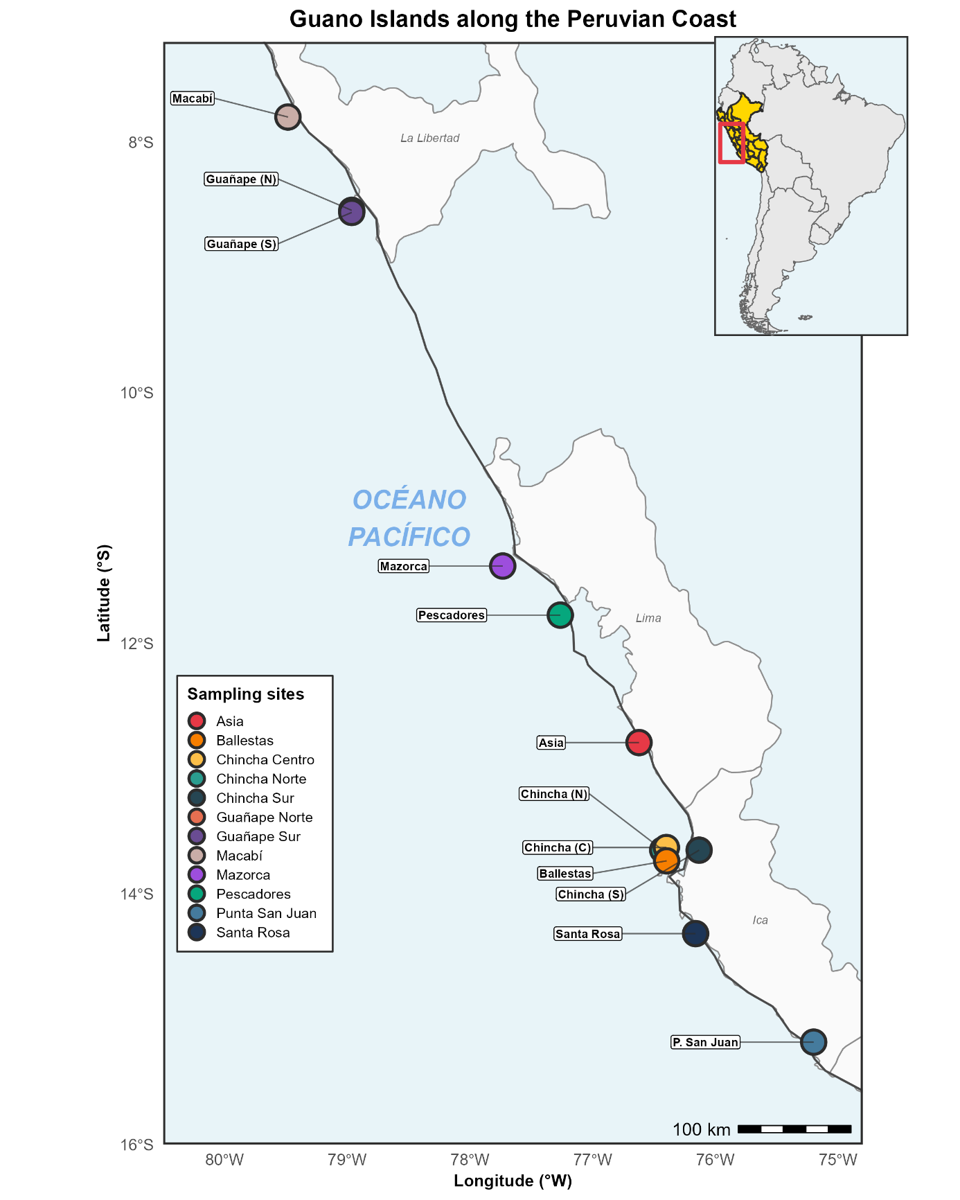
Figure S1. Map showing the location of the guano islands and headlands sampled along the Peruvian coast. Colored points indicate the sampling sites evaluated in this study, including Macabí, Guañape Norte, Guañape Sur, Mazorca, Pescadores, Asia, Chincha Norte, Chincha Centro, Ballestas, Chincha Sur, Santa Rosa, and Punta San Juan. The upper-right inset shows the location of Peru within South America and highlights the coastal sector where the guano-producing areas included in the sampling are distributed.

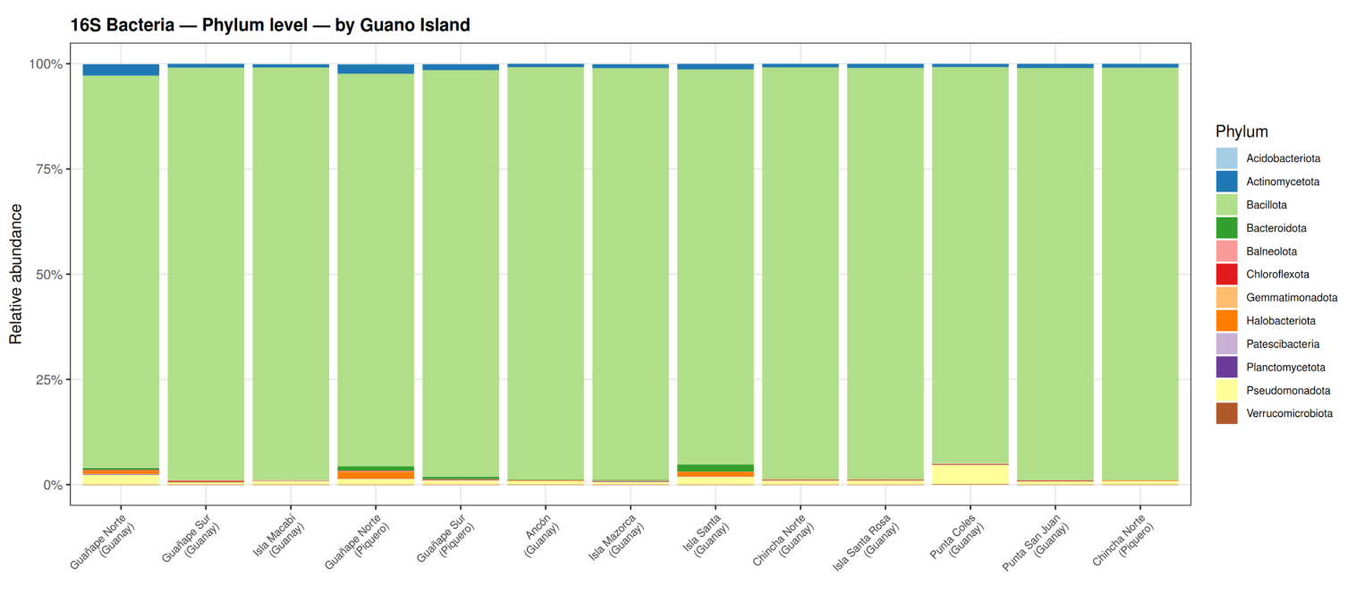

Figure S2. Relative taxonomic composition of bacterial communities associated with island guano, determined by 16S rRNA marker sequencing at the phylum level. Each stacked bar represents a composite sample corresponding to an island or guano headland and the bird species associated with the guano, showing the relative abundance of the main bacterial phyla identified. Colors indicate the different taxonomic groups. The figure highlights the marked dominance of Bacillota across all evaluated localities, as well as the relative variation of minor phyla among samples.
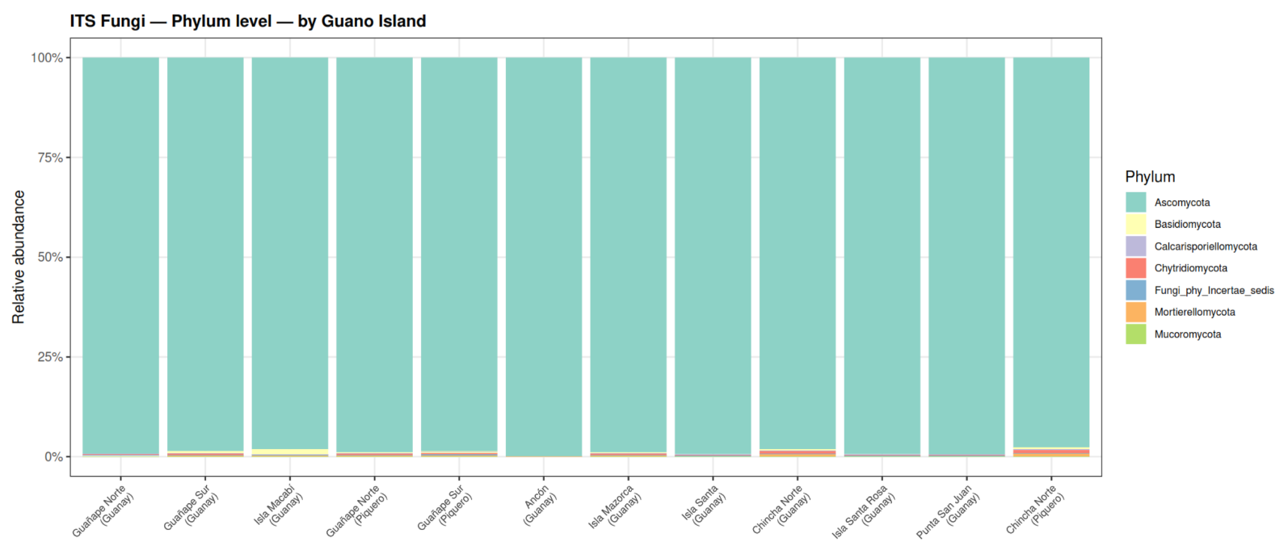

Figure S3. Relative taxonomic composition of fungal communities associated with island guano, determined by ITS marker sequencing at the phylum level. Each stacked bar represents a composite sample corresponding to an island or guano headland and the bird species associated with the guano, showing the relative abundance of the main fungal phyla identified. Colors indicate the different taxonomic groups. The figure highlights the marked dominance of Ascomycota across all evaluated localities, as well as the low representation and relative variation of minor phyla among samples.

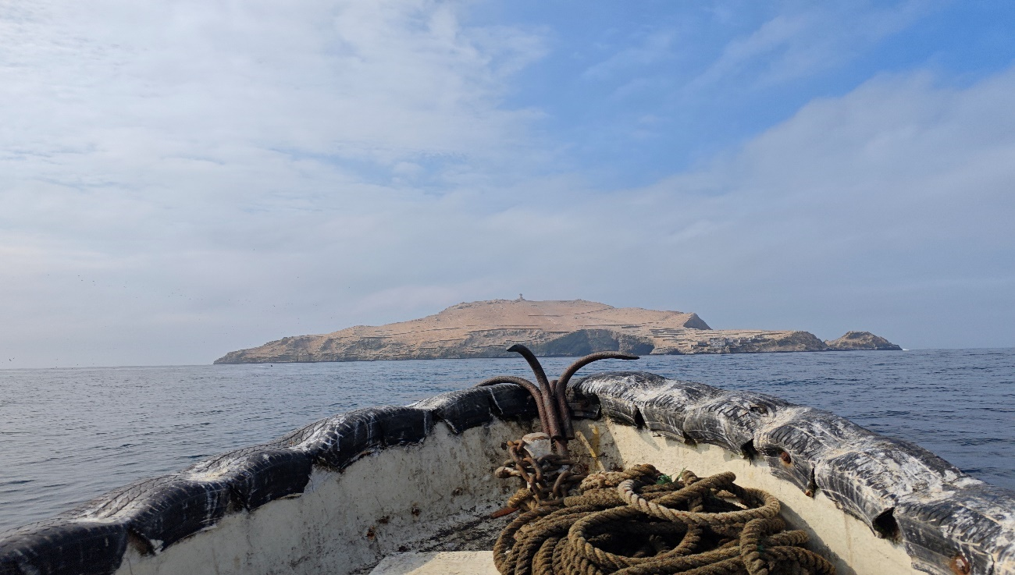
Figure S4. Sampling expedition for guano collection on Chincha Norte Island, Ica, Peru, in November 2024.
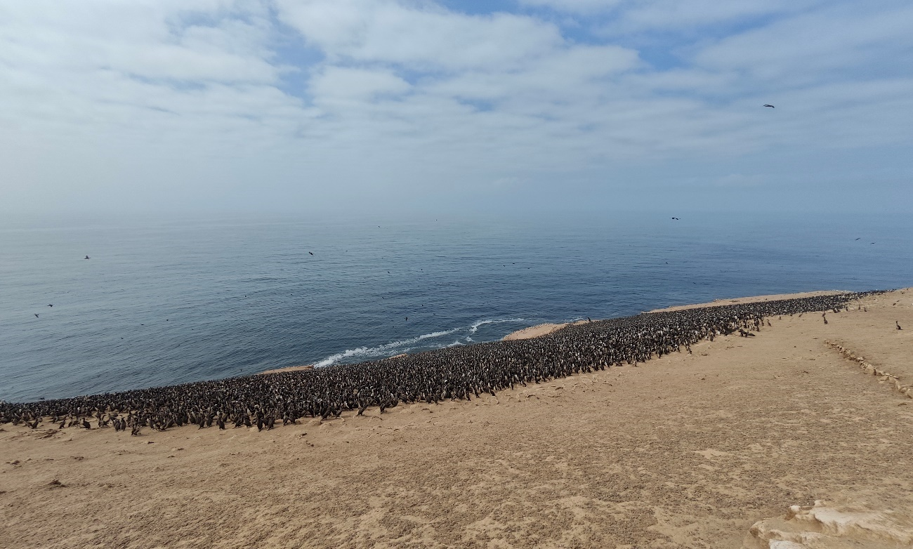
Figure S5. Population of Guanay cormorants (Leucocarbo bougainvillii) on Mazorca Island, off the coast of Lima, Peru, during the guano sampling expedition in December 2024.

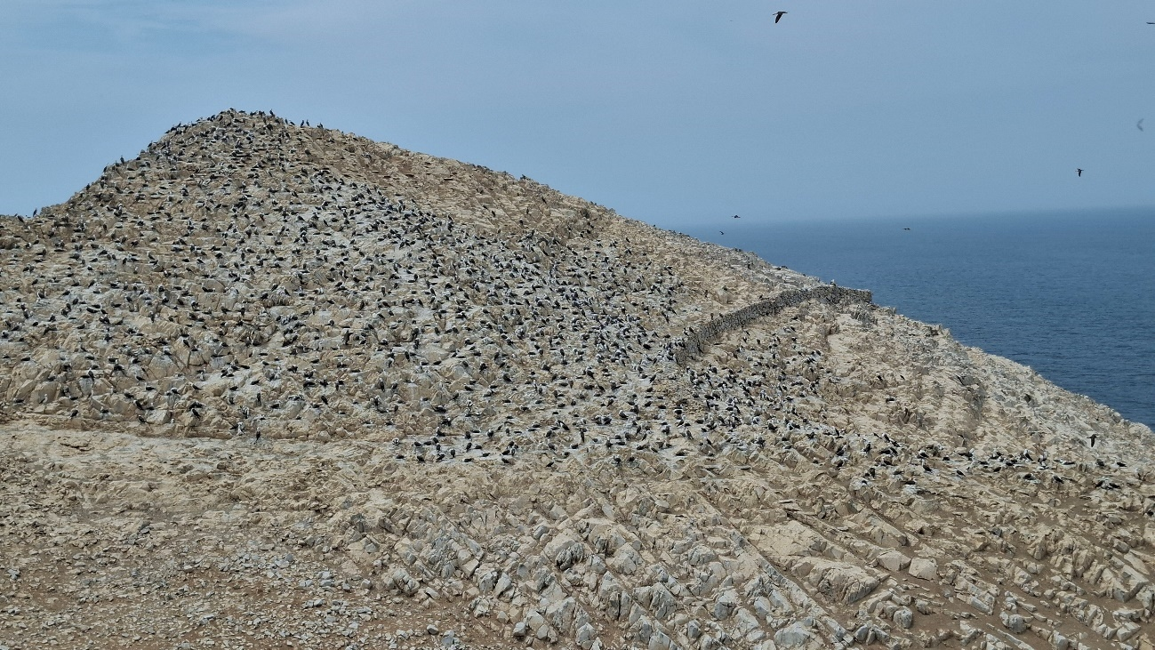
Figure S6. Population of Peruvian boobies (Sula variegata) on Guañape Sur Island, off the coast of the La Libertad region, Peru, during the guano sampling expedition in December 2024.
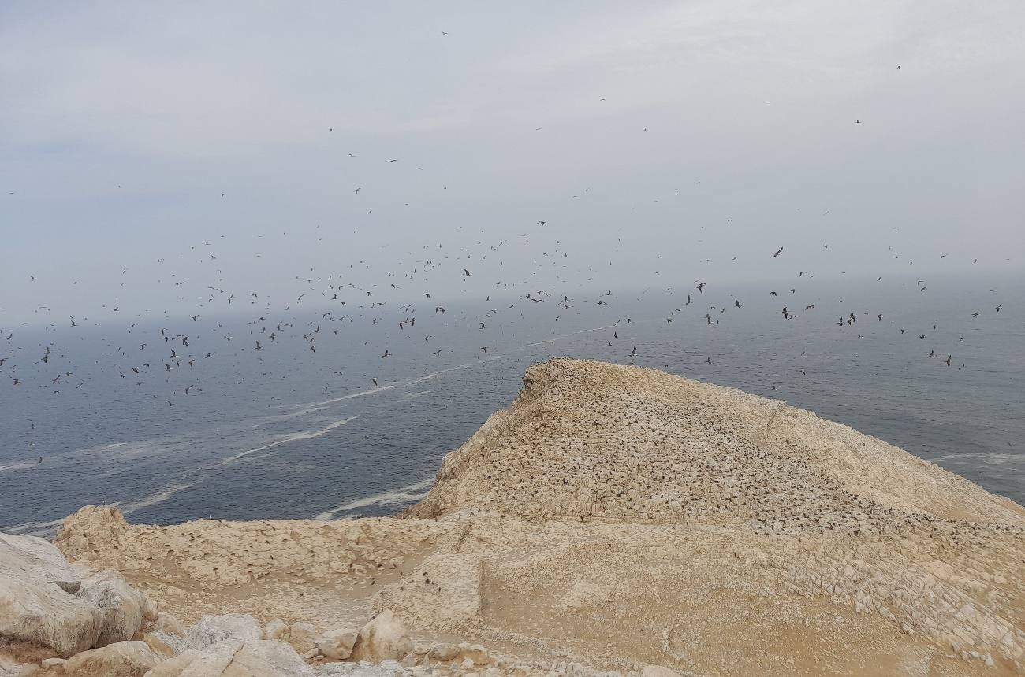
Figure S7. Peruvian boobies (Sula variegata) in flight over Guañape Sur Island, off the coast of the La Libertad region, Peru, during the guano sampling expedition in December 2024.
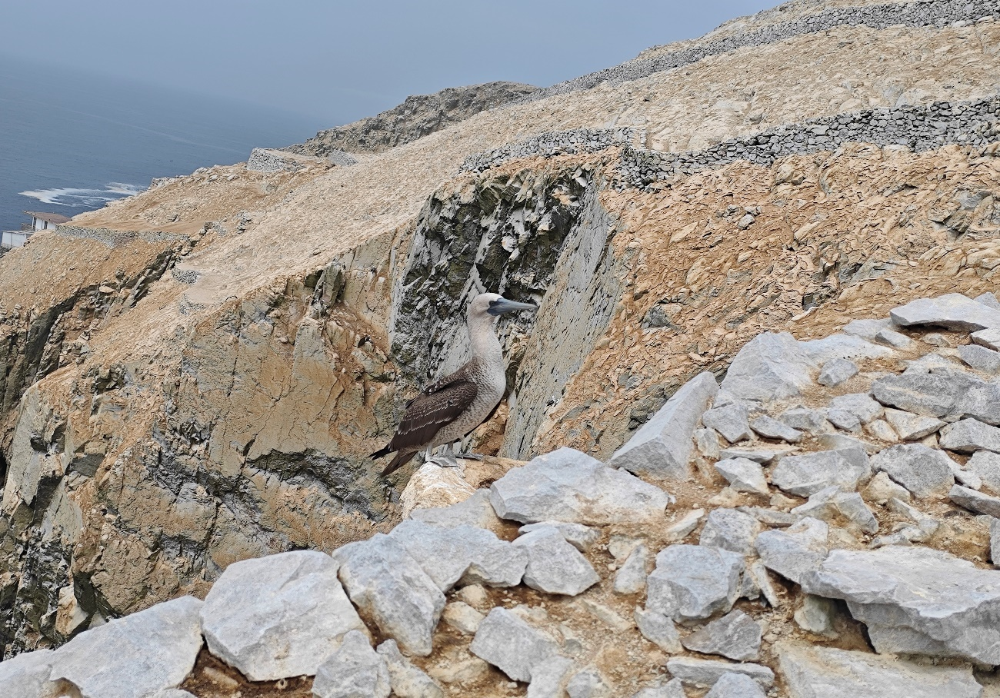
Figure S8. Peruvian booby (Sula variegata) on Pescadores Island, off the coast of Lima, Peru, during the guano sampling expedition in December 2024.
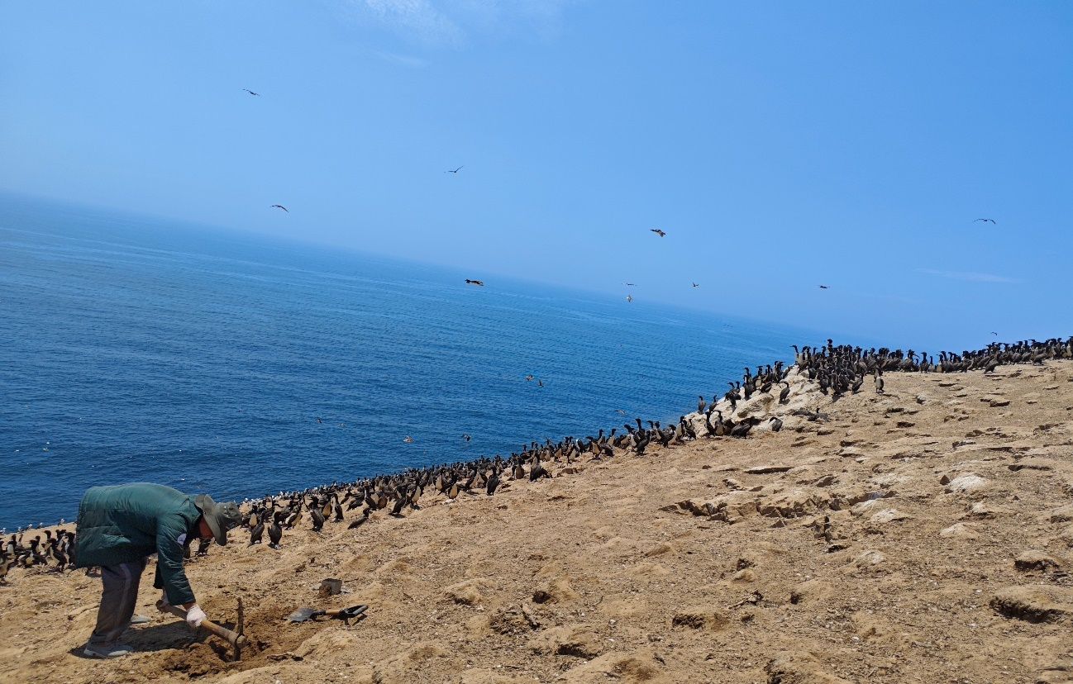
Figure S9. Excavation of a 0–30 cm pit for guano sampling from Guanay cormorants (Leucocarbo bougainvillii) on Pescadores Island, off the coast of Lima, Peru, during the guano sampling expedition in December 2024.
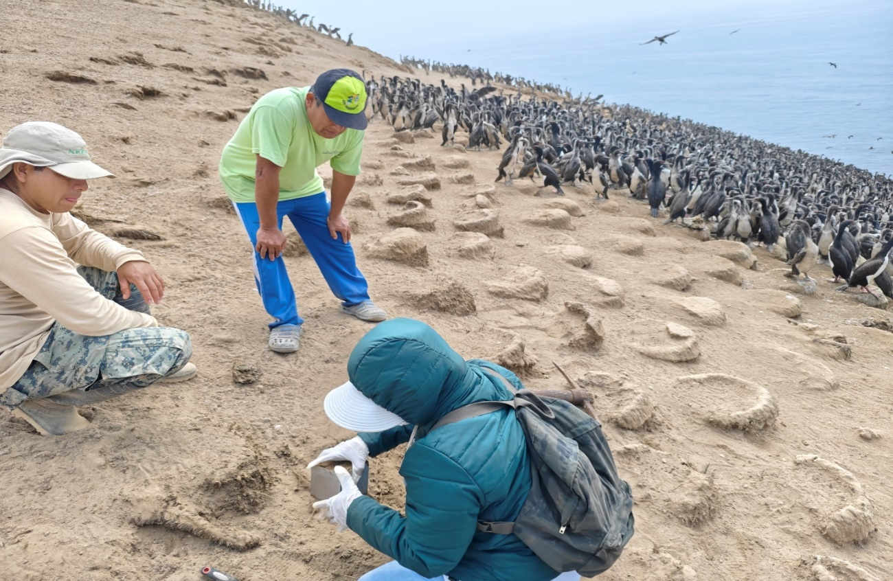
Figure S10. Island ranger observing guano sampling from Guanay cormorants (Leucocarbo bougainvillii) for molecular studies on Pescadores Island, off the coast of Lima, Peru, during the guano sampling expedition in December 2024.
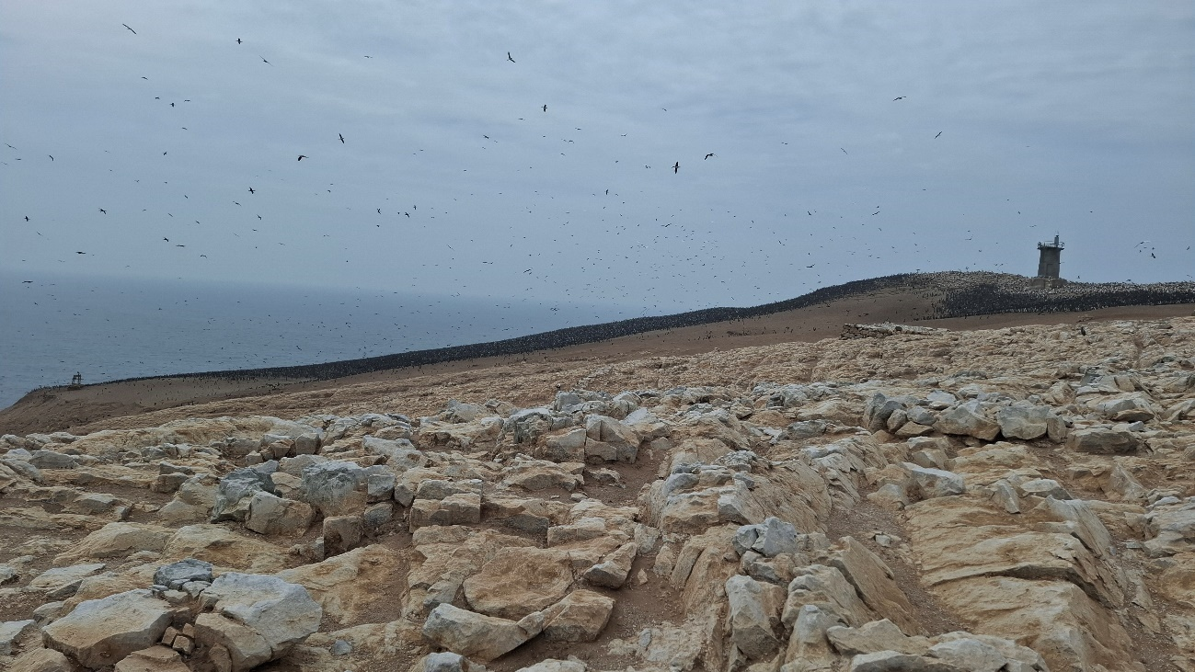
Figure S11. Population of Guanay cormorants (Leucocarbo bougainvillii) on Guañape Norte Island, off the coast of the La Libertad region, Peru, during the guano sampling expedition in December 2024.
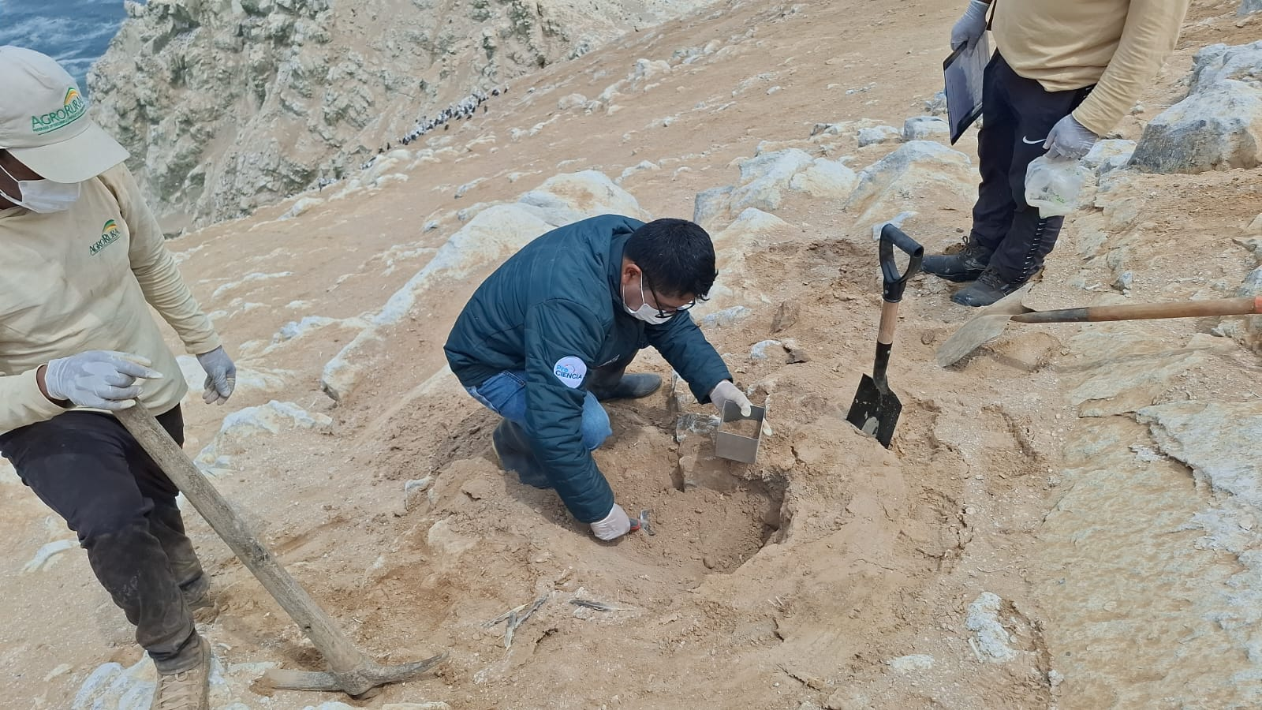
Figure S12. Guano sampling from Peruvian boobies (Sula variegata) on Isla Guañape Norte, off the coast of the La Libertad region, Peru, during the guano sampling expedition in December 2024.
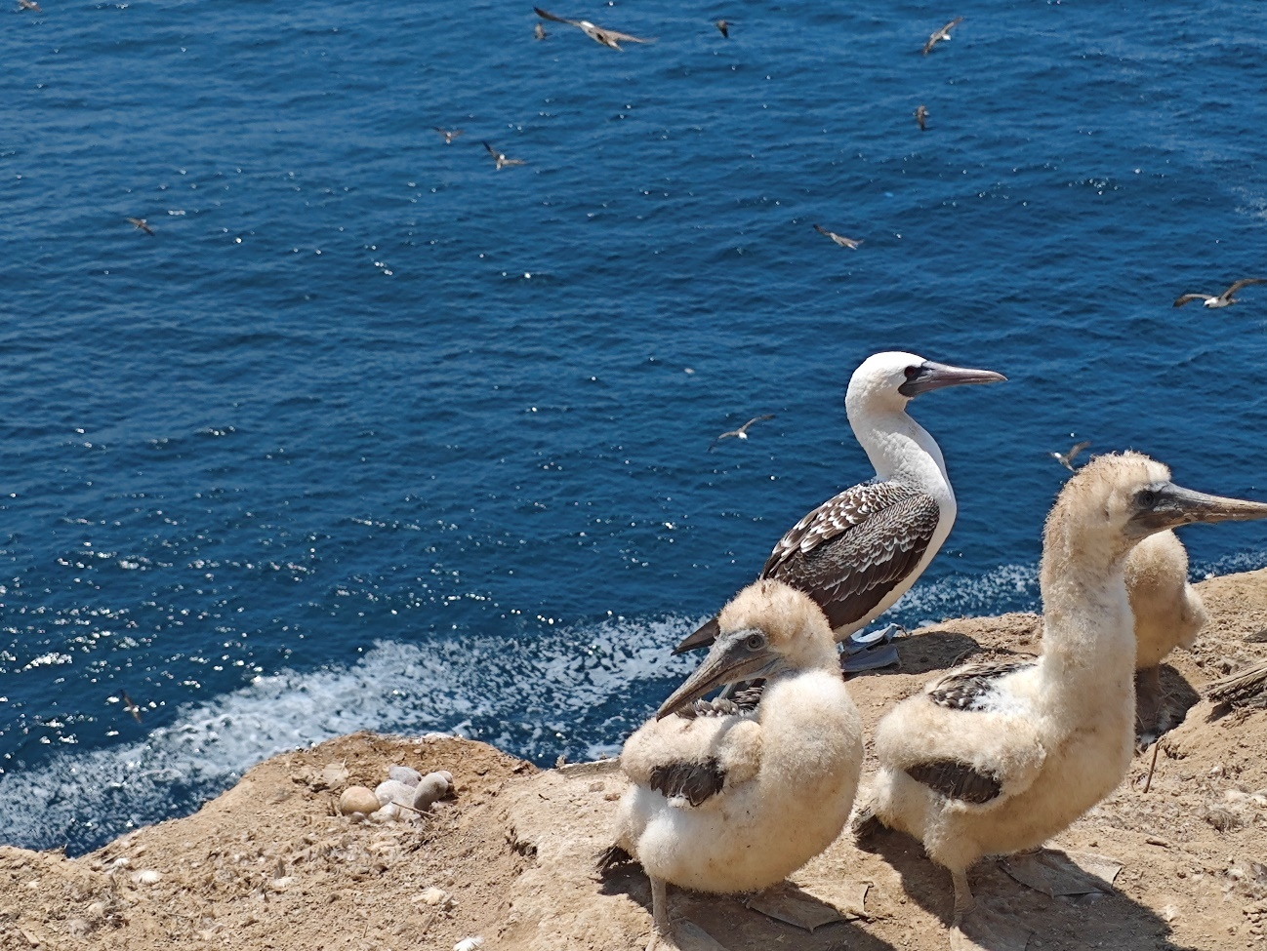
Figure S13. Chicks and juvenile Peruvian boobies (Sula variegata) on Mazorca Island, off the coast of Lima, Peru, during the guano sampling expedition in December 2024.
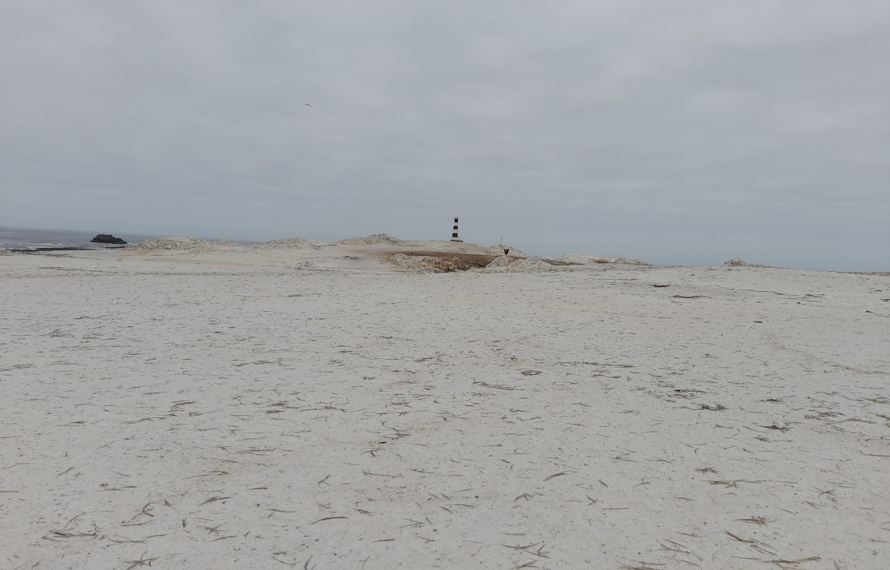
Figure S14. Guano-rich headland with accumulated Guanay cormorant (Leucocarbo bougainvillii) guano at Punta Coles, off the coast of the Moquegua region, Peru, during the guano sampling expedition in November 2024.
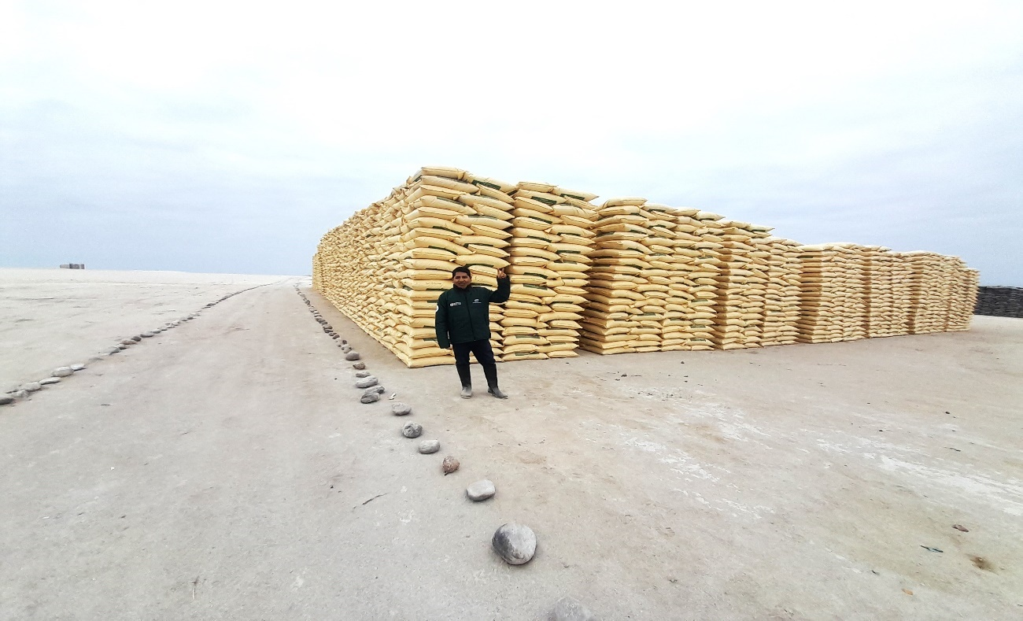
Figure S15. Loading of more than 500 tons of Guanay cormorant (Leucocarbo bougainvillii) guano for use as fertilizer in family farming in Peru, at Punta Coles, off the coast of the Moquegua region, during the guano sampling expedition in November 2024.

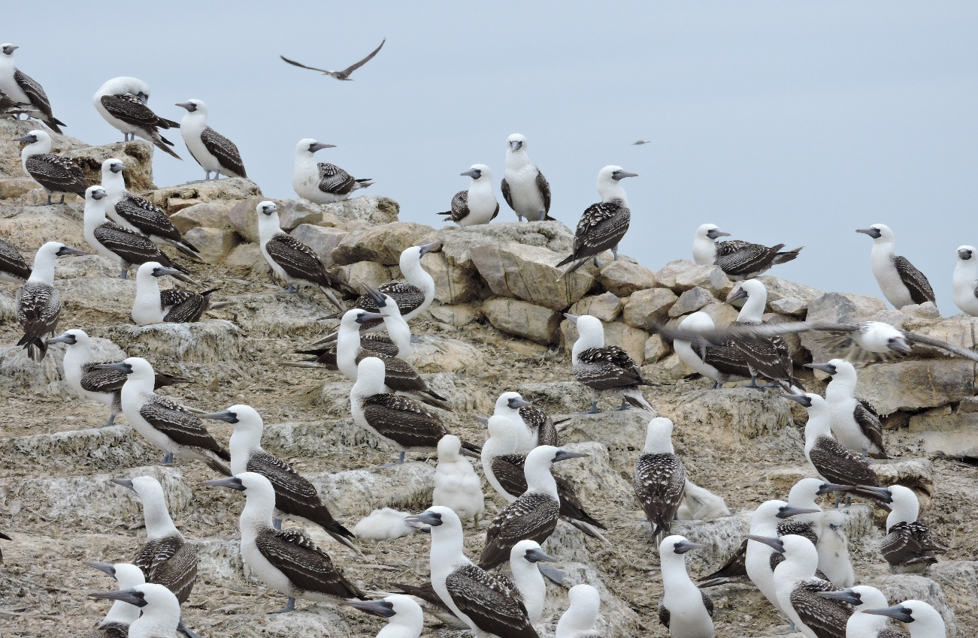
Figure S16. Population of juvenile Peruvian boobies (Sula variegata) on Macabi Island, off the coast of the La Libertad region, Peru, during the guano sampling expedition in December 2024.
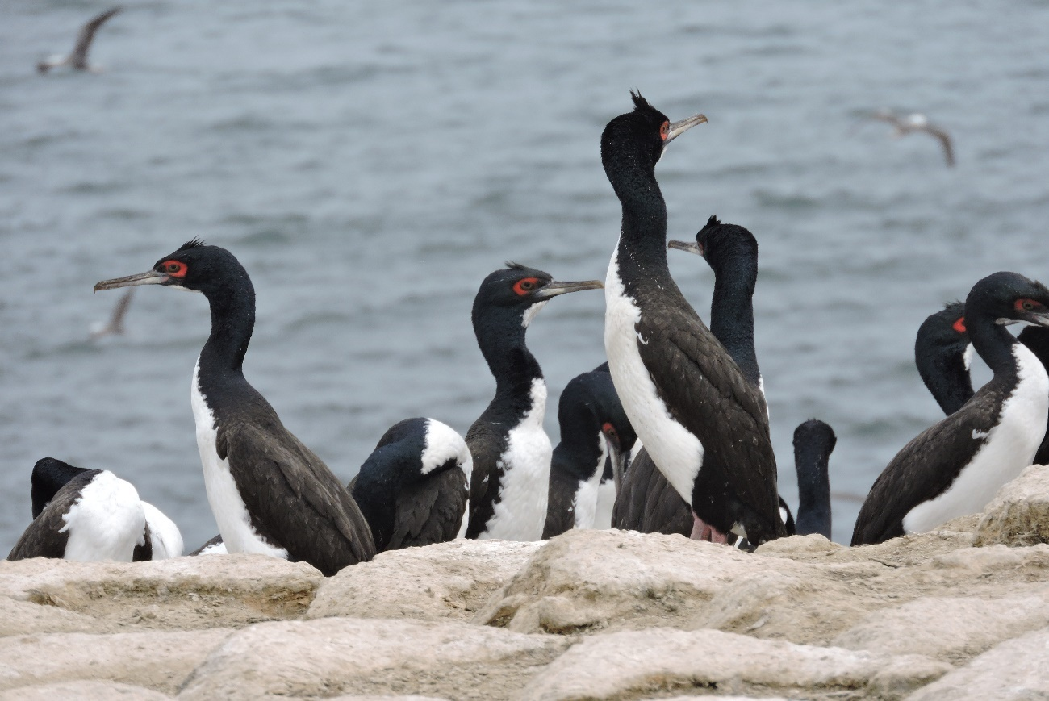
Figure S17. Population of juvenile Guanay cormorants (Leucocarbo bougainvillii) on Macabi Island, off the coast of the La Libertad region, Peru, during the guano sampling expedition in December 2024.

