Supplementary Materials
A highly sensitive, laser-free, and fully integrated, quantum magnetometer based on van der Waals magnet CrCl₃
Authors

Prem B. Karki,^{1†} Ayodimeji E. Aregbesola,^{1†} Karishma Prasad,² Arjun Thapa,¹ Jonathan Skeels,¹ Jian Wang,² Kapildeb Ambal¹*
Affiliations

¹Department of Mathematics, Statistics, and Physics, Wichita State University, 1845 Fairmount Street, Wichita, KS 67260

²Department of Chemistry and Biochemistry, Wichita State University, 1845 Fairmount Street, Wichita, KS 67260

*Corresponding author: Kapildeb.ambal@wichita.edu
†Equal contribution

- Temperature-dependent broadband magnetic resonance measurement
We evaluated the magnetometer from room temperature to 50 K and quantified its sensitivity as a function of temperature. We repeat the broadband magnetic resonance measurement at various temperatures using the same procedure as described in the main text. Figure S1A shows a representative broadband resonance spectrum measured at 100 K. Figure S1B shows the magnetic field versus resonance frequency plots at different temperatures from 50 K to room temperature. As shown in Figure S1B, the magnetic field vs. frequency curves for different temperatures overlap (offset to enhance readability), confirming that the proposed sensor’s performance is independent of temperature.

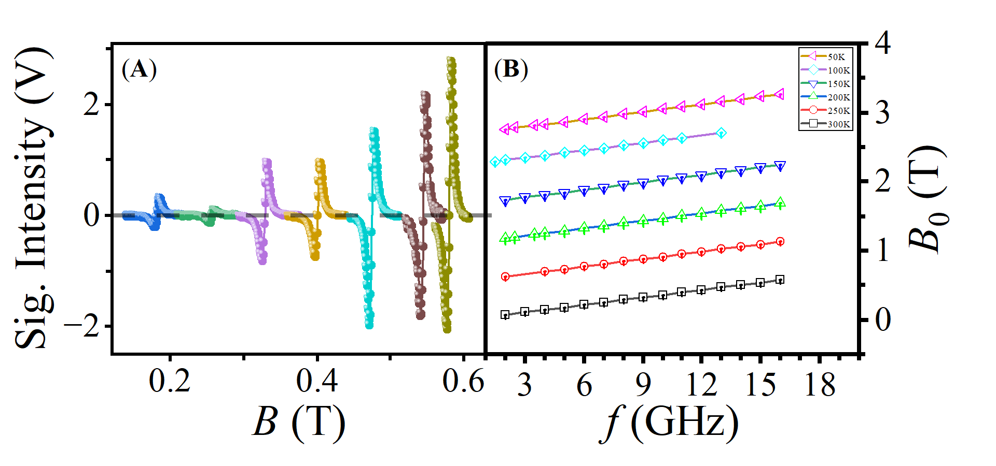
Fig. S1. (A) Representative broadband magnetic resonance spectra measured at 100 K showing the signal intensity as a function of the applied magnetic field B. (B) Shows the resonance magnetic field as a function of resonance frequency measured at temperatures from 300 K down to 50 K. The temperature-dependent magnetic field vs. frequency curves are identical and overlap. We offset each plot by 1T to separate them and enhance the readability. The solid lines are linear fits.
- Determination of various unknown magnetic fields
We applied several arbitrary external magnetic fields and detected them with our magnetometer, following the procedure described in the main text. The resonance spectrum was used to determine the corresponding magnetic field. Figure S2 illustrates representative measurements in different applied magnetic fields. We determined the resonance frequency (f₀) from the resonance spectrum shown in Figure S2A – C, as 5.0333(5) GHz, 10.0167(4) GHz, and 19.984(2) GHz, respectively. The unknown fields are determined by taking the ratio of $f_{0}/γ$, where $γ$ is the measured Gyromagnetic ratio. The measured unknown magnetic fields are 0.1781(1) T, 0.3579(1) T, and 0.7169(1) T, respectively.

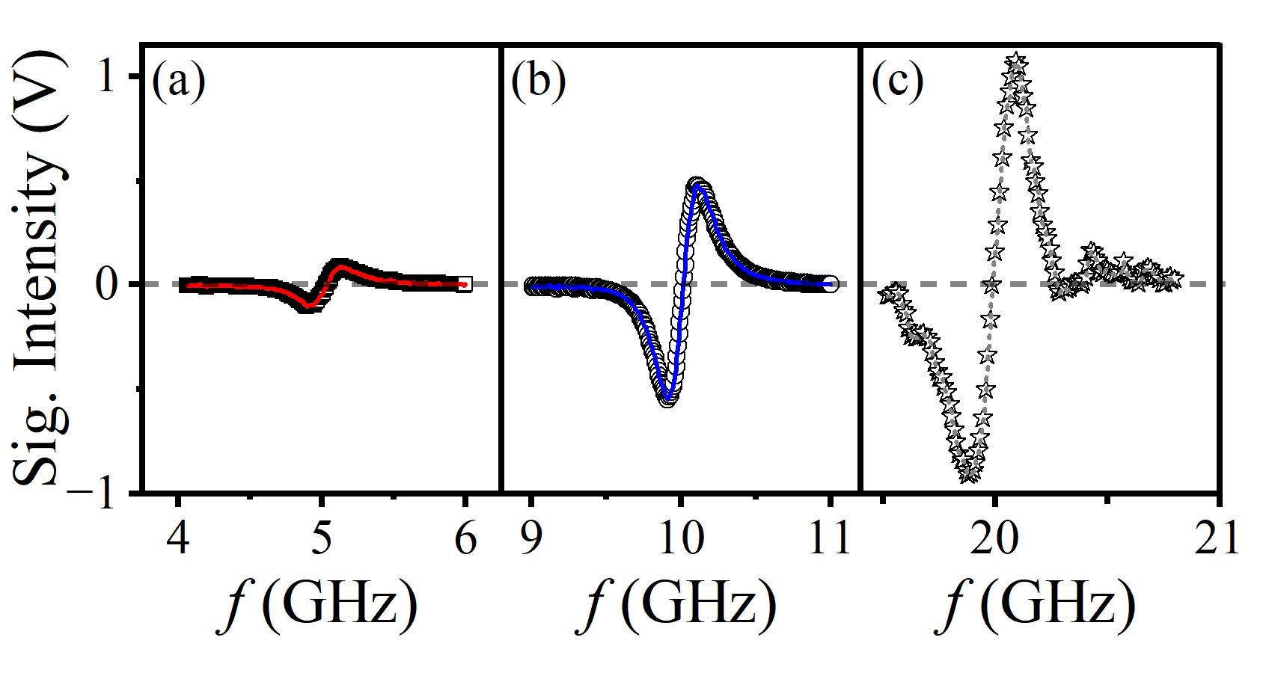

Fig. S2. Detection of unknown magnetic fields. (A)-(C) show the measured signal intensity as a function of microwave frequency for low, intermediate, and High magnetic field regimes, respectively. The resonance positions obtained from the spectra were used to determine the corresponding unknown magnetic fields. The horizontal dashed lines indicate the zero-signal baseline.

- Real-time magnetometry at various magnetic field ranges
In addition to field tracking at 0.9317 (2) T reported in the main text, we also perform magnetic field tracking at different fields, as shown in Figure S3. Figure S3A and Figure S3C report field tracking at 0.3579(2) T, and Figure S3B and Figure S3D demonstrate field tracking at 0.7169(1) T. The square-wave responses indicate a response time of ~10 ms for our magnetometer, while the sinusoidal waveform represents a representative oscillating magnetic field being tracked in real time. The subfigures in Figure S3C & Figure S3D show the Fast Fourier transforms (FFTs) of the recorded signals, revealing clear spectral peaks at various frequencies and confirming the accurate detection and tracking of the magnetic field in real time.

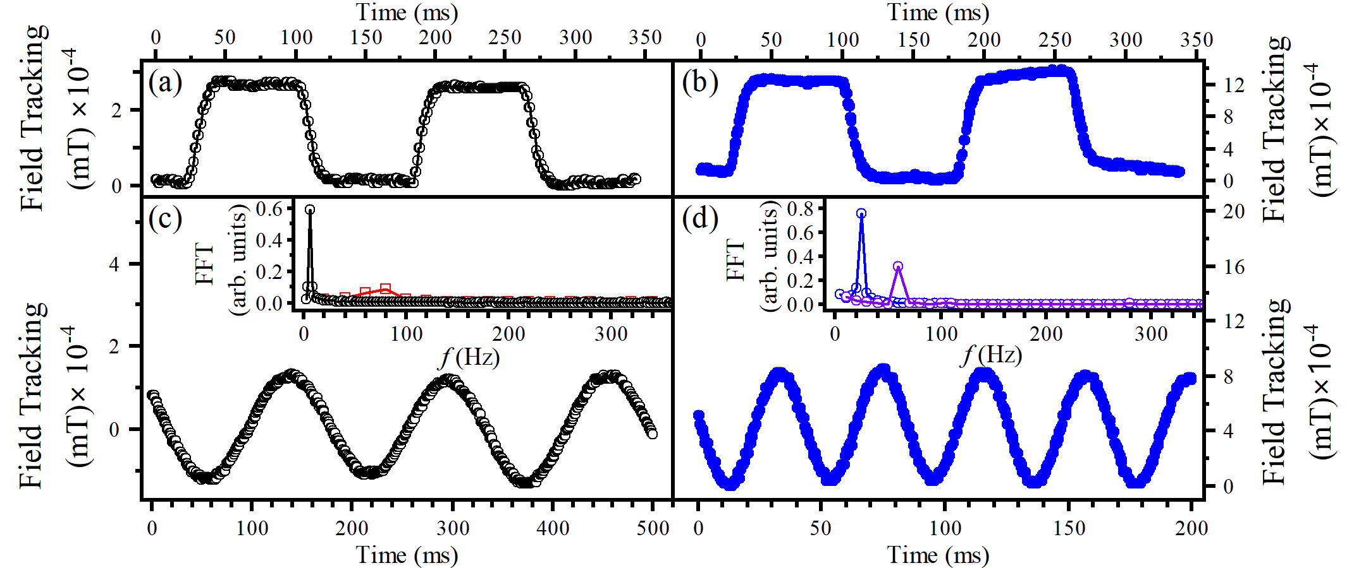

Fig. S3. Magnetic field tracking demonstrated at different resonance conditions. (A) and (C) Measured at 0.3579 T, and (B) and (D) at 0.7169 T. In each panel, the top trace shows the response to a square-wave magnetic field, the middle trace shows tracking of a sinusoidal field, and the sub-figures are the Fast Fourier transforms (FFTs) of the recorded sinusoidal fields at various frequencies.

- CrCl₃ crystal growth and characterization.
Crystal Growth:
Single crystals of CrCl3 were grown using a self-transport technique starting from commercially available CrCl₃ powder (Thermo Fisher, 99.9%). Approximately 0.6 g of CrCl₃ was loaded into a 20 cm long quartz ampoule of inner diameter 17 mm. The ampoule was sealed under vacuum and placed horizontally in a tube furnace, with the starting material positioned near the center (hot zone) of the furnace, while the opposite end of the tube extended into the cooler region near the furnace opening. The furnace was heated to 700 °C over 24 h and maintained at this temperature for an additional 24 h to ensure homogenization. Subsequently, a temperature gradient of 550–450 °C (hot-to-cold end) was established and maintained for several days to facilitate crystal growth via vapor transport. Large violet-colored CrCl₃ single crystals formed at the cooler end of the tube. To obtain larger crystals, the growth procedure was repeated under identical conditions. Millimeter-sized crystals of CrCl₃ were collected and stored in an Ar-filled glovebox. The phase identification and purity of CrCl₃ were verified by single-crystal X-ray diffraction and powder X-ray diffraction.
Powder X-ray diffraction of CrCl₃:
Room-temperature Powder X-ray diffraction (PXRD) measurements were performed using a Rigaku MiniFlex 6G diffractometer with Cu Kα radiation (λ = 1.5406 Å). Data were collected over a 2θ range of 10°–60°, using a step size of 0.05° and an exposure time of 10 seconds per step. Because the measurement was performed on a flake-like single crystal, the PXRD pattern displays only (00l) reflections, which suggests that the crystal is highly oriented along the c-axis. The positions of the observed diffraction peaks closely match those obtained from simulated patterns based on previously reported crystallographic data ¹, confirming that the sample is phase-pure and structurally consistent with the reported crystal structure.
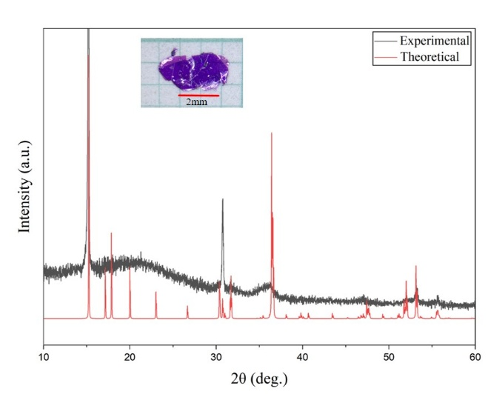

Fig. S4. Powder X-ray diffraction pattern of CrCl₃. Inset: Optical image of a violet CrCl₃ single crystal.

