Supplementary Material for

Title: Tracing the Evolution and Circulation of Measles Virus in Africa

Authors:
Sana Tamim 1#, Herve Kadjo 2#, Samiah Kanwar 3, Anna Salafsky 4, Olayinka Sunday Okoh 5,6, Marius Adagba 7, Yakoura Karidja Ouattara 7, Venance Kouakou 7, Sylla Aboubacar 8, Edgard Valery Adjogoua 9, Annick Dosseh 10, Balcha G Masresha 10, Nidia S. Trovao 11,12,13,14*

1. Public Health Laboratory Division, National Institute of Health, Chak Shahzad, Park Road, Islamabad, Pakistan
2. Department of Epidemic Viruses, Pasteur Institute of Côte d’Ivoire, Adiopodoumé, Km 17, route de Dabou, Côte d’Ivoire
3. Department of Paediatrics and Child Health, The Aga Khan University, Stadium Road, Karachi, Pakistan
4. Thayer School of Engineering, Dartmouth College, Hanover, New Hampshire, USA
5. Department of Chemical Sciences, Anchor University, Lagos, Nigeria
6. Centre for Global Health, Anchor University, Lagos, Nigeria
7. Department of Epidemic Viruses, Pasteur Institute of Côte d’Ivoire, Adiopodoumé, Km 17, route de Dabou, Côte d’Ivoire
8. Molecular Biology Platform, Pasteur Institute of Côte d’Ivoire, Adiopodoumé, route de Dabou, Côte d’Ivoire
9. Department of Epidemic Viruses, Pasteur Institute of Côte d’Ivoire, Adiopodoumé, Km 17, route de Dabou, Côte d’Ivoire
10. World Health Organization African Regional Office, Brazzaville, P.O. Box 06, Republic of the Congo
11. Division of International Epidemiology and Population Studies, Fogarty International Center, National Institutes of Health, Bethesda, Maryland, USA
12. Department of Pathobiology, College of Veterinary Medicine, University of Illinois Urbana-Champaign, Urbana, IL, USA
13. Carl R. Woese Institute for Genomic Biology, University of Illinois Urbana-Champaign, Urbana, IL, USA
14. National Center for Supercomputing Applications, University of Illinois Urbana-Champaign, Urbana, IL, USA
# Authors contributed equally
* Corresponding author

Correspondence: Nidia S. Trovao (ntrovao@illinois.edu).

Supplementary Figures:

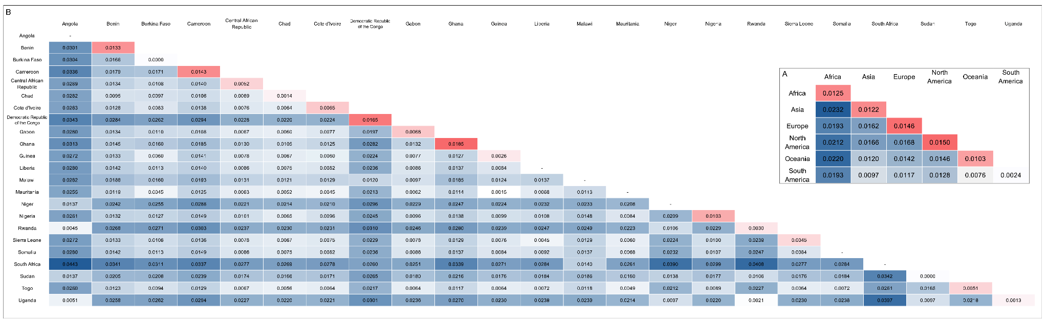
Supplementary Figure S1: Pairwise Genetic Distances of Measles Virus Sequences. The figure displays a matrix of average genetic distances calculated between and within groups. The visualization allows for the rapid identification of groups with closely related (low distance) or highly divergent (high distance) viral lineages, providing insights into global transmission patterns and evolutionary relationships. Genetic distances were estimated using the TN93 substitution model with pairwise deletion in the R package ape (version 5.7). The diagonal of each matrix represents the average genetic distance within each group, while the lower-left triangle shows the average genetic distance between groups. The diagonal and lower-left triangle are colored with a white-to-red and white-to-blue gradient, respectively, as distance increases. A: Continental Pairwise Genetic Similarities. This matrix shows the genetic distances among measles virus sequences from different continents. B: African Country Pairwise Genetic Similarities. This matrix presents the genetic distances among measles virus sequences from individual African countries, providing a higher-resolution view of viral relationships within the continent.

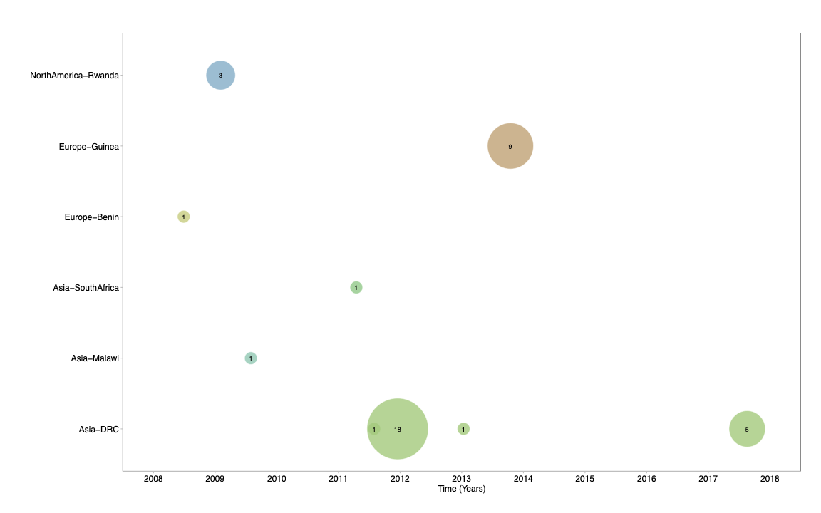
Supplementary Figure S2: The bubble plot elaborates introductions of Measles virus from different geographical regions into Africa from 2008 to 2018. The size of each bubble corresponds to the number of cases sequenced from the geographical location.

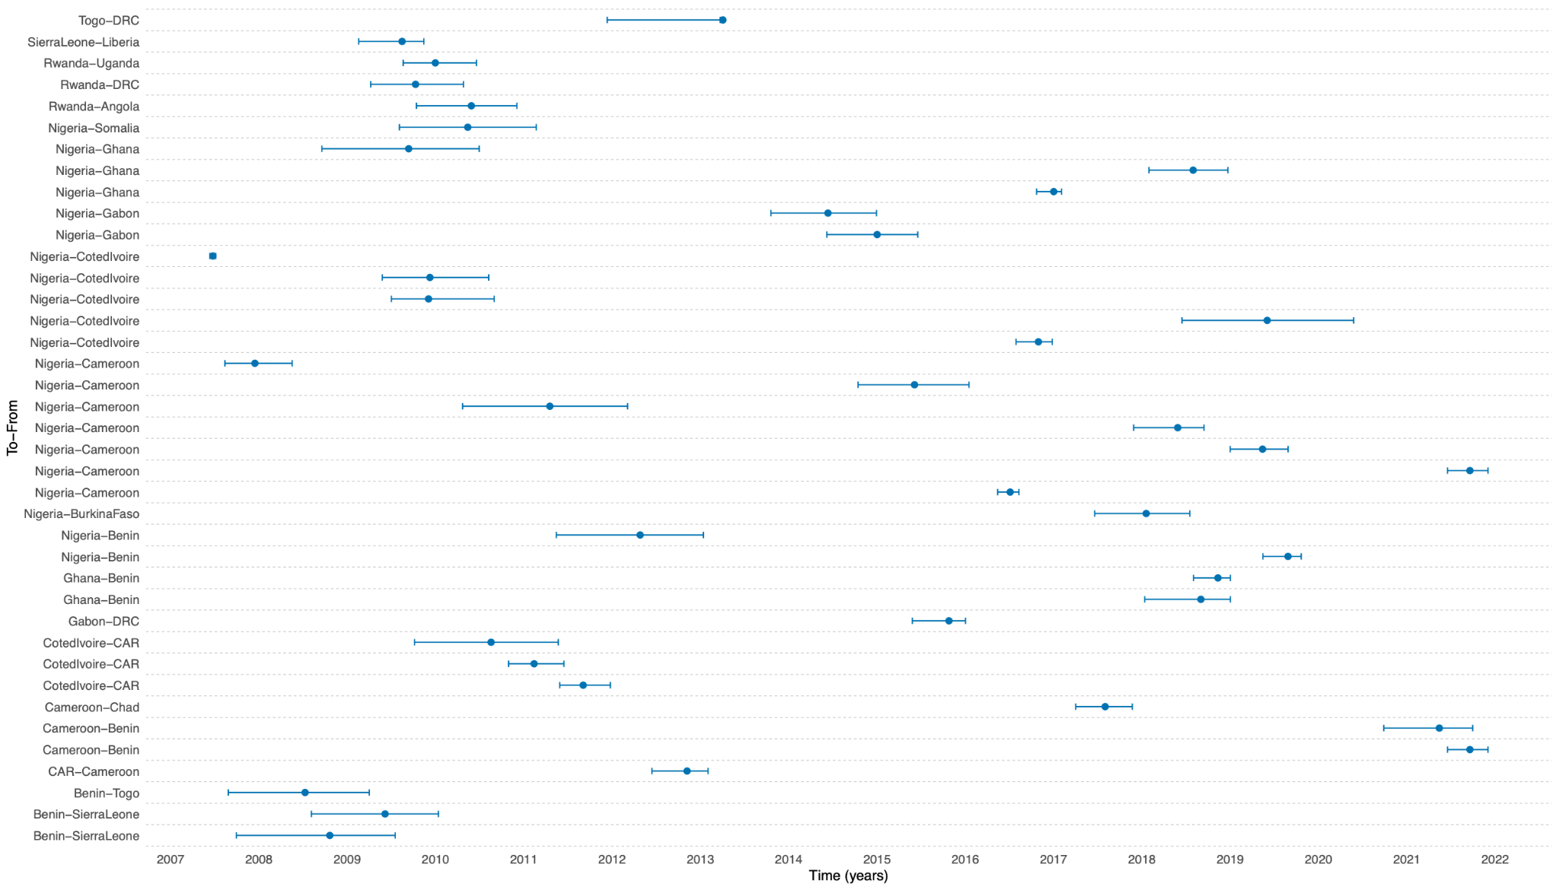
Supplementary Figure S3: Estimated time to the most recent common ancestry of individual transmission pathways events between different African countries. Blue lines depict these transmission events, with the horizontal bars indicating their estimation of upper and lower cortiles, the midpoint of each transmission event is marked by a dot. The labels on the y-axis identify the specific countries among which the MeV circulated, and the x-axis shows time in years.

Supplementary Tables:

Supplementary Table S1: Key data points on measles cases, deaths, and vaccination coverage across various African countries. The table provides the total reported measles cases in 2022, number of measles related deaths in 2021, number of measles virus genetic sequences uploaded to GenBank, in 2024 and the percentage of children who have received their second dose of the measles in 2022.
Country | Number of cases of Measles in 2022 | Number of deaths (2021) | Number of sequences from GenBank in 2024 | Measles second-dose coverage 2022 (%)
Algeria | 47 | 17 | 1 | 71
Angola | 3,271 | 342 | 14 | 25
Benin | 455 | 221 | 13 | -
Botswana | 1 | - | 16 | 77
Burkina Faso | 252 | 1,101 | 64 | 71
Burundi | 212 | 368 | - | 85
Cape Verde | 8 | 1 | - | 86
Cameroon | 3,217 | 934 | 74 | 44
Central African Republic | 155 | - | 64 | -
Chad | 2,158 | 4 | - | 2
Comoros | 4 | 15 | - | 79
Cote d'Ivoire | 1,596 | 830 | 34 | 20
Democratic Republic of the Congo | 4,380 | 1 442 | 312 | 34
Eritrea | 28 | 13 | - | 85
Ethiopia | 9,291 | 3 | 28 | 48
Gabon | 1,293 | 2 | 25 | -
Gambia | 58 | 81 | 24 | 52
Ghana | 395 | 37 | 10 | 84
Guinea | 417 | 1,974 | 24 | 3
Guinea-Bissau | 213 | 418 | 24 | 1
Kenya | 1,774 | 4 | 49 | 56
Lesotho | 3 | 6 | 13 | 75
Liberia | 8,300 | 330 | 5 | 59
Libya | 32 | 93 | 14 | 72
Madagascar | 80 | 84 | - | 32
Malawi | 29 | 406 | 28 | 60
Mali | 765 | 6,834 | 1 | 44
Mauritius | - | - | - | 93
Mauritania | 96 | 78 | 4 | -
Mayotte | - | - | 14 | -
Morocco | - | 25 | 70 | 99
Mozambique | 1,047 | 384 | 23 | 70
Namibia | 31 | - | 69 | 79
Niger | 12,898 | 2,756 | 6 | 42
Nigeria | 23,983 | 5,932 | 265 | 38
Rwanda | 29 | 88 | 20 | 82
Senegal | 508 | 372 | 9 | 66
Sierra Leone | 731 | 89 | 16 | 73
Somalia | 17,361 | 15,330 | 3 | 8
South Africa | 400 | 40 | 96 | 87
South Sudan | 3,401 | 68 | 54 | 63
Togo | 712 | 214 | 27 | 57
Tunisia | 11 | 1 | 72 | 98
Uganda | - | 350 | 59 | 49
United Republic of Tanzania | 612 | 2,368 | - | 76
Zambia | 1,755 | 841 | 35 | 81
Zimbabwe | 5,532 | 43 | 57 | 77

Supplementary Table S2: Pairwise Comparisons of Genetic Distances Between Continents. This table shows the p-values from a pairwise PERMANOVA analysis used to test for significant differences in genetic distances between continents. The p-values were corrected using the Bonferroni method to adjust for multiple comparisons. Corrected p-values less than 0.05 indicate a statistically significant difference in the genetic distances between the two continents.
Continent 1 | Continent 2 | p-value | Corrected p-value
Africa | Asia | 0.001 | 0.015
Africa | Europe | 0.001 | 0.015
Africa | North America | 0.001 | 0.015
Africa | Oceania | 0.001 | 0.015
Africa | South America | 0.001 | 0.015
Asia | Europe | 0.001 | 0.015
Asia | North America | 0.001 | 0.015
Asia | Oceania | 0.023 | 0.345
Asia | South America | 0.527 | 1
Europe | North America | 0.001 | 0.015
Europe | Oceania | 0.002 | 0.03
Europe | South America | 0.203 | 1
North America | Oceania | 0.015 | 0.225
North America | South America | 0.225 | 1
Oceania | South America | 0.95 | 1

Supplementary Table S3: Pairwise Comparisons of Genetic Distances Between African Countries. This table shows the p-values from a pairwise PERMANOVA analysis used to test for significant differences in genetic distances between African countries. The p-values were corrected using the Bonferroni method to adjust for multiple comparisons. Corrected p-values less than 0.05 indicate a statistically significant difference in the genetic distances between the two countries.
Continent 1 | Continent 2 | p-value | Corrected p-value
Angola | Benin | 0.031 | 1
Angola | Burkina Faso | 0.001 | 0.232
Angola | Cameroon | 0.017 | 1
Angola | Central African Republic | 0.046 | 1
Angola | Chad | 0.019 | 1
Angola | Cote d'Ivoire | 0.063 | 1
Angola | Democratic Republic of the Congo | 0.118 | 1
Angola | Gabon | 0.046 | 1
Angola | Ghana | 0.25 | 1
Angola | Guinea | 0.104 | 1
Angola | Liberia | - | -
Angola | Malawi | - | -
Angola | Mauritania | - | -
Angola | Niger | - | -
Angola | Nigeria | 0.006 | 1
Angola | Rwanda | 0.25 | 1
Angola | Sierra Leone | 0.136 | 1
Angola | Somalia | - | -
Angola | South Africa | - | -
Angola | Sudan | 0.33333333 | 1
Angola | Togo | 0.084 | 1
Angola | Uganda | 0.139 | 1
Benin | Burkina Faso | 0.001 | 0.232
Benin | Cameroon | 0.001 | 0.232
Benin | Central African Republic | 0.001 | 0.232
Benin | Chad | 1 | 1
Benin | Cote d'Ivoire | 0.003 | 0.696
Benin | Democratic Republic of the Congo | 0.001 | 0.232
Benin | Gabon | 0.001 | 0.232
Benin | Ghana | 0.629 | 1
Benin | Guinea | 0.002 | 0.464
Benin | Liberia | 0.482 | 1
Benin | Malawi | 0.082 | 1
Benin | Mauritania | 0.966 | 1
Benin | Niger | 0.033 | 1
Benin | Nigeria | 0.003 | 0.696
Benin | Rwanda | 0.001 | 0.232
Benin | Sierra Leone | 0.02 | 1
Benin | Somalia | 0.49 | 1
Benin | South Africa | 0.04 | 1
Benin | Sudan | 0.005 | 1
Benin | Togo | 0.016 | 1
Benin | Uganda | 0.001 | 0.232
Burkina Faso | Cameroon | 0.003 | 0.696
Burkina Faso | Central African Republic | 0.001 | 0.232
Burkina Faso | Chad | 0.001 | 0.232
Burkina Faso | Cote d'Ivoire | 0.001 | 0.232
Burkina Faso | Democratic Republic of the Congo | 0.002 | 0.464
Burkina Faso | Gabon | 0.001 | 0.232
Burkina Faso | Ghana | 0.012 | 1
Burkina Faso | Guinea | 0.002 | 0.464
Burkina Faso | Liberia | 1 | 1
Burkina Faso | Malawi | 0.153 | 1
Burkina Faso | Mauritania | 0.153 | 1
Burkina Faso | Niger | 0.001 | 0.232
Burkina Faso | Nigeria | 0.002 | 0.464
Burkina Faso | Rwanda | 0.019 | 1
Burkina Faso | Sierra Leone | 0.004 | 0.928
Burkina Faso | Somalia | 1 | 1
Burkina Faso | South Africa | 0.133 | 1
Burkina Faso | Sudan | 0.031 | 1
Burkina Faso | Togo | 0.001 | 0.232
Burkina Faso | Uganda | 0.001 | 0.232
Cameroon | Central African Republic | 0.001 | 0.232
Cameroon | Chad | 0.001 | 0.232
Cameroon | Cote d'Ivoire | 0.001 | 0.232
Cameroon | Democratic Republic of the Congo | 0.001 | 0.232
Cameroon | Gabon | 1 | 1
Cameroon | Ghana | 0.104 | 1
Cameroon | Guinea | 0.005 | 1
Cameroon | Liberia | 0.679 | 1
Cameroon | Malawi | 0.133 | 1
Cameroon | Mauritania | 0.837 | 1
Cameroon | Niger | 0.013 | 1
Cameroon | Nigeria | 0.001 | 0.232
Cameroon | Rwanda | 0.002 | 0.464
Cameroon | Sierra Leone | 0.056 | 1
Cameroon | Somalia | 0.509 | 1
Cameroon | South Africa | 0.012 | 1
Cameroon | Sudan | 0.003 | 0.696
Cameroon | Togo | 0.035 | 1
Cameroon | Uganda | 0.001 | 0.232
Central African Republic | Chad | 0.001 | 0.232
Central African Republic | Cote d'Ivoire | 0.001 | 0.232
Central African Republic | Democratic Republic of the Congo | 0.001 | 0.232
Central African Republic | Gabon | 0.001 | 0.232
Central African Republic | Ghana | 0.029 | 1
Central African Republic | Guinea | 0.001 | 0.232
Central African Republic | Liberia | 0.141 | 1
Central African Republic | Malawi | 0.083 | 1
Central African Republic | Mauritania | 0.308 | 1
Central African Republic | Niger | 0.064 | 1
Central African Republic | Nigeria | 0.001 | 0.232
Central African Republic | Rwanda | 0.001 | 0.232
Central African Republic | Sierra Leone | 0.001 | 0.232
Central African Republic | Somalia | 0.139 | 1
Central African Republic | South Africa | 0.045 | 1
Central African Republic | Sudan | 0.006 | 1
Central African Republic | Togo | 0.002 | 0.464
Central African Republic | Uganda | 0.001 | 0.232
Chad | Cote d'Ivoire | 0.001 | 0.232
Chad | Democratic Republic of the Congo | 0.001 | 0.232
Chad | Gabon | 0.001 | 0.232
Chad | Ghana | 1 | 1
Chad | Guinea | 0.001 | 0.232
Chad | Liberia | 0.015 | 1
Chad | Malawi | 0.013 | 1
Chad | Mauritania | 0.042 | 1
Chad | Niger | 0.01 | 1
Chad | Nigeria | 1 | 1
Chad | Rwanda | 0.001 | 0.232
Chad | Sierra Leone | 0.001 | 0.232
Chad | Somalia | 0.015 | 1
Chad | South Africa | 0.009 | 1
Chad | Sudan | 0.001 | 0.232
Chad | Togo | 0.001 | 0.232
Chad | Uganda | 0.001 | 0.232
Cote d'Ivoire | Democratic Republic of the Congo | 0.001 | 0.232
Cote d'Ivoire | Gabon | 0.001 | 0.232
Cote d'Ivoire | Ghana | 0.328 | 1
Cote d'Ivoire | Guinea | 0.043 | 1
Cote d'Ivoire | Liberia | 0.168 | 1
Cote d'Ivoire | Malawi | 0.044 | 1
Cote d'Ivoire | Mauritania | 0.911 | 1
Cote d'Ivoire | Niger | 0.059 | 1
Cote d'Ivoire | Nigeria | 0.012 | 1
Cote d'Ivoire | Rwanda | 0.002 | 0.464
Cote d'Ivoire | Sierra Leone | 0.006 | 1
Cote d'Ivoire | Somalia | 0.167 | 1
Cote d'Ivoire | South Africa | 0.044 | 1
Cote d'Ivoire | Sudan | 0.005 | 1
Cote d'Ivoire | Togo | 0.018 | 1
Cote d'Ivoire | Uganda | 0.001 | 0.232
Democratic Republic of the Congo | Gabon | 0.001 | 0.232
Democratic Republic of the Congo | Ghana | 0.022 | 1
Democratic Republic of the Congo | Guinea | 0.001 | 0.232
Democratic Republic of the Congo | Liberia | 0.161 | 1
Democratic Republic of the Congo | Malawi | 1 | 1
Democratic Republic of the Congo | Mauritania | 0.188 | 1
Democratic Republic of the Congo | Niger | 0.168 | 1
Democratic Republic of the Congo | Nigeria | 0.001 | 0.232
Democratic Republic of the Congo | Rwanda | 0.008 | 1
Democratic Republic of the Congo | Sierra Leone | 0.004 | 0.928
Democratic Republic of the Congo | Somalia | 0.154 | 1
Democratic Republic of the Congo | South Africa | 0.175 | 1
Democratic Republic of the Congo | Sudan | 0.033 | 1
Democratic Republic of the Congo | Togo | 0.001 | 0.232
Democratic Republic of the Congo | Uganda | 0.001 | 0.232
Gabon | Ghana | 0.136 | 1
Gabon | Guinea | 0.001 | 0.232
Gabon | Liberia | 0.099 | 1
Gabon | Malawi | 0.117 | 1
Gabon | Mauritania | 0.394 | 1
Gabon | Niger | 0.039 | 1
Gabon | Nigeria | 0.001 | 0.232
Gabon | Rwanda | 0.002 | 0.464
Gabon | Sierra Leone | 0.033 | 1
Gabon | Somalia | 0.106 | 1
Gabon | South Africa | 0.033 | 1
Gabon | Sudan | 0.003 | 0.696
Gabon | Togo | 0.068 | 1
Gabon | Uganda | 0.001 | 0.232
Ghana | Guinea | 0.022 | 1
Ghana | Liberia | 1 | 1
Ghana | Malawi | 0.75 | 1
Ghana | Mauritania | 1 | 1
Ghana | Niger | 0.25 | 1
Ghana | Nigeria | 0.458 | 1
Ghana | Rwanda | 0.1 | 1
Ghana | Sierra Leone | 0.061 | 1
Ghana | Somalia | 1 | 1
Ghana | South Africa | 0.25 | 1
Ghana | Sudan | 0.1 | 1
Ghana | Togo | 0.548 | 1
Ghana | Uganda | 0.011 | 1
Guinea | Liberia | 0.104 | 1
Guinea | Malawi | 0.088 | 1
Guinea | Mauritania | 1 | 1
Guinea | Niger | 0.091 | 1
Guinea | Nigeria | 0.009 | 1
Guinea | Rwanda | 0.006 | 1
Guinea | Sierra Leone | 0.001 | 0.232
Guinea | Somalia | 0.089 | 1
Guinea | South Africa | 0.126 | 1
Guinea | Sudan | 0.024 | 1
Guinea | Togo | 0.001 | 0.232
Guinea | Uganda | 0.001 | 0.232
Liberia | Malawi | - | -
Liberia | Mauritania | - | -
Liberia | Niger | - | -
Liberia | Nigeria | 0.306 | 1
Liberia | Rwanda | 0.25 | 1
Liberia | Sierra Leone | 0.725 | 1
Liberia | Somalia | - | -
Liberia | South Africa | - | -
Liberia | Sudan | 0.33333333 | 1
Liberia | Togo | 0.236 | 1
Liberia | Uganda | 0.12 | 1
Malawi | Mauritania | - | -
Malawi | Niger | - | -
Malawi | Nigeria | 0.136 | 1
Malawi | Rwanda | 0.25 | 1
Malawi | Sierra Leone | 0.144 | 1
Malawi | Somalia | - | -
Malawi | South Africa | - | -
Malawi | Sudan | 0.33333333 | 1
Malawi | Togo | 0.075 | 1
Malawi | Uganda | 0.162 | 1
Mauritania | Niger | - | -
Mauritania | Nigeria | 0.611 | 1
Mauritania | Rwanda | 0.25 | 1
Mauritania | Sierra Leone | 0.293 | 1
Mauritania | Somalia | - | -
Mauritania | South Africa | - | -
Mauritania | Sudan | 0.33333333 | 1
Mauritania | Togo | 0.494 | 1
Mauritania | Uganda | 0.135 | 1
Niger | Nigeria | 0.061 | 1
Niger | Rwanda | 0.25 | 1
Niger | Sierra Leone | 0.14 | 1
Niger | Somalia | - | -
Niger | South Africa | - | -
Niger | Sudan | 0.33333333 | 1
Niger | Togo | 0.093 | 1
Niger | Uganda | 0.125 | 1
Nigeria | Rwanda | 0.002 | 0.464
Nigeria | Sierra Leone | 0.031 | 1
Nigeria | Somalia | 0.321 | 1
Nigeria | South Africa | 0.002 | 0.464
Nigeria | Sudan | 0.01 | 1
Nigeria | Togo | 0.089 | 1
Nigeria | Uganda | 0.001 | 0.232
Rwanda | Sierra Leone | 0.009 | 1
Rwanda | Somalia | 0.25 | 1
Rwanda | South Africa | 0.25 | 1
Rwanda | Sudan | 0.1 | 1
Rwanda | Togo | 0.009 | 1
Rwanda | Uganda | 0.318 | 1
Sierra Leone | Somalia | 0.14 | 1
Sierra Leone | South Africa | 0.137 | 1
Sierra Leone | Sudan | 0.034 | 1
Sierra Leone | Togo | 0.002 | 0.464
Sierra Leone | Uganda | 0.001 | 0.232
Somalia | South Africa | - | -
Somalia | Sudan | 0.33333333 | 1
Somalia | Togo | 0.256 | 1
Somalia | Uganda | 0.129 | 1
South Africa | Sudan | 0.33333333 | 1
South Africa | Togo | 0.078 | 1
South Africa | Uganda | 0.137 | 1
Sudan | Togo | 0.011 | 1
Sudan | Uganda | 0.031 | 1
Togo | Uganda | 0.001 | 0.232

Supplementary Table S4: Pairwise Pearson correlation coefficients (r) and corresponding p-values for epidemiological, vaccination, and phylodynamic variables.
 |  | Cases/  Population | Deaths/  Population | Sequences/  Population | 2nd Vaccine Dose | Persistence Period | Period of Undetected Circulation
Cases/ Population | correlation, r | 1
Cases/ Population | p-value | 0
Deaths/ Population | correlation, r | 0.98 | 1
Deaths/ Population | p-value | 0 | 0
Sequences/ Population | correlation, r | -0.21 | -0.28 | 1
Sequences/ Population | p-value | 0.28 | 0.15 | 0
2nd Vaccine Dose | correlation, r | -0.37 | -0.35 | 0.01 | 1
2nd Vaccine Dose | p-value | 0.05 | 0.07 | 0.95 | 0
Persistence Period | correlation, r | -0.03 | -0.08 | 0.09 | -0.08 | 1
Persistence Period | p-value | 0.89 | 0.67 | 0.66 | 0.7 | 0
Period of Undetected Circulation | correlation, r | -0.05 | -0.12 | 0.2 | -0.11 | 0.82 | 1
Period of Undetected Circulation | p-value | 0.78 | 0.54 | 0.31 | 0.57 | 0 | 0

