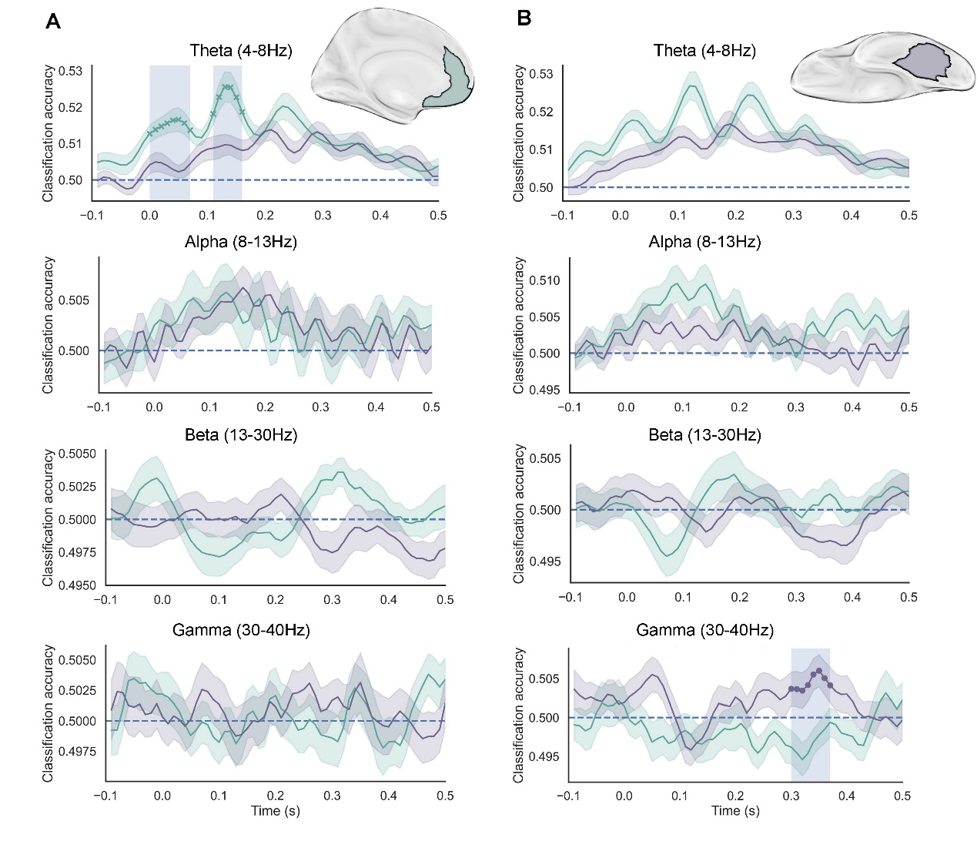
Figure S1. Conceptual advantage in vmPFC expressed in theta band while leads perceptual advantage in VVC expressed in gamma band. (A). In vmPFC, conceptual reinstatement was significantly stronger than perceptual reinstatement in the theta band during the two time windows: 0–70 ms and 110–160 ms ($p_{fwe}$ < 0.05). No significant differences were observed in other frequency bands. (B) In contrast, VVC showed significantly stronger perceptual than conceptual reinstatement in the gamma band from 300–370 ms ($p_{fwe}$ < 0.05). No significant differences were observed in other frequency bands. vmPFC, ventromedial prefrontal cortex; VVC, ventral visual cortex.

