Supplementary Information
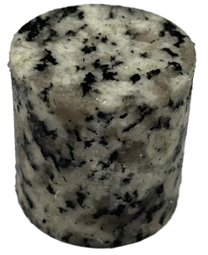  - P-1-1 | 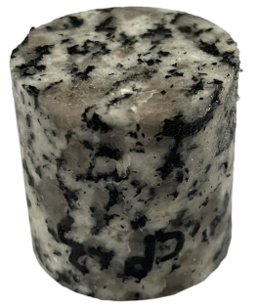  - P-1-12 | 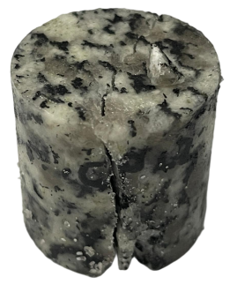  - P-1-14
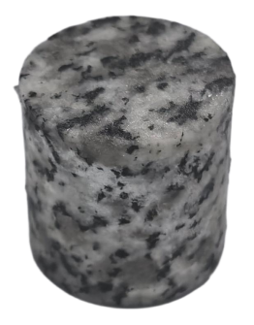  - P-2-1 | 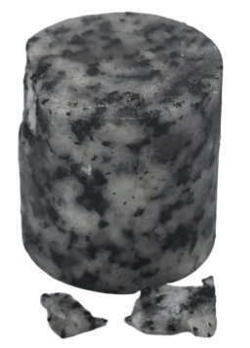  - P-1-4 | 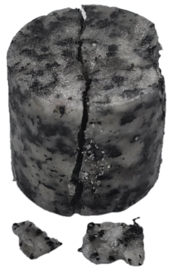  - P-2-5
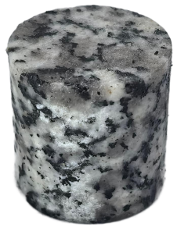  - P-3-1 | 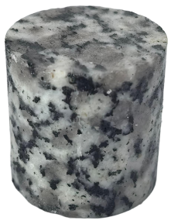  - P-3-2 | 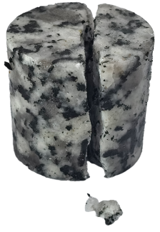  - P-3-3
Fig. S1 Macroscopic morphology of the P group at different key loading stages

Table S1 CP group peak stress-elastic modulus data table
Group no. | Impact air pressure (MPa) | Impact velocity (m/s) | Peak stress  (MPa) | Elastic modulus (GPa)
CP-1-1 | 0.040 | 3.67 | 63.95 | 84.14
CP-1-2 | 0.045 | 4.35 | 74.01 | 221.63
CP-1-3 | 0.050 | 4.89 | 93.74 | 458.12
CP-1-4 | 0.055 | 5.38 | 97.4 | 355.44
CP-1-5 | 0.060 | 5.95 | 119.49 | 192.40
CP-1-6 | 0.065 | 6.48 | 131.23 | 274.37
CP-2-1 | 0.040 | 3.65 | 67.55 | 403.26
CP-2-2 | 0.050 | 4.78 | 92.14 | 424.35
CP-2-3 | 0.060 | 6.00 | 122.38 | 443.74
CP-2-4 | 0.070 | 7.07 | 145.33 | 408.36
CP-3-1 | 0.04 | 3.80 | 71.87 | 222.35
CP-3-2 | 0.06 | 6.37 | 133.50 | 399.12
CP-3-3 | 0.08 | 8.11 | 171.88 | 499.08

Table S2 P group peak stress-elastic modulus data table
Group no. | Impact air pressure (MPa) | Impact velocity (m/s) | Peak stress  (MPa) | Elastic modulus (GPa)
P-1-1 | 0.04 | 3.720 | 80.04 | 537.34
P-1-2 | 0.04 | 3.730 | 78.94 | 478.72
P-1-3 | 0.04 | 3.720 | 77.57 | 414.38
P-1-4 | 0.04 | 3.502 | 72.00 | 375.78
P-1-5 | 0.04 | 4.340 | 70.97 | 345.58
P-1-6 | 0.04 | 3.800 | 69.78 | 321.64
P-1-7 | 0.04 | 4.200 | 67.98 | 298.90
P-1-8 | 0.04 | 3.930 | 67.57 | 292.78
P-1-9 | 0.04 | 3.800 | 65.61 | 260.98
P-1-10 | 0.04 | 4.100 | 65.48 | 236.17
P-1-11 | 0.04 | 3.90 | 62.74 | 213.12
P-1-12 | 0.04 | 3.780 | 56.36 | 167.58
P-1-13 | 0.04 | 3.770 | 51.64 | 141.13
P-1-14 | 0.04 | 4.000 | 48.13 | 139.81
P-2-1 | 0.05 | 5.118 | 102.57 | 446.40
P-2-2 | 0.05 | 5.148 | 100.33 | 208.91
P-2-3 | 0.05 | 5.080 | 100.74 | 348.91
P-2-4 | 0.05 | 5.150 | 99.70 | 188.84
P-2-5 | 0.05 | 5.070 | 95.70 | 100.50
P-3-1 | 0.06 | 5.730 | 117.42 | 417.62
P-3-2 | 0.06 | 5.600 | 116.79 | 219.24
P-3-3 | 0.06 | 5.700 | 113.26 | 109.50

Table S3 Variation of cumulative dissipated energy with impact cycles
Group no. | Dissipated energy per impact  (kJ) | Cumulative dissipated energy (kJ)
CP-1-1 | 0.133 | 0.133
CP-1-2 | 0.073 | 0.206
CP-1-3 | 0.068 | 0.274
CP-1-4 | 0.187 | 0.461
CP-1-5 | 0.307 | 0.768
CP-1-6 | 0.272 | 1.040
CP-2-1 | 0.095 | 0.095
CP-2-2 | 0.083 | 0.179
CP-2-3 | 0.046 | 0.225
CP-2-4 | 0.213 | 0.438
CP-3-1 | 0.141 | 0.141
CP-3-2 | 0.082 | 0.223
CP-3-3 | 0.042 | 0.265
P-1-1 | 0.0375 | 0.0375
P-1-2 | 0.0445 | 0.082
P-1-3 | 0.0474 | 0.1294
P-1-4 | 0.0533 | 0.1827
P-1-5 | 0.0554 | 0.2381
P-1-6 | 0.0625 | 0.3006
P-1-7 | 0.0644 | 0.365
P-1-8 | 0.0665 | 0.4315
P-1-9 | 0.0854 | 0.5169
P-1-10 | 0.0942 | 0.6111
P-1-11 | 0.0955 | 0.7066
P-1-12 | 0.148 | 0.8546
P-1-13 | 0.321 | 1.1756
P-1-14 | 0.724 | 1.8996
P-2-1 | 0.0387 | 0.0387
P-2-2 | 0.0459 | 0.0846
P-2-3 | 0.185 | 0.2696
P-2-4 | 0.212 | 0.4816
P-2-5 | 0.258 | 0.7396
P-3-1 | 0.0395 | 0.0395
P-3-2 | 0.172 | 0.2115
P-3-3 | 0.371 | 0.5825

Table S4 Variation of modulus-based and energy-based damage variables with impact cycles
Group no. | Energy-based damage variable
CP-1-1 | 0.12788
CP-1-2 | 0.19808
CP-1-3 | 0.26346
CP-1-4 | 0.44327
CP-1-5 | 0.73846
CP-1-6 | 1
CP-2-1 | 0.21791
CP-2-2 | 0.40795
CP-2-3 | 0.51348
CP-2-4 | 1
CP-3-1 | 0.53268
CP-3-2 | 0.84057
CP-3-3 | 1
P-1-1 | 0.01974
P-1-2 | 0.04317
P-1-3 | 0.06812
P-1-4 | 0.09618
P-1-5 | 0.12534
P-1-6 | 0.15824
P-1-7 | 0.19215
P-1-8 | 0.22715
P-1-9 | 0.27211
P-1-10 | 0.3217
P-1-11 | 0.37197
P-1-12 | 0.44988
P-1-13 | 0.61887
P-1-14 | 1
P-2-1 | 0.05233
P-2-2 | 0.11439
P-2-3 | 0.36452
P-2-4 | 0.65116
P-2-5 | 1
P-3-1 | 0.06781
P-3-2 | 0.36309
P-3-3 | 1

