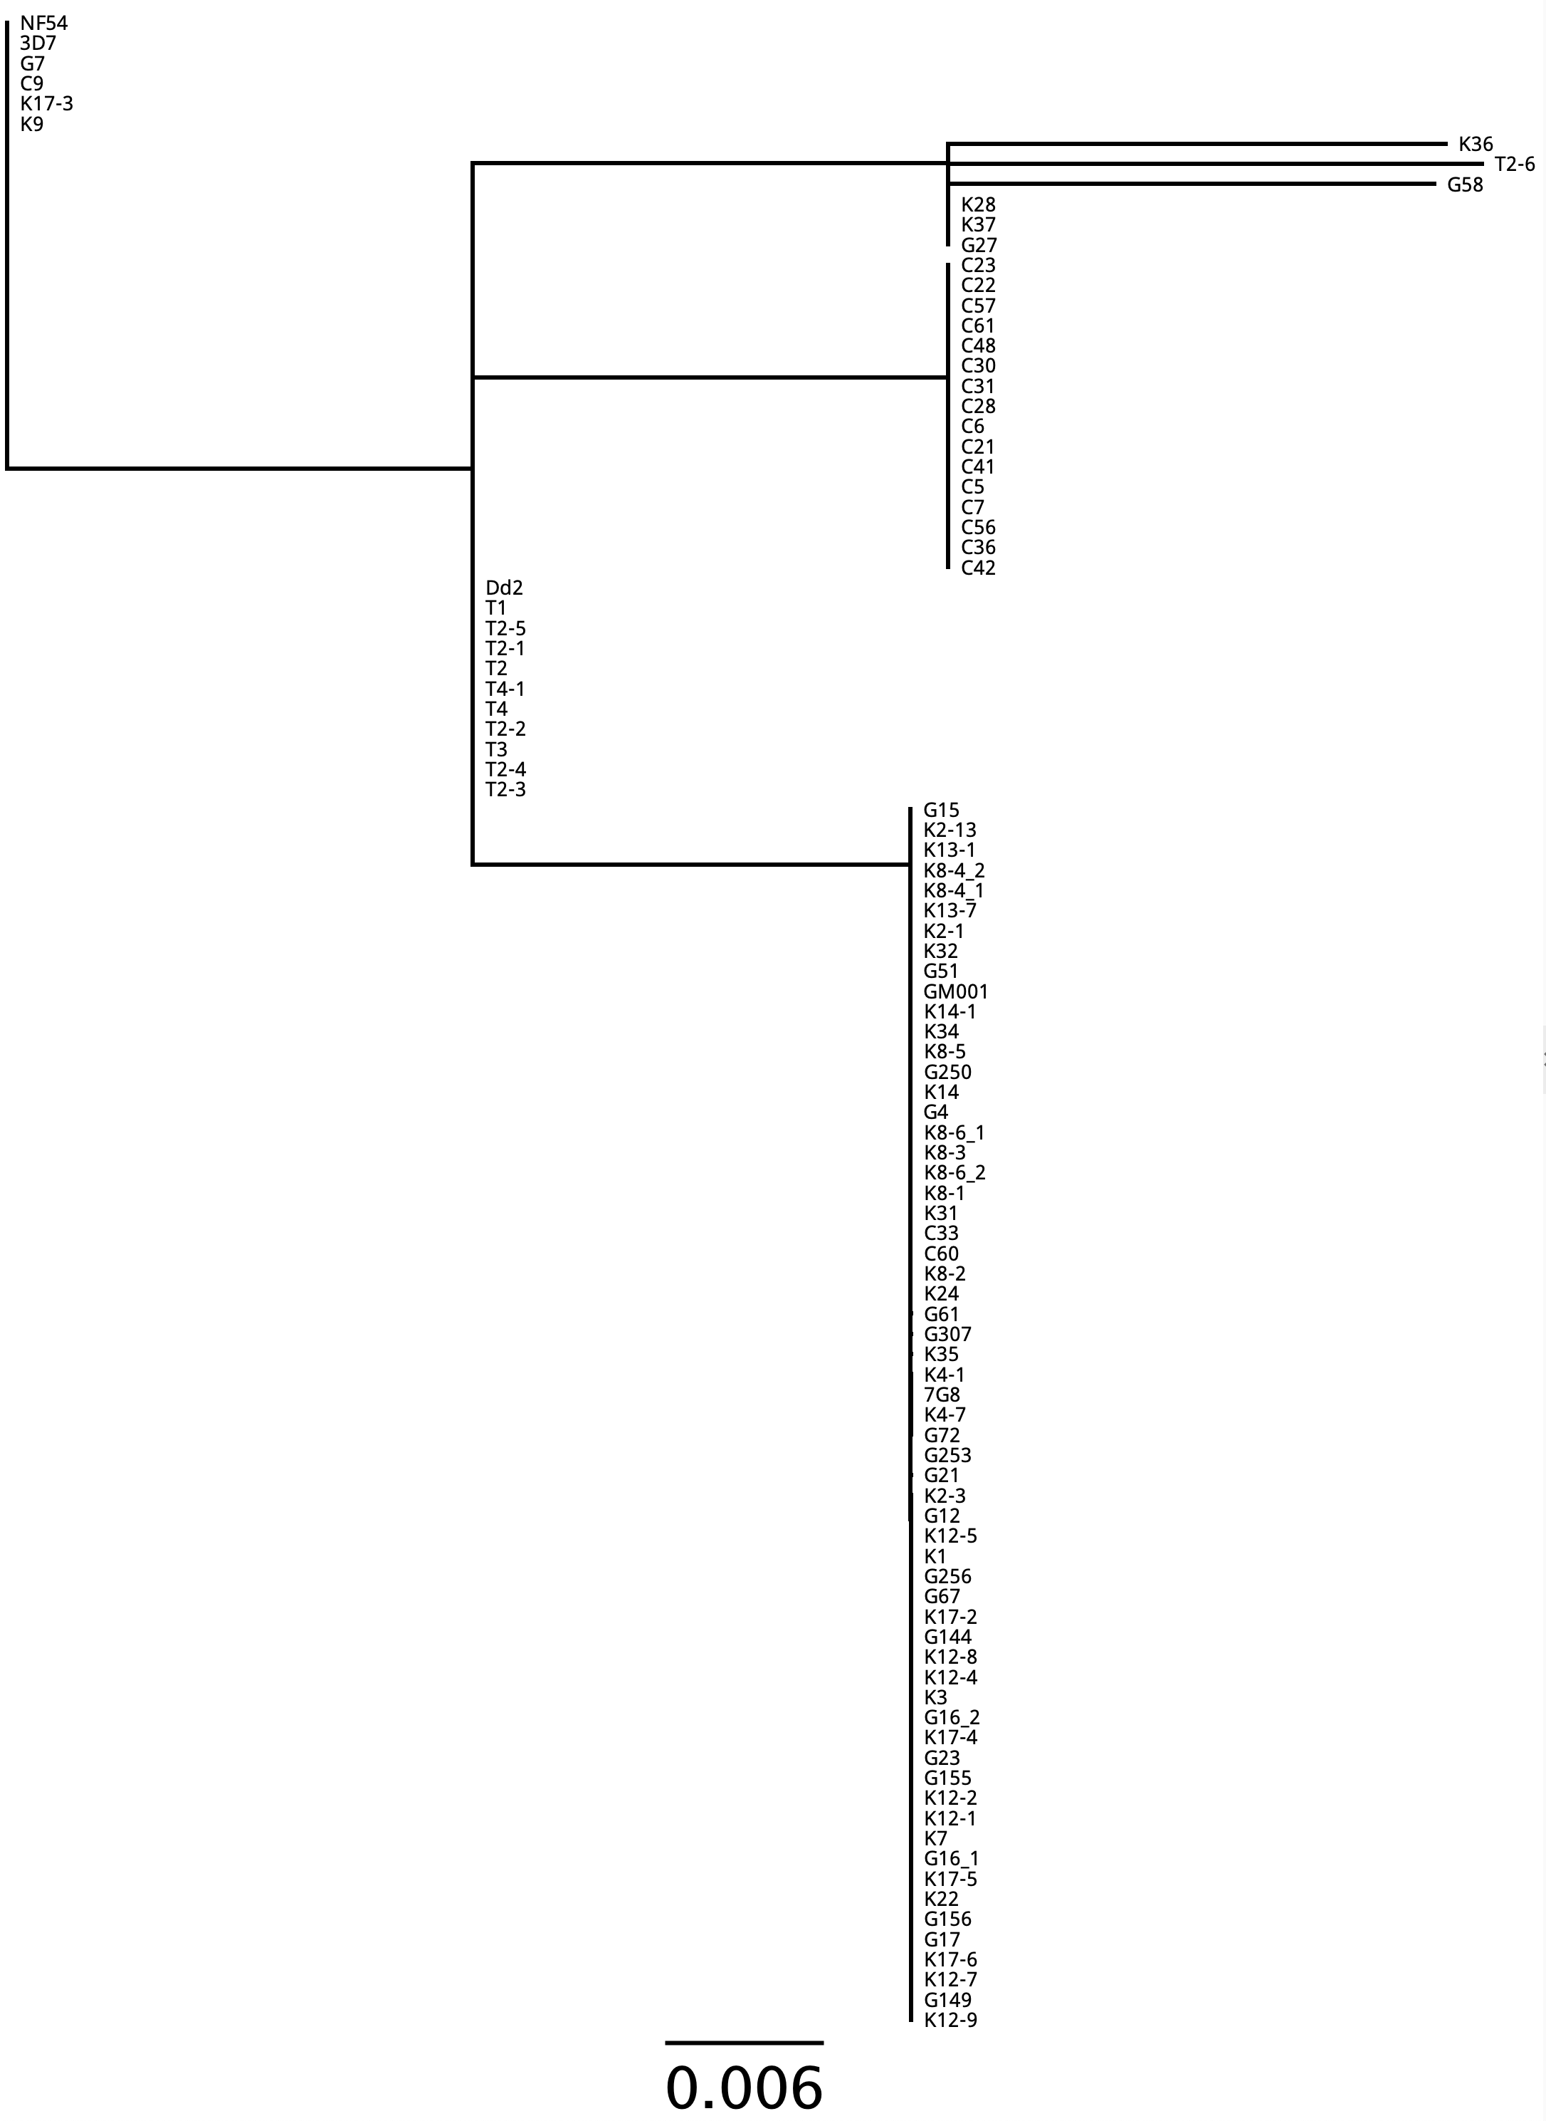
Haplotype 1 (n = 6)
Haplotype 2 (n=11)
Haplotype 3 (n=16)
Haplotype 4
(n=61)
Haplotype
6-8 (n=1 each)
Haplotype 5 (n=3)
Haplotype Composition Descriptions
- 3D7 – Like
- “DD2/T1-Like” All Thailand isolates
- “C23-like” - All Columbian Isolates
- “G15-like” - All Ghana and Kenyan Isolates
- “K28-like” (minor) – mixed Kenyan and Ghanan
- (minor) - G58
- (minor) - Clone T2-6
- (minor) – K36

Supplemental Figure 1. CHMI Isolate pfcsp CRR’s cluster by isolation origin. MAFFT aligned-RAxML tree of the Pf CSP central repeat region (CRR) of 100 representative sequences. Haplotypes are defined as clades which contain sequences ≥ 99.95% alignment identity revealing 4 major clusters with n ≥ 16 observations and 4 minor clusters with ≤ 3 observations.
Supplemental Table 1. Microsatellite Diversity Metrics by Population.

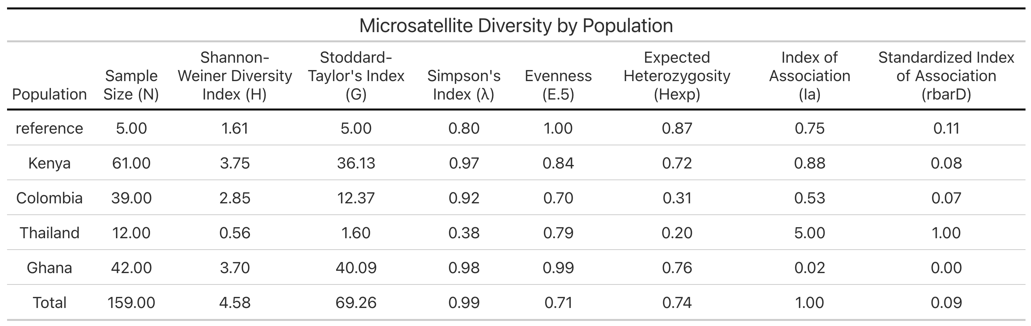
Supplemental Table 2. Microsatellite loci richness. Each number represents the total unique microsatellite alleles by locus and collection site.

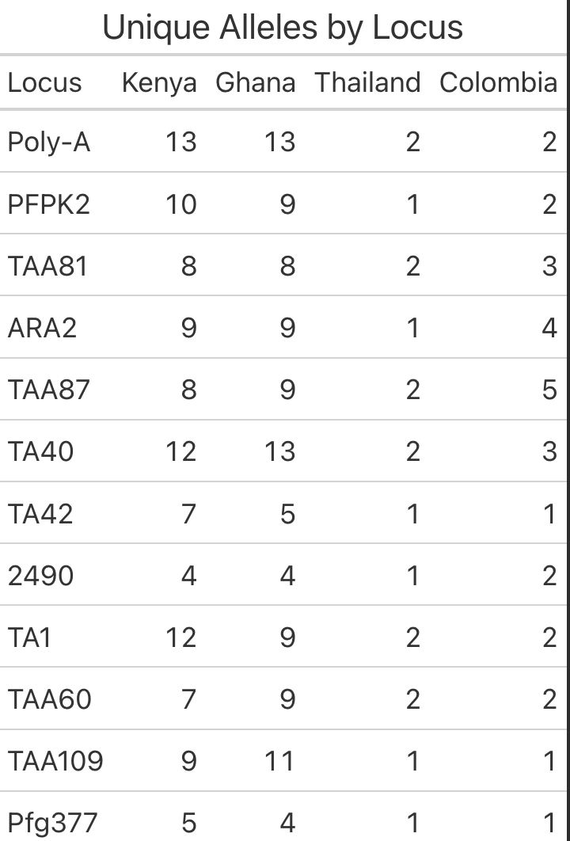
Supplemental Table 3. Controlled Human Malaria Infection (CHMI) clinical site information.

