Implications of bio-preservation using Pediococcus pentosaceus HPM1-derived bacteriocin for the shelf-life enhancement of food
Current Microbiology
Authors:
Payel Sur¹, Harekrishna Jana^{1*}, Mrinal Kanti Paira², Puspendu Shit³, Samiran Sona Gauri⁴
Affiliations:
¹ Department of Microbiology, Raja Narendralal Khan Women’s College (Autonomous), Paschim Medinipur-721102, West Bengal, India.
² Department of Chemistry, Raja Narendralal Khan Women’s College (Autonomous), Paschim Medinipur-721102, West Bengal, India.
³ Department of Zoology, Debra Thana Sahid Kshudiram Smriti Mahavidyalaya (Autonomous), Paschim Medinipur-721126, West Bengal, India
⁴Central Research Facility, Indian Institute of Technology, Kharagpur, West Bengal-721302, India
*Corresponding Author: Dr. Harekrishna Jana
Email: hkjmicro@gmail.com

Supplementary Materials
Table S1 Determination of antibacterial activity of isolate HPM1 against food spoilage bacteria. Data are presented as mean ± standard deviation (n=3).
Strain | Zone of inhibition (mm) Mean± SD
Strain | Bacillus cereus | Staphylococcus aureus | Clostridium botulinum | Enterococcus faecalis. | Escherichia coli | Pseudomonas aeruginosa | Vibrio cholerae | Klebsiella pneumoniae.
Control | 8±0 | 8±0 | 8±0 | 8±0 | 8±0 | 8±0 | 8±0 | 8±0
HPM1 | 17.67±.577 | 16.67±0.577 | 20.33±0.577 | 18.33±0.577 | 17±1 | 21±1 | 18.67±1.157 | 19.33±1.527

Table S2 Determination of antifungal activity of isolate HPM1 against food spoilage fungus. Data are presented as mean ± standard deviation (n=3).
Strain | Zone of inhibition (mm) Mean± SD
Strain | Aspergillus niger | Aspergillus flavus | Aspergillus fumigatus | Candida albicans
Control | 8±0 | 8±0 | 8±0 | 8±0
HPM1 | 15±1 | 12±1 | 10.33±1.154 | 18±1

Table S3 Confirmation of bacteriocin production activity of isolate HPM1 compared with the positive control strain. Data are presented as mean ± standard deviation (n=3). Statistical significance was determined using One-way ANOVA followed by Tukey’s HSD test.
Strain | Zone of inhibition (mm) Mean± SD
Strain | Bacillus cereus | Staphylococcus aureus | Clostridium botulinum | Enterococcus faecalis. | Escherichia coli | Pseudomonas aeruginosa | Vibrio cholerae | Klebsiella pneumoniae. | Listeria monocytogenus
Control | 8±0 | 8±0 | 8±0 | 8±0 | 8±0 | 8±0 | 8±0 | 8±0 | 8±0
Possitive control | 19.67±0.577 | 17±1 | 16.33±0.577 | 23.67±0.577 | 20.67±0.577 | 24.33±0.577 | 18±1 | 21±1 | 19.67±1.154
HPM1 | 18.0±1 | 17±1 | 19.67±0.577 | 18.33±0.577 | 16.33±0.577 | 21.66±0.577 | 17.67±1.155 | 20.0±1 | 17±1

Table S4 Confirmation of bacteriocin production activity of isolate HPM1 using proteolytic enzymes with the positive control. Data are presented as mean ± standard deviation (n=3). Statistical significance was determined using One-way ANOVA followed by Tukey’s HSD test.
Strain | Zone of inhibition (mm) Mean± SD
Strain | Bacillus cereus | Staphylococcus aureus | Clostridium botulinum | Enterococcus faecalis. | Escherichia coli | Pseudomonas aeruginosa | Vibrio cholerae | Klebsiella pneumoniae. | Listeria monocytogenus
control | 8±0 | 8±0 | 8±0 | 8±0 | 8±0 | 8±0 | 8±0 | 8±0 | 8±0
Possitive control | 19±1 | 17±1 | 16.33±0.577 | 23±1 | 20±1 | 24.33±0.577 | 18.33±0.577 | 21±1 | 19.67±1.155
Possitive control+proteinase K | 8±0 | 8±0 | 8±0 | 8±0 | 8±0 | 8±0 | 8±0 | 8±0 | 8±0
HPM1 | 18.0±1 | 17±1 | 19.67±0.577 | 18.33±0.577 | 16.33±0.577 | 21.66±0.577 | 17.67±1.155 | 20.0±1 | 17±1
HPM1+Proteinase K | 8±0 | 8±0 | 8±0 | 8±0 | 8±0 | 8±0 | 8±0 | 8±0 | 8±0

Table S5 Phenotypic and biochemical characterisation of isolate HPM1
Phenotypic and biochemical characteristics of HPM1
Phenotypic characteristics
Shape |  | Rod
Gram Staining |  | Positive
Endospore staining |  | Positive
Motility |  | Immotile
Biochemical characteristics
Catalase test |  | Negative
Methyl red test |  | Negative
Indole test |  | Negative
Urease test |  | Negative
Nitrate reduction test |  | Negative
Citate utilization test |  | Negative
Carbohydrate fermentation test | Lactose | Negative
Carbohydrate fermentation test | Glucose | Positive
Carbohydrate fermentation test | Sucrose | Positive
H₂S production test |  | Negative

Table S6 Determination of Growth kinetics of P. pentosaceus HPM1 at various temperatures. Optical density (OD) at 560 nm was measured at 12-hour intervals up to 72 hours. Data are presented as mean ± standard deviation (n=3).
Time | Optical density (OD) at 560 nm
Time | 4° C | 20°C | 25°C | 30°C | 35°C | 40°C | 45°C | 50°C
0 h | 0.02±0 | 0.02±0.00 | 0.02±0.00 | 0.02±0.00 | 0.02±0.00 | 0.02±0 | 0.02±0 | 0.02±0
12h | 0.02±0 | 0.05±0.01 | 0.06±0.01 | 0.09±0.02 | 0.21±0.01 | 0.20±0.01 | 0.05±0.01 | 0.02±0
24h | 0.02±0 | 0.10±0.01 | 0.13±0.01 | 0.19±0.05 | 0.35±0.01 | 0.40±0.01 | 0.09±0.02 | 0.02±0
36h | 0.02±0 | 0.12±0.01 | 0.18±0.01 | 0.57±0.03 | 0.67±0.01 | 0.69±0.01 | 0.11±0.01 | 0.02±0
48h | 0.02±0 | 0.15±0.01 | 0.15±0.01 | 0.61±0.03 | 0.78±0.01 | 0.77±0.01 | 0.13±0.01 | 0.02±0
60h | 0.02±0 | 0.13±0.01 | 0.13±0.01 | 0.51±0.01 | 0.7±0.01 | 0.70±0.01 | 0.09±0.02 | 0.02±0
72h | 0.02±0 | 0.12±0.01 | 0.11±0.02 | 0.45±0.05 | 0.64±0.02 | 0.61±0.01 | 0.07±0.01 | 0.02±0

Table S7 Determination of Growth Kinetics of P. pentosaceus HPM1 at various pH. Optical density (OD) at 560 nm was measured at 12-hour intervals up to 72 hours. Data are presented as mean ± standard deviation (n=3).
Time | Optical density (OD) at 560 nm
Time | pH3 | pH5 | pH6 | pH6.5 | pH7 | pH8 | pH9
0h | 0.02±0 | 0.02±0 | 0.02±0 | 0.02±0 | 0.02±0 | 0.02±0 | 0.02±0
12h | 0.04±0 | 0.17±0.02 | 0.23±0.01 | 0.23±0.01 | 0.22±0.01 | 0.04±0 | 0.02±0
24h | 0.04±0 | 0.37±0.01 | 0.40±0.01 | 0.46±0.02 | 0.46±0.02 | 0.04±0 | 0.02±0
36h | 0.04±0 | 0.44±0.01 | 0.49±0.04 | 0.62±0.03 | 0.63±0.04 | 0.04±0 | 0.02±0
48h | 0.02±0 | 0.52±0.01 | 0.62±0.02 | 0.79±0.01 | 0.78±0.01 | 0.02±0 | 0.02±0
60h | 0.04±0 | 0.47±0.04 | 0.55±0.01 | 0.73±0.02 | 0.70±0.02 | 0.04±0 | 0.02±0
72h | 0.04±0 | 0.45±0.04 | 0.51±0.02 | 0.57±0.03 | 0.54±0.02 | 0.04±0 | 0.02±0

Table S8 Effect of P. pentosaceus HPM1 bacteriocin on vegetables weight during preservation. Data are presented as mean ± standard deviation (n=3). Statistical significance was determined using One-way ANOVA followed by Tukey’s HSD test.
Vegetable | Weight (gm)
Vegetable | Fresh | Control_treatment | HPM1_ treatment
Tomato | 39.67±1.527 | 32.33±2.516 | 39.00±1
Cucumber | 70.00±2 | 46.67±2.516 | 67.33±1.527
Better gourd | 25.00±2 | 19.67±1.527 | 23.83±1.040
Pointed gourd | 20.00±2 | 14.67±0.577 | 19.83±2.020

Table S9 Effect of P. pentosaceus HPM1 bacteriocin on vegetables pH value during preservation. Data are presented as mean ± standard deviation (n=3). Statistical significance was determined using One-way ANOVA followed by Tukey’s HSD test.
Vegetable | pH
Vegetable | Fresh | Control_treatment | HPM1_ treatment
Tomato | 5.56±0.115 | 7.56±0.208 | 5.56±0.208
Cucumber | 5.67±0.153 | 4.00±0.2 | 5.60±0.100
Better gourd | 5.00±0.1 | 5.70±0.2 | 5.06±0.115
Pointed gourd | 6.27±0.152 | 5.30±0.1 | 6.13±0.115
.
Table S10 Effect of P. pentosaceus HPM1 bacteriocin on vegetables carbohydrate concentration during preservation. Data are presented as mean ± standard deviation (n=3). Statistical significance was determined using One-way ANOVA followed by Tukey’s HSD test.
Vegetable | Carbohydrate concentration (µg/ml)
Vegetable | Fresh | Control_treatment | HPM1_ treatment
Tomato | 185.35±1.782 | 42.54±1.799 | 181.18±1.824
Cucumber | 148.64±0.116 | 55.25±0.11 | 146.91±1.642
Better gourd | 194.09±0.011 | 91.12±1.636 | 193.15±1.633
Pointed gourd | 191.26±0 | 66.56±0.005 | 189.37±1.633

Table S11 Effect of P. pentosaceus HPM1 bacteriocin on vegetables protein concentration during preservation. Data are presented as mean ± standard deviation (n=3). Statistical significance was determined using One-way ANOVA followed by Tukey’s HSD test.
Vegetable | Protein concentration (µg/ml)
Vegetable | Fresh | Control_treatment | HPM1_ treatment
Tomato | 270.99±2.827 | 148.28±3.539 | 269.80±6.174
Cucumber | 202.61±0.584 | 97.15±0.285 | 192.28 ±9.415
Better gourd | 389.60±0.03 | 223.03±0.075 | 382.32±5.623
Pointed gourd | 353.31±5.678 | 196.71±11.296 | 340.15±9.760

Table S12 Effect of P. pentosaceus HPM1 bacteriocin on vegetables fat percentage during preservation. Data are presented as mean ± standard deviation (n=3). Statistical significance was determined using One-way ANOVA followed by Tukey’s HSD test.
Vegetable | Fat percentage (%)
Vegetable | Fresh | Control_treatment | HPM1_ treatment
Tomato | 0.39±0.026 | 0.09±0.055 | 0.31±0.020
Cucumber | 0.58±0.015 | 0.22±0.037 | 0.57±0.020
Better gourd | 0.23±0.036 | 0.01±0.028 | 0.18±.0173
Pointed gourd | 0.38±0.020 | 0.04±0.026 | 0.37±0.036

Table S13 Effect of P. pentosaceus HPM1 bacteriocin on fruits weight during preservation. Data are presented as mean ± standard deviation (n=3). Statistical significance was determined using One-way ANOVA followed by Tukey’s HSD test.
Fruit | Weight (gm)
Fruit | Fresh | Control_treatment | HPM1_ treatment
Apple | 64.33±2.081 | 36.33±4.725 | 61.67±2.309
Banana | 25.67±1.15 | 17.67±2.516 | 24.33±0.577
Grapes | 17.00±2 | 12.00±1 | 16.50±1.500
Sapodilla | 35.33±0.577 | 29.33±1.15 | 34.66±0.577

Table S14 Effect of P. pentosaceus HPM1 bacteriocin on fruits pH value during preservation. Data are presented as mean ± standard deviation (n=3). Statistical significance was determined using One-way ANOVA followed by Tukey’s HSD test.
Fruit | pH
Fruit | Fresh | Control_treatment | HPM1_ treatment
Apple | 4.03±0.057 | 4.6±0.173 | 4.06±0.057
Banana | 4.70±0.173 | 3.33±0.288 | 4.53±0.152
Grapes | 4.13±0.057 | 6.00±0 | 4.16±0.115
Sapodilla | 5.53±0.152 | 6.43±0.115 | 5.85±0.455

Table S15 Effect of P. pentosaceus HPM1 bacteriocin on fruits carbohydrate concentration during preservation. Data are presented as mean ± standard deviation (n=3). Statistical significance was determined using One-way ANOVA followed by Tukey’s HSD test.
Fruit | Carbohydrate concentration (µg/ml)
Fruit | Fresh | Control_treatment | HPM1_ treatment
Apple | 281±1.63 | 136.46±7.131 | 277.23±1.633
Banana | 491.66±2.835 | 117.57±2.835 | 489.79±1.639
Grapes | 192.68±1.42 | 60.89±2.835 | 189.47±0.911
Sapodilla | 382.55±1.415 | 182.76±2.83 | 378.79±2.163

Table S16 Effect of P. pentosaceus HPM1 bacteriocin on fruits protein concentration during preservation. Data are presented as mean ± standard deviation (n=3). Statistical significance was determined using One-way ANOVA followed by Tukey’s HSD test.
Fruit | Protein concentration (µg/ml)
Fruit | Fresh | Control_treatment | HPM1_ treatment
Apple | 900.96±5.652 | 454.32±11.28 | 884.11 ±5.646
Banana | 891.19±5.646 | 350.01±0.005 | 884.10 ±14.929
Grapes | 904.23±5.646 | 454.34±5.646 | 890.61±5.640
Sapodilla | 874.89±5.646 | 385.87±5.646 | 862.93±4.890

Table S17 Effect of P. pentosaceus HPM1 bacteriocin on fruits fat percentage during preservation. Data are presented as mean ± standard deviation (n=3). Statistical significance was determined using One-way ANOVA followed by Tukey’s HSD test.
Fruit | Fat percentage (%)
Fruit | Fresh | Control_treatment | HPM1_ treatment
Apple | 0.91±0.035 | 0.13±0.03 | 0.90±0.040
Banana | 0.48±0.04 | 0.27±0.065 | 0.44±0.020
Grapes | 0.31±0.047 | 0.02±0.046 | 0.22±0.045
Sapodilla | 1.48±0.02 | 0.66±0.017 | 1.45±0.020

Table S18 Effect of P. pentosaceus HPM1 bacteriocin on meat and fish weight during preservation. Data are presented as mean ± standard deviation (n=3). Statistical significance was determined using One-way ANOVA followed by Tukey’s HSD test.
Meat and fish | Weight (gm)
Meat and fish | Fresh | Control_treatment | HPM2_ treatment
Meat | 34±1 | 28.33±1.527 | 34±1
Fish | 34.67±0.577 | 26±1 | 34.00±1

Table S19 Effect of P. pentosaceus HPM1 bacteriocin on meat and fish pH value during preservation. Data are presented as mean ± standard deviation (n=3). Statistical significance was determined using One-way ANOVA followed by Tukey’s HSD test.
Meat and fish | pH
Meat and fish | Fresh | Control_treatment | HPM2_ treatment
Meat | 6.06±0.115 | 7.67±0.152 | 6.06±0.057
Fish | 7.33±0.152 | 8.8±0.2 | 7.43±0.115

Table S20 Effect of P. pentosaceus HPM1 bacteriocin on meat and fish carbohydrate concentration during preservation. Data are presented as mean ± standard deviation (n=3). Statistical significance was determined using One-way ANOVA followed by Tukey’s HSD test.
Meat and fish | Carbohydrate concentration (µg/ml)
Meat and fish | Fresh | Control_treatment | HPM2_ treatment
Meat | 31.61±1.639 | 1.66±0.285 | 29.62±0.167
Fish | 37.75±0.432 | 1.66±0.285 | 36.71±1.277

Table S21 Effect of P. pentosaceus HPM1 bacteriocin on meat and fish protein concentration during preservation. Data are presented as mean ± standard deviation (n=3). Statistical significance was determined using One-way ANOVA followed by Tukey’s HSD test.
Meat and fish | Protein concentration (µg/ml)
Meat and fish | Fresh | Control_treatment | HPM2_ treatment
Meat | 861.85±5.646 | 138.11±5.646 | 857.72±9.791
Fish | 894.45±5.646 | 128.32±5.646 | 889.31±7.046

Table S22 Effect of P. pentosaceus HPM1 bacteriocin on meat and fish fat percentage during preservation. Data are presented as mean ± standard deviation (n=3). Statistical significance was determined using One-way ANOVA followed by Tukey’s HSD test.
Meat and fish | Fat percentage (%)
Meat and fish | Fresh | Control_treatment | HPM1_ treatment
Meat | 6.31±0.191 | 0.01±0.023 | 5.97±0.241
Fish | 4.26±0.051 | 0±0 | 4.25±0.080

Table S23 Cell cytotoxicity profile of P. pentosaceus HPM1-derived bacteriocin by MTT assay. Data are presented as mean ± standard deviation (n=3). Statistical significance was determined using One-way ANOVA followed by Tukey’s HSD test.

Blank | 10 μg/ml | 20 μg/ml | 30 μg/ml | 40 μg/ml | 50 μg/ml | 60 μg/ml | 70 μg/ml | 80 μg/ml | 100 μg/ml | H₂O₂ (1μM)
100±0 | 126.29±1.69 | 125.92±2.56 | 124.44±2.22 | 124.81±4.62 | 125.55±1.11 | 132.96±1.69 | 135.18±0.64 | 139.62±3.57 | 141.11±5.09 | 19.89±1.65

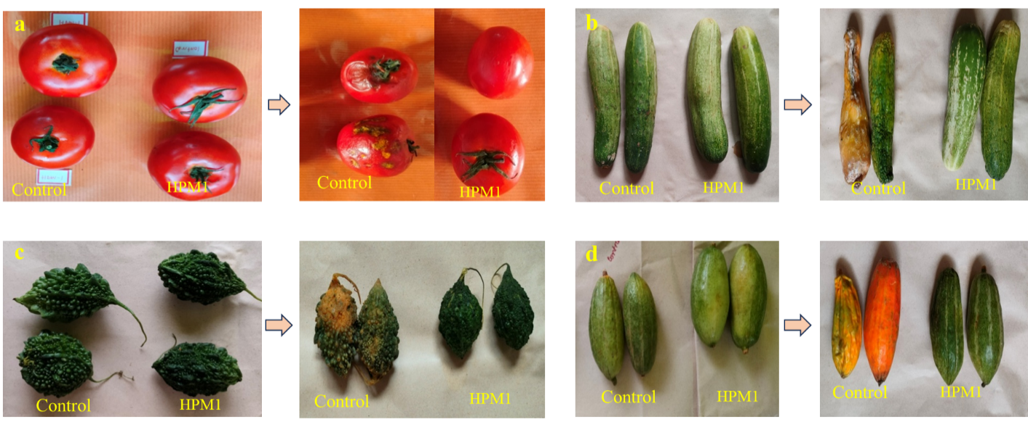
Fig. S1 Vegetables preservation with P. pentosaceus HMP1 bacteriocin in room temperature. (a) Tomato preservation, (b) Cucumber preservation, (c) Bitter gourd preservation, (d) Pointed gourd preservation.
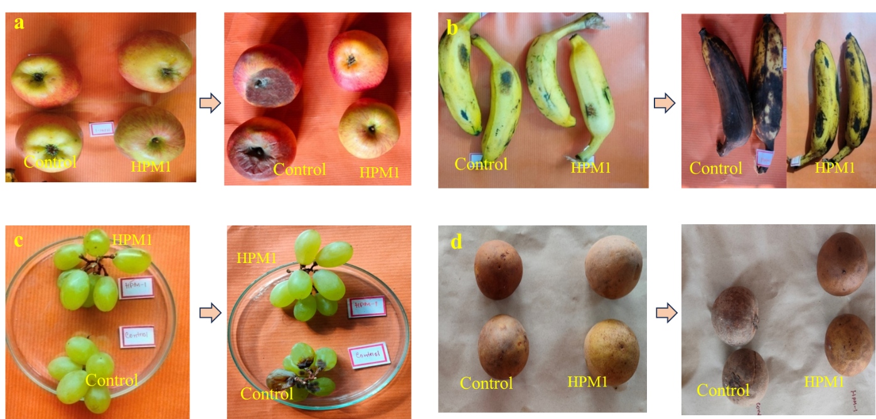
Fig. S2 Fruits preservation with P. pentosaceus HMP1 bacteriocin in room temperature. (a) Apple preservation, (b) Banana preservation, (c) Grapes preservation, (d) Sapodilla preservation.
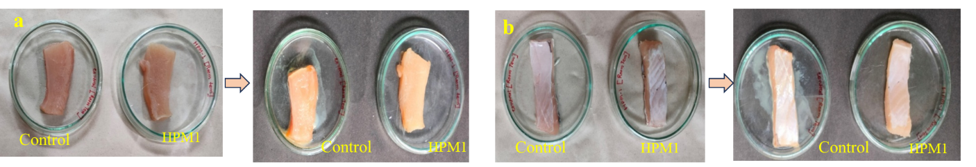

Fig. S3 Meat and fish preservation with P. pentosaceus HMP1 bacteriocin in room temperature. (a) Meat preservation, (b) Fish preservation.

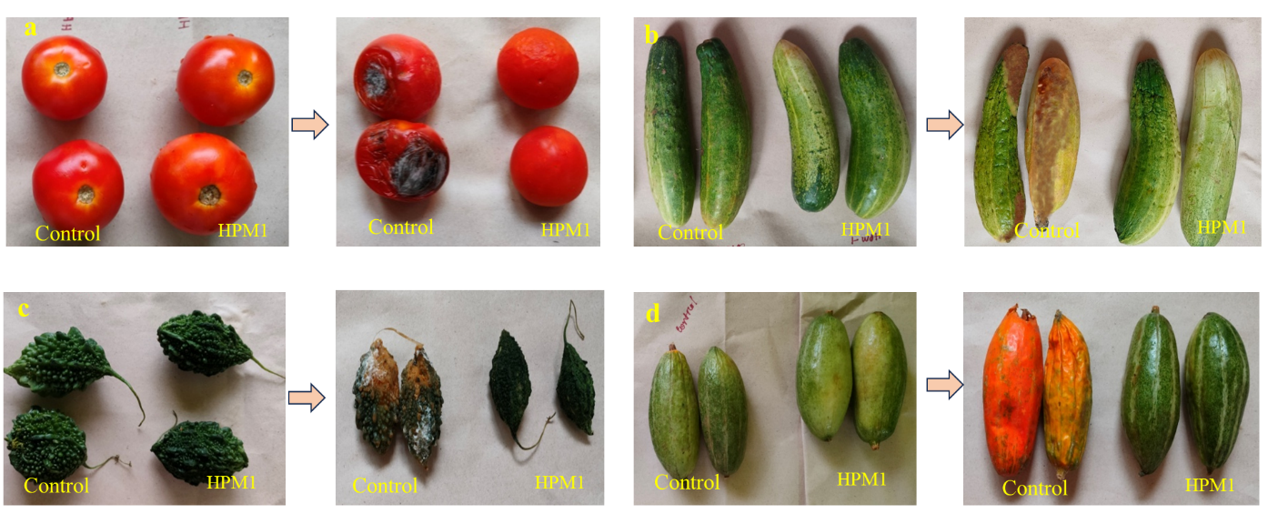
Fig. S4 Vegetables preservation with P. pentosaceus HMP1 bacteriocin in freezing temperature. (a) Tomato preservation, (b) Cucumber preservation, (c) Bitter gourd preservation, (d) Pointed gourd preservation.
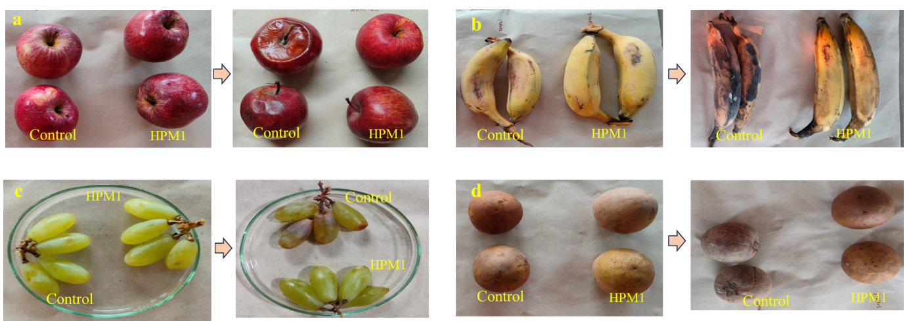

Fig. S5 Fruits preservation with P. pentosaceus HMP1 bacteriocin in freezing temperature. (a) Apple preservation, (b) Banana preservation, (c) Grapes preservation, (d) Sapodilla preservation.

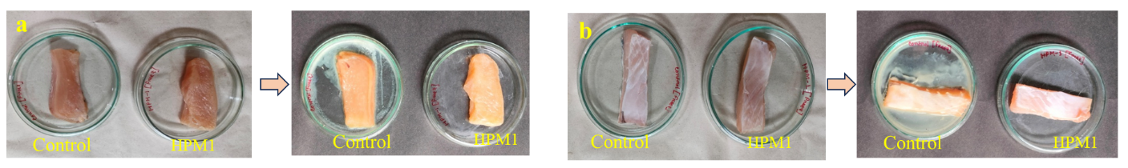
Fig. S6 Meat and fish preservation with P. pentosaceus HMP1 bacteriocin in freezing temperature. (a) Meat preservation, (b) Fish preservation.

