Article title: Holistic compression model to predict post-stroke mood at 6 months

Journal name: Brain Structure and Function

Author names: Suhrit Duttagupta, Michel Thiebaut de Schotten, Thomas Tourdias, Olivier Godefroy, Sylvie Berthoz, Igor Sibon

Affiliation and e-mail address of the corresponding author: Univ. Bordeaux, INCIA UMR 5287, Bordeaux, France 33000; suhritdgupta@gmail.com

Supplementary Material 4: Disconnectome Models
In the DSD, each stroke disconnectome is assigned a voxel in a 2D morphospace. The model relies on having a sufficient number of voxels correlated with the clinical score, based on a Pearson correlation over ±0.2. There were no voxels above the threshold for HAD Anxiety from MOTIV-POSDEP (Figure A) and CES-D from GRECOGVasc (Figure B), so they couldn’t be used as training samples.
In cases where there were significant voxels, it was not sufficient to have distinct clusters, without which there would be strong overfitting. Using the BBS data as a training sample for HAD Anxiety, 558 or 0.8% of voxels were significant (Figure C). Consequently, the predicted MOTIV-POSDEP scores had a mean of 1108 and a maximum score of 23618 (Figure D). For HAD Depression, the scores were valid but with little deviation from the mode of 2.84 (Figure E). For the CES-D scores, the model obtained from MOTIV-POSDEP was applied to test on GRECOGVasc, and the predicted values had minute deviation (St.Dev: 0.11) and negligible correlation with actual values (Pearson r = -0.03).
A
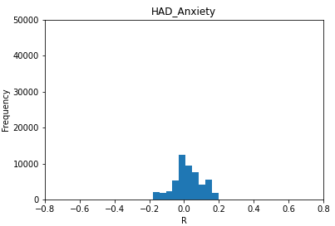

B
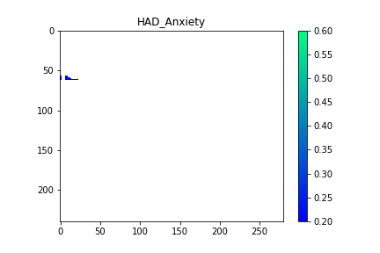
C
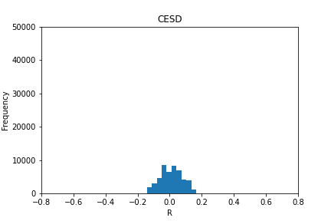

D
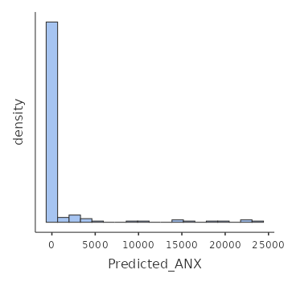

E
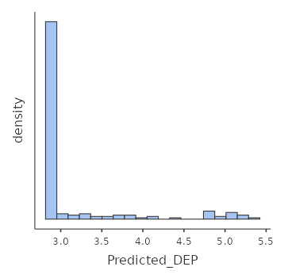
Figure S4: Results from DSD: (A) HAD Anxiety could not be predicted from MOTIV-POSDEP and (B) CES-D from GRECOGVasc due to no voxels on the UMAP morphospace being significantly correlated with the clinical scores with a magnitude over 0.2. The histograms of (C) predicted HAD Anxiety and (D) HAD Depression scores from the testing sample of MOTIV-POSDEP.

