Supplementary Information
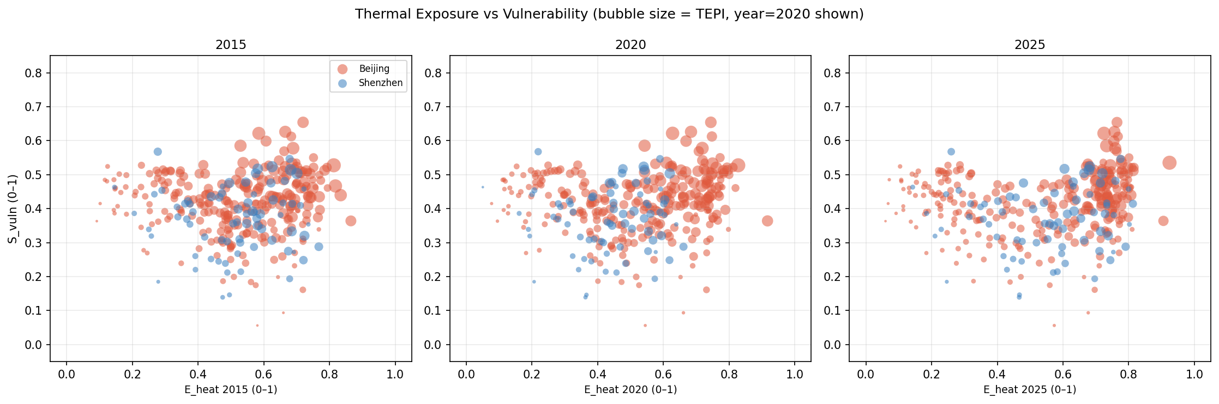
Supplementary Figure S1. Thermal Exposure, Population Vulnerability, and TEPI by City and Year. The horizontal axis represents the normalized thermal exposure score, the vertical axis represents the normalized vulnerability score, and bubble size reflects TEPI.
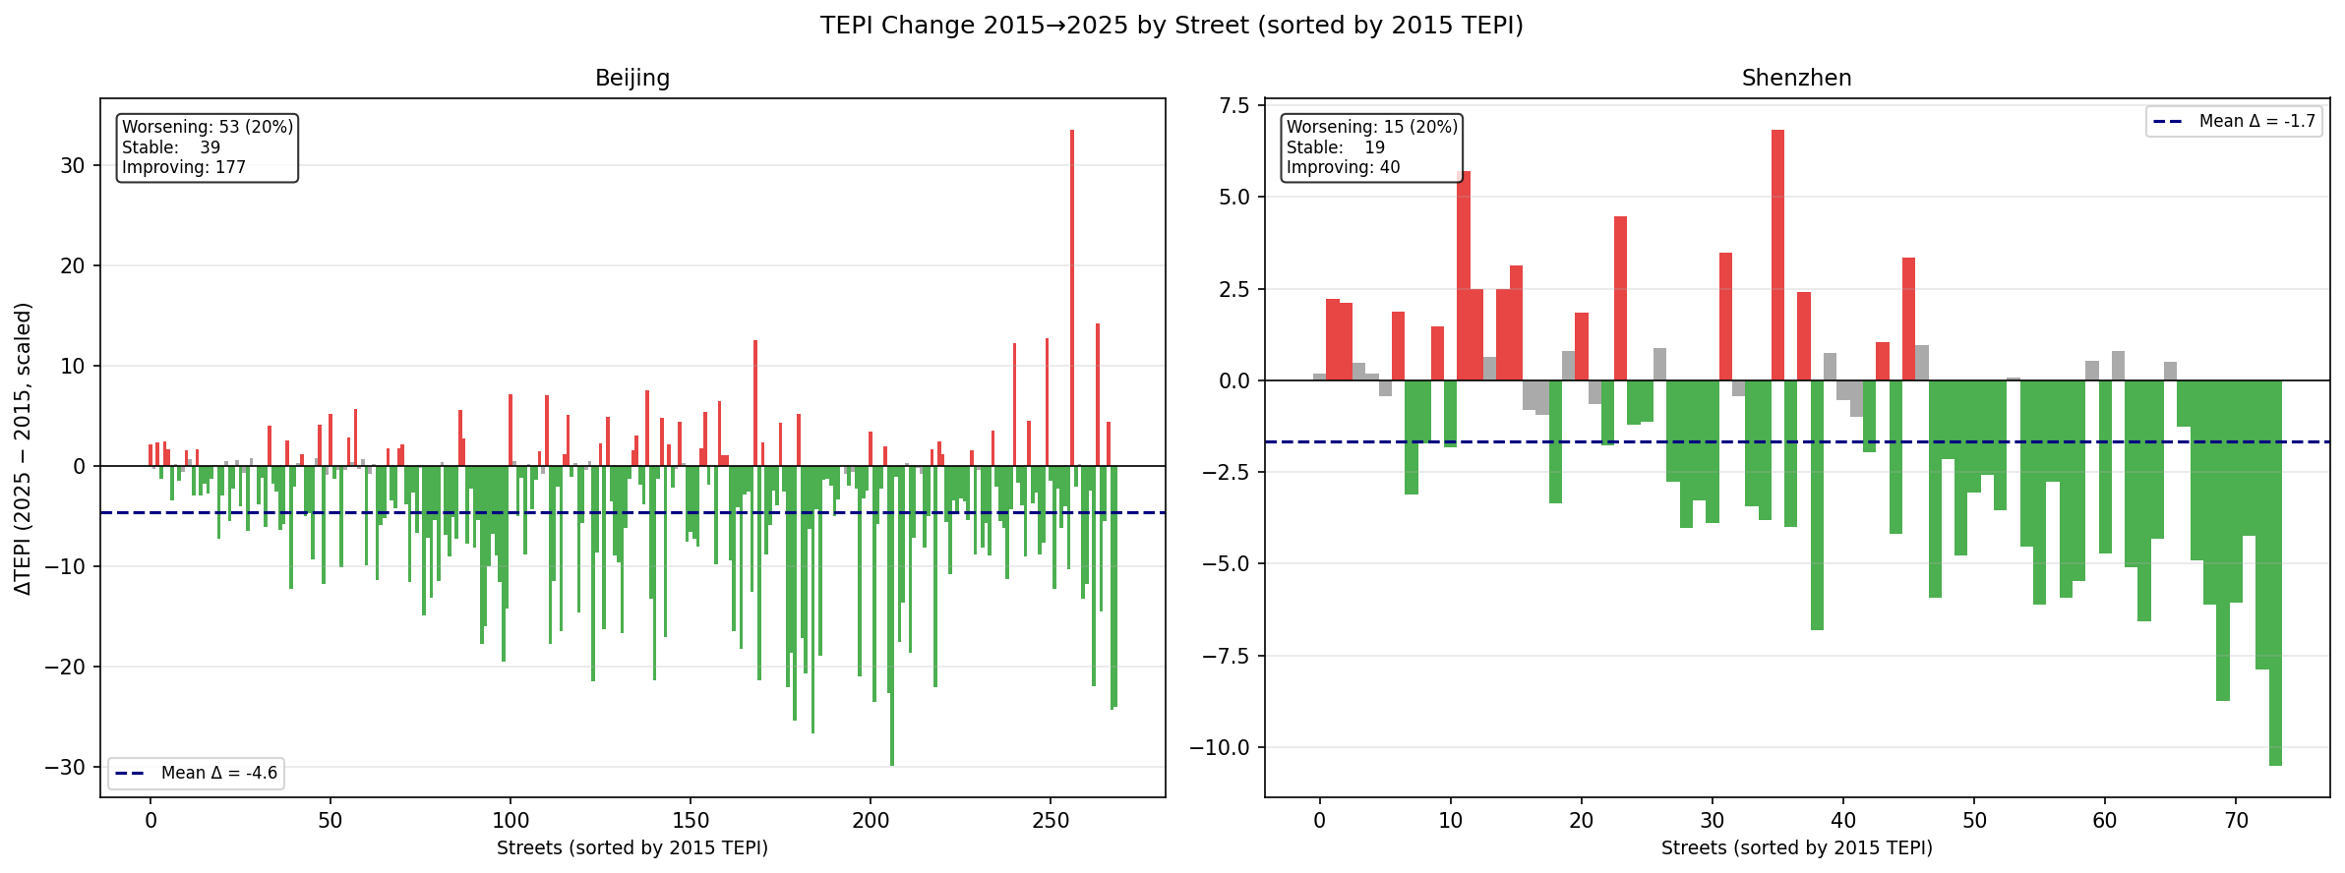
Supplementary Figure S2. Change in TEPI from 2015 to 2025 by Street. Positive values indicate worsening thermal inequity, while negative values indicate improvement.
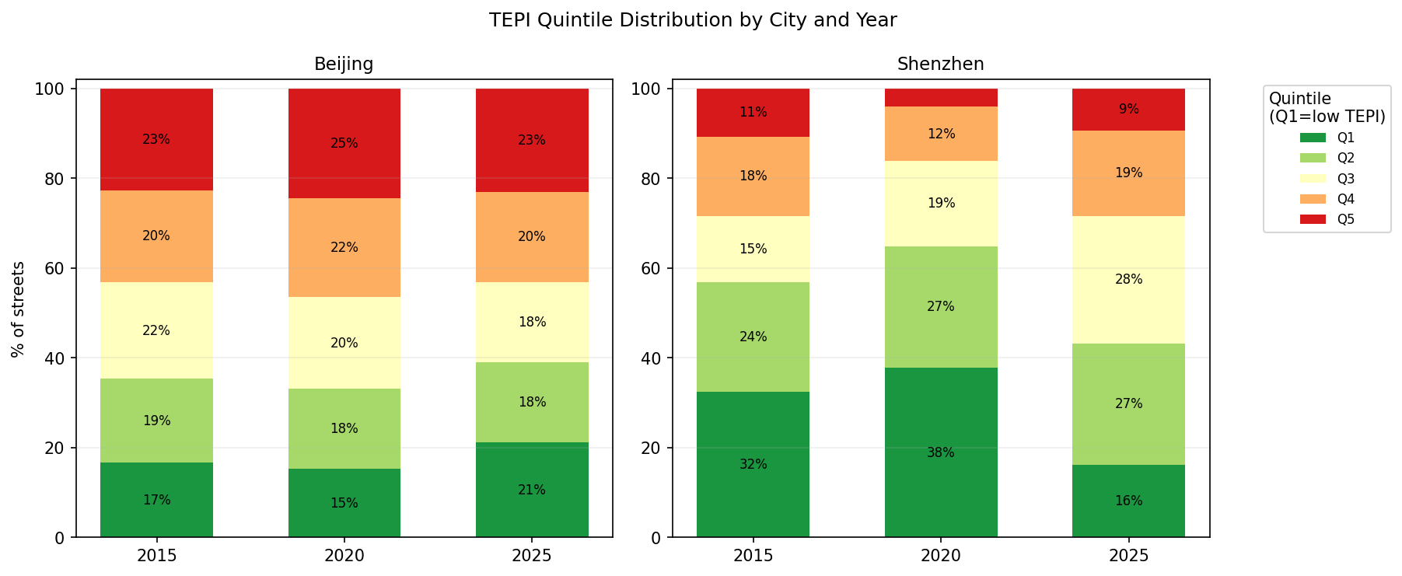
Supplementary Figure S3. TEPI Quintile Distribution by City and Year. Q1 represents the lowest TEPI quintile and Q5 represents the highest TEPI quintile.
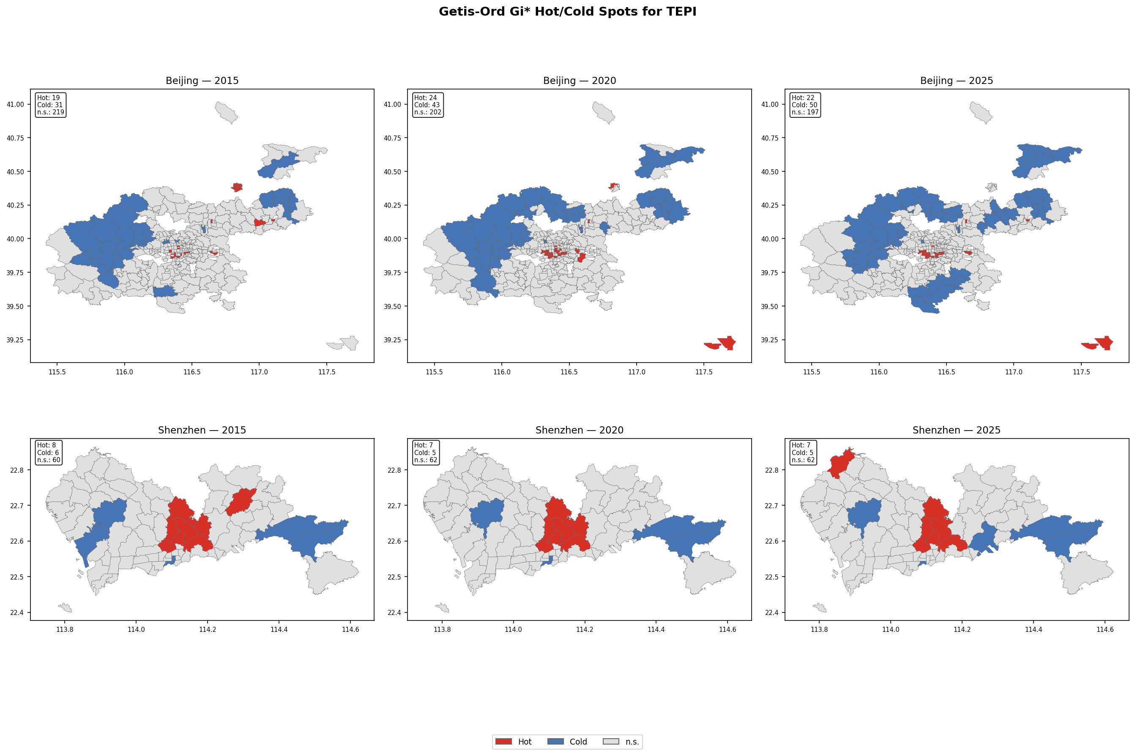
Supplementary Figure S4. Getis-Ord Gi* Hot Spots and Cold Spots of TEPI. Hot spots identify statistically significant concentrations of high TEPI values, while cold spots identify statistically significant concentrations of low TEPI values.
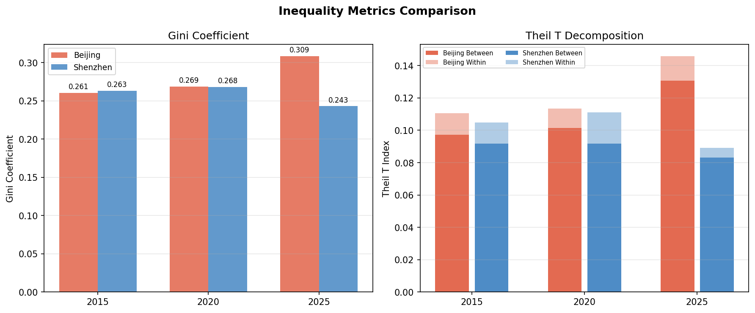
Supplementary Figure S5. Inequality Metrics for TEPI in Beijing and Shenzhen. The left panel shows Gini coefficients. The right panel shows Theil T decomposition into between-group and within-group components.
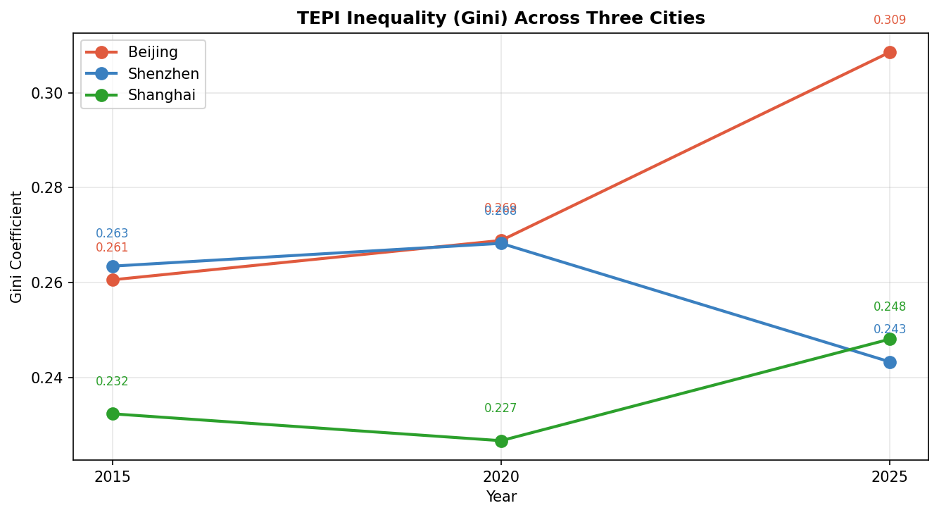
Supplementary Figure S6. Gini Coefficients of TEPI Across Beijing, Shenzhen, and Shanghai. Values summarize the temporal change in TEPI inequality across the three cities.
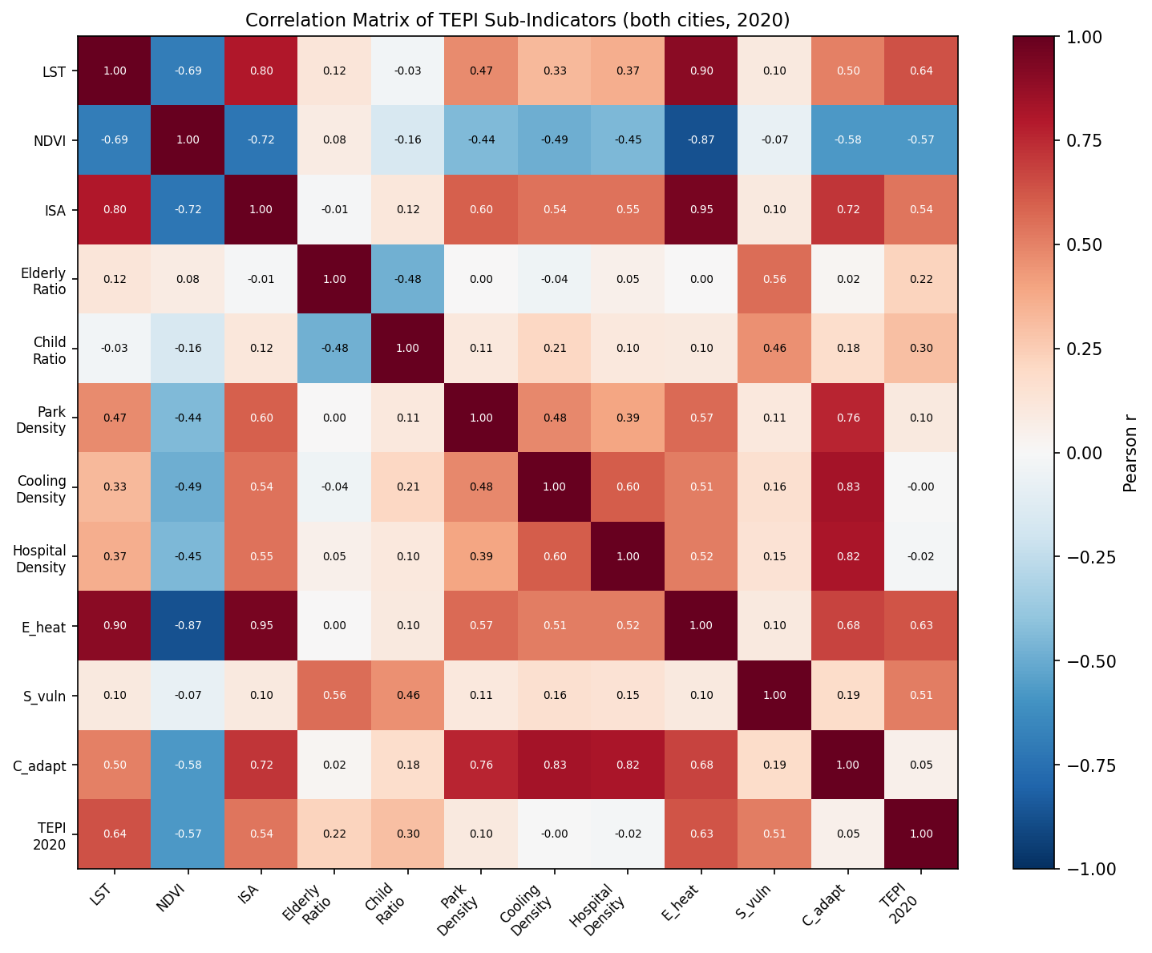
Supplementary Figure S7. Correlation Matrix of TEPI Sub-Indicators in Beijing and Shenzhen, 2020. Values are Pearson correlation coefficients based on the pooled street-level sample for the year 2020.
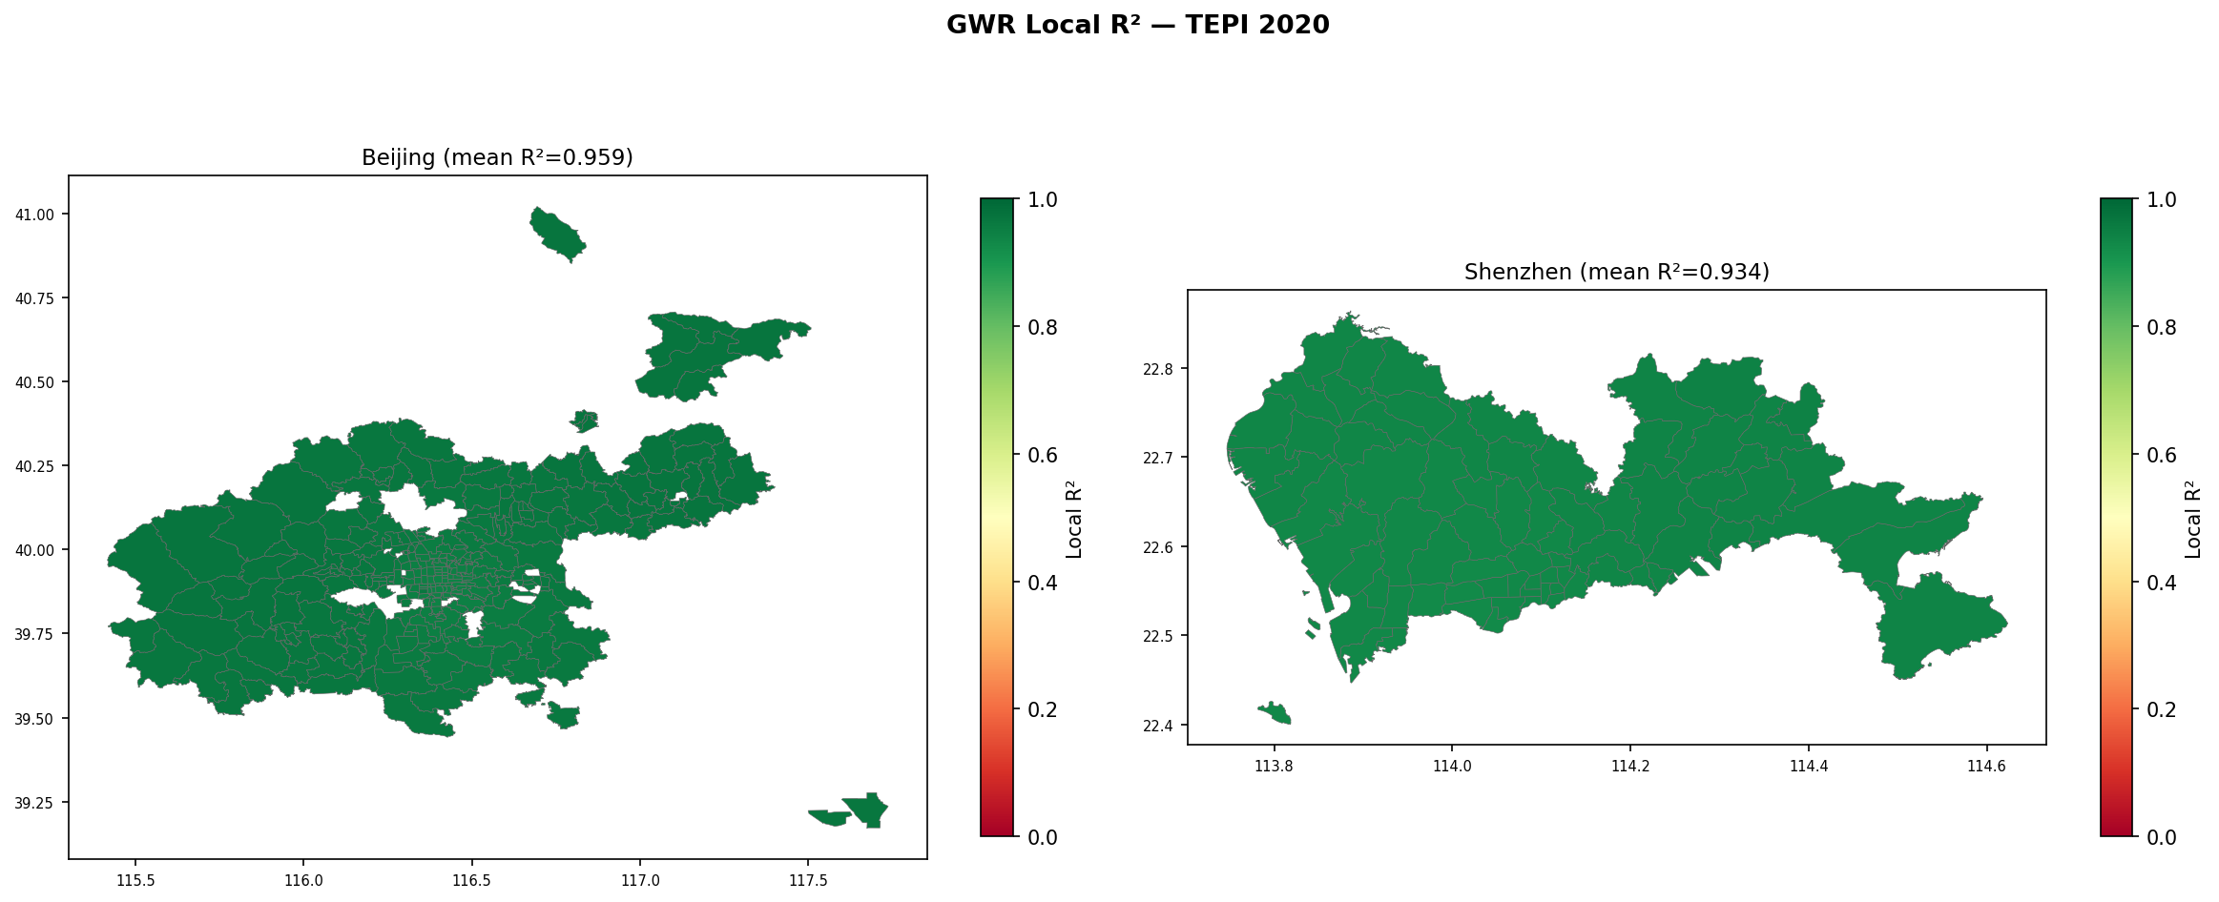
Supplementary Figure S8. GWR Local R² for TEPI Decomposition in 2020. Higher local R² values indicate stronger local model fit.
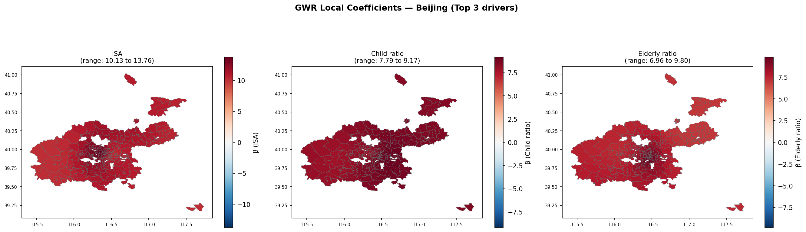
Supplementary Figure S9. GWR Local Component Weights for the Dominant Sub-Indicators of TEPI in Beijing.
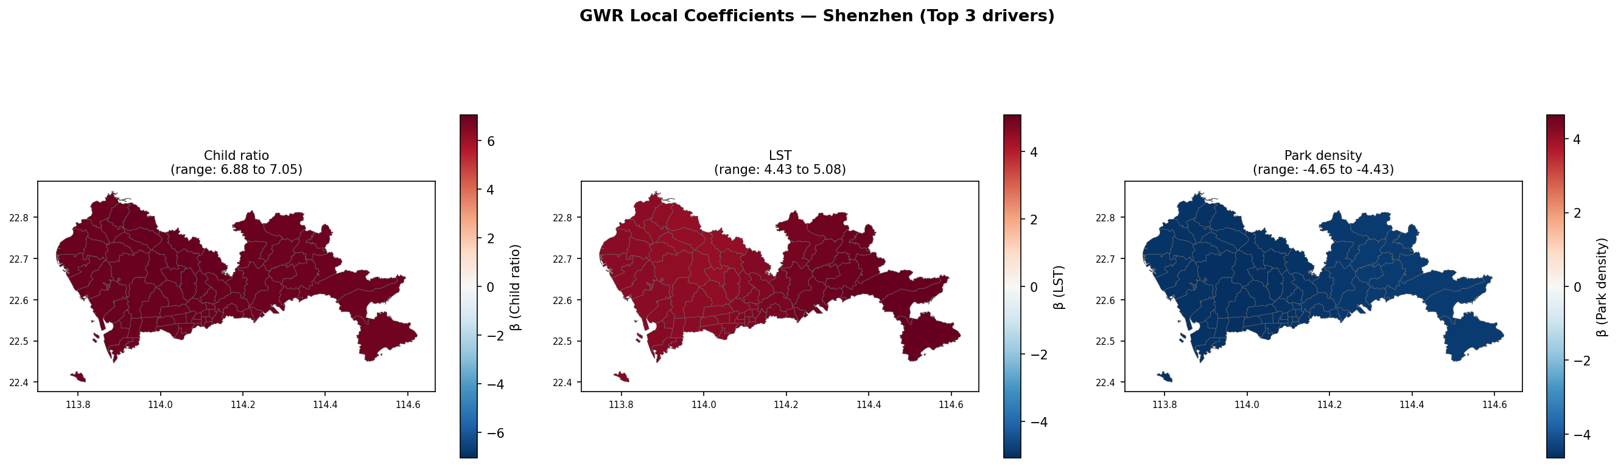
Supplementary Figure S10. GWR Local Component Weights for the Dominant Sub-Indicators of TEPI in Shenzhen.
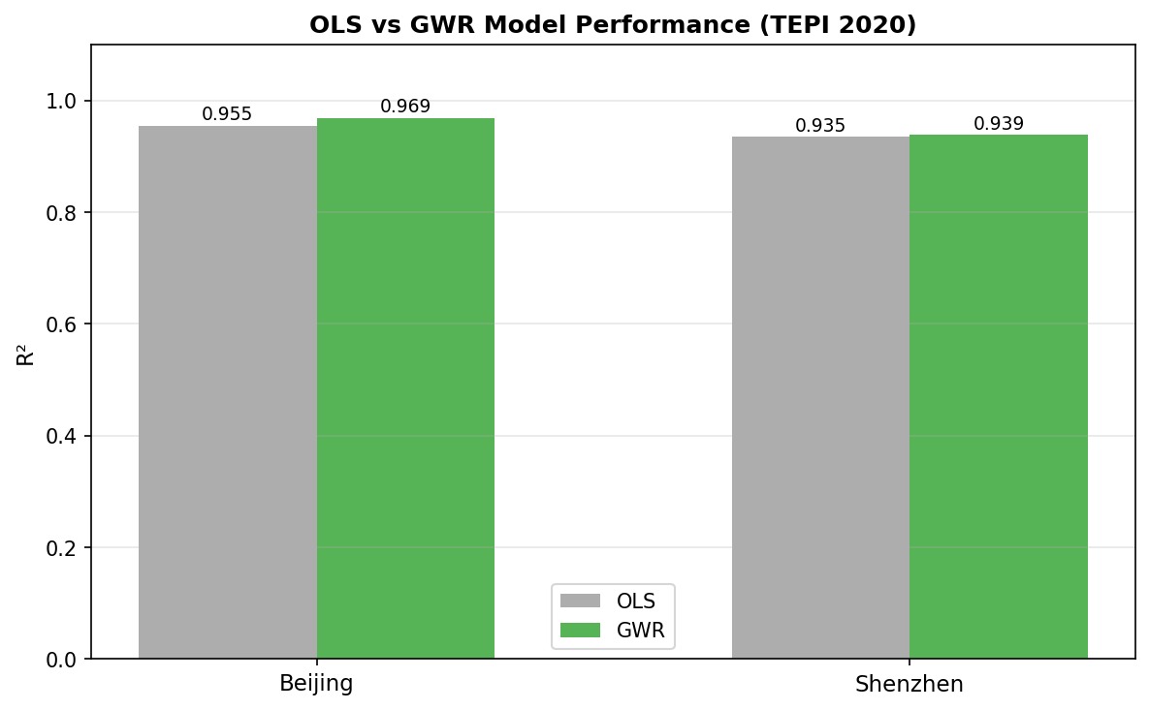
Supplementary Figure S11. Comparison of Global and Spatially Varying Decomposition Model Performance for TEPI in 2020.
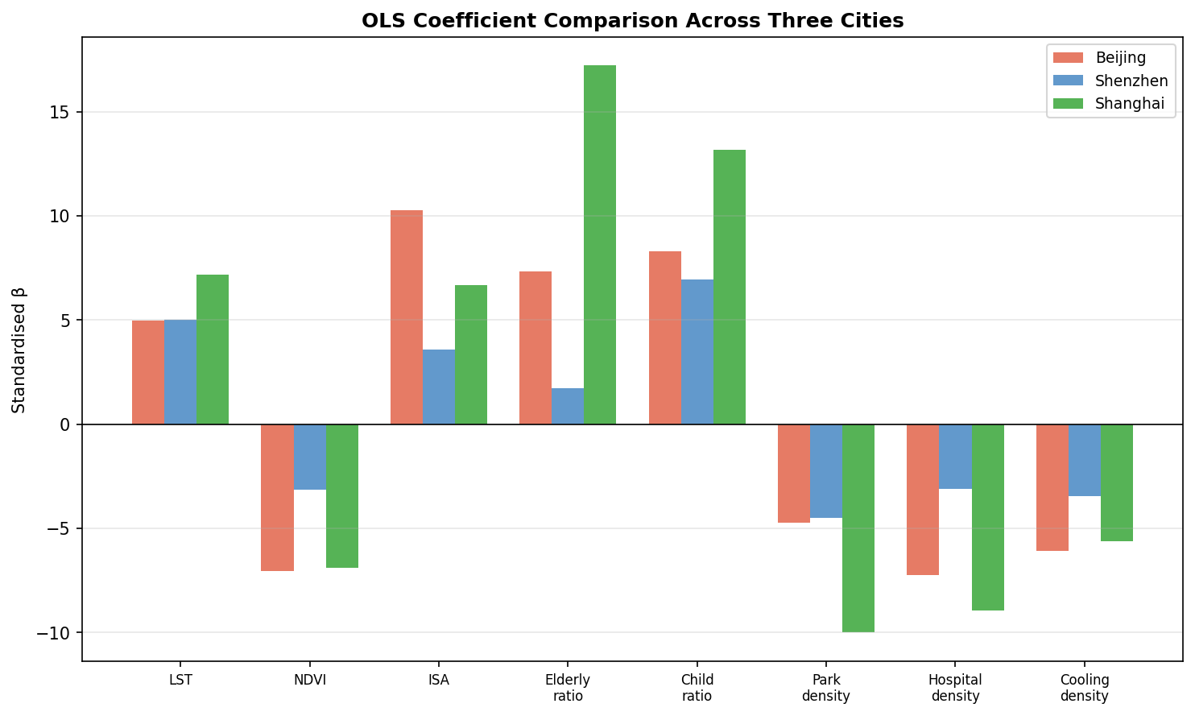
Supplementary Figure S12. Standardized OLS Association Comparison Across Beijing, Shenzhen, and Shanghai.
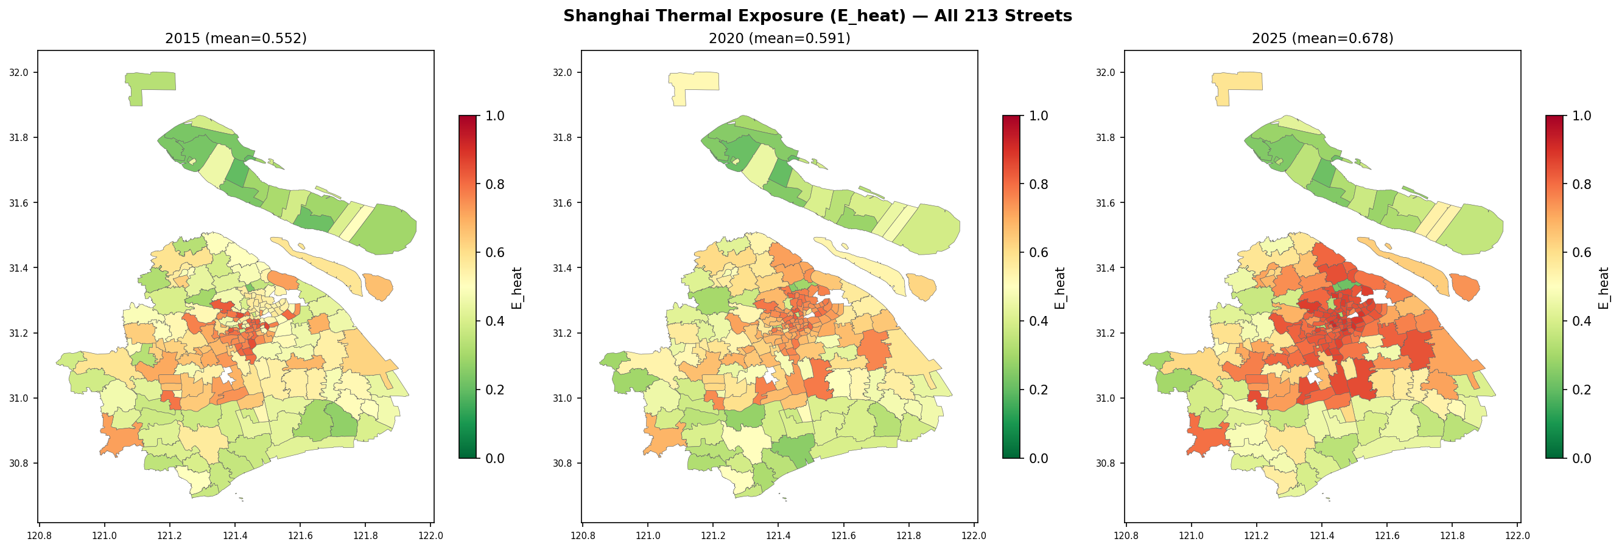
Supplementary Figure S13. Thermal Exposure in Shanghai Across All Streets.

