Supplementary data of the paper:
A PBK Model for PFAS Transfer from Feed to Fillet in Farmed Atlantic Salmon
Tu-Ky Ly^{a, b}, Cathrin Veenaas^{c}, Cleo Bodinª, Kai K. Lie^{c}, Rémy Beaudouin^{a, b*},
Marc Berntssen^{c}

ªNew Approaches and Models for Human Health and Environmental Safety, INERIS, 60550 Verneuil-en-Halatte, France
^{b}UMR-I 02 SEBIO, INERIS, URCA, ULHN, 60550 Verneuil-en-Halatte, France
^{c}Institute of Marine Research, POB 1870 Nordnes, N-5817 Bergen, Norway

*Corresponding author, e-mail: remy.beaudouin@ineris.fr

Summary

1. Materials and methods 3
1.1. Feeding trial and sampling 3
1.2. Chemical analysis 6
1.2.1. Muscle sample extraction 6
1.2.2. Remaining sample extraction 6
1.2.3. LC-MS analysis 7
1.3. PBK model structure 9
1.3.1. Cardiac output 9
1.3.2. Fat growth in fillet 10
1.4. Model parametrization 13
1.4.1. PFAS specific parameters: estimation of the free fraction 13
1.4.2. DEB model calibration and validation 14
1.4.3. PBK model calibration: prior distributions 15
1.4.4. PBK model validation 16
1.5. Sensitivity analysis 17
2. Results 18
2.1. DEB sub-model: calibration of the fish growth 18
2.2. Fat growth in fillet 19
2.3. Sensitivity analysis 19
2.4. PBK model 21
2.4.1. PFAS kinetic profile 21
2.4.2. Elimination route 27
2.4.3. Enterohepatic recirculation 27
2.4.4. Diffusion vs. perfusion in the fillet 28
2.4.5. Linear relationship between feed and fillet concentration 29
3. References 30

Materials and methods

Feeding trial and sampling
Table S1. Fish and organ measurements throughout the trial.
Phase | Tank no. | Trial day | Weight Fish (g) | Length Fish (cm) | Viscera rest  (g) | Liver weight (g) | Fillet (one side)  (g) | Fat content in fillet (%)
uptake | 1 | 0 | 176 | 24.7 | 13.97 | 2.13 | 48.6 | 6.8
uptake | 1 | 0 | 148 | 22.3 | 13.42 | 1.89 | 36.93 | 6.3
uptake | 1 | 0 | 160 | 23.4 | 15.56 | 3.57 | 43.02 | 8
uptake | 2 | 0 | 138 | 23 | 14.49 | 3.106 | 39.02 | 8.3
uptake | 2 | 0 | 138 | 22.2 | 14.52 | 2.26 | 36.12 | 6
uptake | 2 | 0 | 115 | 20.4 | 16.54 | 1.66 | 32.3 | 6.2
uptake | 3 | 0 | 139 | 22.1 | 15.09 | 2.8 | 39.3 | 8.6
uptake | 3 | 0 | 116 | 20.4 | 11 | 1.36 | 32.5 | 5.3
uptake | 3 | 0 | 115 | 20.4 | 12.9 | 2.02 | 30.83 | 5.3
uptake | 1 | 7 | 139 | 22.7 | 13.22 | 2.5 | 37.1 | 6.6
uptake | 1 | 7 | 145 | 22.4 | 13.71 | 1.9 | 40.7 | 6.1
uptake | 1 | 7 | 179 | 24 | 18.8 | 4.1 | 45.4 | 6.7
uptake | 2 | 7 | 181 | 24.2 | 16.4 | 2.4 | 51.8 | 7
uptake | 2 | 7 | 178 | 23.8 | 12.2 | 2 | 51.3 | 5.9
uptake | 2 | 7 | 144 | 22.2 | 10.59 | 1.96 | 42.2 | 5.1
uptake | 3 | 7 | 176 | 23.6 | 12.7 | 2.16 | 51.8 | 7.1
uptake | 3 | 7 | 176 | 23.5 | 15.9 | 2.67 | 48.9 | 9.8
uptake | 3 | 7 | 132 | 21.5 | 10.7 | 1.67 | 37.8 | 6.6
uptake | 1 | 14 | 132 | 21.3 | 7 | 1.8 | 40.95 | 6.2
uptake | 1 | 14 | 131 | 21.5 | 9.94 | 1.7 | 42.7 | 5.7
uptake | 1 | 14 | 192 | 24.7 | 11.7 | 2.2 | 56.2 | 5.9
uptake | 2 | 14 | 191 | 23.7 | 11.9 | 2.6 | 57.2 | 6.9
uptake | 2 | 14 | 223 | 25.4 | 17.1 | 3 | 62.4 | 8.6
uptake | 2 | 14 | 170 | 23 | 11.2 | 2.3 | 47.9 | 6.9
uptake | 3 | 14 | 140 | 22.4 | 9.2 | 2.7 | 39.47 | 8.1
uptake | 3 | 14 | 138 | 22.2 | 9.9 | 2.2 | 37.8 | 6.1
uptake | 3 | 14 | 166 | 22.7 | 11.65 | 2.18 | 45.78 | 7.7
uptake | 1 | 30 | 242 | 25.4 | 15.8 | 2.62 | 59.4 | 6.8
uptake | 1 | 30 | 229 | 25.8 | 15.35 | 4.09 | 60.4 | 7.7
uptake | 1 | 30 | 206 | 24.6 | 13.8 | 3.32 | 47.9 | 7
uptake | 2 | 30 | 253 | 25.4 | 14.1 | 3.47 | 63.1 | 7.3
uptake | 2 | 30 | 209 | 24.7 | 9.8 | 2.52 | 52.4 | 6
uptake | 2 | 30 | 140 | 21.8 | 7.6 | 2.4 | 34.3 | 7.6
uptake | 3 | 30 | 168 | 22.7 | 8.2 | 2.46 | 43.5 | 5.7
uptake | 3 | 30 | 191 | 23.3 | 7.6 | 2.19 | 48.25 | 8.7
uptake | 3 | 30 | 152 | 22.2 | 8.8 | 2.1 | 36.3 | 6.6
uptake | 1 | 56 | 303 | 28.7 | 16.9 | 3.06 | 82.9 | 8.7
uptake | 1 | 56 | 233 | 26.6 | 11.9 | 2.1 | 56.9 | 8
uptake | 1 | 56 | 252 | 26.5 | 14.9 | 3.6 | 60.8 | 7.3
uptake | 2 | 56 | 310 | 28.3 | 16.7 | 3.07 | 79.3 | 8.4
uptake | 2 | 56 | 262 | 26.4 | 12.6 | 3.15 | 60.9 | 7.5
uptake | 2 | 56 | 216 | 24.6 | 10.9 | 2.9 | 54.5 | 8.7
uptake | 3 | 56 | 241 | 26.1 | 14.7 | 3.1 | 61.4 | 6.7
uptake | 3 | 56 | 241 | 24.9 | 9.9 | 3.4 | 63.1 | 13.6
uptake | 3 | 56 | 258 | 26 | 13.7 | 3.1 | 65.7 | 7.9
uptake | 1 | 70 | 426 | 32.1 | 23.5 | 4.1 | 103.8 | 9.2
uptake | 1 | 70 | 274 | 27.3 | 15.08 | 2.8 | 77.5 | 8.5
uptake | 1 | 70 | 356 | 31.1 | 20.9 | 3.4 | 97.2 | 9
uptake | 2 | 70 | 375 | 30.4 | 23 | 3.859 | 90.6 | 10.7
uptake | 2 | 70 | 293 | 28 | 15.9 | 2.86 | 74.4 | 10.6
uptake | 2 | 70 | 256 | 27.2 | 13.4 | 2.36 | 67.7 | 8.1
uptake | 3 | 70 | 240 | 27.1 | 13.5 | 2.9 | 61.8 | 8.5
uptake | 3 | 70 | 272 | 27.1 | 15.83 | 2.98 | 69.73 | 9.1
uptake | 3 | 70 | 347 | 30.2 | 17.5 | 3.2 | 91 | 9.1
depuration | 1 | 80 | 279 | 27.7 | 16.95 | 2.51 | 70.34 | 7.3
depuration | 1 | 80 | 190 | 24.7 | 10.29 | 1.9 | 46.3 | 6.2
depuration | 1 | 80 | 305 | 30 | 15.5 | 2.9 | 85.1 | 8.2
depuration | 2 | 80 | 212 | 26.2 | 11.1 | 1.89 | 49.73 | 8.3
depuration | 2 | 80 | 314 | 30.1 | 12.2 | 2.89 | 80.15 | 9.5
depuration | 2 | 80 | 298 | 29.2 | 15.2 | 2.46 | 78.79 | 8.5
depuration | 3 | 80 | 282 | 28 | 16.6 | 2.28 | 67.69 | 7.1
depuration | 3 | 80 | 439 | 33.2 | 28.2 | 4.036 | 116.9 | 10.7
depuration | 3 | 80 | 151 | 22.3 | 9 | 1.98 | 39.9 | 8.1
depuration | 1 | 85 | 343 | 30.7 | 21.1 | 3.2 | 86.4 | 9
depuration | 1 | 85 | 333 | 30.5 | 15.44 | 2.75 | 88.6 | 7.9
depuration | 1 | 85 | 185 | 24.1 | 10 | 1.99 | 46.9 | 9
depuration | 2 | 85 | 421 | 32 | 21 | 3.4 | 116.9 | 9.9
depuration | 2 | 85 | 429 | 31.5 | 26.9 | 4.2 | 120.5 | 11.1
depuration | 2 | 85 | 415 | 32.4 | 20.46 | 3.68 | 116.8 | 9
depuration | 3 | 85 | 407 | 32.2 | 21.63 | 3.86 | 111.3 | 9.4
depuration | 3 | 85 | 294 | 29 | 14.38 | 2.61 | 73 | 7.8
depuration | 3 | 85 | 249 | 26.6 | 13.14 | 2.61 | 64.17 | 8.4
depuration | 1 | 95 | 366 | 32 | 17.43 | 3.14 | 92.99 | 9.2
depuration | 1 | 95 | 301 | 29 | 14.9 | 2.66 | 78.26 | 8.9
depuration | 1 | 95 | 264 | 27.7 | 15 | 2.96 | 60.91 | 8.3
depuration | 2 | 95 | 286 | 28.5 | 13.9 | 2.46 | 76.54 | 6.5
depuration | 2 | 95 | 299 | 28.2 | 18.1 | 2.69 | 77.72 | 7.5
depuration | 2 | 95 | 154 | 23.6 | 7.2 | 1.2 | 38.25 | 5.4
depuration | 3 | 95 | 396 | 31.1 | 25.9 | 3.99 | 93.18 | 9.6
depuration | 3 | 95 | 371 | 31.4 | 17.8 | 3.33 | 89.5 | 9.2
depuration | 3 | 95 | 292 | 29.2 | 15.7 | 2.46 | 77.56 | 7.6
depuration | 1 | 112 | 427 | 31.9 | 33.76 | 7.16 | 108.2 | 8.7
depuration | 1 | 112 | 366 | 31.6 | 17.48 | 2.99 | 98.3 | 6.8
depuration | 1 | 112 | 366 | 31.5 | 16.62 | 3.27 | 98.9 | 7
depuration | 2 | 112 | 238 | 26.8 | 12.7 | 1.81 | 62.67 | 7.6
depuration | 2 | 112 | 484 | 34.2 | 21.23 | 4.2 | 134.8 | 9.4
depuration | 2 | 112 | 428 | 32.8 | 24.5 | 4.26 | 106.4 | 10.2
depuration | 3 | 112 | 370 | 29.5 | 26.14 | 5.96 | 100.37 | 10.1
depuration | 3 | 112 | 418 | 32 | 25.3 | 3.32 | 113.7 | 10.8
depuration | 3 | 112 | 310 | 30 | 12.49 | 2.63 | 79.2 | 6.4
depuration | 1 | 126 | 475 | 33.6 | 22.9 | 4.45 | 122.6 | 9.5
depuration | 1 | 126 | 685 | 35.7 | 52.1 | 10.3 | 173.8 | 10.6
depuration | 1 | 126 | 491 | 33.7 | 31.6 | 5.5 | 126 | 9.2
depuration | 2 | 126 | 373 | 30.9 | 21.9 | 3 | 102.6 | 10.8
depuration | 2 | 126 | 661 | 35.2 | 37.6 | 7.04 | 179.1 | 11.1
depuration | 2 | 126 | 404 | 30.5 | 29.2 | 5.1 | 92 | 8.8
depuration | 3 | 126 | 457 | 31 | 34.9 | 5.5 | 106 | 11.8
depuration | 3 | 126 | 492 | 35.4 | 24.9 | 4.65 | 128 | 9.2
depuration | 3 | 126 | 505 | 34.5 | 25.6 | 5.3 | 128 | 8.7
Table S2. Number and type of samples per sampling day
Days  total | Blood | Plasma | Liver | Muscle (whole) | Muscle (DoVe) | Muscle (Red) | Muscle (Vert) | Gut | Adipose | Bile** | Feces | Gills | Control fish
0 | 3* | 3* | 9 | 9 | 9 | 9 | 9 | 9 | 9 | 0 | 3* | 0 | 3
7 | 3* | 3* | 9 | 9 | 9 | 9 | 9 | 3* | 3* | 1 | 0 | 0 | 3
14 | 3* | 3* | 9 | 9 | 9 | 9 | 9 | 3* | 3* | 0 | 3* | 9 | 3
30 | 3* | 3* | 9 | 9 | 9 | 9 | 9 | 9 | 9 | 2* | 0 | 0 | 0
56 | 3* | 3* | 9 | 9 | 9 | 9 | 9 | 3* | 3* | 0 | 3* | 0 | 3
70 | 3* | 3* | 9 | 9 | 9 | 9 | 9 | 3* | 3* | 3* | 0 | 0 | 0
80 | 3* | 3* | 9 | 9 | 9 | 9 | 9 | 9 | 9 | 2* | 3* | 9 | 0
85 | 3* | 3* | 9 | 9 | 9 | 9 | 9 | 3* | 3* | 3* | 0 | 0 | 3
95 | 3* | 3* | 9 | 9 | 9 | 9 | 9 | 3* | 3* | 3* | 3* | 0 | 0
112 | 3* | 3* | 9 | 9 | 9 | 9 | 9 | 9 | 9 | 3* | 0 | 0 | 0
126 | 3* | 3* | 9 | 9 | 9 | 9 | 9 | 9 | 9 | 1* | 3* | 0 | 6
*Pooled samples
**In some cases bile sampling was not planned but bile was present anyways and collected. Hence, uneven numbers occur.

Chemical analysis

Muscle sample extraction
Approximately 1 g of muscle tissue was spiked with 5 ng internal standard and 4 mL methanol (≥99.9 %, Riedel-de Haën) was added. The samples were shaken for 15 min and sonicated for 60 min followed by centrifuging for 10 min at 4000rpm. Afterwards the supernatant was decanted to a polypropylene syringe and filtered through a 0.45 µm Millex syringe filter (nylon, 33 mm diameter, Merck Millipore). The extract was diluted with 32 mL milliQ water and split in two. Clean up was performed on an ASPEC GX-274 automated solid phase extraction system (Gilson, Middleton, WI, USA) equipped with an Oasis WAX (60 mg sorbent, 3 mL; Waters, Milford, MA, USA). The column was conditioned with 5 ml of 1% (v/v) ammonium hydroxide (25%, Merck KGaA, Darmstadt, Germany) in methanol, 5 mL methanol and 5 mL milliQ water and washed with 5 mL of 2% (v/v) formic acid (≥98%, Supelco) in milliQ water prior to adding the samples. The samples were eluted with 1 mL 1% (v/v) ammonium hydroxide in methanol. Finally, 5 ng recovery standard was added, and samples were stored at -20 °C until analysis with LC-HRMS. In addition to the samples, two matrix blanks (tissue samples from control tank fish) were prepared similarly and spiked with 0.2 ng and 5 ng native standard mix, respectively, before the extraction. Moreover, a solvent blank was prepared as well and processed alongside each batch of samples. Both solvent blank and matrix blank were spiked with internal and recovery standard similarly to the samples.

Remaining sample extraction
Liver, adipose tissue, gut, plasma, blood, bile, feces and gills were extracted using a modified QuEChERS approach. Approximately 1 g of tissue was added to a 50 mL polypropylene centrifuge tube and spiked with 5 ng internal standard. For each batch of samples, a matrix blank containing tissue material from fish held in control tanks and a solvent blank were prepared and spiked similarly. In addition, the matrix blank was spiked with 5 ng native PFAS.
The samples were diluted with 5 mL of milliQ water followed by adding 10 mL of 1% (v/v) formic acid (purity ≥98%; Merck KGaA) in acetonitrile. Acetonitrile for liver and adipose samples was of 99.99% purity (VWR International, Rosny-sous-Bois-cedex, France) and 100% purity (Fisher Scientific, Loughborough, UK) for all other samples. The tubes were vortexed and then sonicated for 30 minutes. Afterwards the content of Supel QuE non-buffered Tube 2 (Sigma Aldrich, St Louis, MO, USA) was added to the sample and the sample tube was immediately shaken and vortexed for at least 1 minute. Samples were subsequently centrifuged at 3000rpm and -9 °C for 10 minutes and stored in the freezer for 4 hours or overnight.
To guarantee that enough material could be transferred the samples were centrifuged again for 3 minutes (3000rpm, -9 °C) before transferring 5mL of the supernatant to Supel QuE PSA/ENVI-Carb Tube 3 (Sigma Aldrich, St Louis, MO, USA). The samples were again shaken, vortexed and then centrifuged (3 minutes, 3000rpm, at room temperature). Finally, 1 mL of the supernatant was transferred to LCMS vials and spiked with 0.5 ng recovery standard. Samples were stored in the freezer before analysis with LC-HRMS.
As the gill samples were low in sample weight (average 0.24 g) instead of transferring 1mL of the final extract to an LCMS vial, the whole supernatant (approximately 4mL) was transferred to a 15mL centrifuge tube and evaporated to a volume of approximately 1mL which was then transferred and spiked with 0.5 ng recovery standard before analysis.

LC-MS analysis
Table S3. List of native, internal and recovery standards used during sample extraction and analysis. All standards were from Greyhound Chromatography/ Wellington Lab (Supplier/Manufacturer).

Suppliers’ product no. | Compound | Usage
PFAC-MXC | PFBA, PFPeA, PFHxA, PFHpA, PFOA, PFNA, PFDA, PFUnDA, PFDoDA, PFTrDA, PFTeDA, PFHxDA, PFODA, PFBS, PFPeS, PFHxS, PFHpS, PFOS, PFNS, PFDS, PFDoDS | Native standard
MPFAC-C-ES | 13C4-PFBA, 13C5-PFPeA, 13C5-PFHxA, 13C4-PFHpA, 13C8-PFOA, 13C9-PFNA, 13C6-PFDA, 13C7-PFUnDA, 13C2-PFDoDA, 13C2-PFTeDA, 13C3-PFBS, 13C3-PFHxS, 13C8-PFOS | Internal standard
MPFAC-C-IS | 13C3-PFBA, 13C2-PFOA, 13C2-PFDA, 13C4-PFOS | Recovery standard

Table S4. Liquid chromatography gradient
Time  (min) | Aqueous phase  (%) | Organic phase  (%) | Flow  (ml/min)
0.00 | 85 | 15 | 0.2
0.10 | 85 | 15 | 0.2
0.11 | 25 | 75 | 0.2
11.0 | 10 | 90 | 0.2
11.01 | 0 | 100 | 0.2
15.0 | 0 | 100 | 0.2
15.01 | 85 | 15 | 0.2
23.0 | 85 | 15 | 0.2
Table S5. High-resolution mass spectrometer parameters
Parameter | Setting
Ionization Mode | H-ESI negative
Spray voltage (V) | 3000
Sheat gas (Arb) | 40
Aux gas (Arb) | 10
Sweep gas (Arb) | 1
Ion Transfer Tube Temperature (°C) | 320
Orbitrap Resolution (Full Scan) | 60 000 @ m/z 200
Scan Range (m/z) | 150-950
RF Lens (%) | 70
HCD Collision Energies (V) | 10, 20, 60
Orbitrap Resolution (tMS²) | 30 000@ m/z 200
Table S6. MS method (HRMS)
Analyte | Cate-gory | Internal standard (ISTD) | Recovery standard (RSTD) | Quan peak  (full scan MS1) m/z | Confirming ion (MS2)  m/z | HCD Collision Energies (V)
PFOA | Target | 13C8-PFOA |  | 412.9664 | 368.9766 | 10
13C8-PFOA | ISTD |  | RS-13C2-PFOA | 420.9933 | - | -
RS-13C2-PFOA | RSTD |  |  | 414.9731 | - | -
PFNA | Target | 13C9-PFNA |  | 462.9632 | 418.9734 | 10
13C9-PFNA | ISTD |  | RS-13C2-PFDA | 471.9934 | - | -
PFDA | Target | 13C6-PFDA |  | 512.9600 | 468.9702 | 10
13C6-PFDA | ISTD |  | RS-13C2-PFDA | 518.9802 | - | -
RS-13C2-PFDA | RSTD |  |  | 514.9667 | - | -
PFBS | Target | 13C3-PFBS |  | 298.9430 | 79.9574, 98.9558 | 20
13C3-PFBS | ISTD |  | RS-13C4-PFOS | 301.9526 | - | -
PFHxS | Target | 13C3-PFHxS |  | 398.9366 | 79.9574, 98.9558 | 60
13C3-PFHxS | ISTD |  | RS-13C4-PFOS | 401.9467 | - | -
PFOS | Target | 13C8-PFOS |  | 498.9302 | 79.9574, 98.9558 | 60
13C8-PFOS | ISTD |  | RS-13C4-PFOS | 506.9571 | - | -
RS-13C4-PFOS | RSTD |  |  | 502.9436 | - | -

PBK model structure

Cardiac output
Cardiac output (F_{card}, mL/d), depending on both water temperature and fish mass, was implemented in the model as proposed by [1], integrating a correction by the Arrhenius function and including the free fraction of PFAS:
$$F_{card,g}=F_{card,ref}×e^{\frac{TA}{TR}-\frac{TA}{T_{K}}}×{\frac{BW}{{BW}_{Fcard, ref}}}^{-0.1}$$ | Eq. S1
$$F_{card}= F_{card,g}×BW×Free$$ | Eq. S2
Where F_{card,g} is the cardiac output (mL/d/g), F_{card,ref} is the reference cardiac output (mL/d/g), TA is the Arrhenius temperature (°K), TR is the reference temperature (°K), T_{K} is the water temperature during the experiment (°K), BW is the bodyweight (g), BW_{Fcard,ref} is the reference bodyweight at which F_{card,ref} was recorded (g), Free is the plasmatic fraction of PFAS (%).
To estimate the Arrhenius temperature of the cardiac output, we refitted the initial value (TA_{rainbow trout} = 6930°K) proposed for the rainbow trout [2] with a dataset with specific Atlantic salmon data during maximum effort [3] (Table S7). The estimated Arrhenius temperature for the Atlantic salmon is TA = 2545 ± 1521°K (SE) (p < 0.236) (Figure S1).
Table S7. Cardiac output dataset
F_{card,g} (mL/d/g) | T_{K} (°K) | BW (g) | References
56.84 | 281.15 | 681.4 | [3]
58.48 | 277.15 | 721.9 | [3]
40.12 | 274.15 | 625.9 | [3]

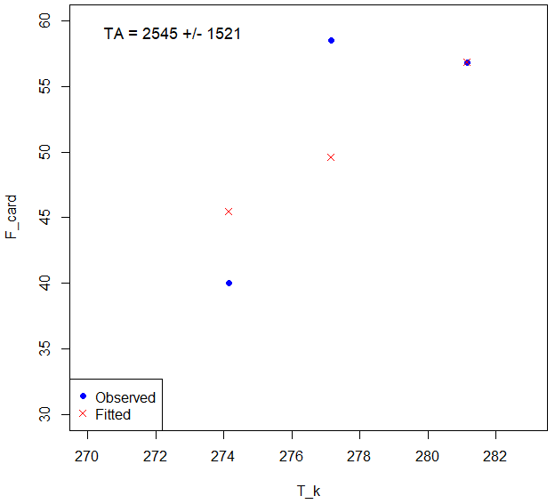
Figure S1. Fitting of Arrhenius temperature for cardiac output

Fat growth in fillet
A linear regression was performed to estimate the growth of the fat fraction in the fillet to the body weight (sc_{fat fillet}, no unit) and the body weight (BW, g) from 0.1 kg smolt fish to 5 kg adult fish. Data used were physiological data from this study, [4] and [5], as presented Table S8. In this study, the fat fraction in fillet represented 8.1 ± 1.6% (mean ± SD). Based on total weight of fish fillet, we estimated the volume of the fat fraction in fillet.
Table S8. Physiological data of fat fraction in fillet in Atlantic salmon.
BW (g) | sc_{fatfillet} (no unit) | References
176 | 0.038 | This study
148 | 0.031 | This study
160 | 0.043 | This study
138 | 0.047 | This study
138 | 0.031 | This study
115 | 0.035 | This study
139 | 0.049 | This study
116 | 0.030 | This study
115 | 0.028 | This study
139 | 0.035 | This study
145 | 0.034 | This study
179 | 0.034 | This study
181 | 0.040 | This study
178 | 0.034 | This study
144 | 0.030 | This study
176 | 0.042 | This study
176 | 0.054 | This study
132 | 0.038 | This study
132 | 0.038 | This study
131 | 0.037 | This study
192 | 0.035 | This study
191 | 0.041 | This study
223 | 0.048 | This study
170 | 0.039 | This study
140 | 0.046 | This study
138 | 0.033 | This study
166 | 0.042 | This study
242 | 0.033 | This study
229 | 0.041 | This study
206 | 0.033 | This study
253 | 0.036 | This study
209 | 0.030 | This study
140 | 0.037 | This study
168 | 0.030 | This study
191 | 0.044 | This study
152 | 0.032 | This study
303 | 0.048 | This study
233 | 0.039 | This study
252 | 0.035 | This study
310 | 0.043 | This study
262 | 0.035 | This study
216 | 0.044 | This study
241 | 0.034 | This study
241 | 0.071 | This study
258 | 0.040 | This study
426 | 0.045 | This study
274 | 0.048 | This study
356 | 0.049 | This study
375 | 0.052 | This study
293 | 0.054 | This study
256 | 0.043 | This study
240 | 0.044 | This study
272 | 0.047 | This study
347 | 0.048 | This study
279 | 0.037 | This study
190 | 0.030 | This study
305 | 0.046 | This study
212 | 0.039 | This study
314 | 0.048 | This study
298 | 0.045 | This study
282 | 0.034 | This study
439 | 0.057 | This study
151 | 0.043 | This study
343 | 0.045 | This study
333 | 0.042 | This study
185 | 0.046 | This study
421 | 0.055 | This study
429 | 0.062 | This study
415 | 0.051 | This study
407 | 0.051 | This study
294 | 0.039 | This study
249 | 0.043 | This study
366 | 0.047 | This study
301 | 0.046 | This study
264 | 0.038 | This study
286 | 0.035 | This study
299 | 0.039 | This study
154 | 0.027 | This study
396 | 0.045 | This study
371 | 0.044 | This study
292 | 0.040 | This study
427 | 0.044 | This study
366 | 0.037 | This study
366 | 0.038 | This study
238 | 0.040 | This study
484 | 0.052 | This study
428 | 0.051 | This study
370 | 0.055 | This study
418 | 0.059 | This study
310 | 0.033 | This study
475 | 0.049 | This study
685 | 0.054 | This study
491 | 0.047 | This study
373 | 0.059 | This study
661 | 0.060 | This study
404 | 0.040 | This study
457 | 0.055 | This study
492 | 0.048 | This study
505 | 0.044 | This study
130 | 0.037 | [4]
124 | 0.046 | [4]
379 | 0.060 | [4]
349 | 0.065 | [4]
297 | 0.067 | [4]
308 | 0.064 | [4]
750 | 0.055 | [4]
1366 | 0.085 | [4]
1477 | 0.086 | [4]
1869 | 0.097 | [4]
1867 | 0.098 | [4]
1863 | 0.099 | [4]
2010 | 0.097 | [4]
81 | 0.058 | [5]
205 | 0.058 | [5]
326 | 0.063 | [5]
627 | 0.069 | [5]
2406 | 0.084 | [5]
2953 | 0.090 | [5]
4270 | 0.10 | [5]
4980 | 0.11 | [5]

Model parametrization

PFAS specific parameters: estimation of the free fraction
The free fraction of each PFAS was estimated using SwissDock [7, 8], which estimates the Gibbs free energy (∆G, kcal/mol) of the binding. We used the docking with attracting cavities option with a number of Random Initial Conditions (RIC) of 3. The smallest SwissParam Score (∆G) was used to estimate the free fraction of each PFAS (Table S9) by applying Eq. 9-10 presented in the article. The more negative the value, the stronger the binding interaction. The rationale behind Eq. 10, linking the free fraction to the equilibrium dissociation constant is presented hereafter:
$$Free= \frac{{\left[PFAS\right]}_{free}}{{\left[PFAS\right]}_{total} } where {\left[PFAS\right]}_{total}={\left[PFAS\right]}_{bound}+{\left[PFAS\right]}_{free}$$ | Eq. S3
$$K_{A}=\frac{\left[PL\right]}{\left[P\right]×[L]} → K_{A}=\frac{{\left[PFAS\right]}_{bound}}{{\left[PFAS\right]}_{free}×\left[{Albumine}_{blood}\right]}$$ | Eq. S4
Combining Eq. S3 and S4:
$${[PFAS]}_{total}=K_{A}×{[PFAS]}_{free}×\left[{Albumine}_{blood}\right]+{[PFAS]}_{free}$$ | Eq. S5

Resolving Eq. S5, allowing to estimate the free fraction:
$Free= \frac{1}{1+K_{A}×\left[{Albumine}_{blood}\right]}$ where $K_{A}=\frac{1}{K_{D}}$ | Eq. S6
Table S9: Gibbs free energy, dissociation constant and free fraction estimated values.
PFAS | ∆G (kcal/mol) | K_{D} (mol/L) | Free (%)
PFOA | -6.182 | 5.95E+04 | 5.84
PFDA | -6.227 | 6.45E+04 | 5.42
PFNA | -6.276 | 7.04E+04 | 4.98
PFBS | -6.043 | 4.65E+04 | 7.36
PFHxS | -6.395 | 8.70E+04 | 4.08
PFOS | -6.468 | 9.90E+04 | 3.60

DEB model calibration and validation
Two datasets were used to re-calibrate the DEB parameter, data from [6] and from [7]. For both studies, the datasets consisted solely of data from salmon reared in seawater with similar feeds of 3mm in diameter to start with. The data from [7] included a freshwater stage (as seen from the feeds with a diameter of <3mm), however this growth data was not included in the modelling dataset. In the [6] dataset, at around day 317, fish were moved from small pens (seawater start growth) to larger pens (grow out). This resulted in a drop in relative growth from day 317 to day 384 (Specific Growth Rate SGR is 0.94% despite the highest water temperature being 7.46). The data were therefore split into two sub-sets: 1) pre-net pen and 2) post-net pen transfer. The water temperatures reported in the two studies were used as input to the model. For this purpose, daily temperatures were estimated by linear interpolation between the measurements available in the dataset. Datasets provide the Specific Growth Rate (SGR) and the Food Conversion Rate (FCR). SGR is a coefficient that measures the percentage increase in fish weight per day.
$$SGR= 100 ×\frac{ln W_{2} -ln W_{1} }{t_{2}-t_{1}}$$ | Eq. S7
The Feed Conversion Ratio (FCR) is the mathematical relationship between the amount of feed consumed and the weight gain of a population (feed intake (g) / fish weight gain (g)).
$$FCR=\frac{Afeed}{W_{2}-W_{1}}$$ | Eq. S8

We have adapted the implementation of the feeding level in the DEB model by using a hyperbolic functional response, as suggested by [8], for a given fish.
Table S10. Estimated daily feed intakes (g) from Lock et al. (2011) [6] and Torstensen et al. (2005) [7]
Experiment | Age | Time | BW | Length | Feed conversion factor | SGR | Food quantities
 | (day) | (day) | (g) | cm | (g feed / g fish weight) | % dw /day | (g/d)
[6] | - | 0 | 81.0 | 19.1 | - | - | 0.4
[6] | - | 109 | 205.0 | 26.0 | 0.76 | 0.95 | 0.86
[6] | - | 168 | 326.0 | 30.3 | 0.8 | 0.98 | 1.64
[6] | - | 217 | 627.0 | 36.3 | 0.78 | 0.95 | 4.79
[6] | - | 317 | 2406.0 | 54.6 | 0.84 | 0.96 | 14.94
[6] | - | 384 | 2953.0 | 59.1 | 0.89 | 0.94 | 7.27
[6] | - | 489 | 4270.0 | 66.9 | 0.87 | 0.81 | 10.91
[6] | - | 529 | 4980.0 | 70.0 | 0.93 | 0.78 | 16.51
[7] | 284 | 0 | 125.0 | 22.0 | 0.82 | 0.96 | 1.0
[7] | 356 | 72 | 254.2 | 27.1 | 1.06 | 1.19 | 1.90
[7] | 456 | 172 | 456.7 | 34.1 | 0.88 | 1.36 | 1.79
[7] | 512 | 228 | 928.4 | 42.0 | 1.12 | 0.97 | 9.48
[7] | 680 | 396 | 2443.4 | 56.8 | 1.88 | 0.38 | 16.99

PBK model calibration: prior distributions
Table S11. Prior distributions for all six PFAS calibration. LogU: loguniform defined by the minimum and the maximum of the sampling range (real numbers) in natural space. TN_cv: truncated normal distribution defined by the mean, the coefficient of variation, the minimum and the maximum. When no prior distributions were defined, the value of the parameter was fixed.
Parameters | Prior distribution
Partition coefficients organ i: plasma (PC i, no unit)
Plasma:water | LogU(1, 1E5)
GIT | LogU(1E-3, 20)
Liver | LogU(1E-3, 10)
Adipose | LogU(1E-3, 10)
RPT | TN_cv(1E-3, 0,3) [1E-12;1]
Carcass | TN_cv(1E-3, 0,3) [1E-12;1]
Skin | TN_cv(0.27, 0,3) [1E-12;1]
Gills | LogU(1E-3, 10)
RM | LogU(1E-4, 10)
WM | LogU(1E-8, 1)
Blood cells | LogU(1E-3, 20)
Brain | -
Kidney | -
Permeability coefficient (PA i, mL/d)
WM | LogU(1E-4, 1E4)
Fat in fillet | LogU(1E-12, 1)
Free fraction (%)
Free | -
First-order kinetic constant (1/d)
Ke bile | LogU(1E-3, 10)
Ke feces | LogU(1E-12, 10)
K UtoL | LogU(1E-4, 10)
Ku | LogU(1E-3, 10)

PBK model validation
Table S12. Data set used to validate the PBK model. Surveillance data were obtained from the IMR’s routine surveillance.
 |  | PFOA | PFNA | PFHxS | PFDA | PFBS | L-PFOS
Feeds concentration (µg/kg)
Surveillance
IMR, n=8 | Average | 0.07 | 0.19 | 0.01 | 0.04 | ND | 0.73
 | Max | 0.29 | 0.65 | 0.03 | 0.15 | ND | 2.83
Ali et al 2025
n = 4 | Min | <0.05 | 0.025 | <0.03 | <0.03 | <0.03 | 0.06
 | Max | 0.26 | 0.65 | 0.075 | 0.15 | <0.03 | 2.36
Salmon fillet concentration (µg/kg)
Surveillance
IMR, n=260 | Max (<LOQ) | <0.2 | <0.5 | <0.1 | <0.1 | <0.1 | 0.12

Sensitivity analysis
Table S13. Parameters selected to perform the sensitivity analysis following Sobol method.
Parameters | Definition | Unit | Mean | Lower | Upper
PC_blood_water | Blood:water partition coefficient | - | 7814.1 | 6251.28 | 9376.92
PC_GIT | GIT:Blood partition coefficient | - | 2.3 | 1.84 | 2.76
PC_liver | Liver:Blood partition coefficient | - | 0.9 | 0.72 | 1.08
PC_adipose | Adipose:Blood partition coefficient | - | 0.13 | 0.104 | 0.156
PC_rp | Rp:Blood partition coefficient | - | 0.0013 | 0.00104 | 0.00156
PC_carcass | Carcass:Blood partition coefficient | - | 0.0012 | 0.00096 | 0.00144
PC_gills | Gills:Blood partition coefficient | - | 0.19 | 0.152 | 0.228
PC_RM_fillet | RM:Blood partition coefficient | - | 0.094 | 0.0752 | 0.1128
PC_WM_fillet | WM:Blood partition coefficient | - | 0.06 | 0.048 | 0.072
PA_WM | White muscle permeability coefficient | 1/d | 0.38 | 0.304 | 0.456
PA_fat | Fat in fillet permeability coefficient | 1/d | 0.002 | 0.0016 | 0.0024
Ke_bile | Bile elimination rate | 1/d | 0.35 | 0.28 | 0.42
Ke_feces | Feces elimination rate | 1/d | 0.75 | 0.6 | 0.9
K_UtoL_GIT | Upper to lower intestine transfert rate | 1/d | 2.74 | 2.192 | 3.288
Ku | Oral absorption rate | 1/d | 0.38 | 0.304 | 0.456
Free | Unbound fraction of PFAS in blood | - | 0.2 | 0.16 | 0.24
frac_adipose | Adipose tissu blood fraction | - | 0.006 | 0.0048 | 0.0072
frac_RM_fillet | Fillet blood fraction | - | 0.001 | 0.0008 | 0.0012

Results

DEB sub-model: calibration of the fish growth
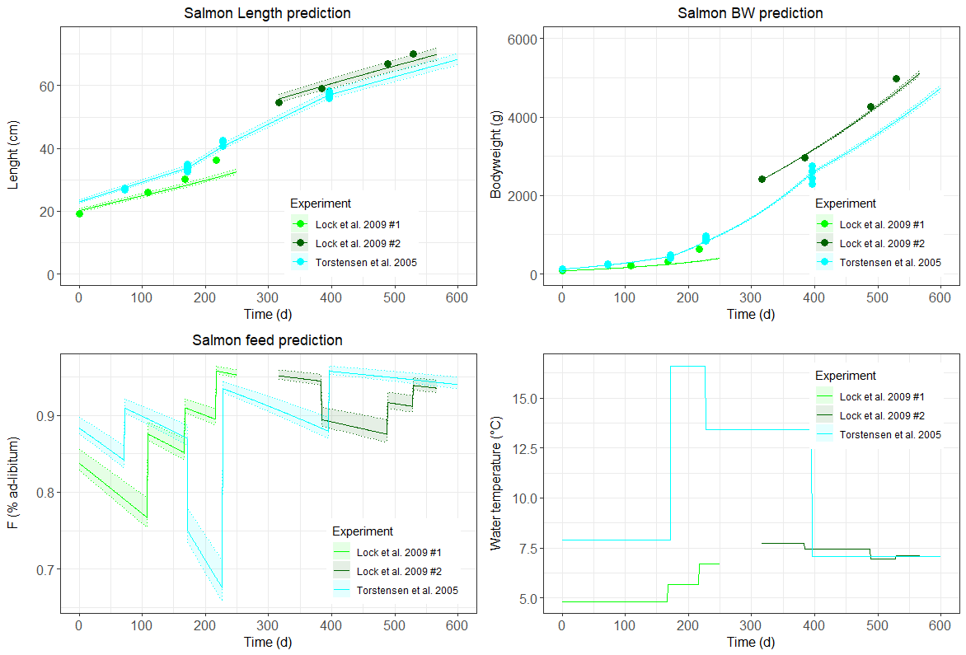
Figure S2. Re-calibration of the DEB parameters on the data from Lock et al. (2011) [6] and Torstensen et al. (2005) [5], using the parameter values proposed in Add my pet as prior values and the f (the feeding level estimated as input of the DEB model) and interpolated water temperature (input of the DEB model) represented in the bottom panels as input data.

Fat growth in fillet

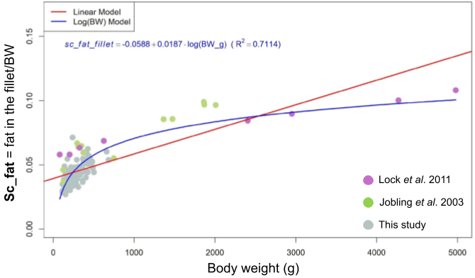
Figure S3. Fitted model defining the relationship between fat fraction in the fillet and in the whole body. The equation is: sc_{fat fillet} = - 0.059 + 0.019 x log(BW), where sc _{fat fillet} has no unit and BW is in g.

Sensitivity analysis
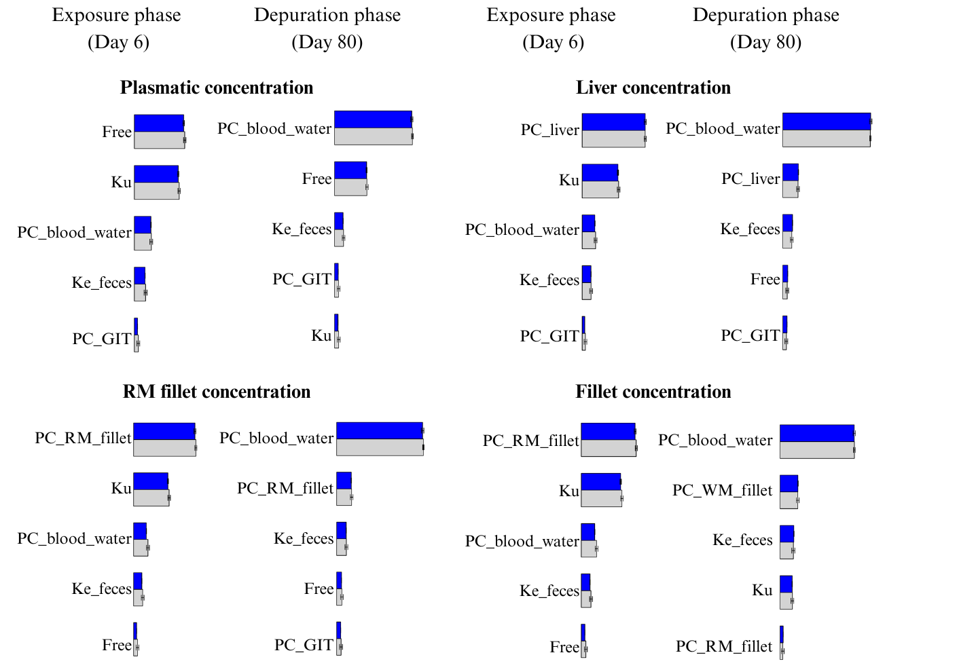

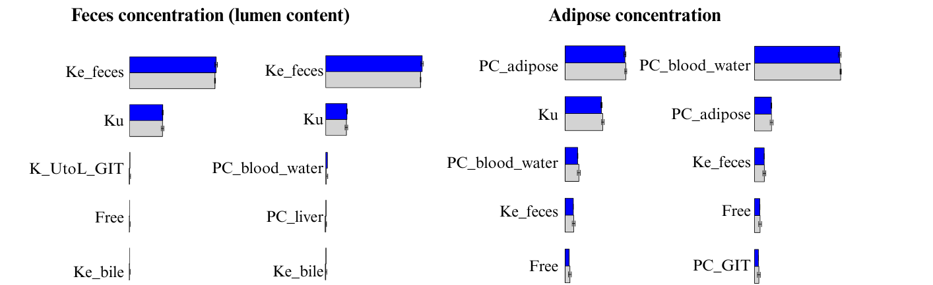
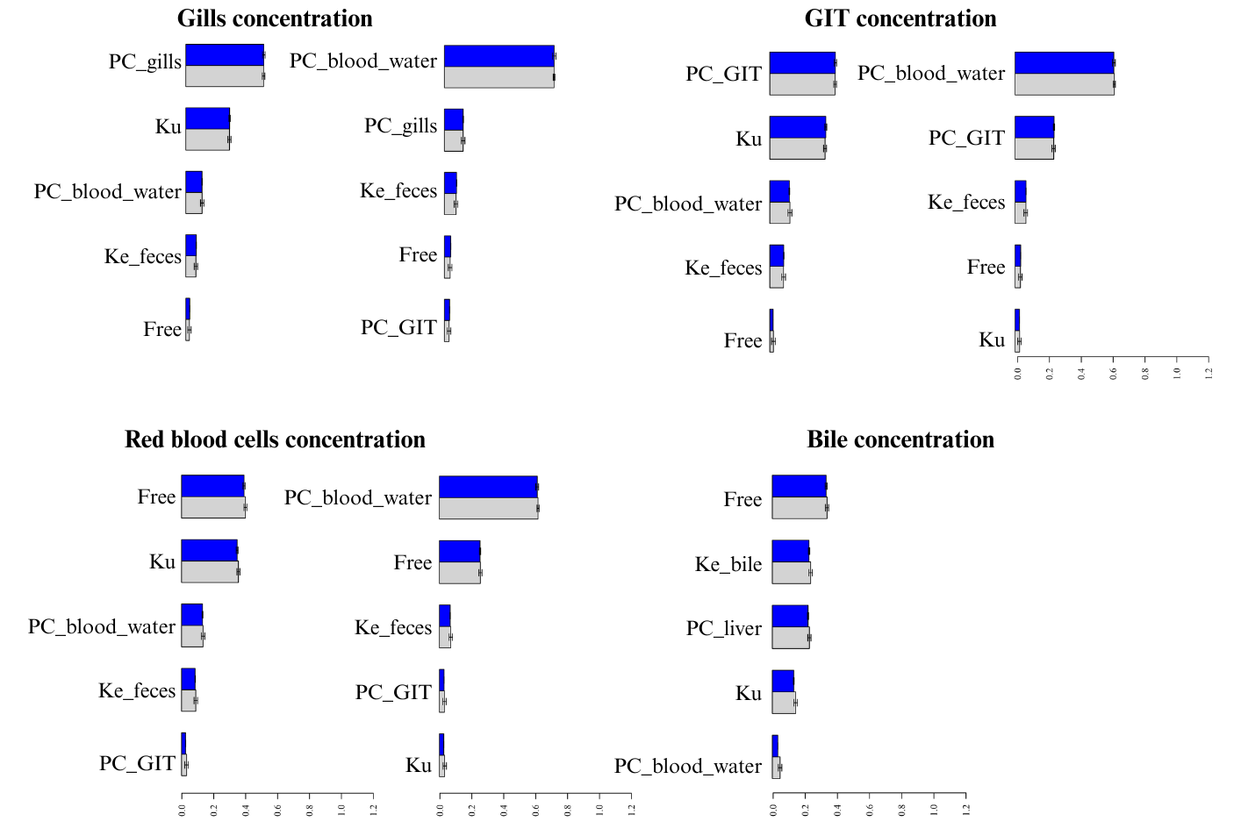
Figure S4. Sobol sensitivity results. Grey bars represent first-order index. Blue bars represent total index.

PBK model

PFAS kinetic profile
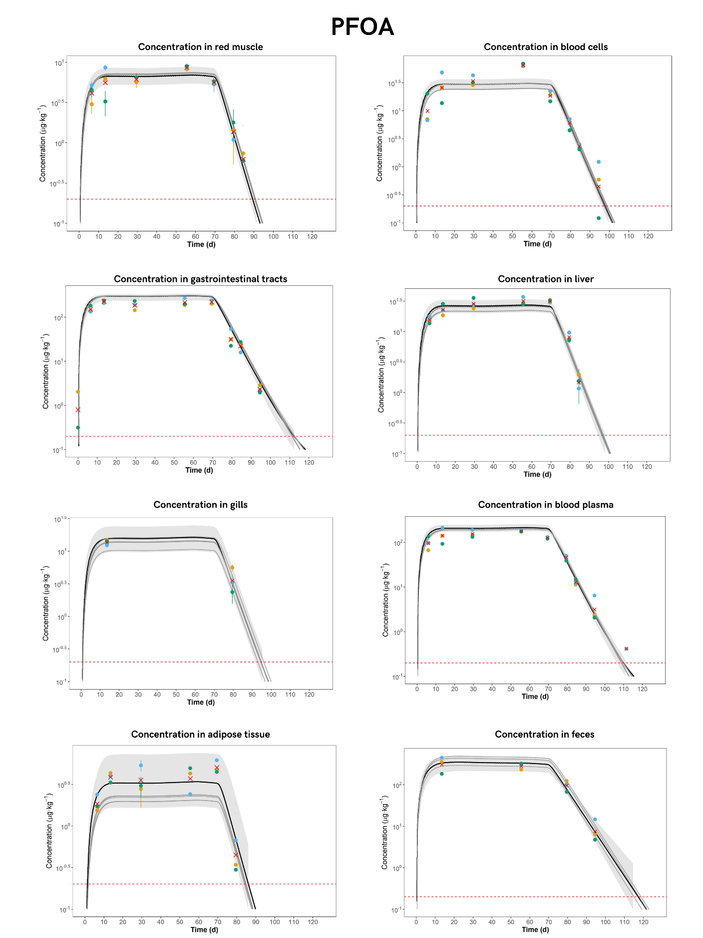
Figure S5. Kinetic profile of PFOA. Concentration is shown on a log-scale. Each point represents a tank (n = 3), and the red cross represents the mean across the three replicates.

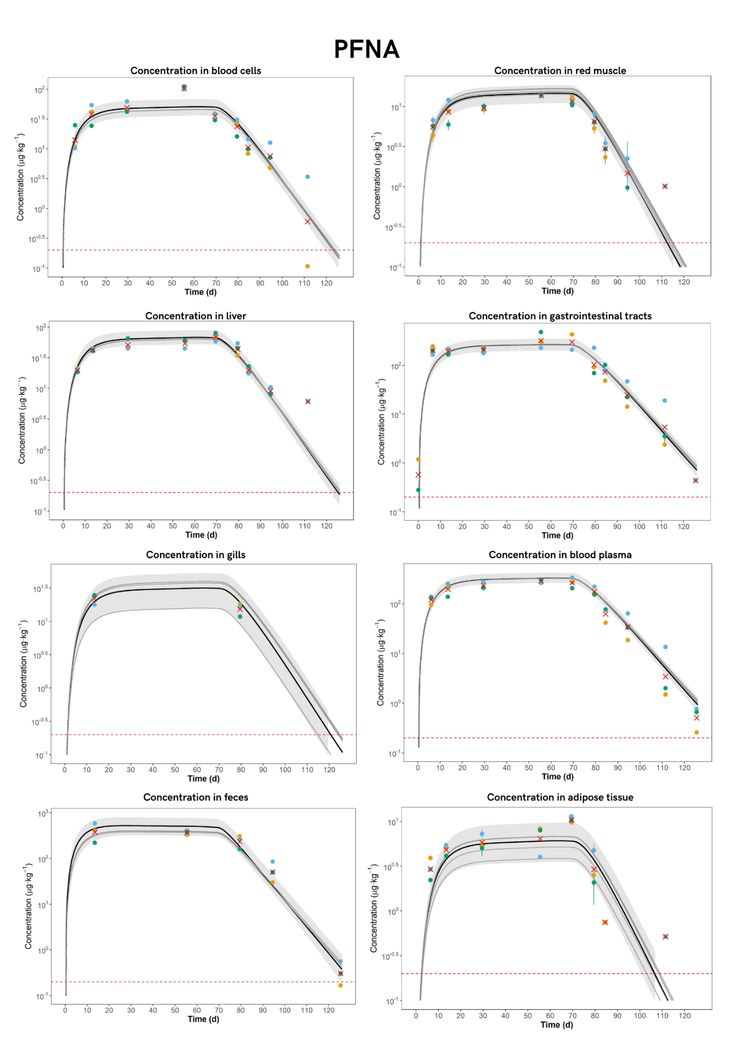Figure S6. Kinetic profile of PFNA. Concentration is shown on a log-scale. Each point represents a tank (n = 3), and the red cross represents the mean across the three replicates.

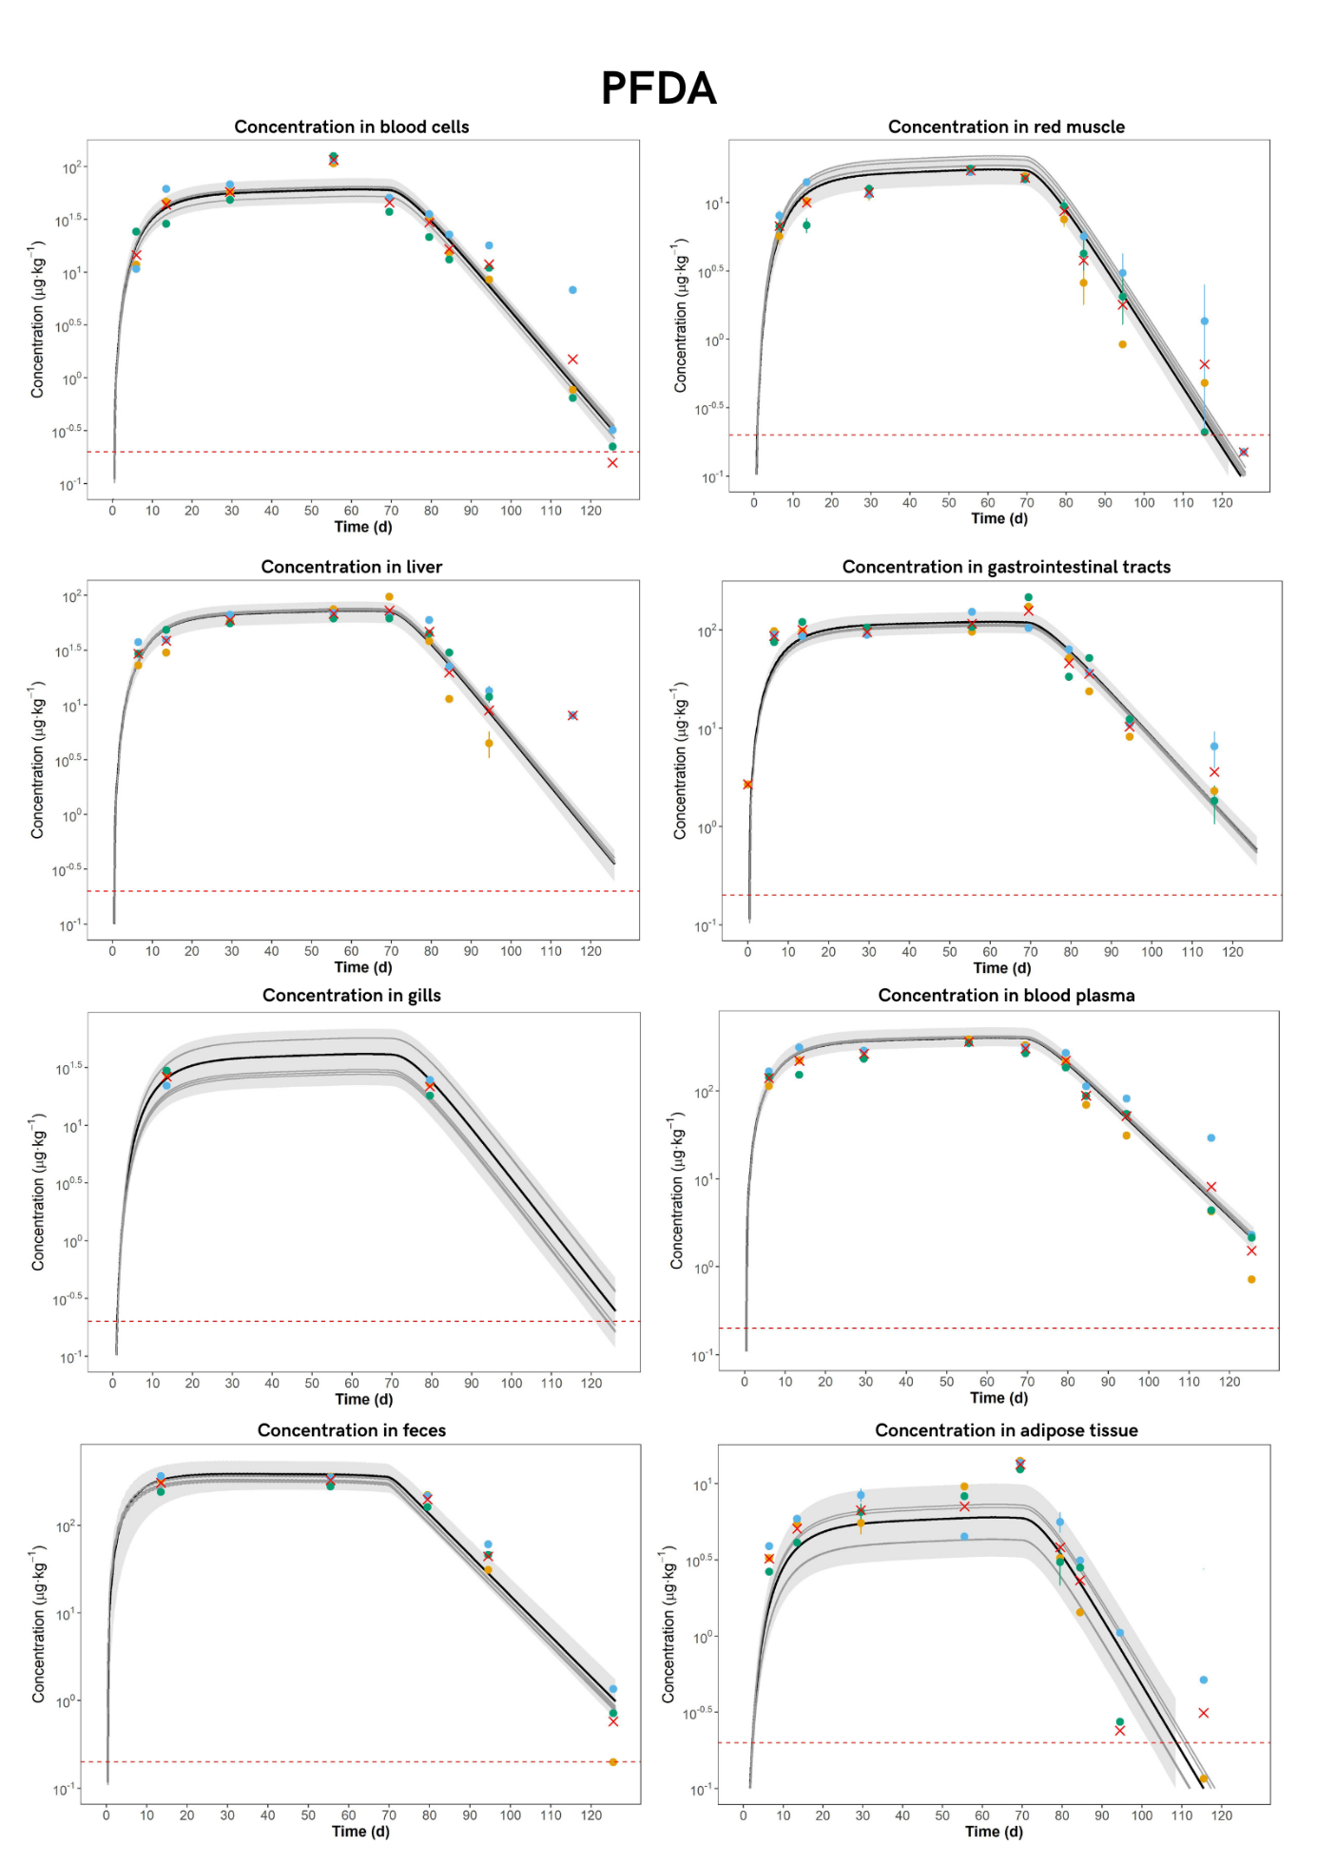
Figure S7. Kinetic profile of PFDA. Concentration is shown on a log-scale. Each point represents a tank (n = 3), and the red cross represents the mean across the three replicates.

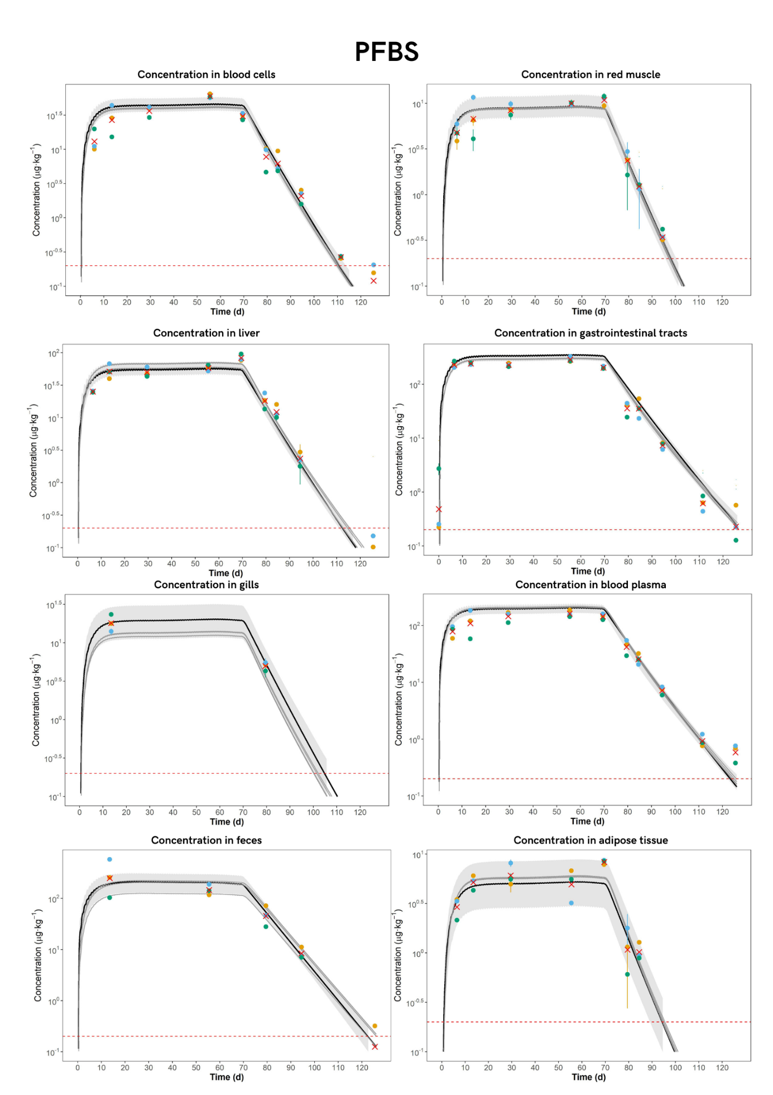
Figure S8. Kinetic profile of PFBS. Concentration is shown on a log-scale. Each point represents a tank (n = 3), and the red cross represents the mean across the three replicates.

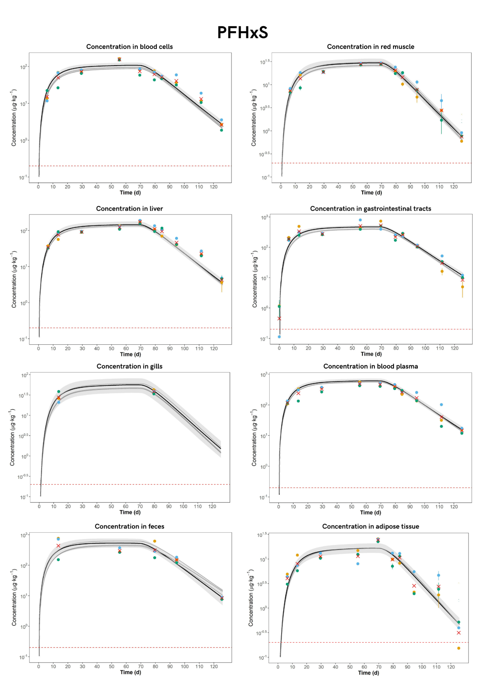
Figure S9. Kinetic profile of PFHxS. Concentration is shown on a log-scale. Each point represents a tank (n = 3), and the red cross represents the mean across the three replicates.

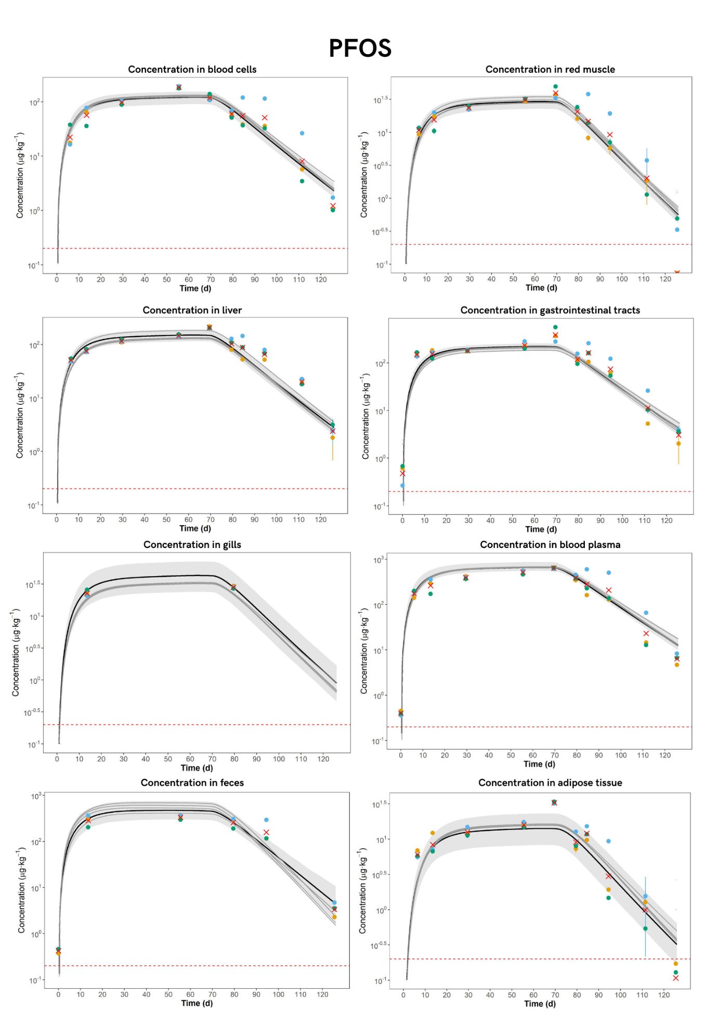
Figure S10. Kinetic profile of PFOS. Concentration is shown on a log-scale. Each point represents a tank (n = 3), and the red cross represents the mean across the three replicates.

Elimination route
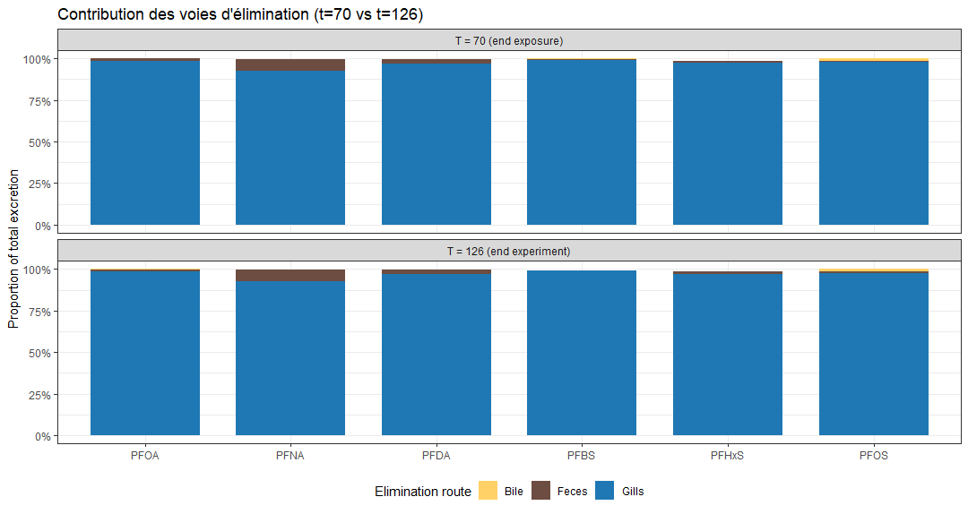
Figure S11. Proportion of each elimination route in comparison to all elimination routes together.

Enterohepatic recirculation
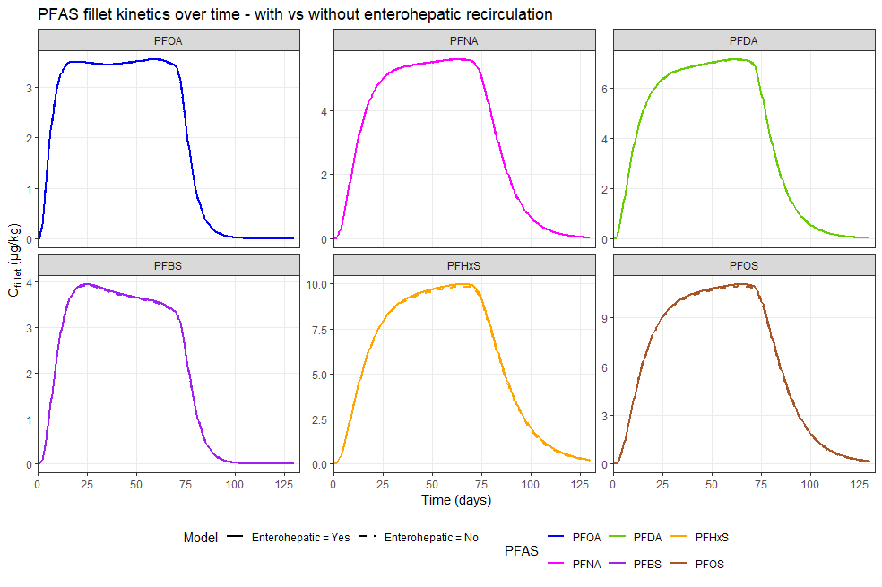
Figure S12. PFAS fillet kinetics over time – with or without enterohepatic recirculation

Diffusion vs. perfusion in the fillet
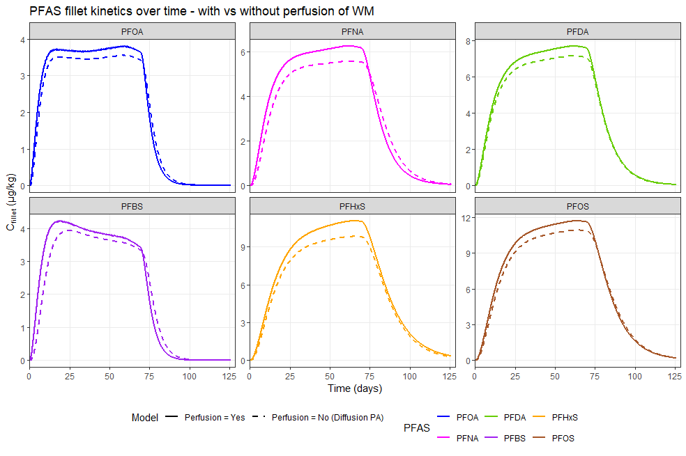
Figure S13. PFAS fillet kinetics over time – with or without perfusion of white muscle (WM).

Linear relationship between feed and fillet concentration
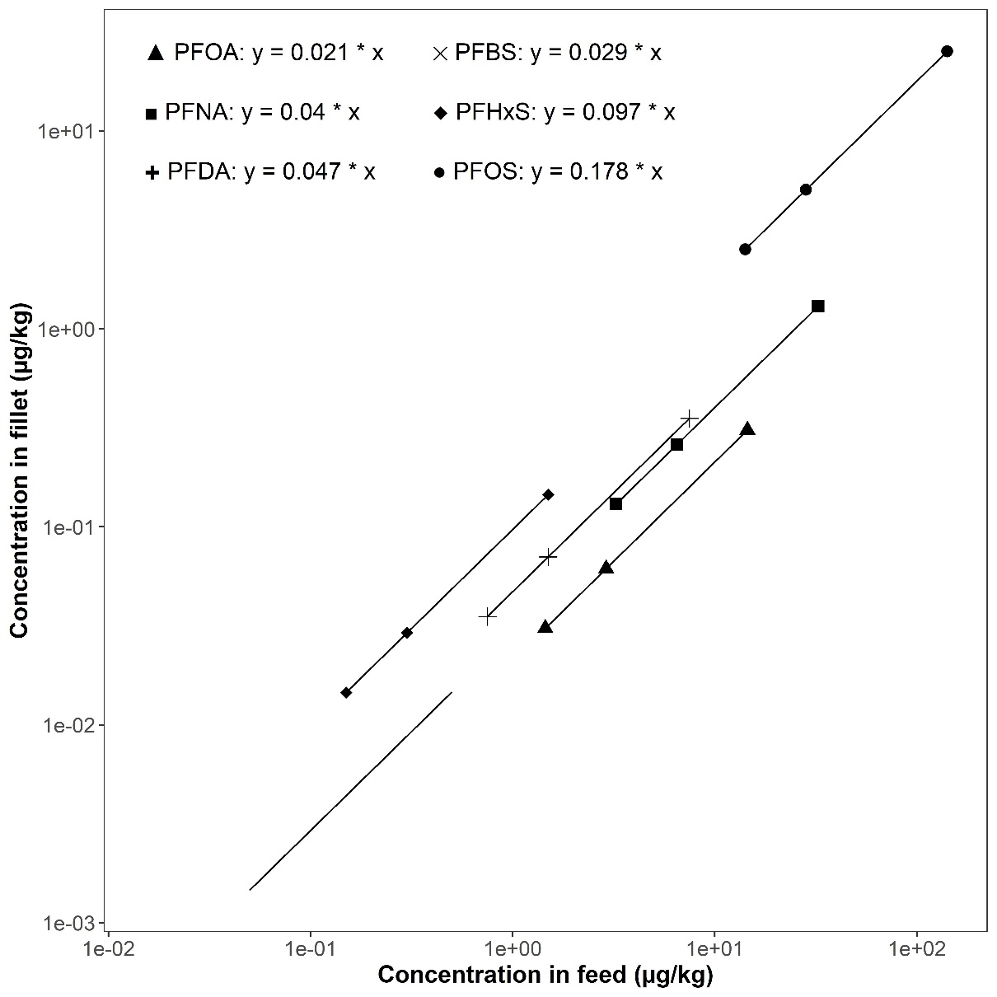
Figure S14. Linear relationship between PFAS concentrations in feed and predicted fillet concentrations. Each point represents 5×, 10×, or 50× the highest commercially observed level for each PFAS in feed, and the corresponding fillet concentration predicted by the PBK model.

References
[1] A. Grech, C. Tebby, C. Brochot, F.Y. Bois, A. Bado-Nilles, J.-L. Dorne, N. Quignot, R. Beaudouin, Generic physiologically-based toxicokinetic modelling for fish: Integration of environmental factors and species variability, Science of The Total Environment, 651 (2019) 516-531.
[2] A. Vidal, M. Babut, J. Garric, R. Beaudouin, Elucidating the fate of perfluorooctanoate sulfonate using a rainbow trout (<i>Oncorhynchus mykiss</i>) physiologically-based toxicokinetic model, Science of the Total Environment, 691 (2019) 1297-1309.
[3] E.S. Porter, A.K. Gamperl, Cardiorespiratory physiology and swimming capacity of Atlantic salmon (Salmo salar) at cold temperatures, J Exp Biol, 226 (2023).
[4] M. Jobling, S.J.S. Johansen, Fat distribution in Atlantic salmon <i>Salmo salar</i> L. in relation to body size and feeding regime, Aquaculture Research, 34 (2003) 311-316.
[5] B.E. Torstensen, J.G. Bell, G. Rosenlund, R.J. Henderson, I.E. Graff, D.R. Tocher, Ø. Lie, J.R. Sargent, Tailoring of Atlantic salmon (Salmo salar L.) flesh lipid composition and sensory quality by replacing fish oil with a vegetable oil blend, J Agric Food Chem, 53 (2005) 10166-10178.
[6] E.-J. Lock, P.-G. Fjelldal, B.E. Torstensen, M. Bjornevik, O. Breck, J. Johansen, P. Reynolds, T. Sigholt, N. Joerum, J.-V. Jakobsen, K. Ruohonen, R. Waagbo, M.H.G. Berntssen, Dietary decontaminated fish oil has no negative impact on fish performance, flesh quality or production-related diseases in Atlantic salmon (Salmo salar), Aquaculture Nutrition, 17 (2011) e760-e772.
[7] B.E. Torstensen, J.G. Bell, G. Rosenlund, R.J. Henderson, I.E. Graff, D.R. Tocher, Ø. Lie, J.R. Sargent, Tailoring of Atlantic Salmon (Salmo salar L.) Flesh Lipid Composition and Sensory Quality by Replacing Fish Oil with a Vegetable Oil Blend, Journal of Agricultural and Food Chemistry, 53 (2005) 10166-10178.
[8] B. Kooijman, Dynamic Energy Budget Theory for Metabolic Organisation, 3 ed., Cambridge University Press, Cambridge, 2010.

