Modeling the impact of improved seed varieties on common bean productivity in agroecological zones of Tanzania: A stochastic simulation approach.

Supplementary Material A (SM A): Yield distributions for local and improved seed varieties in Tanzania.
Tables SM1 and SM2 provide comparative summary statistics for bean yield distributions across Tanzania’s agroecological zones (AEZs), disaggregated by seed type (local vs. improved) and by season. Under the Short Rainy Season (SRS), Table SM1 shows that across all zones, farms using improved seeds consistently achieved higher mean yields than those using local seeds. For instance, in the Eastern Zone (EZ), improved seed users attained a mean yield of 1.495 t/ha compared to 1.360 t/ha for local seed users. Similarly, the Lake Zone (LZ) reported an average yield of 1.432 t/ha under improved seeds, up from 1.336 t/ha under local seeds. Standard deviations (STD) and coefficients of variation (CV) also varied slightly but remained within comparable ranges, with CVs typically between 27% and 36%, reflecting moderate yield variability among farmers. Notably, yield ranges (Min–Max) show that improved seeds were not only more productive on average but also performed well across a broader range of productivity levels, especially in zones like the Northern Highlands and Eastern Tanzania.

During the Long Rainy Season (LRS), the trend of improved seed performance persisted, as detailed in Table SM2. Again, improved seeds recorded higher mean yields in all AEZs, such as 0.814 t/ha in the Western Zone (WZ) and 0.739 t/ha in the Eastern Zone, compared to 0.650 t/ha and 0.649 t/ha for local seeds, respectively. Despite the lower absolute yields during LRS relative to SRS (due to seasonal factors), the improved seed advantage remained evident. Coefficient of variation values under LRS were generally higher than those in SRS, with CVs peaking above 40% in some regions (e.g., WZ_LRS1_Improved at 41.62%), indicating greater variability in yield outcomes. This increased variation could be linked to climatic inconsistencies or input interactions during the longer growing season. Overall, both tables underscore the productivity benefits of improved bean seeds, regardless of season, while also highlighting the inter-zone variability in yield performance and the critical role of seasonal dynamics.

Table SM1: Summary Statistics for Bean Yield (t/ha) Distribution in Tanzania During the Short Rainy Season
 | Mean | STD | CV | Min | Max
CZ_SRS_Local Seeds | 1.417 | 0.509 | 35.92 | 0.889 | 2.372
EZ_SRS_Local Seeds | 1.360 | 0.418 | 30.73 | 0.593 | 3.089
LZ_SRS_Local Seeds | 1.336 | 0.370 | 27.67 | 0.593 | 3.084
NZ_SRS_Local Seeds | 1.304 | 0.373 | 28.59 | 0.593 | 3.163
SHZ_SRS_Local Seeds | 1.255 | 0.360 | 28.66 | 0.642 | 1.977
WZ_SRS_Local Seeds | 1.309 | 0.340 | 25.95 | 0.618 | 2.076
TZ_SRS_Local Seeds | 1.321 | 0.367 | 27.77 | 0.593 | 3.163
EZ_SRS_Improved Seeds | 1.495 | 0.425 | 28.43 | 0.741 | 2.989
LZ_SRS_Improved Seeds | 1.432 | 0.410 | 28.61 | 0.553 | 2.780
NZ_SRS_Improved Seeds | 1.429 | 0.455 | 31.81 | 0.618 | 2.965
SHZ_SRS_Improved Seeds | 1.313 | 0.452 | 34.47 | 0.593 | 2.989
TZ_SRS_Improved Seeds | 1.401 | 0.421 | 30.03 | 0.556 | 3.058

Table SM2: Summary Statistics for Bean Yield (t/ha) Distribution in Tanzania During the Long Rainy Season
 | Mean | STD | CV | Min | Max
CZ_LRS_Local Seeds | 0.656 | 0.232 | 35.35 | 0.296 | 1.500
EZ_LRS_Local Seeds | 0.649 | 0.214 | 33.04 | 0.296 | 1.577
LZ_LRS_Local Seeds | 0.660 | 0.218 | 33.04 | 0.297 | 1.504
NZ_LRS_Local Seeds | 0.678 | 0.252 | 37.16 | 0.297 | 1.647
SHZ_LRS_Local Seeds | 0.644 | 0.199 | 30.95 | 0.049 | 1.581
WZ_LRS_Local Seeds | 0.650 | 0.209 | 32.21 | 0.145 | 1.483
TZ_LRS_Local Seeds | 0.626 | 0.153 | 24.36 | 0.297 | 1.647
CZ_LRS_Improved Seeds | 0.681 | 0.271 | 39.83 | 0.395 | 1.483
EZ_LRS_Improved Seeds | 0.739 | 0.273 | 36.90 | 0.494 | 1.494
LZ_LRS_Improved Seeds | 0.699 | 0.273 | 38.98 | 0.494 | 1.494
NZ_LRS_Improved Seeds | 0.734 | 0.300 | 40.84 | 0.262 | 1.498
SHZ_LRS_Improved Seeds | 0.706 | 0.266 | 37.66 | 0.297 | 1.516
WZ_LRS_Improved Seeds | 0.814 | 0.339 | 41.62 | 0.395 | 1.500
TZ_LRS_Improved Seeds | 0.699 | 0.268 | 38.42 | 0.262 | 1.516

Supplementary Material B (SM B): Stochastic formula for simulation used in modeling the impact of improved seed varieties on common bean productivity in agroecological zones of Tanzania.

Equation 1 computes the deterministic (non-random) yield per hectare for a given seed type 𝑖, in a specific agroecological zone, 𝜔, and for a farming cluster, 𝑐. It is calculated as the ratio of harvested tonnage to the area harvested. Equation 2 introduces randomness (stochasticity) into the deterministic yield by multiplying it by a random shock factor 𝜀, simulating real-world variability. The $ε$ is the variability about the mean, and is the unexplained portion of the random variable (yield) as expressed in Equation 3. Equation 4 is the simplified stochastic yield expression using a multiplicative shock, indicating how the observed yield is adjusted for uncertainty using empirical distributions and simulation randomness.

Deterministic yield ($\bar{y}$)
${ yield (\bar{y}}_{c,i,ω})=\frac{Tones harvested (tones)}{Hectares harvested (a)}$ (1)

Stochastic yield ($\tilde{y}$)

${\tilde{y}}_{i,ω}={ \bar{y}}_{c,i,ω}*ε$ (2)

$ε =y_{i,ω}-{\bar{y}}_{c,i,ω}$ (3)

${\tilde{y}}_{i,ω}={\bar{y}}_{c,i,ω}*\left(1+EMP\left(S_{y,i,ω},P\left(S_{y,i,ω}\right),CUSD_{y,i,ω}\right)\right)*β_{{\tilde{y}}_{0}}$ (4)
Where:
~ | = | A tilde represents a random (stochastic) variable.
i | = | Type of farming practices used (local seeds, improved seeds).
$ω$ | = | Represents farms in six agroecological zones
a_{i} | = | Hectares (ha) allocated for farming practice i
y | = | Individual farm yield
 | = | Stochastic mean yield per ha for farming practice i
$${\overline{y}}_{i}$$ | = | Deterministic (mean) yield per ha for farming practice i
$$β_{{\tilde{y}}_{0}}$$ | = | The normalization factor, which is given by $\frac{{\tilde{y}}_{c,i}}{{\tilde{y}}_{h,i}}$and it is used to scale/adjust the 2019/20 NCSA mean yield.
$${\tilde{y}}_{c}$$ | = | Stochastic yield for the current survey (2019/20 NCSA)
$${\tilde{y}}_{h}$$ | = | Stochastic yield for the historical or previous survey (2007/08 NCSA) (URT, 2012)
S_{y} | = | Fraction deviations from the mean or sorted array of random yields for farming practice i
P(S_{y}) | = | Cumulative probability function for the S_{y} values
CUSD_{y} | = | Simetar function to simulate the correlated uniform standard deviation of random variables.
EMP() | = | Simetar function used to simulate a stochastic variable (yield)

Supplementary Material C (SM C): Model Validation Using Statistical Tests and Graphs for the Observed vs. Simulated yields
After simulating the variable, it is necessary to determine whether the simulated series is statistically equal to the parent or historical distribution. This means that if the simulation model does not reproduce the statistics for the random variables, the model is not validated and can not be used for decision-making. Thus, both statistical tests and graphs were conducted to ensure that the simulated variables are from the appropriate probability distribution, i.e., have the correct means and standard deviation. Means - test that the mean of each simulated variable equals its respective historical or observed mean using a Student’s –t test. Chi-Squared test for validating the standard deviation was also used. Charts of the simulated stochastic variables vs. the historical data were also developed to help verify the simulated variables. In this regard, PDFs or probability distribution functions were developed for the simulated values and the historical data to check for similar shapes.
Model validation by PDFs
Figure SM1 illustrates the probability density functions (PDFs) comparing observed and simulated yield distributions of common beans under long and short rainy seasons (LRS and SRS) across Tanzania’s AEZs for farms using local seed varieties. Each subplot represents a specific zone (e.g., Central, Eastern, Lake, Northern Highlands, Southern Highlands, and Western), with black lines representing observed data and red lines representing simulated distributions. In all zones, the shapes and peaks of the PDFs align closely, demonstrating that the simulated distributions effectively mimic the empirical yield behavior in both LRS and SRS seasons.
The overlap between observed and simulated PDFs is particularly strong in zones like the Western, Southern Highlands, and Central Zones, where the curves are nearly identical in both shape and spread. Even in areas with slightly more variation, such as the Northern Highlands and Eastern Zones, the deviations remain minor and within acceptable bounds. These visual validations reinforce the statistical findings in SM2 and confirm the model’s suitability for simulating yield distributions under varying climatic and geographic conditions. Consequently, the model provides a reliable tool for assessing policy scenarios and intervention impacts in Tanzania’s bean farming systems.

Supplementary Material C: Model Validation Using Graphs for the Observed vs. Simulated yields
Figure SM1: PDF charts comparing observed and simulated distributions for common bean yields across AEZs of Tanzania for farms using local seed varieties (S1), under the long rainy season (LRS). The black chart represents observed data, with red representing the simulated dataset.

Statistical Validation of the Simulation Model
Figure SM2 presents the results of hypothesis tests assessing the accuracy of the simulated yield distributions for common bean production under improved seeds during the short rainy season (SRS) across Tanzanian agroecological zones (AEZs). Specifically, panels (a) through (e) report Student’s t-tests and Chi-square tests comparing simulated mean yields and standard deviations against their observed (historical) counterparts. The critical value of the t-test at a 5% significance level (α = 0.05) is 2.25. In all AEZs, the calculated t-values are far below this threshold and the associated p-values are high (ranging from 0.91 to 1.00), indicating that the differences between simulated and observed mean yields are not statistically significant. Therefore, we fail to reject the null hypothesis that the simulated mean equals the historical mean at the 95% confidence level.

Likewise, the Chi-square test results further confirm the model’s robustness. All calculated Chi-square statistics fall within the acceptable range between the lower (439.00) and upper (562.79) bounds of the critical region. The high p-values (mostly above 0.70) demonstrate no significant difference between simulated and observed standard deviations, thus supporting the model’s capacity to reproduce historical yield variability. These validation results collectively suggest that the simulation model is well-calibrated and statistically replicates real-world yield patterns under improved seed usage, thereby justifying its use for further scenario analysis and policy simulations across the country’s AEZs.
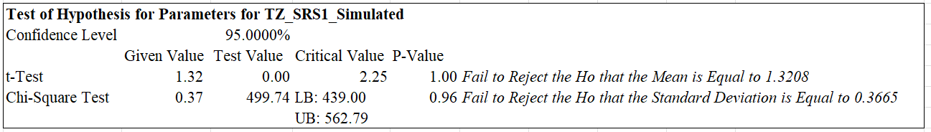
(a)
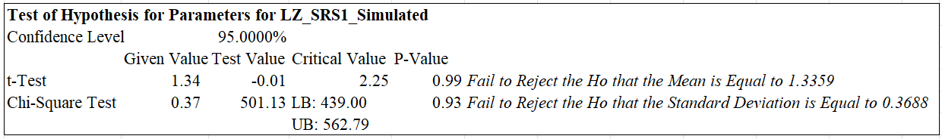
(b)
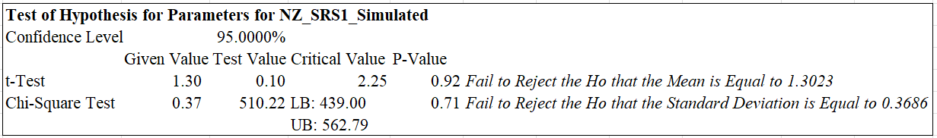
(c)
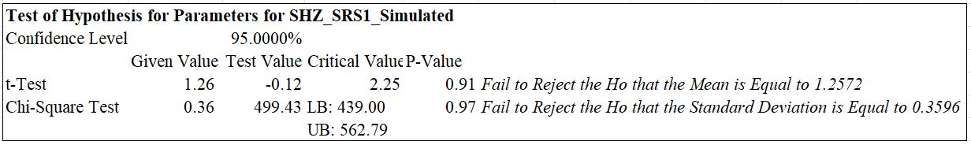
(d)
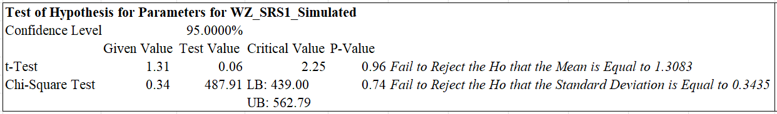
(e)
Figure SM2: Panel a–e shows statistical tests observed and simulated distributions for common bean yields across AEZs of Tanzania for farms using improved seeds under the short rainy season (SRS).

Supplementary Material D: Statistical Tests of the Local vs. Improved yields
Figure SM3 provides statistical evidence comparing the yield distributions of farms using improved seed varieties across different Agroecological Zones (AEZs) in Tanzania during the Short Rainy Season (SRS). Using Student’s t-tests and Chi-square tests at a 95% confidence level, the panels (a–e) assess whether the simulated means and standard deviations of yields from improved seeds differ significantly from historical benchmarks. The results indicate that in all AEZs, the simulated mean yields are significantly higher than the reference values, as all t-test statistics exceed the critical value of 2.25 and report p-values below 0.05.

In terms of variability, Chi-square tests reveal that in most AEZs, the standard deviation of yields has also changed significantly, suggesting variations in yield risk across zones. However, in the Eastern Zone (EZ), the standard deviation is not statistically different from the baseline, indicating stable variability despite higher mean yields. These results affirm the robustness of the simulation model and provide strong evidence that the adoption of improved seeds not only boosts productivity but also alters yield risk profiles. This zone-specific insight is essential for policy and investment decisions tailored to Tanzania’s ecological diversity.

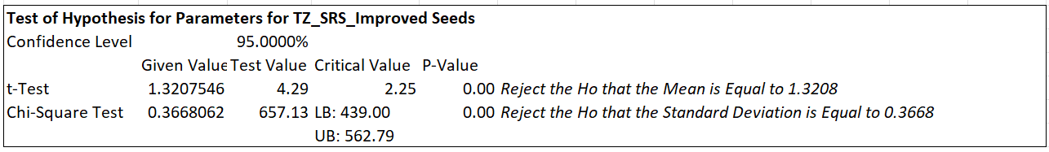
(a)
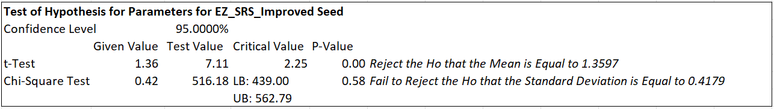
(b)
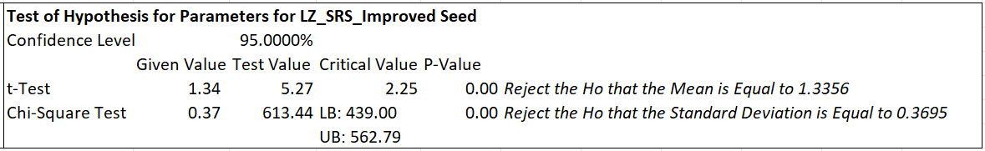
(c)
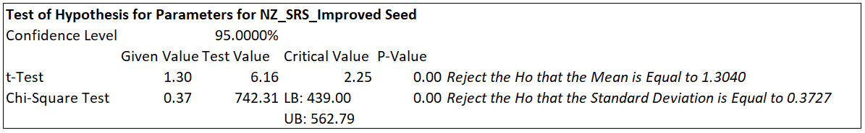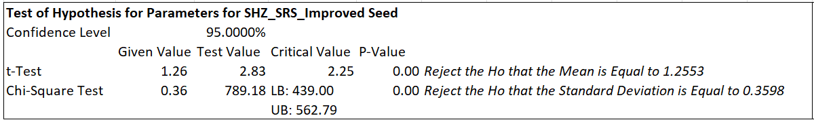
(e)
(d)
Figure SM3: Panel a – e shows statistical tests of the yield of local and improved seed distributions for common bean yields across AEZs of Tanzania under the short rainy season (SRS).

