Editing open metal sites for unlocking industrial-level seawater electrolysis
Pengqi Yang^{1,2,4#}, Hongjian Ge^{2,3#}, Yunfeng Song^{6,7}, Caoyu Yang^{1,5}, Fulin Jia^{1,5}, Yizhe Li¹, Chao Peng⁴, Longlong Fan⁸, Huijun Xin¹⁰, Daojin Zhou⁹, Xiaoming Sun⁹, Shuang-Feng Yin⁴*, Zhengyan Wu^{2,3}*, Zhiyong Tang^{1,5}*

¹CAS Key Laboratory of Nanosystem and Hierarchical Fabrication, National Center for Nanoscience and Technology, Beijing 100190, P. R. China
²Key Laboratory of High Magnetic Field and Ion Beam Physical Biology, Hefei Institutes of Physical Science, Chinese Academy of Sciences, Hefei, Anhui 230031, P. R. China
³University of Science and Technology of China, Hefei 230026, P. R. China
⁴College of Chemistry and Chemical Engineering, Hunan University, Changsha 410082, P. R. China
⁵University of Chinese Academy of Sciences, Beijing 100049, P. R. China
⁶Zhejiang University, Hangzhou, Zhejiang 310030, P. R. China
⁷School of Engineering, Westlake University, Hangzhou 310030, P. R. China
⁸Institute of High Energy Physics, Chinese Academy of Sciences, Beijing 100049, P. R. China
⁹State Key Laboratory of Chemical Resource Engineering, College of Chemistry, Beijing University of Chemical Technology, Beijing 100029, P. R. China
¹⁰Zhangjiakou Ruiqing Technology Co., Ltd., Zhangjiakou 075000, P. R. China.
*Corresponding author. Email: sf_yin@hnu.edu.cn (S.F.Y.); zywu@ipp.ac.cn (Z.W.); zytang@nanoctr.cn (Z.T.)
#These authors contributed equally to this work.

Table of contents
Supplementary Section 1. Experimental Details
Materials characterizations………………………………………………………………………….S3
Commercial electrolyzer stack test………………………………………………………….S3
In situ ATR-SEIRAS measurement………………………………………………………S3
Supplementary Section 2. Figures and Discussion
Supplementary Fig. 1 ‒ 60………………………………………………………………S5 - S65
Supplementary Section 3. Tables
Supplementary Table 1 ‒ 9………………………………………………………………S66 – S79
Supplementary Section 4. References
References……………………………………………………………………………………S80

Supplementary Section 1. Experimental Details
Materials characterizations
Powder X-ray diffraction (XRD) patterns were recorded on the Rigaku D/MAX-TTRIII (CBO) equipped with a Cu Kα irradiation source (λ = 1.54 Å). Scanning electron microscopy (SEM) images were obtained with the Hitachi SU8200 at 10 kV. Transmission electron microscopy (TEM) images were taken on the JEOL JEM-ARM200F. The nitrogen adsorption-desorption isotherms were measured on the Micromeritics Tristar II 3020 M analyzer, with samples thermally treated at 225℃ under vacuum to remove trace adsorbate before testing. X-ray photoelectron spectroscopy (XPS) was conducted using a Thermo Scientific ESCALAB 250 to provide information about the surface electronic states of the elements. The amount of metal contained in or leaching from the MOF samples was quantified by inductively coupled plasma-optical emission spectrometry (ICP-OES) on the Thermo Fisher Scientific ICAP7200. Quantitative analysis of binary linkers in the samples was performed using ¹H nuclear magnetic resonance (NMR) on the 400 kHz Bruker Avance III instrument. Before analysis, the MOF samples were digested in the DMSO-d6 solution (pH = 1).
Commercial electrolyzer stack test
The commercial electrolyzer stack consisted of four continuous single cells. DHTP_{0.8}HTP_{0.2}-MOF-74 grown in situ on Ni foam (~100 cm²) and commercial NiCoFeP/Ni mesh were integrated into the cell as the anode and cathode, respectively. A solution containing 20 wt.% NaOH and 0.5 M NaCl were used as the electrolyte, while ZIRFON UTP 500 was employed as the membrane. The assembly sequence of the single cell was as follows: anode plate, diffusion layer, anode, seal ring, membrane, cathode, diffusion layer, cathode plate. The operating temperature of the electrolyzer remained unchanged, rising continuously from room temperature to 80℃ over the run time. The stability of the catalyst was tested using a LANHE (Wuhan, CHINA) battery tester in constant-current mode. The number of tandem single cells in the electrolyzer could be adjusted according to the actual operational requirements.
In situ ATR-SEIRAS measurement
In situ attenuated total reflectance surface-enhanced infrared absorption spectroscopy (ATR-SEIRAS) was performed using a Thermo Scientific Nicolet iS50 spectrometer equipped with an HgCdTe (MCT) detector cooled with liquid N₂ and a VeeMax III (PIKE Technologies) accessory. Electrochemical tests were conducted in a customized electrochemical microcell with a three-electrode system. A Pt wire, a saturated Ag/AgCl, and 1 M KOH + seawater were used as counter electrode, reference electrode, and electrolyte, respectively. The Au film deposition on the Si prism was used as the working electrode to load catalysts. An Au thin-layer with a thickness of 40 nm was deposited by solvent reaction. The reflecting plane of the Si prism was polished with Al₂O₃ powder (0.03 µm), and sonicated in ethanol and water before deposition. For the ATR-SEIRAS measurement, 32 scans were collected at a spectral resolution of 4 cm⁻¹ per spectrum. The background spectra of the working electrode were recorded under open-circuit conditions. The recorded spectra were processed via OMNIC software.

Supplementary Section 2. Figures and Discussion
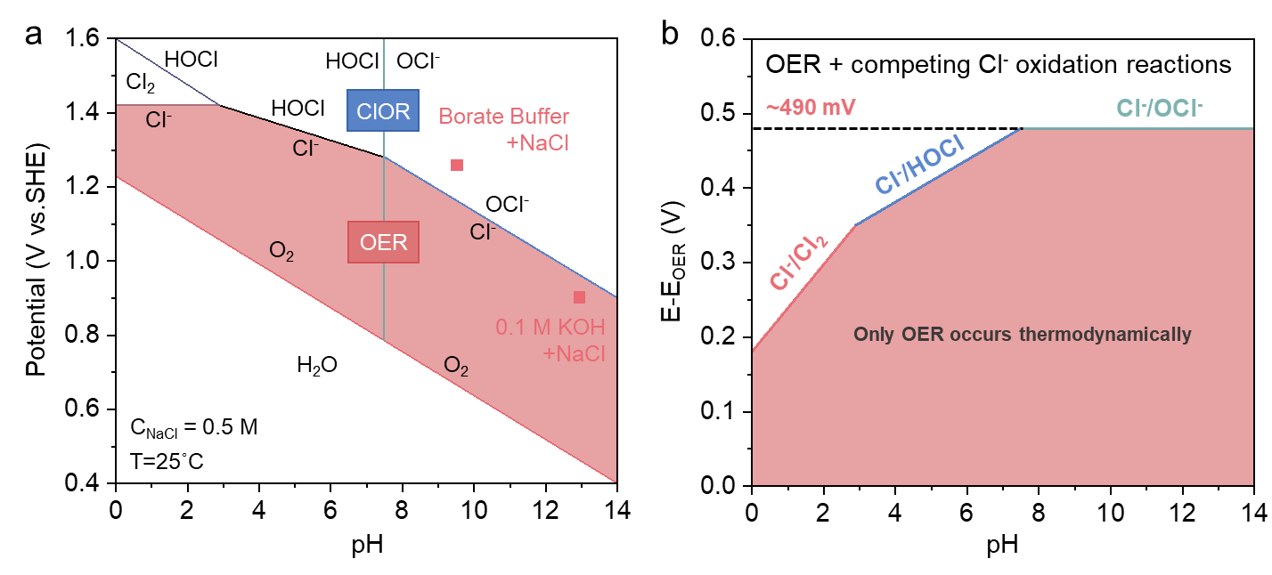
Supplementary Fig. 1| Competitive mechanism between OER and ClOR. (a) Pourbaix diagram of OER and CER; (b) Overpotential derived from the Pourbaix diagram. The red area represents the thermodynamic safety zone for OER. Reproduced with permission from Ref. 1.
According to the Pourbaix diagram of OER and CER (Supplementary Fig. 1)¹, the OER is thermodynamically more favorable than ClOR. As shown in Supplementary Fig. 1B and by the following equations, when the electrolyte pH exceeds 7.5, the theoretical potential difference reaches its maximum and stabilizes at ~490 mV.^{2,3} Conversely, in acidic media, the theoretical potential difference is minimal, being only ~130 mV. It should be noted that the practical potential window for 100% OER is relatively narrow due to the slower kinetics of four-electron OER compared to the two-electron ClOR. Alkali pretreatment of seawater not only creates a larger safe potential zone but also removes Ca²⁺/Mg²⁺ via precipitation. Therefore, alkaline seawater is the optimal choice for durable, industrial-scale operation.
Acidic conditions:
2H₂O → 4H⁺ + O₂ + 4e⁻ E^{θ} = 1.23 V (vs. SHE) or E^{θ} = 1.23 V (vs. RHE, pH = 0)
2Cl⁻ → Cl₂ + 2e⁻ E^{θ} = 1.36 V (vs. SHE) or E^{θ} = 1.36 V (vs. RHE, pH = 0)
Alkaline conditions:
4OH⁻ → 2H₂O + O₂ + 4e⁻ E^{θ} = 0.40 V (vs. SHE) or E^{θ} = 1.23 V (vs. RHE, pH = 14)
Cl⁻ +2OH⁻ → ClO⁻ + H₂O + 2e⁻ E^{θ} = 0.89 V (vs. SHE) or E^{θ} = 1.72 V (vs. RHE, pH = 14)

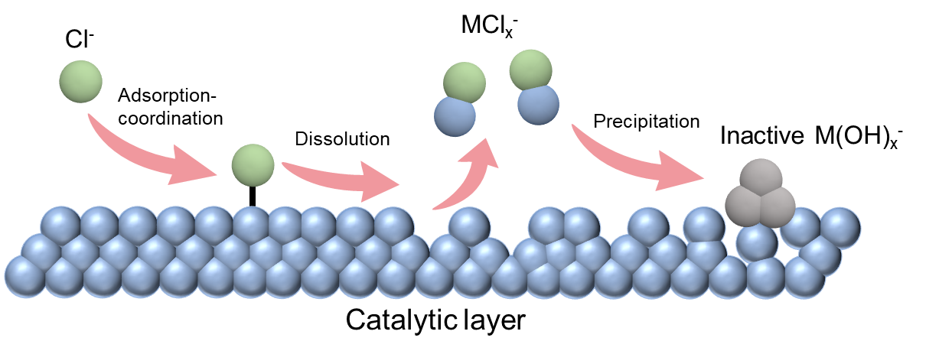
Supplementary Fig. 2| Schematic of Cl⁻ induced corrosion mechanism at active metal sites in catalysts.
Chloride ions (Cl⁻) in seawater cause severe catalyst corrosion during electrolysis, posing a significant challenge to maintaining structural stability (Supplementary Fig. 2). The corrosion process is as follows^{4,5}:
(1) adsorption of Cl⁻ by surface polarization:
M + Cl⁻ → MCl + e⁻
(2) dissolution by further coordination:
MCl + Cl⁻ → MCl_{x}⁻
(3) conversion from chloride to hydroxide:
MCl_{x}⁻ + OH⁻ → M(OH)_{x}⁻ + Cl⁻
This corrosion process originates from a chloride-hydroxide formation mechanism, as shown in the equations above, where M denotes a metal component of the catalyst layer. This chloride-hydroxide formation continuously converts the active metal sites into inactive metal hydroxide, causing progressive catalyst deactivation during the reaction (Supplementary Fig. 2).

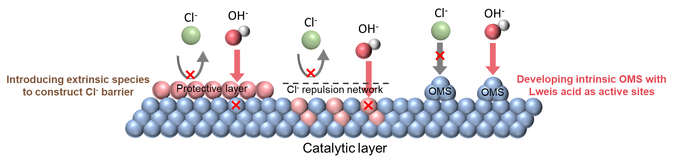
Supplementary Fig. 3| Schematic of current strategies for preventing Cl⁻ induced corrosion at metal active sites in catalysts.
To mitigate Cl⁻ corrosion at the catalyst surface, strategies such as forming a protective layer, heteroatom doping, and ion intercalation have been employed to create a Cl⁻ barrier layer.^{2,6} Although these methods have made impressive progress in inhibiting Cl⁻ corrosion, the introduction of extrinsic, inert components inevitably disturbs the kinetic process of OER intermediates at active sites (Supplementary Fig. 3).^{2,7} For instance, although effective in reducing ClOR selectivity and enhancing corrosion resistance, Mn-O_{x} coatings⁸ and carbon-based layers⁹ are inert primarily with respect to OER. Therefore, directly constructing open metal sites (OMS) with Lewis acid properties¹⁰ as intrinsic active OER sites that kinetically favor adsorption of OH⁻ over Cl⁻ will be an ideal approach (Supplementary Fig. 3).

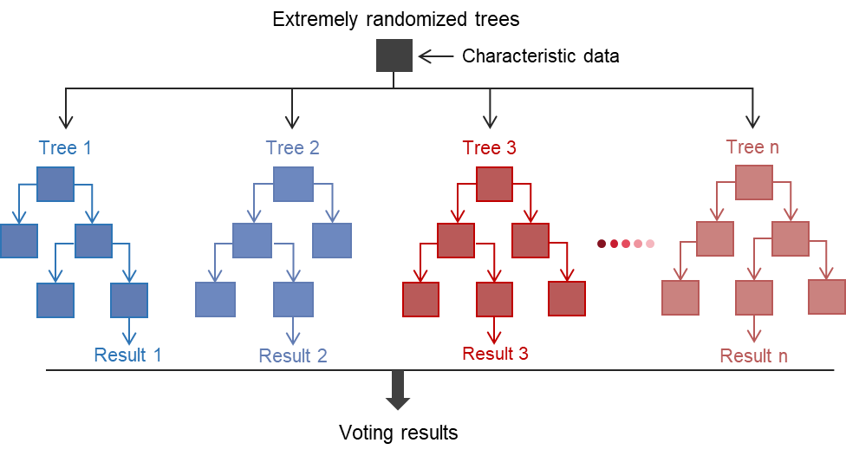
Supplementary Fig. 4| Data-driven machine learning based on an extremely randomized trees algorithm to obtain the optimal prediction model.
Initially, we summarized and compiled a machine-learning dataset of reported MOF-based OER electrocatalysts. A data-driven workflow employing the extremely randomized trees algorithm was then developed to enable accurate prediction and efficient screening of promising MOF candidates.

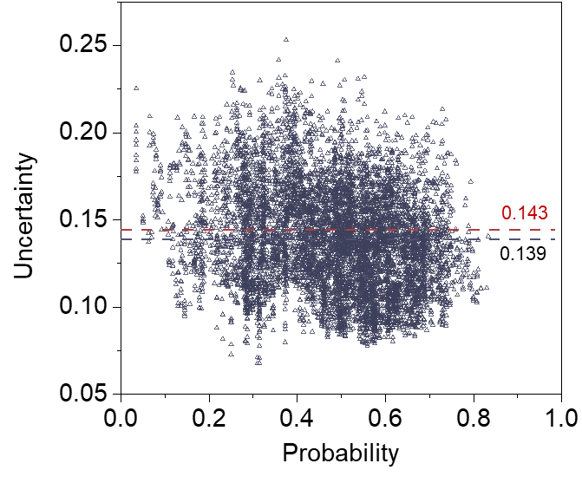
Supplementary Fig. 5| Performance probability distribution and associated uncertainty of 7,650 MOF candidates (η₁₀ ≤ 300 mV) after adding synthesized MOFs. Red and black lines indicate differences in the median uncertainty before and after adding synthesized MOFs, respectively.
The inclusion of twelve synthesized MOFs slightly reduces the median uncertainty across 7,650 candidates from 0.143 to 0.139, highlighting the robustness of the machine learning model and the reliability of its predictions.

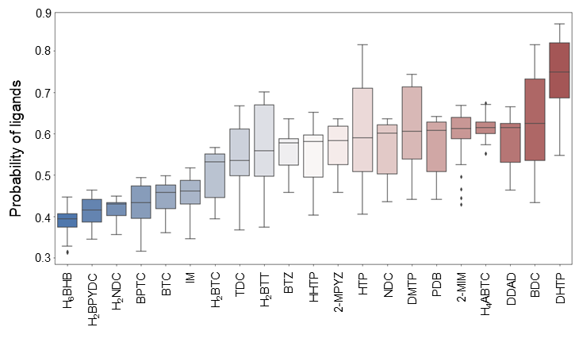
Supplementary Fig. 6| Box plots of twenty-one ligands in 7,650 MOF candidates.
As shown in Supplementary Fig. 6, MOF candidates composed of DHTP linker exhibit the highest median and upper-bound scores, indicating that DHTP-based MOFs have high potential to become highly active OER catalysts.

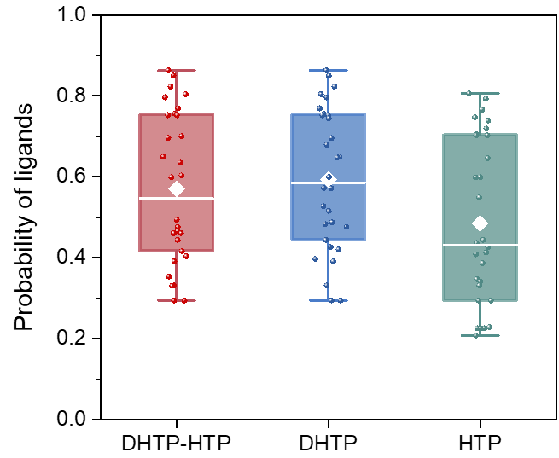
Supplementary Fig. 7| Box plots of DHTP-HTP linker pair and the corresponding monomer in 7,650 MOF candidates.
In the prediction results, the DHTP-HTP linker pair, as the top-performing combination, shows the most promise. By contrast, the box plot for HTP alone indicates a low probability, implying that HTP likely functions as a secondary linker to modulate the catalytic properties of DHTP-HTP based MOFs.

Supplementary Fig. 8| (a) Violin plots of transition metal and (b) corresponding heatmap of metal combination types extracted from 7,650 MOF candidates.
As shown in Supplementary Fig. 8a, the data distribution features in the violin plot, including the median, mean, and upper bound, suggest that Ni-based nodes confer greater potential than Co- or Fe-based candidates for developing high-performance MOF-based OER electrocatalysts. Furthermore, among the single-metal (Co, Fe, Ni) and bimetallic MOF candidates, NiFe bimetallic systems outperform others (Supplementary Fig. 8b).

Supplementary Fig. 9| Heatmap of MOF candidates composed of ligands (HTP, DHTP, and DHTP-HTP) and different Ni/Fe ratios.
The scores for DHTP-HTP, DHTP, and HTP based MOF candidates with varying Ni/Fe ratios are extracted from the predicted pool. As shown in Supplementary Fig. 9, the DHTP-HTP-Ni_{0.8}Fe_{0.2} and DHTP-Ni_{0.8}Fe_{0.2} combinations achieve the highest predicted score (0.86), suggesting their exceptional promise as OER catalysts. Both of these predictive combinations are subsequently confirmed by experiments.

Supplementary Fig. 10| Heatmap of MOF candidates composed of ligands (HTP, DHTP, and DHTP-HTP) and different Co/Ni ratios.
As shown in Supplementary Fig. 10, DHTP-HTP-Co_{0.8}Ni_{0.2} and DHTP-Co_{0.8}Ni_{0.2} combinations obtain the highest score (0.77), which is lower than that of DHTP-HTP-Ni_{0.8}Fe_{0.2} (0.86, Supplementary Fig. 9).

Supplementary Fig. 11| Heatmap of MOF candidates composed of ligands (HTP, DHTP, and DHTP-HTP) and different Fe/Co ratios.
The scores for DHTP-HTP, DHTP, and HTP based MOFs with varying Co/Fe ratios are extracted from the predicted pool. The optimal DHTP-Co achieves only a score of 0.57 (Supplementary Fig. 11).

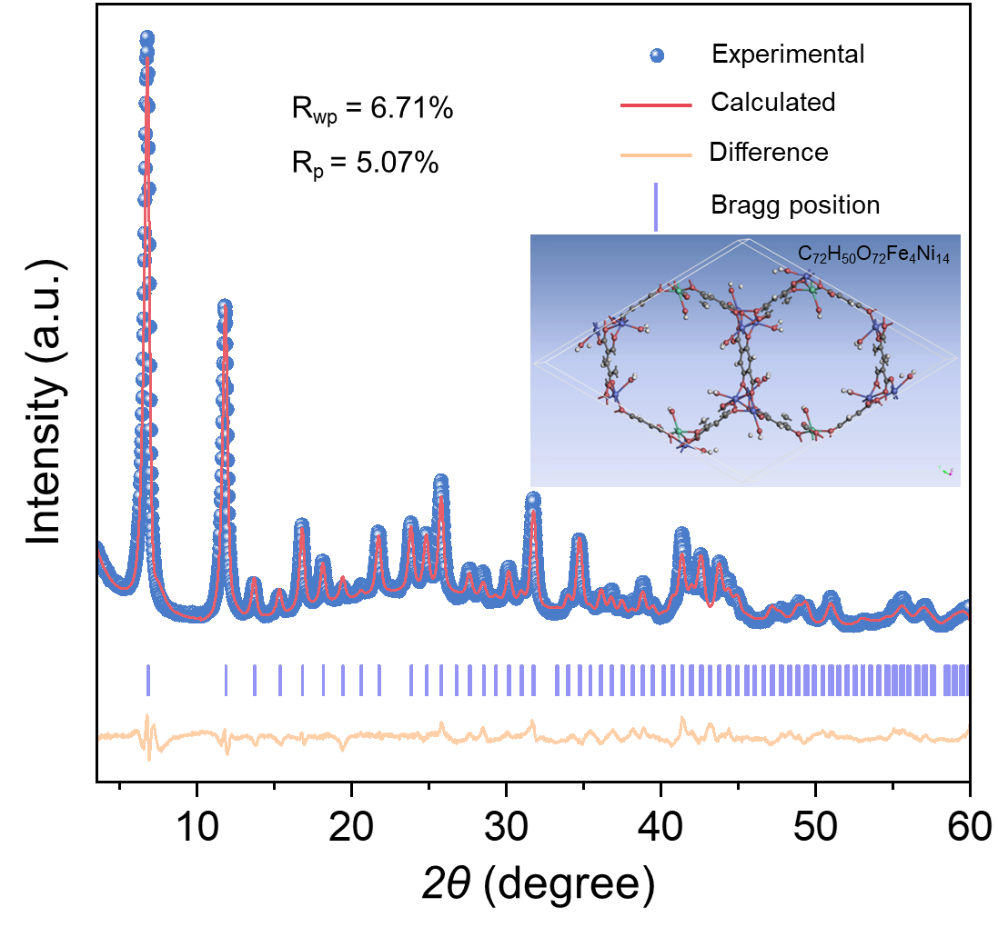
Supplementary Fig. 12| Rietveld refinement of experimental PXRD data of DHTP-MOF-74.
Refinement results of R_{wp} = 6.71% and R_{p} = 5.07% (reasonable range less than 10%) confirm that the MOFs comprised of Ni_{0.8}Fe_{0.2} node and DHTP linker belong to the crystal structure of typical MOF-74 (CCDC No. 1494752).

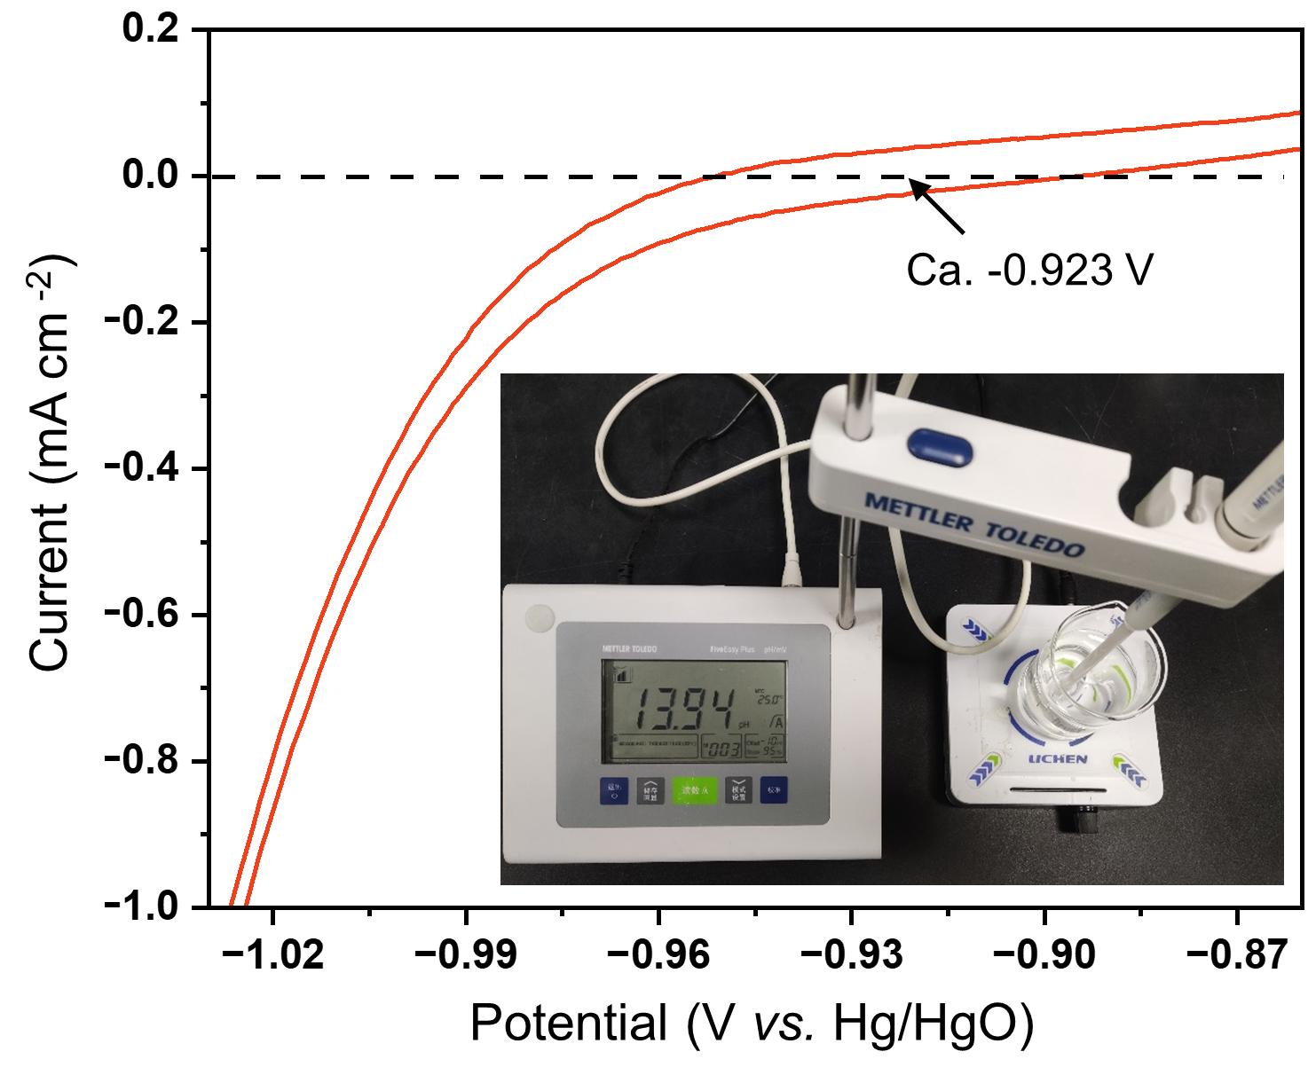
Supplementary Fig. 13| Calibration curves of reference electrode (Hg/HgO filled with 1 M KOH solution) in H₂-saturated 1 M KOH solution (pH = 13.94).
The calibration experiment based on the Nernst equation yields a theoretical value of 0.920 V, closely matching the experimental value of 0.923 V in KOH (pH = 13.94), with a deviation of only 0.003 V.

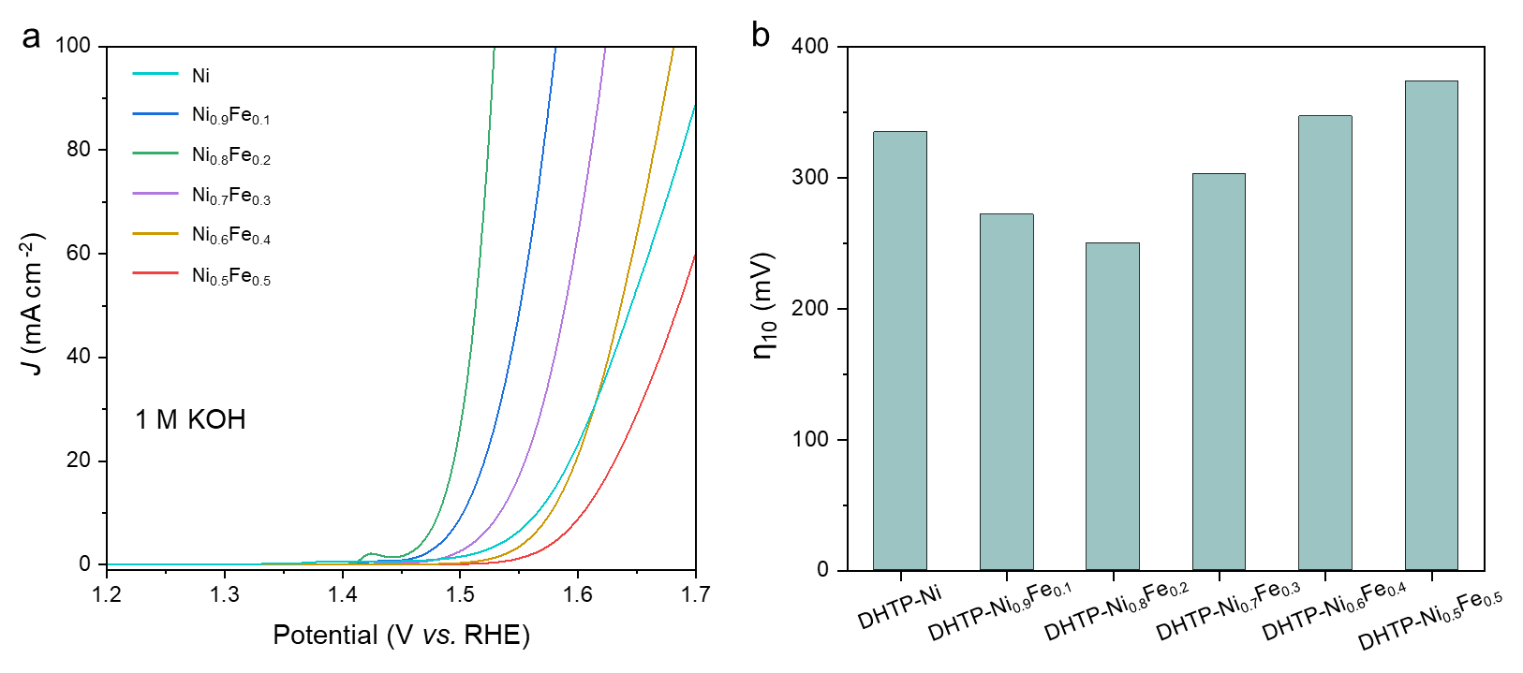
Supplementary Fig. 14| (a) Polarization curves of DHTP-MOF-74 with different metal ratios, measured using a rotating disk electrode in 1 M KOH with 90% iR compensation; (b) Overpotentials at 10 mA cm⁻².
Among these catalysts, DHTP-MOF-74 with Ni_{0.8}Fe_{0.2} exhibits the highest OER activity, with an overpotential of only 250 mV at 10 mA cm⁻², indicating that Ni_{0.8}Fe_{0.2} is the optimal metal combination. The quantitative metal analysis of the DHTP-MOF-74 electrocatalysts, as determined by ICP-OES, is provided in Supplementary Table 1.

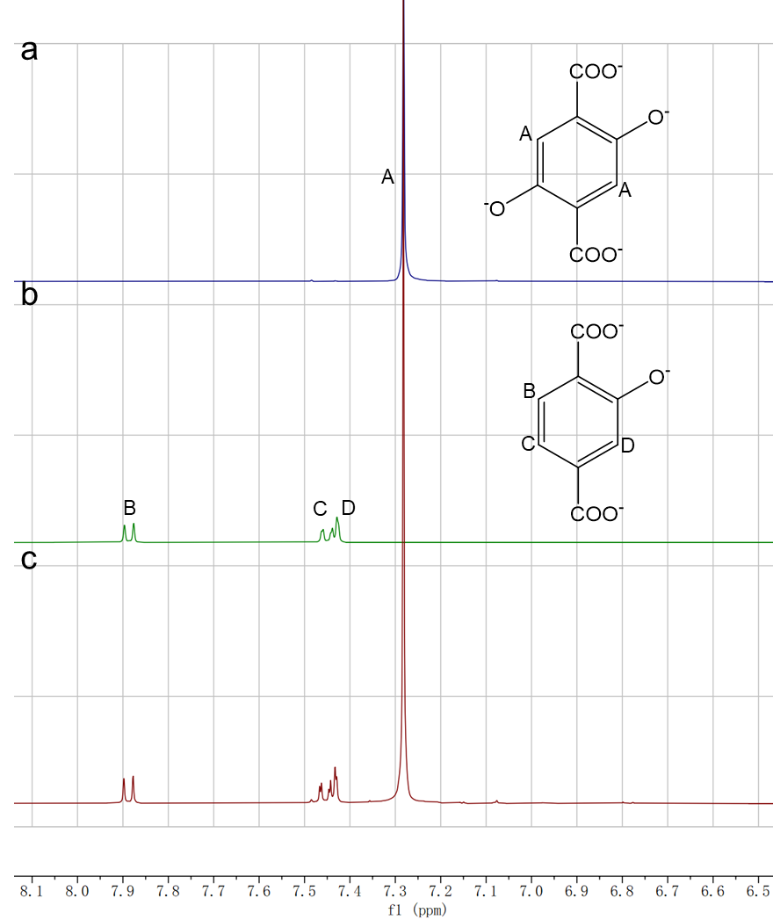
Supplementary Fig. 15| ¹H NMR spectra of the standard ligands: (a) DHTP, (b) HTP, and (c) DHTP@HTP.

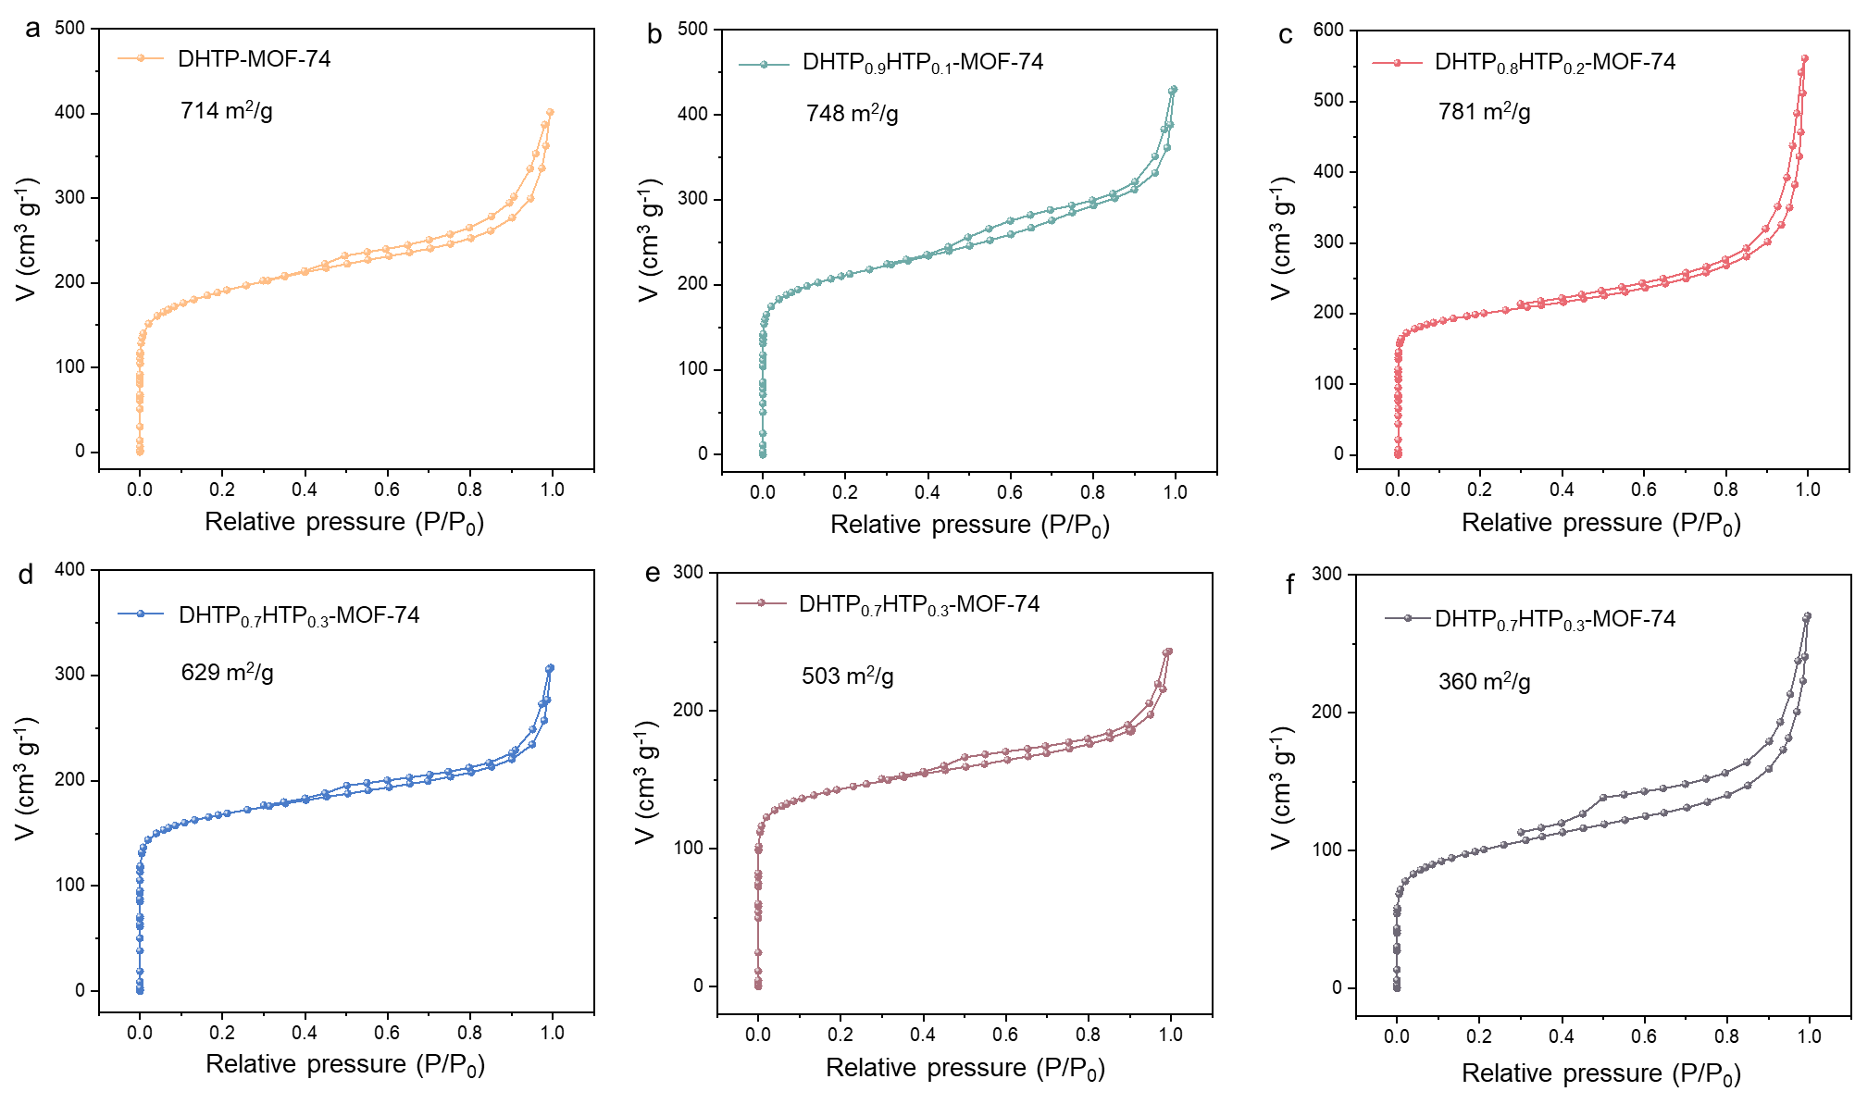
Supplementary Fig. 16| N₂ sorption isotherms of (a) DHTP-MOF-74, (b) DHTP_{0.9}HTP_{0.1}-MOF-74, (c) DHTP_{0.8}HTP_{0.2}-MOF-74, (d) DHTP_{0.7}HTP_{0.2}-MOF-74, (e) DHTP_{0.6}HTP_{0.4}-MOF-74, and (f) DHTP_{0.5}HTP_{0.5}-MOF-74.
N₂ sorption measurements indicate the limited incorporation of HTP. From DHTP-MOF-74 to DHTP_{0.8}HTP_{0.2}-MOF-74, the specific surface area increases slightly with the introduction of the secondary HTP linker (Supplementary Fig. 16a-c), confirming its successful integration without disrupting the framework. However, when the HTP content reaches ≥ 30%, the specific surface area declines sharply (Supplementary Fig. 16d-f), suggesting that excessive incorporation of the secondary linker disrupts the continuity of the porous framework.

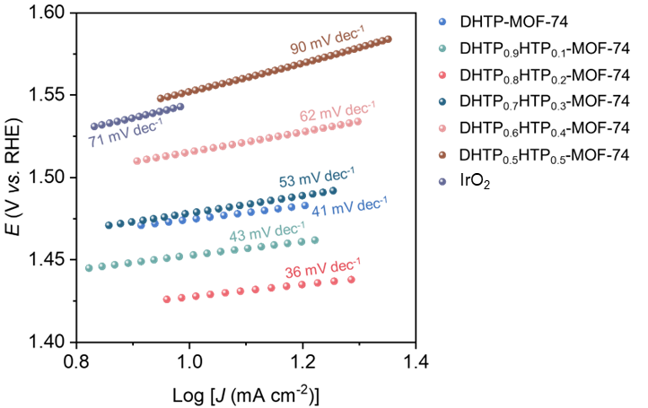
Supplementary Fig. 17| Tafel slope of samples from polarization curves in Fig. 2d.
As shown in Supplementary Fig. 17, Tafel slopes of DHTP-MOF-74, DHTP_{0.9}HTP_{0.1}-MOF-74, DHTP_{0.8}HTP_{0.2}-MOF-74, DHTP_{0.7}HTP_{0.2}-MOF-74, DHTP_{0.6}HTP_{0.4}-MOF-74, DHTP_{0.5}HTP_{0.5}-MOF-74, and IrO₂ are 41 mV dec⁻¹, 43 mV dec⁻¹, 36 mV dec⁻¹, 71 mV dec⁻¹, 62 mV dec⁻¹, 90 mV dec⁻¹, and 71 mV dec⁻¹, respectively.

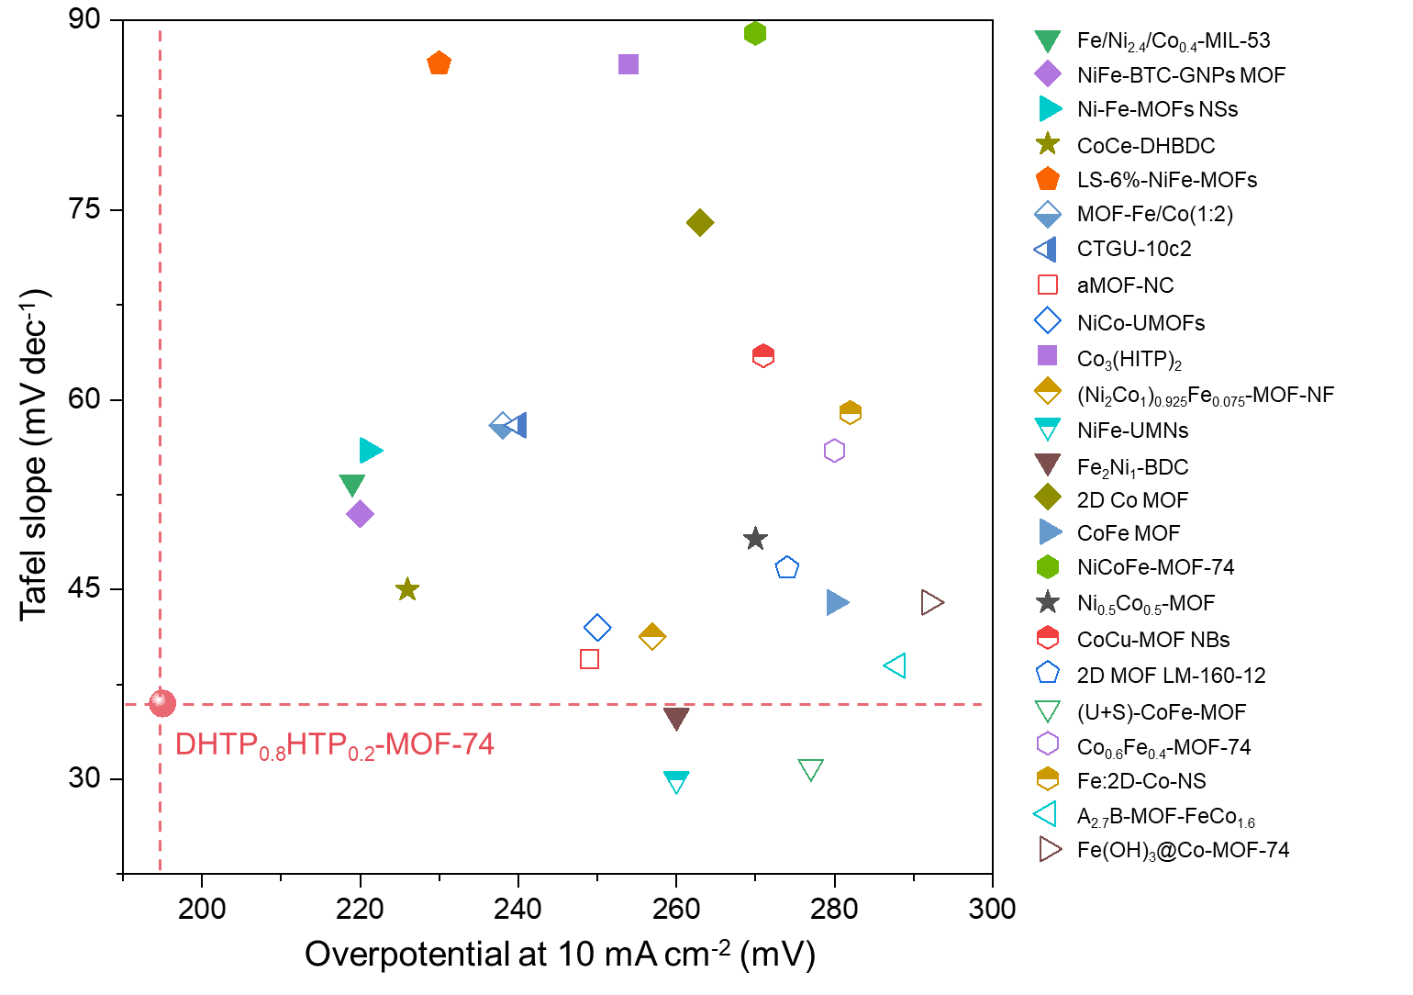
Supplementary Fig. 18| Comparison of intrinsic OER performance of DHTP_{0.8}HTP_{0.2}-MOF-74 and reported MOFs in 1 M KOH (Supplementary Table 2).
DHTP_{0.8}HTP_{0.2}-MOF-74 shows the lowest overpotential of 195 mV at 10 mA cm⁻² among all MOF electrocatalysts reported to date.

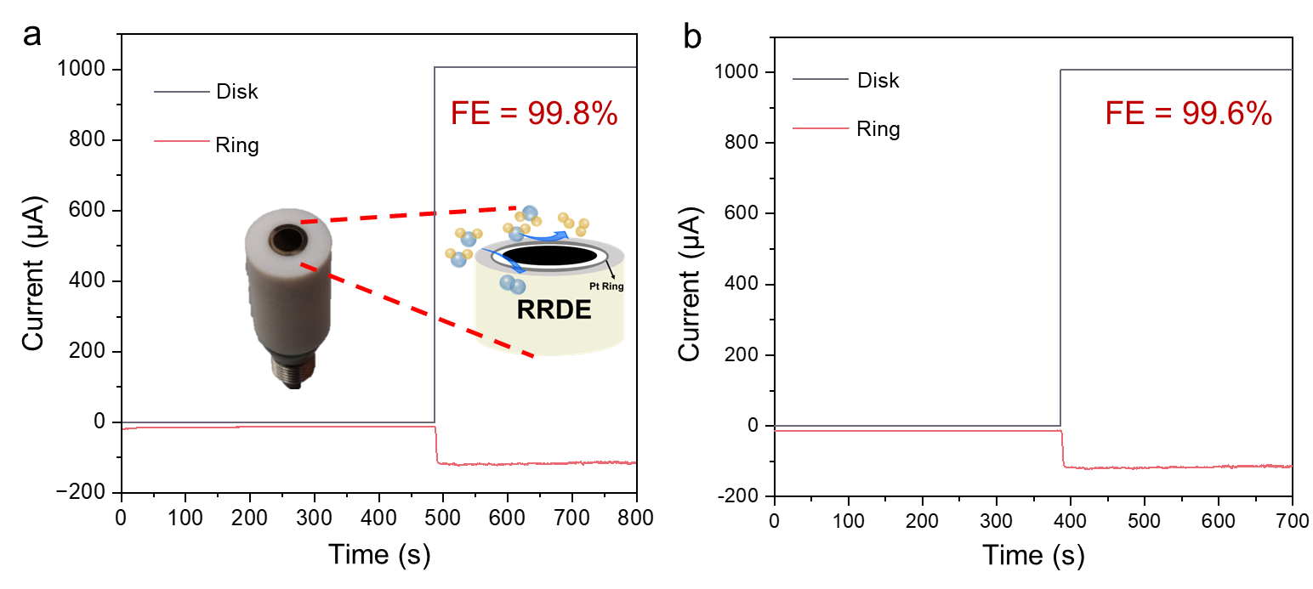
Supplementary Fig. 19| Faraday efficiencies (FEs) of OER for (a) DHTP_{0.8}HTP_{0.2}-MOF-74 and (b) DHTP-MOF-74 in 1 M KOH.
As shown in Supplementary Fig. 19, the Faraday efficiencies (FEs) of the OER for DHTP_{0.8}HTP_{0.2}-MOF-74 and DHTP-MOF-74 are measured up to 99.8% and 99.6% using the rotating disk electrode (RRDE) test, further confirming their high OER activity.

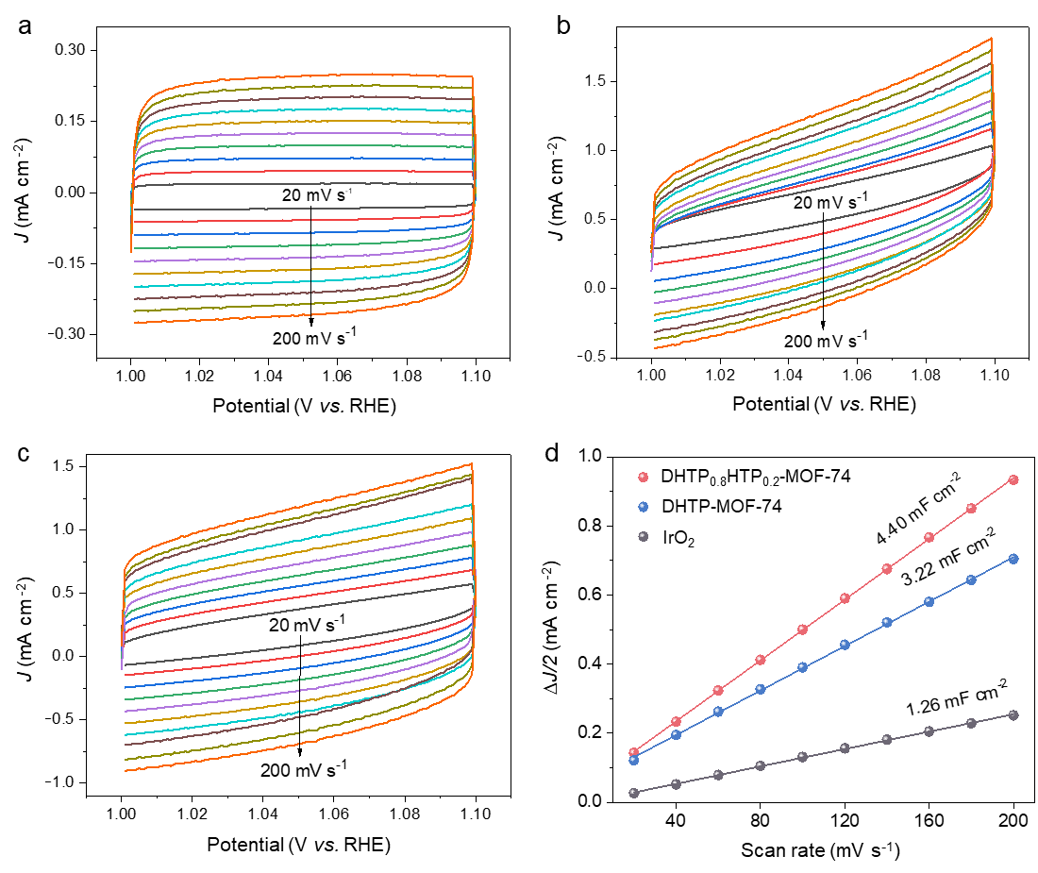
Supplementary Fig. 20| CV curves of (a) benchmark IrO₂, (b) DHTP-MOF-74, and (c) DHTP_{0.8}HTP_{0.2}-MOF-74 recorded in a potential window between 1.0 and 1.1 V (vs. RHE) at the scan rates from 20 to 200 mV s⁻¹ in 1 M KOH. (d) Capacitive current density as a function of scan rates of different catalysts. The slopes represent the double-layer capacitance.
As shown in Supplementary Fig. 20, the calculated electrochemically active areas (ECSA) for IrO₂, DHTP-MOF-74, and DHTP_{0.8}HTP_{0.2}-MOF-74 are 25.2, 64.4, and 88, respectively (Supplementary Table 3), indicating that DHTP_{0.8}HTP_{0.2}-MOF-74 possesses the biggest electrochemically active sites.

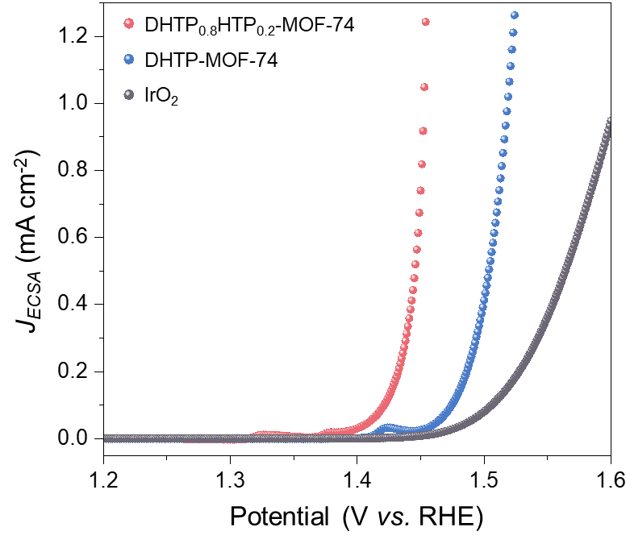
Supplementary Fig. 21| Polarization curves of DHTP-MOF-74, DHTP_{0.8}HTP_{0.2}-MOF-74, and benchmark IrO₂ with 90% iR-compensation, using the rotating disk electrodes in 1 M KOH. The current is normalized by the electrochemically active area.
As shown in Supplementary Fig. 21, the intrinsic activities of the samples are further assessed using J_{ECSA} (Supplementary Table 3), among which DHTP_{0.8}HTP_{0.2}-MOF-74 shows the highest OER activity.

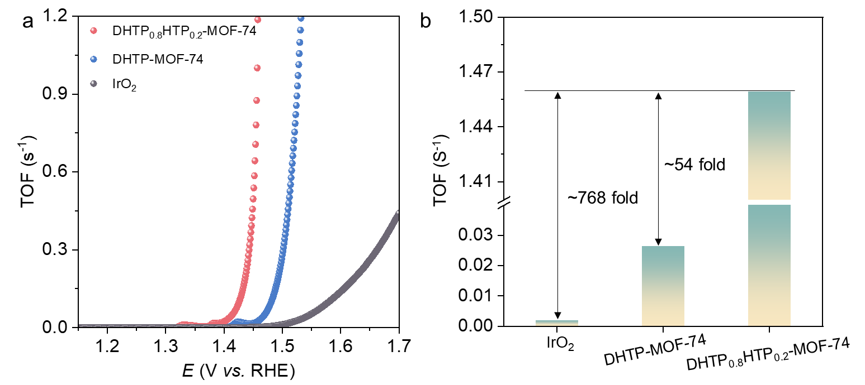
Supplementary Fig. 22| (a) Turnover frequencies (TOFs) of DHTP_{0.8}HTP_{0.2}-MOF-74, DHTP-MOF-74, and benchmark IrO₂; (b) Corresponding TOFs at the overpotentials of 230 mV.
The intrinsic activity of MOFs is also assessed based on turnover frequencies (TOFs), among which DHTP_{0.8}HTP_{0.2}-MOF-74 exhibits the highest TOF, reaching 1.46 O₂ s⁻¹ per electrochemically accessible metal site (Supplementary Fig. 22b).

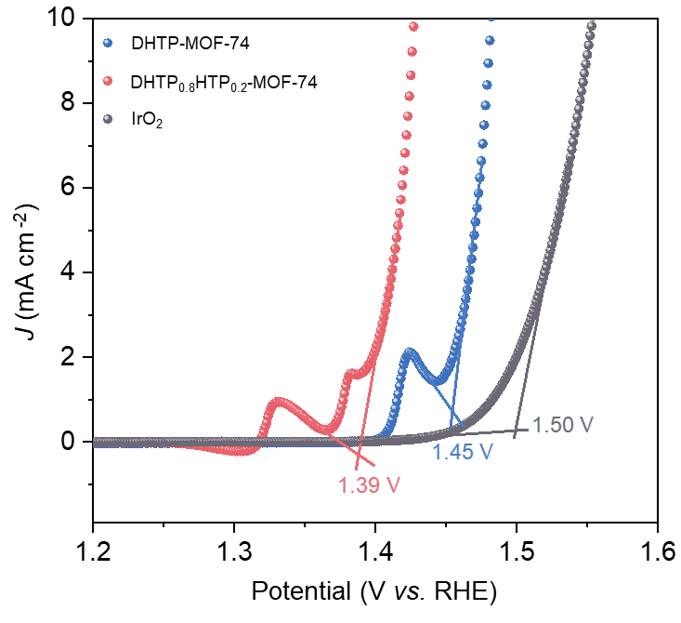
Supplementary Fig. 23| Onset potentials of DHTP-MOF-74, DHTP_{0.8}HTP_{0.2}-MOF-74, and benchmark IrO₂.
The onset potentials of OER, defined as the critical potential for oxygen evolution, are determined using the tangent method. As shown in Supplementary Fig. 23, DHTP_{0.8}HTP_{0.2}-MOF-74 exhibits the lowest onset potential of 1.39 V, which is 0.06 V and 0.11 V lower than that of DHTP-MOF-74 (1.45 V) and the IrO₂ benchmark (1.50 V), respectively.

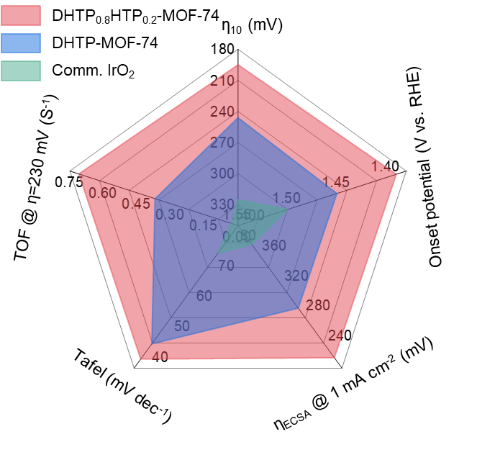
Supplementary Fig. 24| Summary of five intrinsic OER performance metrics in 1 M KOH.
Compared to DHTP-MOF-74 and benchmark IrO₂, DHTP_{0.8}HTP_{0.2}-MOF-74 exhibits superior OER activity across multiple performance metrics.

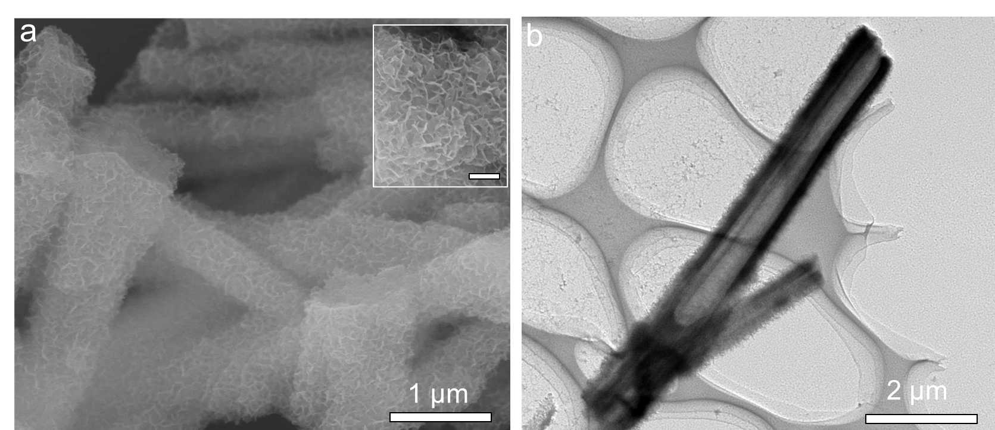
Supplementary Fig. 25| (a) SEM and (b) TEM images of DHTP_{0.8}HTP_{0.2}-MOF-74 in the shape of nanotubes; Inset is an enlarged SEM image (scale bar, 200 nm).

Supplementary Fig. 26| Location of seawater sampling on February 11, 2023. The raw seawater was obtained from the Yellow Sea in Qingdao, China. 36.069 N, 120.382E.
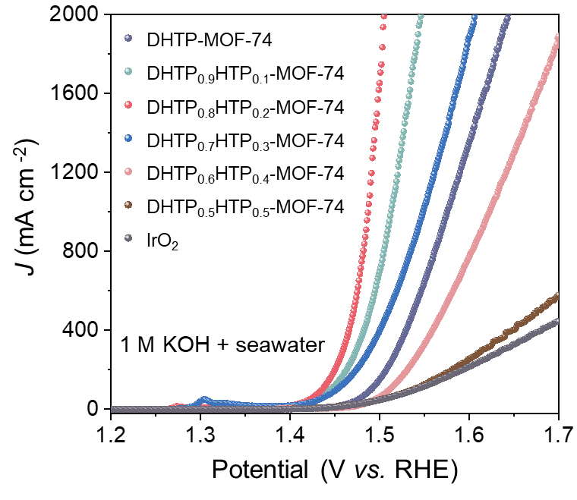
Supplementary Fig. 27| Polarization curves with 90% iR-compensation of prepared MOFs and benchmark IrO₂ on nickel foam substrate in 1 M KOH + seawater.
Among these samples, DHTP_{0.8}HTP_{0.2}-MOF-74 exhibits the highest OER activity with overpotentials of 205, 240, 257 mV at 100, 500, 1000 mA cm⁻², respectively.

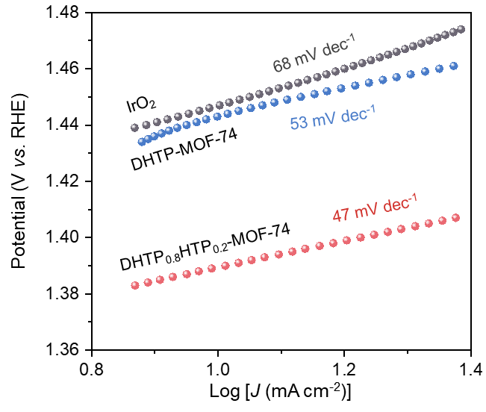
Supplementary Fig. 28| Tafel slope of DHTP-MOF-74, DHTP_{0.8}HTP_{0.2}-MOF-74, and benchmark IrO₂ from polarization curves in Supplementary Fig. 27.
As shown in Supplementary Fig. 28, the Tafel slope of DHTP-MOF-74, DHTP_{0.8}HTP_{0.2}-MOF-74, and IrO₂ is 53 mV dec⁻¹, 47 mV dec⁻¹, and 68 mV dec⁻¹, respectively.

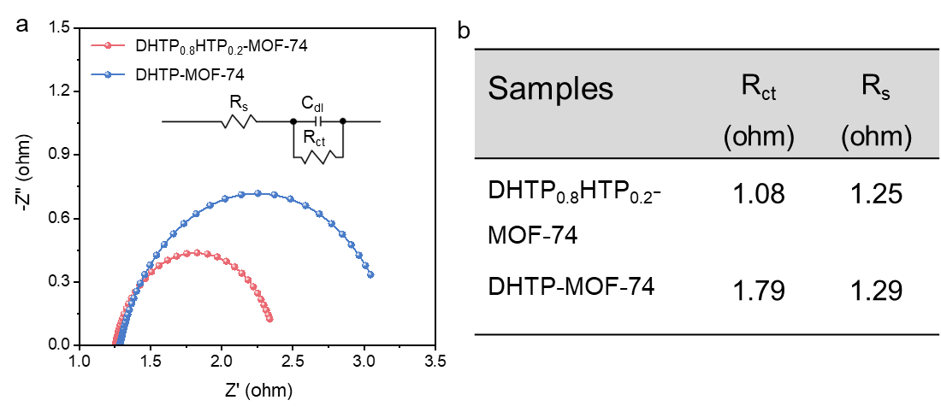
Supplementary Fig. 29| (a) Nyquist plots from electrochemical impedance spectroscopy; (b) corresponding fitted resistance values from the equivalent circuit model.

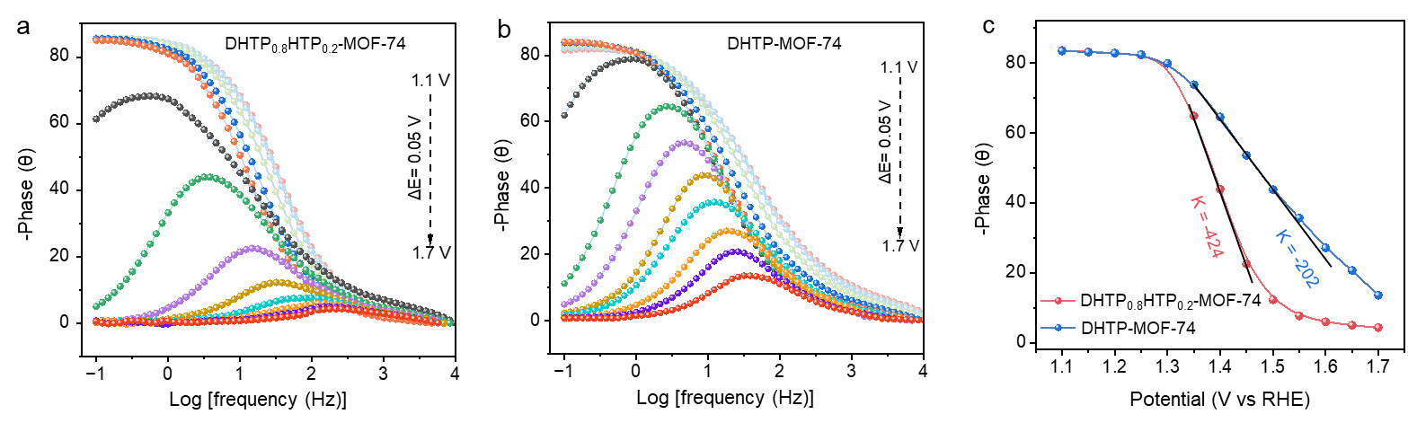
Supplementary Fig. 30| In situ Bode phase plots of (a) DHTP_{0.8}HTP_{0.2}-MOF-74 and (b) DHTP-MOF-74; (c) Comparison of characteristic phase angle as a function of applied potential.
A large slope indicates more efficient electron transfer as the applied potential increases. Compared with DHTP-MOF-74, DHTP_{0.8}HTP_{0.2}-MOF-74 exhibits a superior kinetic process, characterized by a lower electron transfer resistance of 1.25 ohms (Supplementary Fig. 29) and higher charge transfer kinetics of 424 θ V⁻¹ (Supplementary Fig. 30c).

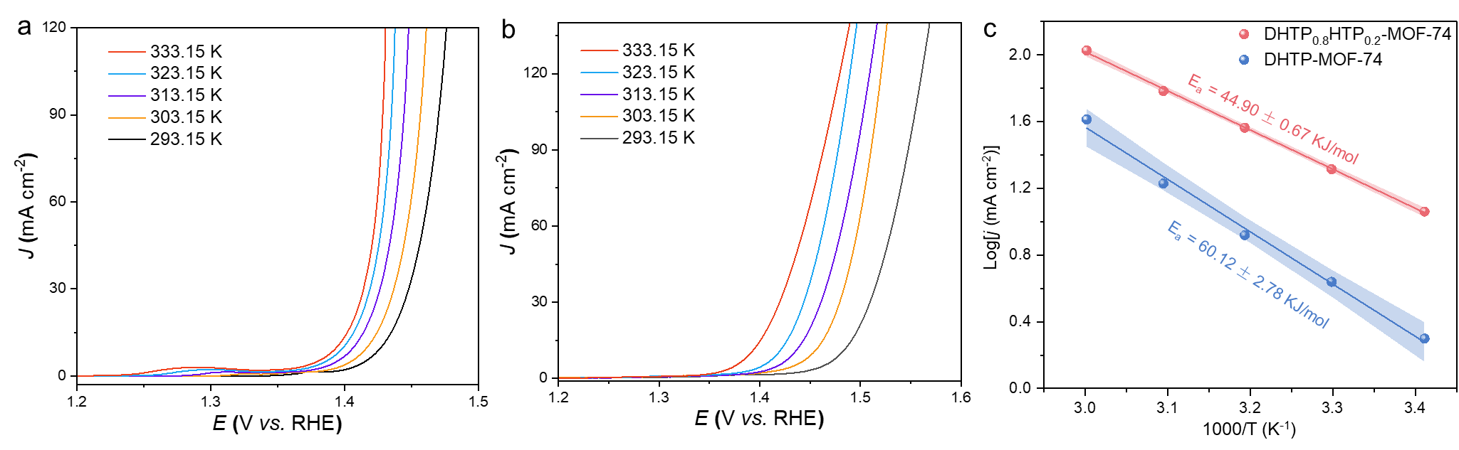
Supplementary Fig. 31| Active energy measurements by temperature-dependent polarization curves of (a) DHTP_{0.8}HTP_{0.2}-MOF-74 and (b) DHTP-MOF-74. (c) Apparent activation energy of MOFs at an overpotential of 200 mV.
Compared with DHTP-MOF-74, DHTP_{0.8}HTP_{0.2}-MOF-74 exhibits the lowest apparent activation energy (E_{a}) of 44.90 kJ mol⁻¹ (Supplementary Fig. 31).

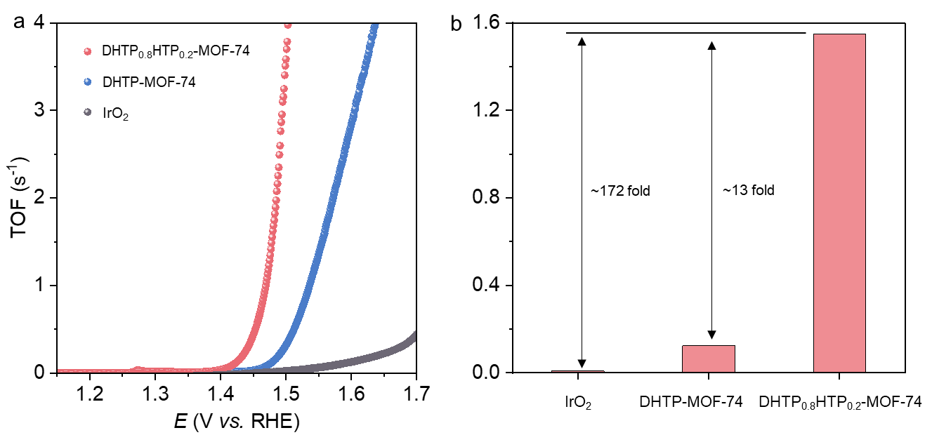
Supplementary Fig. 32| (a) TOFs of prepared MOFs and benchmark IrO₂ in 1 M KOH + seawater, and (b) corresponding TOFs at overpotentials of 250 mV.
The intrinsic catalytic activity of the MOFs is further evaluated by turnover frequency (TOF). DHTP_{0.8}HTP_{0.2}-MOF-74 exhibits the highest TOF, reaching 1.55 O₂ s⁻¹ per electrochemically accessible metal site, which is ~13-fold higher than that of DHTP-MOF-74 and ~172-fold higher than that of benchmark IrO₂, respectively.

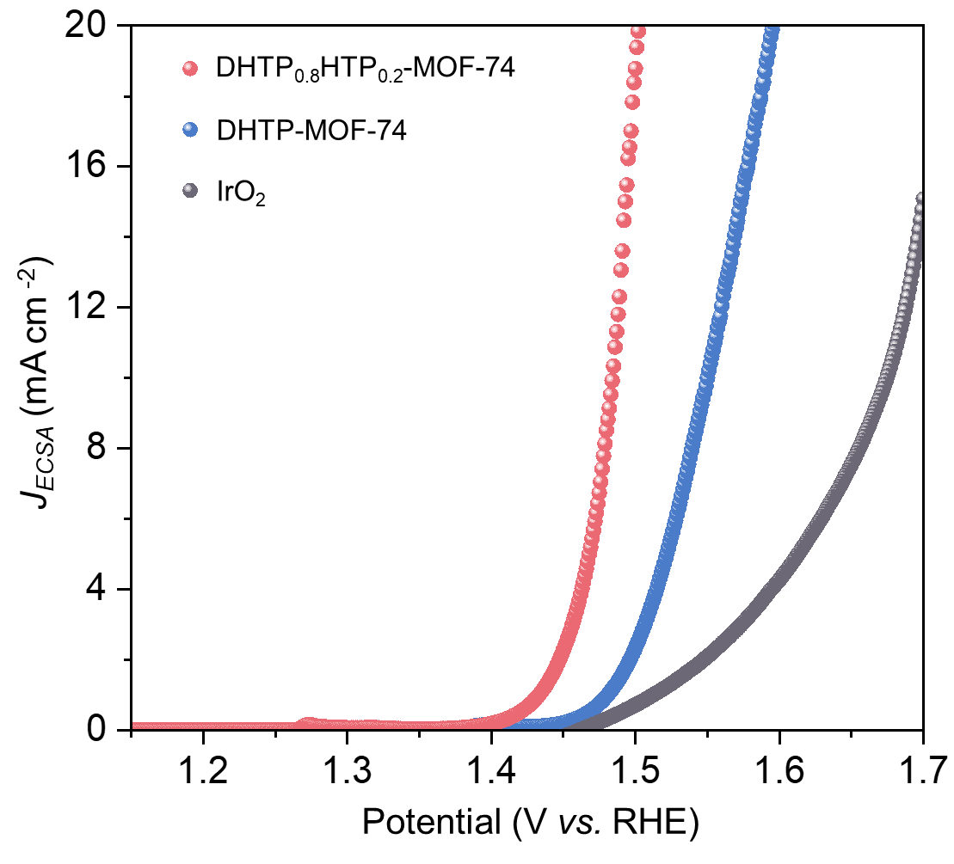
Supplementary Fig. 33| Polarization curves of prepared MOFs and benchmark IrO₂ in 1 M KOH + seawater. The current is normalized by the electrochemically active area from Supplementary Table 3.

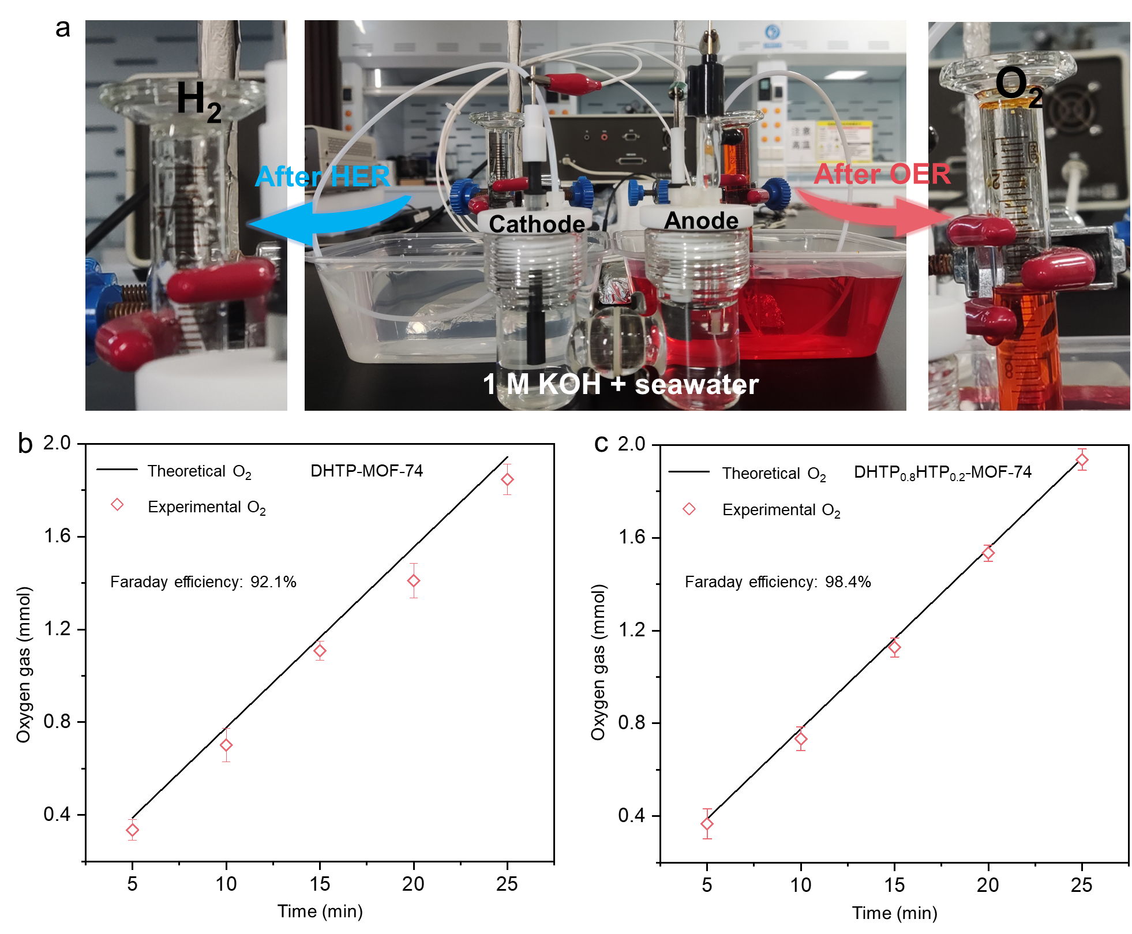
Supplementary Fig. 34| (a) H-type cell set-up for determining the Faraday efficiency of OER during alkaline seawater electrolysis using the volumetric method in oxygen-saturated solutions under a constant current density of 500 mA cm⁻². Calculation of Faradaic efficiency for (b) DHTP-MOF-74 and (c) DHTP_{0.8}HTP_{0.2}-MOF-74.
As shown in Supplementary Fig. 34, the FE for oxygen evolution of DHTP-MOF-74 and DHTP_{0.8}HTP_{0.2}-MOF-74 in the alkaline seawater electrolysis process, calibrated by a gas volumetric method, is 92.1% and 98.4%, respectively.

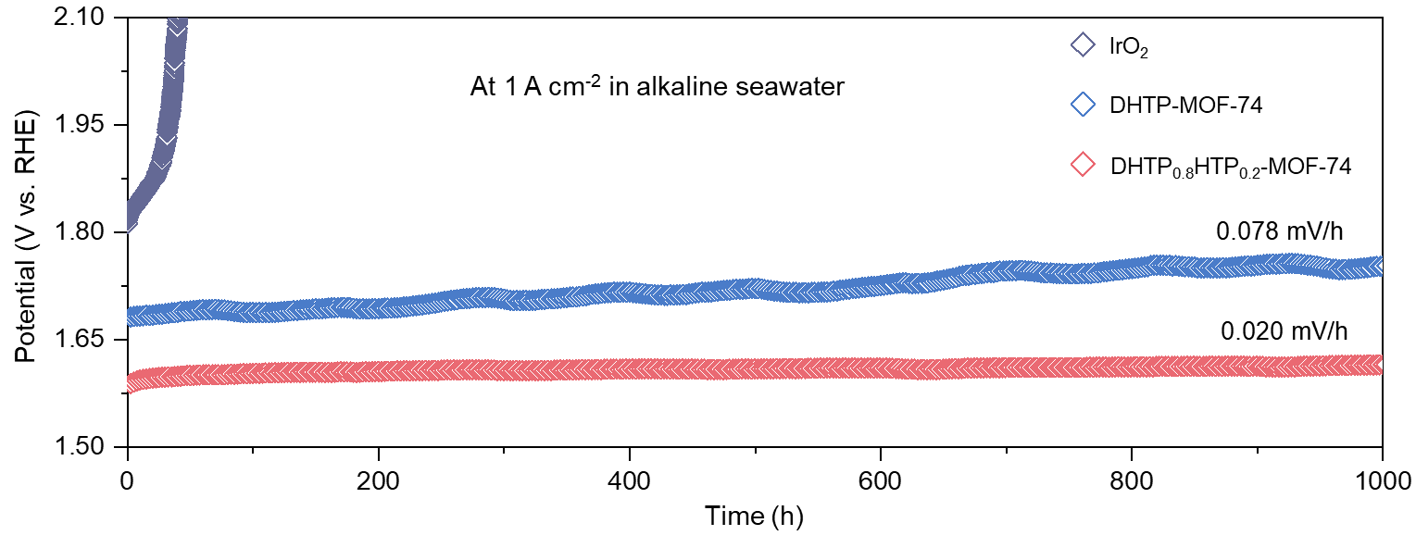
Supplementary Fig. 35| Stability test of DHTP_{0.8}HTP_{0.2}-MOF-74, DHTP-MOF-74, and benchmark IrO₂ in 1M KOH + seawater using a three-electrode system.
Compared with benchmark IrO₂, DHTP_{0.8}HTP_{0.2}-MOF-74 and DHT-MOF-74 exhibit a stable alkaline seawater electrolysis at 1 A cm⁻² for 1000 h. Moreover, DHTP_{0.8}HTP_{0.2}-MOF-74 exhibits a lower decay rate of 0.020 mV/h than that of DHTP-MOF-74 (0.078 mV/h).

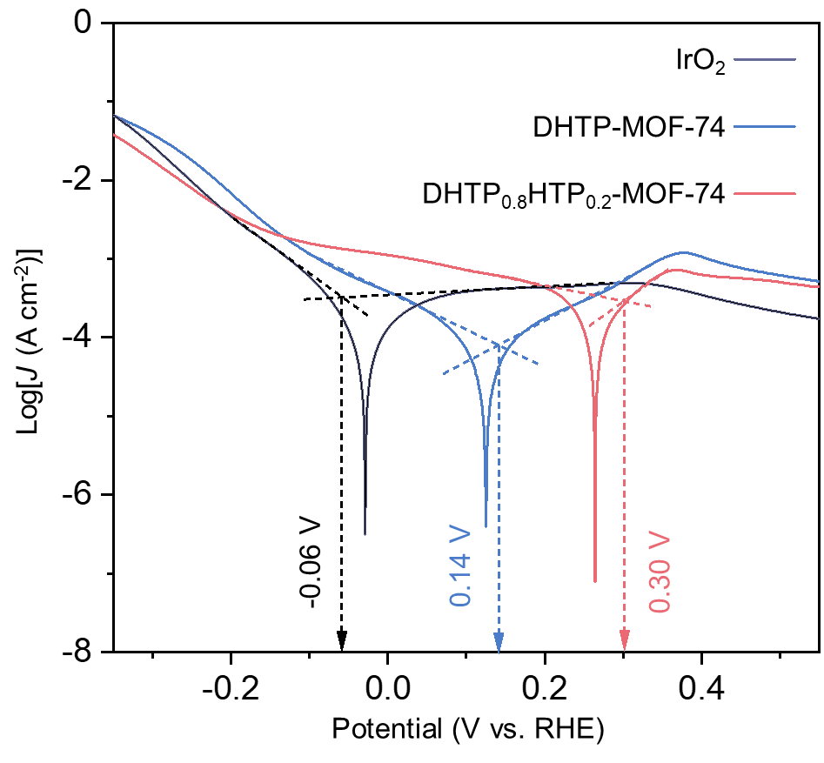
Supplementary Fig. 36| Corrosion resistance test of DHTP_{0.8}HTP_{0.2}-MOF-74, DHTP-MOF-74, and benchmark IrO₂ in 1 M KOH + seawater.
As shown in Supplementary Fig. 36, the corrosion potential of DHTP_{0.8}HTP_{0.2}-MOF-74 (0.30 V) is substantially higher than that of DHTP-MOF-74 (0.14 V) and IrO₂ (-0.06 V), indicating its superior corrosion resistance.

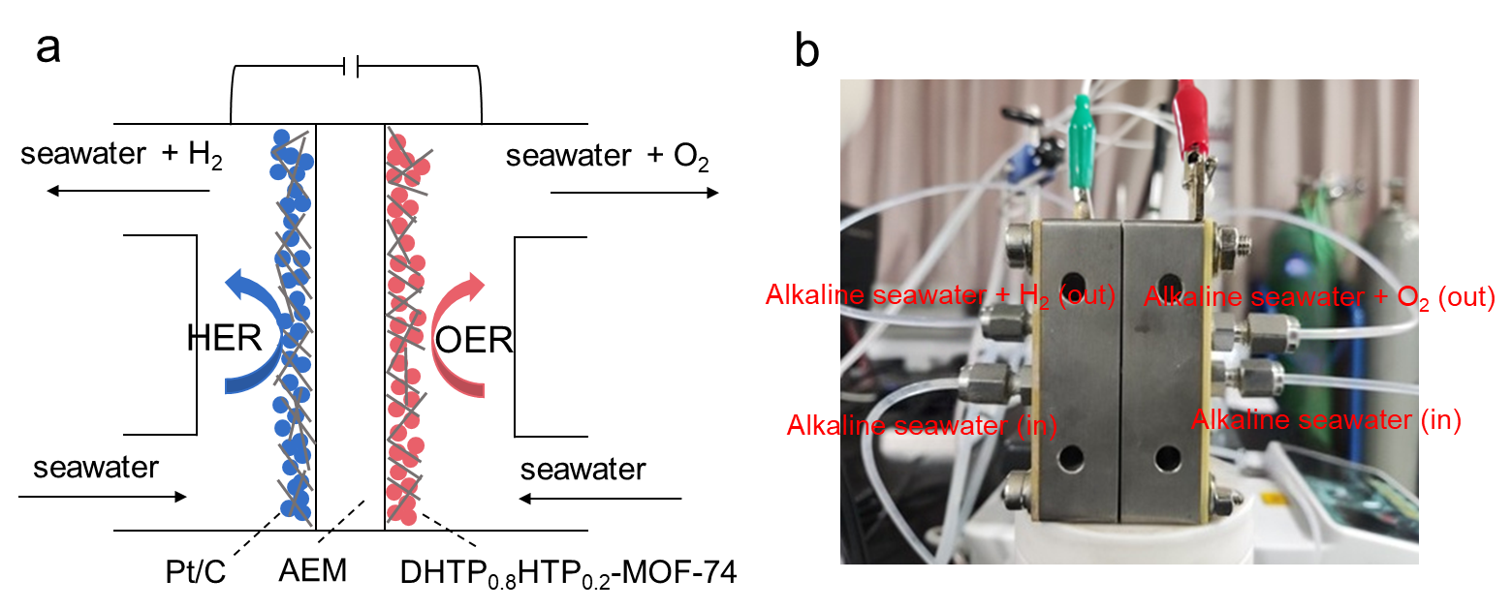
Supplementary Fig. 37| (a) Schematic of alkaline seawater splitting in an AEME and (b) corresponding photograph.

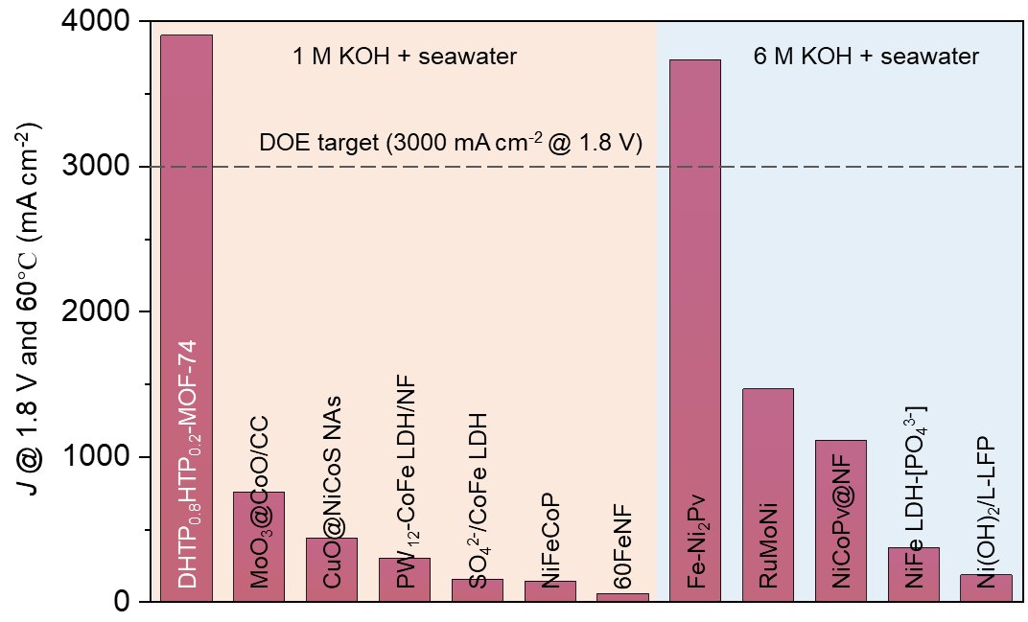
Supplementary Fig. 38| Activity comparison in an AEME system of DHTP_{0.8}HTP_{0.2}-MOF-74 with reported electrocatalysts at a cell voltage of 1.8 V and 60℃ (Supplementary Table 5).
When the operating temperature is raised to 60°C in 1 M KOH + seawater, the catalytic activity of DHTP_{0.8}HTP_{0.2}-MOF-74 can meet the U.S. Department of Energy (DOE) 2026 technical target (3,000 mA cm⁻² @ 1.80 V, Supplementary Fig. 38), which reaches the current density of 3,910 mA cm⁻² at 1.8 V and exceeds the current record of 755 mA cm⁻² by more than fivefold (Supplementary Table 5). Among the previously reported systems (Supplementary Table 5), only one study meets the DOE target; however, that work employed 6 M KOH + seawater, in which the high alkali concentration significantly enhances electrolyte conductivity and OH⁻ mass transfer kinetics.¹¹⁻¹²

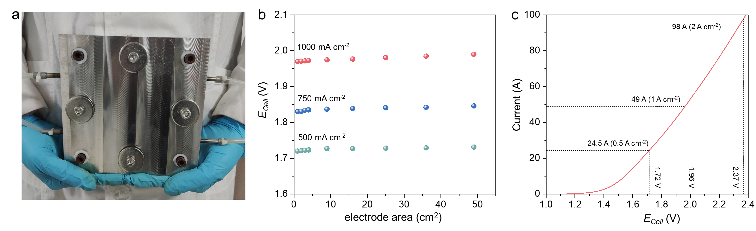
Supplementary Fig. 39| (a) Photograph of custom-designed anion exchange membrane electrolyzer (AEM, 15 cm × 15 cm × 4 cm) with an electrode area of 7 cm × 7cm, (b) corresponding stability assessment of DHTP_{0.8}HTP_{0.2}-MOF-74 in the electrode area scaling up process, and (c) polarization curve with manual iR-compensation of the large-current alkaline seawater electrolysis (DHTP_{0.8}HTP_{0.2}-MOF-74 and 20%Pt/C as the anode catalysts and cathode catalysts, respectively).
During electrode area scaling, the cell voltages at given current densities remain remarkably stable (Supplementary Fig. 39b). Consistently, the system exhibits competitively low voltages of 1.72, 1.98, and 2.87 V when delivering high currents of 24.5, 49, and 98 A, respectively, in seawater electrolysis (Supplementary Fig. 39c). These results highlight the excellent scalability of DHTP_{0.8}HTP_{0.2}-MOF-74 anode in an AEM system.

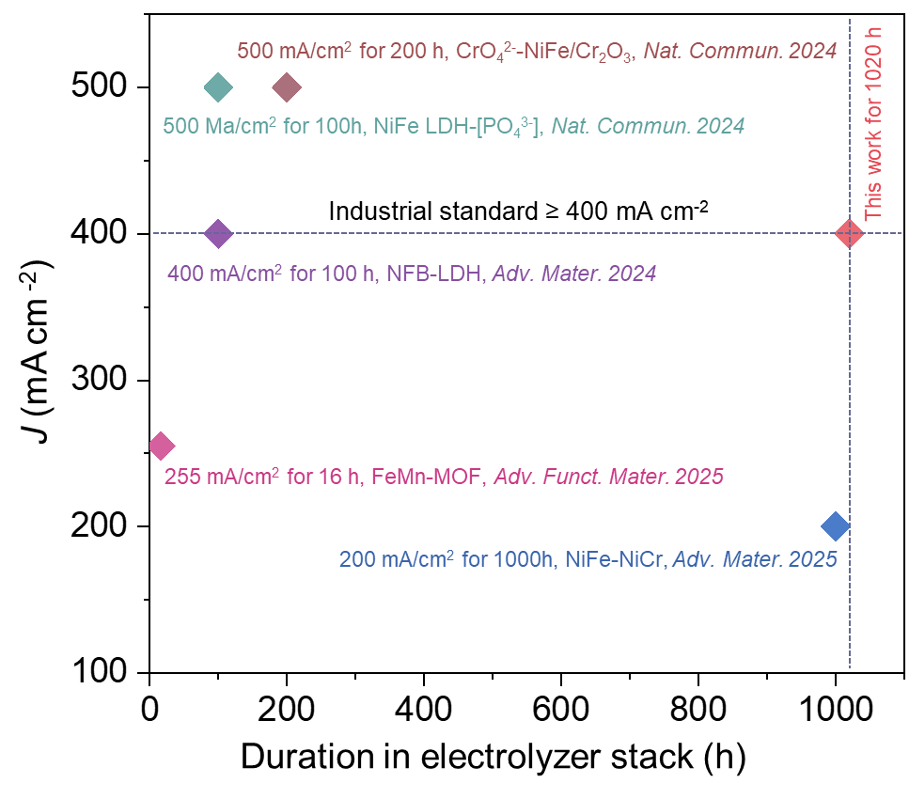
Supplementary Fig. 40| Duration comparison of DHTP_{0.8}HTP_{0.2}-MOF-74 with reported electrocatalysts in an electrolyzer stack under industrial conditions for alkaline (simulated/raw) seawater electrolysis (Supplementary Table 7)
Compared with prior reports (Supplementary Table 6), the DHTP_{0.8}HTP_{0.2}-MOF-74 based electrolyzer stack outperforms all previous systems, achieving the longest reported stability of 1,020 hours at 400 mA cm⁻² and 80°C in alkaline (simulated/raw seawater) seawater electrolysis. Notably, under industrial testing conditions (≥ 400 mA cm⁻², 80°C)¹³⁻¹⁴, this duration extends the previous 200‑hour record by over fivefold (Supplementary Fig. 40).

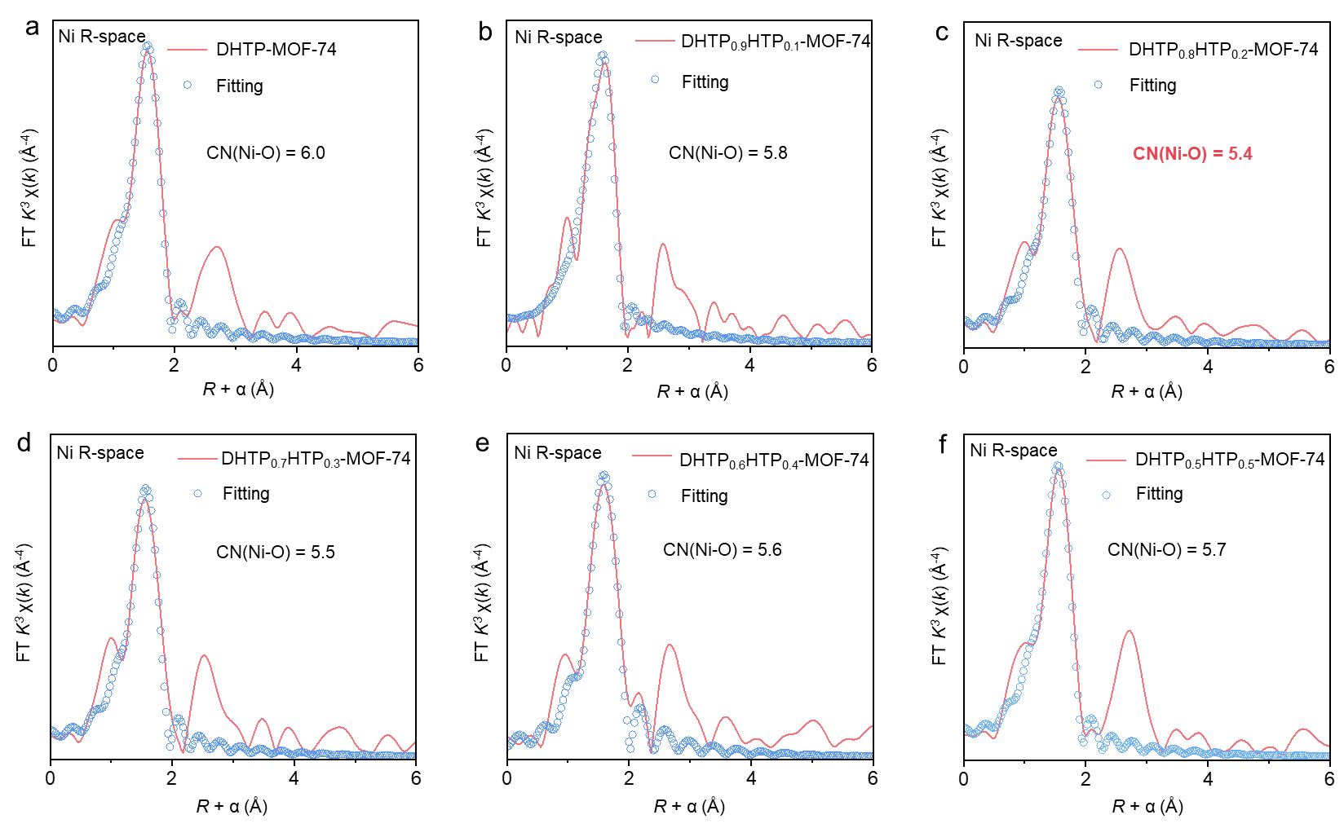
Supplementary Fig. 41| (a-f) Ni K-edge EXAFS spectra and corresponding fitting results of the coordination number for the samples. The best-fit parameters and detailed results are summarized in Supplementary Table 8.
Powder X-ray diffraction (PXRD) and N₂ sorption isotherms have demonstrated the limited incorporation of HTP into DHTP_{x}HTP_{1-x}MOF-74 (Fig. 2b and Supplementary Fig. 16). This is further evidenced by extended X-ray absorption fine structure (EXAFS) fittings. From DHTP-MOF-74 to DHTP_{0.8}HTP_{0.2}-MOF-74, the coordination number of the Ni‒O first shell gradually decreases from ~6.0 to ~5.4 (Supplementary Fig. 41a-c), confirming that HTP is perfectly incorporated into the framework and precisely edits Ni nodes into open sites. However, as the HTP content increases further (≥30%), the coordination number of the Ni‒O first shell rises slightly again (Supplementary Fig. 41d-f). This occurs because excess HTP fails to integrate into the contiguous framework in MOF-74, thereby being unable to effectively tune the Ni nodes within the framework.

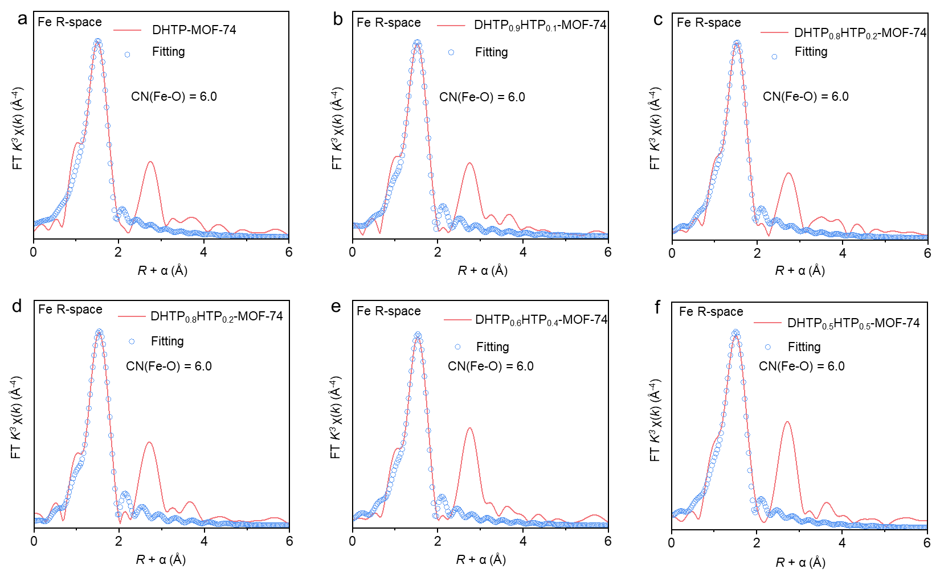
Supplementary Fig. 42| (a-f) Fe K-edge EXAFS spectra and corresponding fitting results of the coordination number for the samples. The best-fit parameters and detailed results are summarized in Supplementary Table 9.
As shown in Supplementary Fig. 42, with the HTP content increasing in DHTP_{x}HTP_{1-x}-MOF-74, the first-shell Fe‒O coordination number is nearly unchanged, indicating that the introduction of HTP does not modulate the coordinate configuration of Fe nodes.

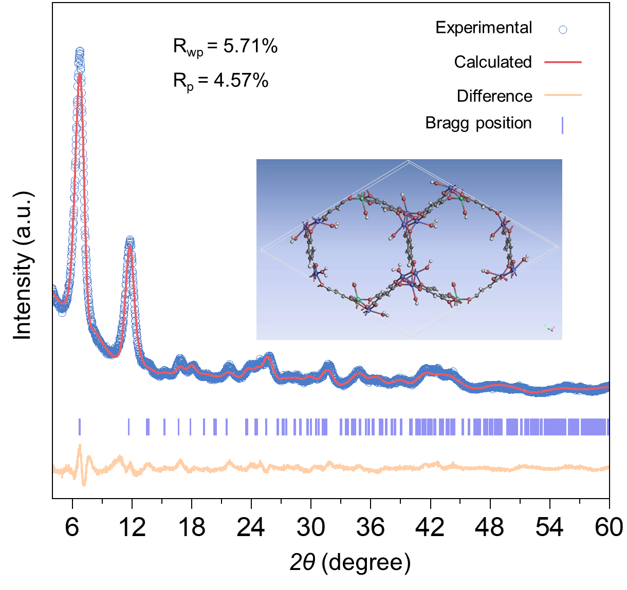
Supplementary Fig. 43| Rietveld refinement of experimental PXRD data of DHTP_{0.8}HTP_{0.2}-MOF-74.
Refined results of R_{wp} = 5.71% and R_{p} = 4.57% (reasonable range less than 10%) demonstrate that the constructed DHTP_{0.8}HTP_{0.2}-MOF-74 structure is reliable.

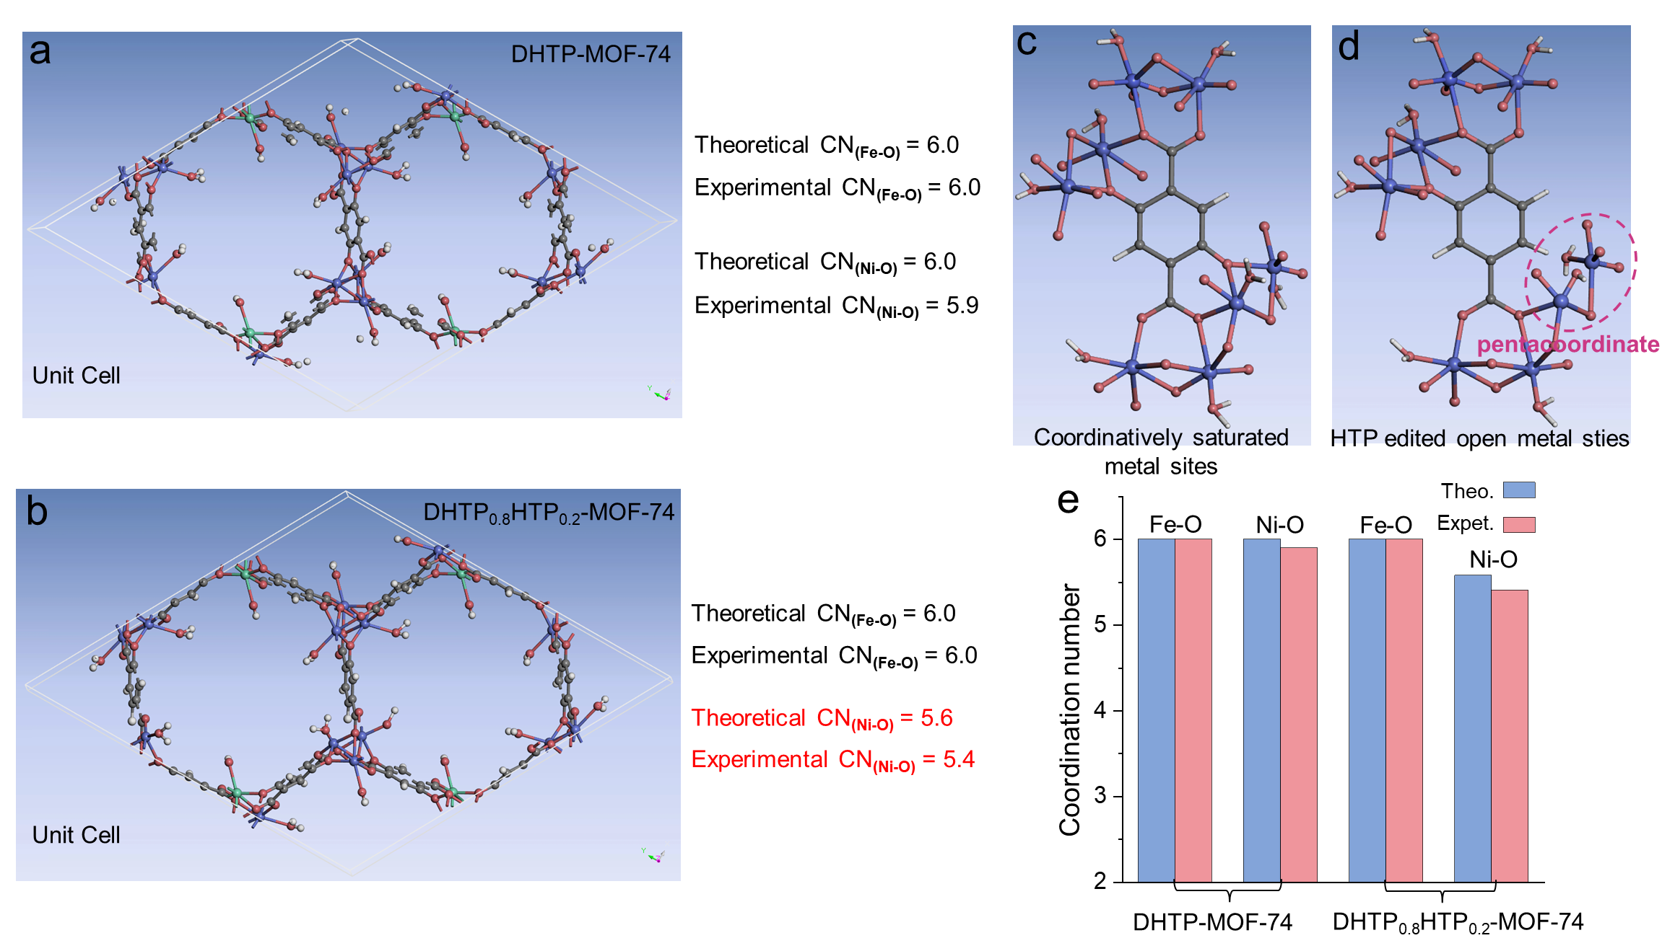
Supplementary Fig. 44| Structural models of (a) DHTP-MOF-74 and (b) DHTP_{0.8}HTP_{0.2}-MOF-74, along with the coordination modes of (c) DHTP and (d) HTP linkers to Ni nodes. (e) Theoretical coordination number of metal nodes derived from the unit cell calculation, and experimental coordination number obtained by fitting the FT-EXAFS spectra.
It is known that the classic MOF-74 first reported by Yaghi and co-workers¹⁵ is composed of +2 metal nodes (such as Co²⁺, Ni²⁺, Zn²⁺, and Mg²⁺) and 2,5-dihydroxyterephthalic acid linkers. The metal nodes adopt a hexacoordinate geometry, coordinated by five oxygen atoms from the ligands and one oxygen atom from the coordinated H₂O molecule (Supplementary Fig. 44c). When Fe³⁺ partially substitutes Ni²⁺ in MOF-74, charge conservation in the system drives the deprotonation of the coordinated H₂O to OH⁻ on Fe nodes. Therefore, in NiFe-based MOF-74, each Ni²⁺ center remains coordinated to five ligand O atoms and one H₂O molecule, whereas each Fe³⁺ node is coordinated by five ligand O atoms and one OH⁻.
Notably, the unit cell of DHTP_{0.8}HTP_{0.2}-MOF-74 is constructed from approximately nine organic linkers (seven DHTP and two HTP) and eighteen metal centers (fourteen Ni and four Fe) (Supplementary Fig. 44b). Our experiments show that the Fe coordination environment remains intact upon HTP incorporation (Supplementary Fig. 42), indicating that the two HTP linkers edit Ni sites exclusively (Supplementary Fig. 41). Since HTP lacks one phenolic –OH group compared to DHTP, charge conservation upon substitution requires deprotonation of a coordinated H₂O molecule on the affected Ni centers to OH⁻. This results in two Ni centers adopting a pentacoordinate configuration, as shown in Supplementary Fig. 44d. The close agreement between the theoretical and experimental coordination numbers further supports this structural model (Supplementary Fig. 44e).
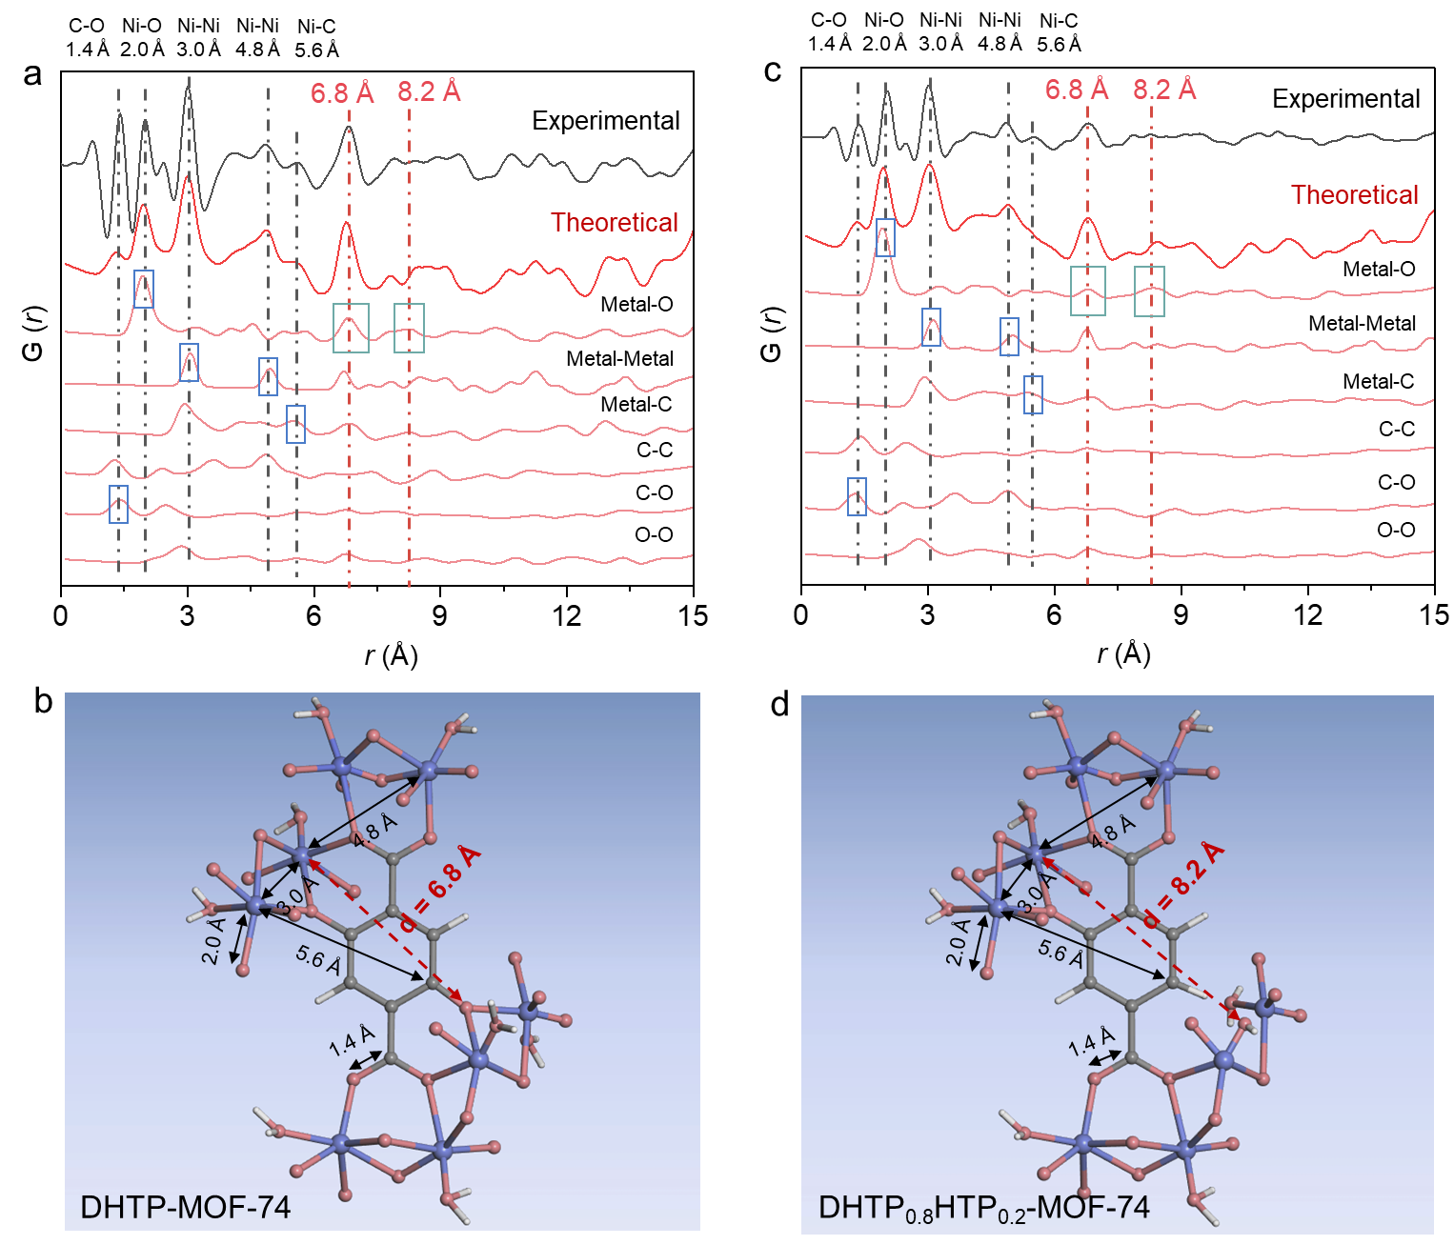
Supplementary Fig. 45| Experimental (black curve) and theoretically calculated PDF (red curve) for (a) DHTP-MOF-74 and (c) DHTP_{0.8}HTP_{0.2}-MOF-74, and the corresponding distance between atom pairs in (b) DHTP-MOF-74 and (d) DHTP_{0.8}HTP_{0.2}-MOF-74.
The calculated pair distribution functions (PDFs) exhibit oscillations consistent with the experimental PDF, confirming the structural accuracy of the constructed DHTP_{0.8}HTP_{0.2}-MOF-74 model. Furthermore, the different interatomic scattering contributions obtained from theoretical calculations corroborate the assignment of the experimentally observed PDF peaks.

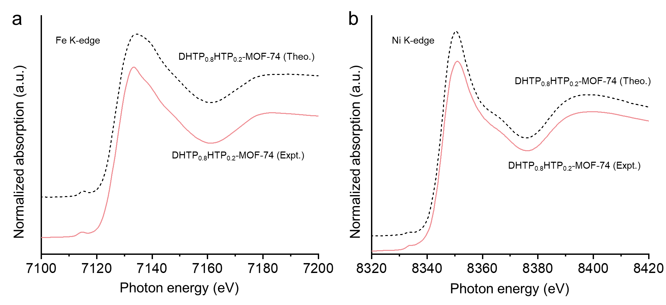
Supplementary Fig. 46| Theoretical and experimental (a) Ni and (b) Fe K-edge XANES spectra in DHTP_{0.8}HTP_{0.2}-MOF-74. Theoretical XANES spectra are calculated from the DHTP_{0.8}HTP_{0.2}-MOF-74 model.
As shown in Supplementary Fig. 46, the excellent agreement between theoretical and experimental Ni and Fe K-edge XANES spectra further validates the structural accuracy of the constructed DHTP_{0.8}HTP_{0.2}-MOF-74 model.

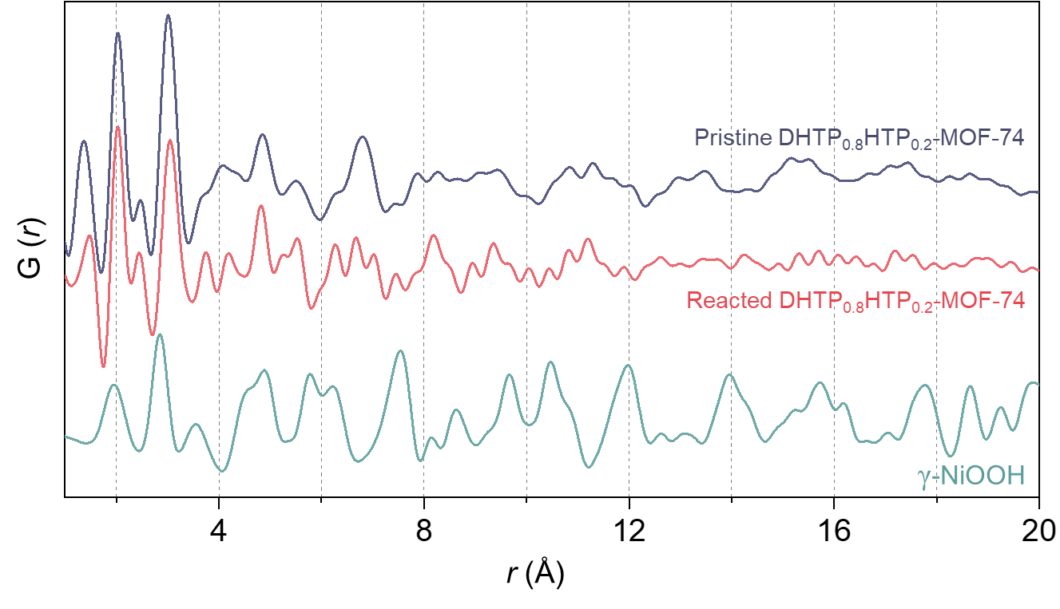
Supplementary Fig. 47| PDFs of pristine DHTP_{0.8}HTP_{0.2}-MOF-74, reacted DHTP_{0.8}HTP_{0.2}-MOF-74, and γ-NiOOH. The reacted DHTP_{0.8}HTP_{0.2}-MOF-74 was collected following potentiostatic electrolysis at 1.5 V in 1 M KOH + seawater.
The comparison reveals that the oscillation pattern of the reacted DHTP_{0.8}HTP_{0.2}-MOF-74 closely matches that of its pristine counterpart, indicating that the metal-centered coordination environment remains structurally intact and does not transform into γ-NiOOH. Specifically, the preservation of oscillation features within the long-range region of 20 Å confirms the retention of framework structure after reaction.

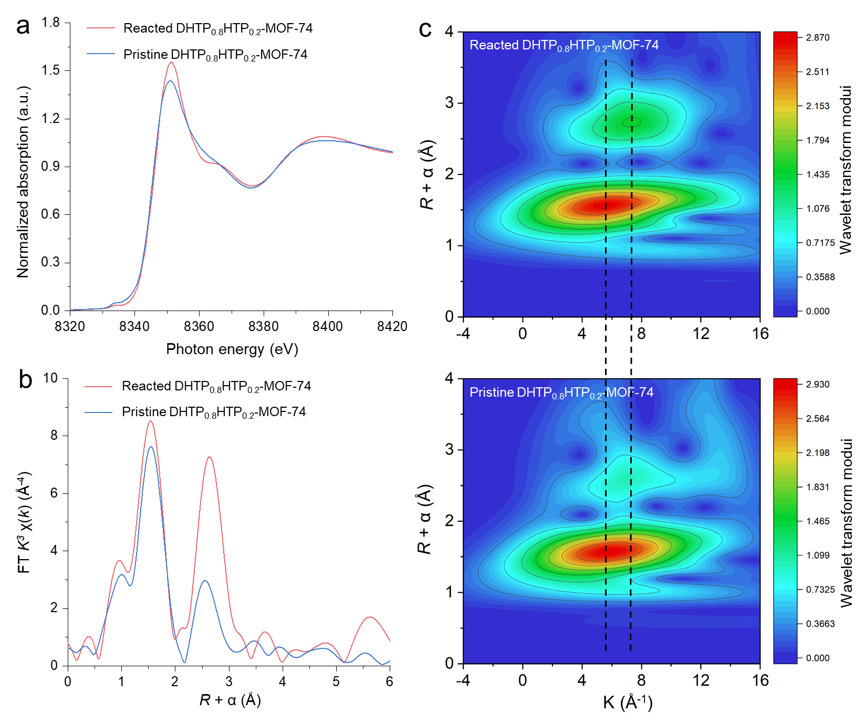
Supplementary Fig. 48| (a) Ni K-edge XANES spectra and (b) Ni K-edge EXAFS spectra. (c) Wavelet-transformed extended X-ray absorption fine structure (WT-EXAFS) of pristine and reacted DHTP_{0.8}HTP_{0.2}-MOF-74.
Extended X-ray absorption fine structure (EXAFS) analysis offers critical insight into the local coordination environment of metal centers in MOFs. As shown in Supplementary Fig. 48a, the Ni centers in the reacted DHTP_{0.8}HTP_{0.2}-MOF-74 retain their +2 oxidation state, consistent with the pristine counterpart. Notably, their local coordination configuration remains virtually unchanged (Supplementary Fig. 48b, c), confirming that the secondary linker-edited environment at Ni centers remains stable throughout the OER.

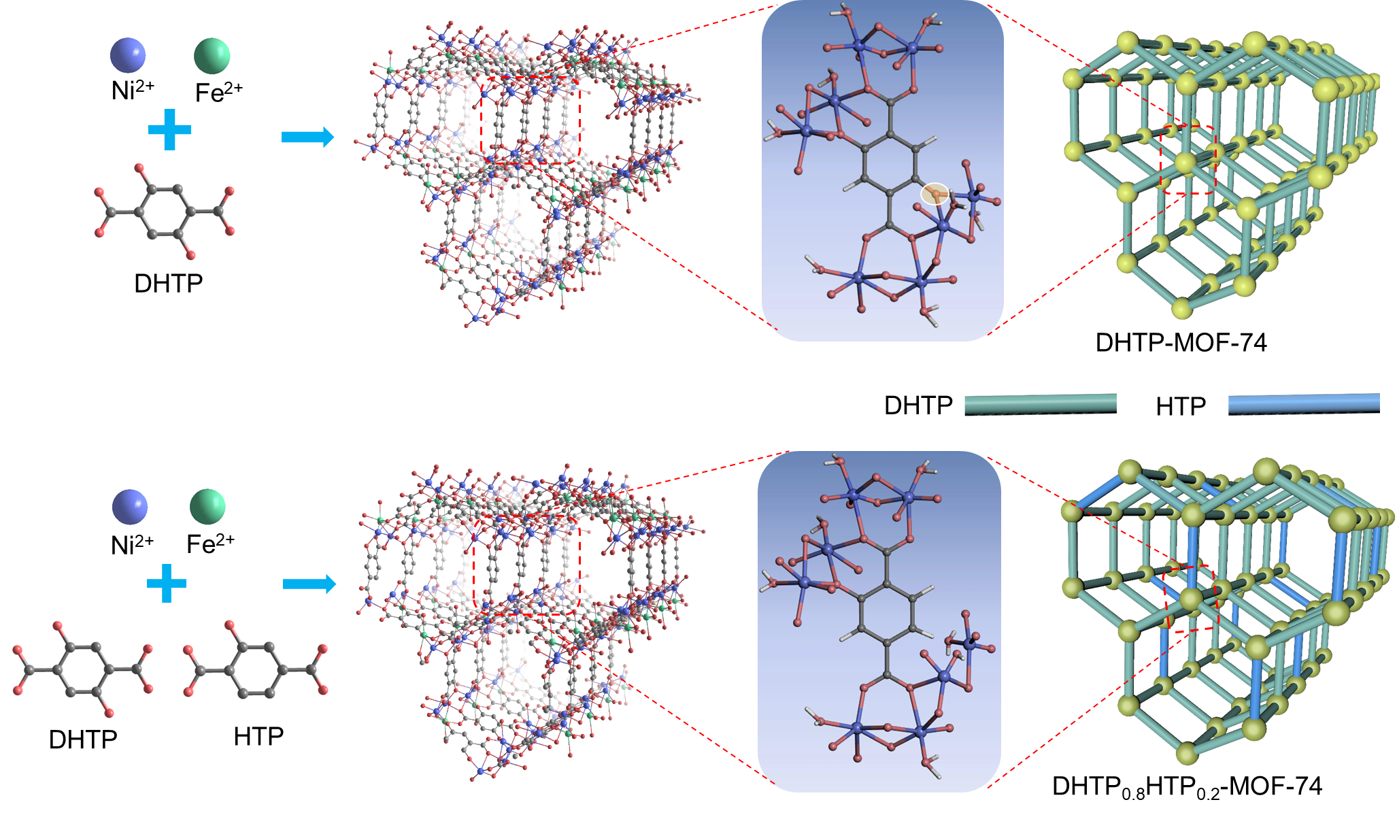
Supplementary Fig. 49| Schematic of de novo syntheses and structures for DHTP-MOF-74 (up) and DHTP_{0.8}HTP_{0.2}-MOF-74 (bottom).
As shown in Supplementary Fig. 49, the de novo incorporation of the secondary HTP linker generates open metal sites while preserving the linking backbone, thereby optimizing both activity and stability.

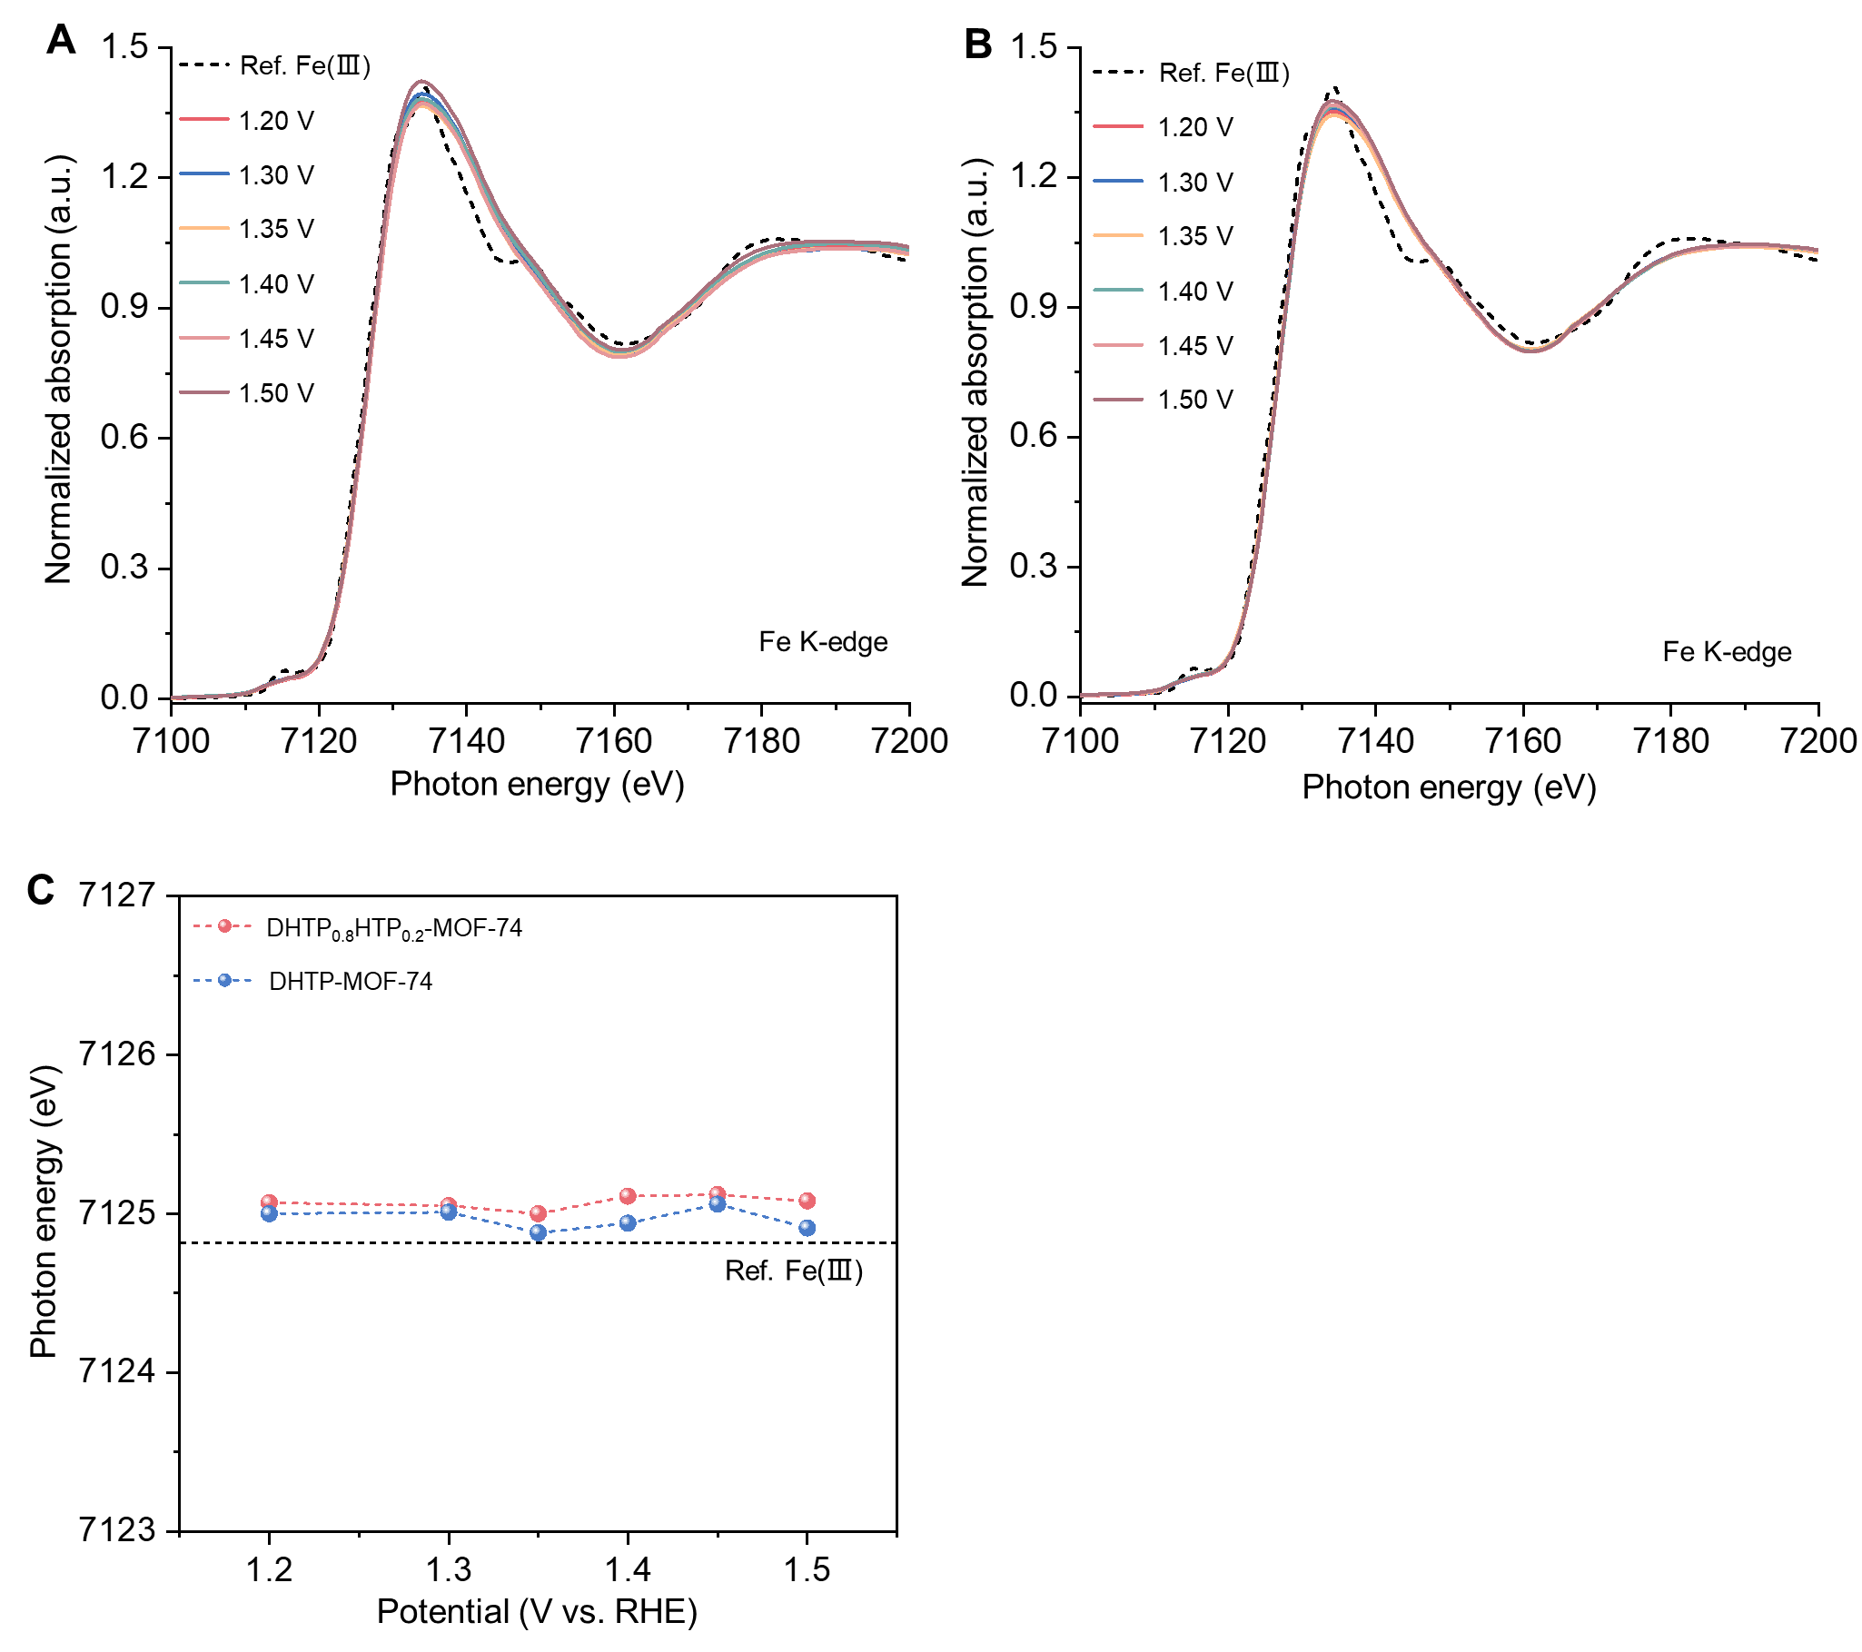
Supplementary Fig. 50| Operando Fe K-edge XANES spectra of (a) DHTP-MOF-74 and (b) DHTP_{0.8}HTP_{0.2}-MOF-74 at different potentials, and standard Fe₂O₃ K-edge XANES spectra. (c) The variation of the Fe absorption edge position at different potentials compiled by operando XANES spectra.
Fe K-edge XANES results indicate that the chemical valence state of Fe remains consistently +3 throughout alkaline seawater electrolysis.

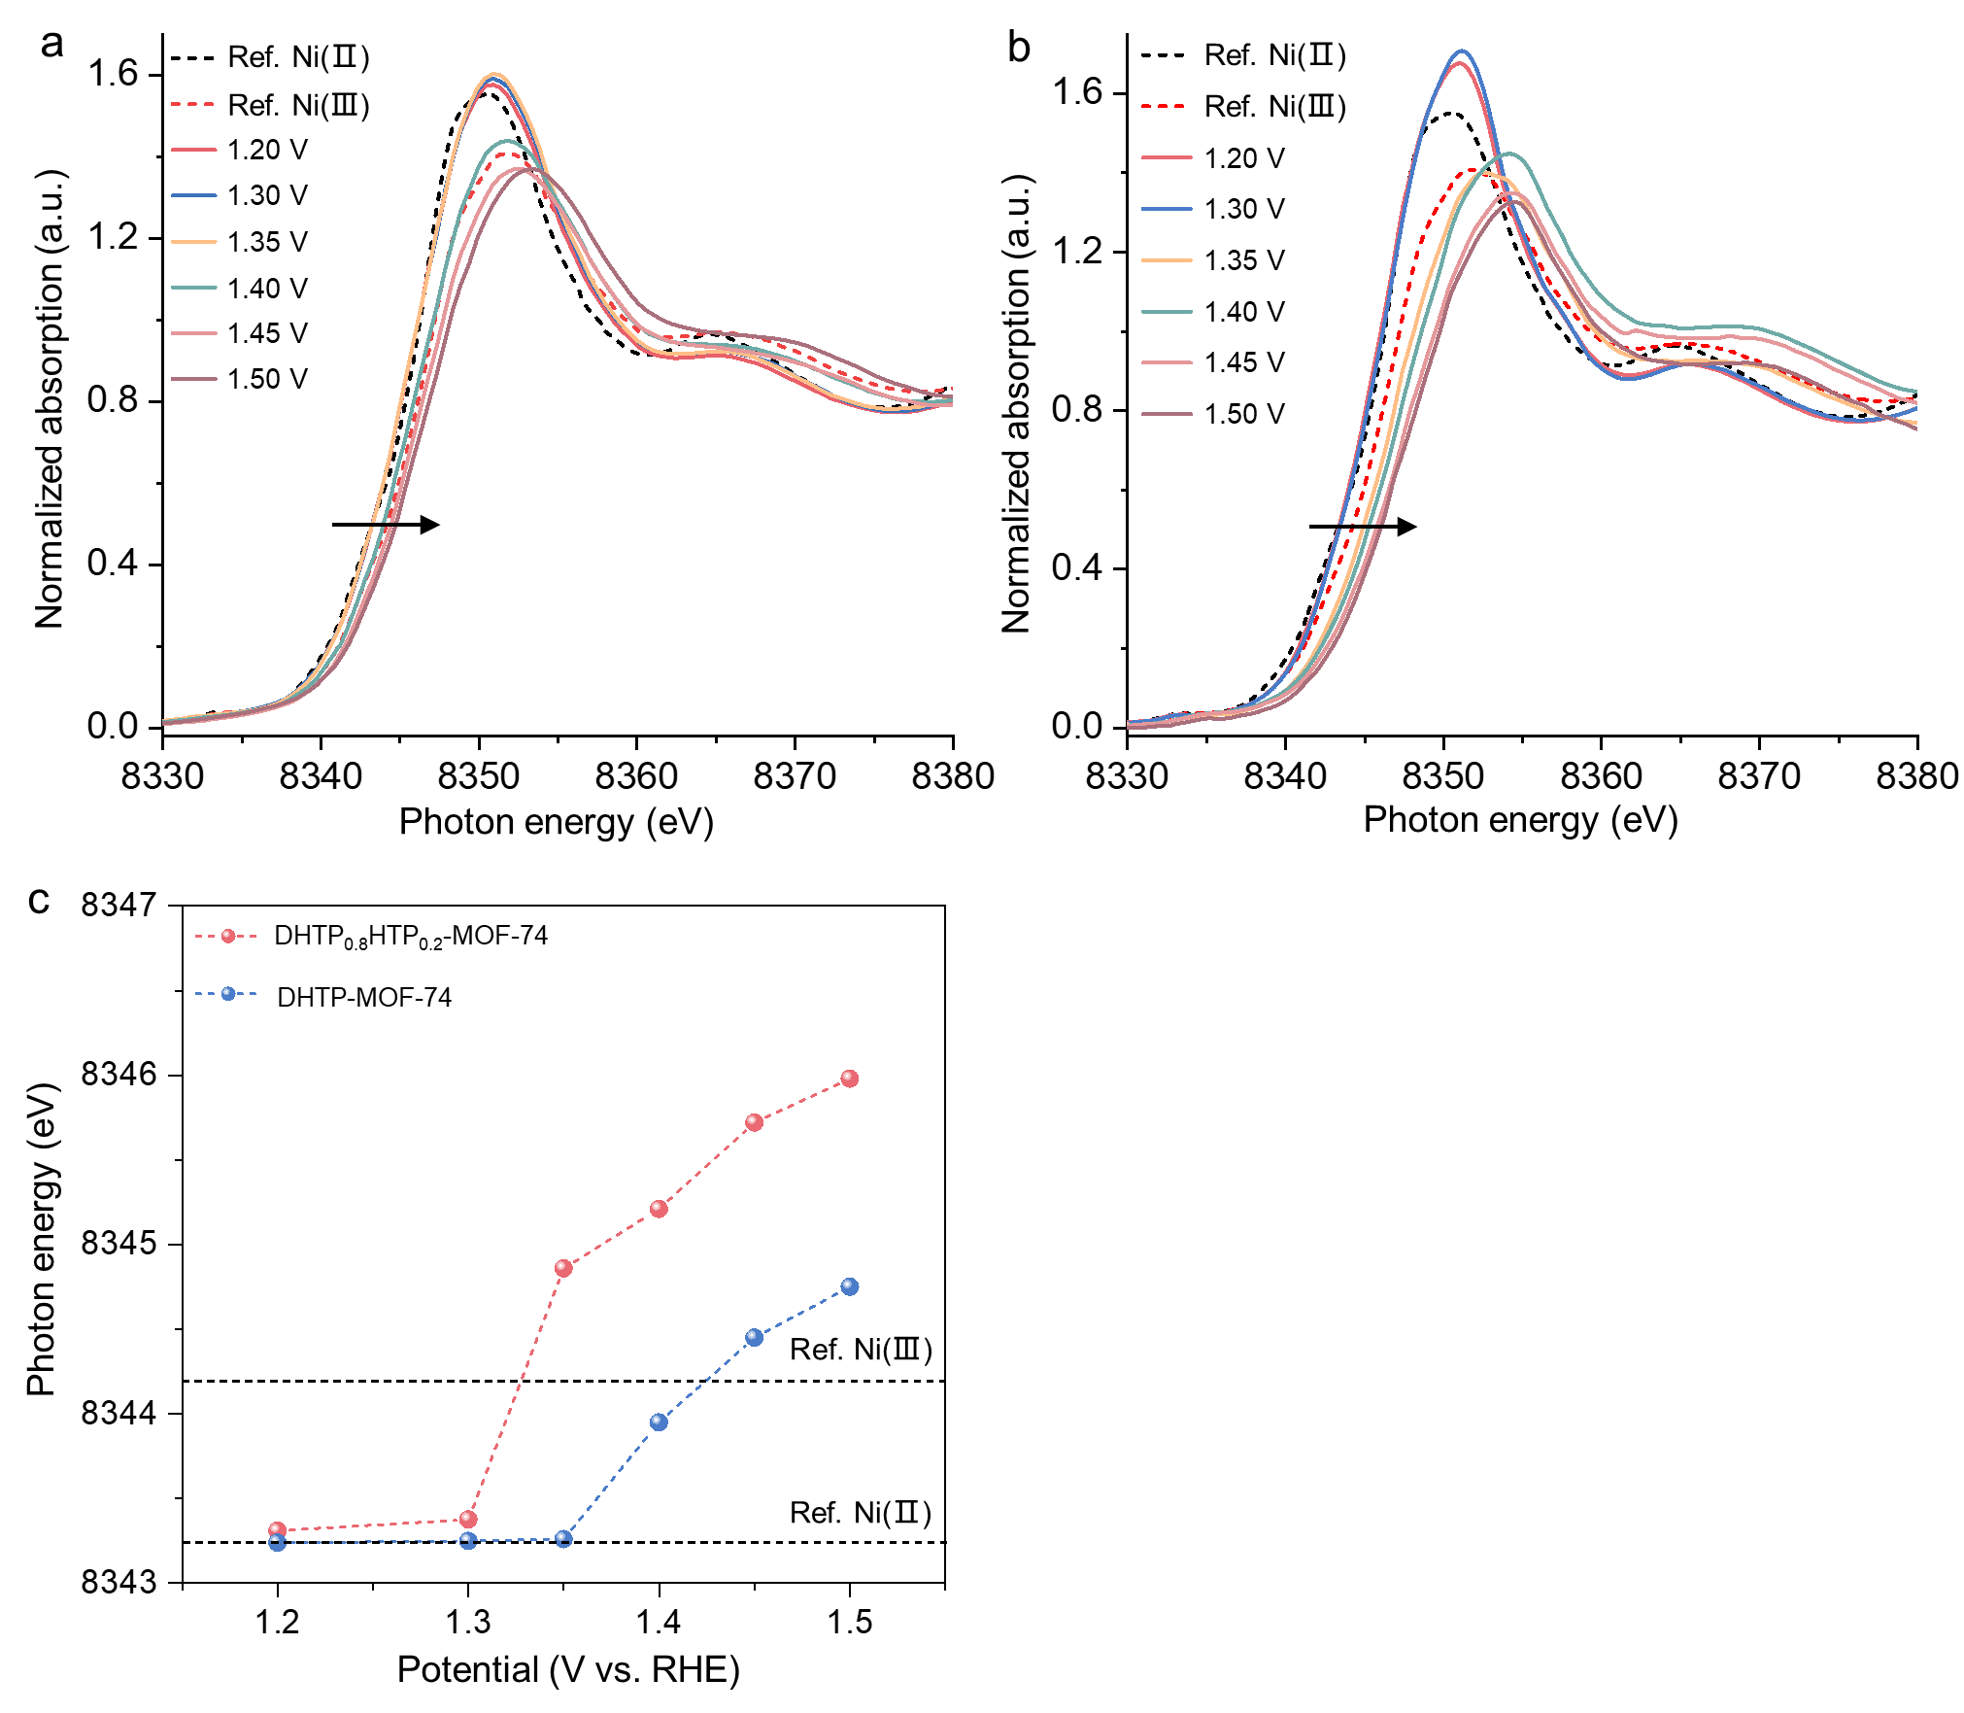
Supplementary Fig. 51| Operando Ni K-edge XANES spectra of (a) DHTP-MOF-74 and (b) DHTP_{0.8}HTP_{0.2}-MOF-74 at different potentials, and standard Ni(OH)₂ and NiOOH K-edge XANES spectra (The black arrows show the shift of absorption edge positions under increasing applied voltage). (c) The variation of the Ni absorption edge position at different potentials compiled by operando XANES spectra.

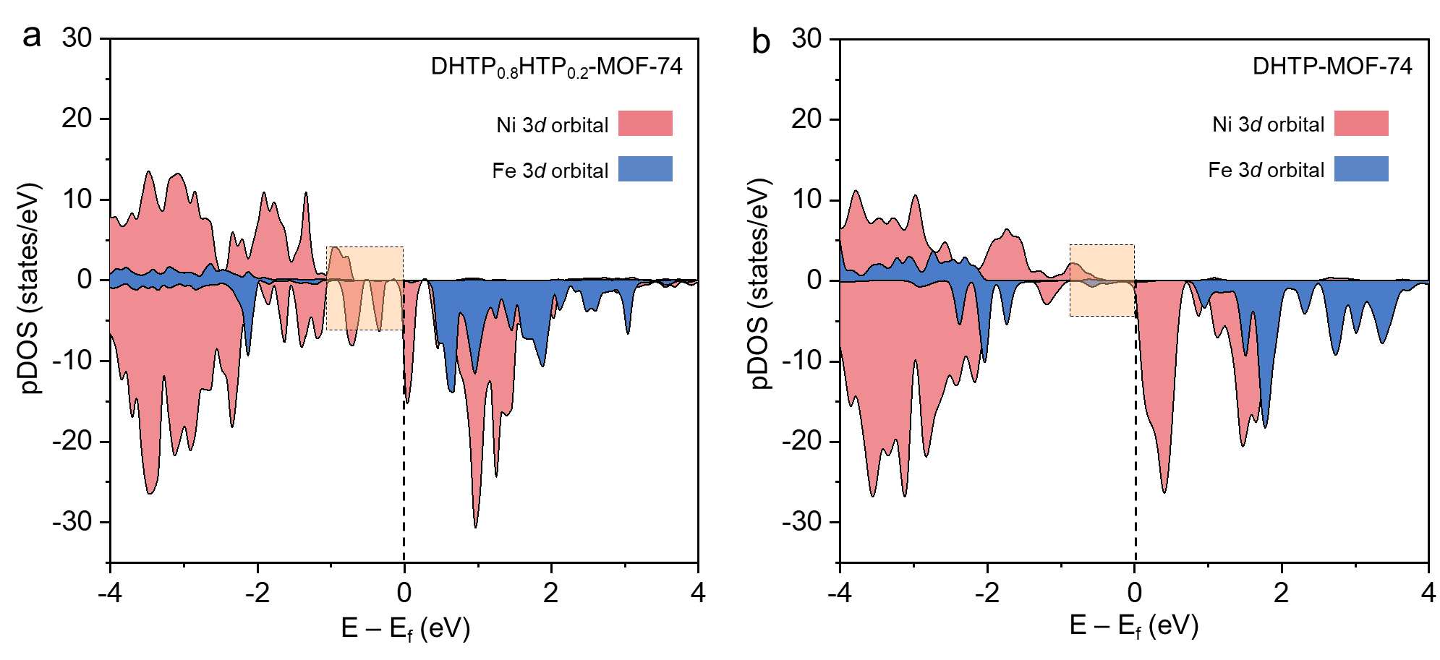
Supplementary Fig. 52| Partial density of states (pDOS) of Fe 3d (blue) and Ni 3d (red) orbitals in (a) DHTP-MOF-74 and (b) DHTP_{0.8}HTP_{0.2}-MOF-74 models. The yellow regions represent the metal pDOS near the Fermi level.
As shown in Supplementary Fig. 52, the partial density of state (pDOS) of Ni centers near the Fermi level is significantly higher than that of Fe centers, suggesting that electron transfer is more facile at Ni sites.

Supplementary Fig. 53| (a) Partial density of states (pDOS) of DHTP-MOF-74 (blue) and DHTP_{0.8}HTP_{0.2}-MOF-74 (red). The yellow regions represent the metals’ pDOS near the Fermi level. (b) The d-band centers of Ni in DHTP-MOF-74 and DHTP_{0.8}HTP_{0.2}-MOF-74.
Compared to the coordinatively saturated Ni centers in DHTP-MOF-74, open Ni centers in DHTP_{0.8}HTP_{0.2}-MOF-74 exhibit a higher partial density of states (pDOS) near the Fermi level and a lower d-band center, suggesting enhanced electron transfer capability and stronger reactant adsorption.

Supplementary Fig. 54| Depth profiling of OH⁻ and Cl⁻ in DHTP-MOF-74 and DHTP_{0.8}HTP_{0.2}-MOF-74 after OER in alkaline seawater, acquired by a time-of-flight secondary ion mass spectrometry (TOF-SIMS).
As shown in Supplementary Fig. 54, OH⁻ signal intensity in the bulk of DHTP_{0.8}HTP_{0.2}-MOF-74 is over 54-fold higher than that of Cl⁻. In comparison, this ratio is only approximately 21 in DHTP-MOF-74. During sputtering, the Cl⁻ signal remains nearly unchanged in DHTP_{0.8}HTP_{0.2}-MOF-74 but gradually increases in DHTP-MOF-74, indicating that DHTP-MOF-74 exhibits stronger competitive adsorption affinity toward Cl⁻.

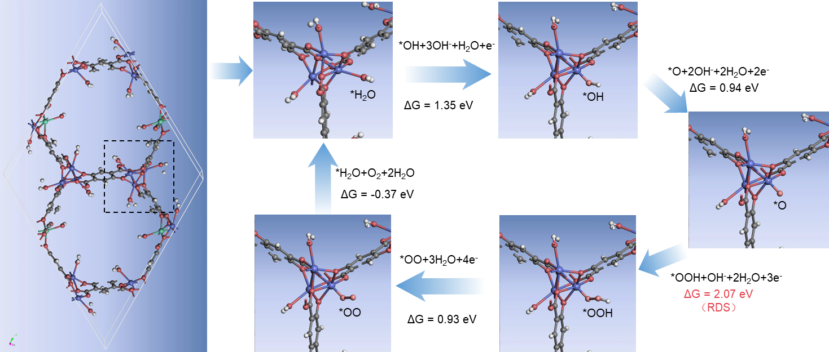
Supplementary Fig. 55| Schematic of the OER process on DHTP-MOF-74 and the corresponding Gibbs free energy in an alkaline medium (pH = 14).
Throughout the OER process on DHT-MOF-74, the step *O + OH⁻ → *OOH + e⁻ presents the highest Gibbs free energy barrier (2.07 eV) and is thus identified as the potential-determining step.

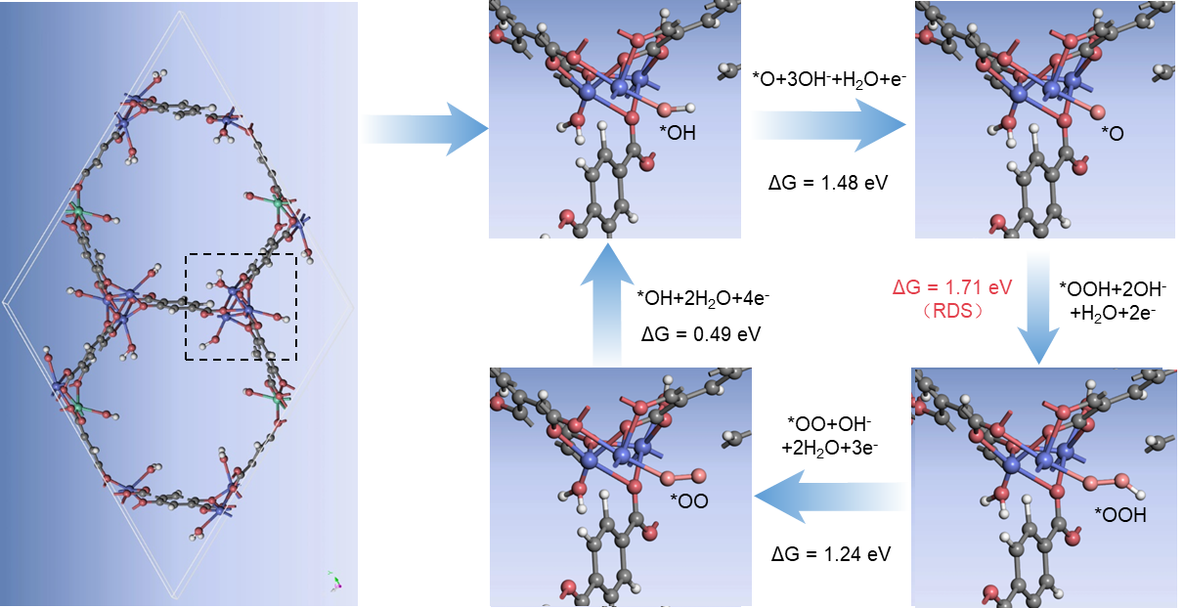
Supplementary Fig. 56| Schematic of the OER process on DHTP_{0.8}HTP_{0.2}-MOF-74 and the corresponding Gibbs free energy in an alkaline medium (pH = 14).
Throughout the OER process on DHTP_{0.8}HTP_{0.2}-MOF-74, the step *O + OH⁻ → *OOH + e⁻ presents the highest Gibbs free energy barrier (1.71 eV) and is thus identified as the potential-determining step.

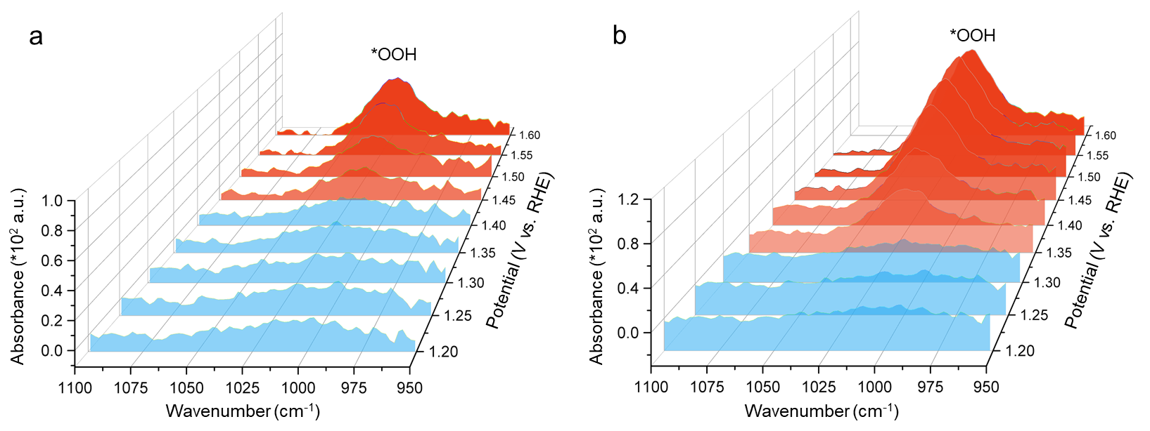
Supplementary Fig. 57| In situ Fourier transform infrared spectroscopy of (a) DHTP-MOF-7 and (b) DHTP_{0.8}HTP_{0.2}-MOF-74 at different potentials in alkaline seawater. The *OOH signals at ~1020 cm⁻¹ gradually increase with potential.
Compared to DHTP-MOF-74, the *OOH signals in DHTP_{0.8}HTP_{0.2}-MOF-74 appear at lower applied potentials (~1.35 V), suggesting that open Ni sites more readily facilitate the formation of this key intermediate during OER.

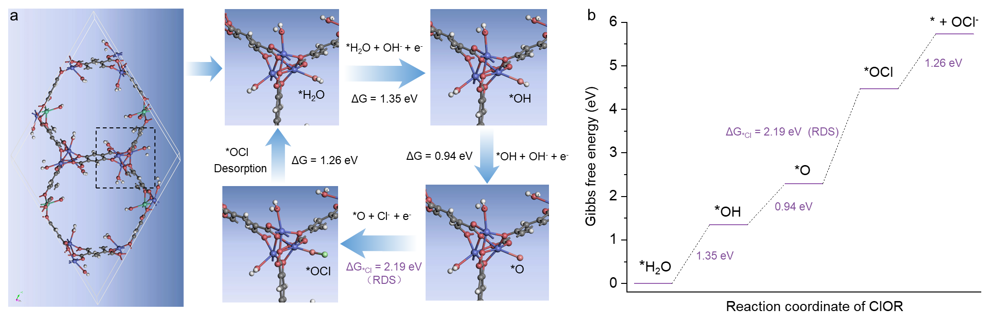
Supplementary Fig. 58| (a) Schematic of the ClOR process on DHTP-MOF-74 and (b) the corresponding Gibbs free energy in an alkaline medium (pH = 14).
In an alkaline medium, the oxidation of Cl⁻ to OCl⁻ (ClOR) initiates with the deprotonation of oxygenerated species to form *O at active sites.^{1,6} As depicted in Supplementary Fig. 58a, on saturated Ni sites, this process involves H₂O deprotonation to *O, followed by competitive adsorption of Cl⁻ to form *OCl. Notably, this pathway severely competes with *OOH formation in the OER (Supplementary Fig. 56). As shown in Supplementary Fig. 58b, throughout the ClOR process on DHTP-MOF-74, the step *O + Cl⁻ → *OCl + e⁻ is the rate-determining step, with an energy barrier of 2.19 eV. This value is 0.12 eV higher than that of its OER.

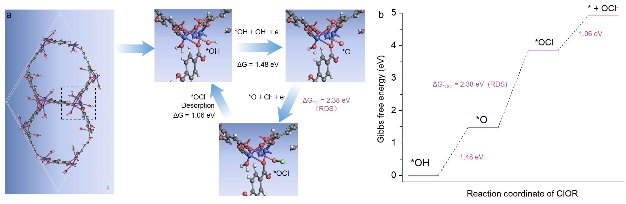
Supplementary Fig. 59| (a) Schematic of the ClOR process on DHTP_{0.8}HTP_{0.2}-MOF-74 and (b) the corresponding Gibbs free energy in an alkaline medium (pH = 14).
As depicted in Supplementary Fig. 59a, the competitive ClOR at open Ni sites proceeds via deprotonation of a coordinating OH⁻ to form *O, followed by competitive adsorption of Cl⁻ to form *OCl. This pathway likely competes with *OOH formation in the OER (Supplementary Fig. 55). As shown in Supplementary Fig. 59b, throughout the ClOR process on DHTP-MOF-74, the step *O + Cl⁻ → *OCl + e⁻ is the rate-determining step, with a notably higher energy barrier of 2.38 eV. This value is 0.67 eV above the corresponding OER step, suggesting that open Ni sites suppress ClOR more effectively and enhance OER selectivity.

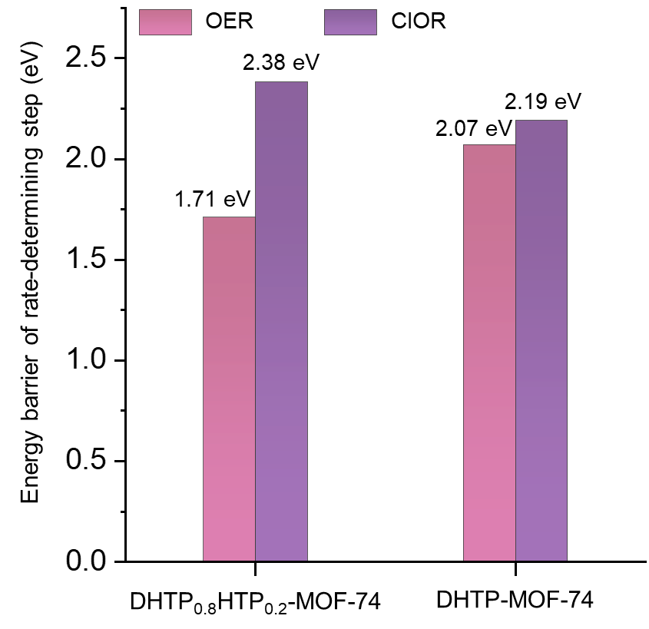
Supplementary Fig. 60| Energy barrier of the rate-determining step in OER and ClOR on DHTP_{0.8}HTP_{0.2}-MOF-74 and DHTP-MOF-74.
As shown in Supplementary Fig. 60, the rate-determining step for OER has a lower energy barrier than that for ClOR in all samples, thermodynamically favoring OER over ClOR during alkaline seawater electrolysis. Notably, while DHTP-MOF-74 shows a modest OER/ClOR barrier difference of 0.12 eV, DHTP_{0.8}HTP_{0.2}-MOF-74 exhibits a substantially larger difference of 0.67 eV. This indicates that the introduced open Ni sites more effectively suppress competitive ClOR through a preferential OH⁻ adsorption-evolution pathway.

Supplementary Section 3. Tables
Supplementary Table 1. Ni and Fe contents of the samples measured by ICP-OES.
Sample Denotation | Ni (wt.%) | Fe (wt.%) | Ni (mol%) | Fe (mol%)
DHTP-Ni | 21.21 | 0 | 100 | 0
DHTP-Ni_{0.9}Fe_{0.1} | 15.74 | 1.62 | 90.2 | 9.76
DHTP-Ni_{0.8}Fe_{0.2} | 11.41 | 2.90 | 78.9 | 21.1
DHTP-Ni_{0.7}Fe_{0.3} | 8.81 | 3.43 | 71.0 | 29.0
DHTP-Ni_{0.6}Fe_{0.4} | 6.38 | 3.87 | 61.1 | 38.9
DHTP-Ni_{0.5}Fe_{0.5} | 2.65 | 2.34 | 51.9 | 48.1
DHTP_{0.8}HTP_{0.2}-MOF-74 | 11.08 | 2.81 | 79.0 | 21.0

Supplementary Table 2. Intrinsic OER activity comparison of DHTP_{0.8}HTP_{0.2}-MOF-74 with reported MOFs using an inert substrate, such as glassy carbon electrode (GCE), carbon paper (CP), and carbon cloth (CC). Our work breaks the current record of overpotential at 10 mA cm⁻².
Catalyst | Electrolyte | ƞ₁₀ (mV) | Tafel slope  (mV dec⁻¹) | Substrate | Ref.
DHTP_{0.8}HTP_{0.2}-MOF-74 | 1 M KOH | 195 | 36 | GCE | This work
Fe/Ni_{2.4}/Co_{0.4}-MIL-53 | 1 M KOH | 219 | 53.5 | GCE | 16
NiFe-BTC-GNPs MOF | 1 M KOH | 220 | 51 | CP | 17
Ni-Fe-MOFs NSs | 1 M KOH | 221 | 56 | GCE | 18
CoCe-DHBDC | 1 M KOH | 226 | 45 | GCE | 19
LS-6%-NiFe-MOFs | 1 M KOH | 230 | 86.6 | GCE | 20
MOF-Fe/Co(1:2) | 1 M KOH | 238 | 58 | GCE | 21
HHTP@ZIF-67 | 1 M KOH | 238 | 104 | GCE | 22
NiCo-UMOFs | 1 M KOH | 250 | 42 | GCE | 23
FeCoNi-MOFs | 1 M KOH | 254 | 21.4 | GCE | 24
Co₃(HITP)₂ | 1 M KOH | 254 | 86.5 | CC | 25
(Ni₂Co₁)_{0.925}Fe_{0.075}-MOF-NF | 1 M KOH | 257 | 41.3 | GCE | 26
NiFe-UMNs | 1 M KOH | 260 | 30 | GCE | 27
Fe₂Ni₁-BDC | 1 M KOH | 260 | 35 | GCE | 28
2D Co MOF | 1 M KOH | 263 | 74 | GCE | 29
CoFe MOF | 1 M KOH | 265 | 44 | GCE | 30
NiCoFe-MOF-74 | 1 M KOH | 270 | 89 | GCE | 31
Ni_{0.5}Co_{0.5}-MOF | 1 M KOH | 270 | 49 | GCE | 32
CoCu-MOF NBs | 1 M KOH | 271 | 63.5 | CP | 33
2D MOF LM-160-12 | 1 M KOH | 274 | 46.7 | GCE | 34
(U+S)-CoFe-MOF | 1 M KOH | 277 | 31 | GCE | 35
Co_{0.6}Fe_{0.4}-MOF-74 | 1 M KOH | 280 | 56 | GCE | 36
Fe:2D-Co-NS | 1M KOH | 282 | 59 | GCE | 37
A_{2.7}B-MOF-FeCo_{1.6} | 1 M KOH | 288 | 39 | GCE | 38
Fe(OH)₃@Co-MOF-74 | 1 M KOH | 292 | 44 | GCE | 39
CTGU-10c2 | 0.1 M KOH | 240 | 58 | GCE | 40
aMOF-NC | 0.1 M KOH | 249 | 39.5 | GCE | 41

Supplementary Table 3. Double-layer capacitance C_{dl} and electrochemically active area of MOFs. Note that C_{s} = 0.04 mF cm⁻².
Catalyst | DHTP_{0.8}HTP_{0.2}-MOF-74 | DHTP-MOF-74 | IrO₂
C_{dl} (mF cm⁻²) | 4.40 | 3.22 | 1.26
ECSA=C_{dl}/C_{s} | 88 | 64.4 | 25.2

Supplementary Table 4. Overpotential comparison of DHTP_{0.8}HTP_{0.2}-MOF-74 with reported catalysts under high current densities in alkaline natural/artificial seawater at room temperature. Note that only reports with both J₅₀₀ and J₁₀₀₀ are included in Fig. 3B.
Catalyst | J (mA cm⁻²) | Overpotential (mV) | Electrolyte | Ref.
DHTP_{0.8}HTP_{0.2}-MOF-74 | 500 | 240 | 1 M KOH + seawater | This work
DHTP_{0.8}HTP_{0.2}-MOF-74 | 1000 | 257 | 1 M KOH + seawater | This work
Ag/NiFe-Ru LDH | 500 | 268 | 1 M KOH + seawater | 42
Ag/NiFe-Ru LDH | 1000 | 287 | 1 M KOH + seawater | 42
Fe-Ni₂P/NiMoO₄ | 500 | 260 | 1 M KOH + seawater | 43
Fe-Ni₂P/NiMoO₄ | 1000 | 299 | 1 M KOH + seawater | 43
Fe-Ni₂Pv | 500 | 292 | 1 M KOH + seawater | 44
Fe-Ni₂Pv | 1000 | 306 | 1 M KOH + seawater | 44
Fe_{0.01}&Mo-NiO | 500 | 297 | 1 M KOH + seawater | 45
Fe_{0.01}&Mo-NiO | 1000 | 326 | 1 M KOH + seawater | 45
CrO₄²⁻-NiFe LDH/Cr₂O₃/NF | 500 | 300 | 1 M KOH + seawater | 46
CrO₄²⁻-NiFe LDH/Cr₂O₃/NF | 1000 | 310 | 1 M KOH + seawater | 46
MCF-LDH | 500 | 304 | 1 M KOH + seawater | 47
MCF-LDH | 1000 | 368 | 1 M KOH + seawater | 47
NiCoP foam/NF | 500 | 304 | 1 M KOH + seawater | 48
NiCoP foam/NF | 1000 | 356 | 1 M KOH + seawater | 48
Ni(OH)₂-P₃O₁₀⁵⁻ | 500 | 307 | 1 M KOH + seawater | 49
Ni(OH)₂-P₃O₁₀⁵⁻ | 1000 | 352 | 1 M KOH + seawater | 49
Fe₄N/Co₃N/MoO₂ | 500 | 318 | 1 M KOH + seawater | 50
Fe₄N/Co₃N/MoO₂ | 1000 | 338 | 1 M KOH + seawater | 50
PW₁₂-CoFe LDH/NF | 500 | 325 | 1 M KOH + seawater | 51
PW₁₂-CoFe LDH/NF | 1000 | 368 | 1 M KOH + seawater | 51
NiFe/NiS_{x}-Ni | 500 | 338 | 1 M KOH + seawater | 52
NiFe/NiS_{x}-Ni | 1000 | 392 | 1 M KOH + seawater | 52
(NiFe)C₂O₄/NF | 500 | 339 | 1 M KOH + seawater | 53
(NiFe)C₂O₄/NF | 1000 | 349 | 1 M KOH + seawater | 53
NiMoSₓ@NiMnFe-PBA | 500 | 347 | 1 M KOH + seawater | 54
NiMoSₓ@NiMnFe-PBA | 1000 | 465 | 1 M KOH + seawater | 54
NiFe-OL(NiFeOₓ) | 500 | 356 | 1 M KOH + seawater | 55
NiFe-OL(NiFeOₓ) | 1000 | 372 | 1 M KOH + seawater | 55
NiMoN@NiFeN | 500 | 369 | 1 M KOH + seawater | 56
NiMoN@NiFeN | 1000 | 398 | 1 M KOH + seawater | 56
FeMn-MOF | 500 | 369 | 1 M KOH + seawater | 57
FeMn-MOF | 1000 | 464 | 1 M KOH + seawater | 57
Ni₂P-Fe₂P/NF | 500 | 375 | 1 M KOH + seawater | 58
Ni₂P-Fe₂P/NF | 1000 | 431 | 1 M KOH + seawater | 58
NiCoPv@NF | 500 | 389 | 1 M KOH + seawater | 59
NiCoPv@NF | 1000 | 441 | 1 M KOH + seawater | 59
Cr-CoXP | 500 | 392 | 1 M KOH + seawater | 60
Cr-CoXP | 1000 | 423 | 1 M KOH + seawater | 60
RuMoNi | 500 | 397 | 1 M KOH + seawater | 61
RuMoNi | 1000 | 484 | 1 M KOH + seawater | 61
S-(Ni,Fe)OOH | 500 | 398 | 1 M KOH + seawater | 62
S-(Ni,Fe)OOH | 1000 | 462 | 1 M KOH + seawater | 62
Ru_{lds}NiCr-LDH | 500 | 445 | 1 M KOH + seawater | 63
Ru_{lds}NiCr-LDH | 1000 | 454 | 1 M KOH + seawater | 63
HEA-Mo₂C | 500 | 333 | 1 M KOH + seawater | 64
CoFe-Ni₂P | 500 | 360 | 1 M KOH + seawater | 65
NiIr-LDH | 500 | 361 | 1 M KOH + seawater | 66
60Fe/NF | 500 | 635 | 1 M KOH + seawater | 67
Os-Ni₄Mo/MoO₂ | 500 | 297 | 1 M KOH + 0.5 M NaCl | 68
Os-Ni₄Mo/MoO₂ | 1000 | 351 | 1 M KOH + 0.5 M NaCl | 68
GO@Fe@Ni-Co@NF | 500 | 303 | 1 M KOH + 0.5 M NaCl | 69
GO@Fe@Ni-Co@NF | 1000 | 345 | 1 M KOH + 0.5 M NaCl | 69
Mo-NiP@NF | 500 | 467 | 1 M KOH + 0.5 M NaCl | 70
Mo-NiP@NF | 1000 | 550 | 1 M KOH + 0.5 M NaCl | 70
GDY/RhO_{x}/GDY | 500 | 285 | 1 M KOH + 0.5 M NaCl | 71
NiCoS NAs/NFF | 500 | 306 | 1 M KOH + 0.5 M NaCl | 72
CuO@NiCoS NAs | 500 | 317 | 1 M KOH + 0.5 M NaCl | 73
FeCoNiCrMo-HEAA | 500 | 319 | 1 M KOH + 0.5 M NaCl | 74
NiCoHPi@Ni₃N | 500 | 474 | 1 M KOH + 0.5 M NaCl | 75
MoO₃@CoO/CC | 500 | 550 | 1 M KOH + 0.5 M NaCl | 76
VO₄³⁻-NiFe LDH/VO_{x}/NF | 500  1000 | 294  368 | 1 M KOH + 0.6 M NaCl | 77
NiFeCoP | 500 | 317 | 1 M KOH + 1 M NaCl | 78

Supplementary Table 5. Activity comparison of DHTP_{0.8}HTP_{0.2}-MOF-74 with reported electrocatalysts in an AEM system at 60°C. Note that the 2026 Department of Energy (DOE) technical target is 3 A cm⁻² at 1.80 V.
Catalyst | Electrolyte | J (mA cm⁻²) at 1.8 V @ 60℃ | Ref.
DHTP_{0.8}HTP_{0.2}-MOF-74 | 1 M KOH + seawater | 3910 | This work
MoO₃@CoO/CC | 1 M KOH + seawater | 755 | 80
CuO@NiCoS NAs | 1 M KOH + seawater | 436 | 73
PW₁₂-CoFe LDH/NF | 1 M KOH + seawater | 300 | 51
SO₄²⁻/CoFe LDH | 1 M KOH + seawater | 156 | 79
NiFeCoP | 1 M KOH + seawater | 142 | 78
60FeNF | 1 M KOH + seawater | 55 | 67
Fe-Ni₂Pv | 6 M KOH + seawater | 3730 | 44
RuMoNi | 6 M KOH + seawater | 1462 | 61
NiCoPv@NF | 6 M KOH + seawater | 1111 | 59
NiFe LDH-[PO₄³⁻] | 6 M KOH + seawater | 373 | 80
Ni(OH)₂/L-LFP | 6 M KOH + seawater | 185 | 81

Supplementary Table 6. Stability comparison of DHTP_{0.8}HTP_{0.2}-MOF-74 with reported electrocatalysts in an AEM system at room temperature. Note that only studies reporting stability ≥500 h in alkaline seawater are included in Fig. 3E. Under the identical test conditions (alkaline seawater and 1000 mA cm⁻²), DHTP_{0.8}HTP_{0.2}-MOF-74 exhibits a stability of 3,110-hour, more than doubling the current record of 1,500-hour. The standard three-electrode test system is excluded from this comparison due to its deviation from practical application.
Catalyst | Electrolyte | J (mA cm⁻²) @ Duration (h) | Ref.
DHTP_{0.8}HTP_{0.2}-MOF-74 | 1 M KOH + seawater | 1000 @ 3110 | This work
Mo-NiP@NF | 1 M KOH + seawater | 1000 @ 1500 | 70
PW₁₂-CoFe LDH/NF | 1 M KOH + seawater | 1000 @ 1000 | 51
CoFe LDH | 1 M KOH + seawater | 1000 @ 1000 | 82
NiFeLDH-[PO₄³⁻] | 1 M KOH + seawater | 1000 @ 1000 | 80
Ru_{lds}NiCr-LDH | 1 M KOH + seawater | 1000 @ 500 | 63
Fe-Ni₂P/NiMoO₄ | 1 M KOH + seawater | 1000 @ 500 | 43
B-Os (HER) | 1 M KOH + seawater | 1000 @ 400 | 83
Ag/NiFeRuLDH | 1 M KOH + seawater | 1000 @ 120 | 72
NiCoS NAs/NFF | 1 M NaOH + seawater | 600 @ 500 | 72
NiMoS_{x}@NiMnFe-PBA | 1 M KOH + seawater | 500 @ 2500 | 54
FeCoNiCrMo-HEAA | 1 M KOH + seawater | 500 @ 1200 | 74
HEA-Mo₂C | 1 M KOH + seawater | 500 @ 1000 | 64
NiIr-LDH | 1 M KOH + seawater | 500 @ 650 | 76
Ir/NiOOH | 1 M KOH + seawater | 500 @ 500 | 84
NiCoP foam/NF | 1 M KOH + seawater | 500 @ 300 | 48
RuMoNi | 1 M KOH + seawater | 500 @ 240 | 61
Fe₄N/Co₃N/MoO₂ | 1 M KOH + seawater | 500 @ 200 | 50
CrO₄²⁻NiFe LDH/Cr₂O₃/NF | 1 M NaOH + seawater | 500 @ 200 | 46
SO₄²⁻/CoFe LDH | 1 M KOH + seawater | 500 @ 150 | 79
NiCoPv@NF | 1 M KOH + seawater | 500 @ 150 | 59
NiMoN@NiFeN | 1 M KOH + seawater | 500 @ 100 | 56
CoFe-Ni₂P | 1 M KOH + seawater | 500 @ 100 | 65
S-(Ni,Fe)OOH | 1 M KOH + seawater | 500 @ 100 | 62
NiFeCoP | 1 M KOH + seawater | 500 @ 100 | 78
Ni₂P-Fe₂P/NF | 1 M KOH + seawater | 500 @ 38 | 58
NiFe-LDH@Ag | 1 M KOH + seawater | 400 @ 1200 | 85
NiFe/NiSx-Ni | 1 M KOH + seawater | 400 @ 1000 | 52
Cr-CoXPa | 1 M KOH + seawater | 400 @ 160 | 60
NFB-LDH | 1 M NaOH + seawater | 400 @ 100 | 86
Fe_{0.01}&Mo-NiO | 1 M KOH + seawater | 400 @ 50 | 45
Ni(OH)₂/L-LFP | 1 M KOH + seawater | 250 @ 100 | 81
(NiMo)_{1−x}Co_{x}P/NF | 1 M NaOH + seawater | 200 @ 250 | 87
Os-Ni₄Mo/MoO₂ | 1 M KOH + seawater | 200 @ 220 | 68
Fe/NiPS₃ | 1 M KOH + seawater | 200 @ 100 | 88
HEPS | 1 M KOH + seawater | 100 @ 1200 | 89
FeMn-MOF | 1 M KOH + seawater | 100 @ 500 | 57
n-Co₃S₄@NF | 1 M KOH + seawater | 34 @ 210 | 90
MoO₃@CoO/CC | 6 M KOH + seawater | 1000 @ 500 | 76
NiFe-E | 6 M KOH + seawater | 400 @ 150 | 91
CoFeAl-LDH | 20%NaOH + seawater | 1000 @ 500 | 92
Ni(OH)₂-P₃O₁₀⁵⁻ | 1 M KOH + 0.5 M NaCl | 1400 @ 240 | 49
GO@Fe@Ni-Co@NF | 1 M KOH + 0.5 M NaCl | 1000 @ 378 | 59
Ru-Bo_{x}-OH-300 | 1 M KOH + 0.5 M NaCl | 1000 @ 200 | 93
NiCoHPi@Ni₃N | 1 M KOH + 0.5 M NaCl | 200 @ 40 | 75
CuO@NiCoS NAs/NF | 1 M KOH + 1 M NaCl | 1000 @ 2000 | 72
GDY/RhO_{x}/GDY | 1 M KOH + 1 M NaCl | 500 @ 53 | 71
CAPist-S1 | 6 M NaOH+ 2 M NaCl + 0.5 M NaBr | 1000 @ 700 | 94
NiFe-NiCr | 6 M NaOH+ 2.3 M NaCl + 0.23 M Na₂SO₄ | 200 @ 1000 | 94
Stability tests in a standard three-electrode system (not included in Fig. 3E)
CoFe-C_{i}@GQDs/NF | 1 M KOH + 0.5 M NaCl | 1200 @ 2800 | 6
MnO₂@Co-Pi@CoP/NF | 6 M KOH + seawater | 1000 @ 3000 | 96

Supplementary Table 7. Stability comparison of DHTP_{0.8}HTP_{0.2}-MOF-74 with reported electrocatalysts in an industrial electrolyzer stack. Note that under industrial testing conditions (≥ 400 mA cm⁻², 80°C), our duration extends the previous 200‑hour record by over fivefold.
Catalyst | Electrolyte | J (mA cm⁻²) @ Duration (h) | Temperature (℃) | Ref.
DHTP_{0.8}HTP_{0.2}-MOF-74 | 20% NaOH + 0.5 M NaCl | 400 @ 1020 | 80 | This work
NiFe LDH-[PO₄³⁻] | 6 M KOH + Seawater | 500 @ 100 | 80 | 95
CrO₄²⁻-NiFe/Cr₂O₃ | 1 M KOH + Seawater | 500 @ 200 | 25 | 76
NFB-LDH | 6 M NaOH + 2.3 M NaCl + 0.23 M Na₂SO₄ | 400 @ 100 | 55 | 83
FeMn-MOF | 1M KOH + 0.5 M NaCl | 255 @ 16 | 25 | 44
NiFe-NiCr | 6 M NaOH + 2 M NaCl + 0.5 M NaBr | 200 @ 1000 | 60 | 86

Supplementary Table 8. Fitting results of Ni K-edge EXAFS spectra for MOFs (FT-EXAFS fitting is shown in Supplementary Fig. 41).
Sample | Path | CN | R (Å) | σ² (Å⁻²) | ∆E₀ (eV) | R_{f} (%)
DHTP-MOF-74 | Ni-O | 6.0 | 2.03 | 0.0075 | 3.19 | 0.761
DHTP_{0.9}HTP_{0.1}-MOF-74 | Ni-O | 5.9 | 2.02 | 0.0061 | 5.26 | 1.546
DHTP_{0.8}HTP_{0.2}-MOF-74 | Ni-O | 5.4 | 2.02 | 0.0081 | 7.00 | 1.219
DHTP_{0.7}HTP_{0.3}-MOF-74 | Ni-O | 5.5 | 2.04 | 0.0088 | 4.32 | 0.871
DHTP_{0.6}HTP_{0.4}-MOF-74 | Ni-O | 5.6 | 2.04 | 0.0066 | 4.23 | 1.268
DHTP_{0.5}HTP_{0.5}-MOF-74 | Ni-O | 5.7 | 2.04 | 0.0086 | 6.11 | 0.465
Note that CN, R, and R_{f} represent coordination number, distance between absorber and backscatter atoms, and the goodness of the fit, respectively. σ² is the Debye-Waller factor that represents both thermal and structural disorder. ΔE₀ is used for the inner potential correction. S₀² was set to 0.80 according to the experimental EXAFS fitting of oxides, with CN fixed to the known crystallographic value. The structural parameters obtained from EXAFS spectroscopy were estimated as CN ± 20%, R ± 1%, σ² ± 20%, ∆E₀ ± 20%.

Supplementary Table 9. Fitting results of Fe K-edge EXAFS spectra for MOFs (FT-EXAFS fitting is shown in Supplementary Fig.42).
Sample | Path | CN | R (Å) | σ² (Å⁻²) | ∆E₀ (eV) | R_{f} (%)
DHTP-MOF-74 | Fe-O | 6.0 | 1.97 | 0.0059 | 7.00 | 1.781
DHTP_{0.9}HTP_{0.1}-MOF-74 | Fe-O | 6.0 | 1.98 | 0.0062 | 2.49 | 0.598
DHTP_{0.8}HTP_{0.2}-MOF-74 | Fe-O | 6.0 | 1.99 | 0.0070 | 3.74 | 1.616
DHTP_{0.7}HTP_{0.3}-MOF-74 | Fe-O | 6.0 | 1.99 | 0.0087 | 3.15 | 1.062
DHTP_{0.6}HTP_{0.4}-MOF-74 | Fe-O | 6.0 | 1.99 | 0.0081 | 5.81 | 0.940
DHTP_{0.5}HTP_{0.5}-MOF-74 | Fe-O | 6.0 | 1.99 | 0.0083 | 5.04 | 1.175
Note that CN, R, and R_{f} represent coordination number, distance between absorber and backscatter atoms, and the goodness of the fit, respectively. σ² is the Debye-Waller factor that represents both thermal and structural disorder. ΔE₀ is used for the inner potential correction. S₀² was set to 0.80 according to the experimental EXAFS fitting of oxides, with CN fixed to the known crystallographic value. The structural parameters obtained from EXAFS spectroscopy were estimated as CN ± 20%, R ± 1%, σ² ± 20%, ∆E₀ ± 20%.

Supplementary Section 4. References
References
- F. Dionigi, et al. Design criteria, operating conditions, and nickel-iron hydroxide catalyst materials for selective seawater electrolysis. ChemSusChem. 9, 962-72 (2016).
- L. Yu, et al. Direct seawater electrolysis for hydrogen production. Nat. Rev. Mater. 10, 857-873 (2025).
- L. Chen, et al. Seawater electrolysis for fuels and chemicals production: fundamentals, achievements, and perspectives. Chem. Soc. Rev. 53, 7455-7488 (2024).
- X. Liu, J. Chi, H. Mao, L. Wang, Principles of designing electrocatalyst to boost reactivity for seawater splitting. Adv. Energy Mater. 13, 2301438 (2023).
- Y. Zhang, et al. Corrosion-resistant single-atom catalysts for direct seawater electrolysis. Natl. Sci. Rev. 12, nwaf060 (2025).
- R. Fan, et al. Ultrastable electrocatalytic seawater splitting at ampere-level current density. Nat Sustain. 7, 158–167 (2024).
- J. Liu, et al. Rationally Designing Efficient Electrocatalysts for Direct Seawater Splitting: Challenges, Achievements, and Promises. Angew. Chem. Int. Ed. 61, e202210753 (2022).
- J. G. Vos, T. A. Wezendonk, A. W. Jeremiasse, M. T. M. Koper, MnO_{x}/IrO_{x} as selective oxygen evolution electrocatalyst in acidic chloride solution. J. Am. Chem. Soc. 140, 10270-10281 (2018).
- H. J. Song, et al. Electrocatalytic selective oxygen evolution of carbon-coated Na₂Co_{1-x}Fe_{x}P₂O₇ nanoparticles for alkaline seawater electrolysis. ACS Catal. 10, 702-709 (2020).
- Ü. Kökçam-Demir, et al. Coordinatively unsaturated metal sites (open metal sites) in metal-organic frameworks: design and applications. Chem. Soc. Rev. 49, 2751-2798 (2020).
- J. Liu, et al. Elucidating the Role of Hydroxide Electrolyte on Anion-Exchange-Membrane Water Electrolyzer Performance. J. Electrochem. Soc. 168, 054522 (2021).
- G. Shi, et al. Lattice O-O ligands in Fe-incorporated hydroxides enhance water oxidation electrocatalysis. Nat. Chem. 17, 1607-1614 (2025).
- Q. Xu, et al. Anion Exchange Membrane Water Electrolyzer: Electrode Design, Lab-Scaled Testing System and Performance Evaluation. EnergyChem 4, 100087 (2022).
- L. Wu, et al. Boosting oxygen evolution reaction of (Fe, Ni) OOH via defect engineering for anion exchange membrane water electrolysis under industrial conditions. Adv. Mater. 35, 2306097 (2023).
- N. L. Rosi, et al. Rod packings and metal–organic frameworks constructed from rod-shaped secondary building units. J. Am. Chem. Soc. 127, 1504-1518 (2005).
- F. L. Li, Q. Shao, X. Huang, J. P. Lang, Nanoscale Trimetallic Metal–Organic Frameworks Enable Efficient Oxygen Evolution Electrocatalysis. Angew. Chem. Int. Ed. 57, 1888-1892 (2017).
- P. Thangavel, et al. Graphene-nanoplatelets-supported NiFe-MOF: high-efficiency and ultra-stable oxygen electrodes for sustained alkaline anion exchange membrane water electrolysis. Energy Environ. Sci. 13, 3447-3458 (2020).
- F. L. Li, et al. Large‐Scale, Bottom-Up Synthesis of Binary Metal–Organic Framework Nanosheets for Efficient Water Oxidation. Angew. Chem. Int. Ed. 58, 7051-7056 (2019).
- Y. Guo, et al. Scalable metal-organic framework-based electrodes for efficient alkaline water electrolysis. Nat. Chem. Eng. 2, 474-483 (2025).
- Q. Ji, et al. Lattice strain induced by linker scission in metal-organic framework nanosheets for oxygen evolution reaction. ACS Catal. 10, 5691 (2020).
- K. Ge, et al. Facile synthesis of two-dimensional iron/cobalt metal-organic framework for efficient oxygen evolution electrocatalysis. Angew. Chem. Int. Ed. 60, 12097 (2021).
- R. Zhu, et al. π-Conjugated molecule boosts metal–organic frameworks as efficient oxygen evolution reaction catalysts. Small. 14, 1803576 (2018).
- S. Zhao, et al. Ultrathin metal-organic framework nanosheets for electrocatalytic oxygen evolution. Nat. Energy. 1, 16184 (2016).
- X. Mu, et al. Superior electrochemical water oxidation in vacancy defect-rich 1.5 nm ultrathin trimetal-organic framework nanosheets. Appl. Catal. B: Environ. 296, 120095 (2021).
- D. Xing, et al. Co₃(hexaiminotriphenylene)₂: A conductive two-dimensional π-d conjugated metal-organic framework for highly efficient oxygen evolution reaction. Appl. Catal. B. 278, 119295 (2020).
- Q. Qian, et al. Ambient fast synthesis and active sites deciphering of hierarchical foam-like trimetal-organic framework nanostructures as a platform for highly efficient oxygen evolution electrocatalysis. Adv. Mater. 31, 1901139 (2019).
- G. Hai, et al. High-performance oxygen evolution catalyst using two-dimensional ultrathin metal-organic frameworks nanosheets. Nano Energy. 44, 345 (2018).
- J. Li, et al. Low-crystalline bimetallic metal-organic framework electrocatalysts with rich active sites for oxygen evolution. ACS Energy Lett. 4, 285 (2018).
- Y. Xu, et al. Ultrathin two-dimensional cobalt-organic framework nanosheets for high-performance electrocatalytic oxygen evolution. J. Mater. Chem. A. 6, 22070 (2018).
- Z. Zou, et al. Expediting in-situ electrochemical activation of two-dimensional metal-organic frameworks for enhanced OER intrinsic activity by iron incorporation. ACS Catal. 9, 7356 (2019).
- X. Wang, et al. Constructing NiCo/Fe₃O₄ Heteroparticles within MOF-74 for Efficient Oxygen Evolution Reactions. J. Am. Chem. Soc. 140, 15336-15341 (2018).
- S. Zhao, et al. Structural transformation of highly active metal–organic framework electrocatalysts during the oxygen evolution reaction. Nat. Energy. 5, 881-890 (2020).
- W. Cheng, et al. Synergetic Cobalt‐Copper‐Based Bimetal–Organic Framework Nanoboxes toward Efficient Electrochemical Oxygen Evolution. Angew. Chem. Int. Ed. 60, 26397-26402 (2021).
- M. Cai, et al. Constructing 2D MOFs from 2D LDHs: A highly efficient and durable electrocatalyst for water oxidation. J. Mater. Chem. A. 8, 190 (2020).
- J. Xu, X. Zhu, X. Jia, From Low- to high-crystallinity bimetal-organic framework nanosheet with highly exposed boundaries: An efficient and stable electrocatalyst for oxygen evolution reaction. ACS Sustain. Chem. Eng. 7, 16629-16639 (2019).
- X. Zhao, et al. Mixed-node metal-organic frameworks as efficient electrocatalysts for oxygen evolution reaction. ACS Energy Lett. 3, 2520-2526 (2018).
- J. Huang, et al. Electrochemical exfoliation of pillared-layer metal-organic framework to boost the oxygen evolution reaction. Angew. Chem. Int. Ed. 130, 4722 (2018).
- Z. Xue, et al. Modulating electronic structure of metal-organic framework for efficient electrocatalytic oxygen evolution. Adv. Energy Mater. 8, 1801564 (2018).
- Z. Gao, et al. Stable iron hydroxide nanosheets@cobalt‐metal-organic-framework heterostructure for efficient electrocatalytic oxygen evolution. ChemSusChem 12, 4623-4628 (2019).
- W. Zhou, et al. Stable hierarchical bimetal-organic nanostructures as high performance electrocatalysts for the oxygen evolution reaction. Angew. Chem. Int. Ed. 58, 4227 (2019).
- C. Liu, et al. Amorphous metal-organic framework-dominated nanocomposites with both compositional and structural heterogeneity for oxygen evolution. Angew. Chem. Int. Ed. 59, 3630–3637 (2020).
- H. Chen, et al. Ruthenium And Silver Synergetic Regulation NiFe LDH Boosting Long‐Duration Industrial Seawater Electrolysis. Adv. Funct. Mater. 34, 2315674 (2024).
- X. Tao, et al. Iron and oxygen vacancies co-modulated adsorption evolution and lattice oxygen dual-path mechanism for water oxidation. Nat. Commun. 16, 8788 (2025).
- X. Liu, et al. Manipulating Electron Redistribution in Ni₂P for Enhanced Alkaline Seawater Electrolysis. Adv. Mater. 36, 2307395 (2023).
- M. Ning, et al. Boosting efficient alkaline fresh water and seawater electrolysis via electrochemical reconstruction. Energy Environ. Sci. 15, 3945-3957 (2022).
- Z. Cai, et al. Stabilizing NiFe sites by high-dispersity of nanosized and anionic Cr species toward durable seawater oxidation. Nat. Commun. 15, 6624 (2024).
- J. Shen, et al. Biomimetic Non‐Coplanar Multilayer Defense Architecture Achieves High Current Density Chloride‐Resistant Seawater Oxidation. Adv. Energy Mater. 15, e03465 (2025).
- L. He, et al. Three-dimensional porous NiCoP foam enabled high-performance overall seawater splitting at high current density. J. Mater. Chem. A. 12, 2680-2684 (2024).
- X. Wang, et al. Surface Anticorrosion Engineering by Polyphosphate Oxyanions for Durable Seawater Oxidation. Adv. Energy Mater. 15, 2402883 (2025).
- L. Liao, et al. Complementary Multisite Turnover Catalysis toward Superefficient Bifunctional Seawater Splitting at Ampere‐Level Current Density. Adv. Mater. 36, 2405852 (2024).
- X. He, et al. Engineered PW₁₂-polyoxometalate docked Fe sites on CoFe hydroxide anode for durable seawater electrolysis. Nat. Commun. 16, 5541 (2025).
- Y. Kuang, et al. Solar-driven, highly sustained splitting of seawater into hydrogen and oxygen fuels. Proc. Natl. Acad. Sci. U.S.A. 116, 6624-6629 (2019).
- Z. Li, et al. Carbon oxyanion self-transformation on NiFe oxalates enables long-term ampere-level current density seawater oxidation. Angew. Chem. Int. Ed. 63, e202316522 (2024).
- P. Wang, et al. Interface Engineering of NiMoS_{x}@NiMnFe Prussian Blue Analogue Nanowires to Efficiently Boost Overall Seawater Splitting at High Current Densities. Adv. Funct. Mater. 35, 2417294 (2025).
- Z. Duan, et al. Laser-Induced NiFeO_{x} Nanolayer Enables Durable and Efficient Seawater Electrolysis at Industrial Current Densities. ACS Nano. 19, 36728-36738 (2025).
- L. Yu, et al. Non-noble metal-nitride based electrocatalysts for high-performance alkaline seawater electrolysis. Nat. Commun. 10, 5106 (2019).
- R. Yuan, et al. Highly Efficiency Seawater Electrolysis Guided by Coordinating Catalysis of Oxygen Evolution Reaction. Adv. Funct. Mater. e08413 (2025).
- L. Wu, et al. Heterogeneous Bimetallic Phosphide Ni₂P‐Fe₂P as an Efficient Bifunctional Catalyst for Water/Seawater Splitting. Adv. Funct. Mater. 31, 2006484 (2020).
- L. Guo, et al. Phosphorus Defect Mediated Electron Redistribution to Boost Anion Exchange Membrane‐Based Alkaline Seawater Electrolysis. Adv. Energy Mater. 14, 2400975 (2024).
- Y. Song, et al. Alleviating the Work Function of Vein‐Like CoXP by Cr Doping for Enhanced Seawater Electrolysis. Adv. Funct. Mater. 33, 2214081 (2023).
- X. Kang, et al. A corrosion-resistant RuMoNi catalyst for efficient and long-lasting seawater oxidation and anion exchange membrane electrolyzer. Nat. Commun. 14, 3607 (2023).
- L. Yu, et al. Ultrafast room-temperature synthesis of porous S-doped Ni/Fe (oxy)hydroxide electrodes for oxygen evolution catalysis in seawater splitting. Energy Environ. Sci. 13, 3439-3446 (2020).
- Y. Gao, et al. A 17.73 % Solar‐To‐Hydrogen Efficiency with Durably Active Catalyst in Stable Photovoltaic‐Electrolysis Seawater System. Angew. Chem. Int. Ed. 64, e202420814 (2024).
- J. Wang, et al. Janus‐Architected HEA‐Mo₂C Heterophase Catalysts with Self‐Optimizing Interfaces for Efficient Alkaline Seawater Electrooxidation. Adv. Funct. Mater. e17862 (2025).
- C. Huang, et al. Functional Bimetal Co‐Modification for Boosting Large‐Current‐Density Seawater Electrolysis by Inhibiting Adsorption of Chloride Ions. Adv. Energy Mater. 13, 2301475 (2023).
- H. You, et al. Monolayer NiIr-Layered Double Hydroxide as a Long-Lived Efficient Oxygen Evolution Catalyst for Seawater Splitting. J. Am. Chem. Soc. 144, 9254-9263 (2022).
- Y. Zhuo, et al. Ultrafast Room‐Temperature Synthesis of Large‐Scale, Low‐Cost, and Highly Active Ni-Fe Based Electrodes toward Industrialized Seawater Oxidation. Adv. Energy Mater. 13, 2301921 (2023).
- D. Liu, et al. Efficient and Ultrastable Seawater Electrolysis at Industrial Current Density with Strong Metal‐Support Interaction and Dual Cl⁻‐Repelling Layers. Adv. Mater. 36, 2408982 (2024).
- A. R. Jadhav, et al. Stable complete seawater electrolysis by using interfacial chloride ion blocking layer on catalyst surface. J. Mater. Chem. A. 8, 24501-24514 (2020).
- W. Hao, et al. Surface Corrosion‐Resistant and Multi‐Scenario MoNiP Electrode for Efficient Industrial‐Scale Seawater Splitting. Adv. Energy Mater. 15, 2403009 (2024).
- Y. Gao, Y. Xue, F. He, Y. Li, Controlled growth of a high selectivity interface for seawater electrolysis. Proc. Natl. Acad. Sci. U.S.A. 119, e2206946119 (2022).
- J. Na, H. Yu, J. Chi, S. Jia, Z. Shao, Operando Electrochemical Reduction Reconstruction Boosted Long-Term Overall Seawater Splitting. ACS Energy Lett. 10, 788-797 (2025).
- J. Na, et al. CuO@NiCoS NAs Heterostructure Boosting Anionic Ligand Defect Sites Enabled 2000 h Stable Seawater Electrolysis. Adv. Funct. Mater. e18289 (2025).
- Z. Zhu, et al. Pinning Effect Suppresses Leaching in High-Entropy Amorphous Alloys for Efficient Selective Electrocatalysis in Alkaline Seawater. ACS Nano. 19, 38696-38708 (2025).
- H. Sun, et al. Nickel-Cobalt Hydrogen Phosphate on Nickel Nitride Supported on Nickel Foam for Alkaline Seawater Electrolysis. ACS Appl. Mater. Interfaces. 14, 22061-22070 (2022).
- L. Zhou, et al. A restricted dynamic surface self-reconstruction toward high-performance of direct seawater oxidation. Nat. Commun. 15, 2481 (2024).
- S. Yin, et al. Suppressing oxygen-vacancy-mediated chlorine corrosion for high-current stable seawater electrolysis. Chem. Sci. 2025, DOI: 10.1039/d5sc07816d.
- Y. Yu, et al. The Corrosive Cl–-Induced Rapid Surface Reconstruction of Amorphous NiFeCoP Enables Efficient Seawater Splitting. ACS Catal. 14, 18322-18332 (2024).
- Y. Yu, et al. Taking Advantage of Activation Potential Coincidence to Unlock Stable Direct Seawater Splitting. Adv. Funct. Mater. 35, 2419871 (2025).
- X. Sun, et al. Corrosion-resistant NiFe anode towards kilowatt-scale alkaline seawater electrolysis. Nat. Commun. 15, 10351 (2024).
- Z. Li, et al. Upcycling of Spent LiFePO₄ Cathodes to Heterostructured Electrocatalysts for Stable Direct Seawater Splitting. Angew. Chem. Int. Ed. 63, e202410396 (2024).
- Y. Yu, et al. A hydrogen-bond network sieve enables selective OH⁻/Cl⁻ discrimination for stable seawater splitting at 2.0 A cm⁻². Energy Environ. Sci. 18, 9949-9958 (2025).
- X. Fu, et al. Ultrafast Construct Local Acidic Microenvironment of Boron-Intercalated Osmium with Anti-Precipitation and Corrosion-Resistant for Seawater-splitting. Angew. Chem. Int. Ed. 64, e202512710 (2025).
- Q. Sha, et al. Lattice Oxygen Mechanism Induced on Nickel Sites by Cl– Adsorption for Efficient Seawater Oxidation Reaction. J. Am. Chem. Soc. 147, 20716-20724 (2025).
- W. Xu, et al. Ag Nanoparticle-Induced Surface Chloride Immobilization Strategy Enables Stable Seawater Electrolysis. Adv. Mater. 36, e2306062 (2024).
- H. Chen, et al. Stable Seawater Electrolysis Over 10000 H via Chemical Fixation of Sulfate on NiFeBa-LDH. Adv. Mater. 36, e2411302 (2024).
- T. Liu, et al. Redox-mediated decoupled seawater direct splitting for H₂ production. Nat. Commun. 15, 8874 (2024).
- Y. Liu, Z. Guo, X. Zhao, Z. Dai, Asymmetric Tacticity Navigates the Localized Metal Spin State for Sustainable Alkaline/Sea Water Oxidation. Sci. Adv. 11, eads0861 (2025).
- Y. Dai, et al. Anti‐dissolving High Entropy Phosphorus Sulfide for Efficient and Durable Seawater Electrolysis. Adv. Funct. Mater. 35, 2417211 (2025).
- T. Li, et al. Energy-saving hydrogen production by seawater electrolysis coupling tip-enhanced electric field promoted electrocatalytic sulfion oxidation. Nat. Commun. 15, 6173 (2024).
- S. Zhang, et al. Concerning the stability of seawater electrolysis: a corrosion mechanism study of halide on Ni-based anode. Nat. Commun. 14, 4822 (2023).
- W. Liu, et al. Self-protecting CoFeAl-layered double hydroxides enable stable and efficient brine oxidation at 2 A cm⁻². Nat. Commun. 15, 4712 (2024).
- L. Shen, et al. Ruthenium nanoparticles decorated with surface hydroxyl and borate species boost overall seawater splitting via increased hydrophilicity. Energy Environ. Sci. 17, 3888-3897 (2024).
- J. Du, et al. Anion Exchange Membrane Seawater Electrolysis at 1.0 A cm⁻² With an Anode Catalyst Stable for 9000 H. Adv. Sci. 12, 2416661 (2025).
- S. Zhang, et al. Ni-X (X = Cl, Br) Reaction Energy Barrier Regulation in Passive Film for Stable Oxygen Evolution Reaction in Alkaline Seawater. Adv. Mater. e12787 (2025).
- Z. Li, et al. A triple-defense electrocatalyst for robust seawater oxidation. Nat. Commun. 16, 10327 (2025).

