Figure: 4 Training Modules & their Content
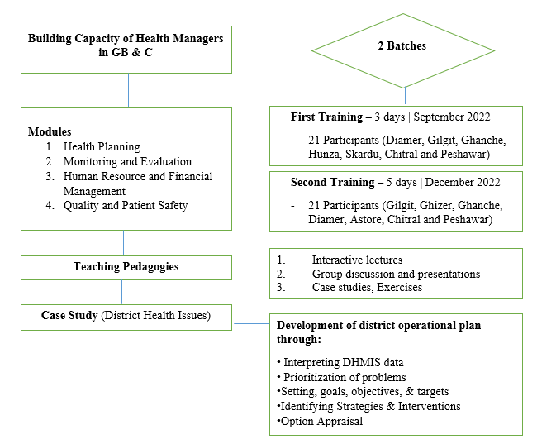
Figure 2 Training Batches, Modules, Teaching Pedagogies, and Case Study

Annexure 2
Table 1: Participants' Key Characteristics (n=44)
Categories | Sub-categories | Number
Gender | Male | 35
Gender | Female | 09
Province/Regions | Gilgit Baltistan (GB) | 27
Province/Regions | Khyber Pakhtunkhwa (KP) | 17
Current Position | Programme/Service Directors | 17
Current Position | District Health Officers | 7
Current Position | District Population Welfare Officers | 8
Current Position | Others | 12
Education Level | Masters | 17
 | Medical Doctors | 7
 | Bachelors | 12
Years of experience | 15-20 Years | 25
 | 10-14 Years | 12
 | 5-13 Years | 7

Annexure 3

Figure 3 - Evaluation of Course Against Indicators

Figure 4 - Overall Rating of Course

Figure 5 - Results from Knowledge Assessment

Table 2: Thematic analysis of recommendations provided by Course participants.
S.no | Theme | Verbatim
 | Sustainability of course for future | - The time allocated for the training activity is too little, which should be increased in future activities.  - Need practical activities for improvement in the system where the participants come according to their needs and demands.  - Time may be enhanced/ increased for such training, and it should be based on public side demand/ issues.  - This type of management course should be arranged at the GB level in coordination with DoH  - Course designing on the public sector issues and problems and their solutions of the subject in training
 | Enhance project management | - This course will help in the development of the strategic and operational plan.  - Created knowledge of quality assurance, Supply chain management, and disease outbreak management  - It would be very good if all the processes were shown practically instead of sitting in class.
 | Practical demonstration of financial management | - More time should be allocated to the HSS career.  - The course design, especially Healthcare financing and supply chain management should be in context to the government health system.  - More practice/ practical demonstration and field visits should be a part of the training.
 | Recommendation for more courses | - Separate certificate-level courses for health managers should be offered.  - Understood operational Plans Development  - Useful knowledge about disease Surveillance and Outbreak Management

Evaluation Indicators:

- Objectives of the activity defined
- Disclosure slide shown
- Overall presentations were at the participants` level of understanding
- Acquired new knowledge
- Time management
- Queries responded
- Adequacy of online sessions` logistic support
- Overall assessment of the course
- Relative to where you were before participating in this activity, please rate how well this activity has affected your ability to understand the topic/subject.
- Based on your participation today, how will you rate this activity as a recommendation to your peer/colleagues

