Appendices:
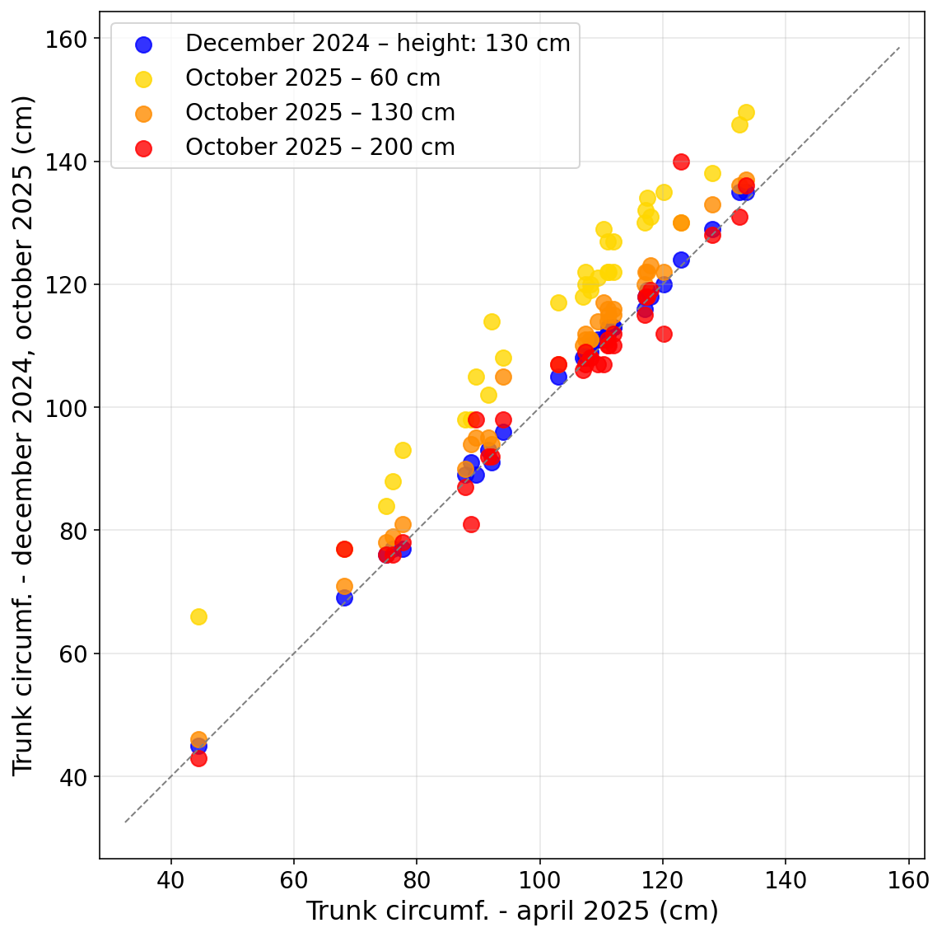
Appendix 1. Comparison of trunk circumference measurements conducted by two different operators, at three different dates (December 2024, April 2025 and October 2025), using two different tools (metal tape measure and flexible plastic measuring tape).
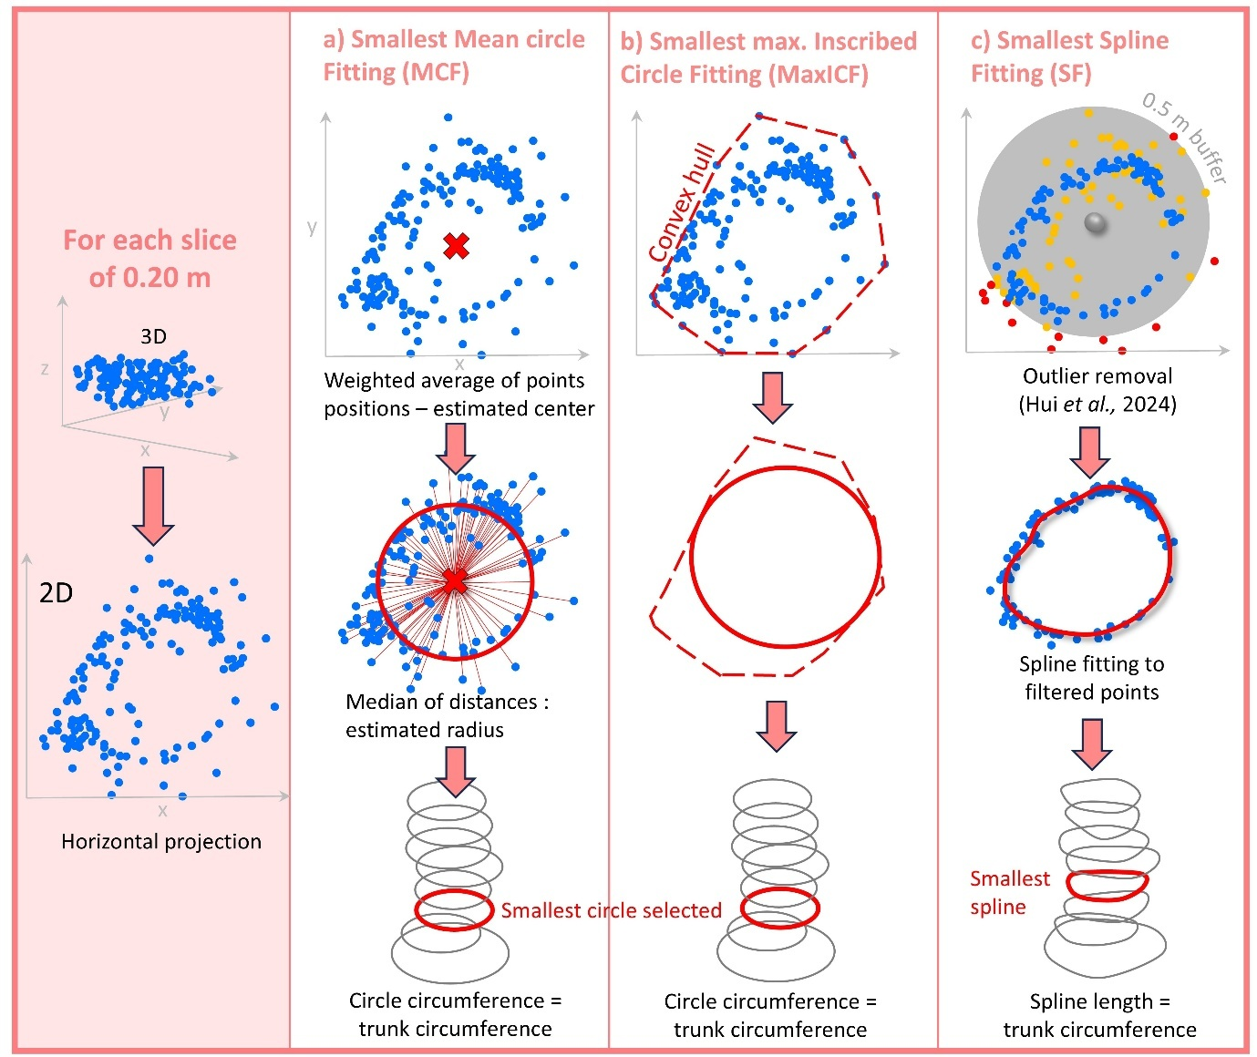
Appendix 2. Schematic overview of the three methods used to extract trunk circumference from LiDAR point clouds: (a) MCF, (b) MaxICF, (c) SF.
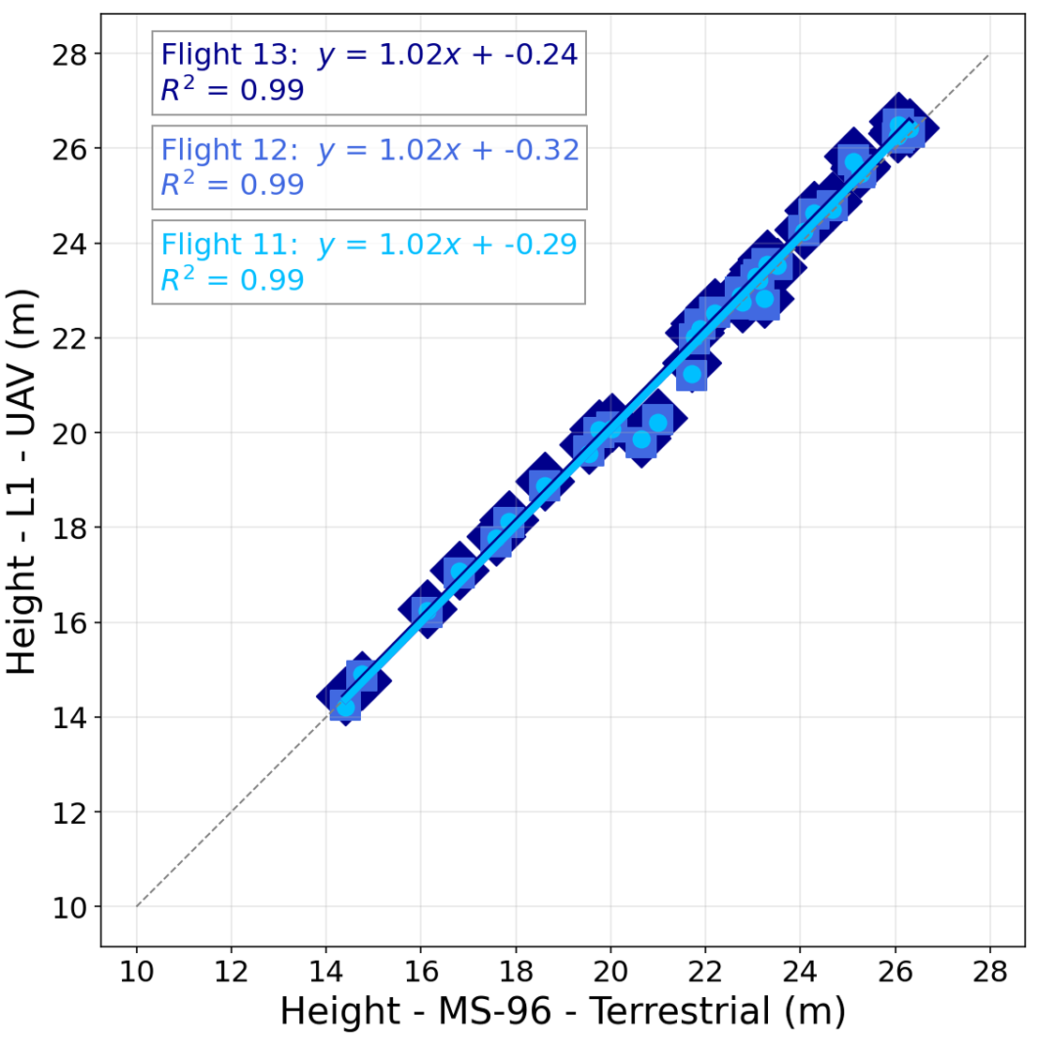
Appendix 3. Comparison of canopy heights derived from UAV acquisitions and terrestrial LiDAR data (2025).
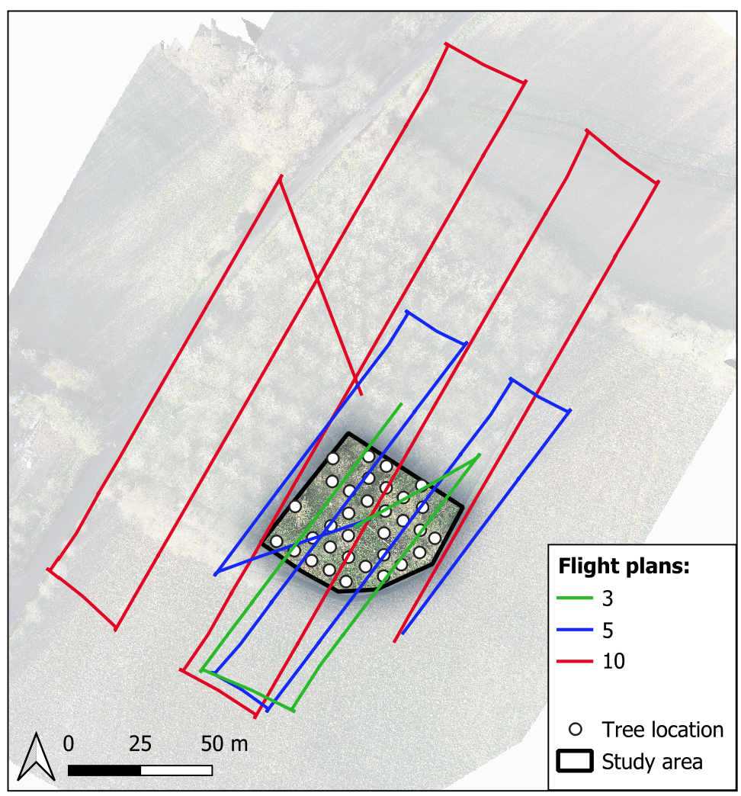
Appendix 4: Compared flight plans of flights number 3, 5 and 10.

