Supplemental material

Supplemental Table 1:
 | Group |  | Time |  | Group*Time |  |  | Post hoc
 | p | ղ²p | p | ղ²p | p | ղ²p |  | p | r_{B}
MAS Wrist Flexors | 0.07 | 0.08 | 0.004 | 0.18 | 0.01 | 0.15 | V1 (INT vs SHAM)  V3 (INT vs SHAM)  INT (V1 vs V3)  SHAM (V1 vs V3) | 0.48  0.03  0.91  0.07 | 0.12  0.38  0.16  0.88
MAS Elbow Flexors | 0.49 | 0.01 | 0.10 | 0.06 | 0.72 | 0.001
MAS_{UL} | 0.45 | 0.01 | 0.19 | 0.04 | 0.09 | 0.07
FMA-UE | 0.11 | 0.06 | 0.001 | 0.57 | 0.046 | 0.10 | V1 (INT vs SHAM)  V3 (INT vs SHAM)  INT (V1 vs V3)  SHAM (V1 vs V3) | 0.40  0.17  0.02  0.09 | 0.15  0.25  0.95  0.92
Mmax | 0.42 | 0.02 | 0.01 | 0.20 | 0.58 | 0.01
Hmax | 0.30 | 0.04 | 0.007 | 0.26 | 0.40 | 0.03
Hmax/Mmax | 0.49 | 0.02 | 0.32 | 0.04 | 0.92 | 0.001

Supplemental Table 1: Statistical results for all parameters evaluated at V1 (baseline, before the start of the protocol) and V3 (after the 6-week LMV protocol). Analyses were conducted using a two-factor repeated-measures Aligned Rank Transform ANOVA (ART ANOVA) with the factors Group (INT and SHAM) and Time (V1 and V3). Partial eta-squared (ղ²p) effect sizes were interpreted as small (0.01-0.06), medium (0.06-0.14) and large (≥ 0.14). Post hoc comparisons were performed using the ARTool package, with rank biserial correlation (r_{B}) reported as effect size, interpreted as follows: small (0.1–0.3), medium (0.3–0.5), and large (≥ 0.5). Statistical significance was set at p ≤ 0.05.

Supplemental Table 2:
SHOULDER | Flexors |  | Extensors |  | Abductors |  | Adductors |  | Internal Rot |  | External Rot
SHOULDER | V1 | V3 | V1 | V3 | V1 | V3 | V1 | V3 | V1 | V3 | V1 | V3
SHAM | 0.0  [0.0-0.0] | 0.0  [0.0-0.0] | 0.0  [0.0-0.0] | 0.0  [0.0-0.0] | 0.0  [0.0-0.0] | 0.0  [0.0-0.0] | 0.0  [0.0-0.0] | 0.0  [0.0-0.0] | 0.0  [0.0-0.0] | 0.0  [0.0-0.0] | 0.0  [0.0-0.0] | 0.0  [0.0-0.0]
INT | 0.0  [0.0-0.0] | 0.0  [0.0-0.0] | 0.0  [0.0-0.0] | 0.0  [0.0-0.0] | 0.0  [0.0-0.0] | 0.0  [0.0-0.0] | 0.0  [0.0-0.0] | 0.0  [0.0-0.0] | 0.0  [0.0-0.0] | 0.0  [0.0-0.0] | 0.0  [0.0-0.0] | 0.0  [0.0-0.0]
ALL | 0.0  [0.0-0.0] | 0.0  [0.0-0.0] | 0.0  [0.0-0.0] | 0.0  [0.0-0.0] | 0.0  [0.0-0.0] | 0.0  [0.0-0.0] | 0.0  [0.0-0.0] | 0.0  [0.0-0.0] | 0.0  [0.0-0.0] | 0.0  [0.0-0.0] | 0.0  [0.0-0.0] | 0.0  [0.0-0.0]
ELBOW | Flexors |  | Extensors |  | Pronators |  | Supinators
ELBOW | V1 | V3 | V1 | V3 | V1 | V3 | V1 | V3
SHAM | 1.0  [0.0-1.0] | 1.0  [0.0-1.5] | 0.0  [0.0-1.0] | 0.0  [0.0-1.0] | 0.0  [0.0-1.0] | 1.5  [0.0-1.5] | 0.0  [0.0-0.0] | 0.0  [0.0-0.0]
INT | 1.0  [0.0-1.0] | 1.0 [0.0-1.0] | 0.0  [0.0-1.0] | 0.0  [0.0-0.0] | 0.0  [0.0-1.5] | 0.0  [0.0-1.0] | 0.0  [0.0-0.0] | 0.0  [0.0-0.0]
ALL | 1.0  [0.0-1.0] | 1.0  [0.0-1.5] | 0.0  [0.0-1.0] | 0.0  [0.0-1.0] | 0.0  [0.0-1.5] | 1.0  [0.0-1.5] | 0.0  [0.0-0.0] | 0.0  [0.0-0.0]
WRIST | Flexors |  | Extensors
WRIST | V1 | V3 | V1 | V3
SHAM | 1.0 [0.0-1.0] | 1.5 [1.0-1.5] | 0.0  [0.0-0.0] | 0.0  [0.0-0.0]
INT | 1.0 [0.0-1.0] | 1.0 [0.0-1.0] | 0.0  [0.0-0.0] | 0.0  [0.0-0.0]
ALL | 1.0 [0.0-1.0] | 1.0 [0.0-1.5] | 0.0  [0.0-0.0] | 0.0  [0.0-0.0]
FINGERS | Flexors |  | Extensors |  | Abductors |  | Adductors
FINGERS | V1 | V3 | V1 | V3 | V1 | V3 | V1 | V3
SHAM | 0.0  [0.0-0.0] | 0.0  [0.0-1.0] | 0.0  [0.0-0.0] | 0.0  [0.0-0.0] | 0.0  [0.0-0.0] | 0.0  [0.0-0.0] | 0.0  [0.0-0.0] | 0.0  [0.0-0.0]
INT | 0.0  [0.0-0.0] | 0.0  [0.0-0.0] | 0.0  [0.0-0.0] | 0.0  [0.0-0.0] | 0.0  [0.0-0.0] | 0.0  [0.0-0.0] | 0.0  [0.0-0.0] | 0.0  [0.0-0.0]
ALL | 0.0  [0.0-0.0] | 0.0  [0.0-0.0] | 0.0  [0.0-0.0] | 0.0  [0.0-0.0] | 0.0  [0.0-0.0] | 0.0  [0.0-0.0] | 0.0  [0.0-0.0] | 0.0  [0.0-0.0]
THUMB | Opponens |  | Extensors |  | Flexors |  | Adductors
THUMB | V1 | V3 | V1 | V3 | V1 | V3 | V1 | V3
SHAM | 0.0  [0.0-0.0] | 0.0  [0.0-0.0] | 0.0  [0.0-0.0] | 0.0  [0.0-0.0] | 0.0  [0.0-0.0] | 0.0  [0.0-0.0] | 0.0  [0.0-0.0] | 0.0  [0.0-0.0]
INT | 0.0  [0.0-0.0] | 0.0  [0.0-0.0] | 0.0  [0.0-0.0] | 0.0  [0.0-0.0] | 0.0  [0.0-0.0] | 0.0  [0.0-0.0] | 0.0  [0.0-0.0] | 0.0  [0.0-0.0]
ALL | 0.0  [0.0-0.0] | 0.0  [0.0-0.0] | 0.0  [0.0-0.0] | 0.0  [0.0-0.0] | 0.0  [0.0-0.0] | 0.0  [0.0-0.0] | 0.0  [0.0-0.0] | 0.0  [0.0-0.0]

Supplemental Table 2. MAS scores (median [Q1–Q3]) for each tested muscle (20 muscle groups) at both visits (V1 and V3). Colors indicate changes between visits: green = decrease visible only in the quartiles; black = no change; orange = increase visible only in the quartiles; red = increase visible in the median.
We can observe that changes toward an increase occur exclusively in the SHAM group, whereas changes toward a reduction occur only in the INT group; and most modifications appear at the elbow and wrist, which are the two joints receiving LMV.

Supplemental Figure 1:
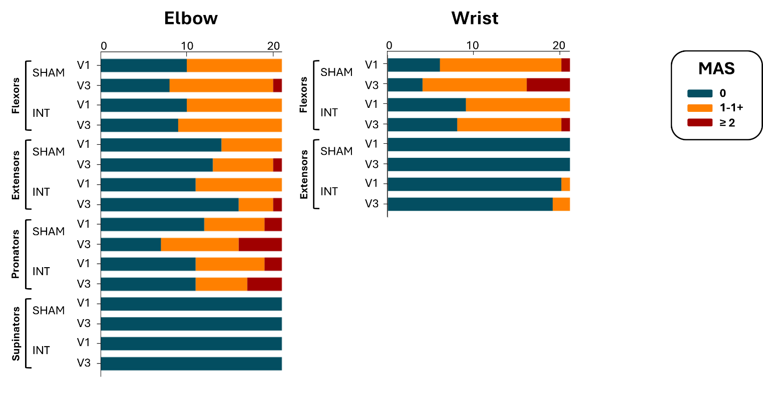
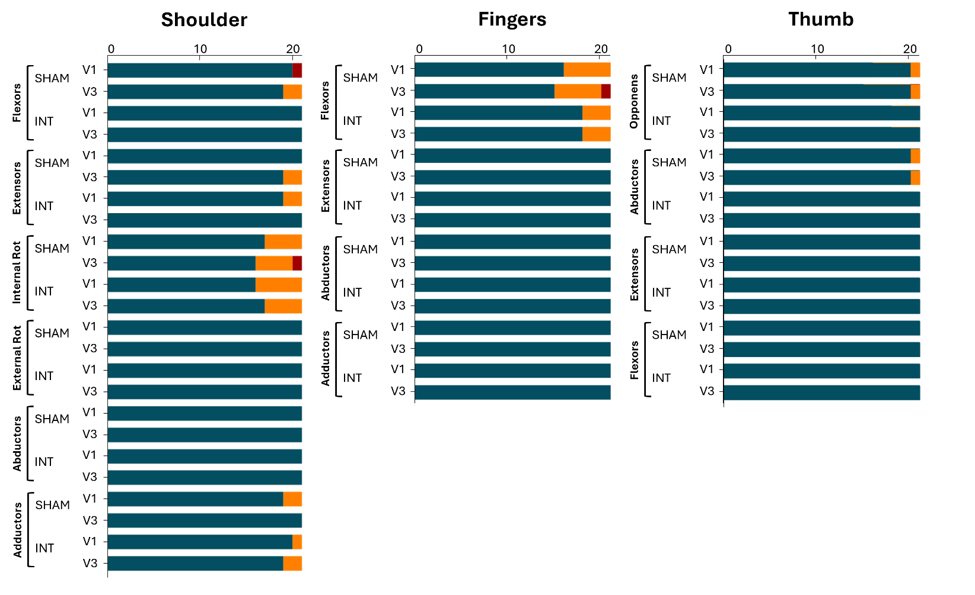
Supplemental Figure 1: Distribution of patients according to MAS score categories (0, 1 - 1+, ≥ 2) for each evaluated muscle group, at baseline (V1) and post-intervention (V3), in the INT group, and the SHAM group. Values of the x-axis represent number of patients.

Supplemental Table 3:
 | SHAM |  | INT |  | ALL
 | V1 | V3 | V1 | V3 | V1 | V3
0-22  No capacities | 19 | 14 | 16 | 11 | 35 (83%) | 25 (60%)
23-31  Poor capacities | 1 | 2 | 3 | 1 | 4 (10%) | 3 (7%)
32-47  Limited capacities | 1 | 3 | 2 | 6 | 3 (7%) | 9 (21%)
48-52  Notable capacities | 0 | 1 | 0 | 2 | 0 (0%) | 3 (7%)
53-66  Full capacities | 0 | 1 | 0 | 1 | 0 (0%) | 2 (5%)

Supplemental Table 3: Distribution of patients across FMA-UE categories according to Hoonhorst et al., 2015, at baseline (V1) and post-intervention (V3), for the INT group, SHAM group, and the entire cohort (ALL).

