Supplementary Note:
Upcycled E-Waste as Precision Instruments: A Low-Cost, Circular-Economy Spectrometer for Equitable Science and STEM Education
Hao Wang^{1,2,3,4, †}, Xiaofan Li^{1,2,3, †}, Hao Zeng^{1,2,3}, Weinan Guan², Hao Qian², Yan Zhang⁵, Meiqi Li⁶, Meng Cheng¹, Cui Zhang^{1,2}, Xusan Yang^{1,2,3, *}
¹Institute of Physics, Chinese Academy of Sciences, Beijing, 100190, China
²Yangtze River Delta Physics Research Center, Changzhou, 213000, China
³College of Energy and Intelligent Manufacturing, University of Chinese Academy of Sciences, Nanjing (UCASNJ), Nanjing,211135, China
⁴College of Energy and Power Engineering, Nanjing Normal University, Nanjing, China
⁵School of Optoelectronic Information and Computer Engineering, University of Shanghai for Science and Technolog, Shanghai, 200093, China
⁶School of Life Science, Peking University, Beijing,100871, China
*Corresponding author. Email: xusanyang@iphy.ac.cn
†Those authors contribute equally.

1. Fabrication of Optical Mounts Using 3D-Printed Bricks
LEGO® bricks, fabricated from acrylonitrile-butadiene-styrene (ABS) materials, are characterized by a patented stud-and-tube interlocking system. Owing to their superior structural precision and flexible assembly performance, these bricks have been widely recognized as ideal building blocks for the development of low-cost scientific instruments.
Taking advantage of these inherent merits, LEGO bricks were adopted as the basic modular units for constructing a laser-induced fluorescence (LIF) system in this study. Nevertheless, commercial standard LEGO bricks are insufficient to accommodate irregularly shaped optical components (e.g., laser pointers, lenses, CMOS cameras) in optical paths, which restricts their application in optical system construction. To overcome this limitation, customized bricks integrated with dedicated grooves and slots were designed and fabricated via 3D printing to match the geometric features of the aforementioned optical elements. Polylactic acid (PLA) was selected as the printing material to prioritize rapid prototyping, cost efficiency, and machinability of the customized bricks, enabling fine positional adjustment through integrated screw mechanisms. Moreover, LEGO-compatible grooves were incorporated into the custom bricks to ensure seamless integration with standard LEGO assemblies.

The positioning accuracy of the 3D-printed LEGO-compatible bricks fabricated by two typical additive manufacturing technologies, namely liquid crystal display mask stereolithography (LCD MSLA) and fused deposition modeling (FDM), was systematically evaluated. The results demonstrated that the dimensional tolerances of the bricks fabricated by LCD MSLA and FDM were 0.02 mm and 0.05 mm, respectively. This level of precision is sufficient to guarantee reliable pre-alignment of optical components (including laser sources, filters, dichroic mirrors, focusing lenses, and CMOS sensors) mounted on the bricks. Consequently, the proposed modular construction strategy eliminates the requirement for specialized optical benches and professional technical personnel, thereby simplifying the assembly process of the LIF system.

2. Assembly of Fluorescence Excitation Module
Figure 1 illustrates the assembly structure of the fluorescence excitation module. As shown in Figure 1(a), the core components include a cuvette module, a dichroic mirror module, and a laser source module. In the cuvette module, the sample solution (Titan, Shanghai) is loaded into a cuvette placed inside a 3D‑printed cuvette holder (Creality, Shenzhen). The dichroic mirror module separates the excitation laser from the emitted fluorescence and consists of a dichroic mirror mount and a short‑pass dichroic mirror (Sensor Home, Handan). The mount is equipped with a positioning slot to fix the dichroic mirror at 45° relative to the direction of the excitation beam. This module interlocks with the cuvette module via Lego 3759 bricks and is supported at the base by two Lego 3003 bricks. The laser source module comprises a 405 nm laser (Xinfei Optoelectronics, Shenzhen) and two adjustable mounts. Micrometer‑level adjustment structures are integrated into the 3D‑printed bricks to ensure beam collimation. The laser holder supports the replacement of excitation light sources for wavelength‑specific excitation. Three lateral adjustment holes with screw‑driven mechanisms enable precise horizontal alignment of the laser beam. Compared with traditional optical bench setups, the present design features a compact size, low cost, and user‑friendly operation.
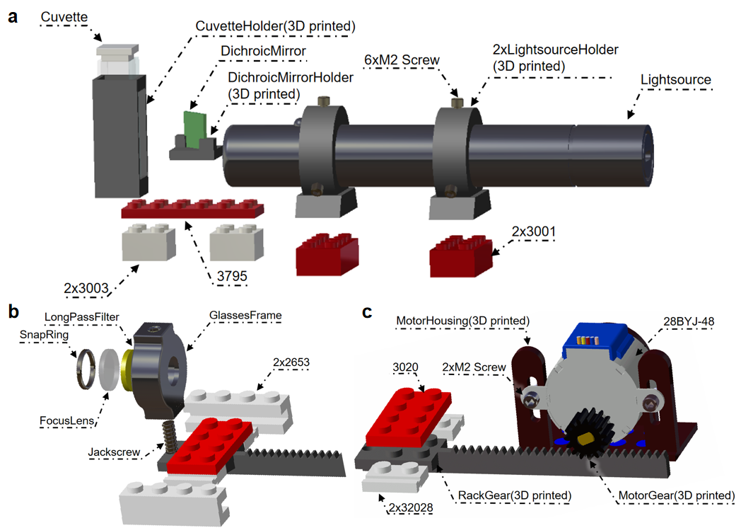
Supplementary Figure. 1 Structural components of the fluorescence excitation module. (a) Fluorescence excitation module: cuvette module, dichroic mirror module and light source module. (b) Filter focusing module: focusing lens and long-pass filter. (c) Remote drive module: stepper motor, rack and pinion.

To enhance fluorescence intensity, a filter focusing module (Figure 1(b-c)) was designed to effectively converge fluorescence signals and eliminate excitation light. The stepper motor (Jinlong Kexin, Jinhua) is mounted on a motor mount via hex bolts and driven by a microcontroller (Zhengdian Atom, Guangzhou) using infrared remote control. The motor shaft drives a rack-and-pinion mechanism, which moves laterally. The rack is connected to a Lego 3020 brick at its base and flanked by two Lego 32028 bricks. A threaded hole at the front of the rack allows attachment of a lens holder (MLNR-05, Hengyang, Guangzhou) via a set screw. The holder houses a long-pass filter (Sensor Home, Handan) and a focusing lens (Sensor Home, Handan), secured by snap rings. The two Lego 32028 bricks are nested within grooves of two Lego 2635 bricks. The microcontroller adjusts the position of the filter focusing module to focus fluorescence signals into the detection module.

3. Stability Assessment of Modular Building Blocks in LIF Detection Systems
In LIF (Laser-Induced Fluorescence) detection systems, the stability of modular building blocks is a critical determinant of system performance. The interfacial compatibility between 3D-printed blocks and existing LEGO® components (e.g., baseplate model 3811) directly governs the reliability and repeatability of system assembly. Common 3D printing techniques include LCD MSLA and FDM. While FDM (0.1 mm layer thickness) exhibits inferior precision and surface smoothness compared to LCD MSLA (0.01 mm layer thickness), the latter inevitably retains residual support marks—even with minimized dendritic support structures - which compromise the mechanical interlock integrity between blocks. In contrast, FDM enables support-free fabrication through optimized print orientation. To validate stability, FDM-printed components (laser diode mount, dichroic mirror holder, cuvette fixture) were assembled into fluorescence excitation and detection modules. After optical alignment, the integrated system was mounted on the LEGO® baseplate and subjected to simulated vibration testing: 20 manual impacts (5 Hz frequency) were applied to the desktop 20 cm from the assembly. Laser beam centroid displacement was monitored via fiducial markers on white cardstock under 532 nm illumination (8 mW output).

Results confirmed that the beam spot collimation remained within 0.5% deviation from initial alignment markers (equivalent to <0.5° angular drift). No observable positional shiftwas detected between modular interfaces, demonstrating robust structural stability of the FDM-LEGO® hybrid system under operational vibration (0.2-5 Hz spectrum). This validates the feasibility of FDM-printed blocks for precision optomechanical applications.

4. Optical Alignment and Focusing
After assembling the fluorescence excitation module and calibrating the detection module, optical alignment and focusing are performed.In optical height alignment, the CMOS camera module is elevated 35 mm above the baseplate. To align the optical axis of shorter modules (e.g., light source, filter focusing modules), additional Lego baseplates (3.2 mm) or bricks (9.6 mm) are added to maintain a uniform height of 35 mm. A simple alignment method employs a white cardstock screen marked with the camera’s central height. By placing the screen sequentially behind the laser source, dichroic mirror and filter focusing modules, alignment is confirmed when the laser spot coincides with the marked position (Figure 2(a-b)). For optical focusing, the focusing lens in the filter module has a 25 mm focal length. The fluorescence excitation module, constructed from Lego bricks, has a width of 16 mm. To focus, the white cardstock is placed at the slit position. The lens holder is moved laterally via the stepper motor until the smallest and brightest laser spot is observed on the cardstock, indicating optimal focus (Figure 2(c)).

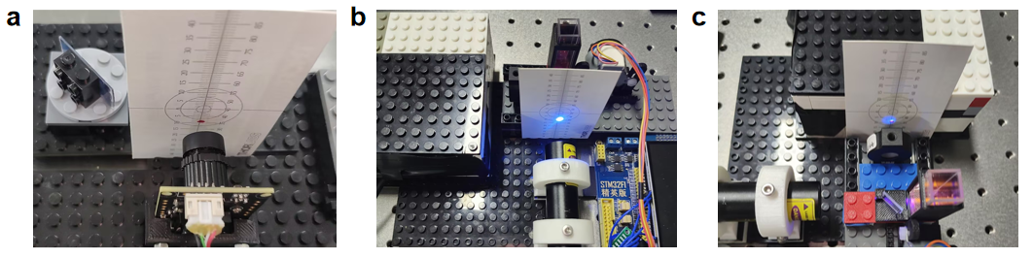
Supplementary Figure. 2: Optical alignment and focusing procedures. (a) Height adjustment using Lego bricks to align the optical axis. (b) Alignment verification: A marked white cardstock screen ensures laser spots match the camera’s central height. (c) Focusing: The lens position is adjusted via the stepper motor to minimize spot size on the screen.

In optical focusing, the focusing lens within the filter focusing module has a focal length of 25 mm. The housing of the fluorescence excitation module, constructed from building blocks, has a width of 16 mm. To achieve optimal focus, a white cardstock screen is positioned at the slit location. The lens holder is translated laterally to the right via the stepper motor until the smallest and brightest laser spot is observed on the cardstock, indicating successful focusing.

5. Focusing Module Design
5.1 Optical Requirement and Motor Selection​
To enhance incident light intensity in the fluorescence detection module (where spectral intensity correlates positively with slit throughput), a focusing lens with motorized adjustment was integrated upstream of the slit. A stepper motor was selected as the driving unit due to its precision control via pulse signals (converting single pulses to fixed angular displacements), load-independent rotation characteristics, and absence of cumulative error-collectively ensuring sub-millimeter positioning accuracy required for precision focusing.
5.2 Motor Specifications and Drive Circuit
The 28BYJ-48 stepper motor was employed with critical parameters listed in Table 1. The drive circuit utilized the ULN2003 Darlington transistor array, whose integrated clamp diodes support high-current driving. The motor was connected to the driver through a rack-and-pinion transmission system, which converts the rotational motion of the motor into the required linear displacement. The control algorithm implemented four-phase eight-beat sequencing pulse distribution (Table 2), generating half-step precision motion.

Supplementary Table 1 28BYJ-48 Stepper motor rotation drive mode
Motor Model | Drive Mode | Step Angle | Reduction Ratio | Detent Torque(g.cm)
28BYJ-48 | 4-phase 8-beat | 5.625/64 | 1:64 | ≥300
Supplementary Table 2 Key specifications of 28BYJ-48 stepper motor
Connector Pin | Step 1 | Step 2 | Step 3 | Step 4 | Step 5 | Step 6 | Step 7 | Step 8
VCC | 5V | 5V | 5V | 5V | 5V | 5V | 5V | 5V
PhaseD | GND | GND |  |  |  |  |  | GND
PhaseC |  | GND | GND | GND
PhaseB |  |  |  | GND | GND | GND
PhaseA |  |  |  |  |  | GND | GND | GND

The stepper motor system features a gear reduction ratio of 1:64 and an effective step angle of 5.625°/64 (≈0.088°) after gear engagement. Pulses per revolution (PPR) are calculated as:
$$\begin{aligned}\text{N = }\frac{{\text{360}}^{\text{°}}}{\text{Step} \text{angle}} \text{= }\frac{{\text{360}}^{\text{°}}}{{\text{5.625}}^{\text{°}}\text{/64}} \text{= 4096}\text{PPR}\#\text{(1)}\end{aligned}$$
Linear displacement is controlled by accumulating pulses in the counter register. When the pulse count reaches 4096 pulses (corresponding to one full motor revolution), the resulting linear travel distance L of the focus lens assembly is given by:
$$\begin{aligned}\text{L = π ∙ }{\text{d}}_{\text{gear}}\#\text{(2)}\end{aligned}$$
where d_{gear} denotes the pitch diameter of the drive gear engaged with the linear rack. This electromechanical conversion achieves micron-level positioning resolution for precision focusing.
5.3 Infrared Remote Control Module​
The microcontroller unit (MCU) employs the STM32F103, a 32-bit ARM Cortex-M3-based microprocessor from STMicroelectronics fabricated on 90nm technology nodes. This architecture delivers optimized high-performance computing capabilities while maintaining power efficiency. With integrated flash memory (64-512KB) and SRAM (20-64KB), it accommodates complex control algorithms, complemented by peripheral resources including multi-channel ADCs, advanced timers, and infrared (IR) reception circuitry for precision data acquisition and multi-device coordination. The hardware is presented in Figure 3(a).
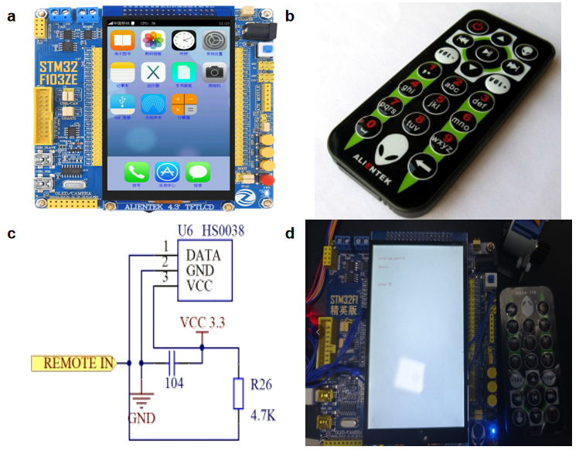
Supplementary Figure. 3: Infrared Remote Control Module. (a) Hardware architecture of STM32F103 microcontroller. (b) Consumer infrared remote transmitter. (c) Interface circuit between IR receiver and STM32 MCU. (d) Focus module displacement control via UP/DOWN keys on IR remote.

The implementation incorporates infrared remote control technology, characterized by robust interference immunity and reliable data transmission.Signal decoding leverages the MCU's timer input capture functionality to display key values (e.g., “UP”/“DOWN”) on the LCD while executing commands through the Remote_Scan() function. Integrated with the 28BYJ-48 stepper motor drive system (Section 2.2), this architecture enables dynamic motor reconfiguration upon IR key detection: the direction control flag (Direction) toggles between CW/CCW rotation states for focus lens advancement/retraction, while the cumulative pulse_count governs displacement magnitude. During operation, spectral intensity is continuously monitored through companion software; Iterative refinement via UP/DOWN keys identifies the position yielding maximum spectral intensity—designated as the optimal focal point through automated peak-detection algorithms. Critical hardware drivers (bsp_uln2003.c, bsp_key.c, remote.c) synthesize this functionality within the control architecture, physically implemented as shown in Figure 3(b-d).
5.4 Wavelength Calibration
As shown in Figure 4, the characteristic peaks of a standard mercury lamp spectrum are displayed. The calibration light source spectrum contains two calibration markers (436 nm and 546 nm emission lines from mercury) for calibrating the fluorescence detection module. Functional validation was performed using an identical mercury lamp type. By dragging the calibration markers to align with actual spectral positions, the software dynamically updates and replots the spectrum in real-time (Figure 4(b)). Results demonstrate that the measured fluorescence peaks of the mercury lamp precisely match the standard reference wavelengths. Simultaneously, a false-color spectral display is rendered in the upper-right corner of the interface.

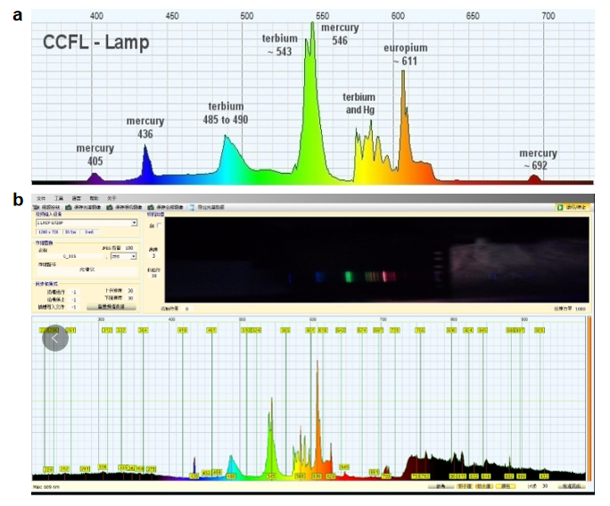
Supplementary Figure. 4: Wavelength Calibration.(a) Characteristic peaks of mercury lamp reference spectrum.(b) Experimentally measured mercury lamp emission peaks.

6 Experiment
6.1 Instruments and Reagents Instruments
Modular building-block laser-induced fluorescence (LIF) spectroscopic detection system (designed and assembled in this work). Reagents and Samples:Fluorescent whitening agents (FWAs): CAS: 7128-64-5 (commercial grade, Lvwei Co., Guangdong, China). Solvents: Dimethyl sulfoxide (DMSO, ≥ 99.9% purity, Shanghai Titan Scientific Co., Ltd., Shanghai, China). Paper products: A4 paper (ZC brand, Guangdong, China). Household tissue samples: (a) Tissue (JR brand, Guangdong, China). (b) Tissue (JSHZ brand, Deyang, Sichuan, China). (c) Tissue (FR brand, Anhui, China). Consumer goods:Toothbrush bristles: Black (unbleached) and white (bleached).Laundry detergent (commercial grade, unspecified brand).

6.2 Experimental method for gradient experiment of fluorescent whitening agent
Preparation of fluorescent whitening agent (FWAs) : solutions fluorescent whitening agents are soluble in alkanes, fats, mineral oils, paraffin, and most organic solvents.
The experimental protocol was as follows:
Stock solution (1 × 10⁻² M): precisely weigh 0.086 g of FWAs (CAS: 7128-64-5) and dissolve in 20 mL of dimethyl sulfoxide (DMSO, ≥ 99.9% purity). Homogenize the mixture using a vortex mixer (MX-SS, Sanko, Japan) for 3 mins, followed by ultrasonic agitation (YL0203-28, Yunyi, Shenzhen, China) for 10 min. Dilution series: prepare concentration gradients via serial dilution of the stock solution using calibrated micropipettes. Transfer 1 mL of each diluted solution to a quartz cuvette (1 cm path length) for spectral analysis. Cross-contamination control: Rinse the cuvette with DMSO thoroughly between measurements until fluorescence signals return to baseline levels (verified by three consecutive blank scans).

Fluorescence detection protocol for consumer products to assess the presence of fluorescent substances in household items, the following procedure was implemented: optical configuration: The test sample (e.g., tissue, toothbrush bristles, or detergent) was positioned between the dichroic mirror module and cuvette holder module to enable coaxial excitation-detection geometry.​
Laser excitation: 405 nm laser was employed for fluorescence excitation. Signal acquisition: fluorescence emission was collected by a CMOS camera interfaced with Theremino_Spectrometer - Tool software. Spectral optimization: the filter-focus module was actuated via a stepper motor to iteratively maximize signal intensity through fine positional adjustments.

7. Lego Parts Information

Supplementary Table 3 List of LEGO parts models used in the experiment
Item No: | Number | Picture | Price(CNY)
3811 | 1 | 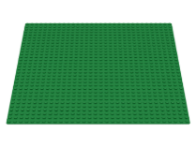 | 57.8
3001 | 4 | 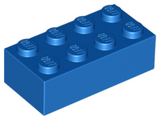 | 6
3795 | 4 | 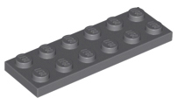 | 2.4
3666 | 4 | 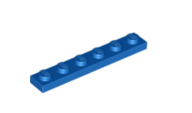 | 2
3002 | 4 | 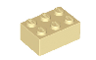 | 2.3
3003 | 7 | 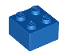 | 2
2456 | 8 | 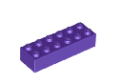 | 4
3008 | 2 | 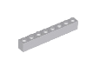 | 0.8
3010 | 8 | 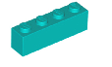 | 2
60581 | 5 | 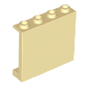 | 2.5
3403 | 2 | 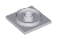 | 16
3404 | 2 |  | 10
3022 | 1 | 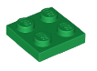 | 1.2
3027 | 1 | 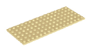 | 2
2456 | 2 | 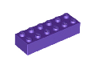 | 4
3795 | 3 | 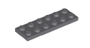 | 2.4
3003 | 4 |  | 2
2653 | 2 | 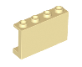 | 0.64
32028 | 2 | 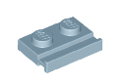 | 0.3

