Supplementary table 1. Multivariable analyses to assess the impact of treatment strategy on the overall survival after patients who received neoadjuvant treatment were excluded
 | Stage ≤ II |  |  | Stage III
 | HR (95% CI) | P value |  | HR (95% CI) | P value
Treatment
CRT | Reference |  |  | Reference
Surgery | 0.69 (0.34–1.40) | 0.30 |  | 1.71 (0.94–3.10) | 0.08
Sex
Female | Reference |  |  | Reference
Male | 1.81 (0.94–3.47) | 0.07 |  | 1.83 (0.96–3.49) | 0.07
Age
≤ 70 | Reference |  |  | Reference
> 70 | 2.53 (1.35–4.73) | 0.004 |  | 2.01 (1.14–3.55) | 0.02
cStage
I | Reference |  |  | NA
IIA | 2.64 (0.94–7.41) | 0.06 |  | NA
IIB | 3.08 (0.71–13.3) | 0.13 |  | NA
TxN0 | 2.97 (1.09–8.05) | 0.03 |  | NA
IIIA | NA |  |  | Reference
IIIB | NA |  |  | 1.38 (0.59–3.24) | 0.45
IIIC | NA |  |  | 1.47 (0.77–2.81) | 0.24
TxN1 | NA |  |  | 1.51 (0.48–4.80) | 0.48
Abbreviations: CRT, chemoradiotherapy; HR, hazard ratio.

Supplementary table 2. Multivariable analyses to assess the impact of treatment strategy on the overall survival after cancers located on perianal skin were excluded
 | Stage ≤ II |  |  | Stage III
 | HR (95% CI) | P value |  | HR (95% CI) | P value
Treatment
CRT | Reference |  |  | Reference
Surgery | 0.96 (0.51–1.81) | 0.91 |  | 1.77 (1.01–3.11) | 0.05
Sex
Female | Reference |  |  | Reference
Male | 1.88 (1.00–3.51) | 0.05 |  | 2.10 (1.15–3.81) | 0.02
Age
≤ 70 | Reference |  |  | Reference
> 70 | 1.94 (1.06–3.54) | 0.03 |  | 1.77 (1.01–3.10) | 0.05
cStage
I | Reference |  |  | NA
IIA | 3.02 (1.09–8.32) | 0.03 |  | NA
IIB | 3.20 (0.75–13.7) | 0.11 |  | NA
TxN0 | 3.04 (1.13–8.19) | 0.03 |  | NA
IIIA | NA |  |  | Reference
IIIB | NA |  |  | 1.25 (0.54–2.90) | 0.60
IIIC | NA |  |  | 1.29 (0.68–2.46) | 0.43
TxN1 | NA |  |  | 1.74 (0.67–4.52) | 0.26
Abbreviations: CRT, chemoradiotherapy; HR, hazard ratio.
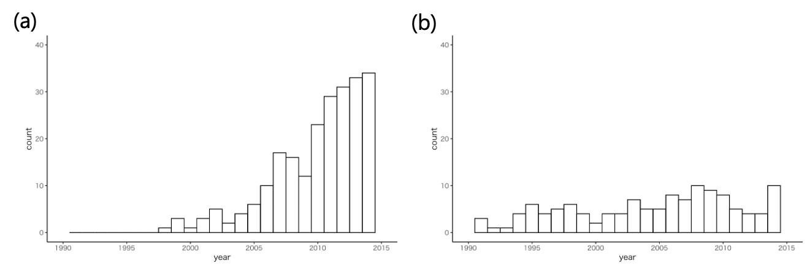
Supplementary figure 1. Change over time in the number of cases in the (a) chemoradiotherapy and (b) surgery groups.

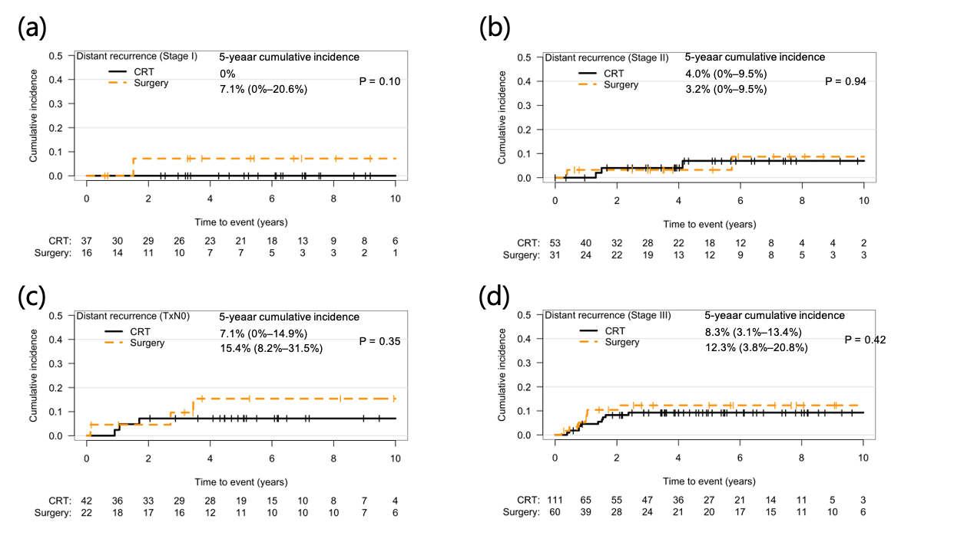
Supplementary figure 2. Comparisons of the cumulative incidence of distant recurrence between chemoradiotherapy and surgery for (a) stage I, (b) stage II, (c) TxN0 and (d) stage III. P values were obtained from Gray’s test. CRT, chemoradiotherapy.

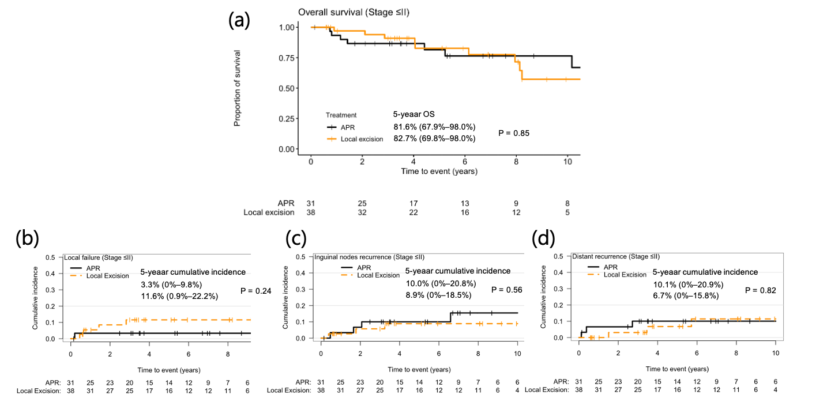
Supplementary figure 3. Comparisons of (a) overall survival, the cumulative incidence of (b) local failure, (c) inguinal node metastasis, and (d) distant recurrence between abdonimoperineal resection and local excision for stage ≤II subcohort. P values were obtained from (a) log-rank test and (b, c, d) Gray’s test. OS, overall survival; APR, abdonimoperineal resection.

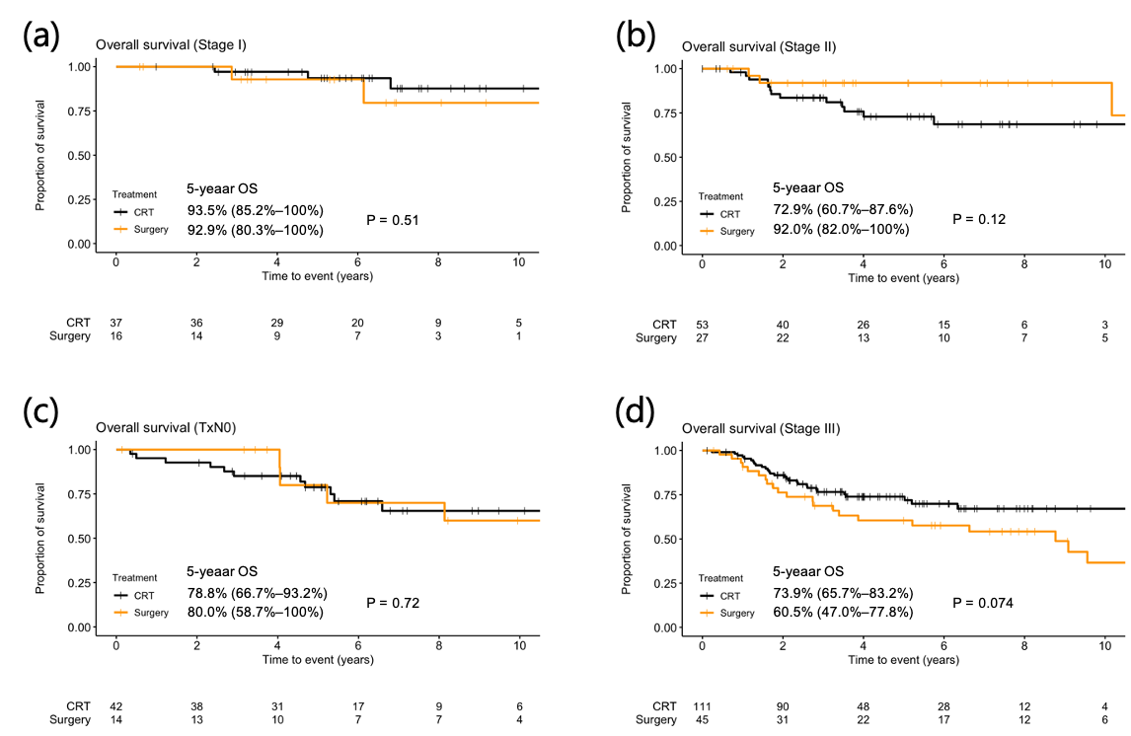
Supplementary figure 4. Comparisons of overall survival between chemoradiotherapy and surgery after patients who received neoadjuvant treatment were excluded for (a) stage I, (b) stage II, (c) TxN0 and (d) stage III. P values were obtained from log-rank test. OS, overall survival; CRT, chemoradiotherapy.

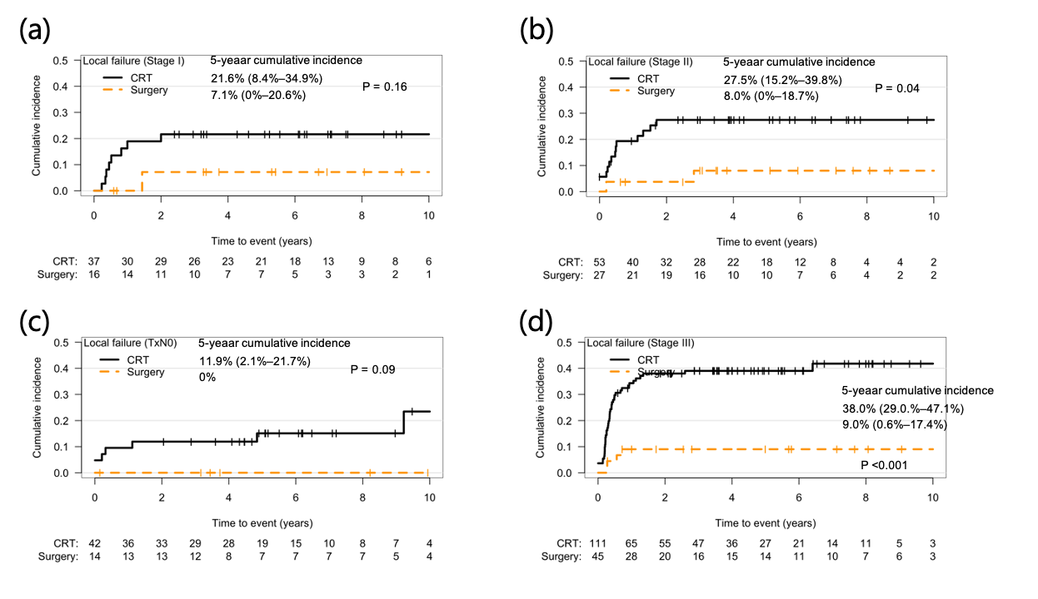
Supplementary figure 5. Comparisons of the cumulative incidence of local failure between chemoradiotherapy and surgery after patients who received neoadjuvant treatment were excluded for (a) stage I, (b) stage II, (c) TxN0 and (d) stage III. P values were obtained from Gray’s test. CRT, chemoradiotherapy.

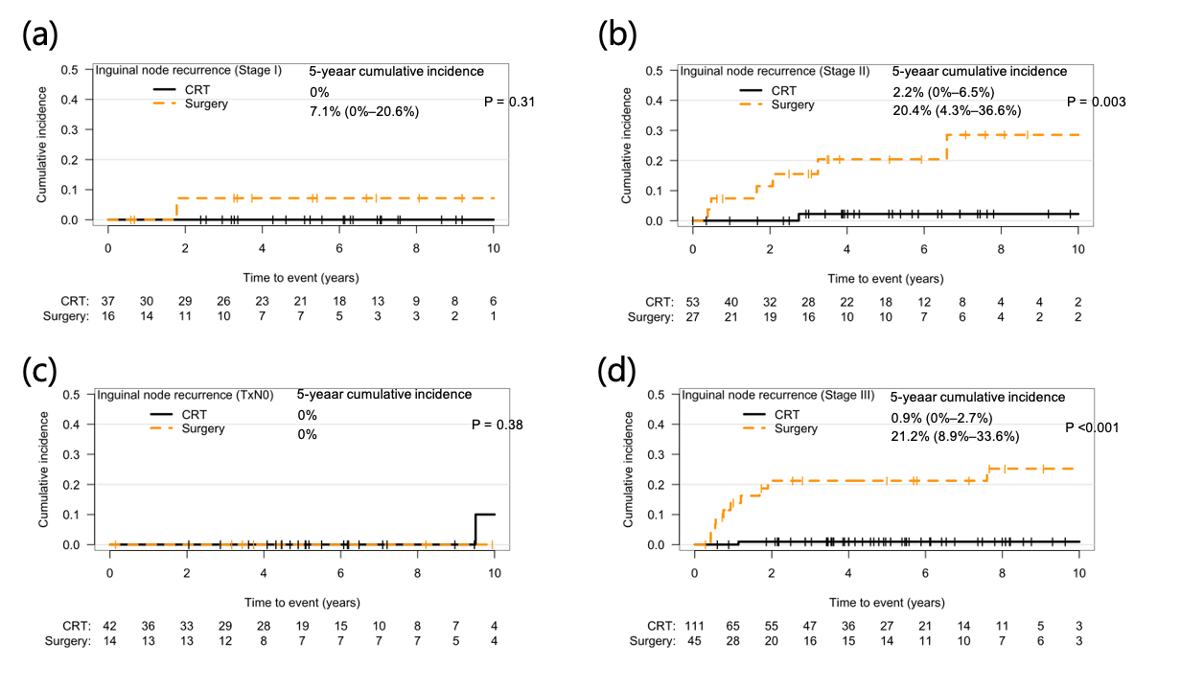
Supplementary figure 6. Comparisons of the cumulative incidence of inguinal node metastasis between chemoradiotherapy and surgery after patients who received neoadjuvant treatment were excluded for (a) stage I, (b) stage II, (c) TxN0 and (d) stage III. P values were obtained from Gray’s test. CRT, chemoradiotherapy.

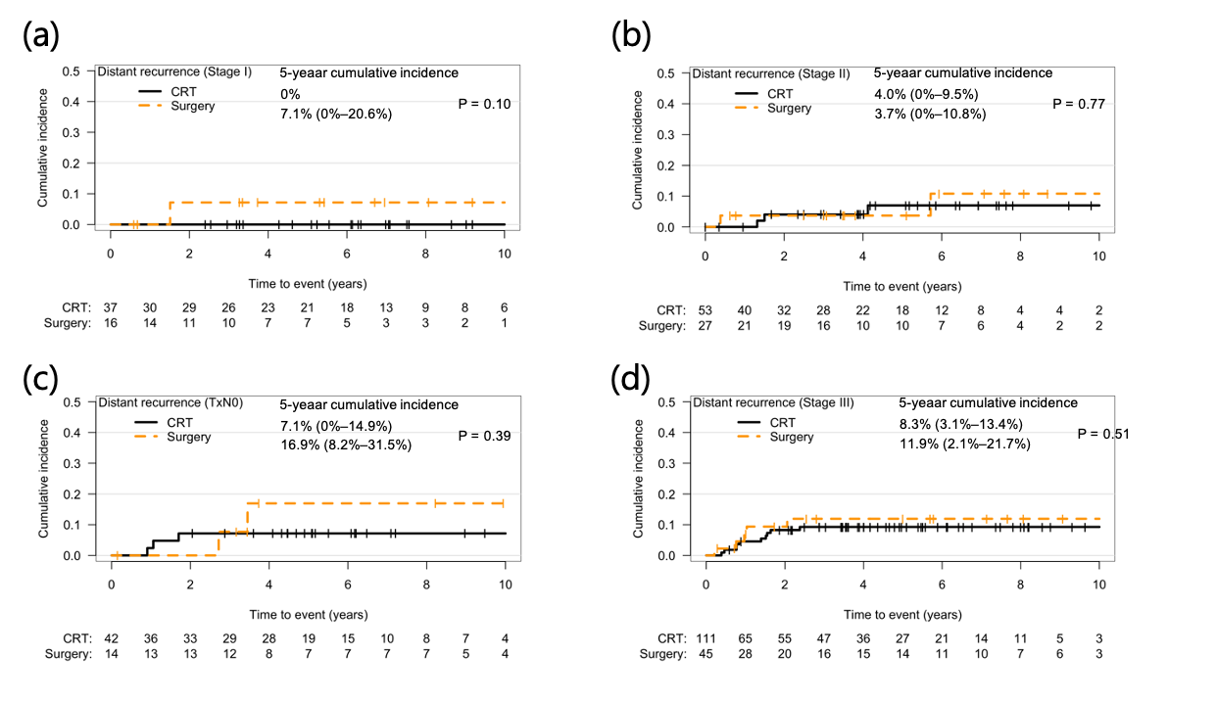
Supplementary figure 7. Comparisons of the cumulative incidence of distant recurrence between chemoradiotherapy and surgery after patients who received neoadjuvant treatment were excluded for (a) stage I, (b) stage II, (c) TxN0 and (d) stage III. P values were obtained from Gray’s test. CRT, chemoradiotherapy.

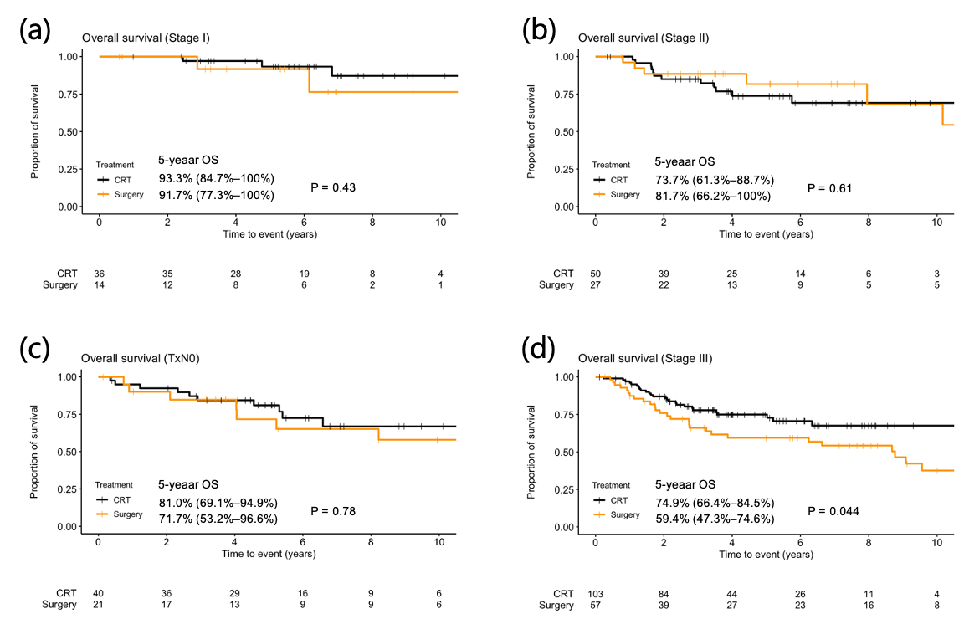
Supplementary figure 8. Comparisons of overall survival between chemoradiotherapy and surgery after cancers located on perianal skin were excluded for (a) stage I, (b) stage II, (c) TxN0 and (d) stage III. P values were obtained from log-rank test. OS, overall survival; CRT, chemoradiotherapy.

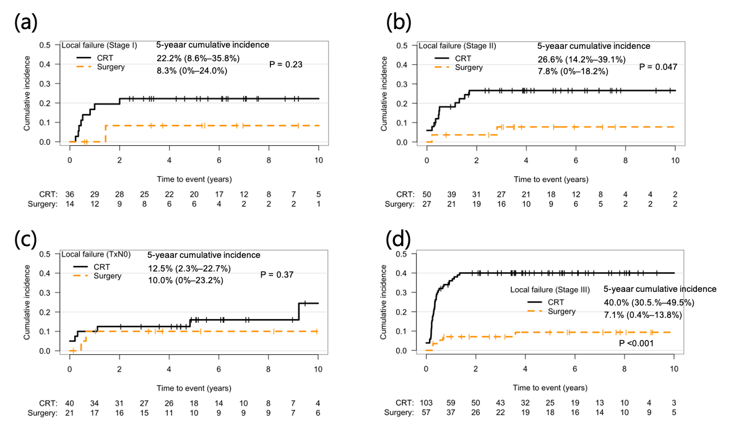
Supplementary figure 9. Comparisons of the cumulative incidence of local failure between chemoradiotherapy and surgery after cancers located on perianal skin were excluded for (a) stage I, (b) stage II, (c) TxN0 and (d) stage III. P values were obtained from Gray’s test. CRT, chemoradiotherapy.

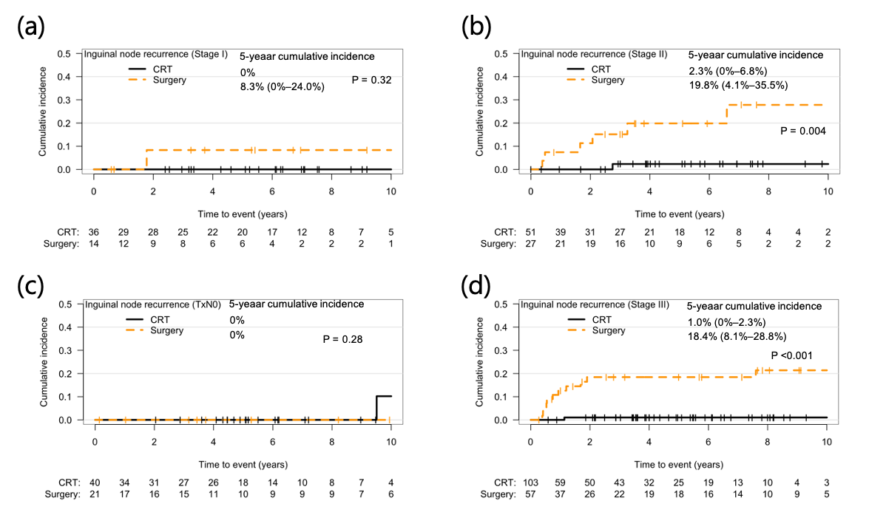
Supplementary figure 10. Comparisons of the cumulative incidence of inguinal node metastasis between chemoradiotherapy and surgery after cancers located on perianal skin were excluded for (a) stage I, (b) stage II, (c) TxN0 and (d) stage III. P values were obtained from Gray’s test. CRT, chemoradiotherapy.

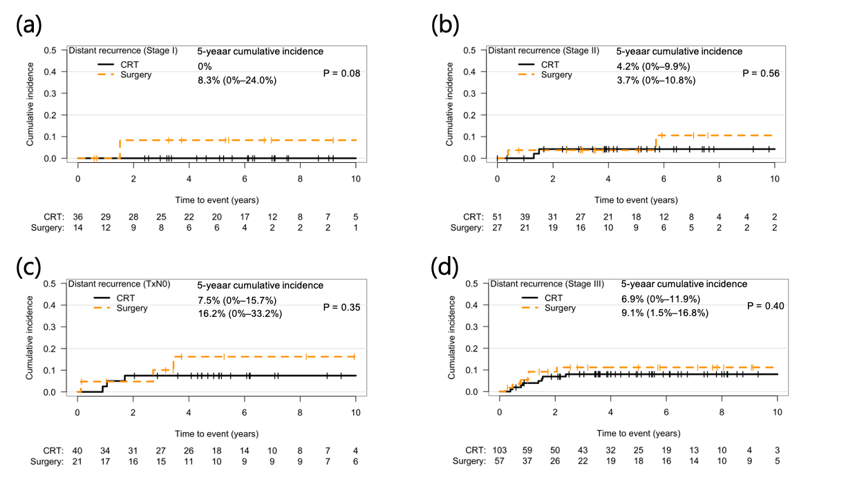
Supplementary figure 11. Comparisons of the cumulative incidence of distant recurrence between chemoradiotherapy and surgery after cancers located on perianal skin were excluded for (a) stage I, (b) stage II, (c) TxN0 and (d) stage III. P values were obtained from Gray’s test. CRT, chemoradiotherapy.

