Appendix

Figure A1: Model 1: predicted probabilities of an ego-network type transition

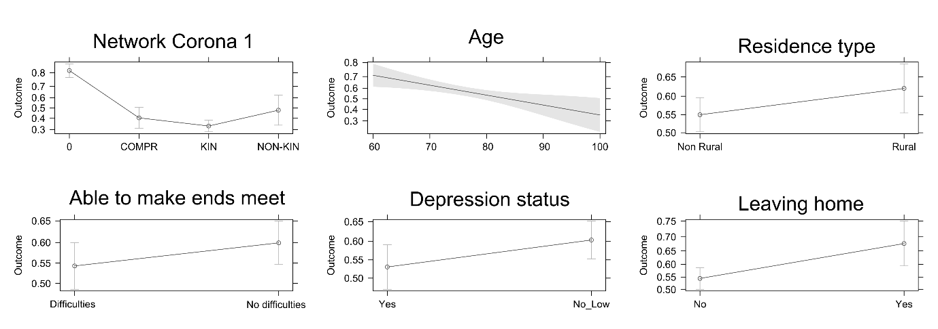

Figure A2: Model 2: predicted probabilities for the probability of an ego-network type transition. No Alters ego-network type in Corona 1

