Supplementary Materials
*Plasma sphingolipid and glycerophospholipid shifts during early treatment in zinc-supplemented adults with HIV–tuberculosis co-infection: a paired exploratory lipidomics study*
Contents:
Supplementary Table S1. All 81 nominally changing lipid species
Supplementary Table S2. Within-class Benjamini–Hochberg adjusted q-values
Supplementary Table S3. Lipid subclass distribution among identified species
Supplementary Note. Quality control and data preprocessing
Supplementary Figure Legends (S1–S3)
Supplementary Table S1. All 81 nominally changing lipid species (paired Wilcoxon p < 0.05)
*Dir., direction of change at follow-up relative to baseline. p, uncorrected paired Wilcoxon signed-rank test applied to all 1,230 lipid species. q (global), Benjamini–Hochberg adjusted p-value calculated from the 1,230 paired Wilcoxon p-values. r, within-subject effect size (|Z|/√N); calculated only for species with ≥5 complete non-imputed pairs. FC, fold change (median of within-pair fold changes, follow-up/baseline). CI, bootstrap 95% confidence interval (10,000 resamples with replacement, seed = 42); calculated only for species with ≥3 complete non-imputed pairs. Pairs, number of participant pairs with both time points above the imputation threshold. Imp., total number of imputed values across 28 observations (14 participants × 2 time points). VIP, variable importance in projection from exploratory OPLS-DA. —, not calculated due to insufficient non-imputed data.*
Paired Wilcoxon signed-rank tests were applied to all 1,230 lipid species as an exploratory screen; features with high missingness are included in this table for transparency but were not considered for candidate prioritization due to imputation-driven instability. Fifty-one features had complete observed data in all 14 pairs; 11 had partial imputation; the remaining 19 had >20% missingness and are classified accordingly.*
*Priority categories: Robust candidate, met all five prioritization criteria (see Methods 2.7): nominal p < 0.05, effect size r ≥ 0.5, observed non-imputed intensities in all 14 pairs, bootstrap 95% CI for fold change excluding 1.0, and directional consistency with the sphingolipid-related biological hypothesis. Complete-data signal not prioritized, met criteria 1–4 but not criterion 5 (DAG 20:1-20:5 showed downregulation; SM 39:2 showed modest fold-change magnitude). Complete-data nominal signal, complete observed data in all 14 pairs but bootstrap CI included 1.0. Partially imputed exploratory signal, 1–10 imputed values out of 28; fold-change estimates should be interpreted cautiously. Heavily imputed exploratory signal, >10 imputed values; fold-change estimates unreliable and not used for mechanistic interpretation.*
Supplementary Table S2. Within-class Benjamini–Hochberg adjusted q-values for complete-data lipid species of primary interest
*Within-class q-values were calculated by applying Benjamini–Hochberg correction within each lipid subclass independently, using all lipids in that subclass as the multiple-testing universe (m). Global q, Benjamini–Hochberg adjusted p-value across all 1,230 lipid species. DAG 20:1-20:5 was the only lipid to reach within-class significance (q = 0.011; m = 46 diacylglycerols), although it was not prioritized under criterion 5. Within-class correction reduced the adjusted q for Cer d18:1/26:0 from 0.55 (global) to 0.052 (within the ceramide class of 13 species), approaching but not reaching the conventional 0.05 threshold. Cer, ceramide; SM, sphingomyelin; PG, phosphatidylglycerol; DG, diacylglycerol.*
Supplementary Table S3. Lipid subclass distribution among identified species
*n identified, number of lipid species passing basic quality control. n nominal, number with uncorrected paired Wilcoxon p < 0.05. Glycerophospholipid subclasses (PG, PI, PE) contributed disproportionately to the nominal signals, partly reflecting the large number of low-abundance species in these subclasses that were sensitive to imputation. TG, triglyceride; PI, phosphatidylinositol; PG, phosphatidylglycerol; PE, phosphatidylethanolamine; PS, phosphatidylserine; SM, sphingomyelin; DG, diacylglycerol; LPC, lysophosphatidylcholine; LPE, lysophosphatidylethanolamine; Cer, ceramide.*
Supplementary Note. Quality Control and Data Preprocessing
All 28 plasma samples (14 paired) were analyzed in a single analytical batch on a Thermo Scientific Q Exactive Plus mass spectrometer. Quality control (QC) samples were prepared by pooling equal aliquots from all study samples and were injected at regular intervals throughout the analytical run. Pearson correlation coefficients among QC replicates exceeded 0.99, confirming analytical stability across the run.
Peak intensities were normalized to internal standards. A total of 1,230 lipid species passed basic quality control, of which 696 had missingness ≤20% across the 28 observations and 534 had missingness >20%. Missing values were handled with a dual imputation strategy: values likely missing due to random analytical variation were imputed using k-nearest neighbors, while values judged to be below the detection limit (based on intensity distribution patterns and positional consistency) were replaced by the minimum observed value after normalization.
Paired Wilcoxon signed-rank tests were applied to all 1,230 features as an exploratory screen. Candidate prioritization and biological interpretation, however, were restricted to features with observed non-imputed intensities in all 14 paired samples, as features with high missingness (>20% of observations) can produce unstable fold-change estimates after imputation. Features with missingness >20% were retained in unsupervised (PCA) and exploratory supervised (OPLS-DA) multivariate overviews, where they contribute to the overall variance structure but are not used for candidate nomination or mechanistic interpretation. No batch correction was applied because all samples were processed in a single run.
For the targeted energy metabolomics panel, 80 MRM transitions were monitored using an AB Sciex QTRAP 6500+ mass spectrometer. Of these, 51 metabolites were quantifiable above the lower limit of quantification, and 42 passed quality filters for paired statistical testing (defined as ≥5 participant pairs with both time points above the detection limit). Paired Wilcoxon signed-rank tests with Benjamini–Hochberg correction were applied separately from the lipidomics dataset.
Supplementary Figure Legends
Supplementary Fig. S1. Study timeline. Baseline blood sampling was performed on day 0, prior to treatment initiation. Zinc supplementation (40 mg elemental zinc/day) and standard anti-TB therapy (isoniazid, rifampin, ethambutol, and pyrazinamide; HRZE) were started immediately after baseline sampling. Antiretroviral therapy (lamivudine, tenofovir disoproxil fumarate, and dolutegravir, with dolutegravir dosed twice daily because of concomitant rifampin use [25]) was initiated at the 2-week follow-up visit. The second blood sample for paired lipidomic analysis was collected at approximately 4 weeks after enrollment (mean 29.6 ± 1.9 days; range 28–34). PCA, principal component analysis; OPLS-DA, orthogonal partial least squares discriminant analysis.
Supplementary Fig. S2. Descriptive KEGG pathway annotation for Cer d18:1/26:0 (KEGG compound C00195). All pathway hits were derived from this single mapped compound; this output is presented for annotation purposes only and does not constitute independent pathway-level enrichment evidence. Pathways are ranked by enrichment p-value. Bubble size indicates the number of pathway-associated compounds detected in the dataset; bubble color indicates the enrichment p-value.
Supplementary Fig. S3. Exploratory heatmap of 32 lipid species from the platform-level exploratory screen across 14 paired samples (paired Wilcoxon testing identified 81 nominal hits in total; see Supplementary Table S1). Columns represent individual samples; rows represent lipid species. Color scale: red indicates relatively higher intensity; blue indicates relatively lower intensity. Clustering was performed for exploratory pattern recognition only and is not treated as independent statistical evidence. Exploratory Spearman correlation analysis among the 81 nominally changing species identified only six species (PG 20:0-20:5, PS 18:2-20:2, PG 18:3-20:3, PG 22:3-22:3, PG 22:2-22:3, PG 18:4-22:0) with qualifying pairwise correlations (|r| > 0.8 and p < 0.05). Given the limited number of nodes, this analysis did not yield a network of sufficient complexity for standalone presentation and is reported here for completeness.

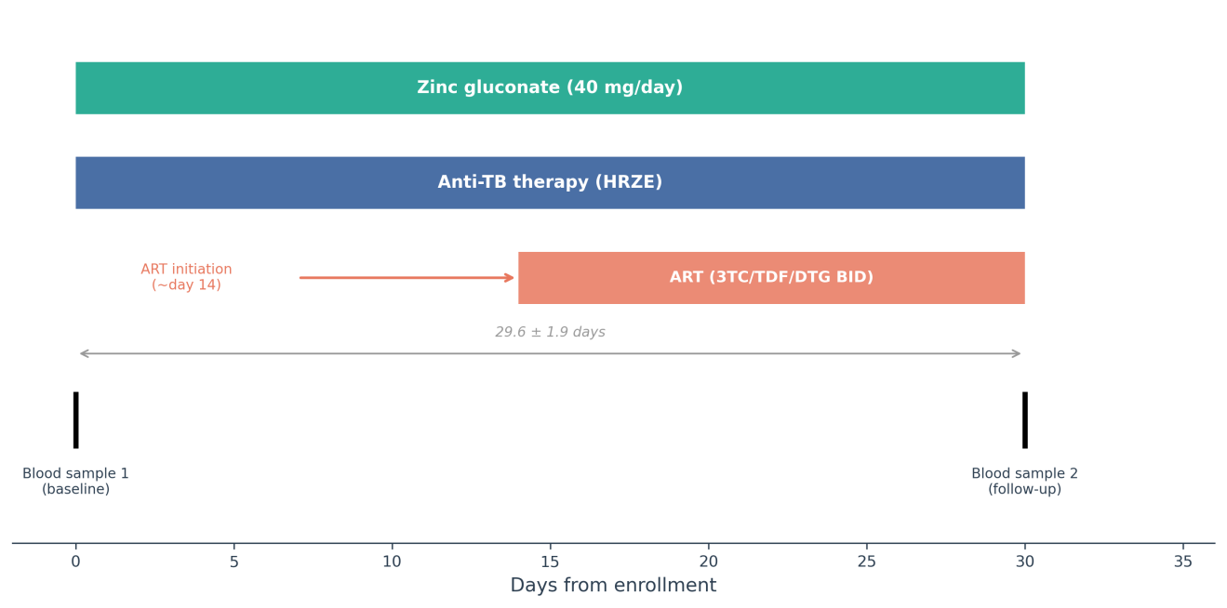
Supplementary Fig. S1 Study timeline. Baseline blood sampling was performed on day 0, prior to treatment initiation. Zinc supplementation and standard anti-TB therapy (HRZE) were started immediately after baseline sampling. ART (lamivudine, tenofovir disoproxil fumarate, and dolutegravir, with dolutegravir dosed twice daily because of concomitant rifampin use [25]) was initiated at the 2-week follow-up visit. The second blood sample for paired lipidomic analysis was collected at approximately 4 weeks after enrollment.

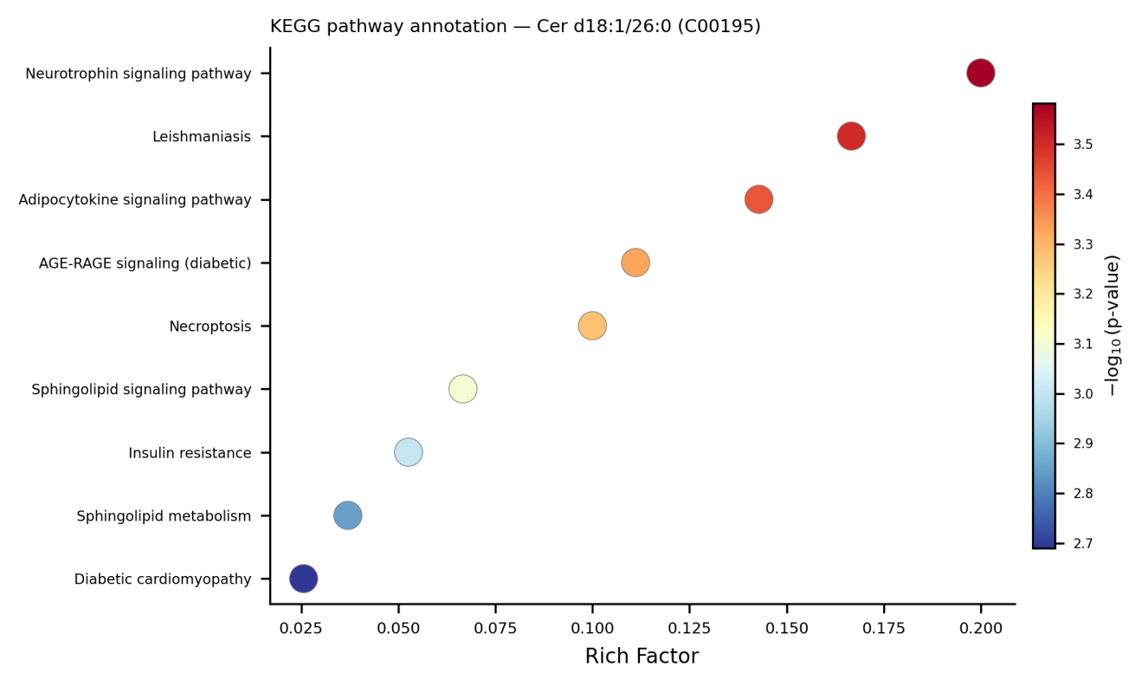
Supplementary Fig. S2 Descriptive KEGG pathway annotation for Cer d18:1/26:0. All pathway hits were derived from the same mapped compound; this output is presented for annotation only.

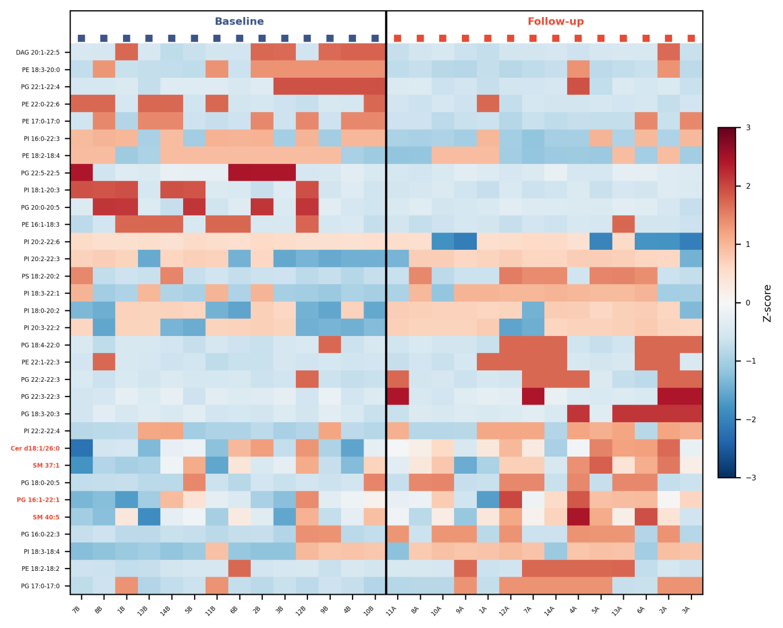
Supplementary Fig. S3 Exploratory heatmap of 32 lipid species from the platform-level exploratory screen across 14 paired samples (paired Wilcoxon testing identified 81 nominal hits in total; see Supplementary Table S1). Color scale: red = relatively higher, blue = relatively lower.

