Supporting Information

Signal-Multiplicated Dual-Channel Visible–NIR Communication in a Single Perovskite Device
Young Un Jeon^{1†}, Jeong min Lee^{1†}, Suhyun Gong¹, Tran Thi Ha Giang¹, Jae-Hyun Kim², Meng Qiang Li¹, Sungjun Park^{2,3}*, Jaewon Lee¹* and Seulki Song¹*
¹Department of Chemical Engineering and Applied Chemistry, Chungnam National University, Daejeon 34134, Republic of Korea
²Department of Intelligence Semiconductor Engineering, Ajou University, 206, World cup-ro, Yeongtong-gu, Suwon-si, Gyeonggi-do, Republic of Korea
³Department of Electrical and Computer Engineering, Ajou University, 206, World cup-ro, Yeongtong-gu, Suwon-si, Gyeonggi-do, Republic of Korea

Keywords: Perovskite, Bulk heterojunction, Li-Fi, Two-channel communication, Two-active layers

Materials and measurements

Materials Unless otherwise specified, all chemicals were purchased commercially and used without further purification. Reagents and solvents were purchased from Sigma-Aldrich, TCI. 2-(5,6-difluoro-3-oxo-2,3-dihydro-1H-inden-1ylidene) malononitrile was purchased from Angene Chemical; (4,8-bis(5-(2-ethylhexyl)thiophen-2-yl)benzo[1,2-b:4,5-b']dithiophene-2,6-diyl)bis(trimethylstannane) (BDT-T), 2-ethylhexyl 4,6-dibromothieno[3,4-b]thiophene-2-carboxylate was purchased from Sunatech Inc

Measurements The ¹H and ¹³C NMR spectra were recorded on a Bruker Avance Neo 400 MHz spectrometer using deuterated chloroform (CDCl₃) as the solvent. Chemical shifts (δ) are reported in parts per million (ppm) relative to tetramethylsilane (TMS) as the internal reference. UV–Vis absorption spectra were obtained with a Jasco V-770 spectrophotometer. Cyclic voltammetry (CV) measurements of small-molecule films were performed on a PowerLab/AD system employing a conventional three-electrode configuration: a glassy carbon disk as the working electrode, Ag/Ag⁺ as the reference electrode, and a platinum wire as the counter electrode. The measurements were carried out in acetonitrile containing 0.1 M tetrabutylammonium hexafluorophosphate (Bu₄NPF₆) at a scan rate of 100 mV s⁻¹, calibrated against the ferrocene/ferrocenium (Fc/Fc⁺) redox couple. Electrochemical onset potentials were determined from the deviation point of the current relative to the baseline.

The analysis of the samples was carried out using equipment supported by NFEC (No. NFEC-2025-04-305399 and NFEC-2025-04-305398)

Supplementary Note 1.
Material Synthesis

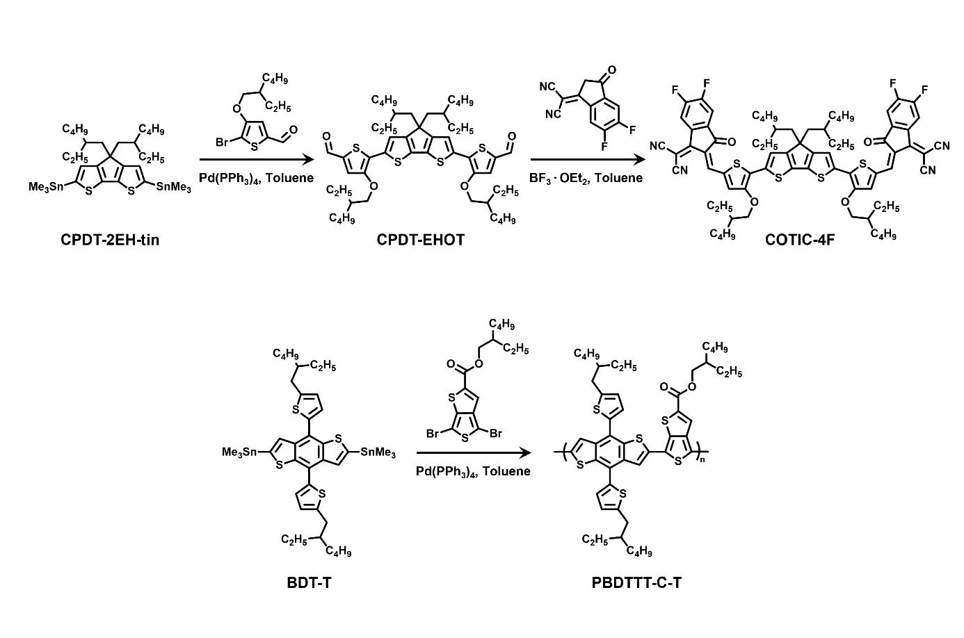
Fig. S1. Synthesis process of COTIC-4F and PBDTTT-C-T.

Synthesis of CPDT-EHOT: CPDT-2EH-tin (1.0 eq), 5-bromo-4-((2-ethylhexyl)oxy)thiophene-2-carbaldehyde (2.5 eq), and Pd(PPh₃)₄ (0.1 eq) were placed into a 50 mL round-bottom flask. The flask was purged with N₂ for 20 min, followed by the addition of anhydrous toluene (20 mL), and the reaction mixture was heated at 110 °C for 24 h. After cooling to room temperature, deionized water was added, and the mixture was extracted with dichloromethane (3 × 50 mL). The organic layer was dried over MgSO₄ and concentrated under reduced pressure. The residue was purified by silica gel column chromatography (n-hexane/dichloromethane, 6:4, Rf = 0.3) to afford a sticky red solid (86%). ¹H NMR (400MHz, CDCl₃, ppm): δ 9.76 (s, 2H), 7.48 (s, 2H), 7.33 (s, 2H), 4.10 (d, 4H), 1.83 – 1.94 (m, 6H), 1.49 – 1.65 (m, 10H), 1.37 – 1.39 (m, 8H), 0.92 – 1.01 (m, 28H), 0.60 – 0.72 (m, 12H) (Supplementary Fig 2a).

Synthesis of COTIC-4F: CPDT-EHOT (1.0 eq) and 2-(5,6-difluoro-3-oxo-2,3-dihydro-1H-inden-1ylidene) malononitrile (2.1 eq) were placed into a 20 mL round-bottom flask. The flask was purged with N₂ for 20 min, followed by the addition of anhydrous toluene (5 mL), and BF₃·OEt₂ (10.5 eq) was added dropwise to the reaction mixture under stirring at room temperature. Acetic anhydride (0.3 mL) was then added, and the reaction mixture was stirred for 30 min at room temperature. After completion of the reaction, the mixture was added dropwise into methanol with stirring, and the resulting precipitate was collected and purified by silica gel column chromatography (n-hexane/dichloromethane, 4:6, Rf = 0.4) to afford a dark blue solid (80%). ¹H NMR (400 MHz, CDCl₃) δ 8.71 (s, 2H), 8.52 (dd, J = 10.0, 6.5 Hz, 2H), 7.66 (t, J = 7.5 Hz, 2H), 7.62 (t, J = 3.3 Hz, 2H), 7.50 (s, 2H), 4.17 (d, J = 5.4 Hz, 4H), 1.94 (dt, J = 28.0, 5.8 Hz, 6H), 1.65 (dt, J = 14.9, 7.3 Hz, 8H), 1.41 (d, J = 7.3 Hz, 10H), 1.26 (s, 1H), 1.08 – 0.92 (m, 35H), 0.73 – 0.61 (m, 15H). ¹³C NMR (101 MHz, CDCl₃) δ 186.15, 161.43, 161.37, 161.30, 158.00, 154.91, 153.03, 143.12, 137.77, 136.58, 136.56, 136.53, 135.96, 134.34, 131.79, 129.67, 122.65, 122.56, 120.69, 114.98, 114.76, 114.67, 114.60, 112.45, 112.26, 77.23, 74.86, 68.38, 53.96, 43.50, 39.75, 35.39, 34.04, 30.54, 30.51, 29.08, 28.47, 27.33, 27.31, 23.98, 23.07, 23.03, 22.84, 14.17, 14.14, 14.05, 14.00, 11.22, 10.61, 10.55 (Supplementary Fig 2b).

Polymerization of PBDTTT-C-T: The polymer was synthesized via palladium-catalyzed Stille polycondensation. BDT-T (1 eq), 2-ethylhexyl 4,6-dibromothieno[3,4-b]thiophene-2-carboxylate (1 eq), and Pd₂(dba)₃ (0.01 eq) were placed into a 10 mL round-bottom flask and dissolved in anhydrous chlorobenzene (5 mL) under a nitrogen atmosphere. The reaction mixture was stirred at 120 °C for 48 h. After completion of the polymerization, end-capping was carried out by the sequential addition of tributyl(thiophen-2-yl)stannane and 2-bromothiophene. The reaction mixture was then precipitated dropwise into methanol, and the crude polymer was further purified by Soxhlet extraction with methanol, acetone, hexane, chloroform, and chlorobenzene in sequence. Finally, the chloroform fraction was precipitated dropwise into methanol to afford a dark blue solid (90%). Mn=35.4 kDa, PDI=1.16.

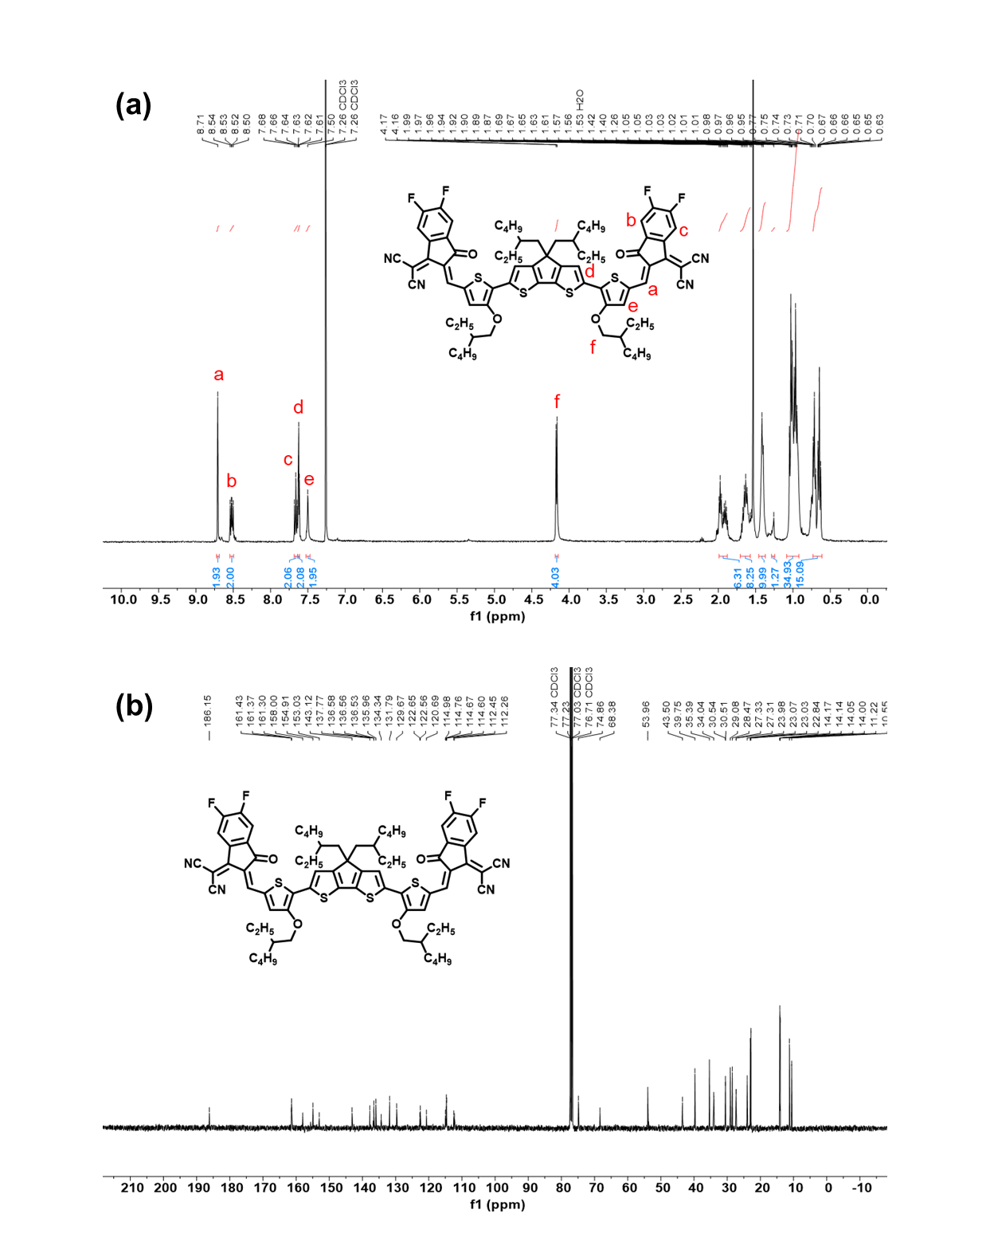
Fig. S2. a)1H NMR and b)13C NMR spectrums of COTIC-4F.

Supplementary Note 2.
Acoustic sensor with an NIR channel
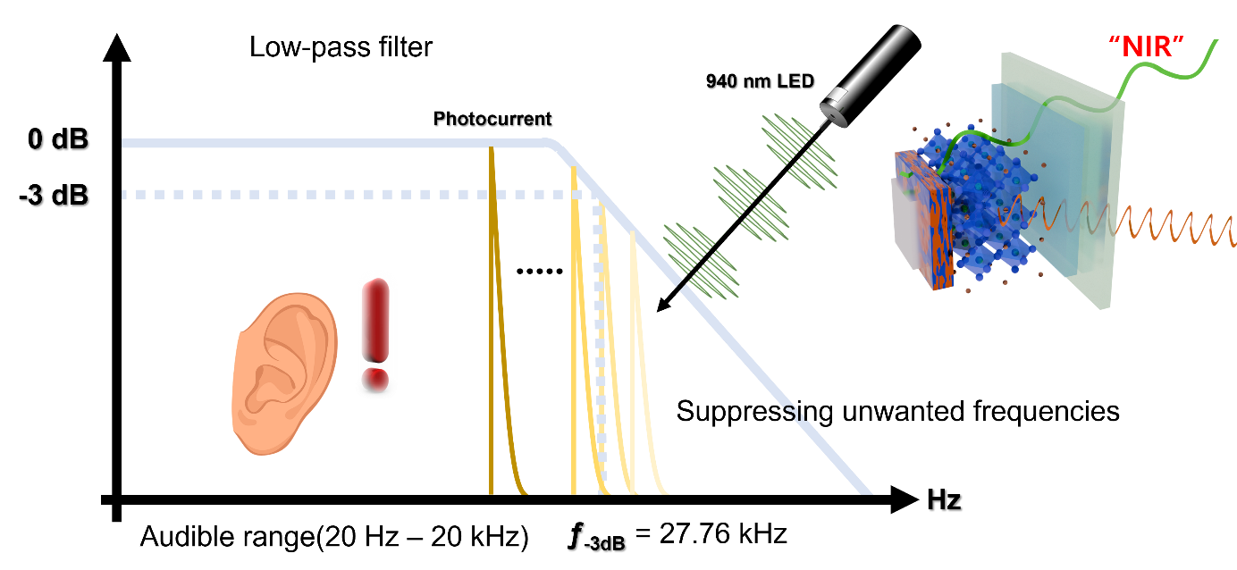
Two-active layer device was exposed to two types of modulated light to elicit the response of the device. First, in the NIR spectrum, a 940 nm LED was employed, and the baseband signal derived from digital audio was applied. The audio signal consists of frequency, amplitude, and phase components. In reproducing the original analog signal, humans can perceive signals in the 20 Hz to 20 kHz range through their sensory organs¹. As shown in Supplementary Fig. 12, the target device used in the demonstration exhibits a characteristic capable of detecting signals modulated above 20 kHz, making it suitable for audio reception.
Additionally, according to the Nyquist theorem, high-frequency signals may be recorded during the acquisition process, potentially resulting in unwanted ghost frequency^{2, 3}. However, since the target device has a −3 dB cut-off frequency of 27.76 kHz, it inherently functions as an optimized low-pass filter.

Supplementary Note 3.
Spectrum selection for the input signal
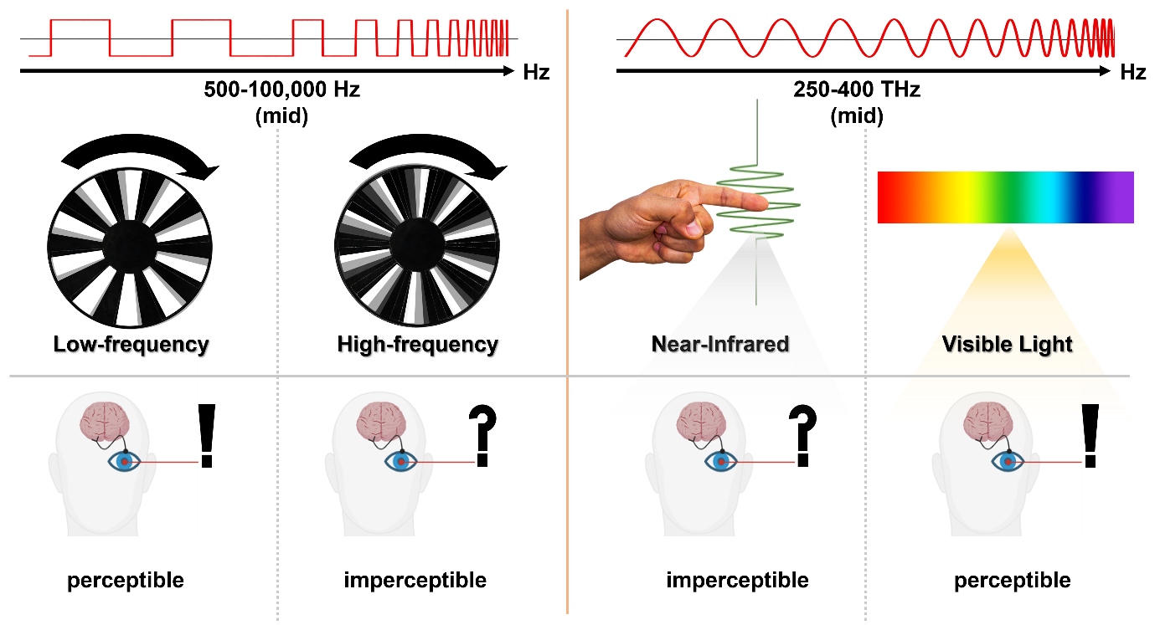
Optimized BHJ acceptor core structure (incorporation of highly electronegative passivating groups (e.g. -F and -CN) ) enhances the −3 dB cut-off frequency in the visible light response, thereby enabling higher bandwidth communication. For audio, the frequency selection remains within the limited 20 Hz to 20 kHz range. However, using visible light sources for signals within 20 Hz to 20 kHz range can cause severe blinking, limiting practical application^{4, 5}. At bandwidth above 100 kHz, visible light is less perceptible to the human eye, justifying the chosen spectral allocation: visible light for text (kHz range) and NIR laser for audio (Hz to kHz range).

Dual-channel communication environment and circuit design
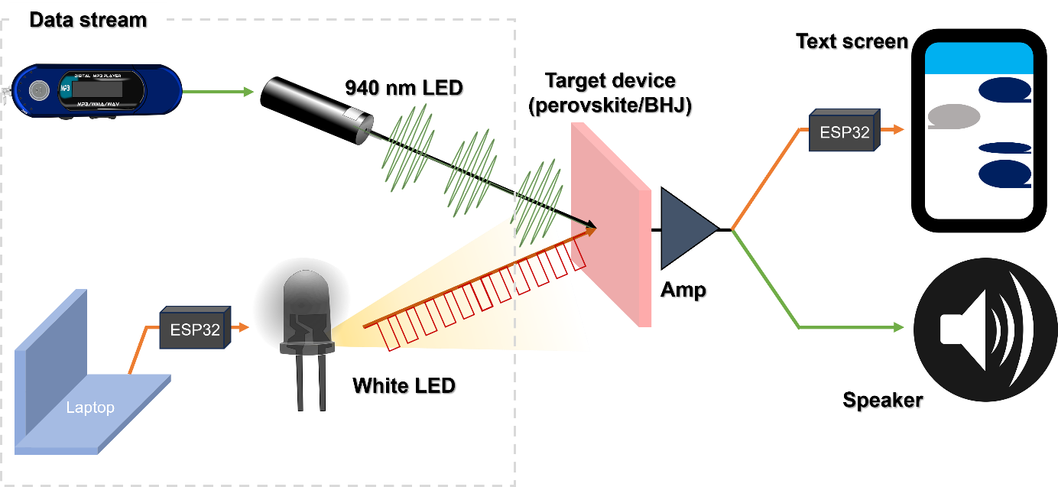
The incoming signals in each single-channel system are shown in Fig. 5e, with channel 1 (Ch 1) representing the frequency input (baseband signal) and channel 2 (Ch 2) representing the on/off input. When both signals are received simultaneously (multi-input), the target device exhibits rapid on/off switching due to saturation of strong visible light response. Furthermore, under saturation, the device converts optical signals at various frequencies into a jagged, mountainous waveform, thereby enabling effective processing of audio signals. Notably, as shown in Fig. 5g, the on/off threshold can be expanded based on the audio waveform, allowing the text signal to be output without interference from the audio. Leveraging the fast response of the device to visible light, binary data containing music lyrics can be transmitted within very short time segments during demonstrations. The device can simultaneously output audio in the 20 Hz ~ 20 kHz range and text in the kbps range, effectively functioning as a signal converter along a single line, replacing the need for an Analogue-to-Video (AV) converter.
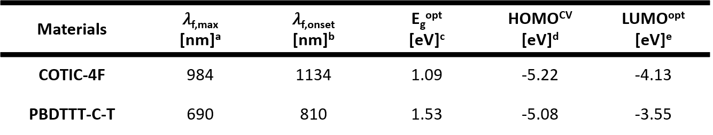
ªAbsorption maximum in film.
^{b}Calculated from the absorption edge.
^{c}Optical bandgap was calculated by UV–vis absorption.
^{d}E_{HOMO} = −(4.8 + (E_{ox} – E_{1/2}(ferrocene))); E_{1/2} (ferrocene) = 0.087 V.
^{f}E_{LUMO} =E_{g}^{opt} + E_{HOMO}. The oxidation and reduction potentials were estimated using the tangential onset point from the cyclic voltammogram.

Table S1. Optical and electrochemical properties of COTIC-4F and PBDTTT-C-T.

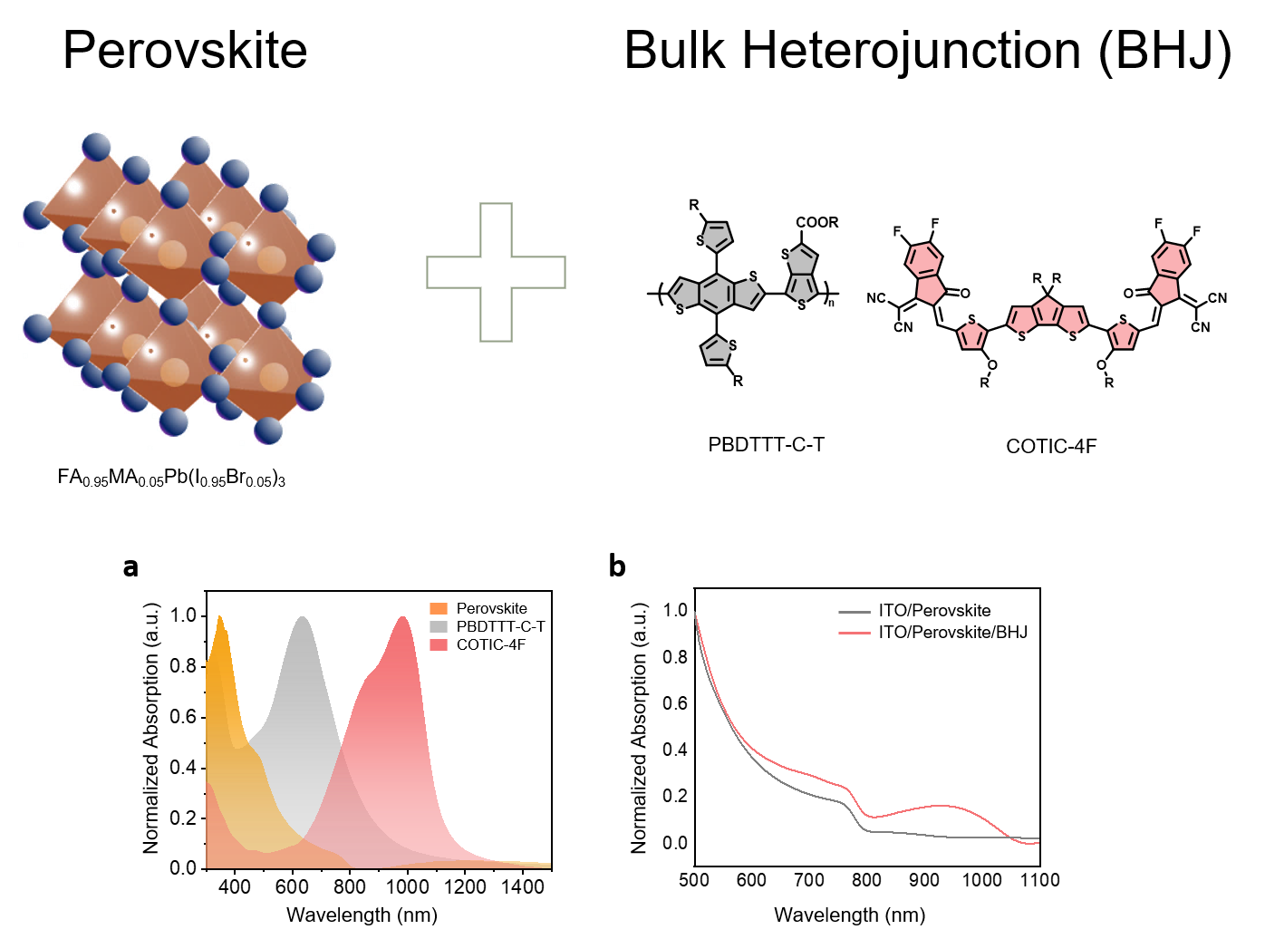
Fig. S3. Absorbance spectra of a)the perovskite, donor, and acceptor, and b)the perovskite/BHJ active layer with and without BHJ.

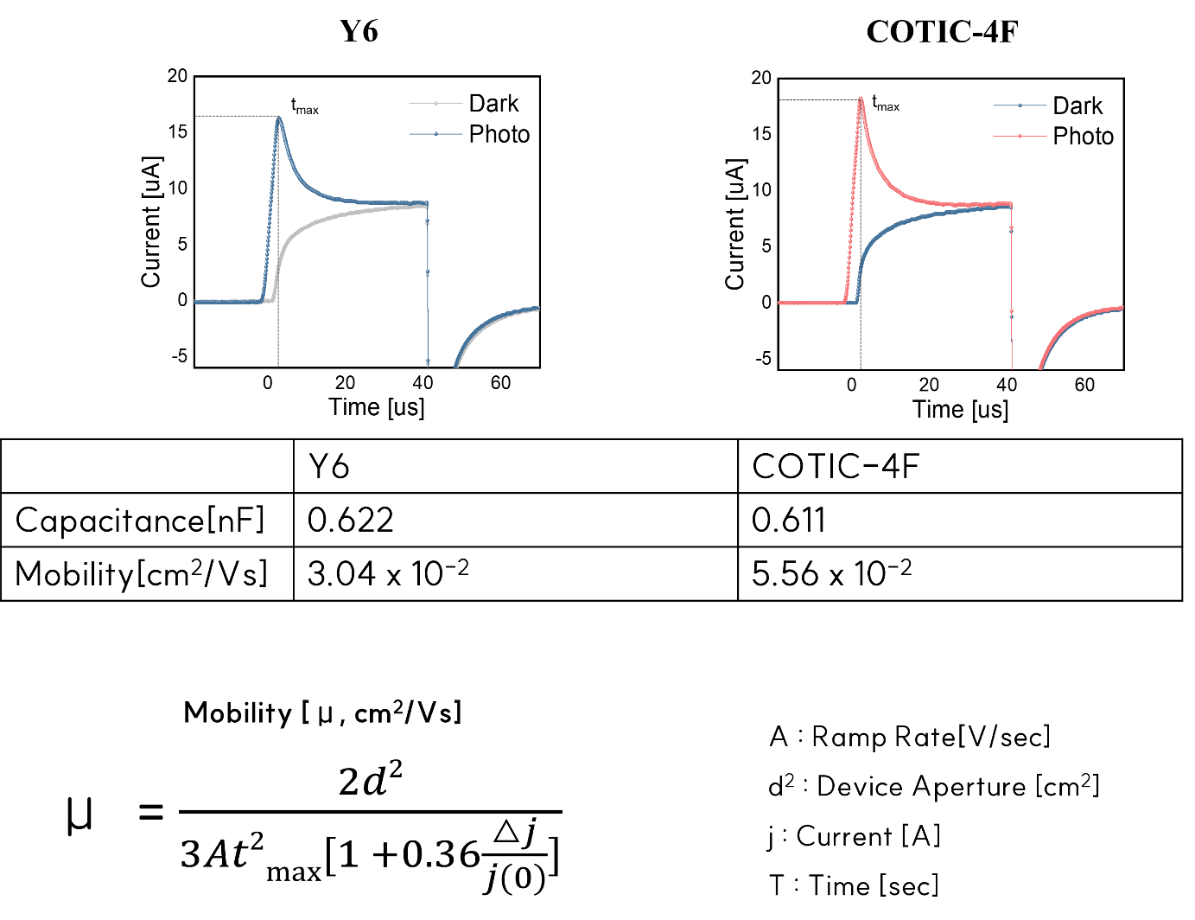
Fig. S4. Capacitance and charge carrier mobility of devices with COTIC-4F and Y6 acceptors, extracted from photo-CELIV analysis.

Photo-CELIV measurements were performed to determine the device capacitance and charge-carrier mobility^{6, 7}. Due to the difference in their central core structures, the use of COTIC-4F led to a reduction in the overall device capacitance, while simultaneously improving the charge carrier mobility compared to the Y6-based device. The number of fused rings in the COTIC-4F molecule is closer to the optimum compared to Y6, enabling faster charge extraction⁸. In addition, as the fused ring size increases, the π-electron cloud becomes more delocalized and the molecular polarizability increases. Consequently, under applied bias, greater charge accumulation occurs, which leads to an increase in capacitance that can limit the charge extraction rate⁹⁻¹¹. Therefore, devices employing COTIC-4F, with an optimized number of fused rings, exhibit lower capacitance than Y6-based devices.

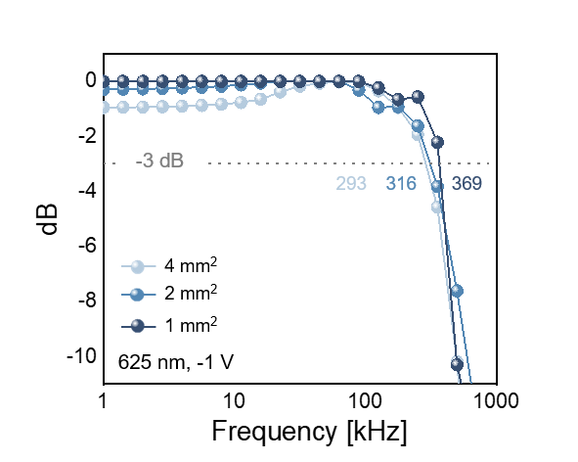
Fig. S5. −3 dB cut-off frequency of the device with COTIC-4F for various active areas.

group | material  (Two-active layers) | -3dB cut-off frequency | spectrum range | functions & usage | ref
Wang et al. | Perovskite/Organic BHJ | 170 kHz | 500-950 nm | Dual-channel OC (secure OC) | [12]
Ollearo et al. | Perovskite/Organic BHJ | Not given | 550-1000 nm | High detectivity of NIR photodiodes | [13]
Lan et al. | Double Organic BHJs | 100 kHz | 400-1000 nm | Dual-channel OC | [14]
Li et al. | Perovskite/Organic BHJ | Not given | 300-950 nm | Image scanning system | [15]
Gao et al. | Perovskite/Organic BHJ | 30 kHz | 400-1000 nm | Visible and NIR array imaging | [16]
Cao et al. | Perovskite/Perovskite | Not given | 300-475 nm | Optic communication | [17]
Ma et al. | Perovskite Single Crystal/Organic BHJ | 9.5 kHz | 825 nm | Narrowband photodetector with multiplication | [18]
Wang et al. | Perovskite/Organic BHJ | 300 kHz | 800 nm | Narrowband photodetector | [19]
This Work | Perovskite/Organic BHJ | > 350 kHz at Visible Spectrum | 400-1100 nm | Simultaneous dual-channel optical communication | this work

Table S2. Detailed performance (−3 dB cut-off frequency, spectral response ranges) table for Fig. 2f.

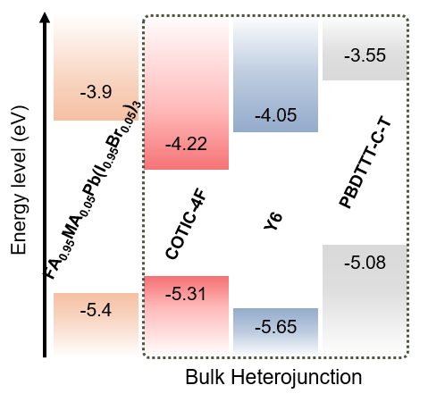
Fig. S6. Energy band diagram of two-channel devices with Y6 and COTIC-4F acceptors. The energy levels of materials (perovskite, Y6) were determined based on previous reports^{20, 21}.

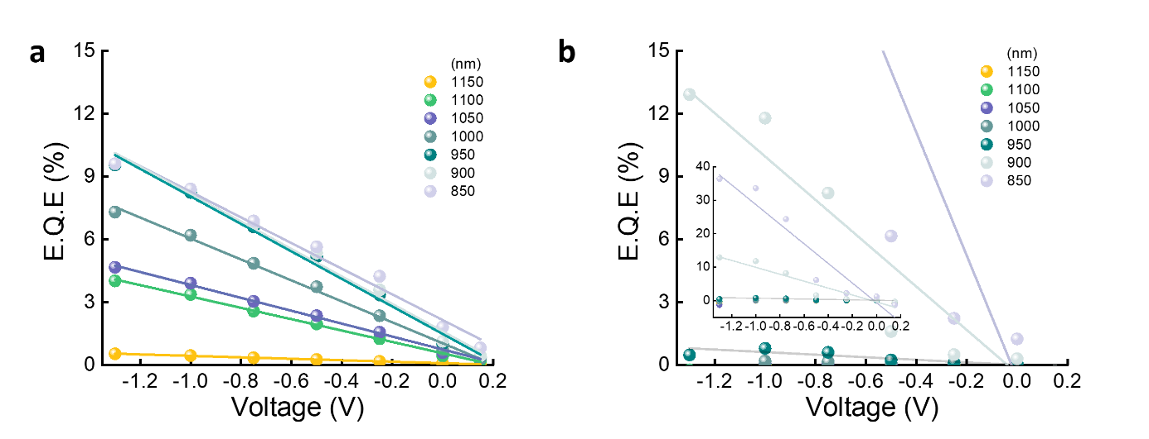
Fig. S7. Bias-dependent EQE increase of a)the COTIC-4F-based device and b)the Y6-based device.

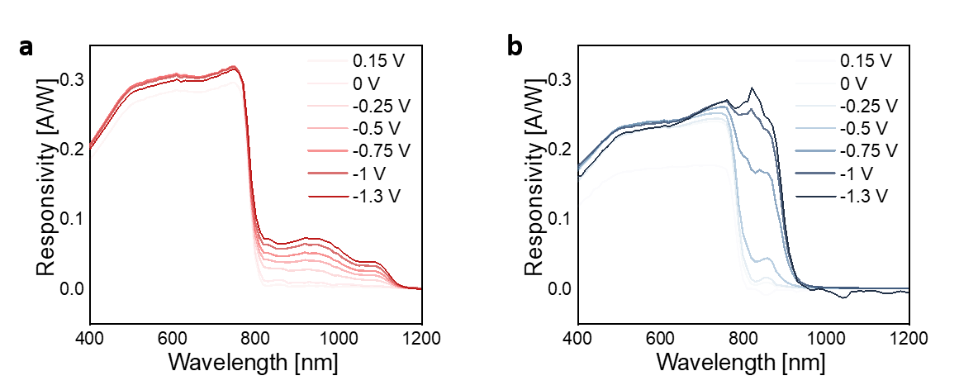
Fig. S8. Responsivity of devices with a)COTIC-4F and b)Y6 acceptor under various bias voltages.

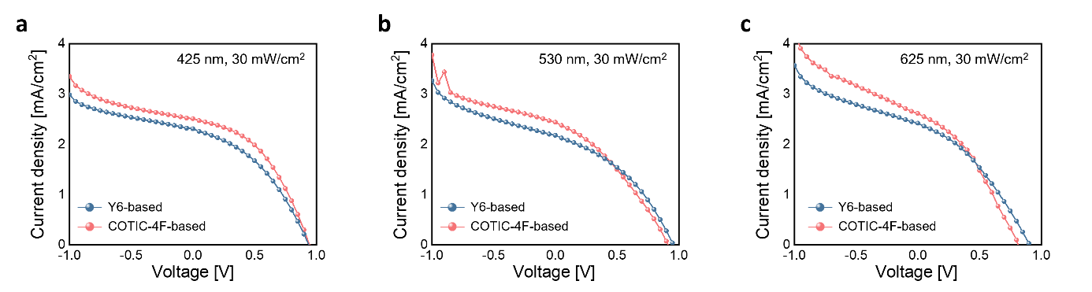
Fig. S9. J-V curves of the devices with COTIC-4F and Y6 acceptors under a)425 nm, b)530 nm, c)625 nm illuminations (30 mW/cm²).

The device with Y6 exhibits a slightly higher V_{OC} than the device with COTIC-4F. These results demonstrate that free charge carriers generated by photons of visible spectrums are influenced by the perovskite/Y6 or perovskite/COTIC-4F interfaces during hole extraction.

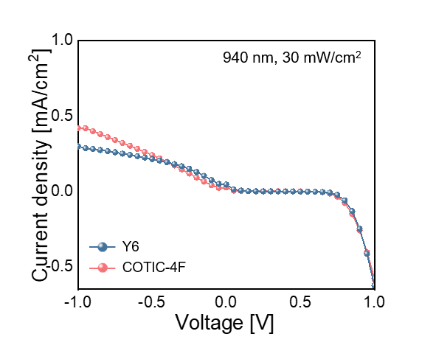
Fig. S10. J-V curve of the device with COTIC-4F and Y6 acceptors under 940 nm illumination (30 mW/cm²).

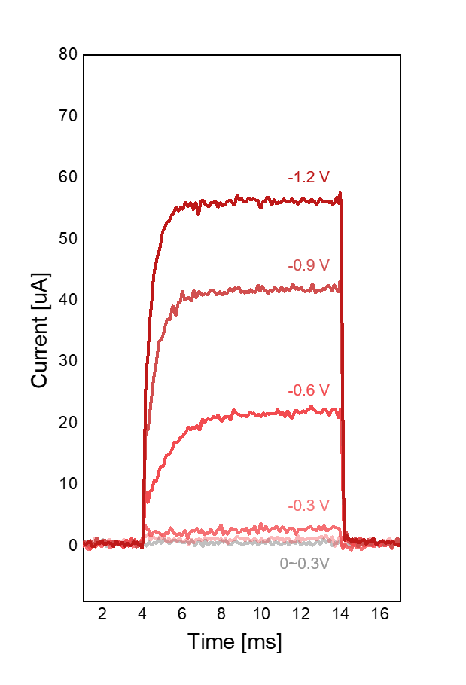
Fig. S11. Responses of the devices with COTIC-4F acceptors at 940 nm under various bias voltages. These results verify that long-wavelength detection and modulation/demodulation functionalities are maintained under reverse-bias operation.

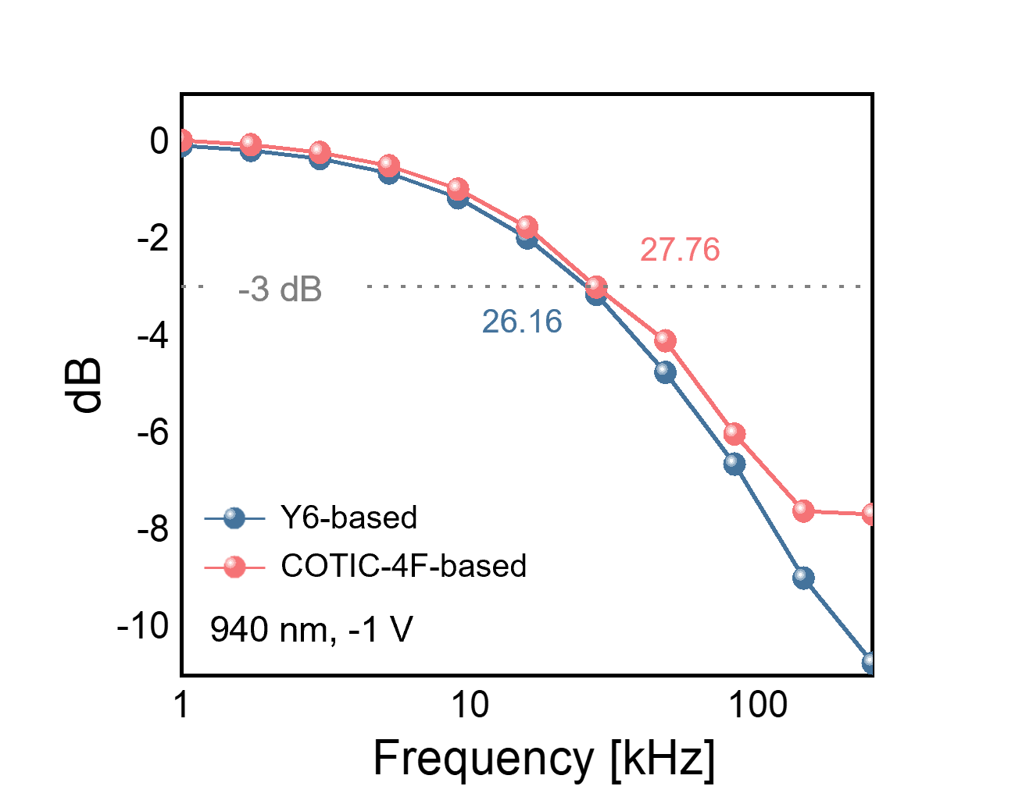
Fig. S12. −3 dB cut-off frequency of the devices with Y6 and COTIC-4F acceptors.

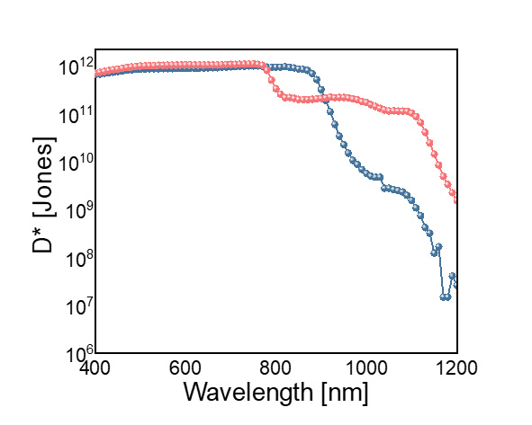
Fig. S13. Detectivity of devices with COTIC-4F (red) and Y6 (blue), calculated from dark current density.

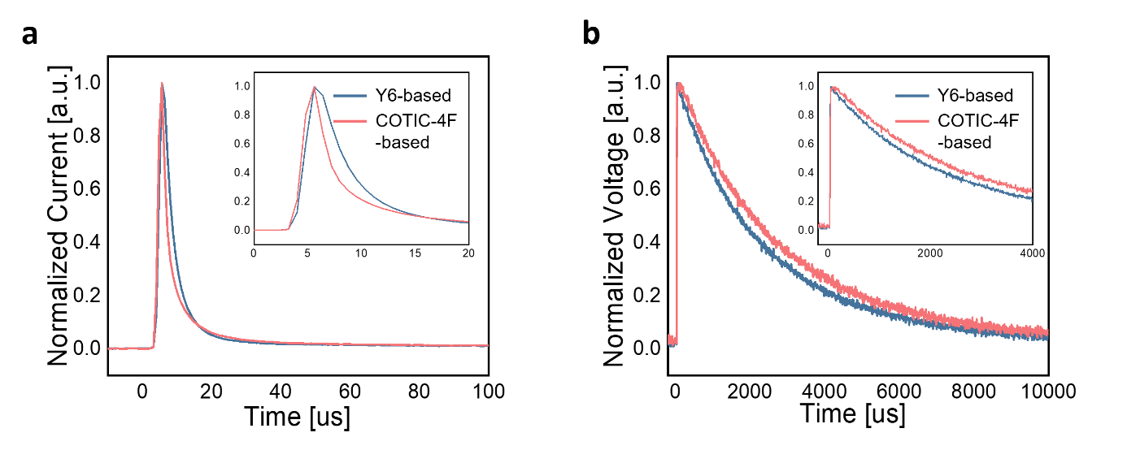
Fig. S14. a) Transient photocurrent of devices with COTIC-4F and Y6 at −1 V, 940 nm. b) Transient photovoltage of devices with COTIC-4F and Y6 at −1 V, 940 nm.

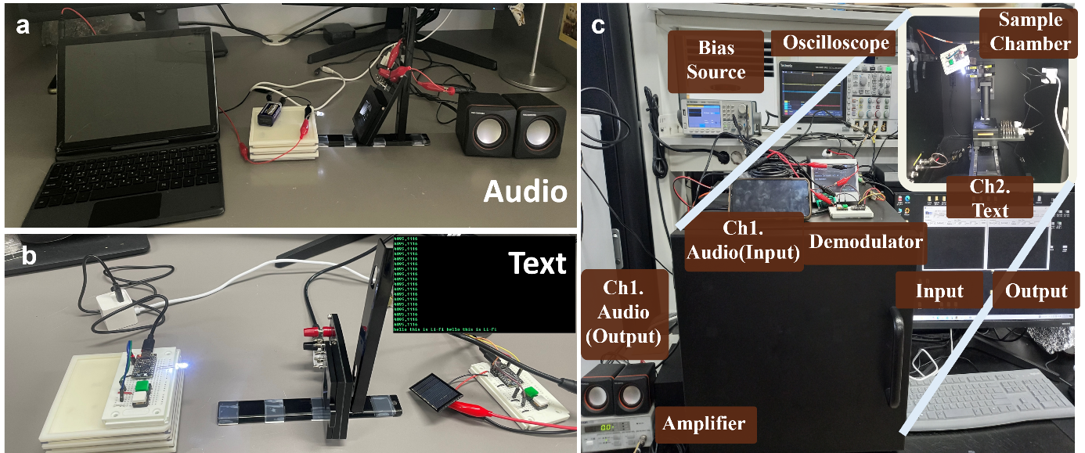
Fig. S15. Photograph of c)the integrated environment for simultaneous a)audio and b)text communication.

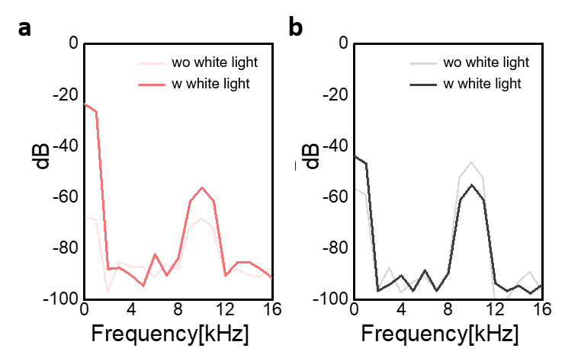
Fig. S16. Fourier transform of the response to white LED (DC) and NIR laser (10 kHz): a) Target device b) Si PDs.

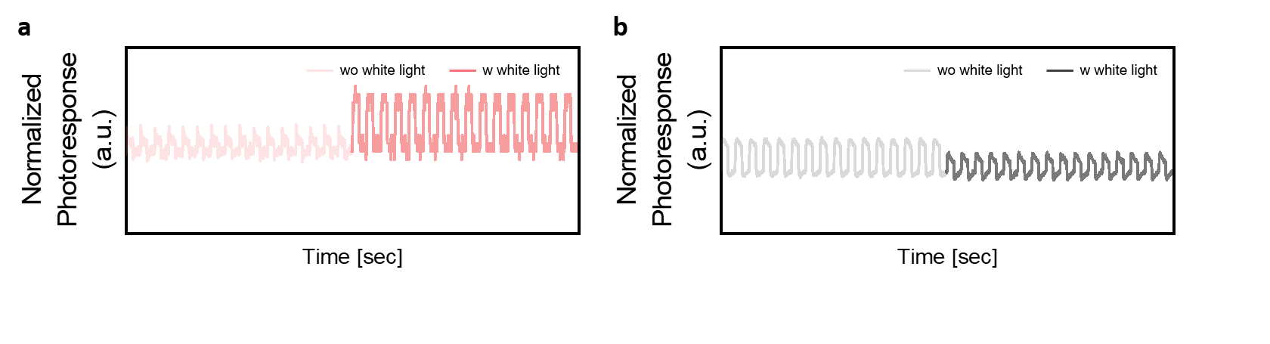
Fig. S17. Effect of visible light illumination on NIR signal waveforms: a) Target device, b) Si PDs.

References
1. Pulkki, V., McCormack, L. & Gonzalez, R. Superhuman spatial hearing technology for ultrasonic frequencies. Sci Rep-Uk 11, 11608 (2021).
2. Amitonova, L.V. & de Boer, J.F. Endo-microscopy beyond the Abbe and Nyquist limits. Light: Science & Applications 9, 81 (2020).
3. Eisma, Y.B., Hancock, P.A. & de Winter, J.C. On Senders’s models of visual sampling behavior. Hum Factors 65, 723-736 (2023).
4. Minotto, A. et al. Visible light communication with efficient far-red/near-infrared polymer light-emitting diodes. Light: Science & Applications 9, 70 (2020).
5. Minotto, A. et al. Towards efficient near-infrared fluorescent organic light-emitting diodes. Light: Science & Applications 10, 18 (2021).
6. Weng, K. et al. Optimized active layer morphology toward efficient and polymer batch insensitive organic solar cells. Nat Commun 11, 2855 (2020).
7. Semeniuk, O. et al. Charge transport mechanism in lead oxide revealed by CELIV technique. Sci Rep-Uk 6, 33359 (2016).
8. Wang, H.T. et al. Molecular engineering of central fused-ring cores of non-fullerene acceptors for high-efficiency organic solar cells. J Mater Chem A 7, 4313-4333 (2019).
9. Yang, S. et al. Unveiling the π-chain effect on charge transfer and charge recombination among donor− π–acceptor material systems. The Journal of Physical Chemistry C 126, 1076-1084 (2022).
10. Zhang, T. et al. High‐Performance Filterless Blue Narrowband Organic Photodetectors. Adv Funct Mater 34, 2308719 (2024).
11. Mica, N.A. et al. Triple-cation perovskite solar cells for visible light communications. Photonics Res 8, A16-A24 (2020).
12. Jung, H. et al. High‐Detectivity UV–Visible–NIR Broadband Polymer Photodetector with Polymer Charge Blocking Layer Cross‐Linked by Organic Photocrosslinker. Adv Funct Mater 34, 2403094 (2024).
13. Ollearo, R. et al. Vitality surveillance at distance using thin-film tandem-like narrowband near-infrared photodiodes with light-enhanced responsivity. Sci Adv 9, eadf9861 (2023).
14. Lan, Z. et al. Dual‐band organic photodetectors for dual‐channel optical communications. Laser Photonics Rev 16, 2100602 (2022).
15. Li, C. et al. Ultrafast and broadband photodetectors based on a perovskite/organic bulk heterojunction for large-dynamic-range imaging. Light: Science & Applications 9, 31 (2020).
16. Gao, Y. et al. Low-voltage-modulated perovskite/organic dual-band photodetectors for visible and near-infrared imaging. Sci Bull 67, 1982-1990 (2022).
17. Cao, F., Li, Z., Liu, X., Shi, Z. & Fang, X. Air induced formation of Cs3Bi2Br9/Cs3BiBr6 bulk heterojunction and its dual‐band photodetection abilities for light communication. Adv Funct Mater 32, 2206151 (2022).
18. Ma, Y. et al. Amplified narrowband perovskite photodetectors enabled by independent multiplication layers for anti-interference light detection. Sci Adv 11, eadq1127 (2025).
19. Lan, Z., Cai, L., Luo, D. & Zhu, F. Narrowband near-infrared perovskite/polymer hybrid photodetectors. Acs Appl Mater Inter 13, 981-988 (2020).
20. Li, M. et al. Orientated crystallization of FA-based perovskite via hydrogen-bonded polymer network for efficient and stable solar cells. Nat Commun 14, 573 (2023).
21. Shi, Y. et al. Small reorganization energy acceptors enable low energy losses in non-fullerene organic solar cells. Nat Commun 13, 3256 (2022).

