Nano-Confinement-Directed Crystallization of Morphochiral Gold Nanohelices with Kinetically Pprogrammable Geometry
Zakaria Anfar a, Masahiro Nakaya b,c, Wijak Yospanya d, Simon Poly a, Yann Battie ^{h}, Yutaka Okazaki e,f, Walid Baaziz ^{i}, Ovidiu Ersen ^{i}, David Talaga ^{k}, Thierry Buffeteau ^{k}, Matthias Pauly ^{j}, Nanami Hano ^{g}, Marco Bertuolo ª, Pamela De La Fuente ª, Sylvain Nlate ª, Emilie Pouget ª, Kuniaki Murase ^{b}, Kazuhiro Fukami ^{b,f}* and Reiko Oda a,d*

ªCBMN, CNRS, UMR 5248, University of Bordeaux, 33600 Pessac, France.
^{b}Department of Materials Science and Engineering, Kyoto University, Kyoto 606-8501, Japan
^{c}Osaka Research Institute of Industrial Science and Technology, Osaka 536-8553, Japan
^{d} WPI-Advanced Institute for Materials Research (AIMR), Tohoku University, Katahira, Aoba-ku, Sendai 980-8577, Japan
^{e}Graduate School of Energy Science, Kyoto University, Kyoto 606-8501, Japan
^{f} Integrated Research Center for Carbon Negative Science, Institute of Advanced Energy, Kyoto University, Kyoto 611-0011, Japan
^{g}Faculty of Advanced Science and Technology, Kumamoto University, 2-39-1 Kurokami, Chuo-ku, Kumamoto 860-8555, Japan
^{h}LCP-A2MC, Université de Lorraine, 57078 Metz, France
^{i}IPCMS, CNRS, Université de Strasbourg, UMR 7504, 23 rue du Loess BP 43, 67034 STRASBOURG Cedex 2 France
^{j}ENS de Lyon, CNRS, LCH, UMR 5182, F-69342 Lyon, France
^{k}ISM, CNRS, UMR 5255, University of Bordeaux, 33405 Talence, France
Corresponding authors: reiko.oda@u-bordeaux.fr, fukami.kazuhiro.2u@kyoto-u.ac.jp

Supplementary Notes
Note 1: Significant increase in chirality was observed upon addition of the gold precursor to the SNH, generating mirror-image induced circular dichroism (ICD) signals at the absorption wavelengths of the gold precursor(Supplementary Fig. S1a). To grow gold nanoparticles (GNPs) or gold nanohelices (GNHs) within the chiral nanospace of SNH, the tartrate counterions were first replaced with chloride ions. After ion exchange, the FTIR peaks associated with the COO⁻ groups of tartrates at 1350 cm⁻¹ and 1600 cm⁻¹ disappeared, confirming complete replacement (Supplementary Fig. S1b).This step confirmed complete insertion of the gold precursor and full removal of chiral tartrate, as shown by the disappearance of CD signals from the supramolecular assembly across the UV range (200–400 nm) (Supplementary Fig. S1c). We also note that the helical structure remained intact after this exchange (Supplementary Fig. S1d).
Note 2 : The reduction of AuCl₄⁻ to Au(0) occurs via oxidation of the reducing agent, and the rates of these reactions must balance each other. Linear sweep voltammograms (LSVs) provide insights into the kinetics of this process. Supplementary Figure S2 shows the LSVs for the reduction of $Au{Cl}_{4}^{-}$to Au(0) and the oxidation reactions of ascorbic acid and a mixture of tannic acid and sodium citrate, measured on a gold electrode. The red curve represents the LSV for Au deposition on a gold electrode, while the blue and green curves represent the LSVs for ascorbic acid and the tannic acid-citric acid mixture, respectively. For Au deposition using a reducing agent, the “mixed potential”, where the oxidation and reduction current densities are balanced, determines the kinetics of Au deposition. Using the tannic acid-citric acid mixture, the mixed potential is approximately 0.77 V vs. Ag|AgCl (referred to as RE hereafter). At this potential, the reduction current density for $Au{Cl}_{4}^{-}$ to Au(0) remains low, suggesting that the rate-determining step for Au reduction is charge transfer.
In contrast, using ascorbic acid, the mixed potential is around 0.25 V vs. RE, where the reduction current density for $Au{Cl}_{4}^{-}$ to Au(0) reaches saturation at approximately -0.8 mA/cm². This indicates that the rate-determining step in this case is the diffusion of $Au{Cl}_{4}^{-}$, meaning the process is under diffusion-limited conditions.
In general, crystal growth under electrochemical conditions is isotropic (producing particles) when charge-transfer-limited, but becomes anisotropic (producing dendritic structures) when limited by diffusion of metal precursors. Although $Au{Cl}_{4}^{-}$confined within the SNHs exists in a different state compared to an aqueous solution, the potential required for its reduction to Au(0) is similar to that observed on a flat electrode in an aqueous solution of $Au{Cl}_{4}^{-}$.
In this experiment, reduction using the tannic acid-citric acid mixture resulted in particulate deposition with a chiral morphology due to the chiral nanocavity. By contrast, when ascorbic acid was used, Au growth occurred in the direction of the diffusion of metal precursor ions, leading to anisotropic Au growth along the supply of $Au{Cl}_{4}^{-}$. Since $Au{Cl}_{4}^{-}$ was confined within the SNHs by ion exchange, the supply of $Au{Cl}_{4}^{-}$ followed the core of the SNHs due to chemical potential differences. As a result, anisotropic Au growth occurred along the SNHs, rather than propagating as conventional dendrites, and instead grew as nanohelices.
Reagents
All reagent-grade solvents and chemicals were obtained from Sigma-Aldrich and used without further purification. The following materials were used as received: tannic acid (TA), sodium citrate (Na₃C₆H₅O₇), L-ascorbic acid (L-AA), potassium tetrachloroaurate (III) (KAuCl₄), sodium hydroxide (NaOH), potassium chloride (KCl), tetraethyl orthosilicate (TEOS, 98%), mercaptopropionic acid (MPA, ≥95%), and tetrahydrofuran (THF, 99.9%). Milli-Q water was used for all preparations.
Characterization techniques
A CM120 (Philips) transmission electron microscope operating at 120 kV was used to visualize the hybrid helix nanostructures. FTIR spectra were recorded using a Thermo-Nicolet Nexus 670 FTIR spectrometer at a resolution of 4 cm⁻¹. Diffuse reflection CD (DRCD) measurements were performed using an integration sphere attachment (DRCD-575), while a JASCO J-1500 spectrometer was employed to record the CD spectra of samples in suspension. During measurements, all samples were stirred at 1000 rpm, and spectra were captured using an EXPM-531 (PMT) detector. The detailed measurement conditions for the J-1500 are as follows: sample volume of 2.5 mL (1 mg/mL concentration) in a 3 mL cell, temperature of 20°C, data pitch of 1 nm, CD scale of 10000 mdeg/1 dOD, and a scanning speed of 200 nm/min with baseline correction based on the solvent. For CD measurements of films in the 200-2500 nm range, a JASCO J-1700 spectrometer was used. The conditions were as follows: DIT of 2 seconds for both visible and NIR, bandwidth of 6 nm (50 nm for NIR), scanning speed of 200 nm/min, and 10 accumulations. CD scale settings varied depending on the case (2000, 200, or 20 mdeg). Slow scans with wide bandwidths and averaging over 10 scans were conducted to enhance the spectrum quality. Scanning electron microscope-energy dispersive X-ray spectroscopy (STEM-EDX) analysis was conducted using a JEM-ARM200F (JEOL) equipped with a JED-2300T (JEOL).

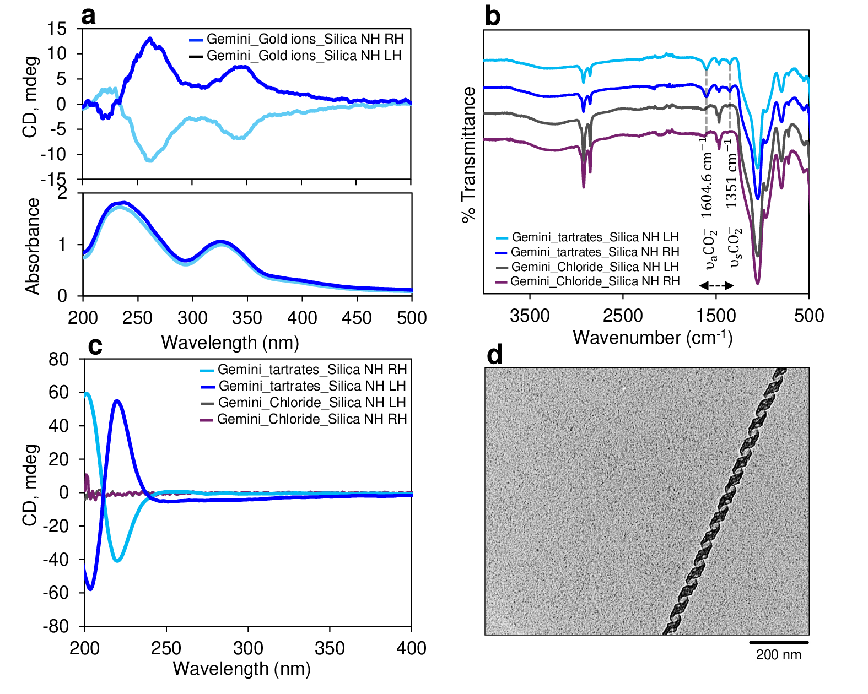
Supplementary Figure S1. a, CD signal and absorbance spectra of different hybrids nanostructures used in this work before and after ion exchange using KAuCl₄. b, FTIR spectra of different hybrids nanostructures used in this work before and after the ion exchange using KCl. c, CD signals before and after ion exchange using KCl and d, TEM image of the RH hybrid nanostructures after chloride ion exchange,

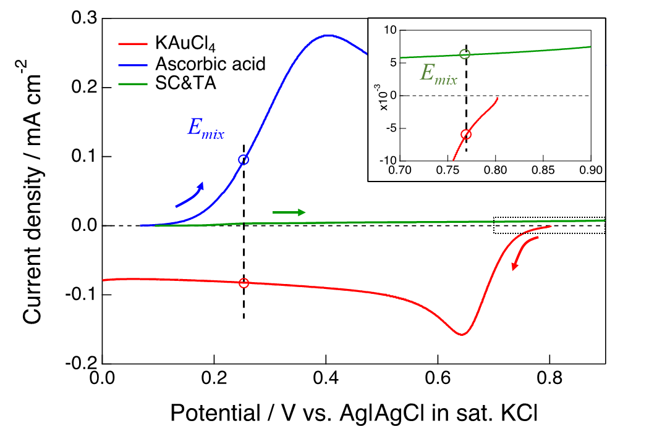
Supplementary Figure S2. LSVs measured on a gold electrode in 1 mM KAuCl₄ in 100 mM KCl aq. (Red), 5 mM Ascorbic acid (AA) in 100 mM KCl aq. (Blue) and the mixture of 0.55 mM trisodium citrate and 0.096 mM tannic acid (SC/TA) in 100 mM Na₂SO₄ aq. (Green). Arrows indicates sweep directions. The inset shows the magnified plot of the black dotted square. The dashed lines indicate the mixed potential of each redox couple (KAuCl₄-AA or KAuCl₄-SC/TA

Supplementary Figure S3. HRTEM image used for tomography presented in Fig. 2g in the main text

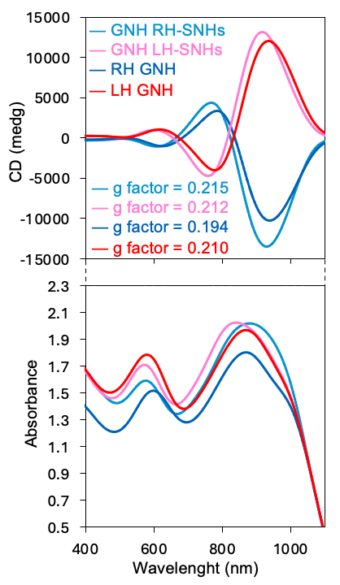
Supplementary Figure S4. CD and absorbance of Figure 3g

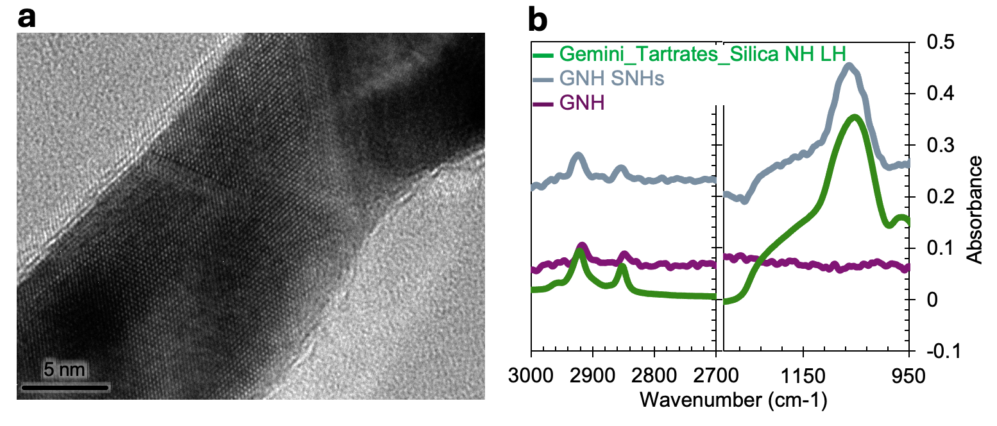
Supplementary Figure. 5. a, HRTEM images of gold nanohelices after chemical denaturation of silica using NaOH for LH and b, FTIR spectra comparison of with and without silica (after NaOH treatment).

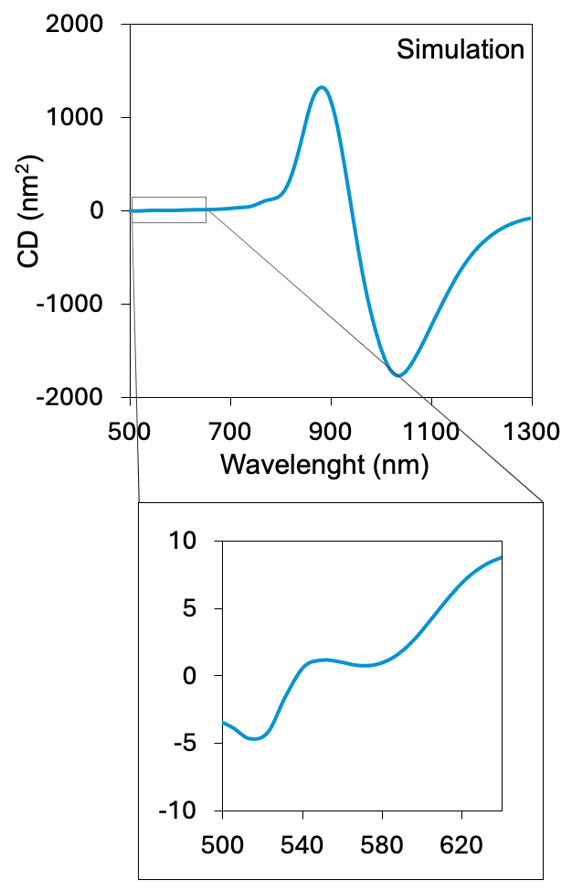
Supplementary Figure S6. Simulated CD spectrum of a perfect RH GNH with defined dimensions (height: 300 nm; thickness: 5 nm; width: 15 nm; diameter: 25 nm; pitch: 72 nm) with a Gaussian length distribution centered at 300 nm with a standard deviation of 100 nm. A bisignate CD signal is observed in the 800–1200 nm range, with a dominant positive peak at 885 nm, and a negative peak at 1030 nm.

Supplementary Figure S7. a, TEM images of GNHs with different length as a function of time, b, Mapping analysis of chiral GNHs, c) effect of time and temperature on the length of chiral GNHs, d, circular dichroism spectrum of prepared chiral GNHs inside SNHs as a function of temperature. GNHs in this experiment are obtained using direct ion exchange from tartrate to AuCl₄– anions.

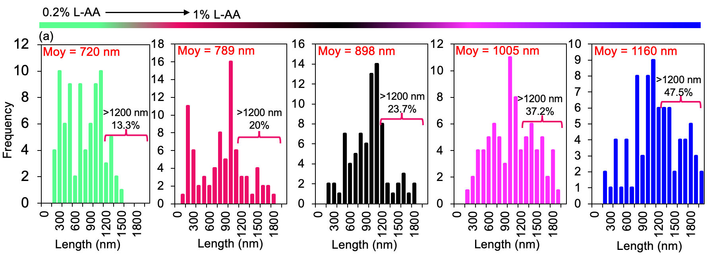
Supplementary Figure S8. Effect of ascorbic acid concentration on the length of GNHs

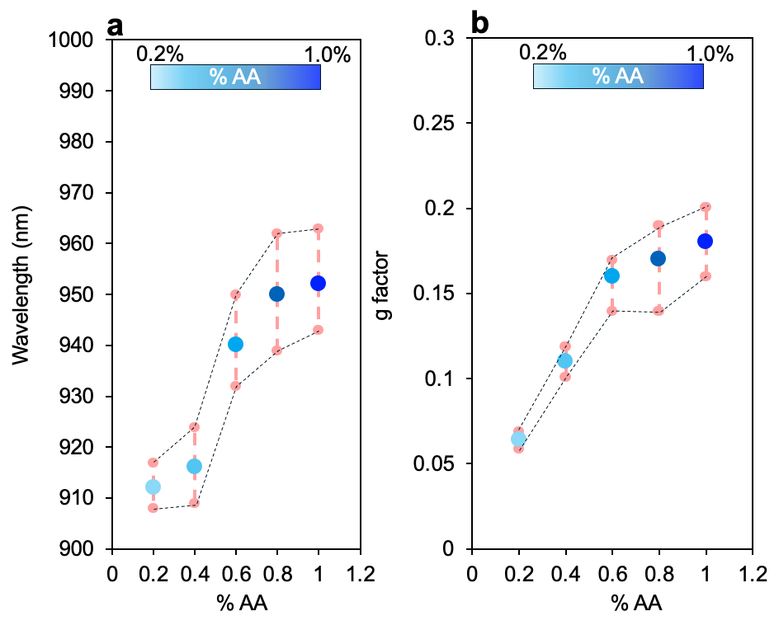
Supplementary Figure S9. a, wavelength and b, g-factor as function of AA concentration of GNHs

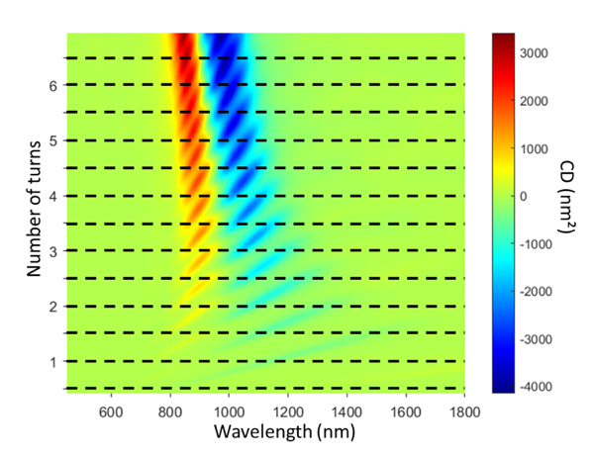
Supplementary Figure S10: Evolution of the CD spectra of a single GNH with its length normalized by the pitch. The thickness, width, diameter, and pitch of the helical structure are 5 nm, 15 nm, 25 nm, and 72 nm. Each spectrum is averaged over 30 wavevector orientations to take into account the random orientation of GNH in water.

Supplementary Figure S11. Absorbance spanning from UV to NIR (200 nm to 1600 nm) of drop-cast GNHs on Quartz slides.

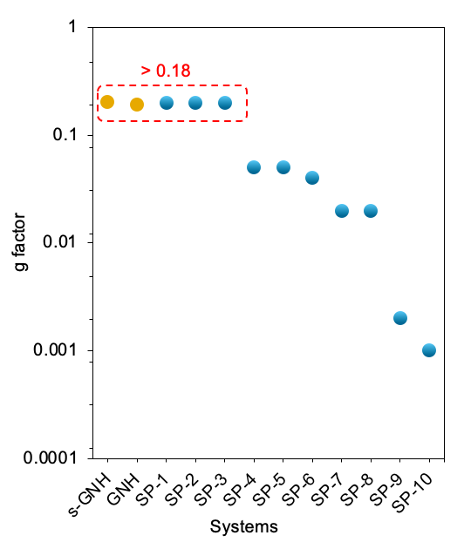
Supplementary Figure S12. Comparison of the GNH g-factor with other reported systems presented in Figure 6.

