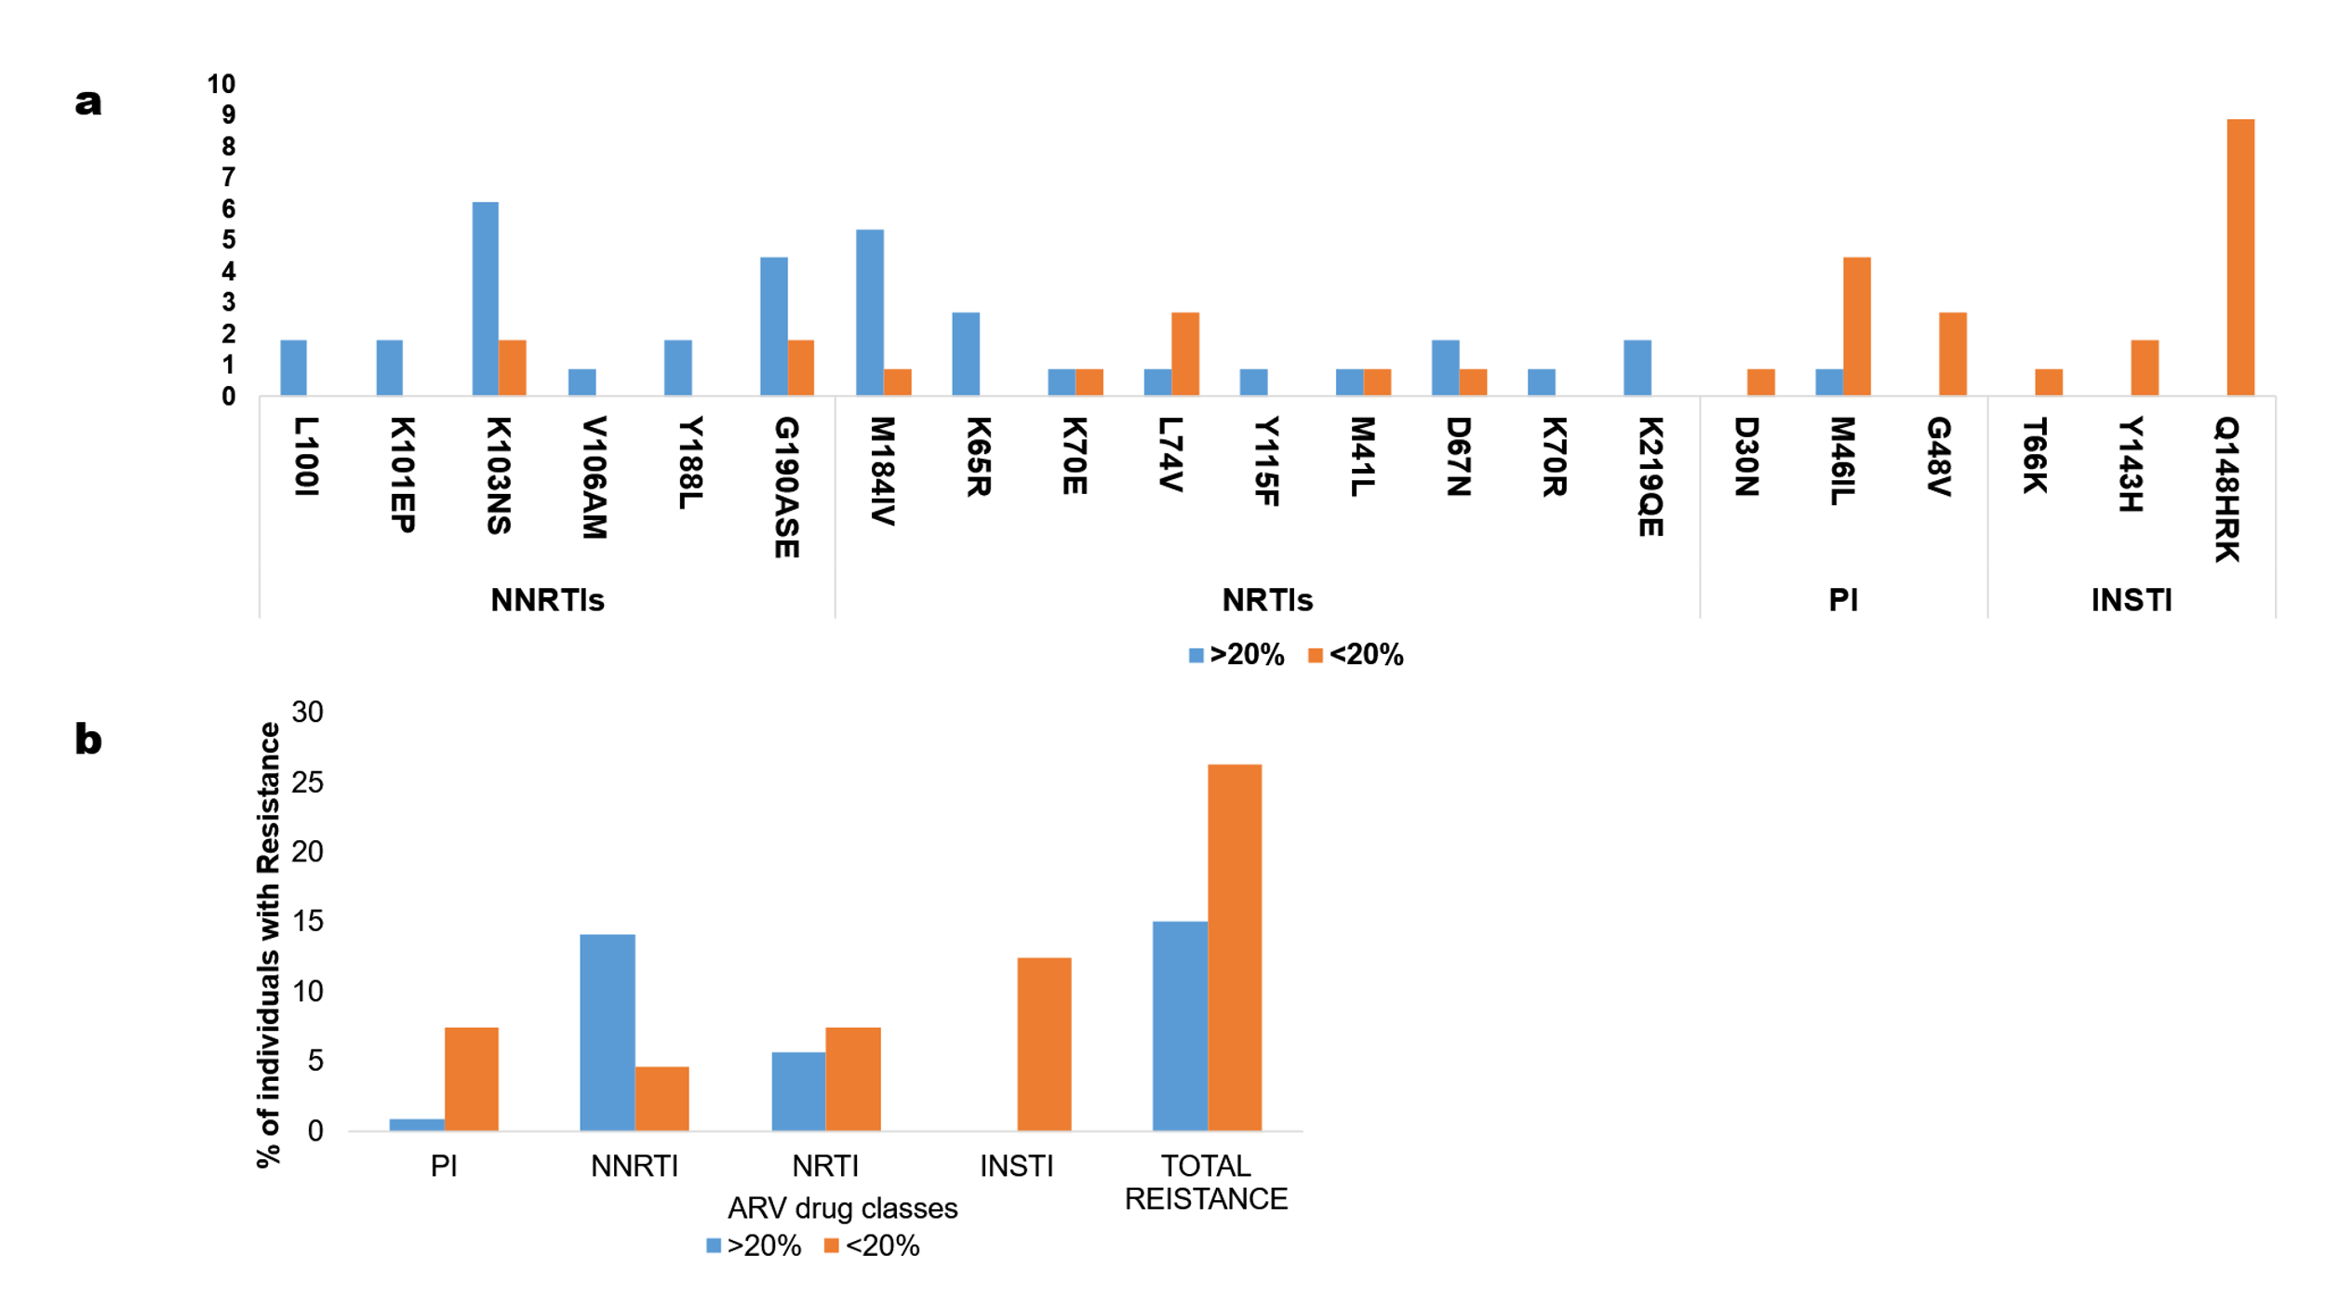
Supplementary Fig. S1. Pretreatment HIV drug resistance profiles.
(a) Distribution of pretreatment HIV drug resistance mutations (HIVDRMs) detected by next-generation sequencing (NGS), categorized as majority variants (≥20%) and minority variants (<20%). Only HIVDRMs detected in the study population are shown; mutations with zero frequency at both majority and minority variant levels are not displayed. Mutations are grouped according to their corresponding antiretroviral drug classes, with horizontal lines indicating class boundaries (NNRTI: L100I–G190ASE; NRTI: M184IV–K219QE; PI: D30N–G48V; INSTI: T66K–Q148HRK).
(b) Intra-class antiretroviral (ARV) drug resistance showing the proportion of individuals with resistanceto each drug class. HIVDRMs were grouped by ARV class and variant frequency (majority ≥20%, minority <20%). Overall resistance represents the proportion of participants with at least one pretreatment HIV drug resistance mutation. PI, protease inhibitors; NNRTI, non-nucleoside reverse transcriptase inhibitors; NRTI, nucleoside reverse transcriptase inhibitors; INSTI, integrase strand transfer inhibitors.

