Readme File for Supplementary Data
Supplementary File: Data.xlsx
Description:
This Excel file contains the raw clinical data of patients included in the study. The dataset includes demographic information, perioperative parameters, and follow-up outcomes.
Sheet Information:
Sheet Name | Content
Sheet1 | Primary dataset of all patients (N=52)
Variable Definitions (Column Headers):
Column | Variable (English) | Variable (Chinese) | Description
A | Patient ID | 患者编号 | Unique identifier for each patient
B | Age (years) | 年龄 | Patient age in years
C | Gender | 性别 | Male / Female
D | Stent type | 支架类型 | Flared-type/ Standard
E | Ureteral wall thickness at impaction site (mm) | 嵌顿处输尿管壁厚度(mm) | Measured at the site of impaction
F | Side of impaction | 嵌顿侧别 | Left / Right
G | Location of impaction | 嵌顿部位 | Upper / Middle / Lower ureter
H | Stone diameter (cm) | 结石直径 | Maximum stone diameter
I | Preoperative APD (mm) | B超肾盂分离前后径 | Anteroposterior diameter of renal pelvis before stenting
J | APD after stent removal (mm) | 支架拔出后 | APD at the time of stent removal
K | APD at 1 month post-removal (mm) | 拔出支架1月 | APD at 1 month after stent removal
L | APD at 3 months post-removal (mm) | 拔出支架3月 | APD at 3 months after stent removal
M | Change in APD at 3 months (mm) | 术后3月APD变化值 | Calculated as Column I - Column L
N | Hydronephrosis grade | 肾积水程度 | Mild / Moderate / Severe
O | Preoperative urine culture | 术前尿培养阳性 | Positive / Negative
P | Presence of polyps | 合并息肉 | Yes / No
Q | Preoperative creatinine (μmol/L) | 术前肌酐水平 | Baseline serum creatinine
R | Creatinine after stenting (μmol/L) | 支架置入术后肌酐水平 | Serum creatinine after stent placement
S | Creatinine at 1 month post-removal (μmol/L) | 术后一月肌酐 | Serum creatinine at 1 month after stent removal
T | Change in creatinine (μmol/L) | 肌酐变化值 | Calculated as Column Q - Column S
U | Low back pain VAS score | 腰痛 VAS 评分 | Visual Analog Scale score for low back pain
V | USSQ hematuria score | USSQ 血尿评分 | Ureteral Stent Symptom Questionnaire — hematuria domain
W | USSQ urinary symptoms score | USSQ 膀胱刺激症状评分 | USSQ — urinary symptoms domain
X | QOL score | QOL 评分 | Quality of Life score
Y | Stent indwelling time (days) | 支架管留置时间 | Duration of stent placement in days
Z | Change in hemoglobin (g/L) | 血红蛋白变化值 | Change in hemoglobin level from baseline

Supplementary File 2:Flared-type stent__image.jpg,KUB-Flared-type stent__image.jpg
Description:
This image highlights the flared-type design of the Flared-type ureteral stent used in this study.
Key Feature Shown in the Image:
- 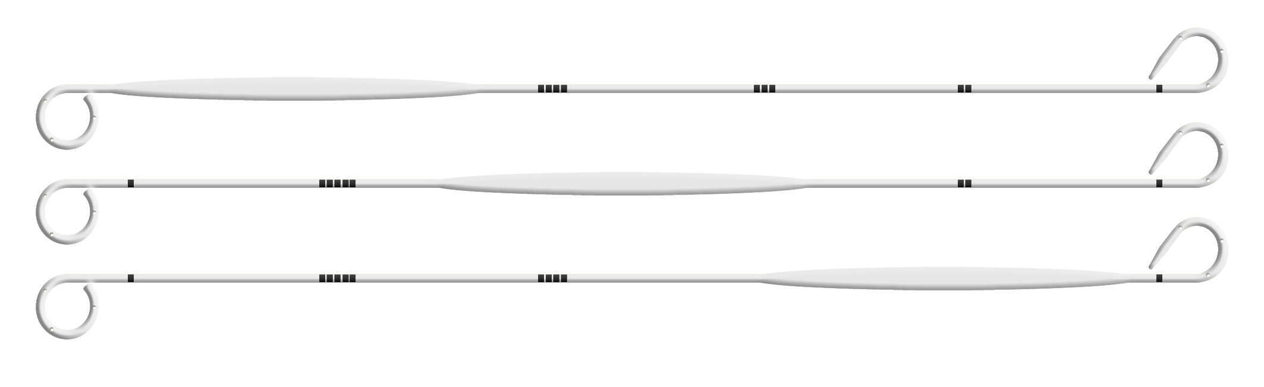
Flared-type ureteral stent configuration at the distal/proximal end of the stent

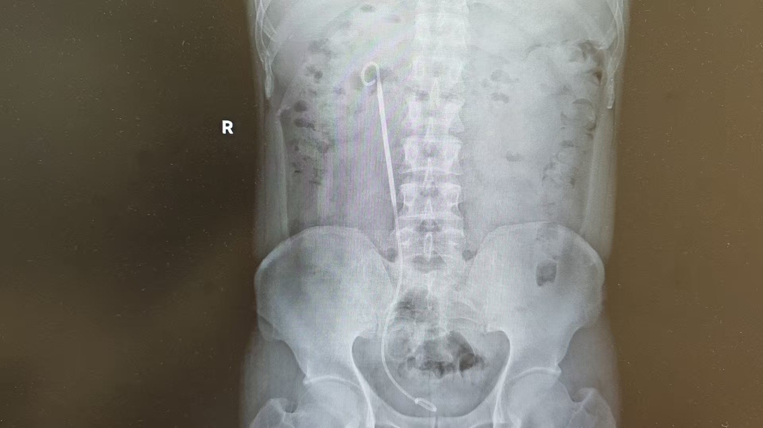
- A representative KUB image showing the position of theFlared-type ureteral stent after placement
Correspondence:
For any questions regarding this supplementary data, please contact the corresponding author.

