Supplementary Figures
For: An ET-dependent VPD threshold frontier of cropland water–carbon coupling and its modulation by deep soil water under salinized irrigation

Supplementary Figure S1. Monthly evolution of ET, GPP, mean VPD excess, and exceedance frequency during the growing season.
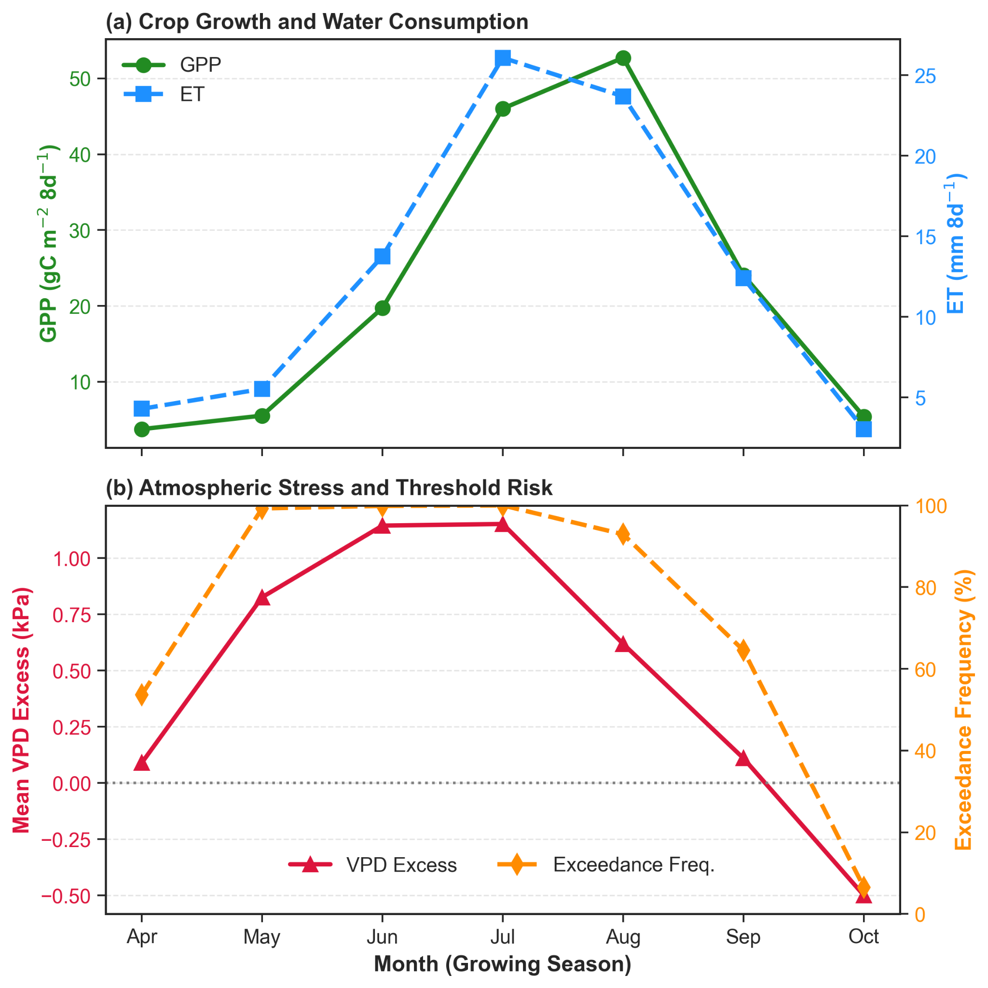
Supplementary Figure S2. Joint density distribution of ET and VPD.
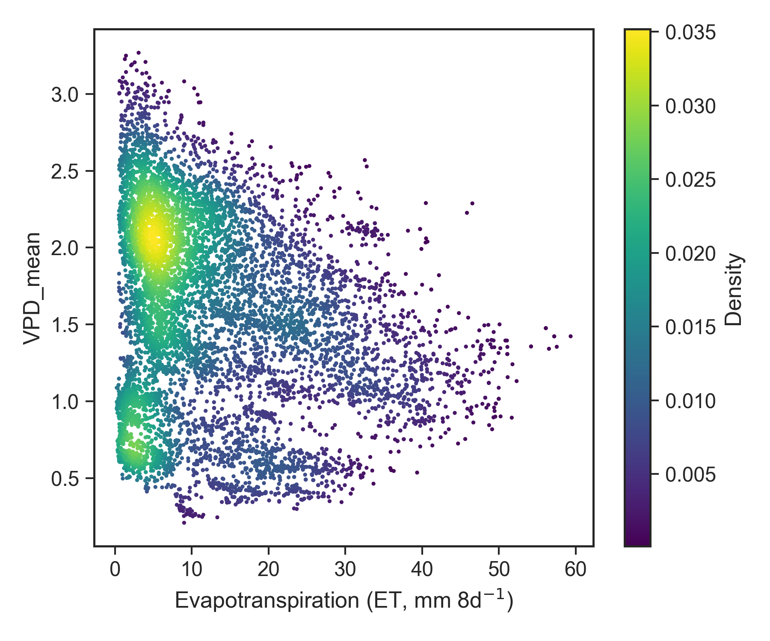
Supplementary Figure S3. Joint density distribution of ET and deep soil water availability index (DSWI).
