Table S1 The diffusion parameter values analysis within the different lesions types.
 | MS- |  | MS+ |  | p
 | P_WML | NP_WML | P_WML | NP_WML | p
FAindex | 0.92 (0.73, 1.11) | 0.95 (0.70, 1.14) | 0.91 (0.72, 1.10) | 0.91 (0.67, 1.17) | 0.640
KFAindex | 0.96 (0.82, 1.11) | 0.97 (0.84, 1.11) | 0.94 (0.81, 1.12) | 0.98 (0.82, 1.12) | 0.459
MDindex | 5.24 (4.67, 5.82) | 5.11 (4.60, 5.81) | 5.12 (4.54, 5.77) | 4.92 (4.28, 5.53) | 0.003
MKindex | 0.85 (0.77, 0.96) | 0.90 (0.79, 1.00) | 0.89 (0.80, 0.99) | 0.93 (0.81, 1.07) | <0.001
Note: The p-values indicate the overall differences among four lesion groups (Kruskal-Wallis H test). MS-: patients with relapsing-remitting multiple sclerosis not receiving disease-modifying therapies; MS+: patients with relapsing-remitting multiple sclerosis receiving disease-modifying therapies; P_WML, perivascular space penetrating white matter lesions; NP_WML, non-perivascular space penetrating white matter lesions; FA, fractional anisotropy; KFA, kurtosis fractional anisotropy; MD, mean diffusivity; MK, mean kurtosis.

Table S2 The correlation between the diffusion parameter values and clinical performance.
 |  |  | SDMT |  | MMSE |  | DST |  | MoCA |  | EDSS
 |  |  | r | p | r | p | r | p | r | p | r | p
MS- | P-WML | FA_{index} | -0.126 | 0.596 | 0.164 | 0.482 | 0.028 | 0.919 | 0.273 | 0.177 | -0.173 | 0.450
MS- | P-WML | KFA_{index} | -0.008 | 0.967 | 0.290 | 0.138 | -0.113 | 0.643 | 0.296 | 0.127 | -0.429 | 0.011
MS- | P-WML | MD_{index} | -0.070 | 0.801 | -0.134 | 0.580 | -0.018 | 0.929 | -0.034 | 0.905 | 0.127 | 0.593
MS- | P-WML | MK_{index} | 0.023 | 0.925 | 0.024 | 0.925 | -0.225 | 0.287 | 0.096 | 0.695 | -0.263 | 0.194
MS- | NP-WML | FA_{index} | -0.207 | 0.341 | 0.198 | 0.367 | -0.078 | 0.772 | 0.245 | 0.234 | -0.108 | 0.666
MS- | NP-WML | KFA_{index} | 0.022 | 0.925 | 0.377 | 0.033 | -0.127 | 0.593 | 0.338 | 0.066 | -0.265 | 0.190
MS- | NP-WML | MD_{index} | -0.104 | 0.678 | -0.182 | 0.419 | 0.007 | 0.967 | -0.069 | 0.803 | 0.134 | 0.581
MS- | NP-WML | MK_{index} | -0.043 | 0.891 | 0.173 | 0.450 | -0.152 | 0.516 | 0.164 | 0.482 | -0.197 | 0.367
MS+ | P-WML | FA_{index} | 0.172 | 0.602 | -0.116 | 0.734 | 0.085 | 0.804 | -0.354 | 0.209 | -0.272 | 0.365
MS+ | P-WML | KFA_{index} | -0.110 | 0.749 | 0.175 | 0.599 | 0.208 | 0.524 | -0.074 | 0.833 | -0.104 | 0.760
MS+ | P-WML | MD_{index} | 0.098 | 0.772 | -0.243 | 0.444 | -0.181 | 0.585 | 0.293 | 0.325 | 0.363 | 0.193
MS+ | P-WML | MK_{index} | 0.042 | 0.892 | 0.203 | 0.531 | 0.236 | 0.461 | -0.277 | 0.354 | -0.500 | 0.049
MS+ | NP-WML | FA_{index} | 0.141 | 0.668 | -0.053 | 0.874 | 0.214 | 0.511 | 0.118 | 0.734 | -0.234 | 0.461
MS+ | NP-WML | KFA_{index} | 0.069 | 0.834 | -0.018 | 0.962 | 0.204 | 0.531 | 0.036 | 0.913 | 0.012 | 0.974
MS+ | NP-WML | MD_{index} | -0.044 | 0.892 | -0.122 | 0.723 | -0.231 | 0.461 | -0.165 | 0.622 | 0.160 | 0.631
MS+ | NP-WML | MK_{index} | 0.142 | 0.666 | 0.239 | 0.454 | 0.377 | 0.170 | 0.117 | 0.734 | -0.473 | 0.068
Spearman's Rho correlation: Bold values denote statistic significance (P < 0.05). MS-: patients with relapsing-remitting multiple sclerosis not receiving disease-modifying therapies; MS+: patients with relapsing-remitting multiple sclerosis receiving disease-modifying therapies; FA, fractional anisotropy; KFA, kurtosis fractional anisotropy; MD, mean diffusivity; MK, mean kurtosis; SDMT, Symbol Digit Modalities Test; MMSE, Mini-Mental State Examination; DST, Digit Span Test; MoCA, the Montreal Cognitive Assessment; EDSS, Expanded Disability Status Scale.

Table S3 The patient-wise correlation between WML metrics and diffusion values.
 |  | P_WML |  |  |  | NP_WML
 |  | FAindex | KFAindex | MDindex | MKindex | FAindex | KFAindex | MDindex | MKindex
 |  | r;  p | r;  p | r;  p | r;  p | r;  p | r;  p | r;  p | r;  p
MS- | No. of WML | -0.001; | -0.037; | -0.128; | 0.046; | -0.038; | -0.070; | -0.022; | 0.020;
MS- | No. of WML | 0.994 | 0.899 | 0.593 | 0.885 | 0.899 | 0.801 | 0.925 | 0.925
MS- | WML volume | -0.214; | -0.144; | 0.124; | -0.229; | 0.105; | 0.062; | -0.045; | 0.101;
MS- | WML volume | 0.316 | 0.539 | 0.599 | 0.278 | 0.676 | 0.828 | 0.885 | 0.685
MS- | P_WML volume | -0.253; | -0.158; | 0.160; | -0.267; | 0.092; | 0.042; | -0.034; | 0.103;
MS- | P_WML volume | 0.216 | 0.499 | 0.495 | 0.186 | 0.711 | 0.891 | 0.905 | 0.681
MS- | NP_WML volume | 0.049; | -0.049; | -0.193; | 0.062; | 0.054; | 0.007; | 0.036; | -0.037;
MS- | NP_WML volume | 0.876 | 0.876 | 0.382 | 0.828 | 0.863 | 0.967 | 0.899 | 0.899
MS+ | No. of WML | -0.391; | -0.095; | 0.031; | -0.070; | -0.459; | -0.414; | 0.436; | -0.408;
MS+ | No. of WML | 0.15 | 0.778 | 0.927 | 0.834 | 0.078 | 0.120 | 0.096 | 0.126
MS+ | WML volume | -0.309; | 0.010; | 0.107; | -0.132; | -0.549; | -0.498; | 0.474; | -0.498;
MS+ | WML volume | 0.294 | 0.976 | 0.751 | 0.687 | 0.026 | 0.049 | 0.068 | 0.049
MS+ | P_WML volume | -0.309; | -0.001; | 0.139; | -0.163; | -0.534; | -0.505; | 0.509; | -0.506;
MS+ | P_WML volume | 0.294 | 0.998 | 0.672 | 0.622 | 0.031 | 0.046 | 0.044 | 0.046
MS+ | NP_WML volume | -0.230; | 0.051; | -0.101; | 0.085; | -0.448; | -0.436; | 0.191; | -0.272;
MS+ | NP_WML volume | 0.461 | 0.881 | 0.765 | 0.804 | 0.086 | 0.096 | 0.564 | 0.365
Spearman's Rho correlation: Bold values denote statistic significance (P < 0.05). P_WML, perivascular space penetrating white matter lesions; NP_WML, non-perivascular space penetrating white matter lesions; FA, fractional anisotropy; KFA, kurtosis fractional anisotropy; MD, mean diffusivity; MK, mean kurtosis; MS-: patients with relapsing-remitting multiple sclerosis not receiving disease-modifying therapies; MS+: patients with relapsing-remitting multiple sclerosis receiving disease-modifying therapies; No. of WML represents the number of white matter lesions.

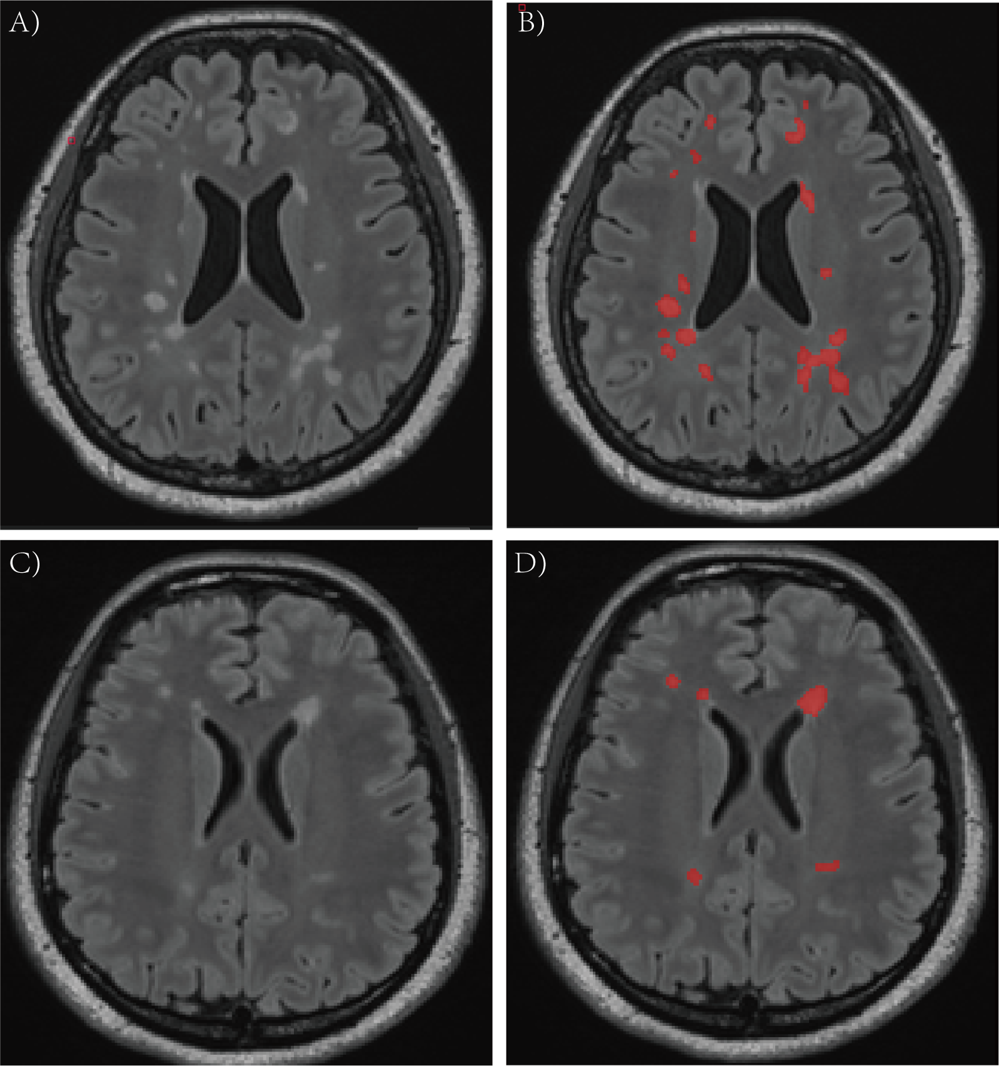

Fig. S1 Examples of segmentation of white matter lesions in two patients with multiple sclerosis. (A, C) Original FLAIR images. (B, D) FLAIR images with lesion segmentation overlaid.
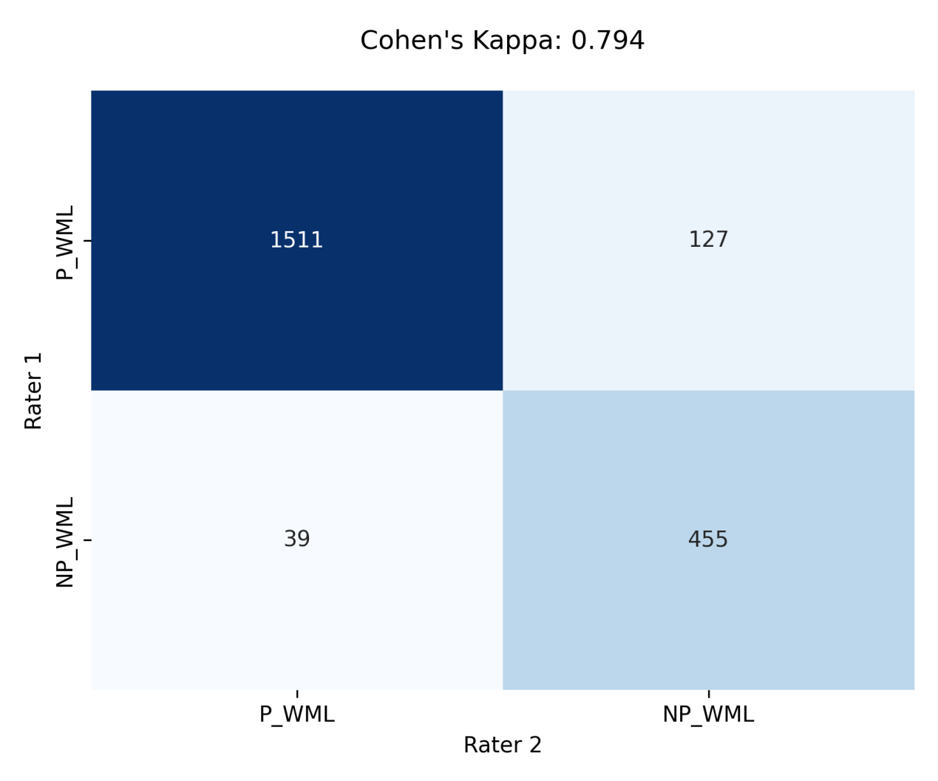

Fig. S2 Confusion matrix illustrates the inter-rater agreement between two independent raters classifying white matter lesions as P_WML or NP_WML. P_WML, perivascular space penetrating white matter lesions; NP_WML, non-perivascular space penetrating white matter lesions.

