Supplementary Data
Elucidation of Inflammatory-Fibrotic Microenvironment in Urethral Stricture Disease
Varshiny Gopinath^{1,2,4} , Manesh Kumar Panner Selvam⁵, Jill Buckley², Jennifer Anger², Kyoko Sakamoto¹, Nirav Patel³, Ratnesh Lal³, Michael Witthaus⁶, Mahadevan Rajasekaran^{1,2}*
¹ VA San Diego Healthcare System, San Diego, USA,
² Department of Urology, School of Medicine, UC San Diego, San Diego, USA,
³ Department of Mechanical Engineering and Department of Bioengineering, School of Engineering, UC San Diego, San Diego, USA
⁴ Department of Biotechnology, Bhupat and Jyoti Mehta School of Biosciences, Indian Institute of Technology Madras, Chennai 600036, Tamil Nadu, India
⁵ Department of Urology, Tulane University School of Medicine, New Orleans, USA
⁶Department of Surgery, University of Maryland School of Medicine, Baltimore, USA
Corresponding author email: mrajasekaran@health.ucsd.edu

Supplementary Figures
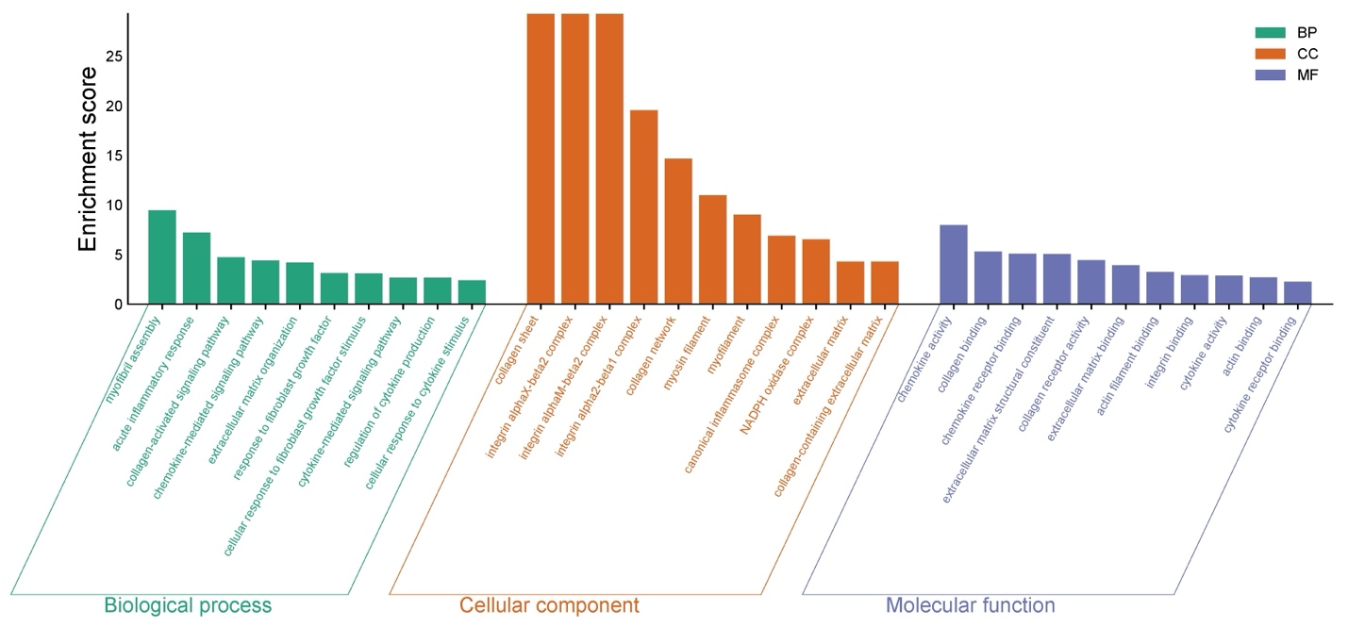

Figure SF1: Gene ontology representing biological processes (BP, green), cellular components (CC, orange), and molecular functions (MF, blue).
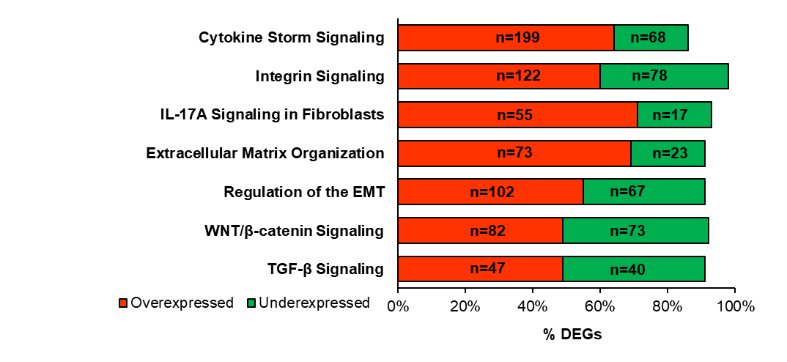
Figure SF2: Pathway enrichment analysis of differentially expressed genes in USD.
Figure SF3: Western blot analysis depicting protein expression bands from control and USD patient samples.

S1. Materials and Reagents
The V-PLEX Proinflammatory Panel 1 Human Kit and MSD Discovery Workbench Software (version 4.0 or current) were obtained from Meso Scale Diagnostics (Rockville, MD, USA); the RNeasy Plus Mini Kit was purchased from Qiagen (CA, USA). Atomic force microscopy (AFM) studies were conducted on a Multimode AFM equipped with a Nanoscope V controller and J scanner (Bruker, USA), using SNL-10 probes (nominal spring constant of 0.06 – 0.12 N/m, and tip radius of 12 nm). Primary antibodies included anti-vimentin monoclonal and anti-elastin from Abcam (CA, USA), anti-collagen type I from Sigma-Aldrich, and anti-TGF-β from R&D Systems. Secondary antibodies were goat anti-mouse IgG (H+L) Alexa Fluor 488 or 555 conjugate and goat anti-rabbit IgG (H+L) Alexa Fluor 488 or 555 conjugate (Invitrogen; catalog numbers A-11008, A-21429). GraphPad Prism (version 9.0 or current; GraphPad Software, San Diego, CA, USA) was used for statistical analysis.
S2. Detailed Methods
S2.1 Patient sample collection:
USD patients and non-stricture controls were recruited according to institutional inclusion and exclusion criteria. Urine samples were collected from all participants during routine clinical evaluation in sterile containers and stored at -80°C for subsequent cytokine analysis. All tissue samples were immediately placed in RNAlater (or appropriate preservation buffer) to maintain RNA integrity, then stored at -80°C until processing.
For the cytokine analysis: The clarified supernatant was carefully transferred to sterile tubes and stored at -80°C until assay. On the day of analysis, samples were thawed. No dilutions were made.
S2.2 RNA Extraction and Sequencing:
RNA quality was evaluated on an Agilent TapeStation 4200, selecting samples with RNA integrity number (RIN) >8.0 for library construction via the Illumina Stranded mRNA Prep kit (Illumina, San Diego, CA). Libraries underwent multiplexing and paired-end sequencing at 150 bp read length (PE150), targeting ~25 million reads per sample on the Illumina NovaSeq X Plus. Demultiplexing employed bcl2fastq v2.20.0.422 (Illumina, San Diego, CA), with run parameters of PE100 for stranded mRNA at 30 million reads/sample. Raw sequencing reads (FASTQ files) were analyzed using the QIAGEN Ingenuity Pathway Analysis (IPA) RNA-seq analysis portal to identify differentially expressed genes (DEGs). The resulting DEG lists were imported into the IPA software for downstream interpretation¹. Upstream Regulator Analysis was subsequently applied to identify putative regulatory molecules and genes implicated in mechanotransduction pathways relevant to the pathogenesis of USD².
S2.3 Immunohistochemistry and Immunofluorescence Staining
Urethral tissue sections (5-10 μm) were cryosectioned and immediately fixed with 4% paraformaldehyde. They were then treated with 0.25% Triton-X to facilitate permeabilization. 5 % Bovine serum albumin was used to block non-specific binding sites, and tissues were then incubated with specific primary mouse monoclonal antibodies (anti-collagen type 1/ TGF- β/ elastin/vimentin (1:500) for 2.5 hr. This was followed by fluorescent labeling with FITC-tagged anti-mouse/Texas Red-tagged secondary antibodies for another 90 min and then with nuclear stain DAPI for 15 min. The samples were imaged using a Keyence automated microscope at excitation/emission wavelengths of 420/520 nm for collagen type I and elastin, 544/590 nm for vimentin and TGF- β, and 350/460 nm for DAPI. Histochemical staining (Verhoeff staining for elastin, Sirius Red staining for collagen) was also performed following established protocols.
S2.4 Western Blot Analysis
Total protein was extracted using RIPA lysis buffer containing protease and phosphatase inhibitors and protein concentration was determined using Bradford assay. Equal amounts of protein (typically 20-50 μg) from each sample were separated by sodium dodecyl sulfate-polyacrylamide gel electrophoresis (SDS-PAGE) on 8-12% gels and transferred to polyvinylidene difluoride (PVDF) membranes. Membranes were blocked with 5% non-fat milk or bovine serum albumin in Tris-buffered saline with Tween-20 (TBST), then incubated with primary antibodies against target proteins (p-SMAD2/3, TGF-β, COL1A1, and appropriate loading control such as GAPDH) overnight at 4°C. Secondary antibodies conjugated to horseradish peroxidase were applied, and protein bands were visualized using chemiluminescent detection. Comparative analysis was performed between USD and control samples, and statistical significance was assessed using appropriate statistical tests.
References
1. Meecham A, McCurdy S, Frias-Anaya E, et al. Silencing KRIT1 Partially Reverses the Effects of Disturbed Flow on the Endothelial Cell Transcriptome. bioRxiv. Published online March 14, 2025:2025.03.12.642862. doi:10.1101/2025.03.12.642862
2. Payne SR, Anderson P, Spasojević N, Demilow TL, Teferi G, Dickerson D. Male urethral stricture disease: why management guidelines are challenging in low-income countries. BJU Int. 2022;130(2):157-165. doi:10.1111/bju.15831

