Figure S1.1: H¹NMR and C¹³NMR of structure of glycyrrhetinic acid

Figure S1. 2: LCMSMS negative and positive mode of structure of glycyrrhetinic acid

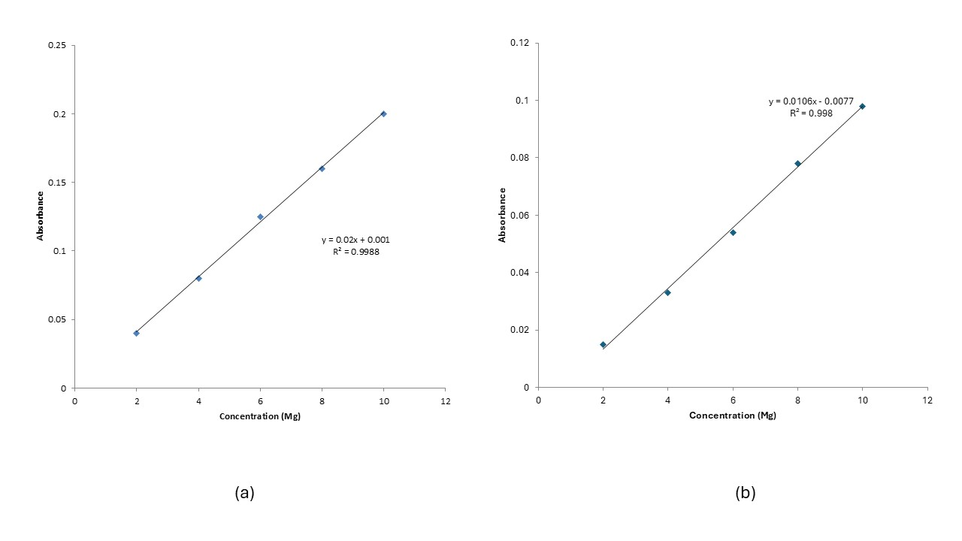
Figure S2: (a) Clibration Curve of Liquorice in PBS (pH 5.5) (b) Clibration Curve of Liquorice in PBS (pH 7.4).

Table S1. Phytochemical screening of Liquorice and their fractions.
Groups | Glycyrrhiza glabra
Groups | Total | Pet. ether | CH₂CL₂ | EtOAc | Butanol | H₂O
Volatile Oils | ˉ | - | - | - | - | -
Carbohydrate | +++ | - | - | + | + | +++
Tannins | +++ | - | - | +++ | +++ | +++
Flavonoids, NaOH | +++ | - | - | ++ | +++ | +
Flavonoids (Shinoda test) | +++ | - | - | + | +++ | ++
Saponin | +++ | - | ++ | ++ | +++ | +++
Sterol and / or triterpenes | ++ | + | +++ | - | - | -
Coumarins | +++ | - | ++ | + | ++ | -
Alkaloids | ++ | + | +++ | ++ | + | -
(++), (+) and (-) refer to high, low and absente amount respectively

Table (S2) Comparative DPPH antioxidant activity of glycyrrhetinic acid with GG.
Sample/DPPH Conc µg/ml | vit C | trolox | EtOAc | Pet. Ether | CH₂CL₂ | Total | BuOH | Glycyrrhetinic acid
30 | 100 ± 0.00 | 100.00 ± 0.00 | - | - | - | - | - | 88.26 ± 0.96
20 | 78.8 ± 0.56 | 80.35 ± 0.52 | 85.18 ± 0.07 | 85.48 ± 0.07 | 79.17 ± 0.12 | 75.58 ± 0.07 | 85.82 ± 0.00 | 70.30 ± 0.03
15 | 70.91± 0.89 | 75.58 ± 0.75 | 81.29 ± 0.07 | 84.98 ± 0.14 | 67.80 ± 0.00 | 60.27 ± 0.00 | 86.56 ± 0.00 | 60.99 ±0.94
10 | 70.91 ±0.94 | 60.59 ± 0.85 | 80.40 ± 0.09 | 82.62 ± 0.09 | 61.35 ± 0.09 | 43.13 ± 0.15 | 83.06 ± 0.09 | 40.27 ± 0.05
5 | 70.91 ± 0.33 | 37.20 ± 0.42 | 77.45 ± 0.09 | 47.96 ± 0.31 | 40.87 ± 0.09 | 34.86 ± 0.00 | 81.88 ± 0.09 | 33.29 ± 0.07
2.5 | 70.91 ± 0.52 | 30.55 ± 0.96 | 62.40 ± 0.12 | - | - | - | 75.37 ± 0.23 | -
1.5 | - | - | 55.59 ± 0.23 | - | - | - | 69.48 ± 0.30 | -
1 | - | - | 46.26 ±0.12 | - | - | - | 55.59 ± 0.30 | -
IC50 | 7.808 | 6.316 | 1.11 | 4.982 | 6.919 | 9.968 | 0.4456 | 10.5

Table(S3) Comparative ABTS⁺ antioxidant activity of glycyrrhetinic acid with GG.
Sample/ABTS Conc µg/ml | vit C | trolox | EtOAc | Pet. Ether | CH₂CL₂ | Total | BuOH | Glycyrrhetinic acid
30 | 100 ± 0.00 | 100 ± 0.00 | - | - | - | - | - | 88.26 ± 0.96
20 | 90.23 ± 0.85 | 83.55 ± 0.81 | 89.94 ± 0.13 | 86.61 ± 0.13 | 79.17 ± 0.12 | 75.58 ± 0.07 | 85.82 ± 0.00 | 70.30 ± 0.03
15 | 83.63 ±0.86 | 80.77 ± 1.02 | 89.66 ± 0.13 | 84.12 ± 0.34 | 67.80 ± 0.00 | 60.27 ± 0.00 | 86.56 ± 0.00 | 60.99 ± 0.94
10 | 70.03 ± 0.99 | 73.42 ± 0.85 | 89.01 ± 0.15 | 80.70 ± 1.39 | 61.35 ± 0.09 | 43.13 ± 0.15 | 83.06 ± 0.09 | 40.27 ± 0.05
5 | 56.19 ± 0.25 | 45.21 ± 0.89 | 87.90 ± 0.15 | 74.79 ± 0.00 | 40.87 ± 0.09 | 34.86 ± 0.00 | 81.88 ± 0.09 | 33.29 ± 0.07
2.5 | 20.52 ± 0.65 | 24.2 ± 0.85 | 62.40 ± 0.11 | 50.23 ± 0.13 | - | - | 75.37 ± 0.23 | -
1.5 | - | - | 55.59 ± 0.23 | 41.33 ± 0.09 | - | - | 69.48 ± 0.30 | -
1 | - | - | 46.26 ± 0.11 | 31.25 ± 0.01 | - | - | 55.59 ± 0.23 | -
IC50 | 5.043 | 5.482 | 1.194 | 2.199 | 0.5323 | 5.643 | 0.6639 | 9.774

LCMSMS in Details
An ion-trap mass spectrometer (Esquire 3000, Bruker Daltonics) equipped with an electrospray ionization (ESI) source was used for liquid chromatography-mass spectrometry (LC-MS) analysis. The instrument was operated in both positive and negative ion modes. Key parameters included a nebulizer pressure of 30 psi, nitrogen (N₂) as the dry gas at 9.0 L/min, and a dry gas temperature of 310 °C. The skimmer voltage was set to –10.0 V. Data were acquired over a mass-to-charge (m/z) range of 150–3000 with a scan rate of 13,000 m/z/s [26, 27].
High-resolution profiling was performed using ultra-performance liquid chromatography (UPLC; Acquity System, Waters, USA) coupled with a hybrid quadrupole-Orbitrap mass spectrometer (Q-Exactive, Thermo Fisher Scientific, Germany). Separation was achieved on a BEH Shield RP18 column (150 × 2.1 mm, 1.7 μm) using a binary solvent system of 0.1% formic acid in deionized water (Solvent A) and acetonitrile (Solvent B). The elution gradient was programmed as follows: 5–50% B (0–14 min), ramped to 98% B (14–20 min), held for 5 min, followed by re-equilibration to initial conditions over 3 min. The flow rate was maintained at 0.4 mL/min. The Q-Exactive operated in both positive and negative modes with a heated ESI (HESI) source using a spray voltage of ±3.0 kV. Sheath gas flow (N₂) was set to 48 L/min, auxiliary gas to 13 L/min, capillary temperature to 250 °C, and auxiliary heater temperature to 380 °C. Collision-induced dissociation (CID) experiments were performed at 15 eV [27]. Mass spectral fragmentations of 60 ion mobility MS/MS scans were processed using MS-DIAL 4.60 after conversion to ABF format. Metabolites were identified by comparing fragmentation patterns and retention indices with reference databases (MassBank, Knapsack Golm, Fiehn Bin Base, RIKEN, LipidBlast) [28, 29].

MS-DIAL molecular spectrum networking was applied to facilitate metabolite annotation and visualization of fragmentation similarities. This approach allowed clustering of structurally related compounds and improved confidence in metabolite identification by integrating spectral alignment, retention time, and library matching. The networking results provided a comprehensive overview of molecular relationships within the dataset, enhancing interpretation of complex metabolomic profiles. MS-DIAL molecular spectrum networking

Surface Morphology (SEM and TEM) in Details
The morphological characteristics of the optimized NSs were examined using TEM (JEOL Co., JEM-2100, Japan). A drop of the diluted sample was placed on a carbon-coated copper grid and left to dry for 15 minutes at room temperature. The grid was then stained with 1% (w/v) phosphotungstic acid for three minutes before imaging. The samples were analyzed under TEM at different magnifications to assess surface features and overall shape [16].
The surface structure of the optimized formulations was further investigated by SEM (Quanta FEG 250, Thermo Fisher Scientific Co., Czech Republic). Freeze-dried samples were fixed onto aluminum stubs with double-sided tape and coated with a thin layer of gold. Imaging was performed at a working distance of 10 mm with an accelerating voltage of 20 kV [34].

