Supplementary Information

Beyond the Last Sip: Unlocking Antioxidant Potential from Spent Yerba Mate through Thermochemical Pathways.
María Milagros Vicho^{1‡}, Débora A. López^{1‡}, Renata Bence^{2‡}, Rodrigo E. Dominguez^{1,3‡}, María Verónica Baroni², Natividad Herrera Cano², and E. Laura Moyano^{1*}
¹ INFIQC/CONICET - Departamento de Química Orgánica, Facultad de Ciencias Químicas, Universidad Nacional de Córdoba, Córdoba, Argentina.
² ICYTAC/CONICET - Departamento de Química Orgánica, Facultad de Ciencias Químicas, Universidad Nacional de Córdoba, Córdoba, Argentina.
³ Present address: Medical Devices and Methods Laboratory, Health Futures Center, Arizona State University, 6161 E. Mayo Blvd., Phoenix, AZ 85054, U.S.A.
‡These authors contributed equally to this work.
*Corresponding author email address: e.laura.moyano@unc.edu.ar

This file contains 3 pages, including Table S1, Fig. S1, Fig. S2 and Table S2.

Table S1. UPLC-MS/MS Triple Quadrupole Acquisition Parameters for Analyzed Compounds.
Name | Ret time (min) | Precursor ion (m/z) |  | CE (eV) | Cone (V) | Quantification trace
Name | Ret time (min) | [M+H]⁺ | [M–H]⁻ | CE (eV) | Cone (V) | Quantification trace
Gallic acid | 0.96 |  | 169 | 15 | 35 | 169 > 125
Theobromine | 1.97 | 181 |  | 18 | 16 | 181 > 138
Protocatechuic acid (PCA) | 2.68 |  | 153 | 15 | 35 | 153 > 109
3-CQA | 2.74 |  | 353 | 15 | 20 | 353 > 191
5-CQA | 3.72 |  | 353 | 15 | 20 | 353 > 191
4-CQA | 3.8 |  | 353 | 15 | 20 | 353 > 173
Caffein | 3.82 | 195 |  | 18 | 16 | 195 > 138
3-FQA | 3.87 |  | 367 | 15 | 20 | 367 > 193
Caffeic acid | 4.16 | 181 |  | 8 | 22 | 181 > 163
5-FQA | 4.49 |  | 367 | 15 | 20 | 367 > 173
Rutin | 4.74 |  | 609 | 22 | 80 | 609 > 300
Isoquercetin | 4.95 |  | 463 | 22 | 80 | 463 > 300
Kaempf-rutinoside | 5.06 | 593 |  | 22 | 30 | 593 > 285

Table S2. Properties of unused yerba mate (YM).
Analysis |  | YM
Proximate analysis (wt.%)ª | Ash | 4.05
Proximate analysis (wt.%)ª | Fixed carbon | 19.82
Proximate analysis (wt.%)ª | Volatile matter | 76.13
Ultimate analysis (wt.%)ª | C | 80.83
Ultimate analysis (wt.%)ª | H | 7.20
Ultimate analysis (wt.%)ª | N | 2.05
Ultimate analysis (wt.%)ª | O^{b} | 5.87

ª Dry basis.
^{b} Calculated by difference.

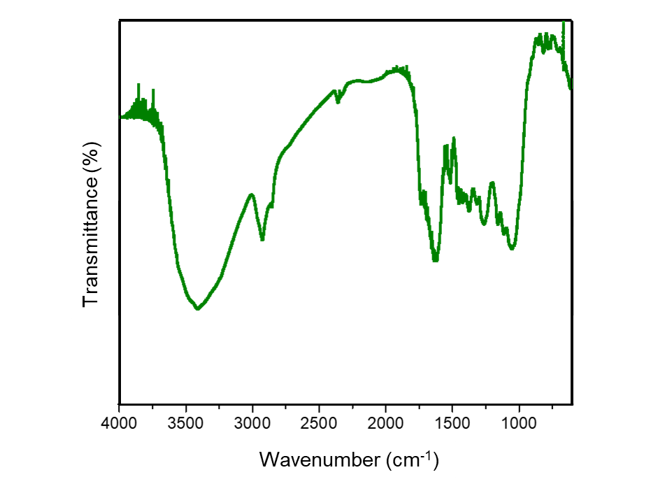
Fig. S1. FT-IR spectra of unused yerba mate.

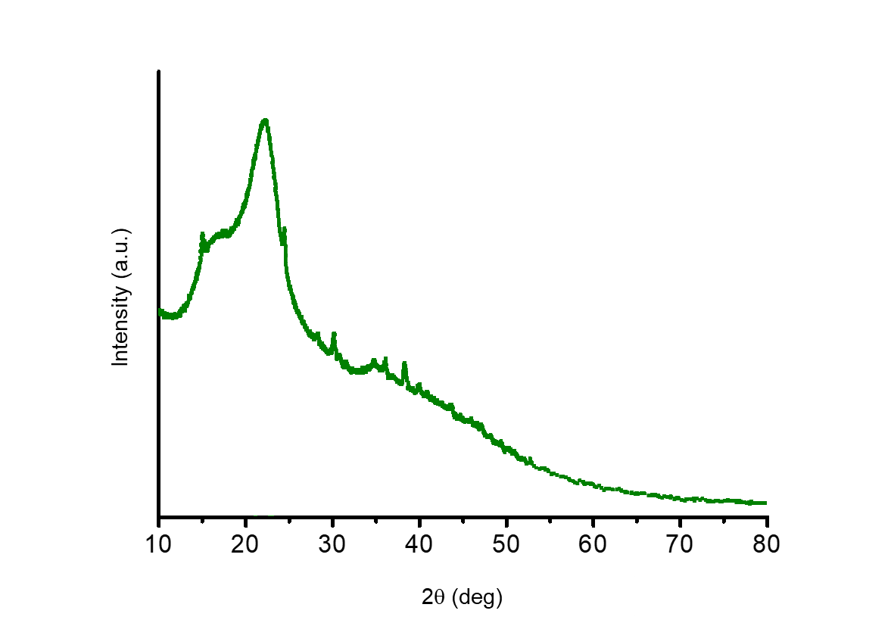
Fig. S2. X-Ray Diffraction Pattern of unsued yerba mate.

