Example conversation between moderator and trainee during acromegaly simulation

Trainee
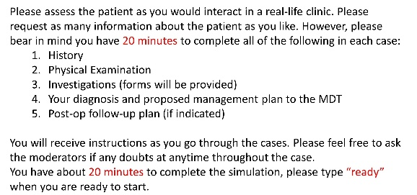
Moderator

Ready
30-year-old woman referred to the endocrine clinic by her dentist who noted facial changed over the last 4 years.
Please assess this patient in your endocrine clinic and request for any information you will need in your assessment.
Good morning. I am Dr. xx. How can I help you today?
Good morning to you too. I am not entirely sure. I believe my doctor has wrote to you and hence I am here.
Okay. Your dentist mentions your facial structure has changed over the last four years. Can you tell me a bit more about when you noticed this and are there any other changes you are aware of?
I noticed it after the dentist mentioned it. My jaw has increased in size. I also noticed tightening of my wedding ring and changes in shoe size from a size 6 to a 7 in the past year. I have also been having headaches and increased sweating.
Have you been diagnosed with any medical conditions?
No
Are you on any medication?
No regular medication
Is there any significant family history?
No family history
What do you do for a living?
* The information you requested is not available – either because it was normal or not relevant to the case.*

You have gathered all the information that is required in the history. What examination would you like to perform for this patient?
Any visual changes? BMI? BP?
Enlargement of her jaw
anterior open bite
BMI: 22.95
BP normal
all other examinations are normal (CVD, cranial nerves – visual fields)
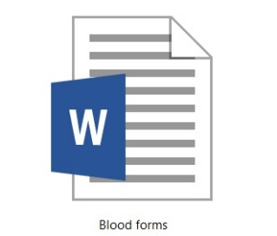
Blood tests please
Please download the form(s) to your laptop. Please tick all the relevant investigations and send it back to the moderator. Results will be provided, and all the irrelevant investigations ordered will not be presented (this might be because that test was not ordered in the real clinical setting).
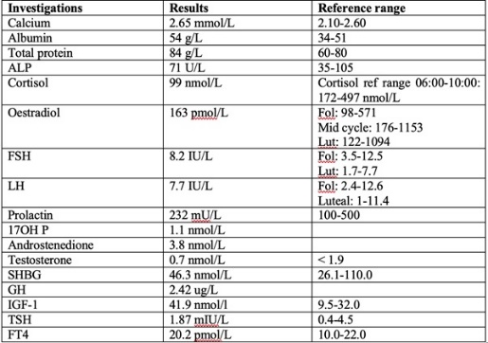
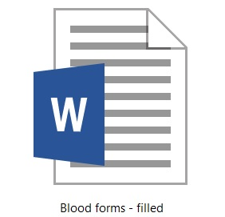

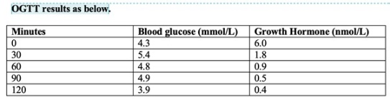
OGTT?
The GH levels presented above are abnormal (low).
Short Synacthen test?
*The information you requested is not available – either because it was normal or not relevant to the case.*
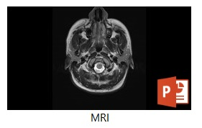
MRI please
Please summarise the MRI findings.
Large pituitary tumour on the right with pressure on chiasm.
You now have all the information required to make a diagnosis for this patient.
Please write to the MDT:
- Summarise your case
- State the diagnosis (and its rationale)
- Propose management plan
Features suggestive of acromegaly with raised IGF-1 levels
With normal OGTT and MRI showing adenoma
Likely to suggest surgery if there are compression effects
MDT
Newly diagnosed acromegaly. GP/self-referral with acromegalic features.
Pituitary adenoma
Size: 18mm x 15mm x 14mm
Location: predominantly right
Consistency: cystic
Cavernous sinus involvement: KNOSP grade 1 on the right
Optic chiasm involvement: none
Normal residual pituitary
MDT outcome: surgery
Operation note:
this procedure (trans-sphenoidal) was completed successfully 6 weeks after her initial presentation.
Please outline your post-op management plan until discharge and long-term follow-up for this patient.
Monitor IGF-1 post-op, monitor osmolalities, repeat MRI in 3 months.
The simulation has ended. Many thanks and the case will be discussed shortly.

