Supporting Information
Turning instability into functionality: Stoichiometry- and moisture-tuned reversible multichromism in ethylammonium perovskites
Aelim Ha^{1,2}, Seunghwan Kim^{1,3}, Kitae Kim^{1,3}, Eunki Yoon^{1,2}, Sooyeon Pak^{1,3}, Yeonjin Yi³, Dongguen Shin⁴, Young Yong Kim^{5,*}, KyuHyoung Lee^{2,*}, and Soohyung Park^{1,6,*}

¹Advanced Analysis Center, Korea Institute of Science and Technology (KIST), Seoul 02792, Republic of Korea
²Department of Materials Science & Engineering, Yonsei University, 50 Yonsei-ro, Seodaemun-gu, Seoul 03722, Republic of Korea
³Department of Physics, Yonsei University, 50 Yonsei-ro, Seodaemun-gu, Seoul 03722, Republic of Korea
⁴Department of Physics, Chonnam National University, 77 Yongbong-ro, Buk-gu, Gwangju 61186, Republic of Korea
⁵Beamline Division, Pohang Accelerator Laboratory, Pohang University of Science and Technology, Pohang, 37673, Republic of Korea
⁶Division of Nano & Information Technology, KIST School, University of Science and Technology (UST), Seoul 02792, Republic of Korea

*Corresponing author e-mail
kimyy@postech.ac.kr, khlee2018@yonsei.ac.kr, soohyung.park@kist.re.kr
TABLE OF CONTENTS
Section 1. Structural identification and compositional analysis 3
Section 1.1. Compositional analysis of EA-based perovskite films by XPS 3
Section 1.2. Structural identification of the pristine [EAI]/[PbI₂] ratio of 1.0 film via comparison with reference EAPbI₃ structure 5
Section 1.3. Comparison with reported EA-based perovskite structures and assignment of the EA₂PbI₄ phase 7
Section 2. Schematics of custom humidity-controlled chambers 8
Section 2.1. Custom humidity-controlled chamber for in-situ GIWAXS measurements. 8
Section 2.2. Custom humidity-controlled chamber for in-situ UV-visible absorption measurements. 9
Section 3. Environmental control performance within the humidity chambers 10
Section 4. Control experiments 11
Section 4.1. PbI₂ control experiments 11
Section 4.2. Beam damage assessment during GIWAXS measurements 13
Section 5. In-situ GIWAXS analysis of humidity-induced dimensionality transformation modulated by EA content 14
Section 6. In-situ UV-visible spectroscopy under humidity modulation 15
Section 6.1. UV-visible data of the [EAI]/[PbI₂] ratio of 2.0 film (related to Fig. 4f) 15
Section 6.2. Composition-dependent evolution of in-situ UV-vis absorption spectra. 16
References 17

Section 1. Structural identification and compositional analysis

Section 1.1. Compositional analysis of EA-based perovskite films by XPS

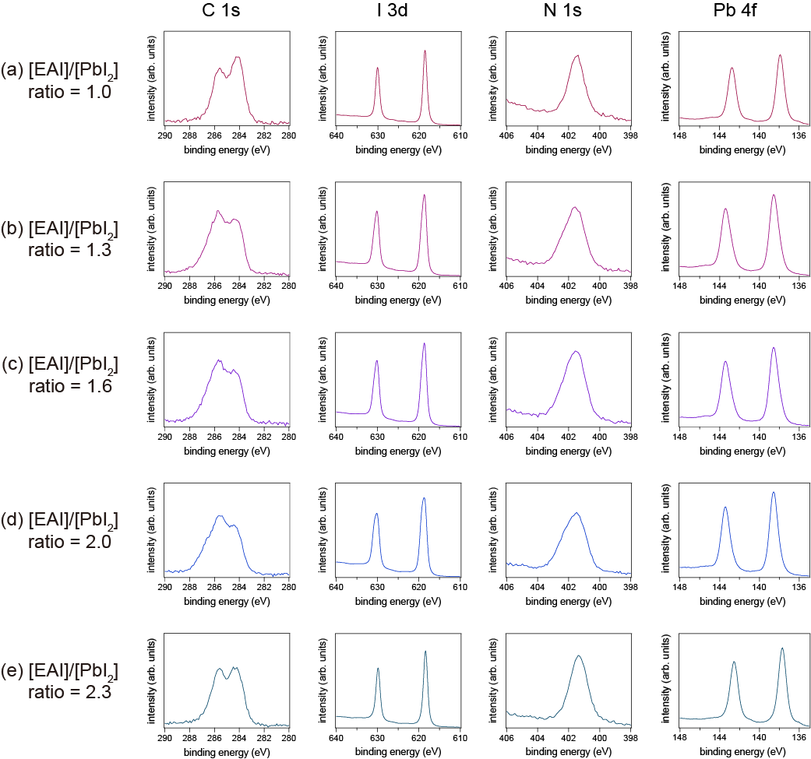

Figure S1. XPS core-level spectra of EA-based perovskite thin films. Evolution of (a–e) C 1s, I 3d, N 1s, and Pb 4f core-level spectra as a function of EA composition (from [EAI]/[PbI₂] ratios of 1.0 to 2.3).
[EAI]/[PbI₂] | - | C (%) | I (%) | N (%) | Pb (%) | Total (%)
1.0 | Ideal ratio | 28.57 | 42.86 | 14.28 | 14.29 | 100
1.0 | XPS ratio | 30.54 | 45.97 | 9.28 | 14.21 | 100
1.3 | Ideal ratio | 31.71 | 40.24 | 15.85 | 12.2 | 100
1.3 | XPS ratio | 36.97 | 40.98 | 13.18 | 8.87 | 100
1.6 | Ideal ratio | 34.04 | 38.3 | 17.02 | 10.64 | 100
1.6 | XPS ratio | 37.38 | 40.58 | 14.57 | 7.47 | 100
2.0 | Ideal ratio | 36.37 | 36.36 | 18.18 | 9.09 | 100
2.0 | XPS ratio | 40.91 | 38.32 | 14.29 | 6.48 | 100
2.3 | Ideal ratio | 37.7 | 35.25 | 18.85 | 8.2 | 100
2.3 | XPS ratio | 39.97 | 38.57 | 14.78 | 6.68 | 100

Table S1. Comparison of nominal and experimental elemental compositions of EA-based perovskite films. Ideal atomic ratios were calculated based on the stoichiometric chemical formulas, while experimental values were determined by XPS analysis of the deposited thin films.

XPS measurements were performed to verify the chemical stoichiometry and structural integrity of the EA-based perovskite films ([EAI]/[PbI₂] ratio of 1.0 to 2.3). To minimize potential photo-induced or environmental degradation, all spectra were acquired immediately after film synthesis with strictly controlled exposure to ambient light. Figure S1 presents the high-resolution C 1s, I 3d, N 1s, and Pb 4f core-level spectra for all compositions. Notably, the Pb 4f region exhibit well-defined doublet peaks without any discernible shoulder features at lower binding energies, confirming the absence of metallic lead (Pb⁰). This indicates that the synthesized films maintain high phase purity without detectable reduction or decomposition during the fabrication process. The quantitative elemental compositions are summarized in Table S1. The atomic ratios derived from the XPS analysis show excellent agreement with the nominal stoichiometric ratios calculated from the respective chemical formulas. These results demonstrate that the intended chemical compositions were successfully preserved in the resulting thin films with negligible stoichiometric deviation.

Section 1.2. Structural identification of the pristine [EAI]/[PbI₂] ratio of 1.0 film via comparison with reference EAPbI₃ structure

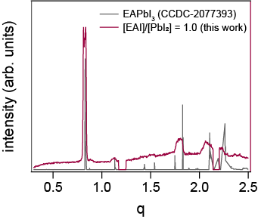

Figure S2. Experimental GIWAXS profile of the pristine [EAI]/[PbI₂] ratio of 1.0 film (purple) compared with the calculated diffraction pattern of the reference EAPbI₃ structure (CCDC-2077393, gray).
The structural identity of the pristine [EAI]/[PbI₂] ratio of 1.0 film was confirmed by direct comparison between its experimental GIWAXS profile and the calculated diffraction pattern of the reference 1D EAPbI₃ structure (CCDC-2077393). As shown in Figure S2, all experimentally observed peak positions (purple) are in excellent agreement with the reference pattern (gray), including the dominant reflection at q = 0.82 Å⁻¹, clearly assigning the [EAI]/[PbI₂] ratio of 1.0 film to the reported EAPbI₃ 1D crystal structure. [1]
 | Nominal formula | Measurement technique | Structural dimensionality | Diffraction (011)_{1D} |  | Diffraction (111)_{1D}
Ref. [1] | EAPbI₃ | XRD | 1D | 2θ (°) | 11.7 | 16.0
 |  |  |  | q (Å⁻¹) | 0.83 | 1.13
This work  ([EAI]/[PbI₂] ratio of 1.0) | EAPbI₃ | GIWAXS | 1D | 0.82 |  | 1.12
Table S2. Structural identification of the 1D phase in [EAI]/[PbI₂] ratio of 1.0 (EAPbI₃) film.
Comparison of the diffraction features (q values) of the synthesized [EAI]/[PbI₂] ratio of 1.0 film with previously reported 1D EAPbI₃ structures. The experimental q values (0.82 Å⁻¹ and 1.12 Å⁻¹) obtained from GIWAXS show an excellent correlation with the characteristic peaks of the 1D phase, confirming the low-dimensional structural identity of the [EAI]/[PbI₂] ratio of 1.0 films. All literature XRD data were converted to the scattering vector q ($q=4π\sin{θ}/λ$) to ensure a consistent comparison across different X-ray sources.

Section 1.3. Comparison with reported EA-based perovskite structures and assignment of the EA₂PbI₄ phase (2D)
 | Nominal formula | Measurement technique | Structural dimensionality | Diffraction (004) |  | Diffraction (006)
Ref. [2] | EAPbI₃ | XRD | 2D or 3D | 2θ (°) | 9.6 | 11.7
 |  |  |  | q (Å⁻¹) | 0.68 | 0.83
Ref. [3] | EA₂PbI₄ | XRD | 2D | 2θ (°) | - | 11.3
 |  |  |  | q (Å⁻¹) | - | 0.80
Ref. [4] | EA₂PbI₄ | XRD | 2D | 2θ (°) | 7.17
 |  |  |  | q (Å⁻¹) | 0.51
This work  ([EAI]/[PbI₂] ratio of EA 2.0) | EA₂PbI₄ | GIWAXS | 2D | 0.54 |  | 0.81
Table S3. Comparison of reported structural features for EA₂PbI₄ phase. Summary of diffraction peaks (q values) for the [EAI]/[PbI₂] ratio of 2.0 (EA₂PbI₄) phase compared with various reported literature values.

As summarized in Table S3, the reported structural data for EA₂PbI₄ ([EAI]/[PbI₂] ratio of 2.0) exhibit significant discrepancies across the literature. The primary diffraction features vary considerably, with reported q values ranging from approximately 0.5 Å⁻¹ to 0.68 Å⁻¹. Such inconsistencies suggest that the structural identity of the EA-based 2D phase has remained elusive, likely due to high sensitivity to fabrication processes or potential phase coexistence. Our high-resolution GIWAXS analysis provides a refined set of scattering features (q = 0.54, and 0.81 Å⁻¹) that uniquely aligns with the high-resolution model proposed in Ref. 4. By resolving these existing ambiguities, our data establishes a consistent structural assignment for the 2D layered framework in our films, ensuring high phase purity and reproducibility.
Section 2. Schematics of custom humidity-controlled chambers

Section 2.1. Custom humidity-controlled chamber for in-situ GIWAXS measurements.

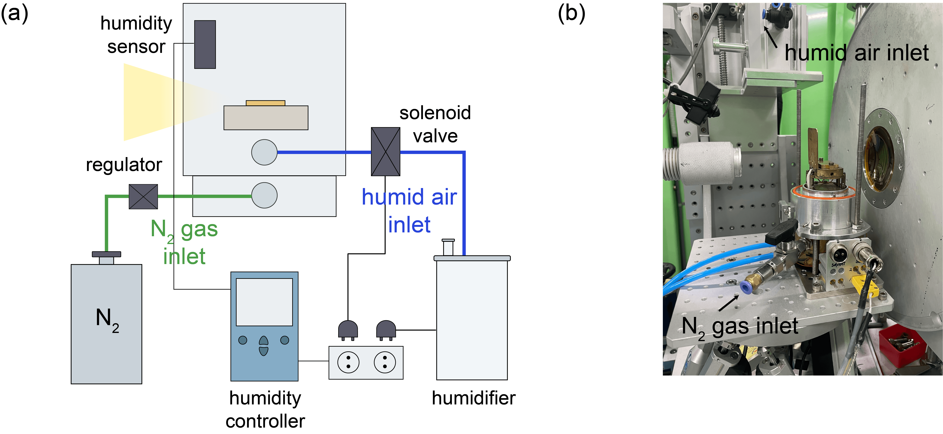

Figure S3. Experimental setup for in-situ humidity-controlled GIWAXS measurements. (a) A schematic illustration of the custom-modified humidity-controlled chamber designed for in-situ GIWAXS measurements. Dry nitrogen (N₂) and humidified air are independently introduced into the chamber to adjust the relative humidity while maintaining the grazing-incidence X-ray geometry. (b) Photograph of the chamber, showing the gas inlets and the sample stage configuration during measurements.

Section 2.2. Custom humidity-controlled chamber for in-situ UV-visible absorption measurements.

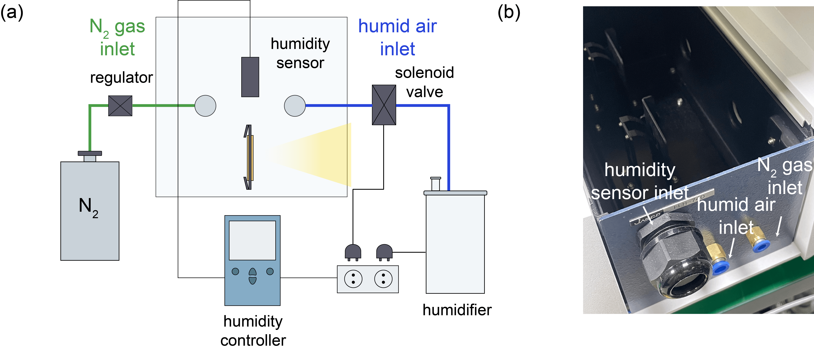

Figure S4. Experimental setup for in-situ humidity-controlled UV-visible absorption spectroscopy. (a) Schematic illustration of the custom-modified environmental chamber adapted for in-situ UV–vis measurements. The system integrates a humidity sensor and independent gas delivery lines (N₂ and humidified air) to maintain a stable vapor environment while ensuring an unobstructed optical path for absorption monitoring. (b) Photograph of the chamber with the integrated humidity sensor and gas distribution ports.

Section 3. Environmental control performance within the humidity chambers

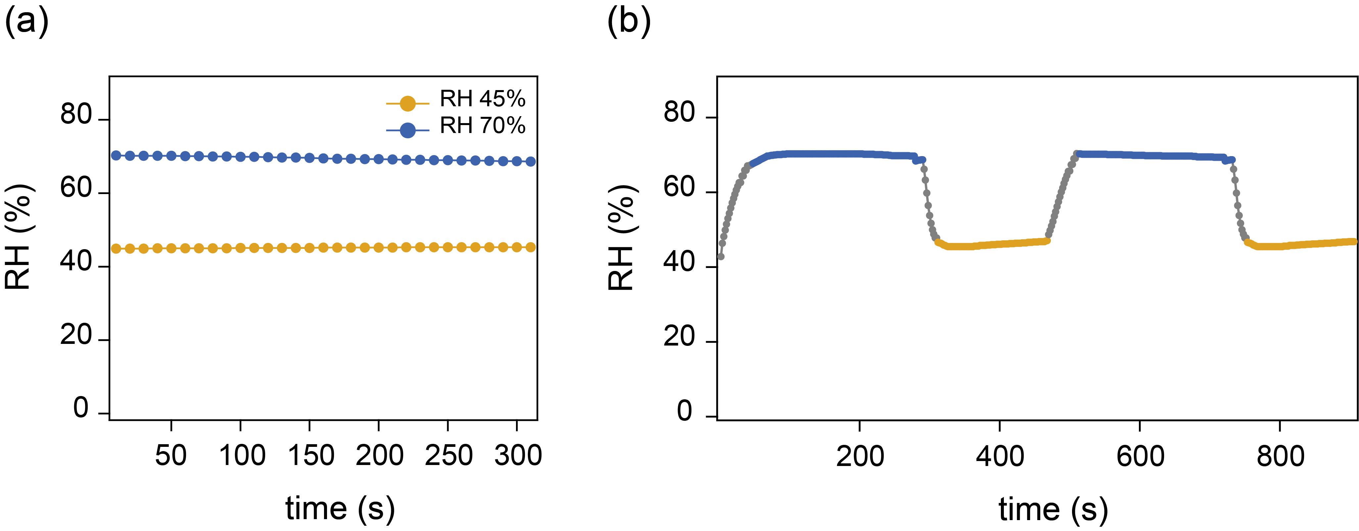

Figure S5. (a) Steady-state humidity stability at 45% (yellow) and 70% (blue) RH. The measured values exhibit negligible fluctuations ( ±0.3% RH) over a duration exceeding the typical GIWAXS acquisition time, ensuring constant environmental conditions during structural monitoring. (b) Dynamic RH profile during cyclic modulation between 45% and 70% RH.

Section 4. Control experiments

Section 4.1. PbI₂ control experiments

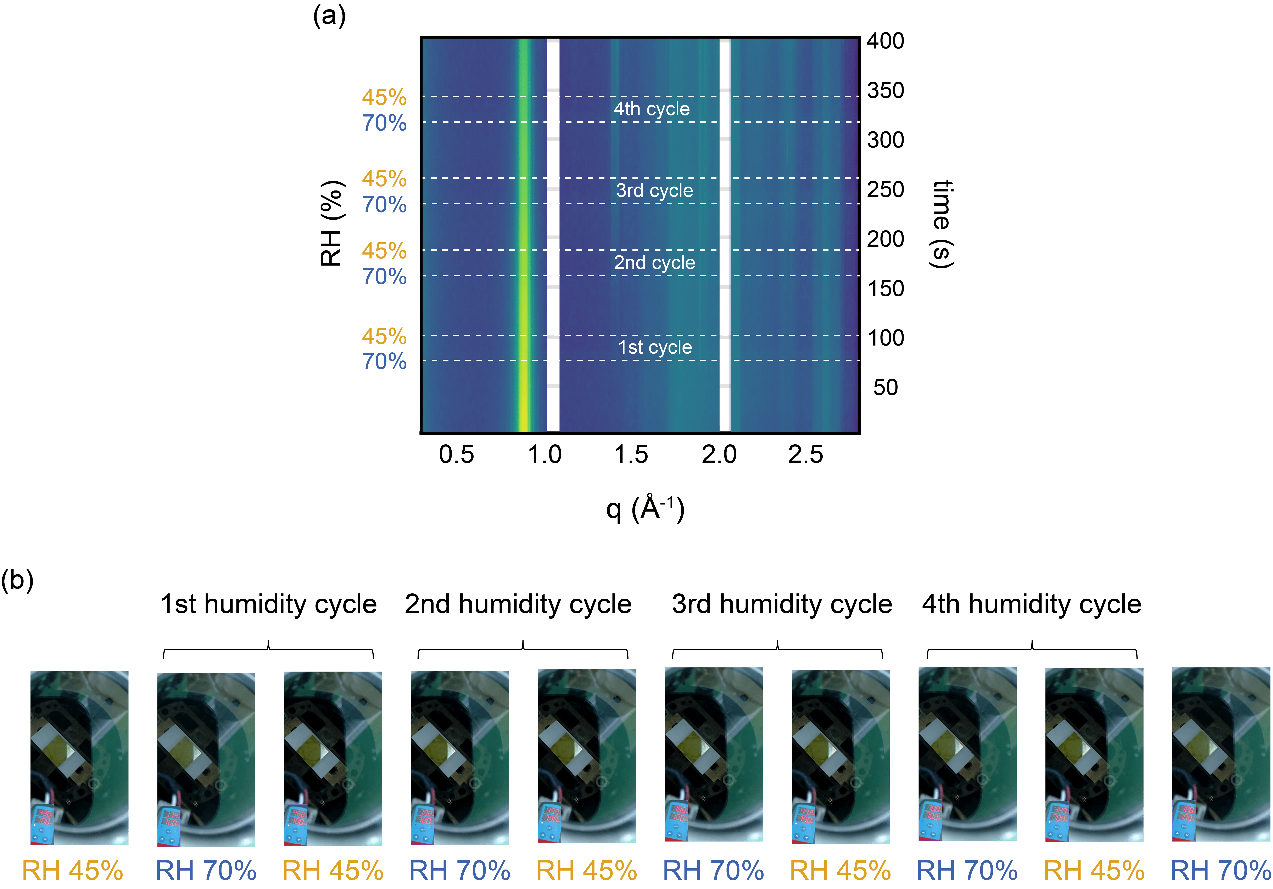

Figure S6. (a) In-situ GIWAXS heatmap of a pure PbI₂ film collected during repeated humidity cycling between 45% and 70% relative humidity (RH). The characteristic diffraction peak of PbI₂ at q = 0.9 Å⁻¹ remains invariant in both position and intensity, with no emerging features detected throughout the cycles. (b) Sequential optical photographs of the PbI₂ film under alternating RH conditions, demonstrating the absence of discernible chromic response.

To determine whether the humidity-induced responses in EA-based perovskites originate from PbI₂-related structural transitions, a control experiment was conducted on a pristine PbI₂ film. As shown in Fig. S6a, the in-situ GIWAXS patterns of PbI₂ exhibit no structural phase transformation during repeated humidity cycling between 45% and 70% RH. Specifically, the characteristic (001) diffraction peak at q = 0.9 Å⁻¹ remains invariant in both position and symmetry, with no emergence of new diffraction features associated with PbI₂ hydrates or other crystalline polymorphs.
These results confirm that PbI₂ does not undergo any discernible humidity-induced phase changes under the given experimental conditions. Consistently, the PbI₂ film shows no chromic response, maintaining its optical profile throughout the cycles (Fig. S6b). This evidence unequivocally demonstrates that the reversible structural reconfiguration observed in EA-based perovskite films is an intrinsic property of the perovskite lattice itself, rather than a consequence of PbI₂ phase evolution or degradation.

Section 4.2. Beam damage assessment during GIWAXS measurements

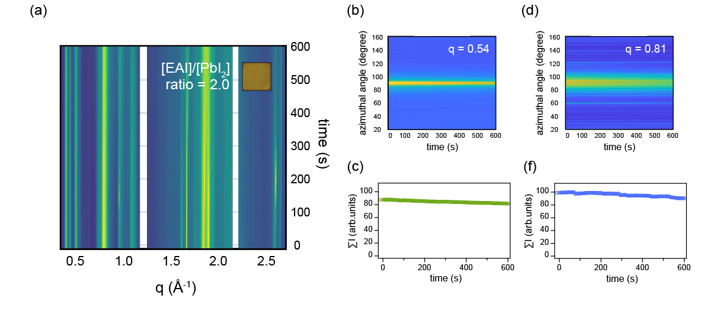
Figure S7. (a) In-situ GIWAXS heatmap of an EA-based perovskite film continuously exposed to X-ray irradiation under constant ambient humidity and temperature. No significant changes in diffraction features are observed during the measurement. (b) Azimuthal intensity distributions extracted at representative q values (q = 0.50 and 0.81 Å⁻¹). (c) Time-dependent integrated intensities of the corresponding diffraction features during continuous irradiation.

To ensure that the reversible structural transitions in EA-based perovskites are not artifacts of X-ray irradiation, we performed a beam damage assessment under continuous exposure. As shown in Fig. S7a, the GIWAXS patterns remain remarkably stable over a prolonged irradiation period of 600 s, with no discernible shifts in diffraction peaks or variations in scattering intensity.
The azimuthal intensity distributions at representative scattering vectors (q = 0.50 Å⁻¹ and 0.81 Å⁻¹) remain constant (Fig. S7b, d), indicating that the crystalline orientation is preserved without beam-induced reorientation. Furthermore, the time-dependent integrated intensities (Fig. S7c, f) show negligible fluctuation, and importantly, no diffraction features corresponding to PbI₂ (at q = 0.9 Å⁻) or other degradation byproducts emerge.
Additionally, the hydrochromic response was observed uniformly across both X-ray irradiated and non-irradiated areas of the film. This confirms that the observed lattice dynamics are an intrinsic response to humidity modulation rather than localized beam-induced heating or chemical damage. These results validate that the structural behaviors discussed in this work originate solely from humidity-driven reconfiguration.

Section 5. In-situ GIWAXS analysis of Humidity-Induced Dimensionality Transformation Modulated by EA Content

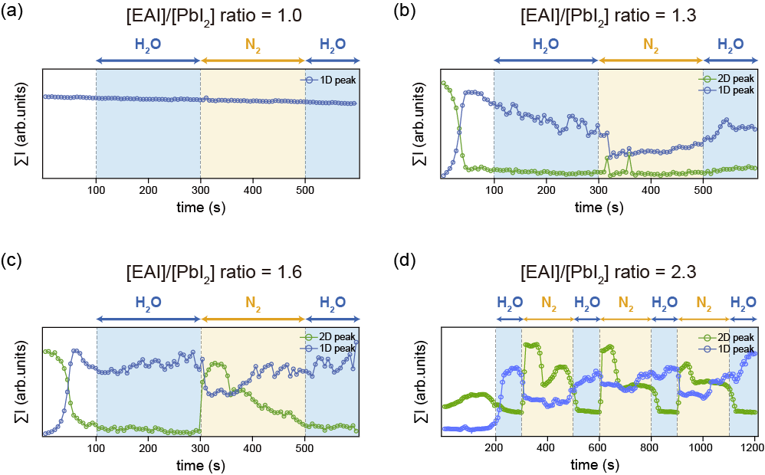

Figure S8. Integrated intensities of characteristic 1D- (blue) and 2D-related (green) diffraction peaks extracted from in-situ GIWAXS measurements for EA-based perovskite films with different compositions: [EAI]/[PbI₂] ratio of (a) 1.0, (b) 1.3, (c) 1.6, and (d) 2.3. The integrated intensities were obtained from the corresponding one-dimensional GIWAXS profiles by integrating the peak areas associated with the 2D- and 1D-related diffraction features. Shaded regions indicate alternating humid (H₂O) and dry (N₂) environments.

Section 6. In-situ UV-visible spectroscopy under humidity modulation

Section 6.1. UV-visible spectra of the [EAI]/[PbI₂] ratio of 2.0 film (For Figure 2j)

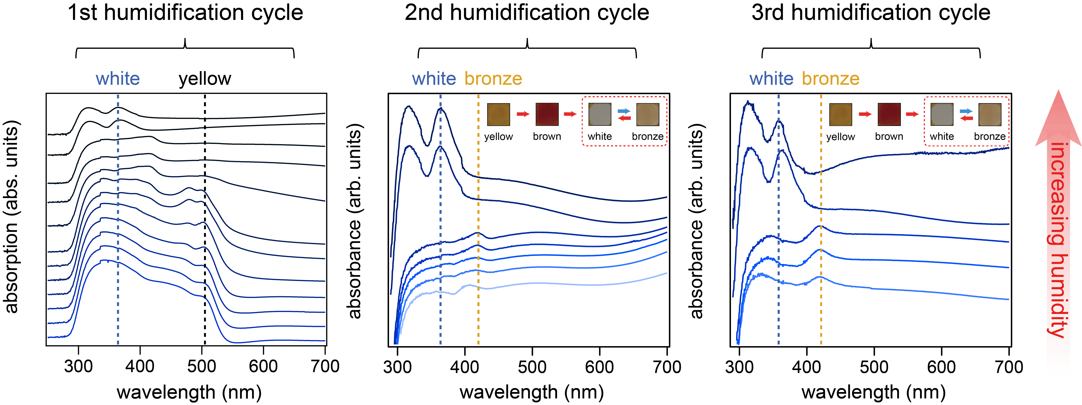

Figure S9. UV-visible absorption spectra of the [EAI]/[PbI₂] ratio of 2.0 perovskite film were collected in situ during a stepwise increase in humidity. The spectra are presented sequentially according to the increasing relative humidity, as indicated by the arrow. Dashed vertical lines indicate specific spectral positions related to the white and bronze optical states. The gradual and reversible changes in the absorption features correspond to the humidity-induced color variations of the film. This provides the underlying spectroscopic data for the peak intensity analysis shown in Fig. 2j.

Section 6.2. Composition-dependent evolution of in-situ UV-vis absorption spectra. (For Figure 3g-k)

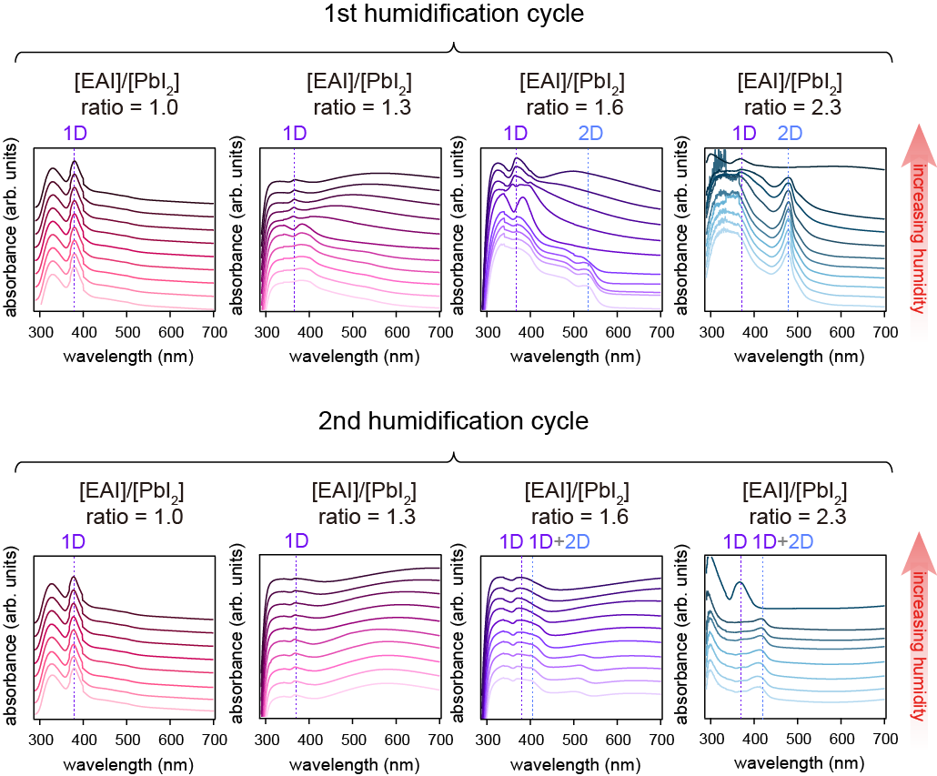

Figure S10. In-situ UV-visible absorption spectra of EA-based perovskite films with varying compositions ([EAI]/[PbI₂] ratio of 1.0, 1.3, 1.6, and 2.3) recorded during the first and second humidification cycles. Arrows indicate the direction of increasing relative humidity. Vertical dashed lines highlight the characteristic exciton absorption features for the 1D (purple) and 2D (blue) optical states. Notably, the [EAI]/[PbI₂] ratio of 1.0 film exhibits structural invariance, maintaining its 1D excitonic profile regardless of humidity modulation, whereas higher EA content (e.g., [EAI]/[PbI₂] ratio of 2.3) facilitates a reversible transition to the 2D phase.

References
1 Muralidhar, J. R. et al. Chemical Storage of Ammonia through Dynamic Structural Transformation of a Hybrid Perovskite Compound. Journal of the American Chemical Society 145, 16973–16977 (2023).
2 Guvenc, C. M. et al. Breaking the Boundaries of the Goldschmidt Tolerance Factor with Ethylammonium Lead Iodide Perovskite Nanocrystals. ACS Nano 19, 1557–1565 (2025).
3 Surel, J. L., Cutlip, E. V., Mandeville, J. R. & Christians, J. A. Switchable Color Semiconductors: Methylamine Intercalation, Deintercalation, and Retention in Two-Dimensional Halide Perovskites. ACS Applied Energy Materials 5, 12029–12038 (2022).
4 Zhou, J. et al. Efficient ambient-air-stable HTM-free carbon-based perovskite solar cells with hybrid 2D–3D lead halide photoabsorbers. Journal of Materials Chemistry A 6, 22626–22635 (2018).

