Supplementary Materials Practice and challenges of newborn hearing screening: Analysis of a five-year database in Italy

- Analysis of incidence per Center

To further corroborate the hypothesis of some organizational issue affecting Level 3 of the screening program, data concerning IP have been compared to the number of births (alive) in the FVG region over the 2019-2023 period, organized by birthing centers and Level 2 centers of reference (Table S1). This analysis allows us to have a detailed view of the local situations and, especially, to rule out causes other than organizational ones, such as the different number of births managed by each center.

Table S1. Number of births (alive) in the FVG region over the 2019-2023 period managed by birthing centers (BC) and aggregated by Level 2 Centers of reference.
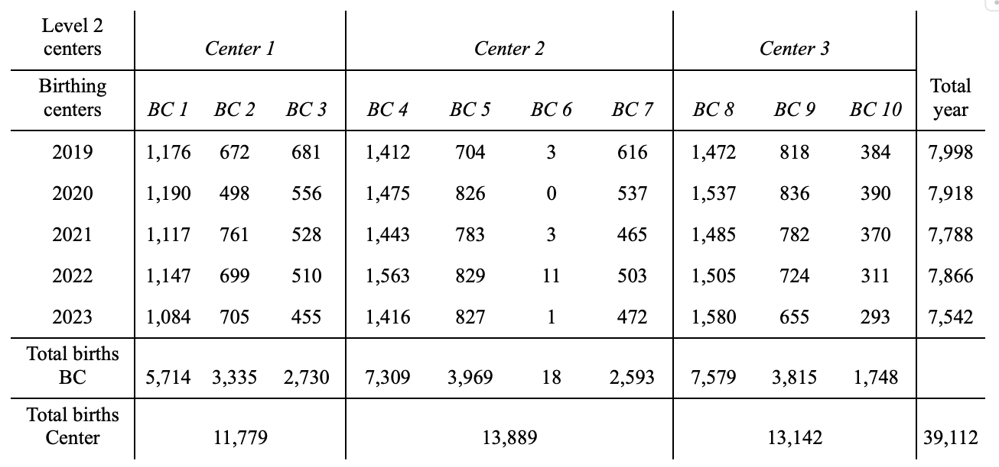

The percentage of suspected hearing impairments varies across centers. Considering the overall number of suspected hearing loss during Phase 3A, consisting in the total number of outcomes for each center reported in Fig. 3 in the text, i.e., 38 in Center 1, 31 in Center 2, and 37 in Center 3, and births effectively managed by each center, Center 1 counts an incidence of suspected hearing issues of 3.23‰ patients, while this percentage is equal to 2.23‰ and 2.82‰ for Centers 2 and 3, respectively. Instead, when the numbers of diagnosed IP after Phase 3D are considered (17 for Center 1 and 24 for both Center 2 and Center 3), these percentages indicate the actual incidence of IP, that is, 1.44‰ (Center 1), 1.73‰ (Center 2), and 1.83‰ (Center 3). These results are in line with the observed incidence of permanent hearing impairments in Italy; however, it is worth noting the difference between the incidence of Center 1 and the other two centers, in particular Center 3, which is the other Level 3 center that is not the regional hub.
As mentioned in the text, the lower incidence of IP from Center 1 as compared with other centers might be due to the lower number of total births administered by Center 1 between 2019 and 2023. In particular, given that births managed by Center 1 are much fewer than those administered by the other two centers, this might have biased the rate of patients accessing Level 3 coming from Center 1, the incidence of IP, and, in turn, our hypothesis that some organizational issues have impacted the management of referrals. However, this potential effect can be effectively ruled out by noting that the number of patients with suspected hearing impairments referred from Center 1 at Phase 3A is similar to that from Center 3 (38 vs. 37). Therefore, the difference in the number of births at Center 1 impacts only the incidence of suspected hearing loss at the very beginning of Level 3 (Phase 3A). Such an effect is, in fact, reduced over the subsequent phases of the program, where the incidence of IP in Center 1 can be explained by the higher number of losses (15 vs. 1 for Center 2 and 9 for Center 3), highlighting a more subtle management issue underlying the screening procedure at Center 1.

- JCIH risk factors

JCIH risk factors associated with codes reported in Figure 4 in the text (see JCIH 2007, 2019).

Perinatal risk factors:
1: Family history of early, progressive, or delayed onset permanent childhood hearing loss;
2: Neonatal intensive care of more than 5 days;
3: Hyperbilirubinemia with exchange transfusion regardless of length of stay;
4: Aminoglycoside administration for more than 5 days;
5: Asphyxia or hypoxic ischemic encephalopathy;
6: Extracorporeal membrane oxygenation;
7: In utero infections, such as herpes, rubella, syphilis, and toxoplasmosis, cytomegalovirus;
8: Certain birth conditions or findings (e.g., craniofacial malformations including microtia/atresia, ear dysplasia, oral facial clefting, white forelock, and microphthalmia, congenital microcephaly, congenital or acquired hydrocephalus, temporal bone abnormalities);
9: Syndromes that have been identified with atypical hearing thresholds.

Perinatal or postnatal risk factors:
10: Culture-positive infections associated with sensorineural hearing loss, including confirmed bacterial and viral meningitis or encephalitis;
11: Events associated with hearing loss, e.g., significant head trauma, chemotherapy;
12: Caregiver concern regarding hearing, speech, language, developmental delay, and or developmental regression.

