Supplement 2 A and B: BMI change, BMI at the last visit during the 9.4 years average follow-up minus BMI at baseline for males A and males B.

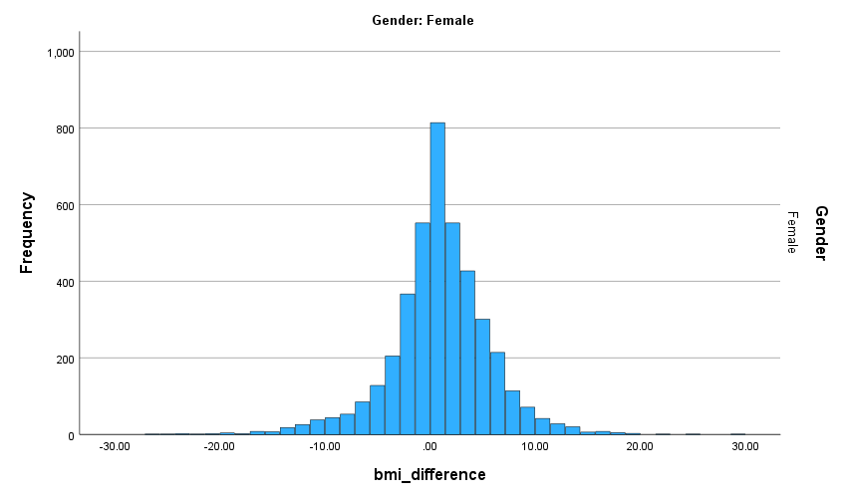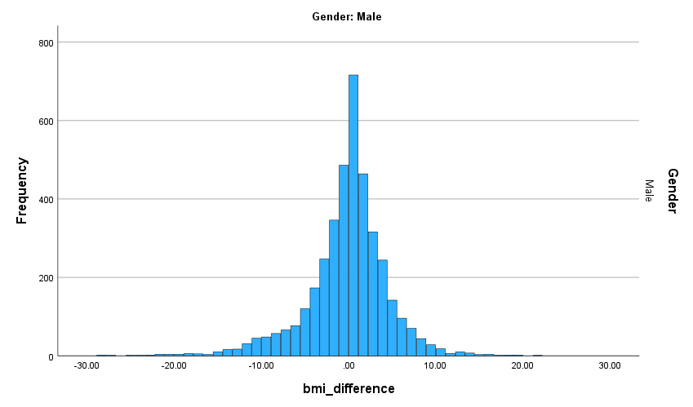

Paired Samples Test |  | Mean | SD | 95% CI |  | P value
Female | Predected BMI - BMI2 | 0.57 | 5.86 | 0.391 | 0.758 | <.001
Male | Predected BMI - BMI2 | 0.40 | 5.43 | 0.228 | 0.567 | <.001

Supplement 1 C and D Scatter Plot figure displays the association of BMI at baseline (BMI 1) and BMI at follow-up (BMI 2)
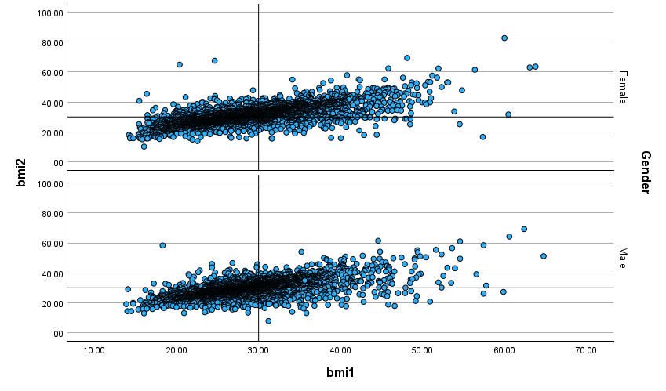
Supplement 1 E and F Scatter plot: This plot is based on the predicted BMI, calculated using the regression coefficient and regression constant, and the last BMI recorded during the follow-up years.
* (predicted BMI= (22.860+ ((9.3+Whole_age) * 0.164))*(Gender=1))+((27.335+((9.3+Whole_age)* 0.032))*(Gender=2)).

