Appendix
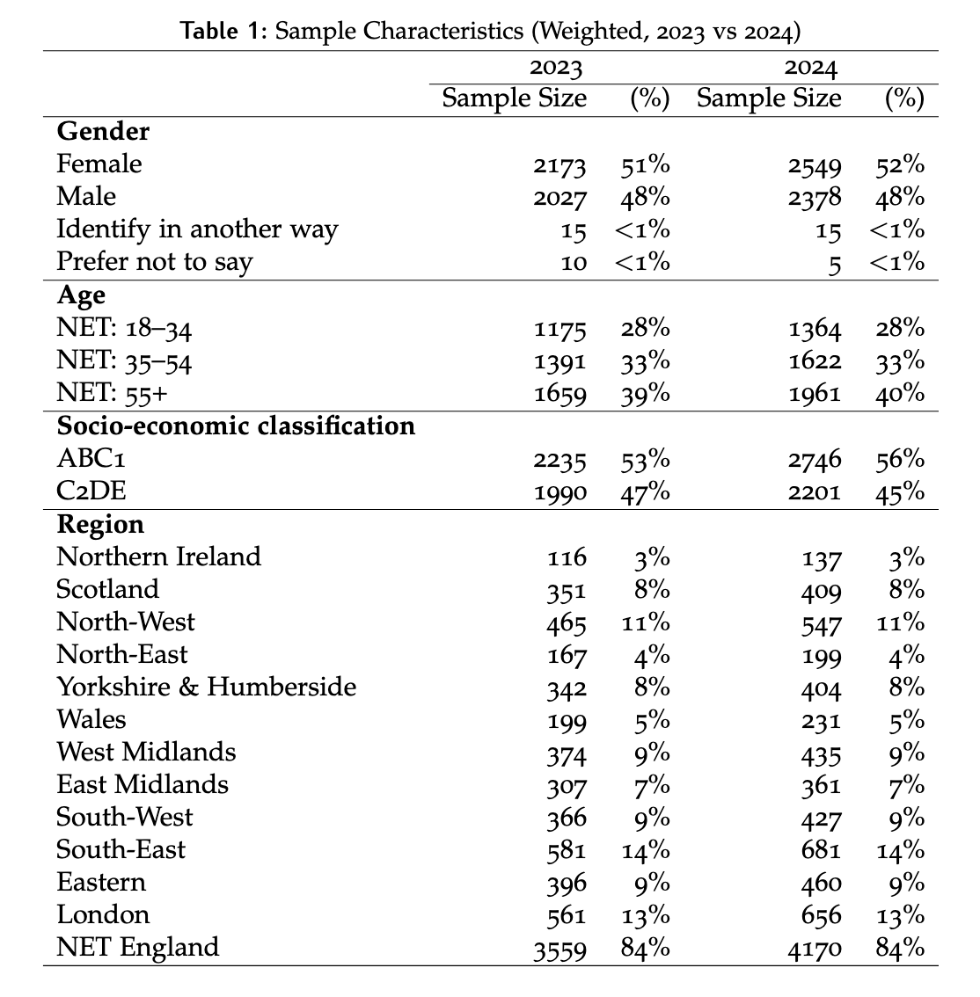

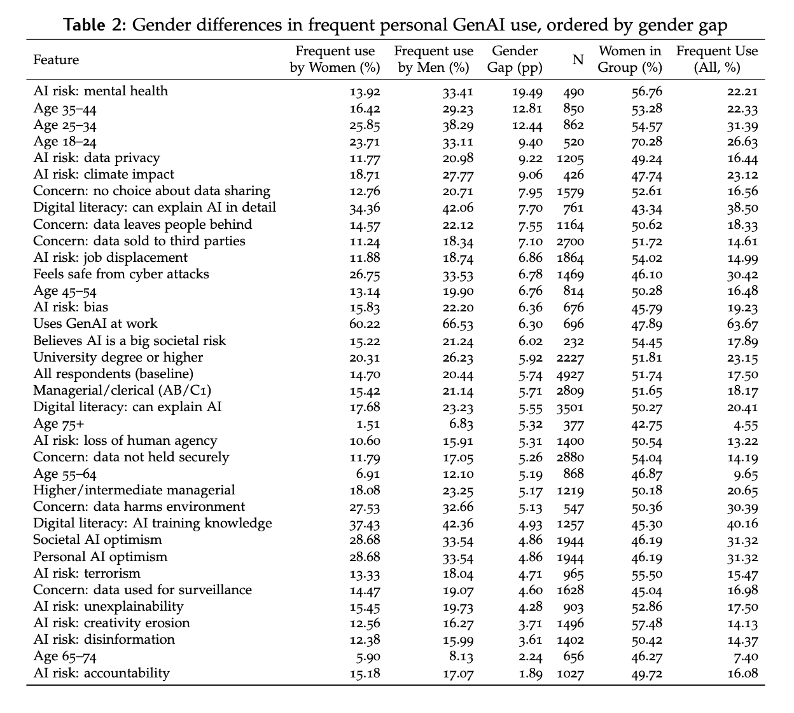
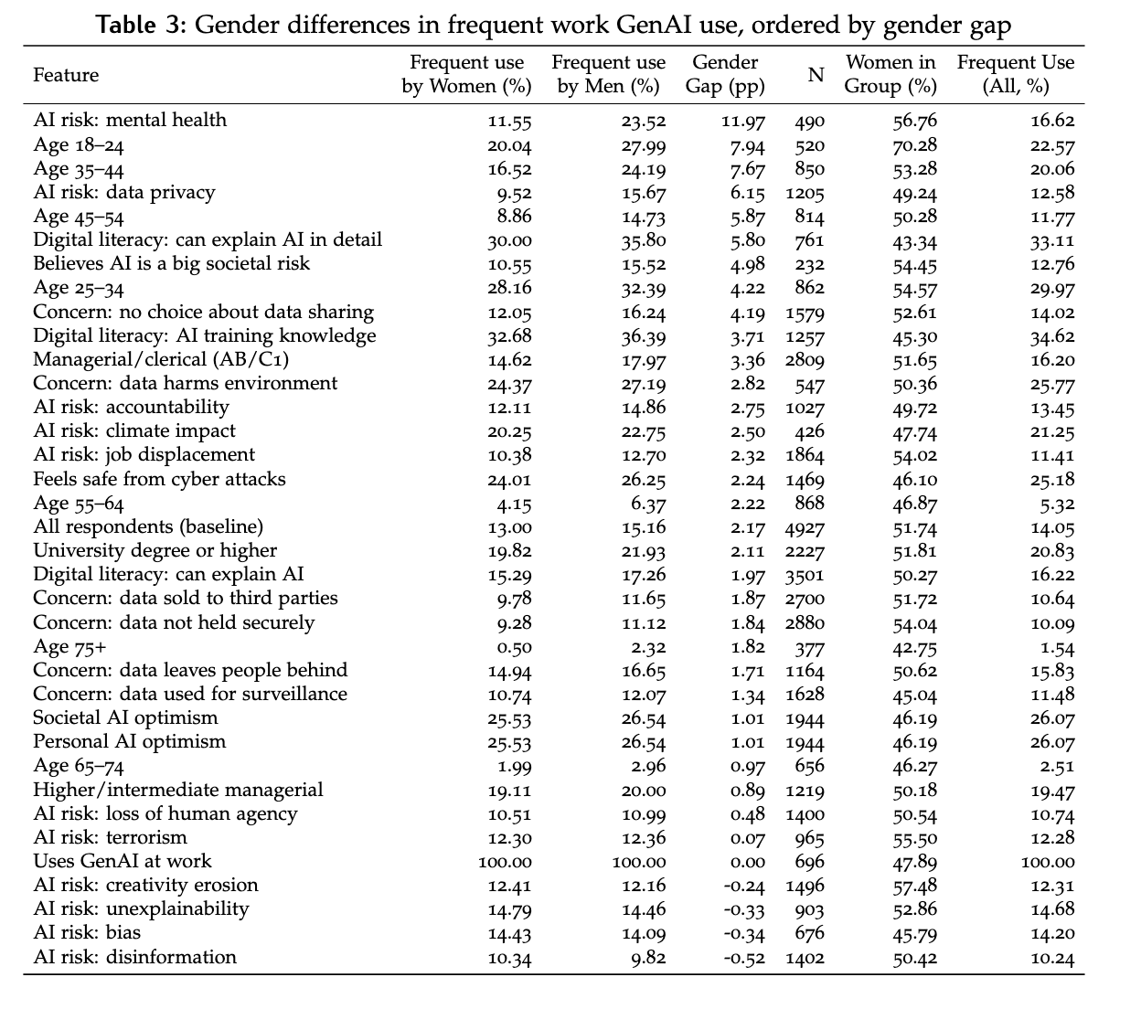

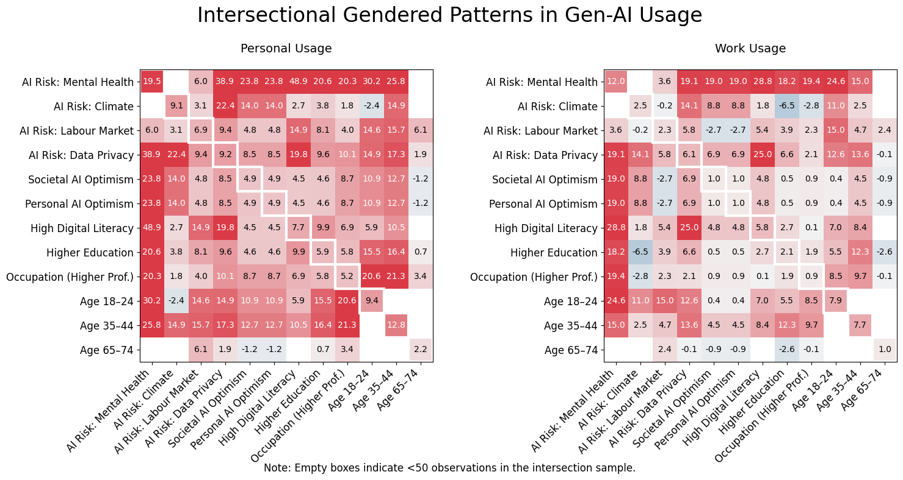

Figure A1. Intersectional gender gaps in GenAI usage across paired factors and attitudes.
The heatmaps show gender differences (percentage-point gaps) in frequent personal (left) and work (right) use of generative AI for respondents when two characteristics or attitudes intersect. Rows represent the primary factor of interest; columns represent secondary intersecting factors. Positive values indicate higher usage among men. Empty cells reflect intersections with fewer than 50 observations.
Figure A1 maps how gender gaps in GenAI adoption widen or narrow when two factors or attitudes intersect. Consistent with the main findings, gender gaps in work-related use are generally smaller than those for personal use across most intersections. A notable exception concerns respondents who view AI as a risk to mental health: for this group, work-related gaps remain similar to personal use gaps, despite the lower overall baseline in the work context (12.0 vs 19.5 percentage points, respectively). The single largest intersectional gap emerges among individuals who both perceive AI as a mental health risk and report high digital literacy (48.9 percentage points in personal use vs 28.8 in work use). Younger adults (18–24) consistently display wide gaps in both contexts. Among those concerned about mental health harms, most additional factors widen the disparity—including privacy concerns (38.9pp) and strong AI fluency (48.9pp)—with one notable moderating exception: pairing mental health concern with labour market concern yields much smaller gaps (6.0pp personal; 3.6pp work). In the work context, gender gaps rise sharply for young respondents who also hold additional worries about AI (e.g., AI as a mental health threat: 24.6pp; labour market threat: 15.0pp; climate harm: 11.0pp), but shrink to near zero for those who are optimistic about AI’s societal or personal impact. Privacy concerns coupled with high digital literacy emerges as an outlier in that the gap is wider in the work context than in personal use, respectively at 25.0pp and 19.8pp. Overall, intersectional attitudes meaningfully modulate the gender gap, highlighting how concern domains and digital fluency jointly shape uneven GenAI uptake.

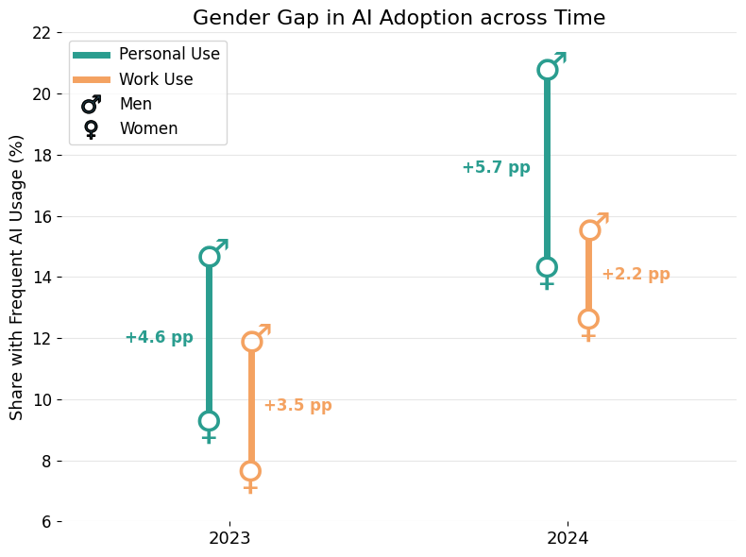

Figure A2. Gender gaps in frequent GenAI use between 2023 and 2024.
Male–female differences in frequent personal and work-related use of generative AI across two survey waves (2023 and 2024). Markers show usage rates for men and women each year. Personal use gaps widen from +4.6 pp in 2023 to +5.7 pp in 2024, whereas work use gaps narrow from +3.5 pp to +2.2 pp.
Figure A2 shows how gender disparities in GenAI adoption have shifted over time. Between 2023 and 2024, frequent personal use rose substantially for both men (14.3% to 20.4%) and women (9.7% to 14.7%), but men’s faster uptake led to a widening gender gap in personal use—from 4.6pp to 5.7pp. In contrast, work-related adoption increased more modestly (men: 11.5% to 15.2%; women: 8.0% to 13.0%), producing a narrowing of the work-use gap from 3.5 pp to 2.2 pp. These patterns suggest that while overall usage is rising, personal adoption is accelerating more quickly among men—reinforcing inequality—whereas workplace adoption appears to be converging modestly across genders.

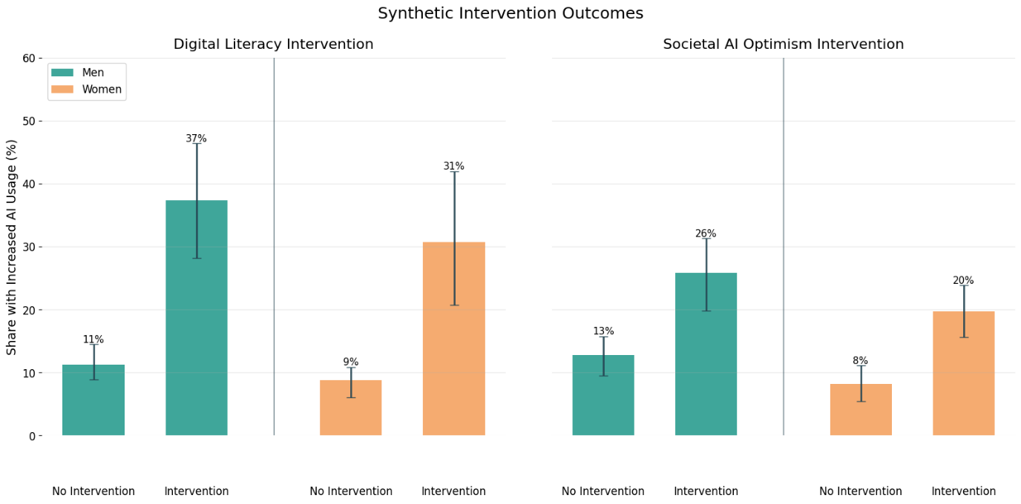
Figure A3. Synthetic intervention effects on changes in personal GenAI use (full sample).
Effects of synthetic interventions in digital literacy (left) and increased optimism about AI’s societal impact (right) on the share of respondents who increased their personal GenAI use between survey waves (2023-2024). Estimates are based on 100 iterations of a synthetic-twin matching design pairing Wave 3 respondents with Wave 4 look-alikes (matched on age, gender, education, and occupation). Error bars represent 95% confidence intervals. This yielded pairs of individuals who were highly similar on stable sociodemographic and labour-market characteristics but differed in whether they experienced a “change” in the putative treatment.
For digital literacy, respondents were classified on a four-point scale of understanding of generative AI (no understanding, little understanding, partial understanding, full understanding). The non-intervention group consisted of matched individuals whose literacy level remained unchanged between waves. The intervention group consisted of matched pairs in which the 2024 twin reported a higher level of understanding than their 2023 counterpart. We then compared these groups on the probability of increasing AI usage by at least one category. Analyses were conducted separately for men and women. An analogous procedure was applied to changes in AI-related risk perceptions, allowing us to isolate how shifts in optimism or concern—net of sociodemographic factors—translate into behavioural change.
Figure A3 shows how the two synthetic interventions operate in the full sample, highlighting a different pattern from the young-adult results in the main text. Here, both interventions have significant positive effects for men and women: improvements in digital literacy raise the share who increase their GenAI use for both groups, while increased societal AI optimism produces similarly broad gains. The effect of the digital literacy intervention remains stronger for men than for women, echoing the young-adult pattern, but in contrast to the younger cohort, women in the full sample also exhibit a clear and significant increase. For the optimism intervention, the boost is slightly stronger for women than for men.

