Fig. S1 Expansion test of water swellable rubber in vitro. (A) Specification of the water swellable rubber: (a) anterior part; (b) tail part. (B-D) Rat venous blood was mixed with anticoagulants, and the rubber immersed in the blood to observe rubber expansion over time. Day 0 means before immersion in the blood. There were significant differences between day 1, day 3, day 5, day 7, and before blood immersion (day 0) in the length (B), diameter of the anterior part (C), and diameter of the tail part (D) (P<0.001). After soaking in the blood, the specification data of the rubber was basically stable from the first day; there was no significant difference between any pairs among day 1, day 3, day 5, and day 7.

Fig. S2 Blood flow changes on the brain surface after rubber insertion. (A) LSCI showing normal CBF before occlusion. (B) SSS is not completely occluded right after rubber insertion. (C) After material expansion, blood flow in the SSS completely disappeared. Scar bar = 0.5 mm. The red to blue color bars on the right side represent blood flow from high to low. CBF, cerebral blood flow, LSCI, laser speckle contrast imaging, SSS, superior sagittal sinus.

Fig. S3 Three-dimensional MRA reconstruction. (A) MRA clearly showing normal cerebrovascular anatomy of rats in the sham group. (B) In the model group, the middle and posterior segments of SSS (white arrows) and the transverse sinus (yellow arrows) have completely disappeared, and the veins surrounding it tend to be tortuous and distorted. MRA, magnetic resonance angiography, SSS, superior sagittal sinus.
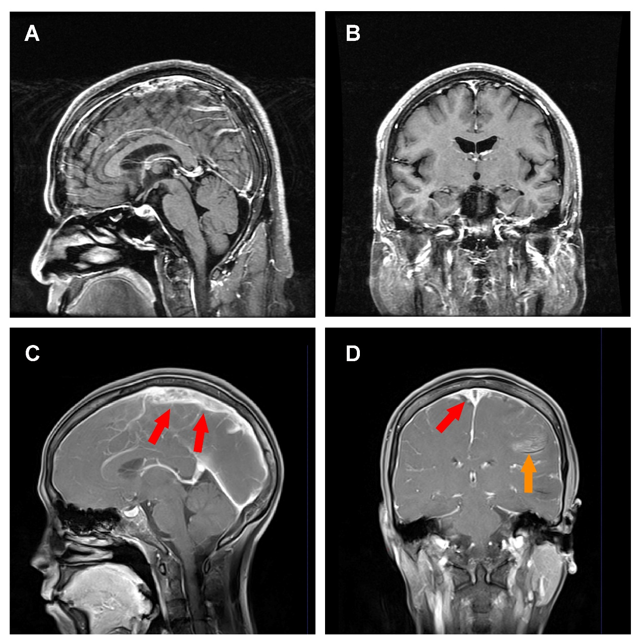
Fig. S4 Thickening of the sinus wall in a patient with CVST. In enhanced T1WI, thickening of the venous sinus wall (red arrows) and the surrounding dura mater is observed in one CVST patient (C-D) compared to a healthy control (A-B). An area of high intensity edema is observed in the left temporal lobe in the CVST patient (yellow arrow). CVST, cerebral venous sinus thrombosis, T1WI, T1-weighted imaging.

