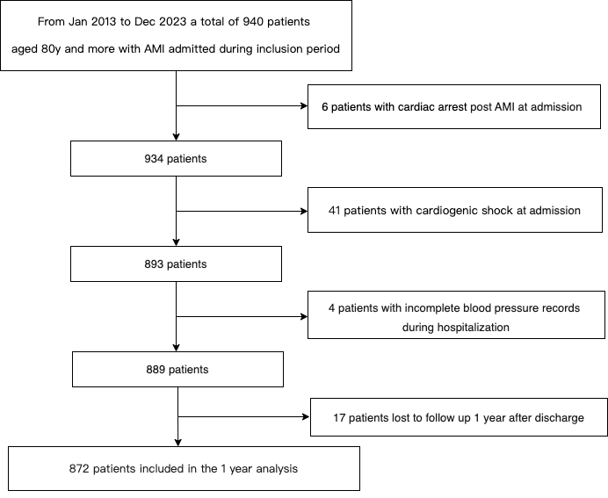

Supplemental Fig 1. Study flowchart.
A All-cause mortality in 1 year B All-cause mortality in 1 month
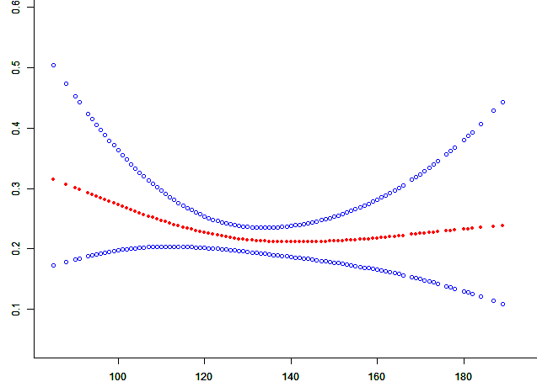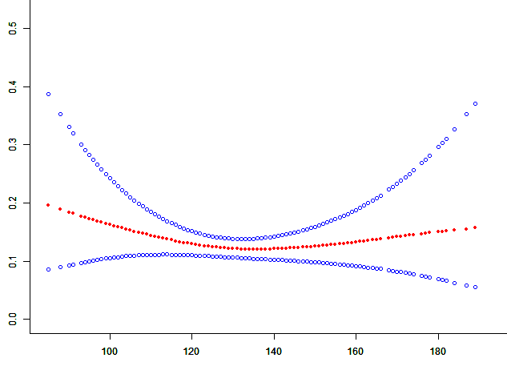
Adjusted Odd Ratio
Admission SBP（mm Hg）
Admission SBP（mm Hg）
Adjusted Odd Ratio

C All-cause mortality in-hospital D Cardiac mortality in 1 year

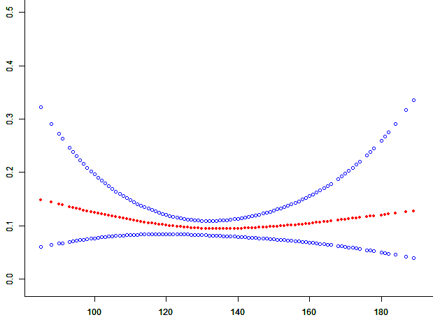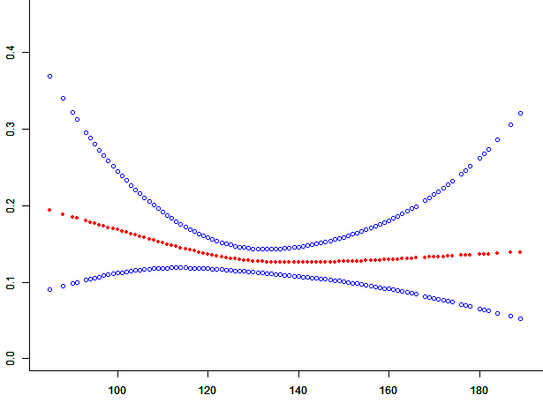
Admission SBP（mm Hg）
Adjusted Odd Ratio
Admission SBP（mm Hg）
Adjusted Odd Ratio

E Cardiac mortality in hospital

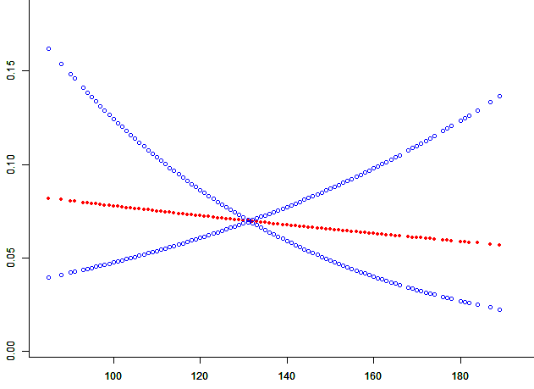
Adjusted Odd Ratio
Admission SBP（mm Hg）

Supplemental Fig 2. The association between the admission SBP following acute myocardial infarction with the risk for all-cause mortality in 1 year (A), all-cause mortality in 1 month (B), all-cause mortality in-hospital (C), cardiac mortality in 1 year (D) and cardiac mortality in hospital (E) after multivariables adjustment.

Supplemental Table 1. Association between change in SBP from pre-AMI home to in-hospital average and outcomes

Primary and Secondary Outcomes | OR (95CI) | P value | OR (95CI) | P value
Primary and Secondary Outcomes | Unadjusted |  | Adjusted#
Δ SBP*
all-cause mortality in 1 year | 1.01 (0.99, 1.03) | 0.092 | 1.01 (0.99, 1.04) | 0.328
all-cause mortality in 1 month | 1.02 (1.00, 1.04) | 0.024 | 1.04 (1.00, 1.07) | 0.032
all-cause mortality in-hospital | 1.03 (1.00, 1.06) | 0.005 | 1.11(1.04, 1.18) | 0.002
cardiac mortality in 1 year | 1.02 (0.98, 1.04) | 0.067 | 1.02 (0.98, 1.05) | 0.562
cardiac mortality in hospital | 1.04 (1.01, 1.07) | 0.012 | 1.05 (1.01, 1.10) | 0.024

*Δ SBP* pre-AMI mean home SBP minus acute-phase in-hospital average SBP
# Adjusted for gender,age, AMI classification, smoking condition, alcohol consumption, history of hypertension, diabetes mellitus, previous myocardial infarction, previous cerebral infarction, chronic kidney disease, peripheral artery disease, previous PCI, previous CABG, HR at admission, cTnT max, NT-proBNP max, total cholesterol, HDL cholesterol, LDL cholesterol, triglycerides, HbA1c, Hct, PCI after AMI, complete coronary vascularization and hemorrhage events. CI indicates confidence interval; OR, odd ratio.

