GENE SYMBOL | GENE NAME | ROLE
PSEN2 | Presenilin 2 | AD causing
PSEN1 | Presenilin 1 | AD causing
APP | Amyloid Beta Precursor Protein | AD causing
TYROBP | TYRO protein tyrosine kinase-binding protein | AD risk factor
TREM2 | triggering receptor expressed on myeloid cells 2 | AD risk factor
APOA1 | apolipoprotein 1 | AD risk factor
TARDBP | TAR DNA-binding protein | involved in FTD/ALS
CHMP2B | charged multivesticular body protein 2B | involved in FTD/ALS
VCP | valosin-containing protein | involved in FTD/ALS
FUS | FUS RNA-binding protein | involved in FTD/ALS
GRN | Granulin precursor | involved in FTD/ALS
MAPT | microtubule-associated protein tau | involved in FTD/ALS
OPTN | optineurin | involved in FTD/ALS
TBK1 | TANK-binding kinase 1 | involved in FTD/ALS
SQSTM1 | sesquestosome 1 | involved in FTD/ALS
HRNRPA2B | heterogeneous nuclear ribonucleoprotein A2/B1 | involved in FTD/ALS
PRKAR1B | protein kinase cAMP-dependent type I regulatory subunit beta | involved in FTD/ALS
CHCHD10 | coiled-coil-helix-coiled-coilhelix domain containing 10 | involved in FTD/ALS
SIGMAR1 | sigma nonopioid intracellular receptor 1 | involved in FTD/ALS
SNCA | synuclein alpha | involved in LBD
SERPINI1 | serpin family I member 1 | involved in other ND
CSF1R | colony stimulating factor 1 receptor | involved in other ND
ITM2B | integral membrane protein 2B | involved in other ND
DCTN1 | dynactin subunit 1 | involved in other ND
UBQLN2 | Ubiquilin 2 | involved in other ND
NOTCH3 | neurogenic locus notch homolog protein 3 | involved in vascular dementia
GSN | gelsolin | involved in vascular dementia
TTR | transthyretin | involved in vascular dementia
PRNP | Prion protein | Prion diseases causing

Table S1: Genes covered in the target sequencing panel.
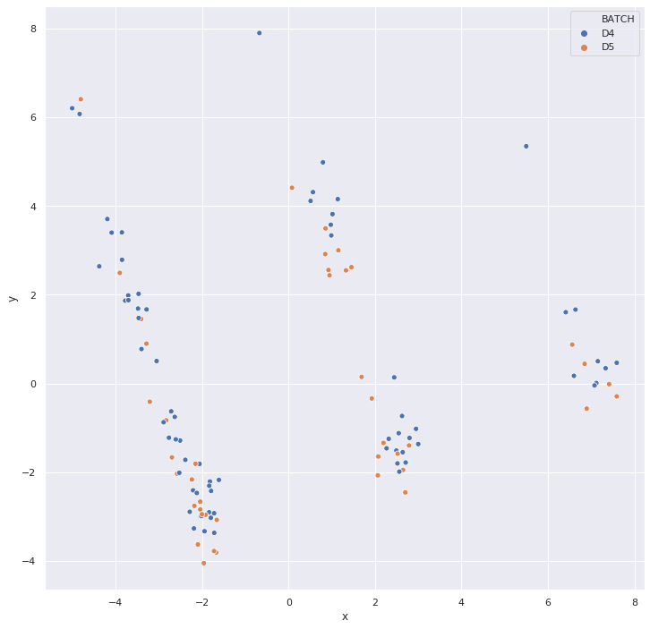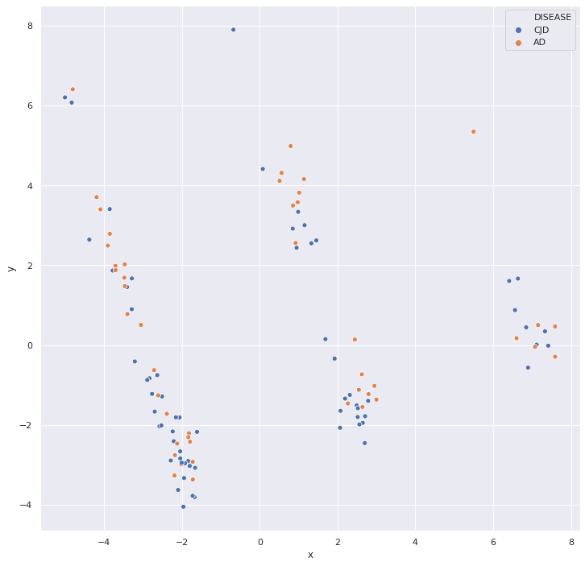
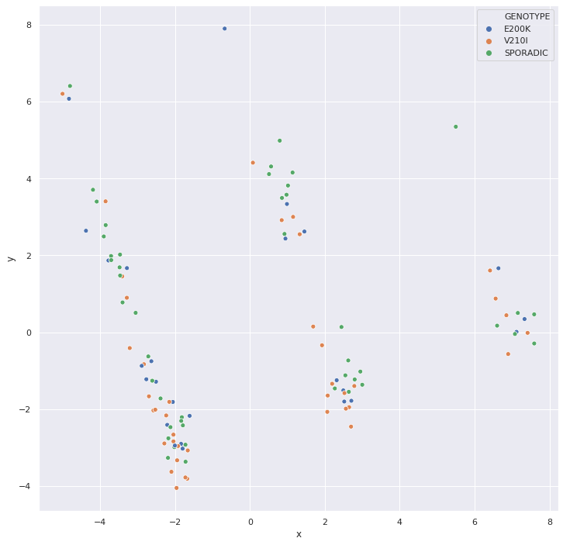
Figure S1: Superimposition of labels of batches, diseases and genotypes on the PCA plot.
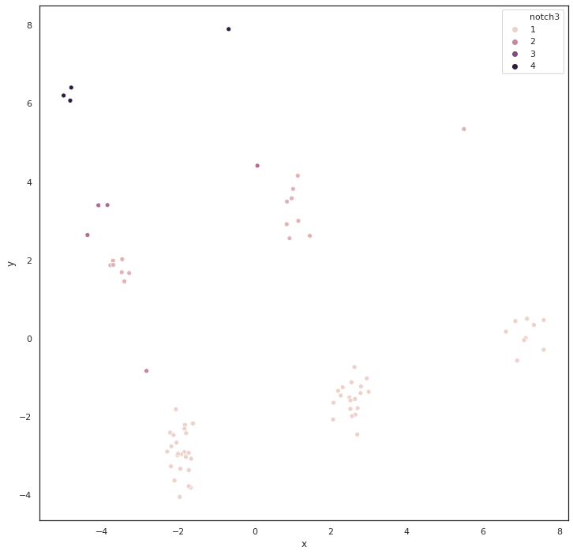
Figure S2: superimposition of labels of available NOTCH3 haplogroups on the PCA plot.

variant | x | y
chr17-43971785-A-G | 0.185702 | 0.067174
chr17-43972025-TC-T | 0.191209 | 0.039996
chr17-43971937-C-A | 0.194484 | 0.05385
chr17-44073973-T-C | 0.197249 | 0.065004
chr17-44039691-A-G | 0.197249 | 0.065004
chr17-44067400-T-C | 0.197249 | 0.065004
chr17-44067508-A-G | 0.197249 | 0.065004
chr17-44068924-G-A | 0.197249 | 0.065004
chr17-44091724-G-A | 0.197249 | 0.065004
chr17-44049329-C-T | 0.197249 | 0.065004
chr17-44061023-G-A | 0.197249 | 0.065004
chr17-44071294-T-C | 0.197249 | 0.065004
chr17-44067546-T-C | 0.197249 | 0.065004
chr17-43972142-G-A | 0.197249 | 0.065004
chr17-44061278-C-T | 0.197249 | 0.065004
chr17-44073739-G-A | 0.197249 | 0.065004
chr17-44051846-A-G | 0.197249 | 0.065004
chr17-44061036-T-C | 0.197249 | 0.065004
chr17-44101563-T-C | 0.197249 | 0.065004
chr17-44073889-A-G | 0.197249 | 0.065004

Table S2: top 20 contributors to the first principal component

PC | Feature
PC1 | chr17-43972142-G-A
PC2 | chr19-15289613-A-T
PC3 | chr1-227069737-C-T
PC4 | chr5-149441016-AC-A
PC5 | chr19-15302844-T-C

Table S3: main contributors to the first five principal components (30% variance explained)

AD | CJD | E200K | V210I
OPTN | OPTN | OPTN | OPTN
APOA1 | FUS | PSEN1 | APOA1
PSEN2 | MAPT | CCNF | ITM2B
FUS | PRNP | FUS | CCNF
MAPT | CHCHD10 | TTR | FUS
NOTCH3 | GSN | PRNP | MAPT
APP |  | DCTN1 | NOTCH3
DCTN1 |  | SERPINI1 | PRNP
SERPINI1 |  | SQSTM1 | APP
CSF1R |  | GSN | DCTN1
PRKAR1B |  |  | CSF1R
GSN |  |  | TREM2
UBQLN2 |  |  | PRKAR1B
 |  |  | GSN
 |  |  | VCP
 |  |  | UBQLN2

Table S4: List of genes harbouring at least one variant with a significantly altered allele frequency in the different classes. As reported in supplementary materials, in the CJD groups PRNP variants with significantly increased allele frequency were causative mutations and SNV at the codon 129, known modifier of prion diseases.

